

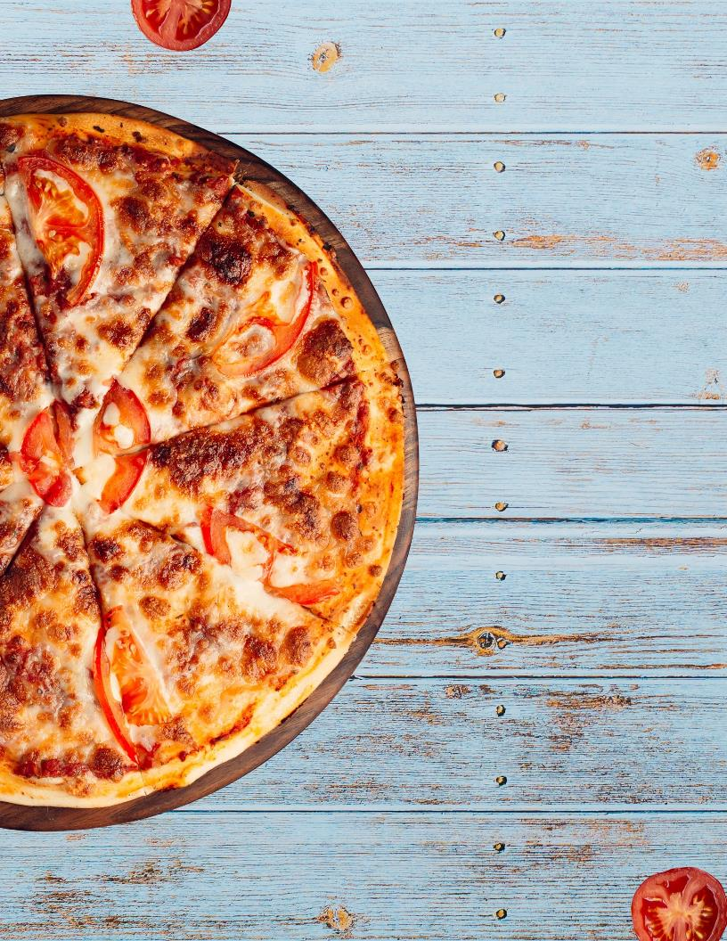

|  |  |  |  |  |  |  |  |  |  |  |  |  |  |  |  |  |
| --- | --- | --- | --- | --- | --- | --- | --- | --- | --- | --- | --- | --- | --- | --- | --- | --- |
|  | | | | |  | **CATERING COMPANY NAME** | | | | | | | | | |  |
|  | | | | |  | MENU NAME | | | | | | | | | |  |
|  | | | | |  |  | | | | | | | | | |  |
|  | | | | |  |  | | SOUPS AND SALADS | | | | | |  | |  |
|  | | | | |  |  | | | | | | | | | |  |
|  | | | | |  | Caesar Salad  Garden Salad  Spring Salad | | | | Price  PricePrice | |  | Minestrone Soup  Chicken Noodle Soup  Cream of Corn Soup | | Price  Price Price |  |
|  | | | | |  |  | | | | | | | | | |  |
|  | | | | |  |  | | PIZZAS | | | | | |  | |  |
|  | | | | |  |  | | | | | | | | | |  |
|  | | | | |  | Margherita  Meat Lovers  Pesto Shrimp | | | | Price  Price Price | |  | Chicken Alfredo  Pepperoni  Hawaiian | | Price  Price Price |  |
|  | | | | |  |  | | | | | | | | | |  |
|  | | | | |  |  | | CLASSIC PASTA DISHES | | | | | |  | |  |
|  | | | | |  |  | | | | | | | | | |  |
|  | | | | |  | Baked Ziti  Baked Macaroni  Penne with Tomato | | | | Price  Price Price | |  | Spaghetti  Shrimp Scampi  Aglio Olio | | Price Price  Price |  |
|  | | | | |  |  | | | | | | | | | |  |
|  | | | | |  |  | | **DESSERTS** | | | | | |  | |  |
|  | | | | |  |  | | | | | | | | | |  |
|  | | | | |  | Banana Muffin  Carrot Muffin  Brownie | | | | Price Price  Price | |  | Blueberry Cake  Ice-cream  Assorted Macarons | | Price Price  Price |  |
|  | | | | |  |  | | | | | | | | | |  |
| MENU NAME | | | | | | | | | | |
|  | | | | | | | | | | |
|  | SOUPS AND SALADS | | | | | |  | | | |
|  | | | | | | | | | | |
| Caesar Salad  Garden Salad  Spring Salad | | Price  PricePrice |  | Minestrone Soup  Chicken Noodle Soup  Cream of Corn Soup | | | | | Price  Price Price | |

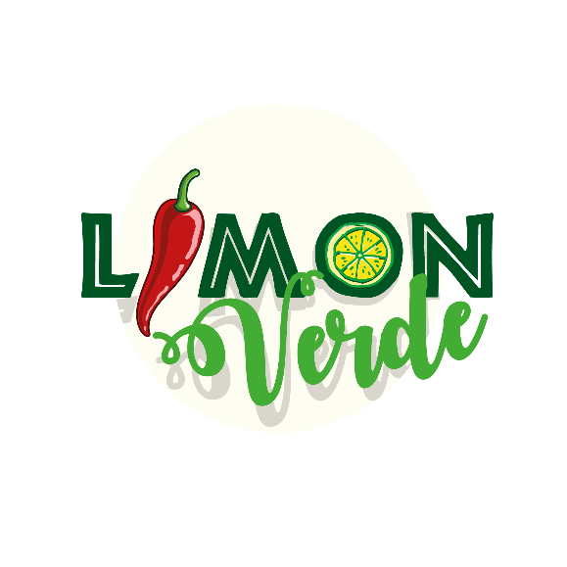

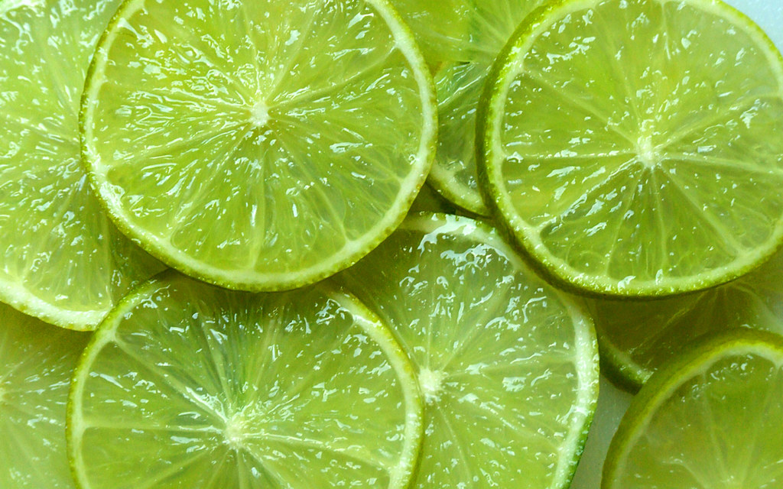

**@limonverde.sg**

## MENU

## ARMA TU COMBO (12oz)

## CEVICHES (16oz)

## Antipasto de berenjenas a la vinagreta Receta de Belkys - Cookpad

## $1.00

$1,25

## Agua

Coca Cola

## Todos nuestros platos vienen acompañados con batata y platanitos chips.

## BEBIDAS

$1,25

$1,25

$1,00

$2.00

$0,95

$0,75

$1.25

$2.00

$1,00

$1,50

$0.95

Mango

Aguacate

Piña

Choclo

Jalapeno

Maiz

Panecillos

Galleta Soda

Platanitos chips

Tomate cherry

Batata

## ACOMPANANTES EXTRAS

## $12,99

### MENU

## (Elige 2)

Mango Tomate

Aguacate Piña

Zanahoria Pepino

Maiz

## (Elige 1)

Ceviche Berlin

Ceviche Cincinnati **($2.50)**

De la Casa **($2.00)**

## Berlín: Pescado blanco fresco, pimentón verde, amarillo y rojo, ají dulce, cilantro y cebolla morada - $13,50

### MENU

## De la casa: Pescado blanco fresco, camarones, pimentón verde, amarillo y rojo, ají dulce, cilantro, cebolla morada y aguacate - $16,99

## Cincinnati: Camarones, pimentón verde, amarillo y rojo, ají dulce, cilantro y cebolla morada - $15,99

## BERENJENA A LA VINAGRETA