**Homework for section 7 (due date tbd)**

**Question 1: Use on-line SHA-2 calculator:**

a) Pick a portion of your resume

b) Hash it with SHA-2

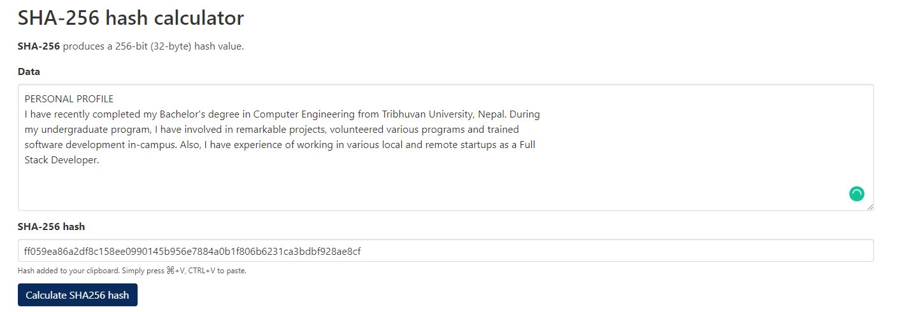

c) Modify one character

Modified last word with one character:

**Developer** to **Developea**

d) Hash it with SHA-2

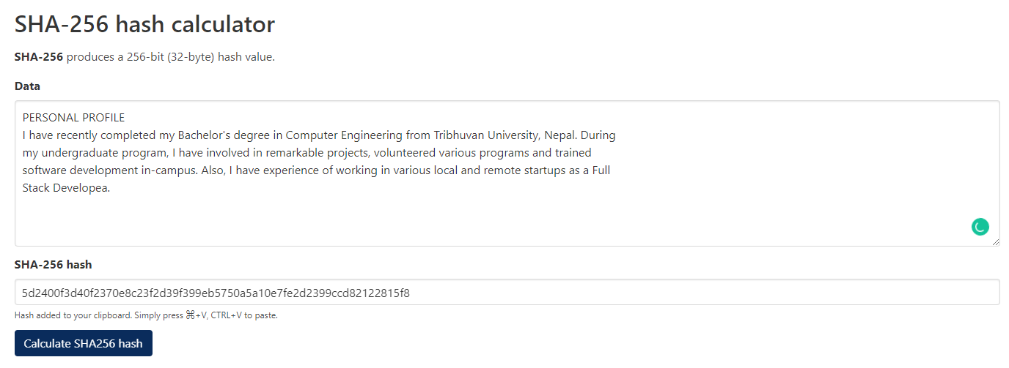

f) Verify the differences in the resulting message digests

Two message digests are completely different with change in one character.

1st case: ff059ea86a2df8c158ee0990145b956e7884a0b1f806b6231ca3bdbf928ae8cf

2nd case: 5d2400f3d40f2370e8c23f2d39f399eb5750a5a10e7fe2d2399ccd82122815f8

**Question 2: Create a blockchain**

1. Segment parts of your resume in 3 blocks

**Block 1:**

PERSONAL PROFILE

I have recently completed my Bachelor's degree in Computer Engineering from Tribhuvan University, Nepal.

**Block2:**

During my undergraduate program, I have involved in remarkable projects, volunteered various programs and trained software development in-campus.

**Block3:**

Also, I have experience of working in various local and remote startups as a Full Stack Developer.

1. Hash the first part: H1

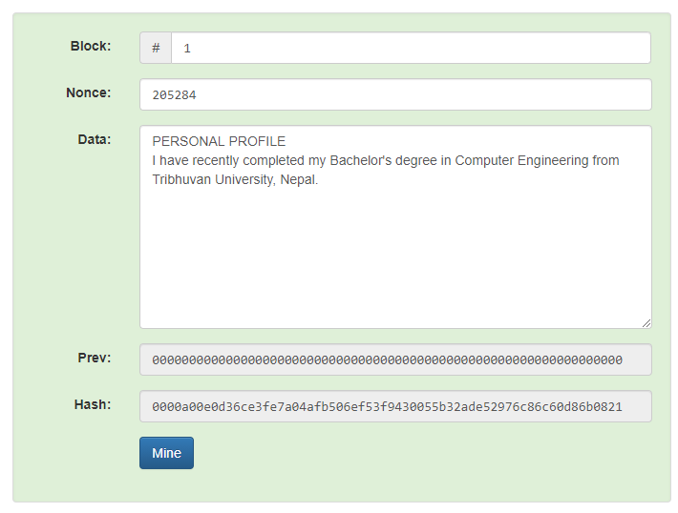

1. Hash (H1 + Part2): H2

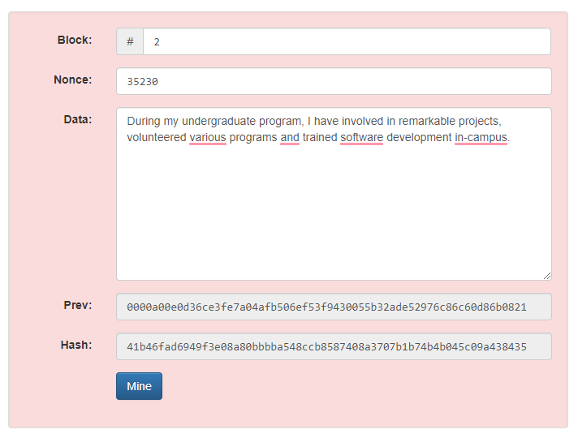

1. Hash (H2 + Part 3): H3

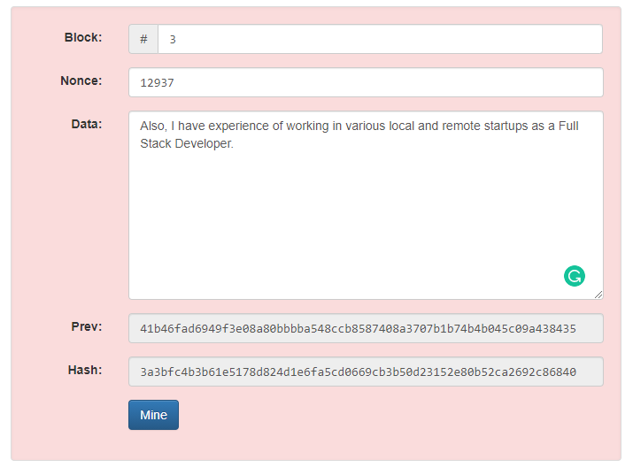

1. Modify one character to verify the resulting message digests

Changed one character of first word in block 1:

**PERSONAL** to **AERSONAL**

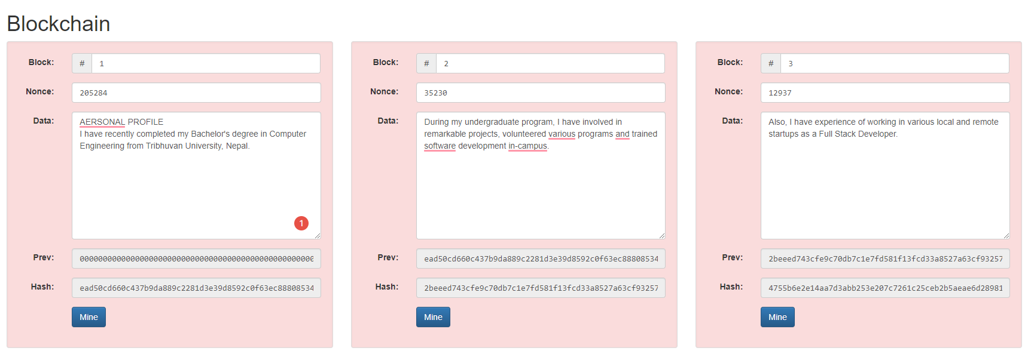

Message Digest has been completely changed.

**Homework for section 8A - part 1 (due date tbd)**

Use EA to find: gcd(9135,8070) and gcd(11296,8976)

gcd(9135,8070)

|  |  |  |  |  |
| --- | --- | --- | --- | --- |
| **i** | **ri-1** | **ri** | **qi** | **ri+1** |
| 1 | r0 = 9135 | r1 = 8070 | q1 = 1 | r2 = 1065 |
| 2 | r1 = 8070 | r2 = 1065 | q2 = 7 | r3 = 615 |
| 3 | r2 = 1065 | r3 = 615 | q3 = 1 | r4 = 450 |
| 4 | r3 = 615 | r4 = 450 | q4 = 1 | r5 = 165 |
| 5 | r4 = 450 | r5 = 165 | q5 = 2 | r6 = 120 |
| 6 | r5 = 165 | r6 = 120 | q6 = 1 | r7 = 45 |
| 7 | r6 = 120 | r7 = 45 | q7 = 2 | r8 = 30 |
| 8 | r7 = 45 | r8 = 30 | q8 = 1 | r9 = 15 |
| 9 | r8 = 30 | **r9 = 15 = g** | q9 = 2 | r10 = 0 |

gcd(11296,8976)

|  |  |  |  |  |
| --- | --- | --- | --- | --- |
| **i** | **ri-1** | **ri** | **qi** | **ri+1** |
| 1 | r0 = 11296 | r1 = 8976 | q1 = 1 | r2 = 2320 |
| 2 | r1 = 8976 | r2 = 2320 | q2 = 3 | r3 = 2016 |
| 3 | r2 = 2320 | r3 = 2016 | q3 = 1 | r4 = 304 |
| 4 | r3 = 2016 | r4 = 304 | q4 = 6 | r5 = 192 |
| 5 | r4 = 304 | r5 = 192 | q5 = 1 | r6 = 112 |
| 6 | r5 = 192 | r6 = 112 | q6 = 1 | r7 = 80 |
| 7 | r6 = 112 | r7 = 80 | q7 = 1 | r8 = 32 |
| 8 | r7 = 80 | r8 = 32 | q8 = 2 | r9 = 16 |
| 9 | r8 = 32 | **r9 = 16 = g** | q9 = 2 | r10 = 0 |

**Homework for section 8A - part 2: (Due date tbd)**

**F**ind **S** and **T** for 11296 and 8976

|  |  |  |  |  |  |  |  |
| --- | --- | --- | --- | --- | --- | --- | --- |
| $$i$$ | **R $$R_{i}$$** | **Q $$Q_{i}$$** | **S $$S_{i}$$** | **T $$T_{i}$$** | **EA $R_{i}$**  = $Q_{i+1}R_{i+1}+R_{i+2}$ | **EEA: S $S_{i}$**  = $S_{i-2}$– $Q_{i-1}$ $S_{i-1}$ | **EEA: T $T_{i}$**  = $T_{i-2}$– $Q_{i-1}$ $T_{i-1}$ |
| **0** | $R_{0}$ = 11296 | - | $S_{0}$ = **1** | $T_{0}$ = **0** | R0 = $Q_{1}$ R1 + R2  = (8976 * 1) + 2320 |  |  |
| **1** | $R_{1}$ = 8976 | $Q_{1}$ =1 | $S_{1}$ = **0** | $T_{1}$ = **1** | R1 = $Q_{2}$ R2 + R3  = (2320 * 3) + 2016 |  |  |
| **2** | $R_{2}$ = 2320 | $Q_{2}$ =3 | $S_{2}$ = 1 | $T_{2}$ = -1 | R2 = $Q_{3}$ R3 + R4  = (2016 * 1) + 304 | S2 = S0 – $Q_{1}$ S1  = 1 – 1 * 0 = 1 | T2 = T0 – $Q_{1}$ T1  = 0 – 1 * 1 = -1 |
| **3** | $R_{3}$ = 2016 | $Q_{3}$ = 1 | $S_{3}$ = -3 | $T_{3}$ = 4 | R3 = $Q_{4}$ R4 + R5  = (304 * 6) + 192 | S3 = S1 – $Q_{2}$ S2  = 0 – 3 * 1 = -3 | T3 = T1 – $Q_{2}$ T2  = 1 – 3 * -1 = 4 |
| **4** | $R_{4}$ = 304 | $Q_{4}$ = 6 | $S_{4}$ = 4 | $T_{4}$ = -5 | R4 = $Q_{5}$ R5 + R6  = (192 * 1) + 112 | S4 = S2 – $Q_{3}$ S3  = 1 – 1 * -3 = 4 | T4 = T2 – $Q_{3}$ T3  = -1 – 1 * 4 = -5 |
| **5** | $R_{5}$ = 192 | $Q_{5}$ = 1 | $S_{5}$ = -27 | $T_{5}$ = 34 | R5 = $Q_{6}$ R6 + R7  = (112 * 1) + 80 | S5 = S3 – $Q_{4}$ S4  = -3 – 6 * 4 = -27 | T5 = T3 – $Q_{4}$ T4  = 4 – 6 * -5 = 34 |
| **6** | $R_{6}$ = 112 | $Q_{6}$ = 1 | $S_{6}$ = 31 | $T_{6}$ = -39 | R6 = $Q_{7}$ R7 + R8  = (80 * 1) + 32 | S6 = S4 – $Q_{5}$ S5  = 4 – 1 * -27 = 31 | T6 = T4 – $Q_{5}$ T5  = -5 – 1 * 34 = -39 |
| **7** | $R_{7}$ = 80 | $Q_{7}$ = 1 | $S_{7}$ = -58 | $T_{7}$ = 73 | R7 = $Q_{8}$ R8 + R9  = (32 * 2) + 16 | S7 = S5 – $Q_{6}$ S6  = -27 – 1 * 31 = -58 | T7 = T5 – $Q_{6}$ T6  = 34 – 1 * -39 = 73 |
| **8** | $R_{8}$ = 32 | $Q_{8}$ = 2 | $S_{8}$ = 89 | $T_{8}$ = -112 | R8 = $Q_{9}$ R9 + R10  = (16 * 2) + 0 | S8 = S6 – $Q_{7}$ S7  = 31 – 1 * -58 = 89 | T8 = T6 – $Q_{7}$ T7  = -39 – 1 * 73 = -112 |
|  | **g = 16** |  | **S = -236** | **T = 297** |  | S9 = S7 – $Q_{8}$ S8  = -58 – 2 * 89 = -236 | T9 = T7 – $Q_{8}$ T8  = 73 – 2 * -112 = 297 |

**Homework for section 8B (due date tbd)**

Fast Exponentiation 2273

|  |  |  |  |  |  |  |  |  |  |  |  |  |  |
| --- | --- | --- | --- | --- | --- | --- | --- | --- | --- | --- | --- | --- | --- |
| **2273** | **1** | **0** | **0** | **0** | **1** | **1** | **1** | **0** | **0** | **0** | **0** | **1** |  |
| **squ** |  | 0 |  |  |  |  |  |  |  |  |  |  | X x X |
| **squ** |  |  | 0 |  |  |  |  |  |  |  |  |  | X2 x X2 |
| **squ** |  |  |  | 0 |  |  |  |  |  |  |  |  | X4 x X4 |
| **squ** |  |  |  |  | 0 |  |  |  |  |  |  |  | X8 x X8 |
| **mul** |  |  |  |  | 1 |  |  |  |  |  |  |  | X16 x X |
| **squ** |  |  |  |  |  | 0 |  |  |  |  |  |  | X17 x X17 |
| **mul** |  |  |  |  |  | 1 |  |  |  |  |  |  | X34 x X |
| **squ** |  |  |  |  |  |  | 0 |  |  |  |  |  | X35 x X35 |
| **mul** |  |  |  |  |  |  | 1 |  |  |  |  |  | X70 x X |
| **squ** |  |  |  |  |  |  |  | 0 |  |  |  |  | X71 x X71 |
| **squ** |  |  |  |  |  |  |  |  | 0 |  |  |  | X142 x X142 |
| **squ** |  |  |  |  |  |  |  |  |  | 0 |  |  | X284 x X284 |
| **squ** |  |  |  |  |  |  |  |  |  |  | 0 |  | X568 x X568 |
| **squ** |  |  |  |  |  |  |  |  |  |  |  | 0 | X1136 x X1136 |
| **mul** |  |  |  |  |  |  |  |  |  |  |  | 1 | **X2272 x X= X2273** |