Alejandra Garcia
English 149
Professor Maddox

DATE: October 11, 2014
TO: Sean Robert Maddox, ENG 149 Professor
FROM: Alejandra Garcia, ENG 149 Student
SUBJECT: Chapter 15 Response

Resumes

General Characteristics of Successful Resume
- Free from errors
- Identifying personal info
- Providing education

Why are they important? When making errors in a resume it can cast doubt on the accuracy of the information presented in it. After attending an interview and the company you have applied for wants to contact you, whether it is by the phone, e-mail, or mail, it is important you provide them with that personal information because the position that was initially going to be yours can easily be given to someone else that was easier to contact. It is also important to supply your education because it mentions the skills you have. Its background information that can meet the particular job you’re applying for.

Job Listings

Soccer Cleat Engineer
- Strong knowledge of soccer and what qualities make a better shoe
- Work well in a team environment
- Experience and knowledge in shoe department
The position didn’t require knowledge in fashion design or knowledge of current trends. The consumer must be attracted to the color as well as how the design looks. Many athletes like to wear things that not only appeal to them but what they think will appeal to others.

Structural Design Engineer
- Bachelors in Mechanical Engineering
- Knowledge of Manufacturing Processes
- Able to work in team environment
Those applying for this position should also mention the experience they have with actually designing and manufacturing, not just have the skills and ability but the experience as well.

Basketball Video Coordinator
- Film editing
- Ability to work with and mentor young adults
- Good understanding of basketball strategy

This job listing should have mentioned the experience the candidate should have with handling a video camera and knowledge and skill with different video uploading systems to capture, rewind and slo-mo sections of video clips that were captured during every game.

DATE: October 11, 2014
TO: Sean Robert Maddox, ENG 149 Professor
FROM: Alejandra Garcia, ENG 149 Student
SUBJECT: Resume & Cover Letter Technical Review Response

I have read through my feedback and noticed some helpful comments
- “Maybe better use of white space”
- I should use more color
- “Good use of action words”

The strengths of my technical document are the usage of action words I provided.
The weaknesses of my technical document are the lack of color I use as well as the amount space I am not taking advantage of.

BEFORE AFTER
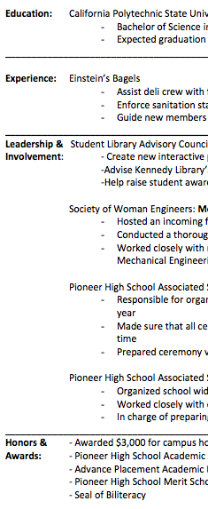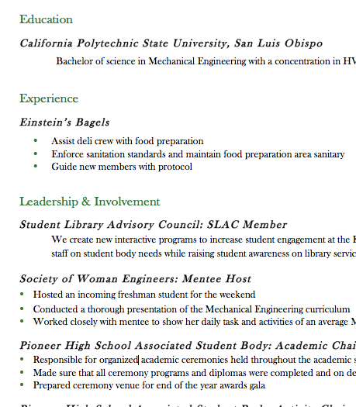
- Shown in the pictures above I have less empty space after I read my reviewer’s feedback.

BEFORE AFTER
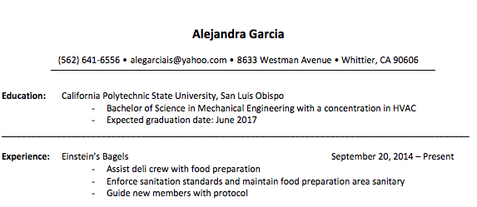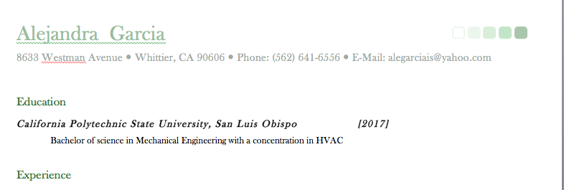

- In the pictures above it can be easily seen which one has more color and looks more appealing.

These revisions have improved my technical document in a more appealing and professional way.

DATE: October 11, 2014
TO: Sean Robert Maddox, ENG 149 Professor
FROM: Alejandra Garcia, ENG 149 Student
SUBJECT: Cover Letter & Resume

___________________________________________________________________________________________

Job Listing

https://uscareers-lennox.icims.com/jobs/3045/mechanical-engineer-%28new-hvac-productdesign%29/job?hub=10&mobile=false&width=965&height=500&bga=true&needsRedirect=false

Cover Letter

Alejandra Garcia
8633 Westman ave
Whittier, Ca 90606
(562) 641-6556
alegarciais@yahoo.com

October 10, 2014

New HVAC Product Design
Lennox Industries

1600 Metrocast Dr.
Carrollton, TX 75006
(972) 416- 7515

To whom it may concern:

My name is Alejandra Garcia, and I am applying for the New HVAC Product Design position with Lennox Industries. As a future graduate of California Polytechnic State University, San Luis Obispo, I have acquired a working knowledge of the characteristics needed to be an HVAC Designer. Coming from a family who has technical background, such as a vehicle mechanic and a CNC machine operator, it has influenced my decision in pursuing a career in Mechanical Engineering especially with Lennox Industries.

I believe I am qualified for the New HVAC Product Design position because not only do I meet the qualifications, but I am a team player and have experience developing and designing different parts on SolidWorks. Since being enrolled at Cal Poly, I have consistently developed my skills with SolidWorks and Design by enrolling in a number of courses that further explain how the design program capabilities. Through these courses, I have acquired a vast knowledge on the Technical Discourses under Mechanical Engineering; in addition, I also have technical experience drafting and designing my hand. During my time at Cal Poly I have also volunteered with the Student Library Advisory Council at Kennedy Library, during my time with SLAC I helped raise student awareness on library services and held meetings to inform library staff on the demands and needs of the student body population.

I would like to thank you for considering me for the position of New HVAC Product Design, and if there are any questions, I can be reached via cell at 562.641.6556 or via email at alegarciais@yahoo.com.

Best Regards,

Alejandra Garcia

Alejandra Garcia
8633 Westman Avenue  Whittier, CA 90606  Phone: (562) 641-6556  E-Mail: alegarciais@yahoo.com

Education

California Polytechnic State University, San Luis Obispo [2017]
Bachelor of science in Mechanical Engineering with a concentration in HVAC

Experience

Einstein’s Bagels [September 20, 2014- Present]
- Assist deli crew with food preparation
- Enforce sanitation standards and maintain food preparation area sanitary
- Guide new members with protocol

Leadership & Involvement
Student Library Advisory Council: SLAC Member [September 25, 2014 – Present]
We create new interactive programs to increase student engagement at the Kennedy library. As well as, advise Kennedy Library’s staff on student body needs while raising student awareness on library services.

Society of Woman Engineers: Mentee Host [March 2014]
- Hosted an incoming freshman student for the weekend
- Conducted a thorough presentation of the Mechanical Engineering curriculum
- Worked closely with mentee to show her daily task and activities of an average Mechanical Engineering student

Pioneer High School Associated Student Body: Academic Chair [September 2012 – June2013]
- Responsible for organized academic ceremonies held throughout the academic school year.
- Made sure that all ceremony programs and diplomas were completed and on delivered on time
- Prepared ceremony venue for end of the year awards gala
- Organized school wide fundraising events

Honors & Awards
- Awarded $3,000 for campus housing Cal Poly Scholars Award Committee
- Pioneer High School Achievement Award: Top 10 seniors
- Advanced Placement Academic Excellence AP Diploma
- Pioneer High School Merit Scholar
- Seal of Biliteracy

Skills
SolidWorks (Computer-Aided Design), Bilingual (Spanish and English), Project organization skills

