Work Packet 5

Chapter 20 Response

To: Professor Maddox
From: Joseph Bolous
Date: 11/1/14

Definitions

This memo will use the reading in chapter 20 to help define parts of my instructions that may need clarification.

1) I chose to make a parenthetical definition for purchase price, voucher, and inspection. I chose these three because they are words that may be out of ones discourse or can be interpreted many ways.
Purchase Price: How much you paid for the cleats
Voucher: Store credit
Inspection: Examined for manufacturing flaws

2) I chose to make a sentence definition for the claim letter and manufacturing flaw. I chose these two because they are important to understanding the directions and need a clear definition.
Claim Letter: A claim letter is a request to fix a problem with a product, usually asking for a refund.
Manufacturing Flaw: A manufacturing flaw is a defect that occurred in a products creation and is not the result of misuse, normal wear and tear or purposeful damage.

3) When a pair of cleats does not perform as well as they were promised to and tear or break too easily, this is the result of a manufacturing flaw. They were not made correctly and can be sent back for a refund.

Claim Letter Packet Technical Review Response

To: Professor Maddox
From: Joseph Bolous
Date: 11/1/14

This memo will follow my revision process; looking at my feedback and how I used it to finalize my instructions.

5) Here are my positive, negative, and chosen comment that I picked out.
Positive: “Your instructions are simple and easy to understand”
Negative: “Try to make your bullet points shorter so it is easier for your reader”
Chosen: “Your setup is nice, but if you put it in a table it might look more clear”

6) I think these comments show that my instructions are easy to understand, but I should be less wordy and cleaner so it makes following the instructions as simple as possible for the reader.

7) These are my revisions influenced by my feedback.
- “Go to the nearest Nike store and bring your flawed product for inspection.”
-Find nearest Nike store -Bring flawed product
- “Fill out a claim letter on the Nike website describing the issue you want to be reimbursed for.”
-Go to the Nike website -Fill out a claim letter describing the issue

8) Right after making these revisions, as well as reformatting the instructions by putting them into a table, there was a noticeable difference. The instructions became much easier to read and there was less area for confusion.

Sequence 2- Claim Letter Packet

To whom it may concern,

I am writing to bring up a problem I have noticed in your design of the Vapor soccer cleats. I have worn Vapors for quite some time, and recently every pair I have owned has had studs break off within 4 months of me owning them. The first time this happened I thought it was a simple accident, but it then happened consistently for every pair of Vapors I bought after that. This is unacceptable, Vapors are not cheap and I expect them to last for some time. A stud breaking may seem like a minor problem, but it makes a huge difference while playing. Missing even one stud cause cause someone to slip, and in a game, that could cost your team a goal.

After noticing this trend, I looked back to when it began. I noticed that my friends and my cleats started to break when there was a sudden change in the design to make the cleats lighter. A small triangle cut was taken out of each stud. In my opinion this made the studs more vulnerable to breaking. I suggest that this design be rethought. I know my friends and I would not mind the slight increase in weight to solve this problem. It would save us money and make your product reliable once again.

Thank you,
Joseph Bolous

NIKE- VAPOR RETURN POLICY
At Nike, we stand by our product for every customer. If there is a manufacturing flaw that appears on your Vapors within 2 years, we will reimburse the purchase.
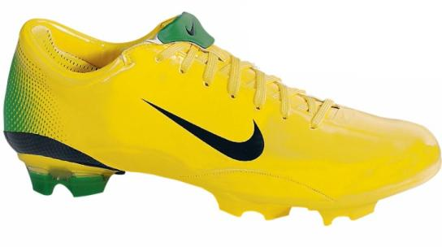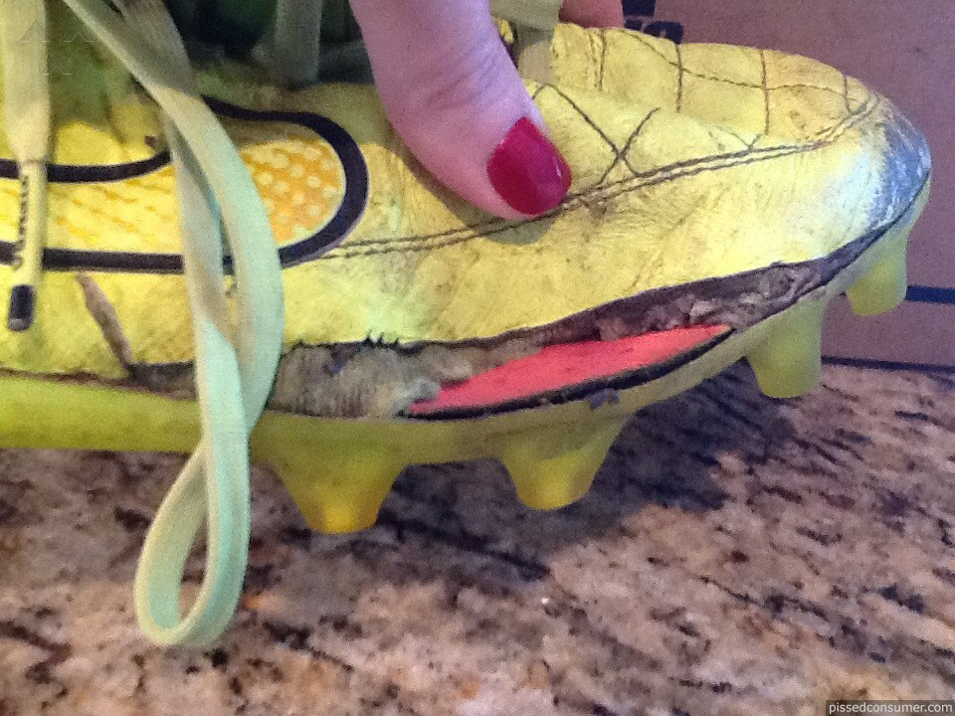
How to Return?
Return to Nike Store | Mail In
-Find nearest Nike location  -Bring flawed product  -Show the product to employee to verify manufacturing flaw  -Store will then take the flawed product and you will receive a voucher in the mail for the purchase price of the Vapors | -Go to the Nike website  -Fill out a claim letter describing the issue  -Send flawed product to:  1 Bowerman Dr  Beaverton Or, 97005  -After inspection, you will receive a voucher in the mail for the purchasse price of the Vapors
**AFTER INSPECTION, IF THE PROBLEM IS RULED NOT A MANUFACTURING FLAW, YOUR CLEATS WILL BE RETURNED TO YOU AND YOU WILL NOT RECEIVE A VOUCHER**
For questions, contact us at:
1 (800) 344-6453

