Nikhil Ahuja
Professor Maddox
Week Packet 6

Sequence 3 – Conference:

Conference was performed on Tuesday 5:00 p.m.

Sequence 3 – Interview Memo:

TO: Professor Sean Maddox

FROM: Nikhil Ahuja

DATE: October 3, 2014

SUBJECT: Interview Memorandum of Rashmi Kishore

Interview Introduction

The following interview was conducted on 30th October 2014 at 8:00 p.m. I made a phone call to a person working at the firm VMware who was a cousin of my friend. She identified herself as Rashmi Kishore, a member of technical staff at VMware which is a Software company located in Palo Alto that provides cloud and virtualization services. A member of technical staff at VMware is also considered a software engineer as a relative position with other software companies.

Duties and how they fit in the larger industry

Rashmi has many responsibilities. As a member of the technical staff in the firm, Rashmi works in development of different features and products in the aspects of designing and coding. Designing as she described is task of coming up with the basic ideas on how to go about a frame work. As different customers have different requirements for their products, it is up to her and her team to come up with the ideas on how to structure and implement the program based on their customer's requirements.

After designing the framework, she then has to code the part of the program that they are making. The part that she focuses on is the “storage” aspect. In this aspect her focus is mainly on designing and implementing code that provides maximum storage while having minimal use of hardware. After that, the code is reviewed and feedback is provided from other team members and supervisors. With that feedback she has to review her code and make the any appropriate changes if needed. Rashmi's other duties also include improving current company's infrastructures by creating new features on existing code and fixing bugs the existing infrastructures.

The ways that Rashmi's work fit in the larger industry is crucial in the aspects of user-experience and networking. She mentions that user-experience is a prime aspect of consideration when building programs. The work she does has to have to enable users to experience simplicity, the programs should be efficient and maintainable. Networking is also as important as it should allow users to connect easily with different servers that are required.

Challenges and Solutions

The key challenges Rashmi and her industry faces are maintenance of the legacy code, rapidly chaning technology and employees resigning or retiring without completing their parts of the projects. Maintenance of the legacy as described by Rashmi is the problem that most of her firm's codes are written in the programming language Perl and in the recent years, her firm is implementing new programming languages such as Java. And most of the new projects requires the base codes that were created in Perl. So, Rashmi works to together with her team in order to find different techniques in which they can link the new projects with the old base code. She also mentioned that the new codes that she and the firm writes are language agnostic. This will remove the dependency of programs to rely on a certain programming language.

A challenge that almost every software firm is facing is that technology is changing very fast. Rashmi mentions that to counter this issue, they constantly need to update and maintain all their codes with the new technology that comes up in the market.

Another challenge that Rashmi and the larger industry faces is when people in charge of a project or a part of a project resigns from that firm. This creates a problem of the code that the resigning person worked on becoming obsolete. This is because it is either left unattended for a sometime or, it is difficult to decode how that person has worked in their part of the project and this makes it difficult for the team to complete the whole project. In a way to solve this, companies sometimes hire their former employees for a short period of time to present and decode their code to the current employees.

How will the industry will change in the future

An additional question I asked her was that how did she think this industry will change in the future. She says many software companies will move towards optimizing storage. There will be a lot more information which will lead to a lot of data that needs to be stored. Traditional storage, which is storing data in huge databases, is not cost-effective. She says the way of storing data will move to a more cloud oriented method. Also, she says the industry will build its products heavily considering the aspects of simplicity, user pattern tracing and social networking. She gives an example of the site Amazon that is very simple to use. Also, it uses patterns of users to recommend other products and how they allow for social networking by allowing users to provide reviews and feedback for different products they purchase.

Memorandum prepared from 31st October 2014 to 2nd November 2014

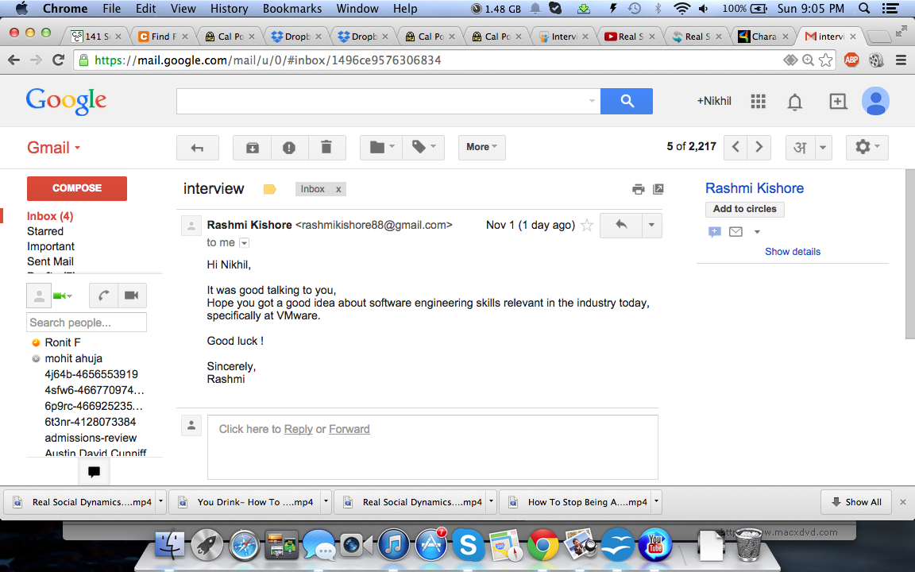
Here is snapshot an email sent by Rashmi Kishore to confirm that she has taken the interview with me.

