Malnutrition is one of the most prevalent problems in today’s society, be it overeating or self-starving for all the wrong reasons. So, we decided to create a simple app that goes a long way in tackling this problem.

**Healthify 360** is an app that calculates the number of calories you are going to consume in a meal by accepting the list of ingredients and then calculating whether they lie within the safe range of the individual’s acceptable calorie intake as prescribed by various medical sources. The app determines by comparing the prescribed calorie limit for the age and gender of the individual with that of the calculated calorie intake.

Walk through video link: <https://drive.google.com/file/d/1Pa9vq0COpuoCbX_8bhGYfUqdx6BcBH7A/view?usp=drivesdk>

1. Opening screen. The user can click “Get Started” to Proceed.

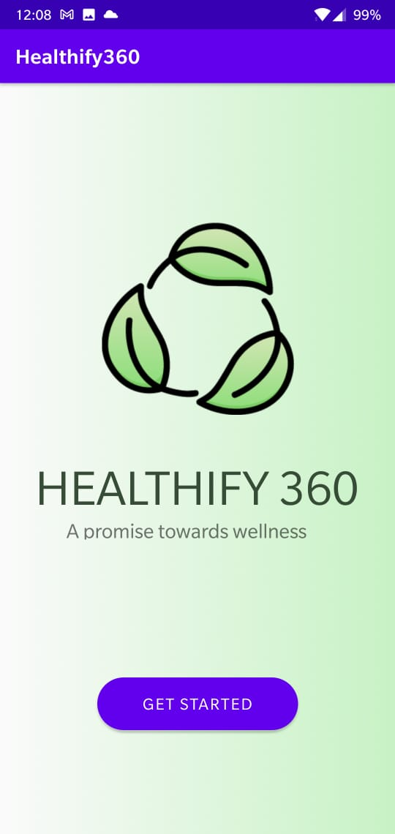

1. Registration Screen: The user’s age and gender are accepted. Click “back” to go back or “proceed” to continue.

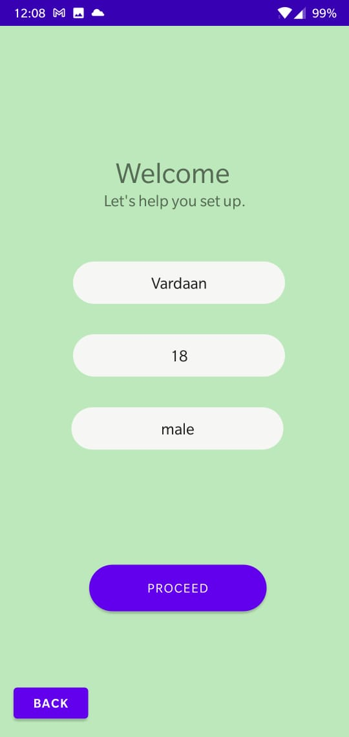

1. The screen where the user can select their choice of food over 11+ ingredients. The user can click on the same food item multiple times to select it more than once. There is also a “Clear” button that can be used to reset the selections in case of a slip of hand. After the necessary selections, the user can click “Next” to proceed.

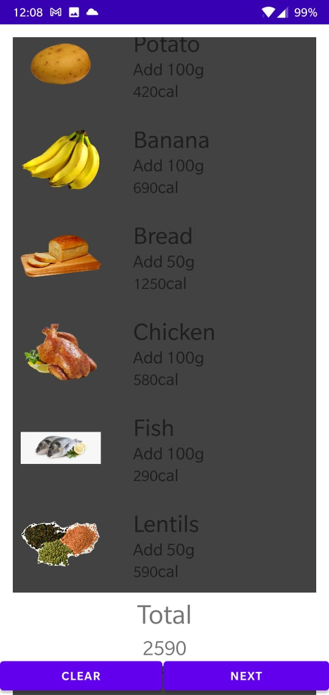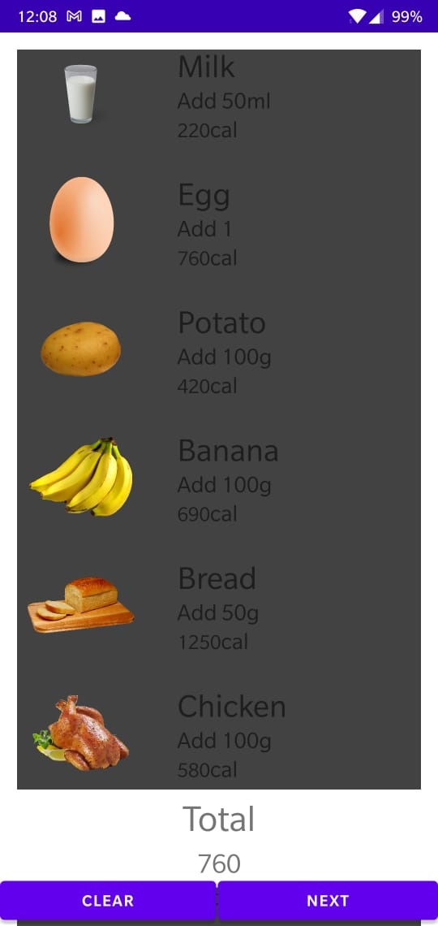

1. The result screen where the user can view the total number of calories calculated and whether it is in the recommended range.

