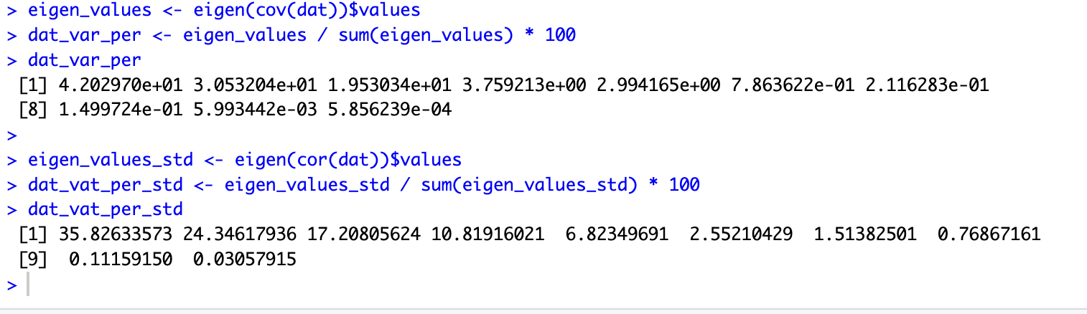

Analyzing the values of the total variance explained by both samples, in the classic sample we can infer that the “Elbow” is located in the third component (92,09208%), while in the standardized sample it’s located in the fourth one (88,19973%). Therefore we should retain the standardized sample because it has the shortest sum of components that adds up to 80%

