Influence of illumination spectrum on dissociation kinetic of iron-boron pairs in silicon

Oleg Olikh, Oleksandr Datsenko, Serhiy Kondratenko

*Taras Shevchenko National University of Kyiv, 64/13, Volodymyrska Street, 01601, Kyiv, Ukraine*

olegolikh@knu.ua

The iron-boron pair is one of the most extensively examined defects in silicon. The complex’s levels, carrier capture cross-sections, kinetic models, dissociation techniques, and even ultrasound influence on pairing have been established [1-3]. However, the exact mechanism underlying the second decay phase — iron ion recharge or a recombination-enhanced defect reaction (REDR) — remains debatable. We believe that investigation of the illumination spectrum impact on light-induced dissociation may reveal which proposed model is correct.

An experimental study was undertaken to explore the efficiency of FeB pair dissociation in silicon solar cells (iron concentration of 8.7×1012 cm-3, doping level by boron of 1.4×1015 cm-3) when different light sources are utilized. To achieve a varied illumination spectrum (see Fig.1), halogen lamps from three manufacturers — Orion, Osram, and General Electric (GE) — were used.

The characteristic time of FeB dissociation τdis was determined by measuring the dependence of the concentration of dissociated pairs on the illumination duration using a methodology referenced in [1]. It was observed that τdis, was influenced not only by the light intensity *W*ill and the carrier generation rate but also by the light source – see Table. It was found that as the photon wavelength decreases, the dissociation rate increases. Fig. 2 shows the average photon energy for different sources, correlating with the data in Table. The findings suggest that REDR is likely to be the dominant mechanism for pair decay.

[1] O. Olikh *et al.*, *J.Appl. Phys.* **2021**, *130*, 235703.

[2] F. E. Rougieux, C. Sun, D. Macdonald, *Sol. Energy Mater. Sol. Cells* **2018**, *187*, 263.

[3] C. Sun *et al.*, *Phys. Status Solidi RRL* **2021**, *15*, 2000520.

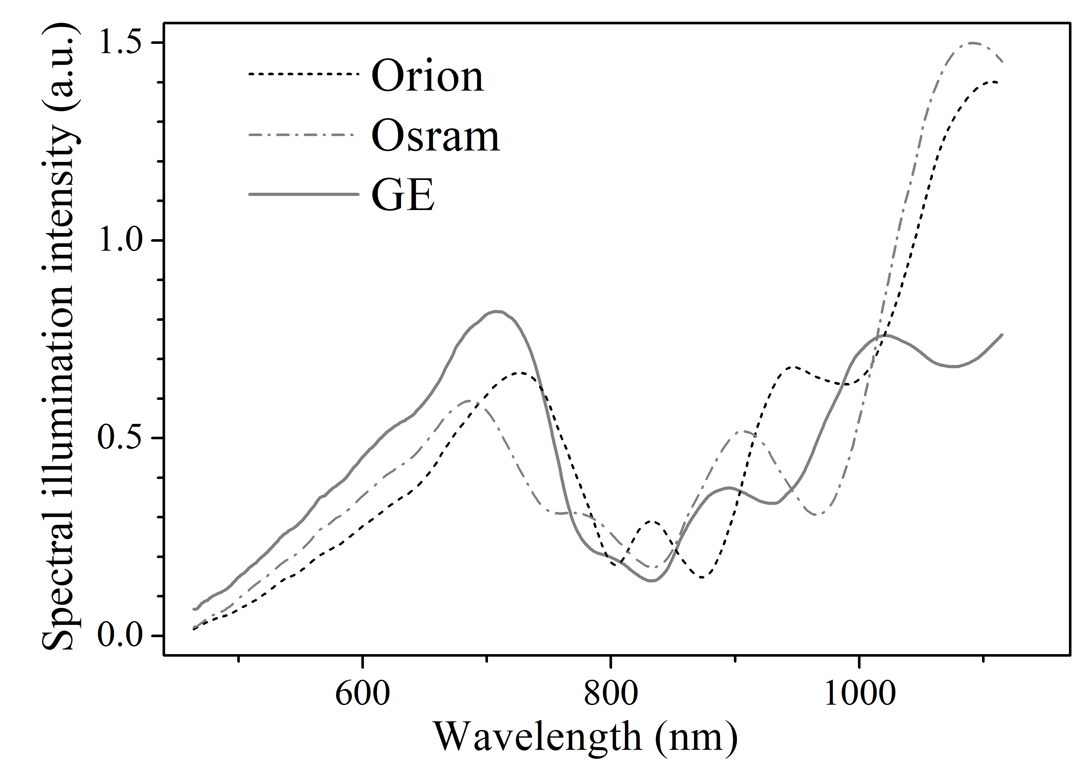

**Fig. 1.** The spectral composition of the sample illumination for different light sources, which is influenced by 1) the temperature of the filament; 2) the surface of the lamp reflector; and 3) the transmission characteristics of the optical fiber through which the illumination was conducted.

**Table.** The characteristic time of FeB dissociation for different illumination intensities and light sources

|  |  |  |  |
| --- | --- | --- | --- |
| *W*ill (mW) | τdis (s) | | |
| Orion | Osram | GE |
| 200 | 42±3 | 20.0±0.7 | 15.1±0.5 |
| 300 | 15.7±0.6 | 12.4±0.1 | 6.5±0.2 |
| 400 | 8.8±0.3 | 6.1±0.3 | 3.6±0.3 |
| 500 | 5.5±0.2 | 4.5±0.2 |  |
| 600 | 3.7±0.2 | 3.0±0.2 |  |
| 700 | 2.4±0.2 | 2.4±0.2 |  |

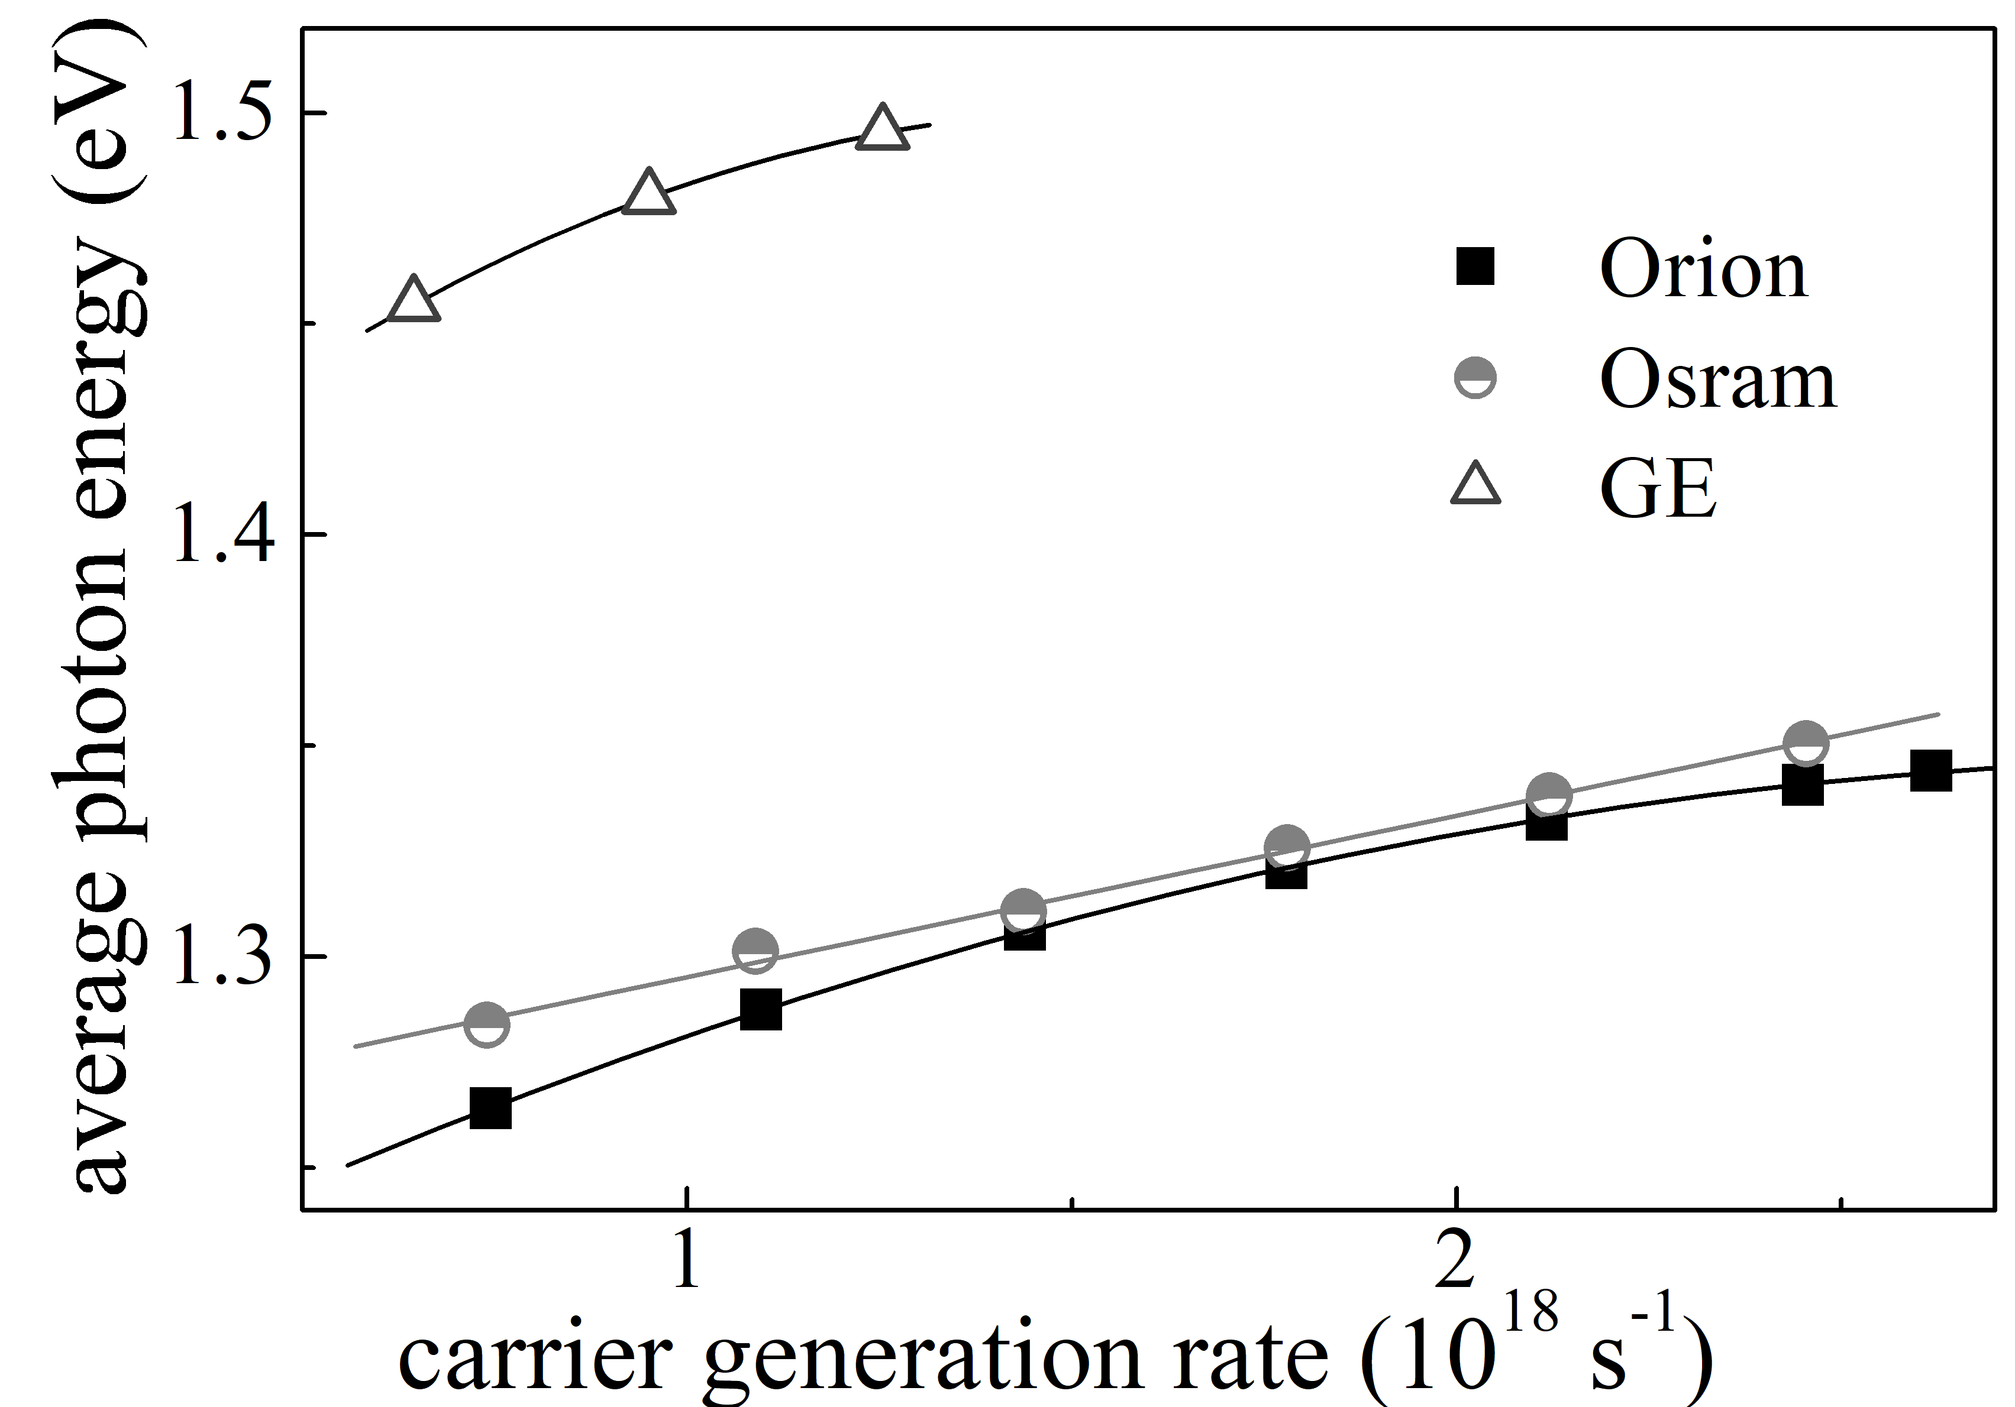

**Fig. 2.** Dependencies of the average photon energy on carrier generation rate for different light sources.