**Influence of illumination spectrum on dissociation kinetic of iron-boron pairs in silicon**

Oleg Olikh, Oleksandr Datsenko, Serhiy Kondratenko

*Taras Shevchenko National University of Kyiv, 64/13, Volodymyrska Street, Kyiv, 01601, Ukraine*

olegolikh@knu.ua

**Estimation of minority carrier diffusion length**

In conditions of homogeneous carrier generation in the solar cell’s base, which is several minority carrier diffusion lengths *L*n, the short circuit current can be described as follows [1,2]:

, (S1)

where *N*ph is the number of photons absorbed in the solar cell; *α*bb is the coefficient of light absorption. *L*n depends on minority carrier lifetime τ:

, (S2)

where μn is the electron mobility in the case of *p*-type base.

In the assumption that it is the iron-related defects that play an predominant role in the recombination, the following expression can be used to estimate τ:

, (S3)

where τi is the lifetime associated with intrinsic recombination; τFei and τFeB are related to the recombination at interstitial iron atoms and at FeB pairs, accordingly. We used Shockley-Read-Hall model to calculate τFei and τFeB and, then, minority carrier diffusion lengths for p-type silicon with different acceptor concentration – see Fig.S1. In our calculation, we took μn from Klaassen [3], the defect parameters from Rougieux et al. [4], and the ratio between the concentrations of interstitial iron atoms and at FeB pairs from Wijaranakula [5]. In calculating τi, band-to-band radiation recombination and Auger recombination were taken into account, and the temperature dependence of the corresponding coefficients was calculated according to Niewelt et al. [6] and Black & Macdonald [7].

We took temperature dependence *L*n from Fig.S1 and *α*bb (T) from Green [8]. We fitted by using Equation (S1) the experimental dependance *I*SC(T), which was established by illuminating the solar cell with monochromatic light of 940 nm wavelength using an LED – see Fig.S2. As fitting parameter, *L*n at 340 K was taken. The fitting was performed by using the metaheuristic method EBLSHADE [8].

The correlation coefficient between the experimental and calculated data was strong (R = 0.998) and observed for *L*n (340 K) = 83 μm.

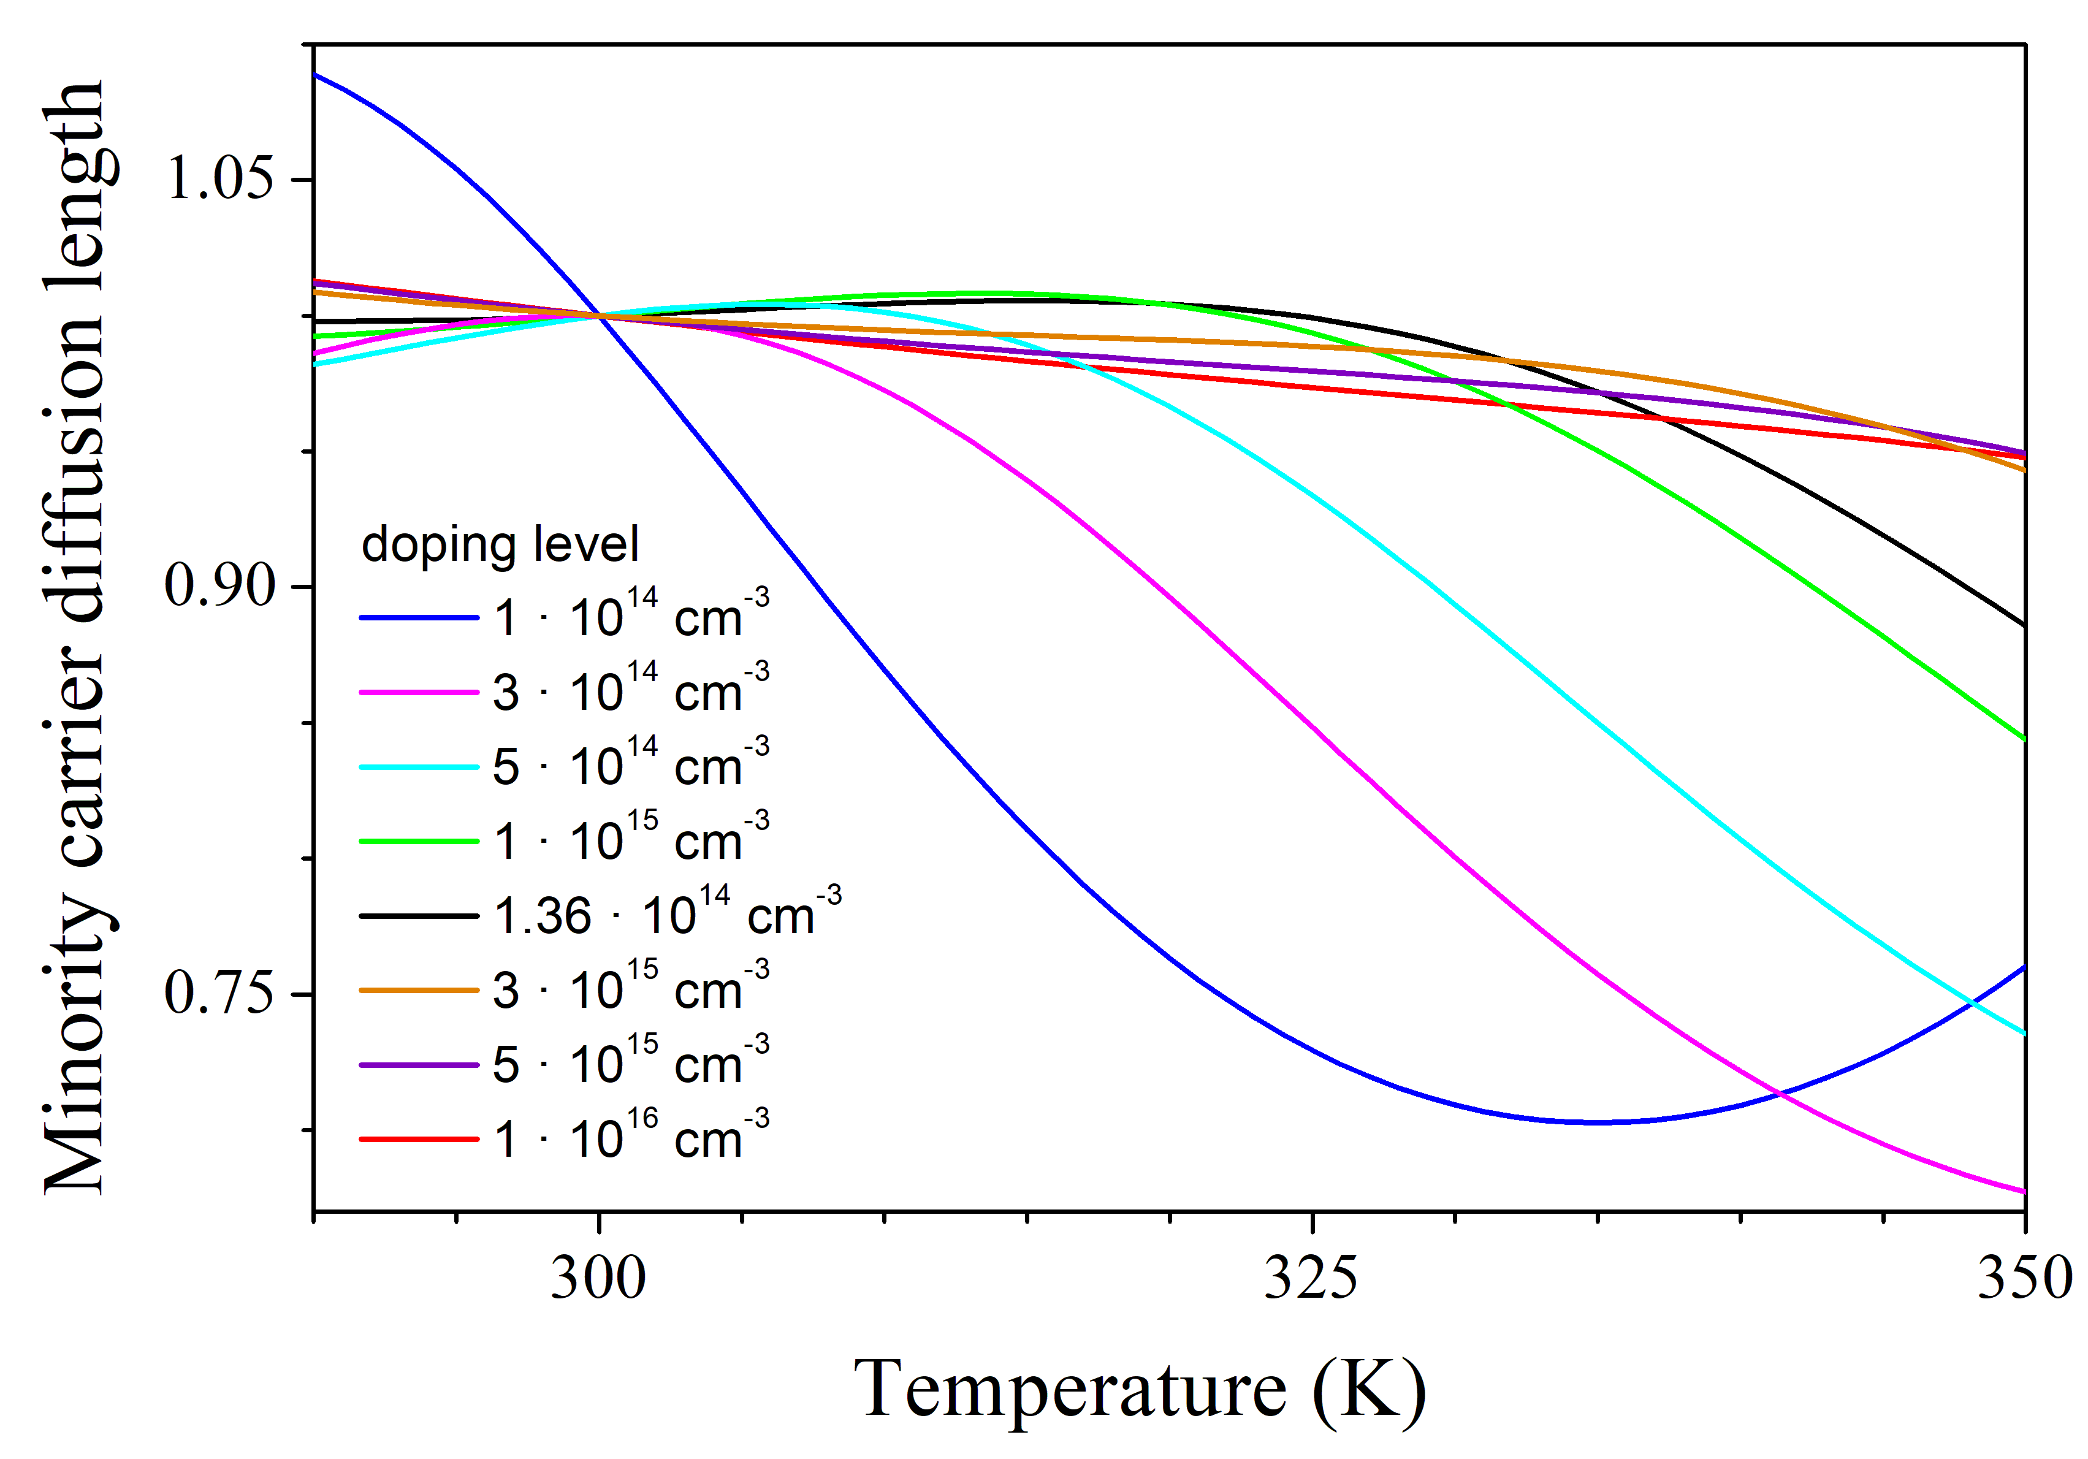

Fig.S1. The temperature dependence of the minority carrier diffusion length in p-Si with predominant recombination at Fe-related defects with total iron concentration in range 1012-1013 cm-3. The values of diffusion length are normalized to the magnitude *L*n at *T* = 300 K.

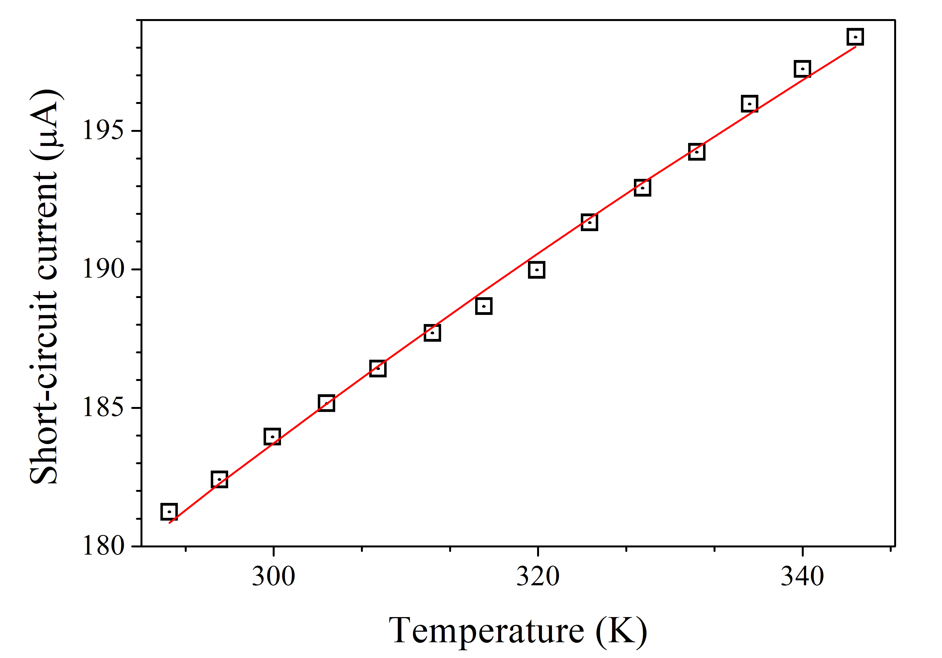

Fig.S2. The temperature dependence of the short-circuit current of investigated solar cell. The marks are the experimental results and the line is the curve fitted by using Equation (S1).

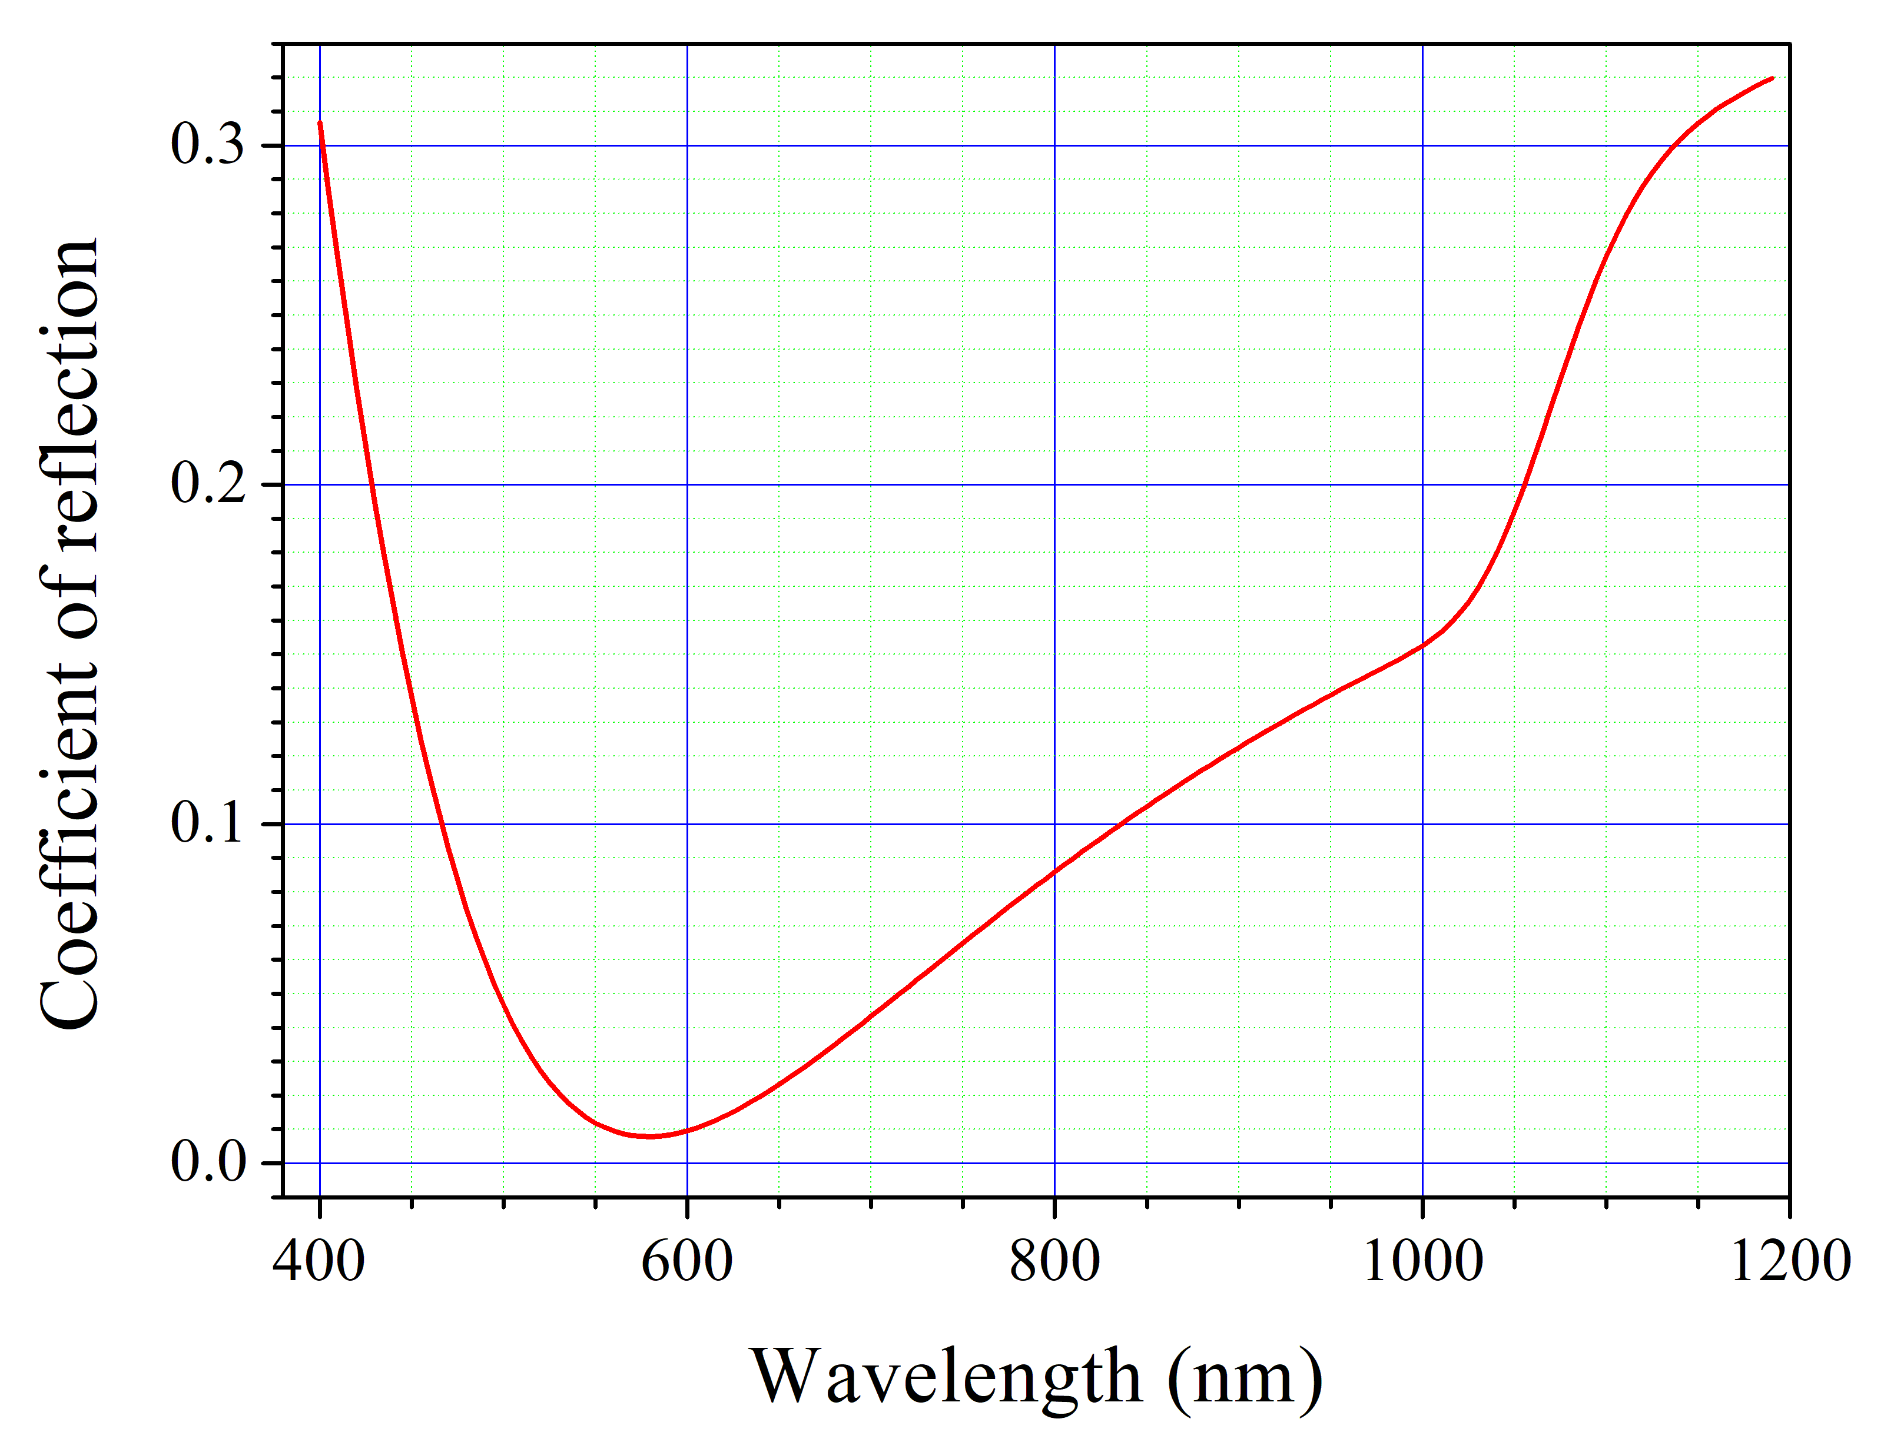

Fig.S3. The spectral dependence of the coefficient of reflectance for silicon solar cell with antireflective and passivating SiO2 (30 nm) and Si3N4 (40 nm) layers on the front surface. The calculations take into account multiple reflections.

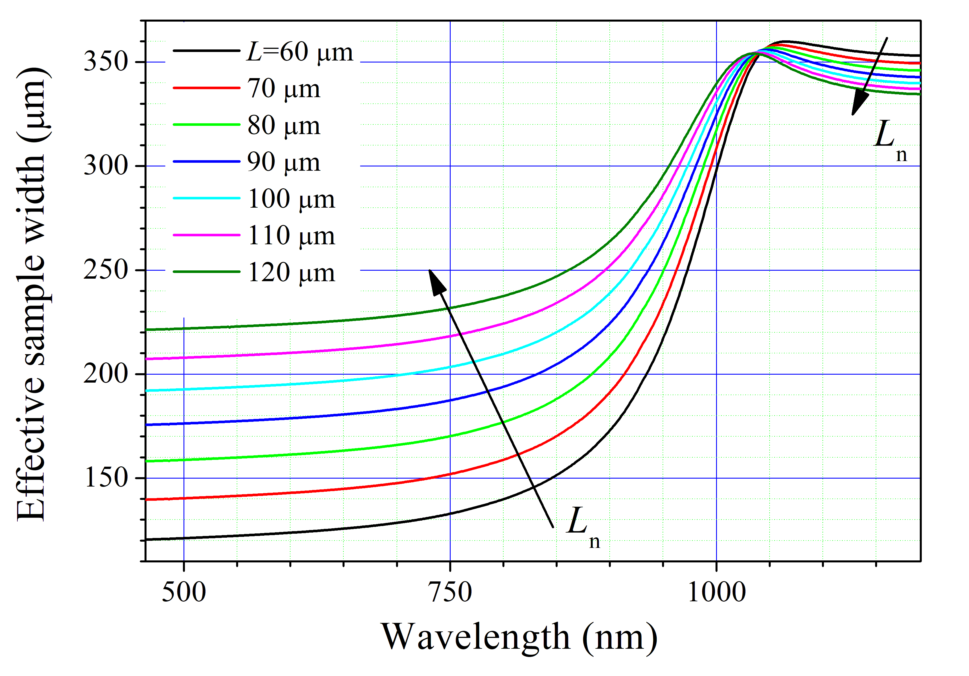

Fig.S4. The spectral dependence of effective width, calculated by using weighted average carrier concentration [10] for the case *T* = 340 K and silicon sample with thick 380 μm, doping level 1.36⋅1015 cm-3, and minority-carrier diffusion length *L*n in the range 60-120 μm.

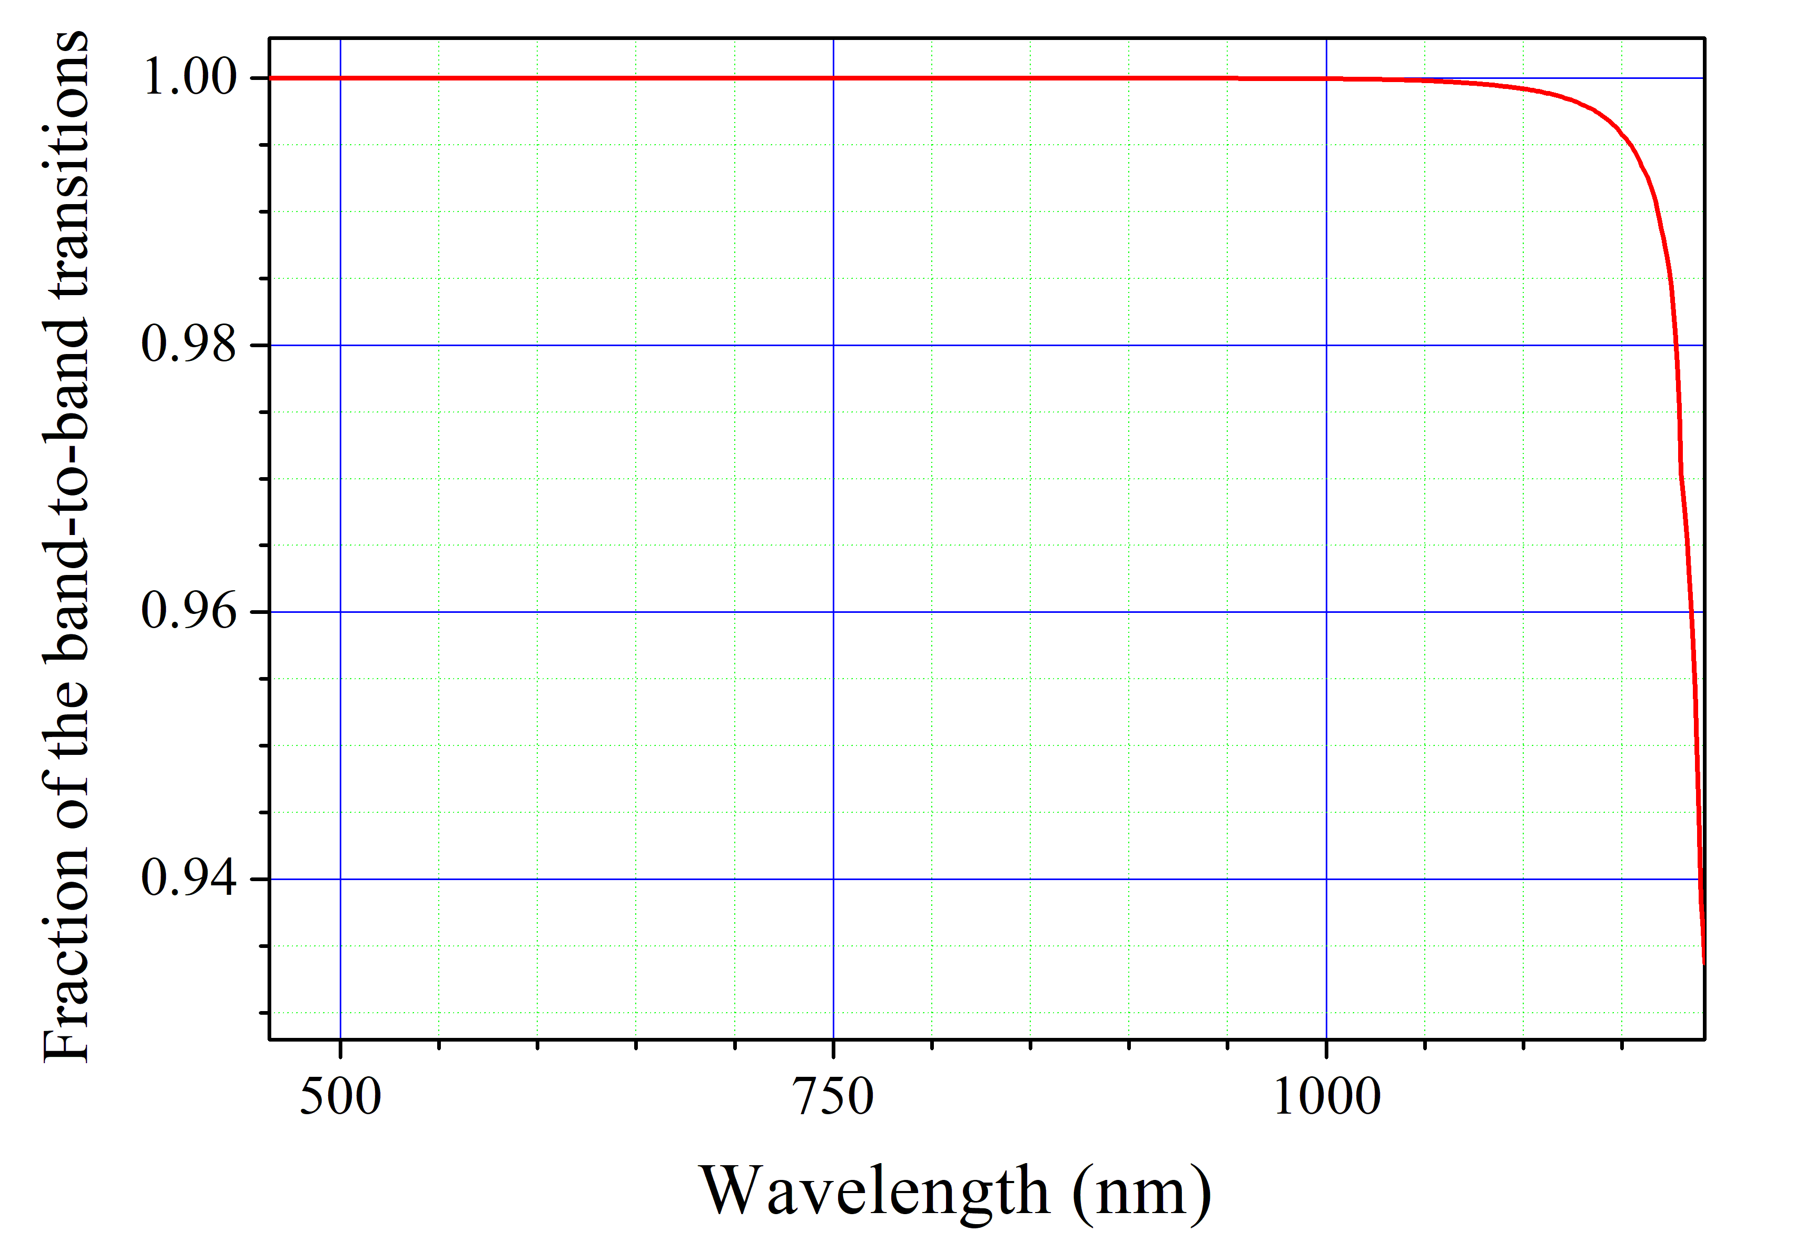

Fig.S5. The spectral dependence of fraction of the band-band transitions, calculated according to [11] for the case *T* = 340 K and silicon sample with thick 380 μm and doping level 1.36⋅1015 cm-3.

**References**

[1] A. Fahrenbruch, R. Bube, *Fundamentals of Solar Cells: Photovoltaic Solar Energy Conversion*, Academic Press, NY, London, Paris, **1983**.

[2] M. Razeghi, A. Rogalski, *J. Appl. Phys.* **1996**, *79*, 10 7433.

[3] D. Klaassen, *Solid-State Electron.* **1992**, *35*, 7 953.

[4] F. E. Rougieux, C. Sun, D. Macdonald, *Sol. Energy Mater. Sol. Cells* **2018**, *187* 263.

[5] W. Wijaranakula, *J. Electrochem. Soc.* **1993**, *140*, 1 275.

[6] T. Niewelt, B. Steinhauser, A. Richter, B. Veith-Wolf, A. Fell, B. Hammann, N. Grant, L. Black, J. Tan, A. Youssef, J. Murphy, J. Schmidt, M. Schubert, S. Glunz, *Sol. Energ. Mat. Sol.* **2022**, *235* 111467.

[7] L. E. Black, D. H. Macdonald, *Sol. Energ. Mat. Sol.* **2022**, *234* 111428.

[8] M. A. Green, *Prog. Photovoltaics Res. Appl.* **2022**, *30*, 2 164.

[9] A. W. Mohamed, A. A. Hadi, K. M. Jambi, *Swarm Evol. Comput.* **2019**, *50* 100455.

[10] S. Bowden, R. A. Sinton, *J. Appl. Phys.* **2007**, *102*, 12 124501.

[11] S. Schafer, R. Brendel, *IEEE J. Photovolt.* **2018**, *8*, 4 1156