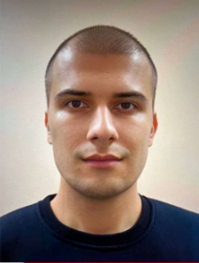

Pavlo Lishchuk

**Date of Birth: 12 July 1992 Gender: male**

**Nationality: Ukraine Phone: +38 (063) 57 57 925**

**E-mail:** [**pavel.lishchuk@gmail.com**](mailto:pavel.lishchuk@gmail.com)[**pavel.lishchuk@knu.ua**](mailto:pavel.lishchuk@knu.ua)

**Official (postal) address:** **Ukraine, 01601, Volodymyrska street, 64/13,   
Faculty of Physics.**

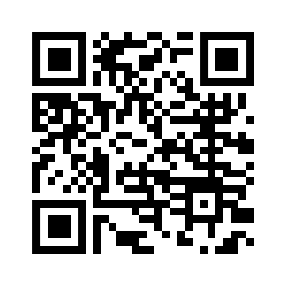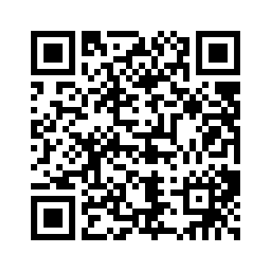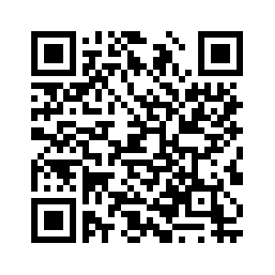

**Profile in Bibliographic Databases:**

**Scopus Researchgate GoogleScholar Orcid**

|  |  |  |
| --- | --- | --- |
| **EDUCATION** | | |
| ­ | | |
| **Ph.D. in Solid State**  **Physics**  Dec 2015 - Nov 2018 |  | **Faculty of Physics, Taras Shevchenko National University of Kyiv**  *Advisor: Dr. Roman Burbelo  Dissertation: Features of thermal transport in porous silicon-based semiconductor structures* |
|  |  |  |
| **MSc in Physics**  **of Nanosystems**  Aug 2013 - June 2015 |  | **Faculty of Physics, Taras Shevchenko National University of Kyiv**  *degree with distinction* |
| **Bachelor in Physics**  **and Astronomy**  Sep 2009 - June 2013 |  | **Faculty of Physics, Taras Shevchenko National University of Kyiv** |
|  | | |
| **RELEVANT WORK EXPERIENCE** | | |
|  | | |
| **Teaching assistant**  2019 – Present  **Engineer of**  **Studied Laboratory**  2018 – 2019 |  | **General Physics Department,**  **Faculty of Physics, Taras Shevchenko National University of Kyiv**  **Faculty of Physics,  Taras Shevchenko National University of Kyiv** |
| |  |  |  | | --- | --- | --- | | **SCOPUS PROFILE INFORMATION** | | | | **h-index – 5, number of records – 21, number of citations – 92** (*date of checking 28-April-2023*) | | | | **ACADEMIC AWARDS** | | | |  | | | | **2022**  Awarded by The Honorary Diploma of the Presidium of National Academy of Science of Ukraine.  **2015** Awarded a Diploma for participating in the All-Ukrainian competition of student research papers in Physics  **(**Ministry of Education and Science of Ukraine) | | | |  | | | | **PARTICIPATION IN THE SCIENTIFIC PROJECTS** | | | |  | | | | **Carbon-based nano-materials for theranostic application.** Funding scheme: Marie Skłodowska-Curie Research and Innovation Staff Exchange (RISE), HORIZON-2020. Call: H2020-MSCA-RISE-2015  **Features of photothermal and photoacoustic processes in low-dimensional silicon-based  semiconductor systems.** Youth project of the Ministry of Education and Science of Ukraine (2018-2020), Ukraine.  **Ultra-small Nanohybrides for Advanced Theranostics (UNAT)** Funding scheme: Marie Sklodowska-Curie Actions (MSCA), Research and Innovation Staff Exchange (RISE), Call:H2020-MSCA-RISE-2020 | | | | **TRAVEL GRANTS FOR THE PRESENTATIONS** | | | | **Impact of thermal annealing on photoacoustic response and heat transport in porous silicon based nanostructured materials.**  Thermophysics 2019, 22nd - 24th October, 2019, Smolenice, Slovakia.  **Characterization of Porous Silicon Based Composite Nanostructures by Means of Photoacoustic Technique**. The 2018 IEEE 8th International Conference on Nanomaterials: Applications & Properties (NAP-2018), 9-14 September, 2018, Zatoka, Ukraine. **Features of thermal transport in porous silicon based nanocomposite systems.**  International Conference Porous Semiconductors Science and Technology (PSST – 2016), 6-11 March, 2016, Тarragona, Spain.  **Investigations of thermal transport properties in porous silicon by photoacoustic technique.**  Conference Photoacoustic and Photothermal Theory and Applications (CPPTA-II), 23-26 September, 2014, Warsaw, Poland. | | | |  | | | | **REFEREE OF THE JOURNALS** | | | | **Advanced Optical Materials, Journal of Applied Physics.** | | | | **PROFESSIONAL SKILLS** | | | |  | | | | **MAIN RESEARCH AREAS:**  Photothermal and photoacoustic phenomena  Heat transport in bulk and nanostructured materials | **COMPUTING SKILLS**  *Fully conversant with* Origin, MatLab, Comsol Multiphysics,  Arduino, LabView, Microsoft Ofﬁce, Inkscape, VEGAS Pro  *Programming skills* in c++ | **LANGUAGE COMPETENCIES**  Superior skills in Ukrainian and Russian (oral and written)  Intermediate skills in English  (oral and written) | | | |