Estimation of parameters for solar cells with S-shaped current-voltage characteristics using meta-heuristic algorithms

Oleg Olikh

*Taras Shevchenko National University of Kyiv, 64/13, Volodymyrska Street, Kyiv, 01601, Ukraine*

ARTICLE INFO

ABSTRACT

*Keywords:*

S-shaped IV characteristics Opposed two-diode model Parameter estimation Meta-heuristic algorithms Nonparametric statistical procedure Solar cell models

Identifying the parameters of photovoltaic (PV) models based on measured current-voltage (IV) char­acteristic curves is crucial for simulating, evaluating, and controlling PV systems. IV characteristics of new-generation solar cells (SCs) often exhibit an S-shaped deformation. In this paper, the potential of using meta-heuristic algorithms to solve the parameter estimation problems of PV cells with S- shaped IV characteristics has been explored. The parameter estimation has been performed within the framework of the opposed two-diode model. A total of14 algorithms from various classes were imple­mented to extract the SC parameters from synthetic IV curves, which were generated with a range of parameter values. The obtained results have been compared using nonparametric statistical methods, including Wilcoxon signed-rank test for pairwise comparisons, Friedman, Friedman Aligned, and Quade tests for multiple comparisons, and post-hoc Finner, Holm, Hochberg, Holland, Shaffer, and Nemenyi procedures. Research has demonstrated that utilizing a squared error-based fitness function offers clear advantages in tackling a provided problem. Comprehensive results and analyses indicate that STLBO and ADELI algorithms have highly competitive performance in terms of accuracy and reliability.

1. Introduction

Photovoltaics (PV) is widely regarded as the most promis­ing sustainable clean energy technology to meet the rising energy demand of our global population. By the end of 2021, the installed capacity of global solar PV panels reached an impressive 971 GW, with an additional 183 GW added in 2021 alone [1]. According to the International Energy Agency (IEA) reports, the cumulative installed PV capacity was predicted to increase to 1.826 TW by 2026 and 14.5 TW by 2050 [2]. Currently, silicon solar cells make up approximately 90% of the global photovoltaic production capacity. But recently, intensive research is underway for innovative developments, further experiments, and practical PV applications of various new-generation solar cells (SCs). The operating principle of new-generation solar cells is qualitatively similar to silicon-based ones. However, it is important to note that the fourth quadrant of their current­voltage (IV) characteristics often exhibits an S-shaped de­formation or kink. This kink's origin has been attributed to various physical phenomena: charge trapping at the cathode interface [3,](#bookmark71) [4], rectifying Schottky junction at the anode interface [5] change of the electric field distribution [6], presence of strong interface dipoles [7], unbalanced charge transport [8]. Furthermore, it is worth noting that such a fea­ture of the IV characteristics is typical in the most promising candidates for the next generation of photovoltaic devices. Specifically, S-shaped IV curves have been observed in silicon heterojunction SCs [9], thin-film SCs such as CdTe, CI(G)S, and amorphous silicon PV devices [9,](#bookmark77) [10], normal and inverted organic SCs [11,](#bookmark79)[12,](#bookmark80)[13], perovskite SCs [9,](#bookmark77)[14], quantum dot SCs [8,](#bookmark76) [15], and hybrid SCs [16,](#bookmark84) [7,](#bookmark75) [4].

One of the most common approaches to understanding the electrical characteristics of PV devices is to use an equivalent circuit model to fit the shape of the IV curve. Such lumped-parameter modeling allows simulation, anal­ysis, and optimization of device performance. The most frequently used conventional solar cell lumped-parameter models are single-diode model (SDM), double-diode model (DDM), and three-diode model (TDM) models. The models incorporate parallel-connected diodes that activate in one direction, a photo-current source, a parallel shunt resistance, and a series resistance. The PV module model (PVMM) is based on SDM and is made up of several diodes in series or parallel.

Unfortunately, the conventional models failed in describ­ing the S-shaped kink. Thus, new models are proposed to give some reasonable IV curve shape explanations on the IV curve shape from the view of electricity. One of the earliest attempts to develop such a model was proposed by Mazhari [17]. This model is essentially a simplified version of the SDM, achieved by excluding resistances and incorporating an additional diode. Up to now, Mazhari's model is the simplest circuit because the least fitting pa­rameters are required for simulations. Mazhari's model fails to capture the linear-like rise S-shaped kink in the third quadrant, and the model, which improved by incorporating two resistance, proposed for organic SCs [18]. Gaur and Kumar [11] proposed equivalent circuit models to represent the behavior of polymer solar in the dark. This model is almost identical to the DDM, except one of the diodes is the opposite. Another way to develop equivalent models involved using multiple series diodes, unlike conventional approaches. Zuo *et al.* [5] offered to explain the S-shape by utilizing a model consisting of two series diodes connected in the same direction, two shunt resistors, and one series resistor. Another lumped-parameter equivalent circuit holds two opposed diodes, two opposed current sources, and no resistors [8]. De Castro et al [6] proposed a model consisting of two opposed diodes with shunt resistance for each, a series resistance, and a photo-current source. The last model represents a significant advancement as it successfully re­produces the S-shaped kink in the power-producing fourth quadrant of the illuminated IV characteristics. However, it falls short of adequately describing the IV curve beyond the open-circuit point in the first quadrant, where the current of many practical devices tends to continue increasing [19]. To address this challenge, a potential solution was suggested — incorporating a third diode that would either replace one of the shunt resistances [20] or be placed in parallel with it [21,](#bookmark89) [10]. In general, the developing models to describe S- shaped IV curves continues. For instance, a relatively recent proposal [3] is the B2BDM model: back-to-back diodes in parallel with a shunt resistor and the photo-current source, all in series with an offset voltage source, and then connected in parallel to another diode and shunt resistor, again in series with a resistor. Some review about models for PV devices with S-shaped IV curves can be found in [19,](#bookmark87) [22].

The next step after developing the model is to identify the corresponding parameters from the IV characteristics. Essentially, this task is an optimization problem. One pop­ular approach for solving such problems is the application of meta-heuristic algorithms. In fact, there have been nu­merous meta-heuristic algorithms developed specifically for this purpose. No Free Lunch theory (NFL) [23] provides the foundation for such diversity, stating that no single meta-heuristic algorithm can solve all optimization tasks effectively. In other words, the optimization algorithm can have brilliant results in a specific class of problems and at the same time fails to solve other ones. As a result, each problem, including the parameter estimation of each equivalent model, necessitates a distinct algorithm selection. Numerous studies have been conducted to compare the effi­ciency of meta-heuristic algorithms for parameter estimation under conventional SC models. Some studies focus on a single model, such as SDM [24], DDM [25,](#bookmark93) [26], or TDM [27], while others examine both SDM and DDM concur­rently [28,](#bookmark96) [29,](#bookmark97) [30,](#bookmark98) [31]. Several papers have investigated algorithms' efficiency in processing IV curves according to three models: SDM, DDM, and PVMM [32,](#bookmark100) [33,](#bookmark101) [34,](#bookmark102) [35]. Indeed, the utilization of conventional SC models for testing newly developed algorithms is among the most popular approaches after using CEC20XX benchmark functions. The wide range of metaheuristic optimization methods allows for situations in which various studies examine identical models but prioritize different algorithms array.

Regarding the estimation of parameters for models of PV devices with S-shaped IV curves, the situation is not as well-explored. Certainly, meta-heuristic algorithms have been utilized in processing experimental S-shaped IV curves [36]. Nevertheless, studies aimed at identifying the most optimal approach for solving these problems are absent to our knowledge. However, the NFL theory suggests that algorithms that have demonstrated exceptional results for silicon monocrystalline SC models may not yield the same effectiveness for models of the next-generation PV devices.

This study aimed to compare the effectiveness of pa­rameter estimation according to the De Castro two-diode model [6] using a set of 14 meta-heuristic algorithms and determine the best-performing among them. The selection of this particular model from the diverse range is motivated by its universality. Despite the mentioned drawbacks in the first quadrant, the model attracts attention in deriving the analytical solutions of the equivalent circuits [15] and is widely used to describe experimental IV curves of SCs with different structures [37,](#bookmark105) [36,](#bookmark104) [38,](#bookmark106) [39,](#bookmark107) [40,](#bookmark108) [41,](#bookmark109) [42,](#bookmark110) [43,](#bookmark111) [44]. In particular, these include polymer [41] and polymer/fullerene [39] bulk heterojunction photocells, ternary organic solar cells [42], and other types of organic structures [36,](#bookmark104) [38], perovskite solar cells with fullerene transport layer and carbon nanotube electrode [44], and perovskite solar cells with ionic liquid gating [43]. The popularity of the De Castro model is also associated with the fact that in experiments, IV curves are typically measured only within the range from short-circuit current to open-circuit voltage, i.e., only in the fourth quadrant. The considered metaheuristic algo­rithms belong to different categories based on their sources of inspiration. Some of these algorithms have been well- known for a long time and have proven their effectiveness in solving a wide range of problems. Other algorithms are more recent, developed with the knowledge gained from their predecessors. The obtained results are compared using various nonparametric statistical methods.

1. Problem definition
   1. Solar cell model

Fig. 1 vividly reveals the structure of the used model [6]. It can be seen from the figure that model contains a current source accompanied by a diode D1, a shunt resistor ***K***pi to show the leakage current, and a series resistor ***R****s* to consider the losses associated with the load current. Besides, the second diode D2 with a second parallel resistance ***R****p-* is placed opposite to the first one and is essential to simulate the non-ideal effects of the active layer/cathode interface. In this model, D1 is responsible for the exponential behavior of the IV curve, the main contribution of D2 is to simulate the S-shape. The analytical solution ***V****(****I***) of the opposed two-diode equivalent circuit model was obtained [45] using Lambert ***W***-function [46]:

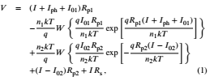

where ***I****01* and ***I****0-* are the saturation currents and ***n****1* and ***n****2* are the ideality factors for D1 and D2 respectively, and

(1)

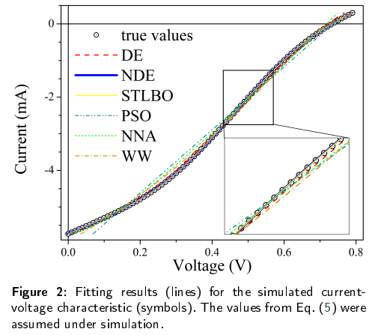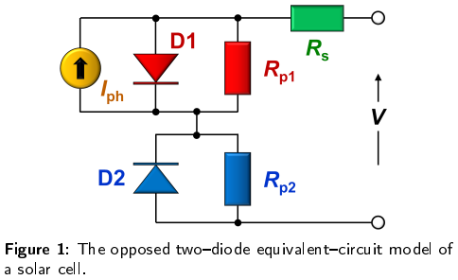***I****ph* is the ideal photocurrent. Thus, the model employs eight lumped parameters (***I***01, ***n****1*, ***A***p1,***I****02*, ***n****2*, ***R****p2*, ***R****s*, and ***I***ph) that need to be determined from the IV curve. Thus, from an optimization perspective, the dimension of the problem is ***D*** = 8.

The expression (1) has a drawback in that it tends to stray from the range of numbers that can be accommodated by the standard 64-bit floating-point format owing to the presence of exponential functions for larger numbers. To overcome this drawback, the use of the ***g***-function ***g****(****x****) = ln(****W***(exp(***x***))) was suggested [47]. The analytical solution ***V****(****I****)* using the ***g***-function is as follows [47]

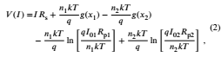

with



and



We used Eqs. (2)-(4) both for simulation IV curves and during the approximation procedure. The ***g***-function was evaluated by using iterative procedure [47].

* 1. Synthetic IV curves

The research involved the parameter estimation of solar cells using meta-heuristic algorithms based on synthetic IV characteristics simulated using the opposed two-diode model. This approach allows for assessing the accuracy of the employed optimization methods, as the simulation was performed using known parameter values.

In first part of the study, a detailed analysis was con­ducted on a single IV curve, evaluating the performance of meta-heuristic algorithms for parameter estimation in a one-time application mainly. Additionally, the suitability of employing two different fitness functions was examined. In the second part, we simulated a set of IV characteristics and evaluated the average performance metrics of various algorithms.

* + 1. Single-IV case

Previous studies have demonstrated [41,](#bookmark109) [48] that when the ideality factor of D2 is either equal to or significantly larger than ***n****1 (****n****1 =* ***n****2 =* 1***.***92 or ***n****1 =* 1***.***00, ***n****2 =* 3***.***00), the nonlinear least-squares method successfully determines a set of equivalent circuit parameters that accurately replicate the experimental data of an organic photovoltaic cell. There­fore this approach does not allow for distinguishing between similar IV curves obtained from solar cells with different parameters. To overcome this issue, Tada [48] successfully employed Bayesian estimation of parameters. To assess the capabilities of meta-heuristic methods in overcoming addi­tional similar challenges, they were applied to a IV curve corresponding to such a problematic case. The parameter values were taken from [48]:

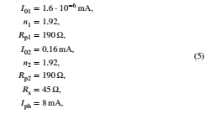

and the IV curve was simulated over a range of 0-0.8 V with step 10 mV at ***T*** = 300 K. The simulation result is presented on Fig. 2 by symbols.

* + 1. IV-setcase

Employing various meta-heuristic algorithms to analyze a single IV curve is insufficient to obtain comprehensive insights into the methods' efficacy in parameter estimation. The accuracy of parameter determination is closely tied to their absolute values. For instance, an increase in the ***R***pvalue can pose challenges for accurately estimating resis­tance because the shunt will have a lesser impact on the overall shape of IV curve. In addition, the ratio between the parameter values also plays a crucial role.

To test the methods across different parameter values, we generated synthetic data in a temperature range from 260 K to 350 K. During the simulation process, we considered various temperature dependencies of the parameters. We based our approach on known physical mechanisms but focused on achieving the diversity of parameter ratio instead of attempting to replicate real-life photovoltaic converters precisely. Furthermore, an S-shaped IV curve is observed in solar cells of various types, and diverse charge transport mechanisms significantly complicate the selection of the only possible temperature dependence for each of the eight model parameters. Therefore, we assumed that the current conduction mechanism through D1 is close to tunneling, and hence, ***I****01*,Rp1, and *(****n****1* ***kT***) remain constant, with ***I****01 =*0***.***015 mA, Rp1 = 104Ω, ***n****1* ***kT*** *= 7* eV. In the case of D2, the thermionic emission current was suggested and ***I****02* and ***n****2* increased and decreased, respectively, with temperature rise [49]:

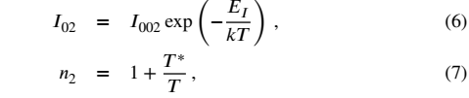

where ***I****002*, ***ET***, and ***T***\* are the constants which are independent of temperature. The values of ***I****002* = 500 A,

EI= 0***.***40 eV, and ***T***\* = 500 K were used. For ***R****p2*, an exponential temperature dependence was employed, as it is widely observed [50] in modern solar cells for the shunt resistance:



with ***R****p20* = 9 mQ, ***E****r* = 0 ***.***32 eV. The linear temperature dependencies is expected for both ***I****ph* [51,](#bookmark119) [52] and ***R****s* [53,](#bookmark121) [54]:



where ***y*** = ***I***ph or ***R****s*, ***y****0* is the parameter value at room tem­perature, TC***y*** is the temperature coefficient of parameter. For most types of monocrystalline silicon solar cells, the TC***jph*** typically ranges from around -0***.***0004 K-1 [55]. However, as the base thickness decreases, the temperature coefficient can increase to -0***.***0014 K-1 [56]. For hydrogenated amorphous silicon solar cells, TC*j* is equal to -10-3 K-1 [57]. For organic solar cells, the temperature coefficient can reach a magnitude of -0***.***003 K-1 [58]. During the simulation, we assumed TC = -10-3 K-1. Furthermore, the values of ***I***ph0 = 1 mA, , and ***A***s0 = 50 Q were used.

The set of I-V data was composed of 10 curves, which were simulated at 10 K intervals from 260 to 350 K; in this case, ***n****1*, ***I****Q2*, ***n****2*, ***R****p2*, ***R****s*, and ***I***ph varied from 6.37 to 4.73, from 9 to 880 μA, from 2.92 to 2.43, from 1***.***4 • 104 to 360 Ω,

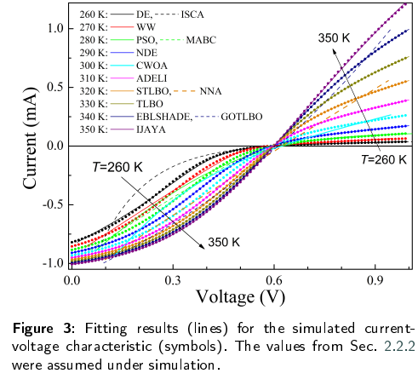

from 10 to 100 Ω, and from 0.96 to 1.05 mA, respectively. The simulation results are presented on Fig. 3 by symbols.

0.0 0.3 0.6 0.9

Voltage (V)

* 1. Meta-heuristic algorithms

In the literature, meta-heuristics are frequently catego­rized based on their sources of inspiration. This categoriza­tion involves incorporating elements of true simulations and principles that incorporate stochasticity, with the objective of emulating diverse characteristics observed in biological behavior, the lives of creatures in nature, human behavior, or natural phenomena. On this basis, any meta-heuristic algorithm can fall into one of the following main classes [59,](#bookmark127) [60,](#bookmark130) [61]: evolution-based methods (emulate the prin­ciples of evolutionary behavior observed in creatures in nature by relying on the concept of survival of the fittest), swarm intelligence-based methods (simulate the collective, dynamic, intelligent, and concerted gregarious conduct of collections of flocks or communities found in nature), bio­based methods (use biological processes unrelated to group behavior), chemical & physical-based methods (originate from the physical phenomena or chemical laws that exist in the universe), human-society-based methods (inspired by human beings, including various activities such as thinking and social behavior), and math-based methods (borrow the mathematical functions). Generally, there are hundreds of meta-heuristic optimization methods available. While we acknowledge that our selection may not be fully compre­hensive, we utilized 14 methods, representing all classes mentioned above, to tackle the parameter estimation task within the framework of the opposed two-diode model for a solar cell. Hereafter, we provide a succinct description of each method alongside the parameters employed during the fitting process.

*Differential evolution* (**DE**). DE is one of the classical methods, and it is based on the natural selection law and uses the randomly generated initial population, differential

mutation, and probability crossover [62]. During the imple­mentation, we employed a penalty function suggested by Ishaque *et al* [63]. Besides, according to Wang and Ye [62], the values of mutation scaling factor ***F*** *=* 0***.***8, crossover rate ***Cr*** *=* 0***.***3, and population size ***Np*** = 8 X ***D*** = 64 were used in this work.

*Adaptive differential evolution with the Lagrange in­terpolation argument* (**ADELI**). The method is based on DE, which integrates an adaptive local search scheme with Lagrange interpolation [64]. This incorporation aims to en­hance the exploitation capability and accelerate the conver­gence speed. In ADELI, the scaling factor and crossover rate are set to self-adapting to optimize the results. We used parameter values recommended by Huang *et al* [64] during the implementation process. Additionally, we set ***Np*** to 64 for our numerical experiments.

*Differential evolution with neighborhood-based adap­tive evolution mechanism* (**NDE**). The method uses a mu­tation strategy, which takes into account neighborhood and individual information, and an adaptive evolution mecha­nism [65]. The determination of ***F*** and ***Cr*** values is achieved through the utilization of the weighted adaptive procedure [66], and an adaptive adjustment of the population size is implemented using a simple reduction method (from 10 X ***D*** *= 80* to 5).

*Success history based DE with hybridization mutation strategies and population size reduction* (**EBLSHADE**). The method is the hybridization framework between *pbest* and *ord_pbest* mutation strategies and stores a set of ***Cr*** and ***F*** values that have performed well in the recent past [67]. A linear ***Np*** reduction (from 18x ***D*** *= 144* to 4) is used as well.

*Particle swarm optimization* (**PSO**). It is another classic method based on observations of the social behavior of animals, such as bird flocking, fish schooling, and swarm theory. According to Ye et al. [68], the values of learning factors ***l****1* = ***l****2* = 2, the final weight and the initial weight ***wmax*** *=* 0***.***9, ***wmin*** *=* 0***.***4, and ***Np*** *=* 15 X ***D*** *= 120* are used in this work.

The *modified artificial bee colony* (**MABC**) algorithm is based on the intelligent foraging behavior of honey bee swarms [69]. The control parameters include the population size *(****Np*** = 8 X ***D*** = 64) and the maximum number of generations after which each non-improved food source is to be discarded *(****Limit*** *=* 36).

*Chaotic Whale Optimization Algorithm* (**CWOA**). WOA draws inspiration from the hunting behavior of humpback whales [70]. On the other hand, CWOA employs chaotic maps to compute and dynamically adjust its internal param­eters [71]. In our study, we utilized the Singer chaotic map and set ***Np*** *=* 100 for the identification of the parameters of the solar cell.

The *Neural Network Algorithm* (**NNA**) is a meta-heuristic algorithm that draws inspiration from both biological ner­vous systems and artificial neural networks [72]. The rec­ommended [72] value ***Np*** *=* 50 is used in our paper.

The *teaching learning based optimization* (**TLBO**) algo­rithm employs the concept of passing on knowledge within a classroom. Similar to learners acquiring knowledge from a teacher and interacting with their peers, TLBO incorporates such interactions [73]. In this study, a value of ***Np*** = 100 is utilized.

*Generalized oppositional teaching learning based op­timization* (**GOTLBO**). This method integrates a concept that incorporates both the current estimate and its opposite estimate simultaneously into the original TLBO algorithm through the initialization step and generation jumping [74]. The values of jumping rate ***Jr*** = 1***.***0 and ***Np*** = 20 were used.

*Simplified teaching-learning based optimization algo­rithm* **BO**). In STLBO, an elite strategy is employed to improve the searching capability, and a the chaotic map is used to enrich the uniformity of random values in the mutation phase [75]. The logistic chaotic map and ***Np*** = 20 were used.

*Water wave optimization* (**WW**) takes inspiration from shallow water wave models and borrows ideas from wave propagation, refraction, and breaking [76]. WW is easy to implement with a small-size population, and there are four control parameters: the maximum wave height ***hmax****,* the wavelength reduction coefficient ***a****,* the breaking coefficient ***P***, and the maximum number ***kmax*** of breaking directions. According to Zheng [76], we used the values ***hmax*** = 6, ***a*** = 1***.***026, ***Np*** = 10, ***kmax*** = min(12***, D***/2) = 4, and ***P*** linearly decreased from 0.25 to 0.001.

*Improved JAYA* (**IJAYA**). Jaya algorithm is based on the concept that the solution obtained for a given problem should move toward the best solution and should avoid the worst so­lution and does not require any algorithm-specific parameter [77]. In IJAYA, a self-adaptive weight is introduced to adjust the tendency of approaching the best solution and avoiding the worst solution; an experience-based learning strategy is employed to maintain the population diversity and enhance the exploration ability, and a chaotic elite learning method is proposed to refine the quality of the best solution in each generation [78]. The logistic chaotic map and ***Np*** = 4x ***D*** = 32 were used.

*Improved sine cosine algorithm* (**ISCA**). SCA based on simulating the behaviors of sine and cosine mathematical functions [79]. ISCA implementation included a modified position-updating equation based on inertia weight *(****wstart*** = 1, *wend* = 1), a nonlinear conversion parameter strategy based on the Gaussian function *(****astart*** = 2, ***aend*** = 0) [80], the creation of the opposite population to jump out from the local optima with ***Jr*** = 0***.***1 [81], a greedy selection, and ***Np*** = 30.

The majority of the utilized algorithms demonstrate ex­cellent performance when it comes to parameter estimation of SCs within conventional models (SDM or DDM) [71,](#bookmark141) [62,](#bookmark132) [74,](#bookmark144) [78,](#bookmark148) [69,](#bookmark139) [68,](#bookmark138) [75,](#bookmark145) [73,](#bookmark143) [82,](#bookmark152) [35].

In meta-heuristic optimization methods, the quality of the extracted parameters is evaluated using the fitness func­tion at every iteration. In our investigation, absolute error and square error fitness functions were under consideration:

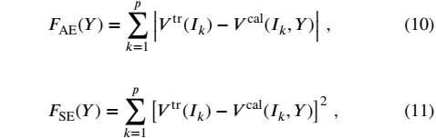

where ***Vtr****(****Ik****)* is the simulated value of voltage at current ***Ik, V****cal(****Ik, Y***) is the calculated values of voltage, which can be obtained by Eqs. (2)-(4), for given set of parameters (i.e. ***Y*** = {***I***oi***,«***i***,^***pi***,l***02***,„***2***,^***p2***,^***s***,****J*ph}) at current ***Ik****,* and ***p*** is the total number of voltage steps in the IV characteristic.

We executed each tested algorithm for ***N***runs = 51 independent runs on each simulated IV curve to generate the statistical results. The search ranges were set as follows:

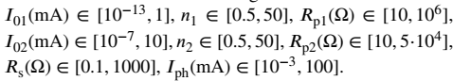

* 1. Evaluation metrics

To better show the performance differences between compared algorithms, several evaluation metrics are consid­ered, which can be described as follows:

1. Mean value (MEAN), median value (MEDIAN), stan­dard deviance (STD), and interquartile range (IQR) for each two-diode model parameter ***y*** *(****y*** is one of {I01 , *n1,* ***R****p1,* ***I****02,* ***n****2*, ***R****p2,* ***R****s,* ***I***ph}). MEAN and MEDIAN are often used to measure the solution quality. The closer the obtained MEAN and MEDIAN values are to the actual parameter values, the closer the obtained solution is to the optimal solution. To quantify, we used the absolute percentage of error (APE):



where ytr is the parameter value used during the IV curve simulation. APE was calculated for *yt,* obtained by one- run algorithm application (APE*,*), MEAN (APEmean), and MEDIAN (APEmedian). Reducing STD and IQR result in a more stable algorithm performance.

1. Another evaluation criterion used to compare the algo­rithms' performance is to compare their execution time. We used average run time ***t***run in seconds for an individual optimizer on one IV curve.
2. Root mean square percentage of error (RMSPE) is a statistical measure that indicates how well the fitted curve matches the actual IV curve:

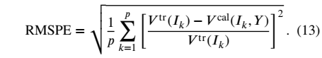

1. Wilcoxon signed-rank test is a nonparametric statistical test used for pairwise comparisons of algorithms. This test assigns a rank to all the scores considered as one group and then sums the ranks of each group.
2. Friedman, Friedman Aligned, and Quade tests are used for comparing the performance differences among opti­mization algorithms (multiple comparisons 1 X ***N*** with a control method). Therefore, the average rankings of the algorithms according to the tests are reported. Besides, the post-hoc Finner, Holm, Hochberg, and Holland pro­cedures are used to establish proper comparisons between each algorithm and a set of other algorithms.
3. Multiple Comparisons Test (Friedman) with Shaffer's static, Nemenyi, and Holm procedures are employed to compute all possible pairwise comparisons between groups *(****N*** X ***N***) and identify the differences.
4. Numerical results and discussion
   1. Comparison of algorithms time

In meta-heuristic algorithms, a different termination can be defined. For instance, a termination condition can be a specific number of iterations ***N***it, constraints on the number of fitness function evaluations ***N***FE, a specific rate of precision, a specific time, no sign of change in solutions after a specific number of iterations, or a combination of these cases [83]. In this study, the primary focus was on the accuracy of parameter estimation. Therefore to ensure that both exploration and exploitation processes could be fully realized by each algorithm with an equal opportunity, the termination criterion used was the absence of changes in the solution. Based on this condition, the required number of iterations ***N***it was determined, and the corresponding calculation time was measured ***t***run. In addition, the ***N***FE was evaluated.

All the applied algorithms have been coded and imple­mented in Embarcadero®Delphi 10***.***3 programming soft­ware. The run time was estimated by using WinAPI-functions *QueryPerformanceCounter()* and *QueryPerformanceFre- quency().* The experiments were performed on Windows 10 Pro 64-bit, 2.9 GHz AMD Ryzen 7 4800H CPU, and 8 GB RAM.

The obtained results are listed in Table 1. As can be seen from the table, the number of iterations required for an algorithm does not always correlate directly with the number of fitness function evaluations or computation time needed to converge. The reason is the unique features of each algorithm. The run time of the algorithms varies consider­ably, with a range of 1.5 seconds to 93 seconds. Notably, WW, ISCA, NNA, and STLBO converge the fastest, while ADELI, TLBO, and MABC require the most time.

* 1. Fitness function selection

To choose the more suitable fitness function, we evalu­ated each algorithm using the IV curve generated from the parameters provided in Eq. (5) with both ***F****ae* and ***F***SE func­tions (see Eqs. (10) and (11)). Afterward, the results obtained using each of the functions were compared through pairwise comparisons. In this case, the absolute percentage error values obtained for one-run algorithm application (APE*,*-) were used. Table 2 gives the statistical results produced by

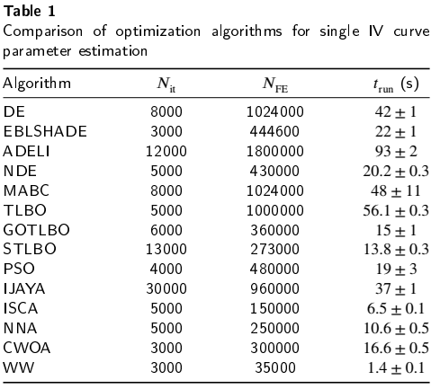

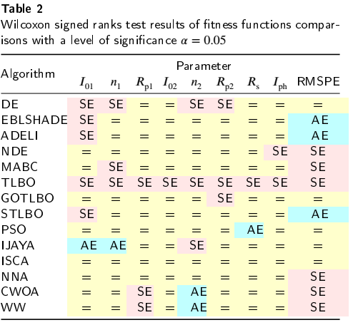

Wilcoxon sign-rank test with a significant level a = 0.05. A cell marked with the symbol “SE” indicates that estimation of parameter specified in the column by the algorithm with FSE outperforms result obtained by this algorithm with FAE. A cell marked with the symbol “AE” indicates better results for function In the case of the symbol “=”, there is no significant difference between function FSE and function F*ae* aplication.

As evidenced in the provided data, utilizing the square error fitness function more frequently yields better outcomes in comparison to Fae In rare cases, the absolute error fitness function can enhance the alignment between the fitted and actual curves, as well as improve the accuracy of some parameter estimations by PSO, IJAVA, CWOA, and WW algorithms. However, RMSPE is not the most crucial factor in determining model parameters, and the mentioned methods, as will be shown later, do not provide the highest

accuracy. As such, the results presented in the following sections are exclusive to the application of the FSE function. Therefore, it can be recommended that researchers consider the square error fitness function as a more effective and reliable option for the task of opposed two-diode model parameter estimation.

* 1. Performance comparison
     1. Evaluation of single-IV

In this subsection, we show and analyze the statistical results of different meta-heuristic algorithm applications to an IV curve, simulated with Eq. (5) values. Several typical fitting results of the synthesized curve are shown in Fig. 2. A more comprehensive version, including the fitting results obtained using each algorithm, is provided in the supplemen­tary materials (figure S1). It can be seen, that the closest match between the approximation curves and the IV curve points is observed for EBLSHADE, ADELI, NDE, IJAYA, TLBO, and STLBO. On the contrary, the PSO and GOTLBO fitting curves had the least replication of the original data.

Fig. 4 shows the results of cell parameters estimation by comparative algorithms. In addition, the figure presents the RMSPE data, which confirms the conclusions of the visual comparison between the fitting lines and the points of the IV curve. The results in terms of MEAN, MEDIAN, STD, and IQR are tabulated as well (table S1 in the supplementary material).

We would like to stress the following. In most cases, median values are more relevant to the actual parameter values than the mean values. Possible exceptions only apply to the estimation of ***R****s* and ***R****p2* only. However, in cases where a method allows for parameter estimation with high accuracy (EBLSHADE, ADELI, TLBO, and STLBO), ME­DIANs are at least as good as the MEANs. As a result, we will utilize median values as a robust measure of central tendency in nonparametric statistical tests. Secondly, the increase in algorithm stability (reduction in STD and IQR values) in determining each model parameter correlates with the accuracy of parameter estimation. Furthermore, IQR values are generally no worse than STD values. Finally, small RMSPE values (close match between the fitting curve and the IV points) do not always indicate high accuracy in determining the parameters of a solar cell — see IJAYA and NDE data. For example, the difference between the MEDIANRMSPE values for NDE and ADELI is approxi­mately 0.0001 (about 0.08% of their absolute value). At the same time, in the ADELI case, the values of APEmedian do not exceed 6⋅10-4 for all model parameters estimation, whereas for the NDE algorithm application, the obtained APEmedian values are significantly higher and range from 0.04 for ***I***ph to 11.4 for ***I****01.* On one hand, this confirms the issue identified by Tada [41,](#bookmark109) [48], which arises when estimating parameters according to the opposed two-diode model from similar IV curves corresponding to photovoltaic cells with distinct characteristics. Furthermore, the results indicate that some metaheuristic algorithms, such as NDE and IJAYA, can fall into a similar trap. On the other hand,

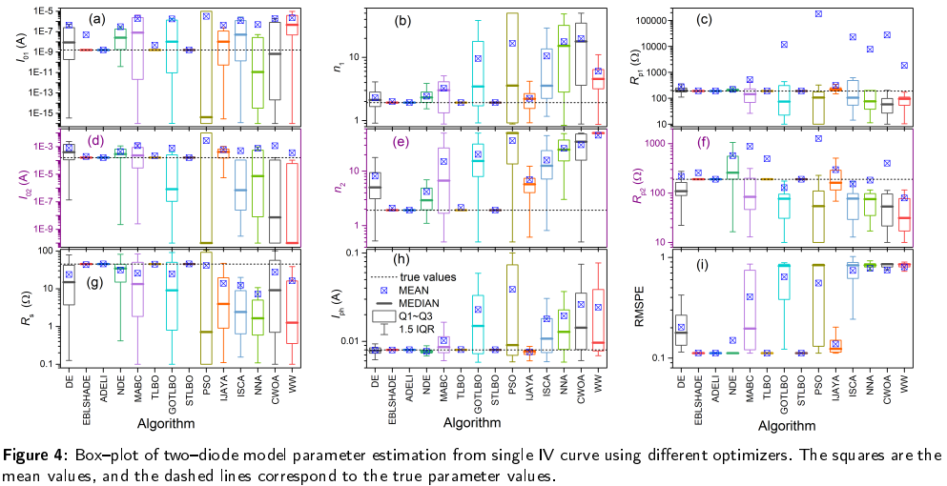

the high accuracy in parameter estimation demonstrated by EBLSHADE, ADELI, and STLBO indicates that these algorithms are able to overcome the mentioned issue when applied. It should be noted that a similar problem has been previously addressed by employing Bayesian estimation of parameters [48]. However, each Bayesian calculation took approximately half a day on a computer better equipped than ours [48] . In our case, when applying meta-heuristic algorithms, the worst-case run time did not exceed 100 seconds.

In order to statistically compare the algorithm under consideration, we use nonparametric tests. In the single-IV case, all nonparametric statistical tests were used to compare the performance of meta-heuristic algorithms in assessing each of the eight model parameters. The APE***Z*** values were used, and the number of case problems in the study ***N****pr* was equal to ***^***nms = 51. Additionally, algorithms were com­pared in terms of curve-fitting accuracy by using RMSPE values. Furthermore, tests were employed for a composite parameter as well. This parameter, referred to as “Comp” hereafter, includes APEmedian for each of the eight defined model parameters, the median value for RMSPE, and ***/***run. This parameter may provide the most valuable insights for comparing algorithms. However, it is important to note that the value of ***N****pr* is only 10. According to Derrac *et al* [84], the number of case problems should be ***N****pr > 2****k****,* where ***k*** is the number of algorithms *(****k*** *= 14* in our study). Therefore, the use of the Comp parameter is not strictly rigorous. Indeed, it would have been possible to increase the ***N****pr* value using, for example, APEMEAN. However, considering the deliberate utilization of a suboptimal parameter would have appeared inappropriate.

Fig. 5 graphically show the non-parametric statistical results of pairwise comparisons of algorithms based on the Wilcoxon signed-rank test. In the case of Comp compar­isons, the differences in performance scores were normal­ized to the interval [0***,*** 1]. As seen from the figure, no algorithm outperforms all others in evaluating each param­eter. Furthermore, no algorithm surpasses all others in the estimation even a single parameter. For example, as the figure states, STLBO shows a significant improvement over DE, NDE, MABC, GOTLBO, PSO, IJAYA, ISCA, NNA, CWOA, and WW across all the parameters considered with a level of significance ***a*** *=* 0***.***05. Simultaneously, it was not detected the significant differences between STLBO and both EBLSHADE and ADELI for all parameter estimations as well as between STLBO and TLBO in the Comp case. EBLSHADE outperforms nearly all other algorithms in the composite parameter, except for STLBO. According to the Wilcoxon test victories count, the worst performances are exhibited by PSO and CWOA. PSO achieved better results than ISCA, NNA, and CWOA in terms of RMSPE value, as well as outperformed WW in ***n****2* estimation and RMSPE. Test detected significant differences between CWOA and WW in ***n****2* and ***A***n estimations, between CWOA and PSO in ***!***01, ***I***02, ***R****s*, and ***I****ph* estimations), and between CWOA and both ISCA and NNA in ***R****s* estimation case only.

Looking at the results of the Wilcoxon signed-rank test from another perspective, it can be observed that neither EBLSHADE nor STLBO had any defeats in pairwise com­parisons, while ADELI had only one loss. ADELI was only outperformed by EBLSHADE in terms of the Comp param­eter, primarily due to its significantly longer run time. The highest count of defeats was observed for the PSO and WW algorithms (104 and 84, respectively). The data regarding the total count of wins and losses when applying the Wilcoxon test for each algorithm are summarized in Fig. 6.

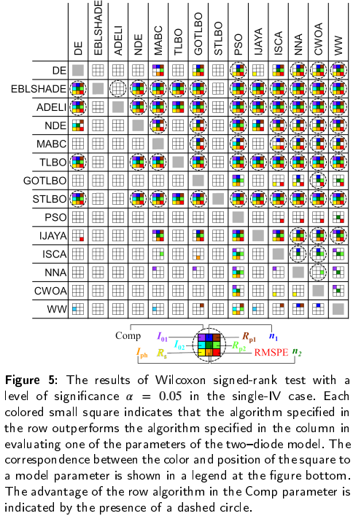

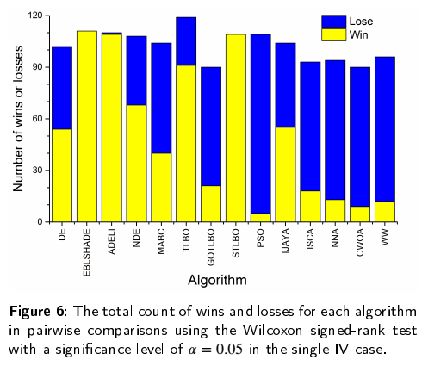

It is recommended [84] to begin the multiple comparisons tests by examining the null hypothesis ***H****0*, which asserts the equality of medians between the populations of results obtained by different algorithms. The null hypothe­sis ***^***-values computed through the statistics of Friedman, Friedman Aligned, and Quade test and the Iman-Davenport extension are given in the supplementary material (table S2).

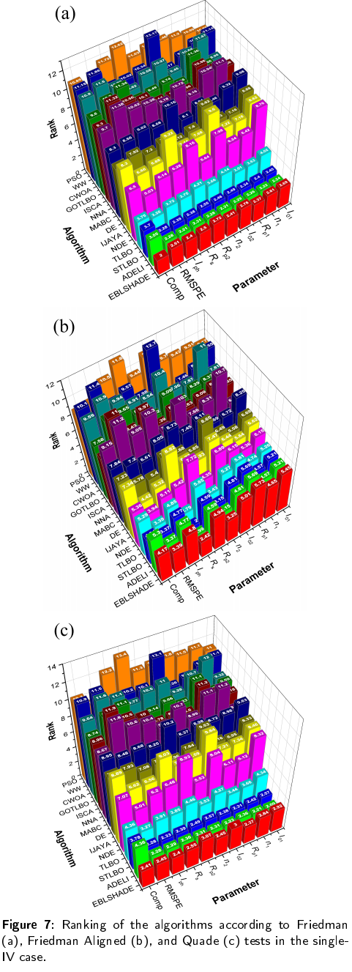

The highest observed p(H0)-values were found to be 2.7 • 10-5 (Friedman Aligned test for the task of Rp1 estimation), 4.4 • 10-4 (Friedman Aligned test for the composite parame­ter case), and 8.3 • 10-6 (Quade test, Comp parameter). Thus obtained data strongly suggest the existence of significant differences among the considered algorithms in the accuracy of all model parameter determination, RMSPE values, and Comp parameter.

Fig. 7 shows ranks achieved by the Friedman, Friedman Aligned, and Quade tests for applied optimization algo­rithms in different tasks. Ranks are tabulated in the supple­mentary material as well (table S3). In almost all cases, the algorithms EBLSHADE, ADELI, and STLBO consistently achieve the top (smallest value) three ranks. For example, in assessing the accuracy of model parameter estimation, ADELI has ranked first 22 times. The STLBO algorithm ranked first six times, taking the sole first place twice *(****I****01* estimation according Friedman Aligned test and ***R***p1 esti­mation according Quade test) and sharing it with ADELI four times *(****n****1,* ***R****p1,* ***n****2*, and ***I***ph estimation according Fried­man Aligned test). In the RMSPE value case, ADELI and STLBO achieved equal and best ranks by all three used tests. When comparing based on the Comp parameter, the STLBO algorithm obtained the top rank according to the Friedman Aligned test, while the Friedman and Quade tests recognized EBLSHADE as the best. In most cases, the TLBO algo­rithm secured the fourth position, and in four cases, it even ranked third. In the majority of cases, the TLBO algorithm consistently ranked fourth out of all the algorithms tested. Interestingly, in four cases *(****I****01* estimation, RMSPE value, and Comp parameter by Friedman Aligned test, and Comp parameter by Quade test), it even achieved a commendable third-place ranking. We must note that overall, the abso­lute values of ranks for ADELI, STLBO, EBLSHADE and TLBO algorithms differ little, and the difference between the first and fourth ranks is often less than 0.5. The worst ranks are observed for PSO, NNA, CWOA, and WW.

It is known [84] that the Friedman, Friedman Aligned, and Quade tests are insufficient in establishing accurate comparisons between the algorithms considered. To com­pare a control method (1 of 14 compared) with a set of other algorithms (rest 13), one can define a family of hy­potheses related to the control method. Applying a post- hoc test makes it possible to obtain a ***p***-value that indicates the extent to which each hypothesis can be rejected. We calculated ***p***-values using four post-hoc procedures (Finner, Holm, Hochberg, and Holland) for all algorithms, tests, and tasks. By following the indications given for the four post- hoc procedures considered, Table 3 shows the ***p***-values ob­tained, using the ranks computed by the Friedman, Friedman Aligned, and Quade tests for the case of control algorithm ADELI and the task of ***R***p1 estimation. These are typical results, the reader is referred to the supplementary material for rest of ***p***-values (Tables S4-S143).

As we can see in the table, the Finner post-hoc procedure exhibits the most powerful behavior, reaching the lowest ***p***-values in the comparisons. The Friedman test shows a significant improvement in ***R***p1 estimation of ADELI over DE, NDE, MABC, GOTLBO, PSO, IJAYA, ISCA, NNA, CWOA, and WW for all the post-hoc procedures considered.

The Friedman Aligned test only confirms the improve­ment of ADELI over the aforementioned 10 algorithms for every post-hoc procedure considered, except Holm, Hochberg, and Holland, which fail to highlight the differ­ences between ADELI and NDE as significant.

Finally, the Quade test find significant difference be­tween ADELI and MABC, GOTLBO, PSO, ISCA, NNA, CWOA, WW for every post-hoc procedure. In the DE and IJAYA cases, ADELI obtains better results in ***R***p1 estimation according Finner post-hoc procedure only. This result sup­ports the conclusion that, although ADELI outperforms the weaker algorithms of our study, its performance differences are not significant when compared to other power algorithms (STLBO, EBLSHADE, TLBO).

In our study, a threshold value of ***pcr*** = 0***.***1 was adopted to establish a critical level for comparing the effectiveness of two algorithms in both multiple 1 X ***N*** and ***N*** x ***N*** comparisons. That is, it was determined that the likelihood of obtaining a result as extreme as the observed one, under the assumption that there is no difference between the two algorithms (null hypothesis), was less than 10%.

The statistical results of the algorithm's effectiveness comparison in the task of ***R***p1 estimation are shown in Fig. 8(a). In the figure, the outperforming of an algorithm in a row over the algorithm in the column is indicated by a colored hexagon in the corresponding cell. The white hexagon suggests a strong likelihood of the null hypothesis. In fact, the data in Table 3 were used to create the third row in Fig. 8(a). The panel (b) of figure presents the statistical results for ***I****02* estimation. The results of the comparison of algorithms based on the other eight parameters are given in the supplementary materials (figure S2).

The results displayed in Fig. 8 demonstrate a consis­tent trend across all parameters. Among the compared al­gorithms, EBLSHADE, ADELI, and STLBO consistently outperform the others in 1 x ***N*** multiple comparisons. On the other hand, algorithms such as PSO, ISCA, CWOA, and NNA consistently produce lower-quality results. The main changes observed in nonparametric statistical estimation of different parameters estimation mainly concern algorithms with moderate effectiveness.

For example, when comparing the accuracy of determin­ing ***R***p1 and ***I****02,* the IJAYA algorithm performs better in the former case. As evident from Figure 3a, IJAYA outperforms GOTLBO, PSO, ISCA, NNA, CWOA, and WW in the results of Friedman and Friedman Aligned tests for every post-hoc procedure considered. While for ***I****02,* IJAYA only outperforms DE, MABC, PSO, and CWOA according to the Friedman test, and in the latter case, only for Finner post-hoc procedure. For DE, the situation is similar in the case of ***I****02* compared to ***R***p1. According to the results of the Friedman and Friedman Aligned tests, the algorithm loses its advantage over GOTLBO, SCA, NNA, CWOA, and

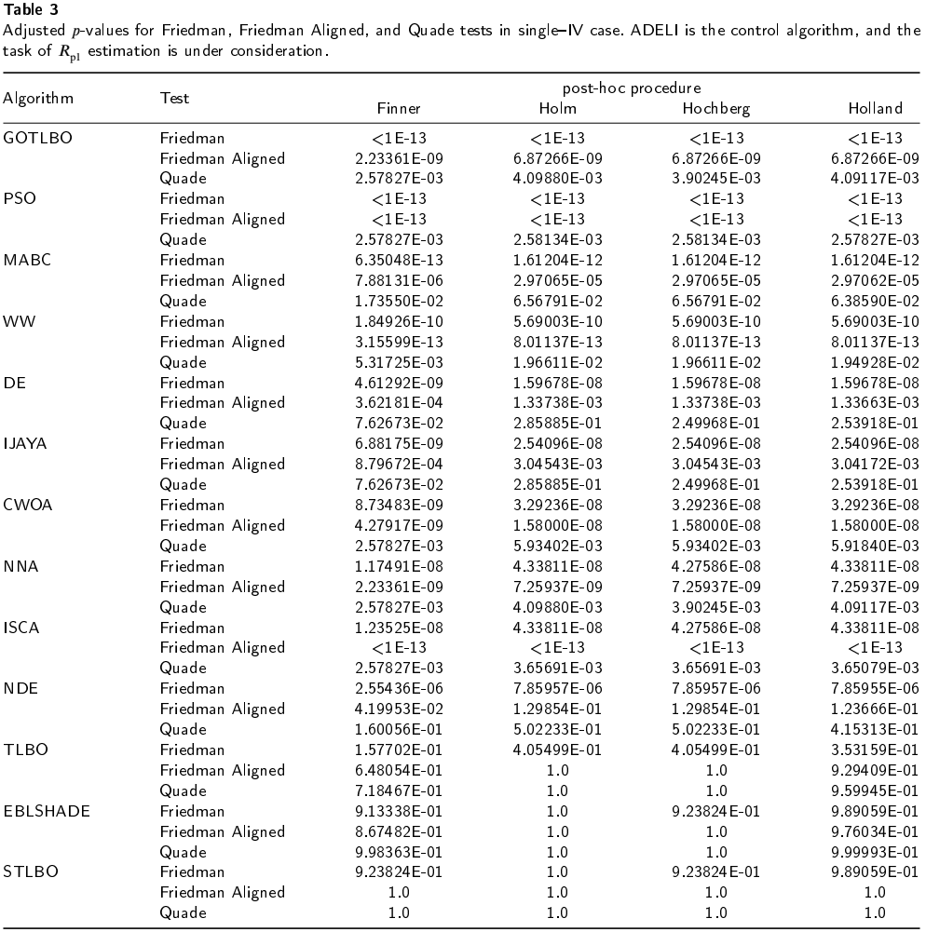WW. Additionally, the Friedman test no longer shows the improvement of DE over PSO.

In all cases, the Quade test yields higher adjusted ***p****-* values. In particular, in the case of the complex parameter, none of the conducted comparisons exceeded the chosen threshold value of the ***p***-value.

The adjusted ***p***-values obtained from the direct compar­isons of EBLSHADE, ADELI, and STLBO do not allow for determining the best algorithm among them. However, for this purpose, the results of this top trio of algorithms can be used, obtained from their comparisons with less efficient optimization methods. Table 4 summarizes count of wins and losses for each algorithm in *1x****N*** multiple comparisons. The maximum possible number of wins achieved in every 10 tasks is 156, obtained from comparing with 13 algorithms in 3 tests using 4 procedures. As can be seen, among the compared algorithms, ADELI showed the highest count of statistically confirmed improvements (1093) over others, indicating its superior performance. Conversely, STLBO demonstrated the lowest count of defeats (0) in similar com­parisons, suggesting its consistently strong performance.

Previously, we employed procedures that controlled the Family-Wise Error Rate (FWER) for comparisons with a control algorithm. We tested each of the 14 algorithms individually to determine if any of them were superior to the others. Below are the results of the carried out a multiple

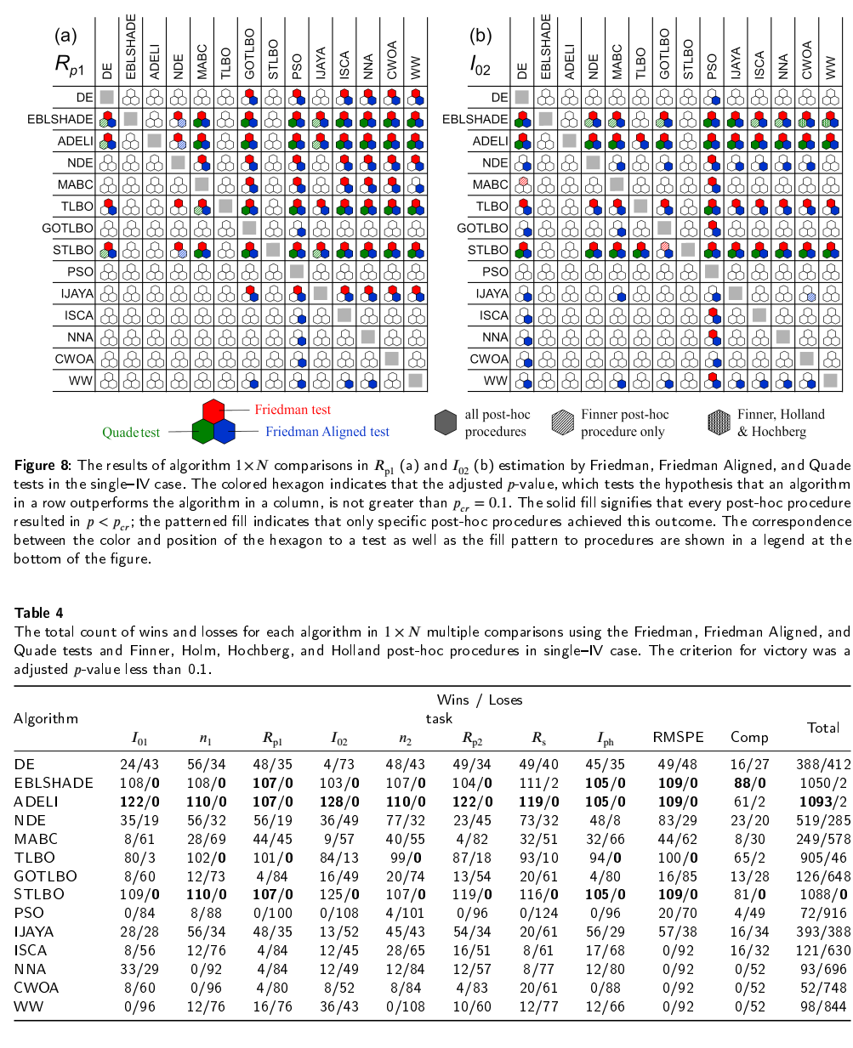comparisons in which all possible pairwise comparisons need to be computed ( N x N comparison), and three procedures (Shaffer's static, Nemenyi, and Holm) have been used to control FWER. These procedures take into account that the hypotheses being tested belonging to a family of all pairwise comparisons are logically interrelated; thus not all combinations of true and false hypotheses are possible.

Starting from the analysis performed by the Friedman test over our results, we can raise the 91 hypotheses of equality among the 14 algorithms of our study for each task, and apply the methods mentioned earlier to contrast them.

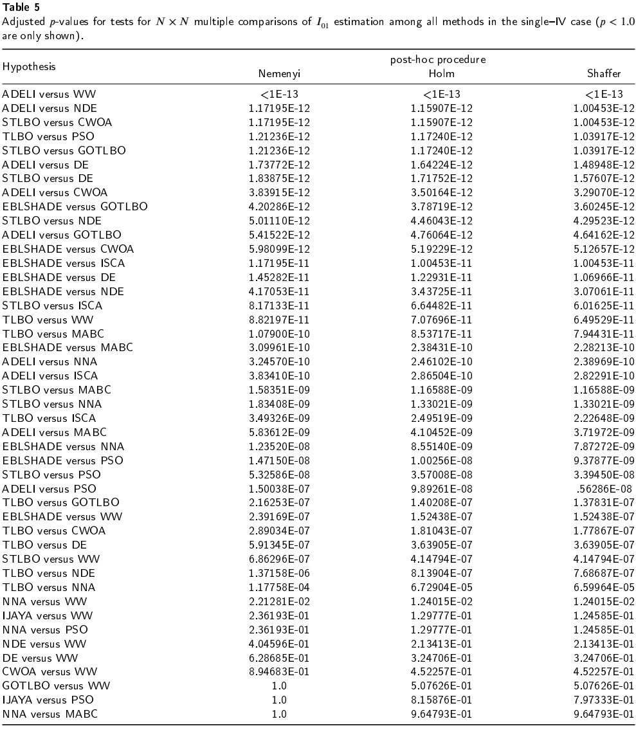Table 5 lists the part of the hypotheses and the adjusted ***p***-values achieved on the task of ***^***01 estimation. For the remaining 46 hypotheses not indicated in the table, a ***p***-value of 1 was obtained after applying each of the procedures. The full version of the table as well as the data, obtained for other task, are given in the supplementary material (tables S144- S153).

It can be seen that using a level of significance 0.1, only 37 hypotheses of equality are rejected by the Nemenyi, Holm, and Shaffer methods. These hypotheses show the improvement of EBLSHADE, ADELI, TLBO, and STLBO over DE, NDE, MABC, GOTLBO, PSO, ISCA, NNA, CWOA, and WW, and NNA over WW. None of the remain­ing 54 hypotheses can be rejected using these procedures.

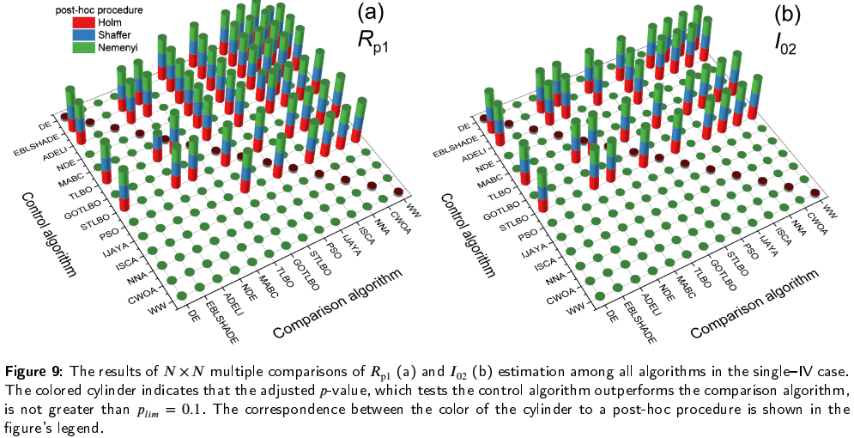It should be noted that when testing complementary hypotheses (“algorithm A vs algorithm B” and “algorithm B vs algorithm A”), only in one out of the two cases can a ***p***-value less than 1 be obtained. For instance, when using the Nemenyi procedure to task ***A***)1 evaluating of comparing “ADELI vs MABC” a p-value of 5***.***84 • 10-9 was obtained. Conversely, when comparing “MABC vs ADELI”, the ***p****-* value was 1. The ***p***-values were computed for all possible hypotheses in the study to identify algorithms whose results statistically deviate from those of other algorithms. In this case, a critical value of ***pcr*** = 0***.***1 was used, similar to the 1X ***N*** multiple comparisons. Typical examples of the obtained results for specific parameter cases are presented in Fig. 9. For more comprehensive data, please refer to figure S3 in the supplementary materials. Generalized results regarding the total count of victories and defeats in the ***N*** *X****N*** comparisons are listed in Table 6. In the case of ***N*** *X* ***N*** comparisons, the maximum possible number of wins achieved in every 10 tasks is 39, obtained from comparing 13 algorithms in 3 post-hoc procedures.

In the majority of cases, all post-hoc procedures consid­ered lead to similar conclusions regarding the outperforming of one algorithm over another. For example, in the case of the ***A***p1 estimation task, the Nemenyi procedure disagrees with Holm and Shaffer methods in only 4 out of 57 cases. Specifically, this occurs for the hypotheses "DE vs WW," "MABC vs ISCA," "MABC vs NNA," and "TLBO vs NDE" — see Fig. 9(a). On the other hand, as evident from Fig. 9(b), such situations are not observed at all for the ***I****02* task. The Holm procedure results, in general, differs from the Shaffer procedure ones in only two comparisons: the improvement of IJAYA over GOTLBO in the ***n****y* estimation and the outper­forming of TLBO over NNA for the composite parameter.

Totally 1 X ***N*** multiple comparisons exhibit more pow­erful behavior than ***N*** *X* ***N*** ones, reaching the lower ***p****-* values. As a result, IJAYA did not lose in any of the ***N*** *X* ***N*** comparisons — see Table 6. Another striking example can be observed when considering the case of the com­posite parameter. Based on the 1 X ***N*** comparisons, con­clusions were drawn about the outperforming of one algo­rithm over another in 67 cases, whereas for the ***N*** *X* ***N*** comparisons, such situations were found in only 20 cases: the improvement of EBLSHADE over MABC, GOTLBO, PSO, ISCA, NNA, CWOA, and WW, the statistically signif­icant difference ADELI and GOTLBO, PSO, NNA, CWOA, and WW, and outperforming of both TLBO and STLBO over PSO, NNA, CWOA, and WW. Consequently, ***N*** *X* ***N*** comparisons provide a less precise ranking of all algo­rithms. However, it is still possible to identify the best and worst-performing algorithms. The obtained data reveal that EBLSHADE, ADELI, and STLBO are the top-performing algorithms in all tasks, while PSO, ISCA, NNA, CWOA, and WW are the worst-performing.

Thus, the results presented in this subsection demon­strate that among the examined algorithms, none can be applied for the maximally accurate determination of a spe­cific individual parameter (e.g., only ***R****p2* or only ***I****02*) in the opposed two-diode model. The algorithms that exhibit high efficiency (EBLSHADE, ADELI, and STLBO) allow for the most precise estimation of all parameters. How­ever, certain algorithms really display higher accuracy in determining specific parameters. Indeed, DE and IJAYA are the most effective in estimating ***R****p2* and ***I****ph —* see table S1. Nevertheless, this highest level of accuracy appears unworthy of significant attention when compared to other optimization methods. As a result, the performance metrics of algorithms for individual parameters will not be analyzed

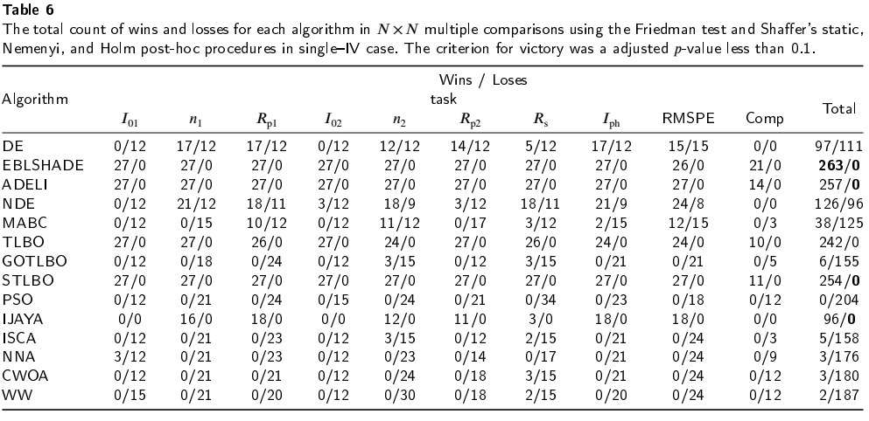in the following subsection, dedicated to the analysis of IV curves with different parameter ratios.

Wins / Loses

1. Evaluation ofIV-set

Fig. 3 shows several typical fitting results of a set of synthetic IV curves simulated according to the opposed two-diode model using the parameter values described in Sec. 2.2.2. A more comprehensive and enhanced version, including the fitting results obtained using each algorithm, is provided in the supplementary materials (figure S4). Similar to the single-IV case, the algorithms EBLSHADE, ADELI, NDE, IJAYA, TLBO, and STLBO show the highest agree­ment between the fitting curves and the points of synthesized current-voltage curves. Fig. 10 represents a portion of the results obtained from evaluating solar cell parameters using various algorithms, along with the corresponding RMSPE data. The supplementary material provides the dependencies of all parameters on synthesis temperature as determined by all the algorithms — see figures S5-S13. The results in terms of MEAN, MEDIAN, STD, and IQR are tabulated as well (table S154 in the supplementary material).

It should be noted that in several cases, the accuracy of parameter estimation depends on temperature, even for con­stant parameters. For instance, as the temperature increases, the errors in determining ***R***p1 by NDE, MABC, GOTLBO, IJAYA, ISCA, and WW decrease. However, under the same conditions, the estimation quality of ***I****01* using DE, ISCA, and WW worsens. These results indicate that the accuracy of parameter estimation depends not only on the parameter value itself but also on its ratio with other parameters. A comprehensive investigation into the specific dependencies of parameter estimation accuracy for each algorithm has not been conducted. This study aimed to determine the best algorithms rather than elucidate the peculiarities of their application in the context of opposed the two-diode model.

The presented data display several characteristics that were also observed in the single-IV case. For instance, the error in parameters estimating by mean values is higher compared to that of median values in the majority of cases. Exceptions are observed at some temperatures only when evaluating ***I****01* using IJAYA, ***n****1* using IJAYA and DE, ***R***p1 using DE and MABC, and ***Rs*** using DE and WW. However, for high-precision algorithms, the deviation of MEDIAN from the true value does not exceed the deviation of MEAN. Additionally, these algorithms exhibit small IQR values that do not exceed STD. Similar to the previous case, small RMSPE values do not always indicate high accuracy in determining the parameters of a solar cell.

At the same time, the number of algorithms exhibit­ing minimal errors has decreased. Significant deviations from true values are observed for median values of ***I****01, n1,* ***R****p1,* ***n****2,* ***Rs****,* and ***I***ph evaluated by EBLSHADE at various temperatures, as well as for median values of diode D1 characteristics and series resistor determined using TLBO at 260 K. Thus, only ADELI and STLBO remain as algorithms without visible errors. Although this claim of infallibility applies only to median values, substantial errors are ob­served for mean values in several cases. Simultaneously, EBLSHADE, TLBO, IJAYA, and NDE form a group of algorithms with low RMSPE values but imperfect model parameter estimation.

In the IV-set case, to assess the statistical performance of compared algorithms, the run time and all APEMEdiAn and RMSPEmEdiAn for each IV curve were taken into account. This approach is similar to the use of the Comp parameter in the previous subsection; however, in this scenario, ***N***pr = 81 is employed:



Therefore, such an approach is well-suited for nonparametric statistical analysis of ***k*** = 14 meta-heuristic algorithms.

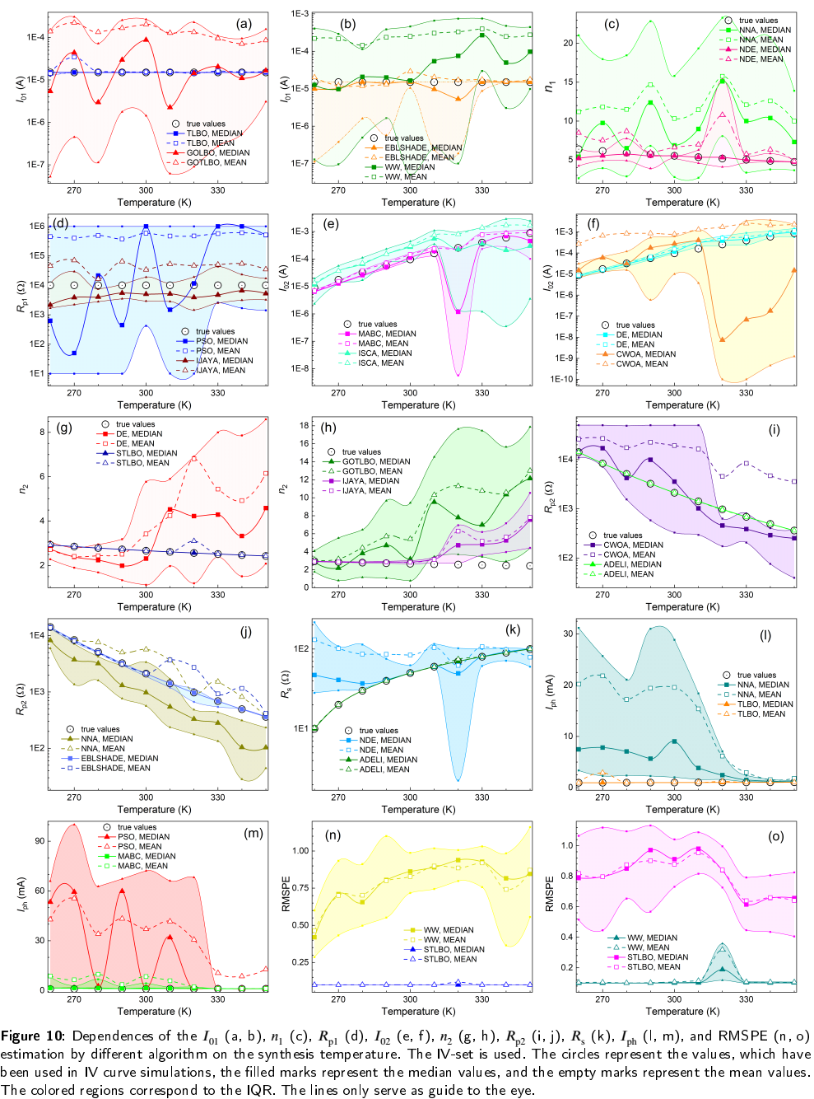

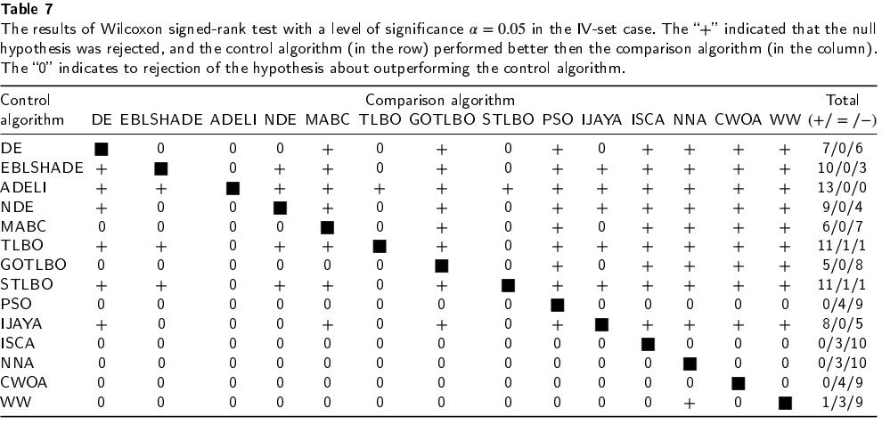

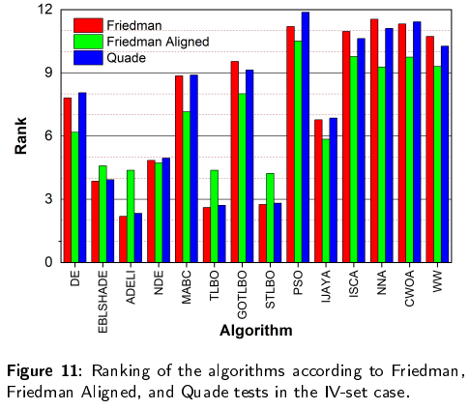Certainly, at first sight, it would be interesting to consider in­corporating an additional 80 values of the interquartile range into the dataset. This approach could provide consideration into the stability of algorithm performance as well. However, it is known [84] that for multiple comparisons, a value of ***N****pr >* 8 • ***k*** *= 112* could be too high, obtaining no significant comparisons as a result.

Table 7 gives the statistical results produced by the Wilcoxon sign-rank test. As the table states, ADELI outper­forms all other algorithms with a level of significance ***a*** *=* 0***.***05. STLBO and TLBO show an improvement over DE, EBLSHADE, NDE, MABC, GOTLBO, PSO, IJAYA, ISCA, NNA, CWOA, and WW. The counts of statistical significant cases (+/ = /-) are presented in the last row of Table 7. It can be seen than PSO, ISCA, NNA, and CWOA did not outperform any of the algorithms, whereas WW statistically significantly improved over NNA only. Therefore, although these algorithms have promising run times, they are not recommended for parameter estimation of a solar cell based on the opposed two-diode model.

The ***p***-values required to test the null hypothesis, com­puted using the Friedman, Friedman Aligned, Quade tests, and the Iman-Davenport extension, can be found in table S2 of the supplementary materials. None of these values ex­ceeds 2***.***3 • 10-6, thereby rejecting the hypothesis of equiva­lent medians in all tests.

Ranks achieved by the Friedman, Friedman Aligned, and Quade tests are shown in Fig. 11 and table S3 in the supplementary material. As per the given results, ADELI has been placed at first rank by Friedman and Quade tests, and STLBO has ranked first by the Friedman Aligned test. TLBO has been recorded the as second-best algorithm by all three tests. Furthermore, PSO was recognized as the worst­performing algorithm by the tests' unanimous decision.

The p-values, obtained for 1 X ***N*** multiple comparisons are shown in tables S155-168 in the supplementary material. There are results of applying Finner, Holm, Hochberg, and Holland procedures, as a post-hoc method after Friedman, Friedman Aligned, and Quade tests. The reader is referred to supplementary material (table S169) for ***p***-values of applying Shaffer, Nemenyi, and Holm post-hoc procedures after the Friedman test in the case of ***N****X****N*** multiple comparisons. The results, which determine whether one algorithm yielded a statistically better estimation of parameters than the other (with a ***p***-value < ***pcr*** *=* 0***.***1), are summarized in Fig. 12 and 13 for 1 X ***N*** and ***N*** *X* ***N*** comparisons, respectively. The counts of statistically significant cases are presented in the Table 8.

As can be seen, ADELI, TLBO, and STLBO were never outperformed by any of the algorithms, both in the case of 1 X ***N*** and ***N*** *X* ***N*** multiple comparisons. By the way, for ***N*** *X* ***N*** comparisons, the same property is observed with

EBLSHADE and IJAYA. Overall, the parameter estimation results obtained from the set of IV curves using ADELI, TLBO, 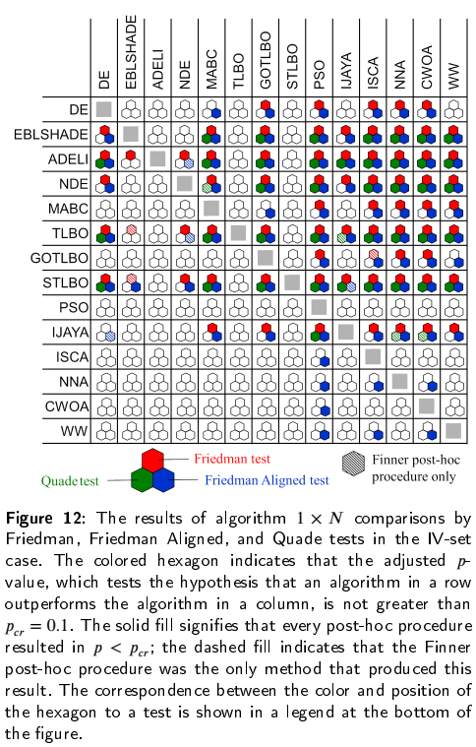

and STLBO algorithms for ***N****X****N*** comparisons in the opposed two-diode model are practically indistinguishable (when it comes to precise ***^***-values, only minor differences can be observed). In *1x****N*** comparisons, TLBO demonstrates lower performance compared to ADELI and STLBO, in terms of efficiency when compared to the EBLSHADE algorithm. Specifically, the improvement of TLBO over EBLSHADE is proved only by the Finner procedure applied in the Friedman test. Based on 1 X ***N*** comparisons, it is observed as well that there are slight differences between ADELI and STLBO, primarily when compared to the non­worst algorithms. For instance, the Quade test confirms the improvement of ADELI over EBLSHADE for every post-hoc procedure, however, the Friedman and Friedman Aligned tests did not show statistically significant differ­ences between these algorithms. Meanwhile, the Friedman Aligned and Quade tests find a difference between STLBO and EBLSHADE for every post-hoc procedure and Finner procedure only, respectively. Regarding comparison with NDE, the Friedman Aligned test demonstrated that STLBO is better according to all post-hoc procedures. In contrast, for ADELI, this outperforming was only observed using

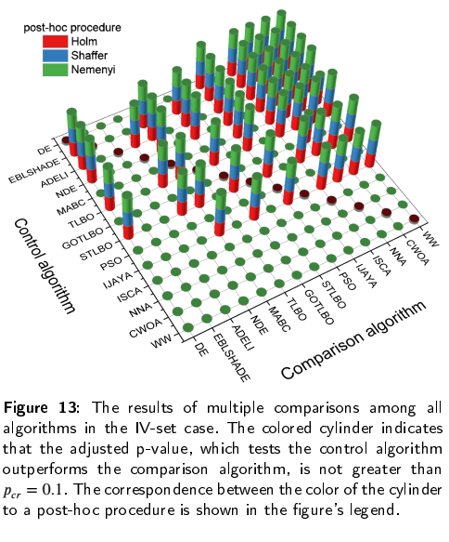

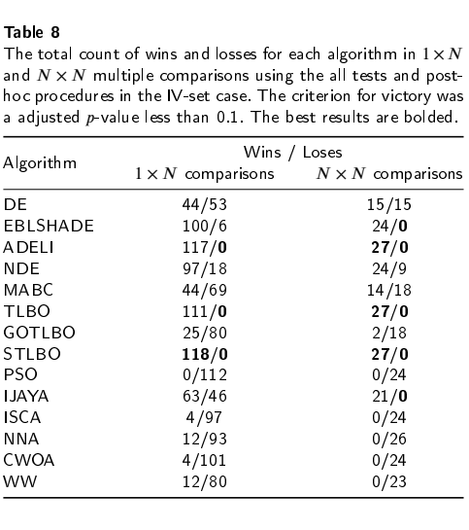

the Finner method. In the case of IJAYA, the results of the Friedman Aligned test show a reversal: only the Finner procedure indicates an improvement for STLBO, whereas ADELI outperforms all post-hoc methods utilized.

In deciding the optimal algorithm for parameter estima­tion of solar cell parameters from the IV curve using the opposed two-diode model, the practical choices boil down to EBLSHADE, ADELI, TLBO, and STLBO. However, TLBO exhibited lower performance when applied in the single-IV case. The parameter estimation error when using EBLSHADE was not always minimal in the IV-set case. Despite the minimal advantage in terms of win counts in 1 x ***N*** comparisons (see Table 8), we hesitate to declare STLBO as the best. In our opinion, STLBO and ADELI both hold the top position in the competition conducted in this study.

1. Conclusion

In this paper, the possibility of using meta-heuristic algorithms to solve the parameter estimation problems of photovoltaic cells with S-shaped current-voltage character­istics has been explored. The parameter estimation has been performed within the framework of the opposed two-diode model. A total of 14 meta-heuristic algorithms from various classes were implemented to extract the solar cell parameters from synthetic IV curves, which were generated with a range of parameter values. The obtained results have been com­pared using nonparametric statistical procedures, including pairwise comparisons, 1 x ***N*** multiple comparisons, and ***N*** *x* ***N*** multiple comparisons.

Research has demonstrated that utilizing a squared error­based fitness function offers clear advantages in tackling a provided problem. The overall performance results of various algorithms generally fit the No Free Lunch theory. GOTLBO, PSO, ISCA, NNA, CWOA, and WW are com­pletely unsuitable for parameter estimation according to the opposed two-diode model. The results of DE, NDE, MABC, and IJAYA are not as poor as those in the previous group; however, in general, it is still not recommended to use these algorithms for solving parameter identification problems. Generally, the EBLSHADE and TLBO are effective in accu­rately determining parameter values in most cases. However, investigation has shown that these algorithms may make mistakes under certain conditions. Therefore, EBLSHADE and TLBO applications in the case of solar cells with S- shaped IV curves should be approached with caution. Fi­nally, results have illustrated that STLBO and ADELI have superior performance in terms of accuracy and reliability when compared with other used algorithms. In particular, these two algorithms successfully solve the task of accu­rately determining parameters from similar IV curves corre­sponding to photovoltaic cells with distinct characteristics.

It is important to note that in this study, the parameters were obtained from idealized IV curves, where the voltage­current relationships were precisely defined by Eq. (2). In a real experiment, there is a potential for errors in the measurement of both current and voltage. Hence, it would be worthwhile to explore the efficacy of various meta­heuristic algorithms in determining parameters from IV data corrupted by noise in future research.

This work of testing and comparative analysis of dif­ferent meta-heuristic algorithms for the estimation of solar cell parameters should be useful for further research and development on photovoltaic systems.

Supplementary data

Supplementary data associated with this article can be found in at bit.ly/44Y24gL

References

