**Ultrasound as Functional Influence Tool on** **FeB pair Association in Silicon Solar Cells**

Oleg Olikh1*, Vitaliy Kostylyov2, Victor Vlasiuk2, Roman Korkishko2

*1Physics Faculty*, *Taras Shevchenko National University of Kyiv, Kyiv, Ukraine*

*2V. Lashkaryov Institute of Semiconductor Physic of NAS of Ukraine, Kyiv, Ukraine*

*\*E-mail address: olegolikh@knu.ua*

Defects are crucial for solar cell (SC) performance. The irradiation and annealing are the widespread techniques of functional defect engineering. But another selective as well as room temperature realized way of defects modification is the ultrasound excitation in a crystal. The acoustic waves are able to cause redistribution of impurities, point defects rebuilding and affect SC properties as well [1]. In this work, the influence of ultrasound loading (USL) on a FeB pair association in silicon SC was under consideration. The iron is a major contaminant as well as one of the most detrimental impurities in silicon photovoltaic devices and the investigation is important from an applied point of view.

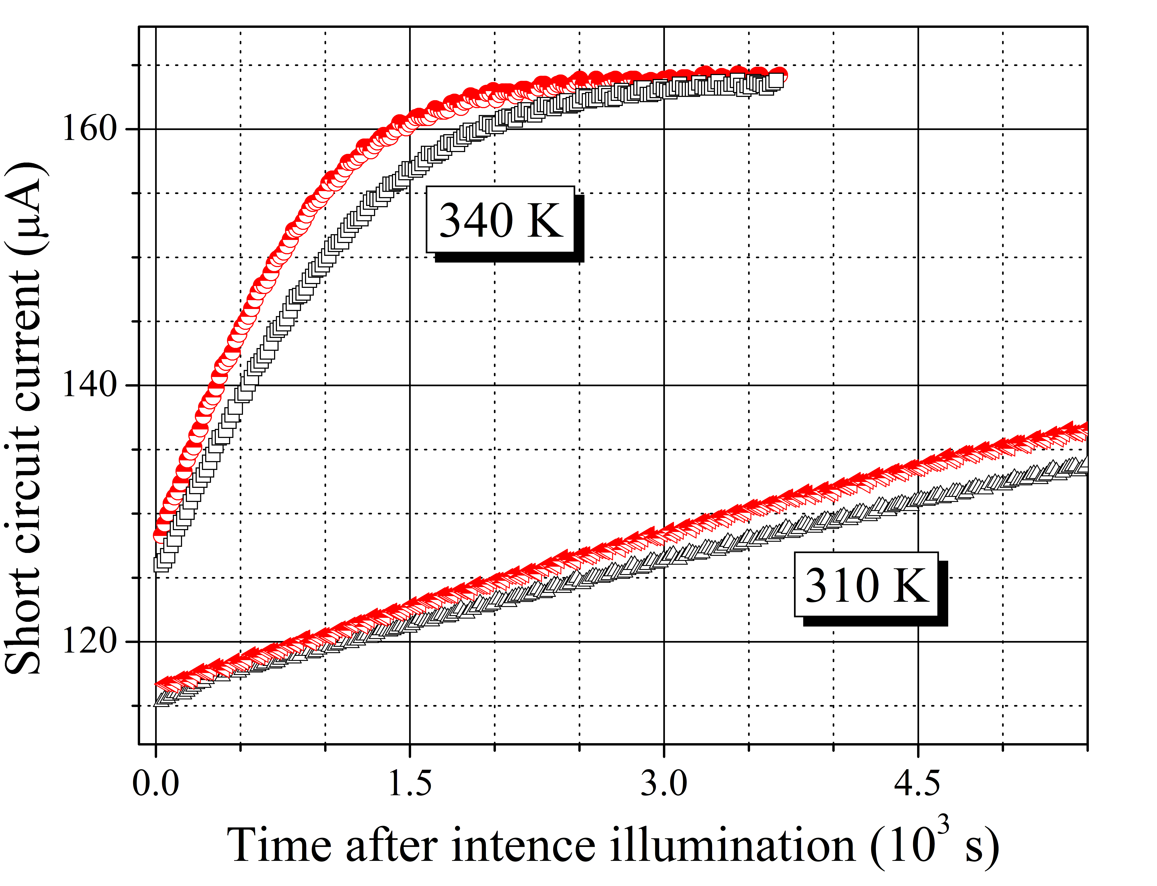

Fig. FeB association related kinetic of short circuit current. Half-filled red marks correspond to USL conditions, empty black marks are obtained without USL.

The Si-SC was fabricated from *p*-type boron doped wafer with <100> orientation and a doping level of 1.4 1015 cm-3. In USL case the longitudinal waves with 4.1 MHz frequency and up to ~0.5 W/cm2 intensity were exited. The FeB pair dissociation was made by halogen lamp illumination (0.25 W/cm2, 15 s). The short circuit current value (LED, 940 nm, 0.15 mW/cm2) was used to characterize recombination process in the SC base. The *I*sc kinetic was fitted by taking into account intrinsic recombination and to Shockley-Read-Hall recombination on interstitial iron and FeB pair and the iron atom migration energy *E*m was determined. The acousto-induced reduction in *E*m value has been revealed. The *E*m decrease runs up to 10 meV and non-linear depends on US intensity. Thus the ultrasound can be effective tool of defect engineering in solar cell functional materials. The work was supported by NRFU (project 2020.02/0036).

*Key Words:* Ultrasound, Silicon, Solar Cell, FeB pair

References

1. O. Ya. Olikh, A. M. Gorb, R. G. Chupryna, J. Appl. Phys., 123 (2018) 161573.