**Ultrasound as Functional Influence Tool on FeB pair Association in Silicon Solar Cells**

Oleg Olikh1*, Vitaliy Kostylyov2, Victor Vlasiuk2, Roman Korkishko2

*1* *Physics Faculty*, *Taras Shevchenko National University of Kyiv, Kyiv, Ukraine*

*2* *Physical and Technical Fundamental of Semiconductor Photovoltaics Laboratory*, *V. Lashkaryov Institute of Semiconductor Physic of NAS of Ukraine, Kyiv, Ukraine*

*\*E-mail address: olegolikh@knu.ua*

Defects are crucial for solar cell (SC) performance.

Integrating nanoscale metal oxides and conducting polymers into three-dimensional graphene (3DG) is a promising route but remains challenging to develop high-performance electrodes for energy storage devices. We developed 3D self-assembly of graphene oxide/reduced graphene oxide with stimuli-responsive polymers poly(N-isopropylacrylamide) (PNIPAM) or poly(propylene oxide) (PPO) and metal oxides (Fe2O5, Nb2O5) , which results in a photo/thermal reversible supramolecular graphene composites hydrogel with adjustable sol–gel transition temperature. The hierarchical structure offers highly interpenetrated porous conductive network and intimate contact between graphene and polymers/metal oxides as well as abundant stress buffer nanospace for effective charge transport and robust structural stability during electrochemical processes.

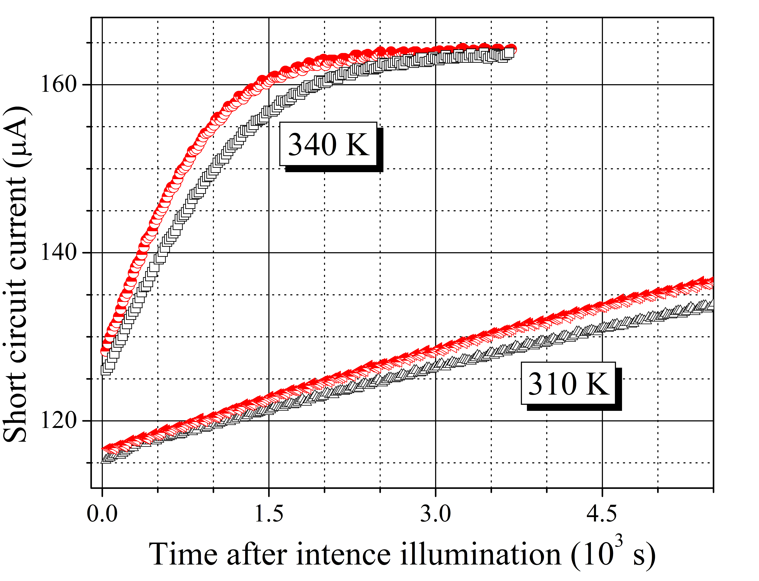

Figure. FeB association related kinetic of short circuit current. Half-filled red marks correspond to UL conditions, empty black marks are obtained without UL.

By systematically tailoring the porosity in the holey graphene backbone, charge transport in the composite architecture is optimized to deliver high areal capacity and high-rate capability at high mass loading, which represents a critical step forward toward practical applications. This study offers a promising route to greatly enhance the electrochemical properties of metal oxides and provides suggestive insights for developing high-performance electrode materials for electrochemical energy storage.

*Key Words:* Ultrasound, Silicon, Solar Cell, FeB pair

References

1. O. Ya. Olikh, A. M. Gorb, R. G. Chupryna, and O. V. Pristay-Fenenkov, J. Appl. Phys., 123 (2018) 161573.