* 1. **random_state =2 (train), random_state =3 (CV), max_trials = 50**

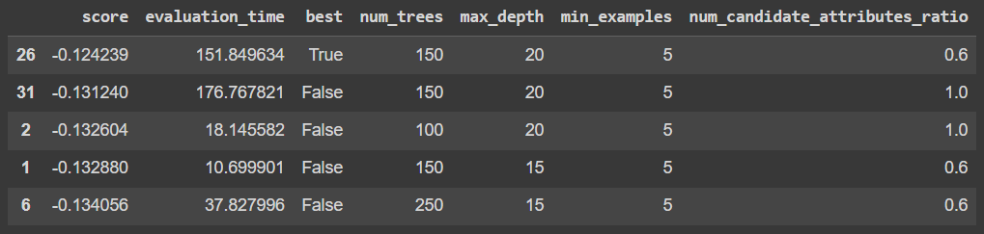

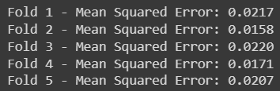

* 1. **random_state =4 (train), random_state =5 (CV), max_trials = 50**

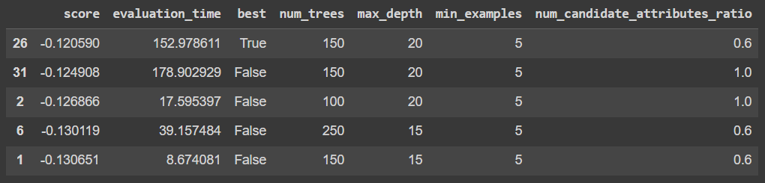

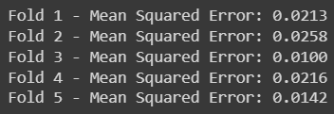

* 1. **random_state =6 (train), random_state =7 (CV), max_trials = 50**

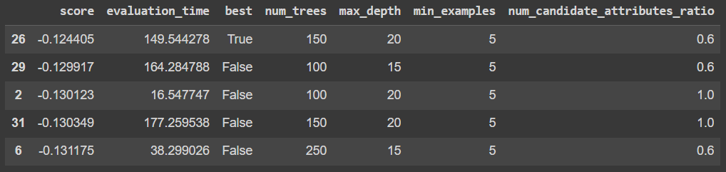

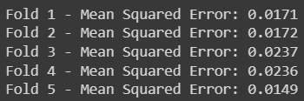

* 1. **random_state =8 (train), random_state =9 (CV), max_trials = 50**

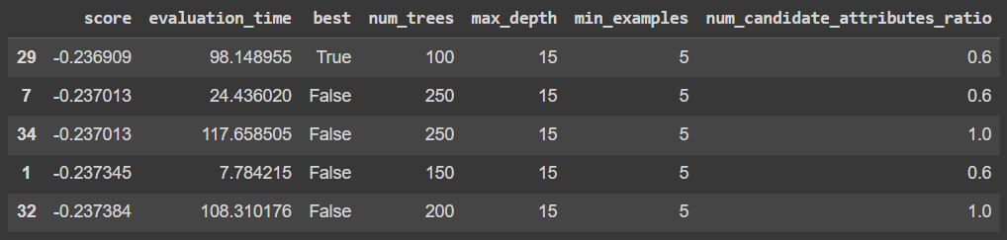

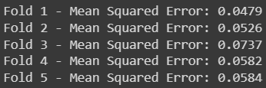

* 1. **random_state =10 (train), random_state =11 (CV), max_trials = 50**

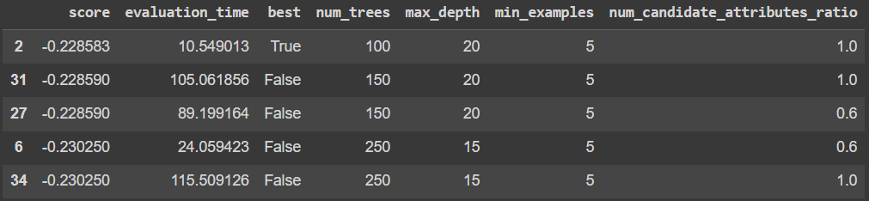

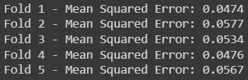

* 1. **random_state =12 (train), random_state =13 (CV), max_trials = 50**

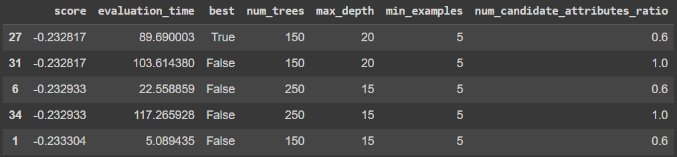

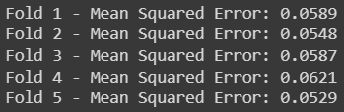

* 1. **random_state =14 (train), random_state =15 (CV), max_trials = 50**

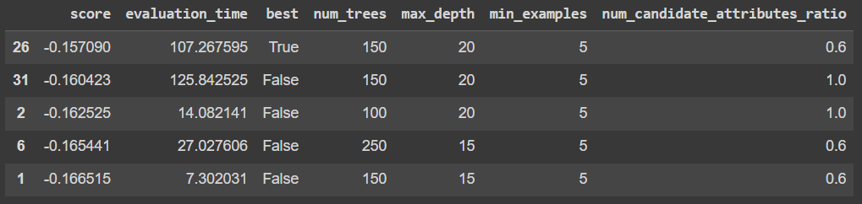

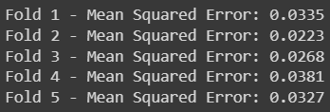

* 1. **random_state =16 (train), random_state =17 (CV), max_trials = 50**

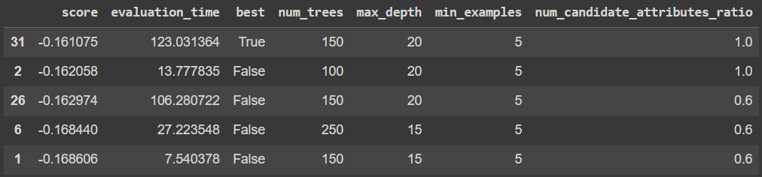

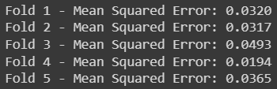

* 1. **random_state =18 (train), random_state =19 (CV), max_trials = 50**

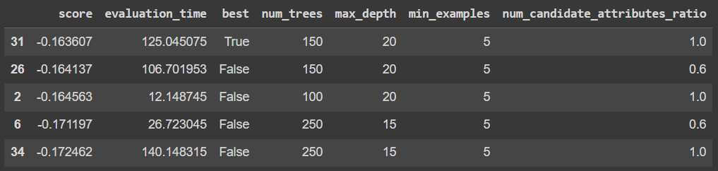

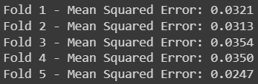

* 1. **random_state =20 (train), random_state =21 (CV), max_trials = 50**

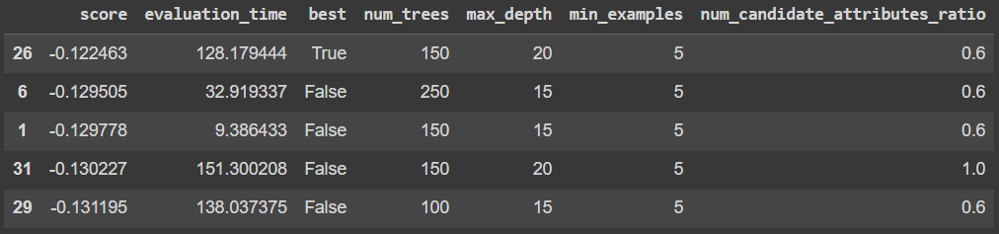

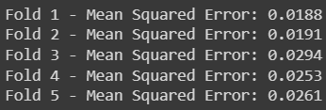

* 1. **random_state =22 (train), random_state =23 (CV), max_trials = 50**

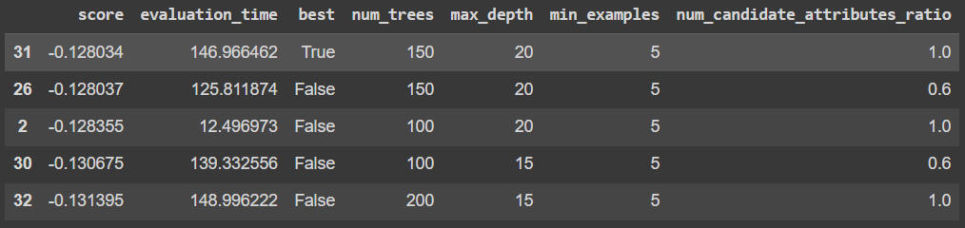

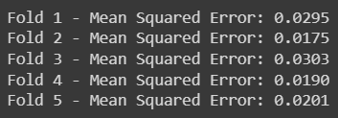

* 1. **random_state =24 (train), random_state =25 (CV), max_trials = 50**

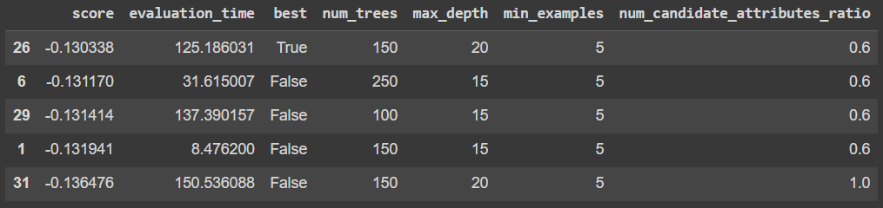

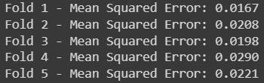

$$〈MSE〉=0.0217$$