With a view of understanding the contribution of two exponentials to the forward characteristics of a diode, I have generated a figure by using the following functions,

$$I1=I_{01}\left[\exp\left(\frac{qV}{kT}\right)-1\right] (1)$$

$$I2=I_{02}\left[\exp\left(\frac{qV}{ηkT}\right)-1\right] (2)$$

$$I3=-I_{Ph}+I1+I2 (3)$$

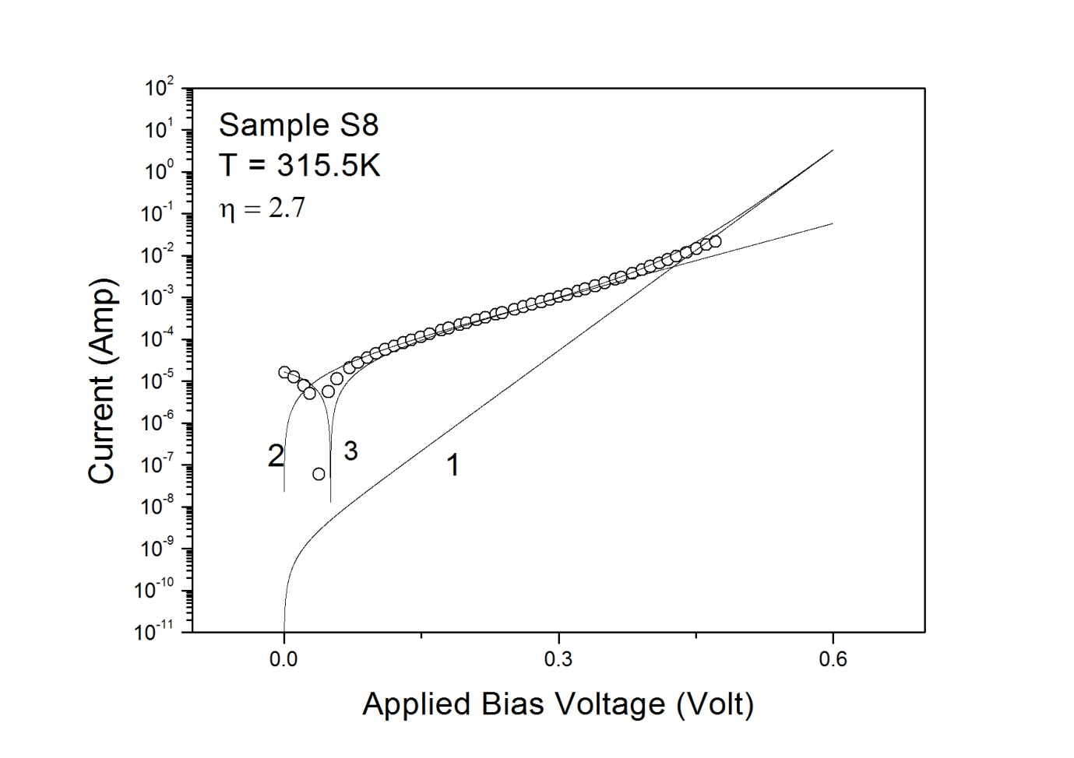

Figure 1: I-V characteristic of solar cell S8.

In figure 1 circles show the experimental data.

Line marked with the number 1 was generated using equation (1) for I01= 8.78e-10 Amp and RS= 0. In practice this line may be considered to be representing contribution of ideal thermal diffusion of carriers to the forward characteristic of solar cell.

Line marked with the number 2 was generated using equation (2) for I02= 1.67e-5 Amp, ƞ = 2.7 and RS= 0. In practice this line may be considered to be representing contribution of SRH recombination term to the forward characteristic of solar cell.

Line marked with the number 3 was generated using equation (3) with Iph = 1.67e-5 Amp.

Based on the contribution of two exponentials shown in eq. (1) & (2), the following observations can be made from Figure 1.

1. Diffusion current appears to contribute to the forward characteristic of solar cell at very high forward voltages. Diffusion current contribution in the low and medium forward bias region is negligibly small
2. SRH recombination current appears to contribute to the major part of forward characteristic of solar cell in low and medium voltage bias region. However higher value of ideality factor (> 2) indicates contribution from complex defects in the depletion region of the solar cell. Alternatively the higher ideality factor of more than 2 may also arise due to the contribution from surface leakage currents.
3. The sum of SRH recombination current and diffusion current appear to account the entire forward characteristic of solar cell including the high forward voltage region.
4. The series resistance correction by using (V – IRS) in place of V may have improved the agreement of the line 3 with the experimental data in the low forward bias range.

Let us now take note of the low shunt resistance (6.8e3 Ohm) of the solar cell that may be indicating the presence of surface leakage currents. Alternatively if it is assumed that non-ideal nature of the I-V characteristic of solar cell is the result of surface leakage currents, then one can fit the forward characteristic shown in Figure 1 with the following single exponential equation,

$$I=-1.67*{10}^{-5}+{2.05789*10}^{-5} \left[\exp\left(\frac{qV}{2.6kT}\right)-1\right] (4)$$

Figure 2 shows the fit of forward characteristic of solar cell S8 to the equation (4) for RS = 0.

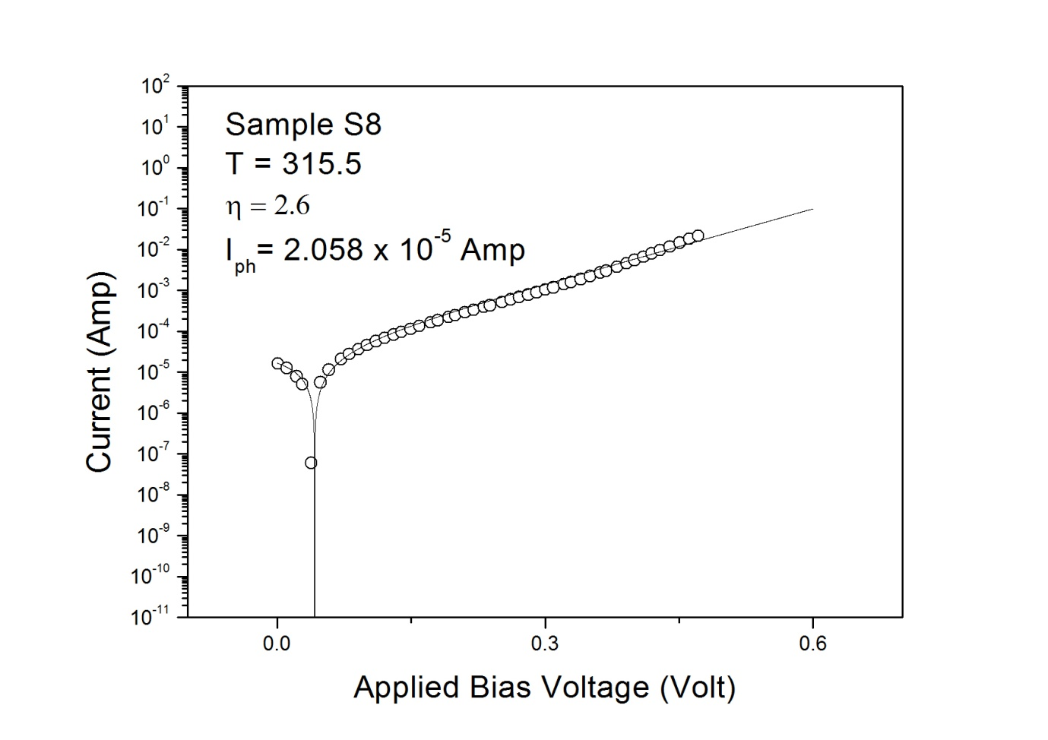

Figure 2.

The coefficient (2.05789 x 10-5) of the exponential term in equation (4) may not necessarily be the recombination current I02. Alternatively it may be the saturation current I01 of the diffused carriers enhanced due to the surface leakage current. The observation of the enhancement of diffusion saturation current with the increase of surface leakage current has been reported previously [J. Appl. Phys. 120: 8, 084508 (2016)].

In summary a gate controlled diode experiment is required to be performed in Si diodes to verify the source of non-ideal I-V characteristics that may be either recombination current at SRH centres or surface leakage current?