Acousto-defect interaction in irradiated and non-irradiated silicon

n+-p-structure

O. Ya. Olikh,1, a) A. M. Gorb,1 R. G. Chupryna,1 and O. V. Pristay-Fenenkov1

Faculty of Physics, Taras Shevchenko National University of Kyiv, Kyiv 01601,

Ukraine

(Dated: 21 August 2017)

The experimental investigation of ultrasound influence on the electrical characteristics of silicon n+-p- structure has been carried out. The effect of reactor neutrons and 60Co gamma iradiation of silicon n+ -p structure on its ultrasound properties were studied. It has been found out that the ultrasound loading of ______ leads to reversible change of shunt resistance, carrier lifetime in both space charge and quasi-neutral regions and ideality factor. Acoustically induced alteration of the last two parameters depends on irradiation considerably. The models of coupled defect level recombination, Shockley-Read-Hall recombination, and dislocation-induced impedance were used to describe the results obtained. The observed phenomena can deal with the increase of distance between coupled defects as well as an extension of carrier capture coefficient of complex point defects and dislocations. The results show that di vacancies and pair vacancies produced by interstitial oxygen are effectively modified by ultrasound in contrast to those produced by complex interstitial carbon-interstitial oxygen.

Keywords: acousto-defect interaction, silicon, irradiation

1. INTRODUCTION

It is well known that ultrasound (US) can effectively interact with defects. US As a defects engineering tool US has certain advantages: (i) locality of action due to the predominant absorption in regions of the lattice periodicity deviation ; (ii) selectivity of influence, which depends on acoustic wave (AW) polarization and type; (iii) possibility of the defect system transformation at resonance frequency in ; (iv) possibility of reversible effect in case of low intensity AW.

In piezoelectric semiconductors, the acousto-defect interaction (ADI) is determined mainly by the intensity of electric field, which accompanies the vibration wave propagation. However this effect is also observed in non-piezoelectric crystals like Silicon, the basic material in microelectronics. Thus it was experimentally observed that US may cause in SI structures, atomic diffusion,1,2 transformation of the native and impurity defects,3-7 modification of interior surface states,8-10 appearance of new defects.11,12 Defects are known to determine most of semiconductor device properties. In particular the ADI governs variation of tunneling ???,13,14 generation-recombination ???15-17 and thermionic emission18,19 current in silicon barrier structures.

The change of population of impurity oscillator levels,20 the displacement of impurity atoms with respect to their surroundings,4,21,22 the decreasing of the diffusion activation energy,23 the local temperature increase by point defect clusters,24 the US absorption by dislocation16,25,26 are considered to be main mechanisms of elastic vibration-defect interaction in non-piezoelectric crystals . However to the best of our knowledge, the complete ADI theory in silicon does not exist. One of a top-ranked reasons for thatis lack of experimental works focusing on investigation of acoustically induced (AI) effects.

Not all silicon defects are acoustically active and subject to modification under US action. The ADI efficiency depends on defect type and structure.8 Thus, the force acting on the point defect during US loading (USL) is determined by the relaxation of the defect volume21,22. The irradiation is most widespread and studied method of semiconductor defects alteration. On the one hand, the high-power US treatment is shown27-30 to lead to residual changes of the irradiated silicon structure properties. This effect deals with AI annealing of radiation defects (RDs). On the other hand, irradiation can be a reason of reversible AI phenomenon initiation,31,32 which is caused by formation of acoustically active RDs. Unfortunately, there are but few reports on acoustically driven phenomenon in irradiated silicon structures.

Our purpose is to investigate experimentally the AI electrical characteristic variation, which takes place in nonirradiated and irradiated n+-p-Si structures. Irradiation was carried out by reactor neutrons and a 60 Co-gamma source. It is expected that y-rays introduce VOj complex predominantly, 33-35 whereas neutrons mainly create vacancy clusters,36,37 disordered regions38 and QOj complex35,39. This work represents distinction of AI effects in silicon structures with different RDs. The intensity of applied US was below the level of irreversible defect subsystem modification, which can deal with a new defect creation, a RDs annealing or a long distance (a many interatomic distance) diffusion. As a result, full recovery of characteristics was observed after AW propagation stop . The models of coupled defect level recombination,40,41 Shockley-Read-Hall (SRH) recombination, and dislocation-induced impedance42,43 were used to describe the processes in the space charge re­gion (SCR), in the diode base, and shunt resistance, re­spectively. The interaction of defects with an AW strain field21,22 was recruited to explain the observed AI phenomena. The investigation would provide not only better ADI understanding but could also facilitate the development of acoustically controlled devices or radiation sensors.

TABLE I. The sample irradiation parameters.

|  |  |  |  |  |  |
| --- | --- | --- | --- | --- | --- |
| Sample | Irradiation | D |  | NIELa | ^ xNIEL |
| type | (rad) | (cm-2) | (MeV cm2/g) | (MeV/g) |
| iSC | non | 0 | 0 | — | 0 |
| nSC | neutron | 4.5-103 | 4-1011 | 2.04-10-3 | 8.2-108 |
| g6SC | Y-60Co | M06 | 1.6-1015 | 1.07-10-7 | 1.7-108 |
| g7SC | Y-60Co | MO7 | 1.6-1016 | 1.07-10-7 | 1.7-109 |

a Ref. 44.

TABLE II. The ultrasound loading parameters. Sample Wus (W/cm2) £us (10-6) -uus (nm) USL label

|  |  |  |  |  |
| --- | --- | --- | --- | --- |
| iSC | 0.22 | 3.1 | 0.67 | Ui-1 |
|  | 0.40 | 4.2 | 0.91 | Ui-2 |
| nSC | 0.24 | 3.2 | 0.70 | Un-1 |
|  | 0.40 | 4.2 | 0.91 | Un-2 |
| g6SC | 0.38 | 4.1 | 0.89 | Ug6-2 |
| g7SC | 0.19 | 2.9 | 0.63 | Ug7-1 |
|  | 0.37 | 4.0 | 0.87 | Ug7-2 |

**II. EXPERIMENTAL AND CALCULATION DETAILS**

The 2 inch (300 ^m thick) p-type boron doped, <111> orientation, Czochralski silicon wafer with resistivity of 10 Q^cm was used for fabrication of n+-p-Si structure. The n+ emitter with carrier concentration of about 1019 cm-3 and thickness of 0.5 ^m was formed by phosphorus implantation. Front and rear Aluminium elec­trodes were deposited by screen printing before rapid annealing. Samples with area of about 2 cm2 were cut from the central part of the wafer and used in experi­ment. Samples were irradiated by reactor neutrons or by 60Co y-rays. Doses D, fluences ^, and sample labels are listed in Table I. Data44,45 were used to determine D and ^ correlation. The non-ionizing energy losses (NIEL) for neutron and y-60Co are shown in Table I too. Since displacement damage effect is characterized by (^ • NIEL), the similar damage was expected in investigated samples. To avoid an impact of long-term annealing, which is typical to neutron damaged structure ,35,36 irradiated samples have been stored for 5 years at room temperature before measuring.

The dark forward current-voltage (I-V) characteristics of the samples both with and without USL were measured over a temperature range of 290-340 K. The temperature was controlled by differential copper-constantan thermocouple. Some curves are shown in Fig. 1.

The double-diode model of n+-p structure I-V char­acteristic is expressed in the following form:

(1)

(2)

(3)

(4)

where Iscr reflects the overall SCR recombination, Ibase is closely related to recombination in the quasi-neutral region, Ish is the shunt current, A is the sample area, ni is the intrinsic carrier concentration, Tg is the SCR carrier lifetime, d is the SCR thickness

(5)

ε is the permittivity (11.7 for Si), pp and nn are the majority carrier concentration in the p– and n–type regions, Eg is the semiconductor band gap, Nc and Nv are the effective density of states in the conduction and valence bands; nid is the ideality factor, Rs and Rsh are the series and shunt resistances, μn and τn are the electron (minority carrier) mobility and lifetime in the diode base.

We used Eqs. (1)–(5) to fit the experimental data and τg, τn, nid, Rsh, and Rs were taken as the fittings parameters. The known46–48 temperature dependencies of ni, Eg, and μn were used. The extremely good fit to the experimental data was obtained — see Fig. 1. In particular, the Rs value about 1 was determined for all samples.

In the USL case, the transverse AWs with frequency of 4.2 MHz were exited with help of a piezoelectric trans-ducer and were injected in samples from the base sidein the [111]–direction. The US intensities WUS, amplitudes of lattice deformation ξUS and lattice atom displacement uUS are listed in Table II. It was reported previously6,7,19 that the characteristic time of change in the silicon structure parameters under the US action did not exceed 2 · 103 s. In order to wait till the AI transitional period the following experimental procedure has been used. After USL start the sample has been kept at room temperature during 60 min and then the I–V measurement and the sample heating were started. In order to avoid the effect of piezoelectric field on I–V characteristics, the piezoelectric transducer has been shielded.

The non-linear fittings were done by using the differential evolution method.49

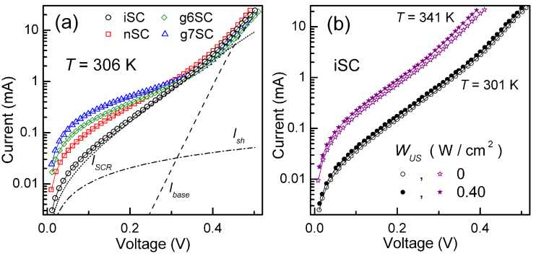

FIG. 1. Dark I-V characteristics measured (a) at 306 K for non-irradiated (circles), neutron-irradiated (squares) and gamma- irradiated (diamonds and triangles) structures without USL; (b) at 301 K (circles) and 341 K (asterisks) with (filled marks, Ui-2) and without (open marks) USL for the iSC. The marks are the experimental results, the solid lines are the fitted curves using Eqs. (1)-(5). The dashed, dot-dashed and dotted lines in (a) are the base, SCR and shunt components of iSC current, respectively.

1. RESULTS AND DISCUSSION
2. Space charge region

The I-V dependence characteristic parameters, which deal with SCR phenomena, are nid and Tg. Thetemperature dependences of ideality factor and SCR carrier life­time are shown in Fig. 2 and Fig. 3, respectively.

As shown by the Fig. 2 and Fig,3 the, ideality factor decreases with temperature increase and the plot nid vs 1 /T is close to linear. Thus dependence nid(T) can be expressed as

nid (T) — nid,ra + Tid/T . (6)

The thermoactivated growth of SCR lifetime is observed over the explored temperature range (see Fig. 3). The temperature dependence of Tg is sufficiently described by the equation (7):

Tg(T) = 7-flOexp • (7)

The Tid and ETg values determined for both non-irradiated and irradiated samples under USL as well as without it are listed in Table III.

We want to stress, that

1. irradiation leads to Tid and ETg changes, in g6SC’s characteristic temperature of the ideality factor and SCR life­time characteristic energy values are closely related to those of g7SC under similar conditions;
2. USL affects nid and Tg values, the absolute value of AI changes of ideality factor Anid — nid,Us — nid,in and the relative AI changes of SCR lifetime eTg — (Tg,us — Tg,in )/Tg,in (where subscripts “US” and “in” identify with the values, obtained at the same temperature with and without USL respectively) are listed in Table IV;
3. Anid and eTg vary with Wus enhancement, whereas Tid and ETg values prac­tically do not depend on US intensity.
4. USL leads to increase of both Tid and ETg in y~ irradiated samples (see Fig. 2(b) and Fig. 3(b)), but this effect is not observed in non-irradiated and neutron-irradiated samples ( see Fig. 2(a) and Fig. 3(a));
5. Anid and eTg have an opposite sign for non-irradiated and irradiated samples (for SCg6 not in whole temperature range);
6. ideality factor is varied by USL more effectively in irradiated samples;

For the purpose of present consideration, it is important to discuss the recombination mechanism in the SCR of the investigated samples. According to classical SRH theory, an ideality factor must be less than 2 and Tg temperature dependence is expected50,51 to be described by the relation rg ~ 2 rn^/an/ap cosh [(Et — Ei) /kT] (where an, ap, and Et are the electron and hole capture cross sections (CCSs) and the energy level of the recombination center, Ei is the intrinsic energy level). In our case, nid is larger than 2 and Tg increases with temperature. Therefore SRH theory does not apply to the investigated samples. Several attempts to explain large nid value have been made with various models.52-55 But all observed features of SCR recombination (ideality factor large value, independence on light intensity, dependence on temperature as well as carrier lifetime small value) can be explained by the model of coupled defect level recombination (CDLR)40,41 only. This model pro­vides a rapid direct charge transfer between defect levels. Such phenomenon has been observed experimentally firstly56,57 and then it was recruited to explain process in semiconductor diodes.40,41,58

According to the CDLR model, recombination is the result of carrier exchange between two defect level and

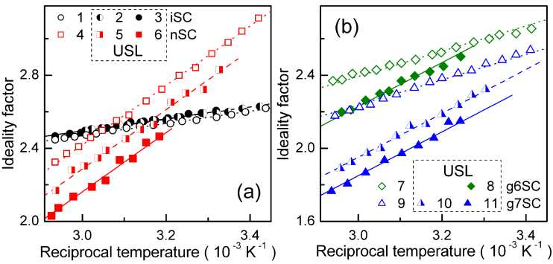

FIG. 2. Temperature dependences of ideality factor for non-irradiated (curves 1-3, circles), neutron-irradiated (4-6, squares) and Y-irradiated (7-11, diamonds and triangles) samples. The curves 1, 4, 7 and 9 (open marks) are obtained without USL, curves 2, 3, 5, 6, 8, 10, and 11 correspond to Ui-1, Ui-2, Un-1, Un-2, Ug6-2, Ug7-1, and Ug7-2 respectively. The marks are the experimental results, the lines are the fitted curves using Eq. (6).

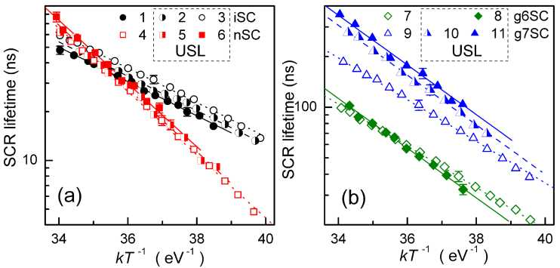

FIG. 3. Temperature dependences of SCR lifetime for non-irradiated (curves 1-3, circles), neutron-irradiated (4-6, squares) and Y-irradiated (7-11, diamonds and triangles) samples. The curves 1, 4, 7 and 9 (open marks) are obtained without USL, curves 2, 3, 5, 6, 8, 10, and 11 correspond to Ui-1, Ui-2, Un-1, Un-2, Ug6-2, Ug7-1, and Ug7-2 respectively. The marks are the experimental results, the lines are the fitted curves using Eq. (7).

TABLE III. Characteristics of temperature dependences of n+-p-Si structure parameters.

|  |  |  |  |  |  |
| --- | --- | --- | --- | --- | --- |
| Sample | USL | Tid (K) | Erg (eV) | ^293,A1 (kO) | CFdis (104 K/O) |
| iSC | non | 330 ± 30 | 0.24 ± 0.01 | 27 ±3 | 41 ±4 |
|  | Ui-1 | 310 ± 30 | 0.24 ± 0.01 | 27 ± 3 | 50 ± 4 |
|  | Ui-2 | 360 ± 30 | 0.24 ± 0.01 | 26 ± 3 | 58 ± 4 |
| nSC | non | 1610 ± 70 | 0.45 ± 0.02 | 2.2 ± 0.4 | 65 ± 7 |
|  | Un-1 | 1600 ± 70 | 0.44 ± 0.02 | 2.3 ± 0.4 | 95 ± 10 |
|  | Un-2 | 1680 ± 70 | 0.44 ± 0.02 | 2.2 ± 0.4 | 130 ± 10 |
| g6SC | non | 610 ± 40 | 0.28 ± 0.01 | 0.7 ± 0.1 | 19 ± 2 |
|  | Ug6-2 | 1080 ± 50 | 0.33 ± 0.02 | 0.8 ± 0.1 | 24 ± 2 |
| g7SC | non | 770 ± 50 | 0.29 ± 0.01 | 0.41 ± 0.06 | 26 ± 3 |
|  | Ug7-1 | 1260 ± 60 | 0.34 ± 0.02 | 0.39 ± 0.06 | 45 ± 4 |
|  | Ug7-2 | 1270 ± 60 | 0.35 ± 0.02 | 0.38 ± 0.06 | 55 ± 4 |

can be expressed as

(13)

Fd = x AQ,

(10)

TD’A

*n,p*

(r)

(11)

where Rda is the coupling parameter, ND and NA are the densities of donor and acceptor-like defects, _and af are electron CCS of donor and hole CCS of acceptor, uth,n and are the thermal electron and hole velocities, nD,A, pD,A, and e depend on ED, Ef, and level degeneracy factors. As Tg « R-1, the values _____ are expected to provide a thermoactivated SCR lifetime behavior. Unfortunately the equation __ does not account for the functional relation between I-V characteristic pa­rameters and attributes of defects, taking part in CDLR.

According to Steingrube et al.41, SSC for defect in a pair differs from that for isolated defect and depends on the distance between donor and acceptor r:

crystal bands. In particular, it is proposed41 that the recombination rate is dominated by sites where acceptor-like defect is coupled with donor-like defect. In simplified case of no carrier exchange between the donor level ED and the valence band as well as between the acceptor level Ef and the conduction band, the re­combination rate R can be expressed40 as

i?!2 - JR{2 - 4T%T$(np - n?)( 1 - e)

R= 2^(1-e)’ (8)

{n + n0){p + pk) D A

R\2 = 1- Tn(p +pD) + T (n + nk), (9)

TABLE IV. Acoustically induced change of n+-p-Si structure parameters (at 330 K).

|  |  |  |  |  |  |
| --- | --- | --- | --- | --- | --- |
| Sample | USL | Ania  (±0.01) | S-TQ  (±5%) | STn  (±0.2) | S^dis  (±10%) |
| iSC | Ui-1 | 0.02 | -14 | 0.7 | 20 |
|  | Ui-2 | 0.03 | -17 | 1.4 | 40 |
| nSC | Un-1 | -0.13 | 5 | 1.5 | 50 |
|  | Un-2 | -0.26 | 13 | 3.0 | 100 |
| g6SC | Ug6-2 | -0.15 | 2 | 2.3 | 30 |
| g7SC | Ug7-1 | -0.26 | 49 | 0.9 | 70 |
|  | Ug7-2 | -0.36 | 70 | 1.9 | 110 |

where CD and Cf are constant values. Besides, RDA is proportional to the overlap integral of the defects wave func­tions . If both defects are characterized by H-like radial- symmetric wave function and equal Bohr radius a0, the following expression can be used:41

(12)

r% = (Nd al Uth,n) 1, TpA = (Na a£ uth,p)

CD,A 2

*Cn,p r*

Rd

where x is the bulk elasticity modulus, is the

crystal volume change per defect, £ is the crystal lattice deformation, and AW propagates along z axis. d£(z,t)/dz <x £US. For interstitial atoms and substitutional impurities with ionic radius exceeding the ionic radius of matrix atoms, the A^d > 0, whereas, for vacancies and substitutional impurities with ionic radius smaller than the ionic radius of matrix atoms, A^d < 0. Therefore, a point defect vibrates under USL and oscillation amplitude and phase are determined by both the defect character and the intensity of AW .

The simplest model, which is shown in Fig. 4. gives the following qualitative conclusion. Initially donor and acceptor are separated by the distance rin. Axis X is drawn through point defect initial positions. Under USL defects would vibrate with amplitudes uD and uA. Vibration axis coincides with AW displacement direction and forms angle ip with X-axis. The defect vibration amplitudes depend on £js, defect elastic strain (A^d and A^d), defect coupling and may have different values. According to suggested model, the donor-acceptor distance in the sample under USL rUS depends on time t:

rus(t) = {[rjn + Uf cos(^ust + 6) - Ud cos(^ust)]2 cos2 p

+ [ua cos(^ust + 6) - Ud cos(^ust)]2 sin2 p}°'5 , (14)

where wus is the US cyclic frequency, 6 is the phase shift between donor and acceptor vibration.

We use Eqs. (11)—(12) to estimate AI relative changes of CCS = [aus — a(rin)]/a(rin) and coupling param­eters £rda = [Rda,us — RDA(rin)]/RDA(rin), where aus and RDA us are averaged over the AW period Tus:

equation

In this estimation, the relaxation time in the CDLR subsystem is assumed to be considerably less than Tus and

*dgz,t)*

*' dz*

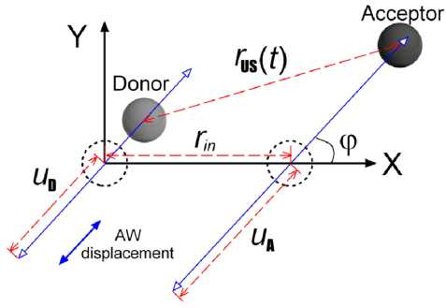

FIG. 4. Model of CDLR center behavior under US action.

In our opinion, the observed reversible AI nid and Tg modifications are induced by donor-acceptor distance alteration in samples under USL. Really, according to data,21,22 the force acting on the point defect during USL

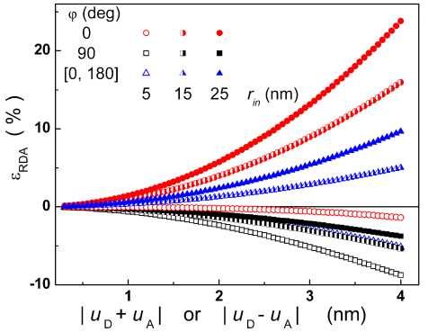

FIG. 5. Simulated dependencies of AI changes of coupling parameter on the vibration amplitudes. Axis |uD + uA | cor­responds to ô = 0o case, whereas axis |uD + uA | corresponds to ô = 180o case. The parameters are set to ao = 3.23 nm, Tin = 5 nm (open marks), 15 nm (semi-filled marks), and 25 nm (filled marks), ^ = 0o (circles), 90o (squares). Trian­gles correspond to mean eRDA value for [0o ^ 180o] ^ range.

the previously used41 value a0 — 3.23 nm is applied. Be­sides, the chosen uD and uA values are commensurate with uus. But it is taken into account, that a displacement of the point defect without covalent bond could exceed a matrix atom displacement. At last, no US absorption by defect is assumed. In this simple case 5 equals to 0°, if (AQd • AQd) > 0, or to 180°, if (AQd • AQd) < 0. In ad­dition, eRDA dependence on uD and uA is only determined by |uD — uA| (5 — 0° case) or |uD + uA| (5 — 180° case). Moreover, these dependences are identical in both cases. The typical simulation results of ____ are shown in Fig. 5.

Epsilon depends on oscillation amplitudes with a similar features and does not depend on f:

epsilon= (ud ± UA)2/2 r?n = KDAWus ,

(15)

where“+” and “—” correspond to 5 — 180° and 5 — 0° respectively, KUDAA characterizes defect couple-ultrasound interaction and depends on properties defects as well as crystal matrix. It is taken into account in Eq. (15), that Ud, <^US OC V^us-

It is worth keeping in mind, that CLDR current flows locally in the locations of extended defects.41,58 On the other hand, dislocations are often sit­uated in the SCR region perpendicularly to p—n junction plane and investigated samples are not exception (see Section IIIC). If CDLR in the dislocation locations is assumed, then dislocations with edge component would affect the pair spatial orientation. Thus axis of donor- acceptor pair with (AQd • AQd > 0) should be predominantly parallel to dislocation line, whereas the axis of the pair of coupled defects with (AQd • AQd < 0) should make a right angle with it. As AW displacement is parallel to the p — n junction plane, the cases of most exciting interest are following:

5 — 0°, f — 90° (AQd • AQd > 0 case);

5 — 180°, f e [0° ^ 180°] (AQd • AQd < 0 case).

In other words, all curves in Fig. 5 can be realized if defect volume relaxation of donor-like defect has the sign opposite to that of acceptor-like defect. And only squares have to be under consideration in AQd • AQd > 0 case.

Taking into account the experimental results and suggested model estimation we can state that:

1. ETg and Tid are mainly determined by couple component energy levels. The alteration of ETg and Tid for nSC, g6SC, and g7SC in comparison with iSC testifies on the change of defect (donor, acceptor, or both), which takes part in CDLR, after irradiation. And g6SC defect is coin­cident to g7SC defect and differs from neutron-irradiated sample defect.
2. USL causes donor-acceptor distance change and results in and eRDA, which increase with Wus.
3. Acoustically induced ETg (and Tid) modification, which is observed in g6SC, and g7SC only, testifies on the rebuilding of Y-induced RD. I.e., Y-induced RD is congu- rationally bistable (or metastable) and transforms from ground state to another under US action. Similar AI defect variations were also reported previously.3,5,32,59
4. sign is immutable — see Eq. (15), whereas eRDA sign can vary for a pair with opposite relaxation volume component (see Fig. 5). Therefore Anid and eTg sign change is an evidence of transformation from (AQd • AQd > 0) to (AQd • AQd < 0) after irradiation. Transformation is confirmed by US influence efficiency rise in irradiated samples. Really, in the case of (AQd • AQd < 0) the US efficiency is determined by the sum of pair component dis­placements, whereas in the contrary case — by their difference. Conceivably, both donor and acceptor are of interstitial- type at non-irradiated sample, and one of pair component is of vacancy-type at irradiated samples. The defect configuration are discussed below, in Section III D.
5. Quasi-neutral region

Base lifetime mirrors the processes, which occur in the quasi-neutral region of p-n-structure. Fig. 6 shows the Tn behavoiur in the explored temperature range. Minority carrier lifetime expectedly rises with temperature increase and Tn values equal to 2 ^ 5 ns for different samples at 320 K. These values correspond to 80 ^ 130 ^m range of diffusion length. In our opinion, the observed Tn dispersion is not defined by irradiation, but deals with sample-ancestor wafer inhomogeneity, which is revealed quite often.60,61

Really, the irradiation induced lifetime reduction is described by the Messenger-Spratt equation:48

(16)

where Tn0 is the minority carrier lifetime in the nonirradiated sample, and KT is a lifetime damage- constants. The known KT values and estimated changes of reciprocal base lifetime KTФ are shown in the Table V. iT shows that the estimated value of radiation-induced t—1 change

|  |  |  |  |  |
| --- | --- | --- | --- | --- |
| Sample | T-n (320 K)  (105 s“1) | KT  ( cm2/s) | Kt x ^  (104 s“1) | k eff  Kus  (cm2/W) |
| iSC | 2.9 | — | — | 3.5 |
| nSC | 4.7 | 10-7(Ref. 33) 2-10"7(Ref. 62) | 4  •I*  00 | 7.1 |
| g6SC | 1.8 | 5-10“12 | 0.8 | 6.0 |
| g7SC | 2.8 | (Refs. 33, 63) | 8 | 5.2 |

TABLE V. Measured and estimated base lifetime parameters.

equals to (8 ^ 17), 4, and 29 % of its measured value for samples nSC, g6SC, and g7SC respectively, and can­not explain dispersion observedexperimentally . Calculated lifetime changes KT^ are in quite good agreement with those, which are expected from RDs production — see Section IIID.

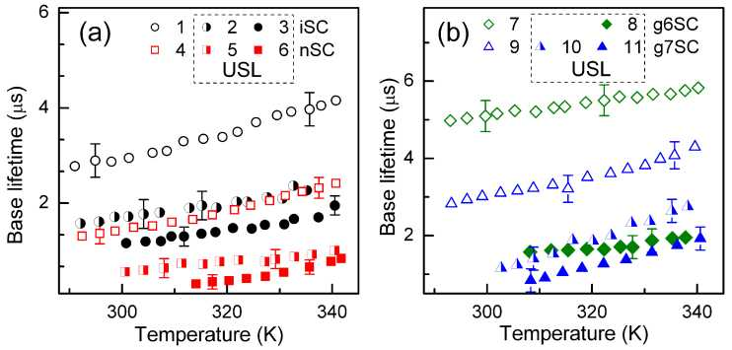

FIG. 6. Temperature dependences of base lifetime for non-irradiated (curves 1-3, circles), neutron-irradiated (4-6, squares) and Y-irradiated (7-11, diamonds and triangles) samples. The curves 1, 4, 7 and 9 (open marks) are obtained without USL, curves 2, 3, 5, 6, 8, 10, and 11 correspond to Ui-1, Ui-2, Un-1, Un-2, Ug6-2, Ug7-1, and Ug7-2 respectively.

Base lifetime can be expressed as following:64

(17)

where Tbb, tce Auger, tSrh are the lifetimes of band-to- band, Coloumb-enhanced Auger, and SRH recombina­tion, respectively. Calculation shows, that t^1 = 14 s-1, TCE1Auger = 6 s-1, therefore tSrh should be under consid­eration only. In case of low injection rate and single recombination centre, SRH lifetime is described by Eq. (10). If there are several centers of recombination equation (18) should be applied

(18)

where Md is the total number of centers, Tn,i characterizes lifetime due to recombination by i-th defect, Nd,i and an,i are the concentration and electron CCS of i-th defect, respectively.

Fig. 6 shows, that USL results in Tn decrease. Relative AI changes of reciprocal base lifetime eTr — (Tn,in —

KUs,j deals with j-th defect-ultrasound interaction.

Tn, US )/Tn, US are listed in Table IV. As AI changes is reversible, in our opinion, this effect deals with increase of on under US action. Following the empirical relation proposed by Ref. 65, we assume that Eq. (11) is correct for complex point defect too. But in this case, r is the distance between complex component. According to the model suggested in Section IIIA, USL leads to r variation and on change in line with Eq. (15). In case of CDLR, AI change of donor (or/and acceptor) SSC is supplemen­tal to variation of both the coupling parameter and the couple distance. But this effect is a single for base lifetime.

On the other hand, not every defect does effectively take part in AID. If MAA and Md°nAA are the total numbers of acoustically active (AA) and non-AA center Eq (18) for t-1 under USL and without it takes the following shape

Eq transforms as follows:

Using Eq (15), eTr results in

(19)

where KUff characterizes ADI in the sample and depends on concentration of both AA and non-AA centers

(20)

The obtained dependences eTr vs WuS are shown in Fig. 7. Linearity of these dependencies prove correctness of our assumptions. . The determined Kff values are listed in the Table V. The non-monotonic KUff alteration with y dose ??? is discussed in Section III D.

-E'dis Ei kT

cosh

R

sh,dis —

-1

sh,Al

(21)

+ R

(22)

**C. Shunt resistance**

Fig. 8 shows the shunt resistance over the explored temperature range. One can see, that irradiation re­sults in Rsh decrease. Besides the Rsh temperature dependence behavior is changed in 7-exposed samples. In particular the shunt resistance decreases with the temperature growth in iSC and nSC, whereas close to linear increase of Rsh vs T is observed in g6SC and g7SC at 293 K neighbourhood. We want to notice that Rsh axis is logarithmic in Fig. 8(a) and linear in Fig. 8(b).

Several non-mechanical reasons of p-n structure shunt resistance appearance are known.66 They are aluminum particles, macroscopic Si3N4 inclusions, inversion layers in precipitates. So in the course of annealing firing Al particle may penetrate into the sample creating p+-doped region around it , which compensates the emitter and stay in ohmic contact with the base. Inversion layers and Si3N4 inclusions occur in multicrystalline silicon cells mainly66 and cannot cause a shunt resistance of investigated samples. In addition, dislocations, which intersect the junction, are generally held responsible as a possible source of ohmic current.66-68 In our opinion, both aluminum particles and dislocations are present in the investigated structure. The overall shunt resistance can be expressed as

where Rsh,Al and Rsh,dis deal with aluminum particles and dislocations, respectively. The linear temperature dependence of metal particles Rsh,Al is suggested:

Rsh,Al — R293,Al[1 + a(T — 293)] ,

1

sh,dis ’

where R293,Al is the shunt resistance at 293 K and a is the resistance temperature coefficient.

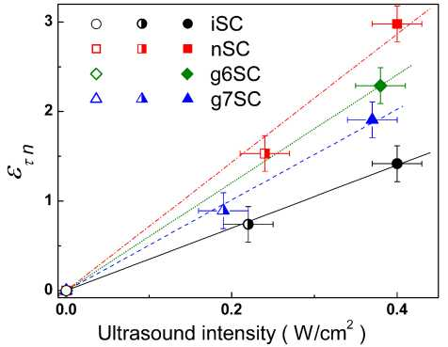

FIG. 7. Dependences of relative base lifetime change on US intensity for non-irradiated (circles), neutron-irradiated (squares), and 7-irradiated (triangles and diamonds) samples. Lines are the fitted curves using Eq. (19).

^dis — *PdisAq* ^4dis *\/KnKp N±±s (rip -\- pp)/k* , (24)

where Edis is the energy level which significantly con­tributes to the dislocation recombination current, Us is the potential at the surface of the dislocation core, pdis and Adis are the dislocation density and surface area, respectively, Kn and Kp are the capture probabilities for electrons and holes by the dislocation states, Ndis is the density of surface states at each dislocation. Eq. (23) is reduced for the simplified case of Kp — Kn.

a was determined from g7SC data. Obtained value 8.3 • 10_3 K_1 is not far from resistance temperature coefficient of bulk Al (4.3 • 10_3 K_1). Then we used Eqs. (21)-(23) to fit the experimental Rsh data. R293,Al, (Edis — Ei), Us, and adis were taken as the fitting parameters. It was established that the experimental data are in good agreement with the fitting curves (see Fig. 8) for values (Edis—Ei) — (0.46±0.02) eV and Us — (5 ± 4) x 10_8 eV, which were independent of irradiation and USL. The obtained value of (Edis — Ei) corresponds to the carrier activation energy 0.10 ± 0.02 eV. This value is comparable to the activation energy of dislocation levels of 0.08 eV, which was early reported69-73 in Cz-Si:B too.69-71

Obtained values of R293,Al and adis are listed in Table III. R293,Al does not depend on USL and increases with irradiation level. In our opinion, Rsh,dis is less than Rsh,Al in iSC. Irradiation leads to vacancy production and Al diffusion out of electrodes. As a result, thequantity of Al particles rises, Rsh,Al decreases and becomes the key factor of overall shunt resistance value. The Al diffusion is more effective in Y-exposed samples due to more uniform distribution of irradiation-induced single vacancies.

adis dispersion on sample set correlates to Tn that. Hence it deals with wafer inhomogeneity too. USL leads to adis increase, relative AI changes £adis — (^dis,us — ^dis,in)/^dis,in are shown in the Table IV. In our opinion this is caused by an Adis augmentation. Namely, the dislocation core atom displacement is normal to the current direction. As the result, carriers are captured by dislocation levels from enlarged volume. Therefore the effective surface area increases and LRsh,dis decreases under US action.

**D. Defect type speculation**

Lifetime killers in boron-doped Czochralski-grown Si are the boron-oxygen related (BO) defects,74,75 iron- boron pairs64,76,77 (or another Fe-related trap in the

+ cosM§

with

(23)

^dis

Gopal and Gupta42,43 introduced the model of dislocation-induced impedance of photovoltaic detector. According to this model, the Rsh,dis can be given by

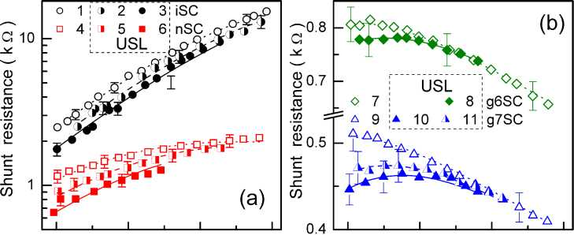

34 36 38 40 34 36 38 40

kT 1 (eV1) kT 1 (eV1)

FIG. 8. Temperature dependences of shunt resistance for non-irradiated (curves 1-3, circles), neutron-irradiated (4-6, squares) and Y-irradiated (7-11, diamonds and triangles) samples. The curves 1, 4, 7 and 9 (open marks) are obtained without USL, curves 2, 3, 5, 6, 8, 10, and 11 correspond to Ui-1, Ui-2, Un-1, Un-2, Ug6-2, Ug7-1, and Ug7-2 respectively. The marks are the experimental results, the lines are the fitted curves using Eq. (21)-(23).

n+p-junctions78,79), and oxide precipitates.160,61,64,80-82 The first two defects are sensitive to intensive illumination at room temperature. To determine the major recombination center of investigated samples the following experimental procedure has been used. The nonirradiated sample was light soaked under halogen lamp (2 Suns) illumination at approximately 305 K. The illumination varied from 1 h to 8 h. After illumination sample is stored in the dark at room temperature. To de­termine the parameters kinetics I-V characteristics have been measured with interval 10-15 min at room temper­ature over a period 5 h after illumination stopping. To determine the permanent light-induced change the I-V characteristics have been measured in 48 h after illumina­tion. After accumulated time under illumination had run up to 15 h the iSC was annealed at 200 0C for 10 min in the dark and parameters ??? were measured at room tem­perature. After that, the illumination and measurements were repeated.

In order to keep the volume of this paper within the reasonable limits , the detailed results of these measurements are not shown. But the main results are as follows/ Illumination did not result in permanent change of either of the t9 , Tn, nid before as well as after annealing. Therefore BO influence on recombina­tion can be neglected in both the SCR and the base. nid increase (about 0.03) and t9 decrease (about 10 %) immediately after illuminationwere observed . These changes vanished gradually, both nid and t9 time dependences were very similar to those, which was expected77 for Fe^Bs repairing. Hence iron-boron pairs take part in SCR recombination. On the other hand, electron and hole CCS of released by illumination interstitial iron are 1.7 and 0.04 times77 as much as those of Fe^Bs. A small (about 10 %) t9 alteration, which is caused by light, is evidence of supporting role of iron-boron pair in SCR recombination. Furthermore, since Tn does not depend on illumination, then Fe^Bs does not influence on base lifetime.

As a result, oxide precipitates are number one in SCR and base recombination. According to Murphy et al.80,81, at least two independent oxide precipitate related de­fects exist. These defects have an/ap = 157 and &p/&n = 1200 respectively.81 So, they are suitable for CDLR. On the basis of mentioned above, we conclude that the defectresponsible for AI phenomena in nSC, is oxide precipitate mainly.

It is worth keeping doping level, oxygen concentration and ??? dose in mind when RD type is foreseen. In our case (Czochralski, oxygen-rich, ^ 7 • 1017 cm-3, p-Si with boron concentration ^ 1015 cm-3 and low dose) it is ex­pected, that CO^, vacancy clusters Vn (divacancy V2, trivacancy V3, ...) and VO^ are produced mainly by neu­tron irradiation83-85 and QO^ and VO^ by Y-rays.85-88 The RD concentration Nt,RD is proportionate to dose, the known introduction rate for neutron nn and gamma irradiation in Cz-Si are shown in the Table VI. The expected values of Nt,RD for investigated samples are listed in the Table VI too.

Another defects, which can be created by irradiation in silicon, are Ip-center, bistable donor (BD), B^O^ and CCs. The defects of the first (BD) and second (BO type are characterized by small introduction rate. For example, expected concentration of BD defects 84,92 is only (1 ^2) • 1010 cm-3 in nSC and g7SC. The lack of B^O^ defects in investigated samples deals with low boron concentration93. Lastly, QCs creation is suppressed in oxygen-rich crystal.83,86,87 Besides QCs is not recombi­nation active center.94

The influence ofRD on base lifetime coulkd be estimated by Eq. (18) taking into account the fact , that VO^ is not active recombination center in p-Si.63,95-98 Estimated Tn,RD for CO^, V2, and V3 are shown in the Table VI. It shows thatthat Tn is effected mainly by QO^ and vacancy clusters in Y- and neutron-irradiated samples, respectively. It should be noted, that nSc, g6Sc, g7SC sums of Tn,RD are in quite good agreement with (KT • ^) values.

Lets consider KUff assuming that that = 1,

MnonAA = 1 in non-irradiated sample and US interac­tion with CjOj and Vn is described by KUO and KjS, re­spectively. Then Eq. (20) gives the following expression for Kus in nSC and irradiated samples:

TABLE VI. Cited and calculated defect parameters.

|  |  |  |  |  |  |  |  |  |  |  |  |
| --- | --- | --- | --- | --- | --- | --- | --- | --- | --- | --- | --- |
| Defect | Jn | nn (cm-1) |  | n7 |  | Nt | ,rd(1011 | -3\ cm 3) | Tn | ,RD (104 S-1) |  |
|  | (1CT15 cm2) | Ref. 85 |  |  |  | nSC | g6SC | g7SC | nSC | g6SC | g7SC |
| CiOi | 0.7 (Ref. 86) | 1.38 | 6-105 rad | -1cm~ | ~3 (Ref. 86) | 5.5 | 6 | 60 | 0.8 -f- 1 | 0.9 1.1 | 9-^11 |
|  | 0.9 (Ref. 87) |  | 4-10-4 | cm-1 | (Ref. 87) |  |  |  |  |  |  |
| V2 | 3 (Ref. 86) | 1.21 | 3-104 rad | -1cm~ | ~3 (Ref. 86) | 4.8 | 0.3 | 3 | O  2  •I*  O  3 | 0   1. *1*   0O  2 | 1 ^ 2 |
|  | 2 (Ref. 89) |  |  |  |  |  |  |  |  |  |  |
| V3 | 2.4 (Ref. 90) | 0.37 |  | — |  | 1.5 | — | — | 0.7 | — | — |
| VOi | 2.4 (Ref. 88) | 0.52 | 7-105 rad | -1cm~ | ~3 (Ref. 86) | 2 | 6 ^ 7 | 6  0  •I*  7  0 |  |  |  |
|  | 4 (Ref. 91) |  | 4-10-4 | cm-1 | (Ref. 87) |  |  |  |  |  |  |

Keff KAA t /tAA

KUS — KUS rn,in/rn,in ,

Keff _ KAAr • /rAA + KCOr • /rCO + KV r • /rV

KUS _ KUS 'n,in/ '„,jn + KUS 'n,in/ ' n,RD + KUS'",*n/ 'n,RD ,

where r«Ain is the base lifetime in case of non-radiative AA defect with KUA is only present in sample.

Two extreme cases are opportune for analysis. In the first one, non-AA defects are distributed uniformly across the wafer and AA defects define a distinction of (r— L — KT • ^) values in different samples. In the second one, non-AA defect distribution is not uniform, whereas rAAin is identical for iSC, nSC, g6SC, and g7SC. However, in the first case (as well as in case of MnonAA _ 0), experimental KUff values lead to unreal (negative) values of KUSj. In the second case, Eq. (20) and the data from the Tables V and VI, give the following array equations::

iSC: 3.5 = KUA • «iJ-1 /2.9 ,

nSC : 7.1 _ KUA • (rAAJ-1 /4.7 + 0.09 KS + 0.02 KO ,

g6SC : 6.0 _ KuAsA • (rAAJ-1 /1.8 + 0.01 KS + 0.05 KO ,

g7SC : 5.2 _ KUA • )-1 /2.8 + 0.05 KS + 0.35 KO ,

where (rAAin)-1 in 104/ s. These equations are correct if KUs •(rAAi„’)-1 _ (10±3) cm2/W, KVs _ (42±15) cm2/W, KCO _ 0. Since (rAAin)-1 < 1.83, then KUS > 5 cm2/W. Thus observed change of the base lifetime is caused by AI modification of the same defect (most likely oxide precipitates) in both non-irradiated and 7-irradiated samples. This effect is added by AI divacancy alteration in neutron- irradiated samples. In other words, CjOj is non-AA defect, whereas V2 is AA defect.

As to SCR recombination, in our judgement, rg and n;d in non-irradiated sample are affected by modification of coupled oxide precipitate related defects under US action. As assumed above in Section III A, the AA radiation defects with A^d < 0 take part in CDLR in irradiated samples. Divacancy is quite suitable explanation for AI influence on rg and in nSC. But a bistable (or metastable) defect

In 7-irradiated samples bistable (or metastable) defects may be expected . There are known a Few defects of the type are known: with A^d < 0 in Si, viz VO2,99 V3,90 and

VO*.100 VO2 appears after 300°C annealing of irradiated crystal, V3 is not typical defect for 7—60Co exposed sili­con. On the other hand, VO* is largo manum produced and can take part in CDLR around n+-p interface in g6SC and g7SC. Metastable state, which is commonly observed at low temperature, is remarkable for the large distance between oxygen and vacancy and more deep energy level.100 The volume change of entire complex is nega­tive, whereas for the complex component A^d(V) < 0 and And(Oj) > 0. Hence, under assumption ??? , VO* is favorable pair for AI alteration of component distance. Thus VO* can be transformed into metastable configuration by USL and this effect results in both T;d and ETg change.

1. CONCLUSION

The experimental investigation of ultrasound influ­ence on the I-V characteristic of silicon n+-p-structure has been carried out. The effects of reactor neutrons and 60 Co gamma radiation on ultrasound influence were studied. The investigation revealed the acoustically driven reversible decrease of both the minority carrier life­time in a structure base and the shunt resistance. The effect intensifies in irradiated structures. The analysis shows that the acoustically induced increase of carrier capture coefficient of point or extended defects is a reason of observed effects. It has been found out that the ultrasound loading leads to the reversible modification of SCR carrier lifetime and ideality factor. Changes are op­posite in sign in non-irradiated and irradiated structures. The qualitative model of observed phenomenon, which is based on the increase of a distance between coupled defects or between defect complex components under ultrasound action, was considered. It has been shown that divacancy and pair vacancy-interstitial oxygen are effectively modified by ultrasound in neutron- and 7-exposed structures respectively. Interstitial carbon-interstitial oxygen complex does not practically take part in acousto-defect interaction. Thus, ultrasound can be an effective tool for controlling silicon structure characteristics.