The Company’s Employer Brand Vulnerability Level Assessment
Tetiana Bilorus[0000-0001-7620-4622], Lesia Olikh[0000-0002-4365-8107], and Svitlana Firsova [0000-0003-0848-1390]
Taras Shevchenko National University of Kyiv, 90A Vasylkivska Street, Kyiv, 03022, Ukraine
t_bilorus@ukr.net lesyaolikh@ukr.net sfirsova@ukr.net
Abstract. The question of attracting, retaining and using highly qualified personnel is one of the leading aspects of companies’ competitiveness support. This can be ensured by forming and developing a strong employer brand. The authors propose the algorithm for assessing the company's employer brand attributes (components) vulnerability level. It is proposed to use CARVER matrix as the basic evaluation criteria. CARVER means: C – criticality, A – accessibility, R – recuperability, V – vulnerability, E – effect, R – recognizability. SBW-method (Simplified Best-Worst Method) is used to calculate these criteria weighting factors. The authors highlight the following four employer brand attributes. They are organizational attribute, functional attribute, economic attribute, psychological attribute. The value of the company's employer brand attributes’ vulnerability level according to the criteria is presented. This article aims to provide companies’ managers and HR-specialists with a reliable and flexible tool. It refers to the mathematical formalization of the employer brand attributes (components) rating task according to their vulnerability degree. The article is the contribution to the application of mathematical methods and models in management. It is a practical tool for justifying management decisions.
Keywords: Company's Employer Brand, Employer Brand attributes (components), Vulnerability Assessment Criteria, CARVER Matrix, SBW-method.
- Introduction
The labor market of most countries today is characterized by an increased demand for highly specialized and highly professional specialists. Namely, this market is characterized by a high level of competition. The company’s powerful employer brand formation and development helps to solve this problem.
In the Universum company management opinion, employer brand management is a vital management tool for any company today [1]. The Universum company is one of the global leaders in the HR-branding market. They call the main reasons for the need to pay attention to the employer brand management question: qualified employees’ shortage; more results with less costs; growth and profitability; popularity and power.
Different authors’ approaches to the employer brand definition were analyzed. We pay attention to this one: “employer brand is the organizational, functional, economic and psychological attributes complex. They distinguish the company as an employer from other companies. They ensure its competitiveness in the eyes of potential and existing employees [2]”.
In our opinion, in the conditions of "highly qualified employees struggle" there is a need to develop a systematic and objective method regarding the definition of the so-called bottlenecks first of all. Namely, those employer brand attributes (components) which are potentially the most vulnerable to the negative impact of both internal and external factors.
There is the problem of assessing the risk of losing the company's competitive position on the labor market due to its employer brand attractiveness decrease in. Now it is traditionally solved by most managers on the situation subjective assessment basis. Therefore, the purpose of the research is the need to develop he algorithm and methodical support for solving this problem.
Subsequent paragraphs, however, are indented.
- Methodology
  - A Subsection Sample
In a competitive environment, the company's employer brand, which has a high level of development and a considerable number of competitive advantages in the labor market today, is not a guarantee of maintaining such positions in the strategic perspective. In this situation it is relevant question how to determine its most vulnerable components. This is necessary in order to protect them and to create conditions for preservation and further development.
For the purpose of the company's employer brand attributes’ (components’) vulnerability level determination, the following algorithm was developed within the study (Fig. 1).
Let's consider each stage of the proposed algorithm in more detail.
Stage 1. As an object of vulnerability level assessment, all attributes (components) can act comprehensively with further analysis of their components. Also, separate employer brand attributes (components) can be taken as an object of vulnerability level assessment, depending on the research objectives.
Stage 2. In order to build a system for ranking the employer brand attributes’ (components’) vulnerability, we suggest using an adapted matrix CАRVER. CАRVER means: C – criticality; A – accessibility; R – recuperability; V – vulnerability; E – effect; R – recognizability. This approach makes it possible to balance different criteria importance. It makes it possible to take into account their impact on mission performance. And it also contributes to the optimal resources’ use [3].
The proposed tool was initially used only when solving military tasks. But currently, a number of researchers [4, 5] suggest its use in justifying management decisions.

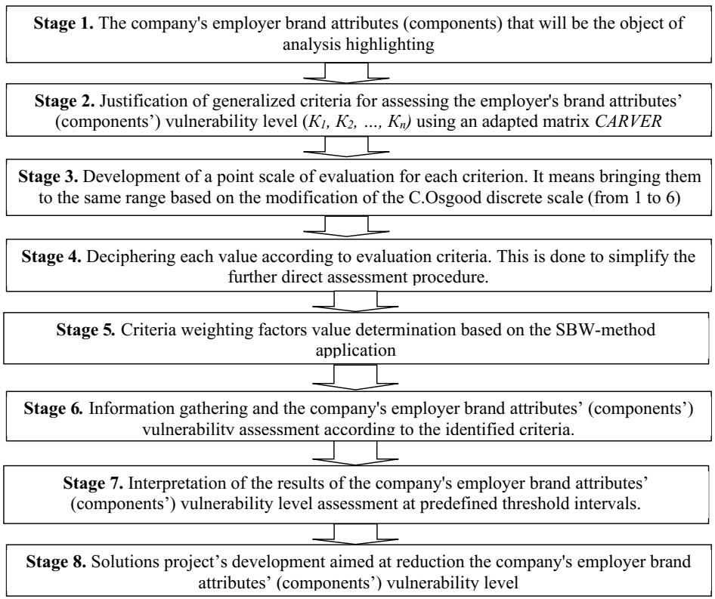
Fig. 1. The company's employer brand attributes’ (components’) vulnerability level assessing algorithm.
The research design requires experts’ survey using a semantic differential. In order to obtain respondents' answers and their further interpretation, the basic scale by C.Osgood [6] was slightly modified in the study. The basic scale by C.Osgood is a discrete scale on which the respondent can rate his attitude to the object under study using a 5-dimensional rating scale between two bipolar statements. 1 is the worst grade. 5 is the best grade. The authors propose to use a discrete 6-point scale. The values and characteristics behind them differ for each defined criterion. The negative aspect of this scientific and methodical approach can be manifested in the difficulty of finding qualified experts.
Stage 3-4. So, the first sub-step in determining the employer brand attributes’ (components’) vulnerability is their criticality for the company. The attribute (component) is considered to be critical for the company if its condition deterioration has a significant impact on the company’s processes. In particular, these processes are related to the company's personnel policy implementation and personnel management strategy. We suggest evaluating criticality on a 6-point scale:
- 6 points – the indicator’s deterioration is of crucial importance for the company's personnel management strategic goals realization;
- 5 points – the indicator’s deterioration is important for the company's personnel management current goals realization;
- 4 points – the indicator’s deterioration significantly affects the company's personnel management goals achievement;
- 3 points – the indicator’s deterioration requires the company's personnel management plans slight adjustment;
- 2 points – the indicator’s deterioration is not decisive for the company's personnel management goals achievement;
- 1 point – the indicator’s deterioration consequences will mostly not prevent the company's personnel management goals achievement.
In the second sub-stage, it is proposed to evaluate the accessibility criterion. It the employer brand attribute (component) uniqueness degree (unavailable)/difficult to reproduce by competing companies. The criteria’s accessibility ranking:
- 6 points – competing companies are significantly ahead of us in terms of attribute (component) uniqueness and/or have a level of its development much higher than ours;
- 5 points – competing companies are ahead of us in terms of attribute (component) uniqueness and/or have a level of its development somewhat higher than ours;
- 4 points – the attribute (component) has a minimal uniqueness degree and/or its development level is on the same level as competitors; therefore, competing companies have no difficulty in reproducing it;
- 3 points – the attribute (component) has a sufficient uniqueness degree and/or its development level is not much ahead of competitors; therefore, competing companies have only a partial difficulty in reproducing it;
- 2 points – the attribute (component) is mostly unique and/or its development level is quite high; therefore, competing companies have a minimal possibility of its reproduction;
- 1 point – the attribute (component) is unique and/or its development level is very high; this fact makes impossible its full reproduction by competing companies.
Sub-stage 3 – the company's employer brand attributes’ (components’) renewability criterion assessment. That is, how much time will it take for the company to take measures and return its value to the basic (desired) level in the event of a deterioration in the level of development of the attribute. The criteria of renewability ranking on a 6-point scale:
- 6 points – it is difficult to predict how long it will take to restore the base values by attribute;
- 5 points – it will take more than 1 year to restore the attribute;
- 4 points – it will take from 6 months to 1 year to restore the attribute;
- 3 points – it will take from 3 to 6 months to restore the attribute;
- 2 points – it will take from 1 to 3 months to restore the attribute;
- 1 point – it will take less than 1 month to restore the attribute.
In the fourth sub-stage, we evaluate the vulnerability criterion. That is, the presence of weak points (competitive disadvantages) and the ability to withstand the negative impact of the company's environmental factors. Ranking of vulnerability criteria:
- 6 points – the attribute (component) is vulnerable; its value reflects the negative impact of any factors, both internal and external environment of the company;
- 5 points – the attribute (component) is vulnerable; its value reflects the negative impact of more factors, both internal and external environment of the company;
- 4 points – the attribute (component) is vulnerable; its value reflects the negative impact of separate factors, both internal and external environment of the company;
- 3 points – the attribute (component) has bottlenecks; but it is invulnerable to the negative influence of internal and microenvironmental factors and most of the company's macroenvironmental factors;
- 2 points – the attribute (component) has bottlenecks; but it is invulnerable to the negative impact of most factors of the company's micro- and macro-environment;
- 1 point – the attribute (component) has no bottlenecks; it is invulnerable to the negative influence of environmental factors.
Within the fifth sub-stage, there is a ranking according to one of the key criteria. It is effect. It is closely related to the criterion of criticality. The effect reflects the impact on the company's activities (achieving personnel management goals) that a deterioration in the development level of an attribute (component) can have. It is worth noting that in the process of ranking attributes (components) according to the criterion of effect, the consequences should be marked only as assumptions. That is, they can only be hypothetical. Ranking of effect criteria:
- 6 points – the attribute (component) deterioration is of crucial importance for the company's personnel management strategic goals’ realization;
- 5 points – the attribute (component) deterioration is important for the success of the company's current activities in terms of managing its personnel;
- 4 points – the attribute (component) deterioration significantly affects the personnel management processes of the company;
- 3 points – the attribute (component) deterioration requires a slight adjustment of the company's personnel management plans;
- 2 points – the attribute (component) deterioration is not critical to the company's success in managing its personnel;
- 1 point – the consequences of the attribute (component) deterioration will mostly not prevent the achievement of the company's personnel management goals.
At the final (sixth) sub-stage, it is proposed to take into account the criterion of recognizability. This criterion represents the degree to which an attribute (component) is considered by management to be valuable to the company. Namely, how much managers focus on it and whether they manage the employer brand effectively. Recognition, like other factors, is suggested to be evaluated on a 6-point scale:
- 6 points – the company's managers do not consider the attribute (component) to be critical in realizing the goals of the company's activities as a whole and managing its personnel in particular; therefore, they make only the most necessary management decisions regarding its support;
- 5 points – company managers believe that changing an attribute (component) will not have a positive effect on the implementation of the company's goals (personnel management goals); therefore, they make only the most necessary management decisions regarding its support;
- 4 points – company managers believe that changing the attribute (component) will not have a significant impact on the implementation of the company's goals (HR goals); therefore, they make an insufficient number of necessary management decisions regarding its support and development;
- 3 points – the company's managers believe that the attribute (component) has an indirect effect on the realization of the company's activity goals (personnel management goals); therefore, they pay insufficient attention to making management decisions regarding its support and development;
- 2 points – company managers believe that the attribute (component) has a positive effect on the realization of the company's goals (HR goals); therefore, it is the object of constant attention and the adoption of a sufficient number of management decisions for its support and development;
- 1 point – company managers believe that the attribute (component) has the maximum positive impact on the realization of the company's goals (HR goals); therefore, it is the object of constant attention and implementation of complex management actions.
Stage 5. Criteria for assessing the level of vulnerability of attributes (components) of the company's employer brand are: K1 – criticality; K2 – accessibility; K3 – renewability; K4 – vulnerability; K5 – effect; K6 – recognition. The weight of these criteria in the study was determined using the SBW-method (Simplified Best-Worst Method) [7, 8]. The procedure of this method provides the use of two approaches. They are “best”-approach and “worst”-approach. The results of both approaches are combined to determine integral importance values.
The “best” and the “worst” criterion is determined based on reaching a consensus by a group of experts. For the "best" approach, a linguistic assessment of the importance (priority) of each criterion compared to the most important ("best"-criterion) is provided using terms. These terms are given in the table 1. With the help of the same terms, the linguistic evaluation of the criteria for the "worst"-approach is carried out by comparing the worst-criterion with each of the other criteria.

Subsequent paragraphs, however, are indented.

Sample Heading (Third Level). Only two levels of headings should be numbered. Lower level headings remain unnumbered; they are formatted as run-in headings.

Sample Heading (Forth Level). The contribution should contain no more than four levels of headings. The following Table 1 gives a summary of all heading levels.
- First Section
  - A Subsection Sample
Please note that the first paragraph of a section or subsection is not indented. The first paragraphs that follows a table, figure, equation etc. does not have an indent, either.
Subsequent paragraphs, however, are indented.

Sample Heading (Third Level). Only two levels of headings should be numbered. Lower level headings remain unnumbered; they are formatted as run-in headings.

Sample Heading (Forth Level). The contribution should contain no more than four levels of headings. The following Table 1 gives a summary of all heading levels.
Table 1. Table captions should be placed above the tables.
Heading level | Example | Font size and style
Title (centered) | Lecture Notes | 14 point, bold
1st-level heading | 1 Introduction | 12 point, bold
2nd-level heading | 2.1 Printing Area | 10 point, bold
3rd-level heading | Run-in Heading in Bold. Text follows | 10 point, bold
4th-level heading | Lowest Level Heading. Text follows | 10 point, italic
Displayed equations are centered and set on a separate line.
x + y = z (1)
Please try to avoid rasterized images for line-art diagrams and schemas. Whenever possible, use vector graphics instead (see Fig. 1).

Fig. 1. A figure caption is always placed below the illustration. Short captions are centered, while long ones are justified. The macro button chooses the correct format automatically.
For citations of references, we prefer the use of square brackets and consecutive numbers. Citations using labels or the author/year convention are also acceptable. The following bibliography provides a sample reference list with entries for journal articles [1], an LNCS chapter [2], a book [3], proceedings without editors [4], as well as a URL [5].

References
- Author, F.: Article title. Journal 2(5), 99–110 (2016).
- Author, F., Author, S.: Title of a proceedings paper. In: Editor, F., Editor, S. (eds.) CONFERENCE 2016, LNCS, vol. 9999, pp. 1–13. Springer, Heidelberg (2016).
- Author, F., Author, S., Author, T.: Book title. 2nd edn. Publisher, Location (1999).
- Author, F.: Contribution title. In: 9th International Proceedings on Proceedings, pp. 1–2. Publisher, Location (2010).
- LNCS Homepage, http://www.springer.com/lncs, last accessed 2016/11/21.

