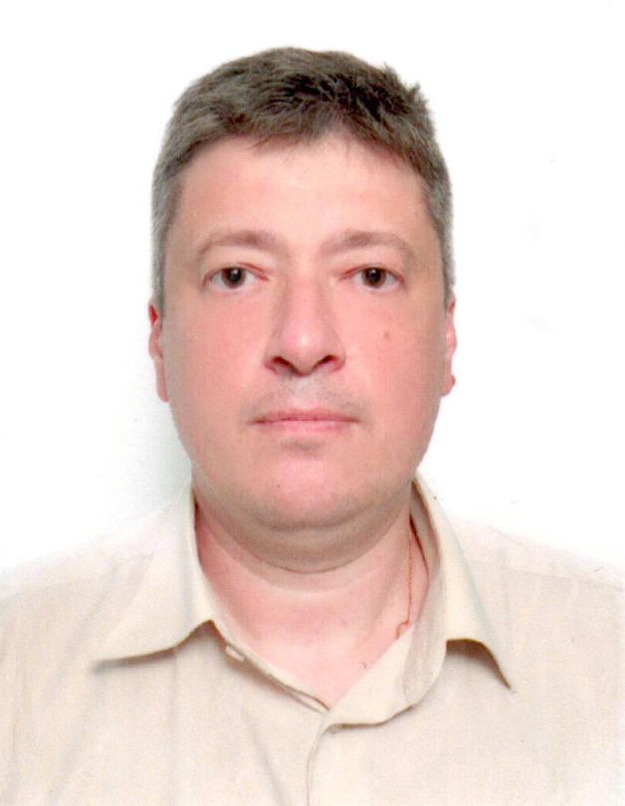
Curriculum vitae
PERSONAL INFORMATION
First Name, Surname | Oleh Olikh
Date of Birth | 1974-06-05
Citizenship | Ukraine
E-mail | olegolikh@knu.ua
Mobile Telephone | +380673169020
Scopus ID | 6506623724
EDUCATION
1996-2000 | Post-graduate course at the general physics department in Taras Shevchenko National University of Kyiv
1991-1996 | Physics faculty of Taras Shevchenko University of Kyiv, master in solid state physics (diploma ЛТ ВЕ №001760, 28.06.1996)
ACADEMIC DEGREE, ACADEMIC RANK
2022 | Academic rank of professor at the general physics department
2018 | Doctor of Science Degree (Dr. Hab., Physics and Mathematics), solid-state physics specialty, thesis «Acoustically and radiation induced phenomena in surface barrier silicon and gallium arsenide structures»
2004 | Academic rank of associate professor at the general physics department
2001 | Ph.D. Degree (Physics and Mathematics), solid-state physics specialty, thesis «Investigation of acousto-photo-electric interaction in GaAs and Si semiconductor structures»
WORK EXPERIENCE
2021 - Present | Professor at the general physics department,  Taras Shevchenko National University of Kyiv, Kyiv (Ukraine)
2002 - 2021 | Associate professor at the general physics department,  Taras Shevchenko National University of Kyiv, Kyiv (Ukraine)
1998-2002 | Assistant at the general physics department  Taras Shevchenko National University of Kyiv, Kyiv (Ukraine)
AWARDS AND HONORS
2021 | I. Puluj Prize of the National Academy of Sciences of Ukraine for the implementation of controlled acoustic field influence on processes of defect reordering in semiconductors and surface barrier structures
GRANTS AND PROJECTS
1997-2000 | researcher in project of Ministry of Education and Science of Ukraine " Study of physical properties of emission phenomena in heterogeneous materials" (No 97017)
2001-2005 | researcher in project of Ministry of Education and Science of Ukraine «Theoretical and experimental study of physical properties of heterogeneous systems based on materials of acousto-optoelectronics and microelectronics» (No 01БФ051–09)
2006-2010 | researcher in project of Ministry of Education and Science of Ukraine «Experimental and theoretical study of the structure and physical properties of low-dimensional systems based on semiconductor structures, various modifications of carbon, and composites» (No 0106U006390)
2006-2008 | researcher in project of Science & Technology Center in Ukraine "Research and development of methods for opto-acoustic monitoring of materials" (№3555)
2011-2015 | researcher in project of Ministry of Education and Science of Ukraine «Fundamental research in the field of condensed matter and elementary particles, astronomy, and materials science for the creation of the foundations of advanced technologies» (No 0111U004954)
2016-2018 | researcher in project of Ministry of Education and Science of Ukraine «Formation and physical properties of nanoscale composite materials and functional surface layers based on carbon, semiconductor, and dielectric components» (No 0116U004781)
2019-2021 | researcher in project of Ministry of Education and Science of Ukraine «Development of physical principles for the functionalization of nanostructured materials based on carbon, semiconductor heterostructures, and porous silicon» (No 0119U100303)
2020-2021 | leader of the project of National Research Foundation of Ukraine «Development of physical base of both acoustically controlled modification and machine learning-oriented characterization for silicon solar cells» (No 2020.02/0036)
2022-… | researcher in project of Ministry of Education and Science of Ukraine «Physico-chemical properties of nanostructured carbon-containing and semiconductor thin-film structures for the needs of renewable-hydrogen energy» (No 0122U001953)
LANGUAGES | Ukrainian - С2, English – В2.
SCIENTIFIC ACTIVITY
Number of Scientific Papers | 89
Main Stream of Research | Field of knowledge "Nature Sciences"  - the ultrasound effect on materials;  - defect engineering in semiconductor structures;  - using of ultrasound methods to determine the semiconductor structure parameters;  acoustо-stimulated dynamic phenomena in semiconductor barrier structures
Papers in Q1 and Q2 Journals (2021–2022) | - Olikh O., Lytvyn P. «Defect engineering using microwave processing in SiC and GaAs», Semiconductor Science and Technology, 2022, vol.37, is.7, 075006, https://doi.org/10.1088/1361-6641/ac6f17  - Olikh O., Kostylyov V., Vlasiuk V., Korkishko R., Chupryna R. «Intensification of iron–boron complex association in silicon solar cells under acoustic wave action», Journal of Materials Science: Materials in Electronics, 2022, vol.33, is.13, P. 13133-13142, https://doi.org/10.1007/s10854-022-08252-3  - Olikh O., Lozitsky O., Zavhorodnii O. «Estimation for iron contamination in Si solar cell by ideality factor: Deep neural network approach», Progress in Photovoltaics: Research and Applications, 2022, vol.30, is.6, p. 648-660; https://doi.org/10.1002/pip.3539  - Olikh O., Kostylyov V., Vlasiuk V., Korkishko R., Olikh Ya., Chupryna R. «Features of FeB pair light-induced dissociation and repair in silicon n+-p-p+ structures under ultrasound loading», Journal of Applied Physics, 2021, vol.130, is.23, 235703; https://doi.org/10.1063/5.0073135

