Modeling CuS–CdSe Solar Cell S-Shaped I-V Characteristics
Oleg Olikh, Dmytro Krasko
Taras Shevchenko National University of Kyiv, Ukraine
64/13, Volodymyrska Street, Kyiv 01601, Ukraine,
phone: +380673169020, e-mail: olikh@univ.kiev.ua
The process of designing practical photovoltaic applications calls for the availability of dc lumped-parameter equivalent circuit models. The electrical characteristics of thin film CuS_{1.8}–CdSe solar cell are more complex than conventional photovoltaic devices; varying from an ideal ‘J’ shape to a non-ideal ‘S’ shape with a ‘kink’ in the current-voltage (I-V) plot when under illumination – see Fig.1. Our work is focused on the determination of the proper equivalent model of CuS–CdSe structure by using the I-V characteristics, which have been measured over a temperature range 290-340 K.
The model, proposed in [1], was chosen as an initial approximation. The experimental I-V characteristics were fitted by the exact closed form analytical solution, which uses the Lambert W function [2]. To avoid the risk of numerical overflow in the calculation, the solution was rewritten by using the g(x) function [3]. The analysis has been shown that i) the effect of series resistance must be omitted for illuminated I-V plot; ii) dark I-V characteristics are fitted by the conventional single diode model quote enough – see Fig.2. The temperature dependencies of the shunt resistances and the both saturation currents and ideality factors of the diodes were determined.
[1] F. A. de Castro et al., IEEE J. Sel. Top. Quantum Electron 16, 1690 (2010)
[2] B. Romero, G. del Pozo, B. Arredondo, Solar Energy 86 3026–3029 (2012).
[3] K, Roberts, S. R. Valluri, arXiv preprint arXiv:1601.02679 (2015)

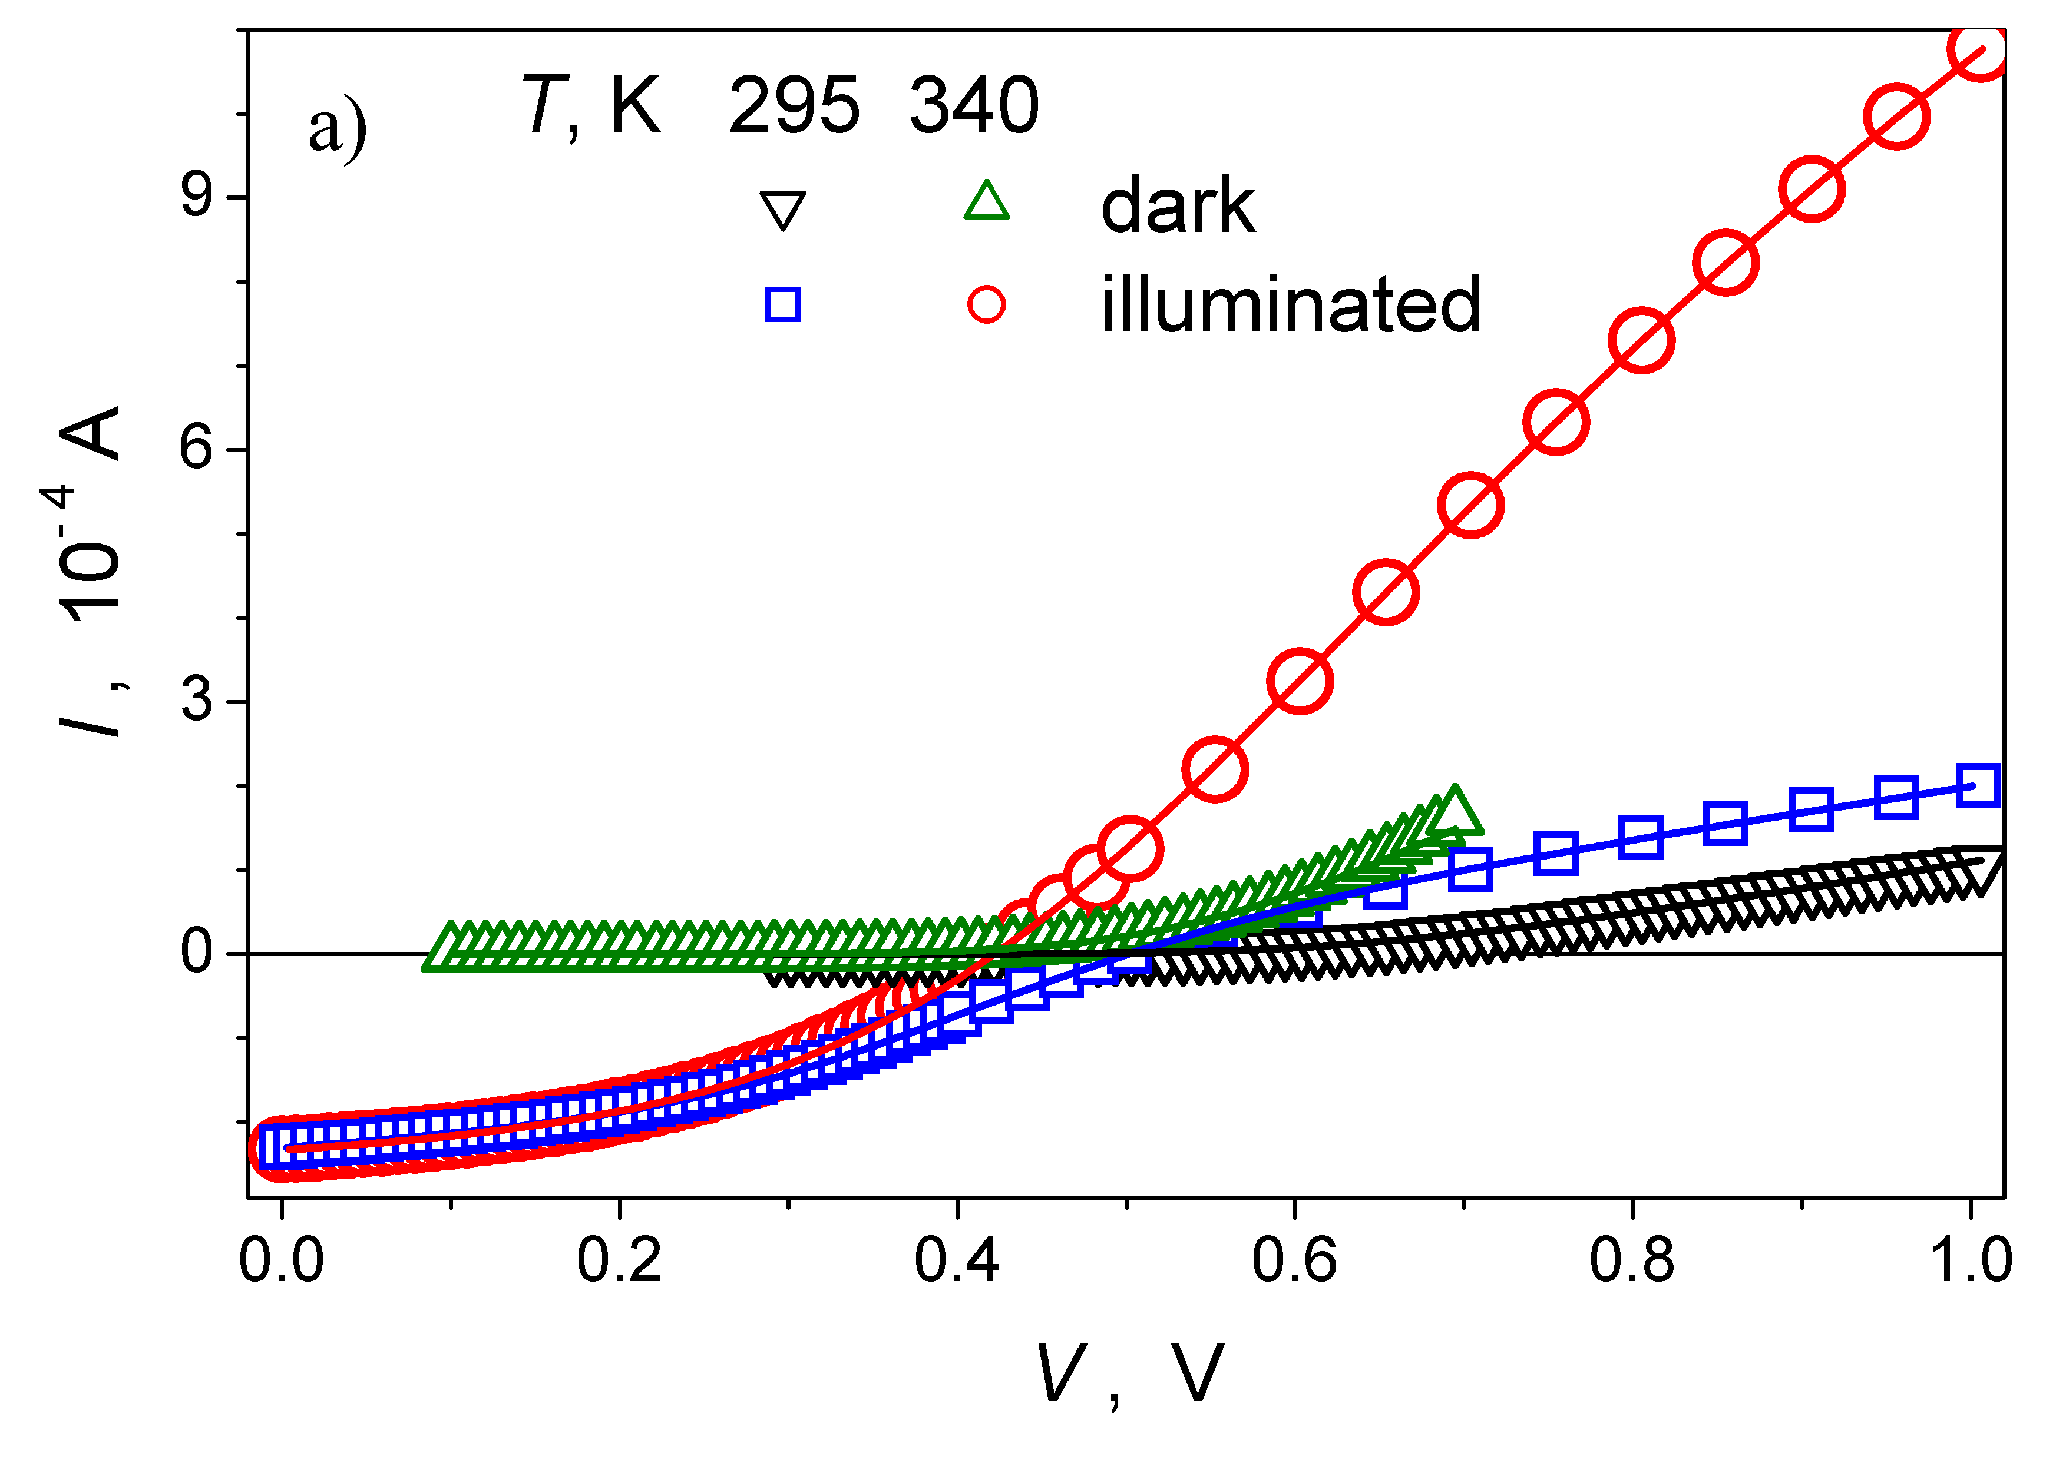 | 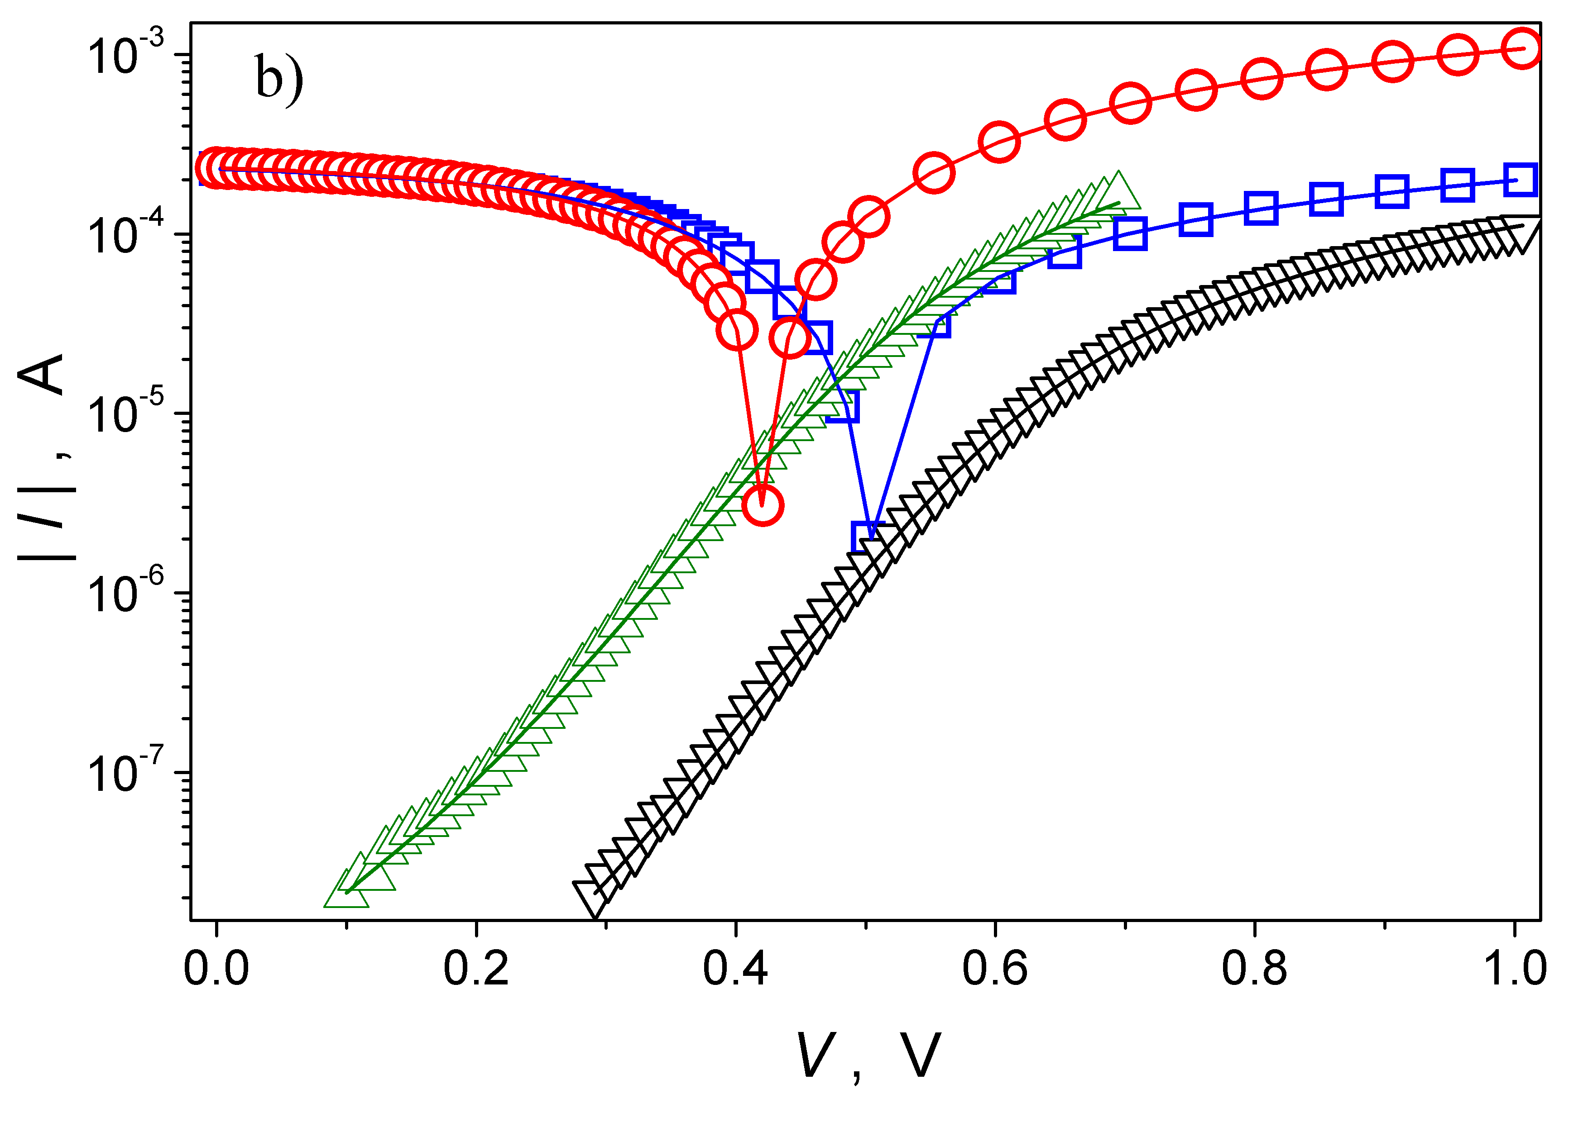
Fig.1. The dark (triangles) and illuminated (circles and squares) I-V curves for CuS–CdSe solar cell at different temperatures. The experimental (marks) and fitted (solid lines) results are presented.

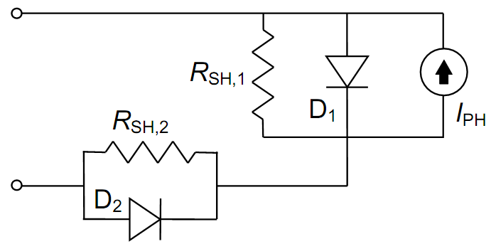 | 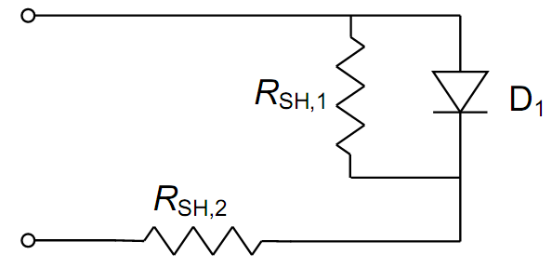
Fig.2. The proposed DC lumped-parameter equivalent circuit model of CuS–CdSe solar cell under illumination (left) and dark condition (right).

R_{SH,1}
R_{SH,2}
I_{PH}
D₁
D₂

R_{SH,1}
R_{SH,2}
D₁
Figure. Temperature dependencies of tunneling parameter 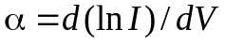 (a), series resistance (b) and barrier height (c). The measurements were taken before UST (curves 1, squares), immediately after UST (curves 2, circles), and after UST and ~75 h room temperature storage (curves 3, triangles).

