SUPPLEMENTARY MATERIAL

TABLE I
Parameters’ values used for training dataset creation
Parameter | Value
d_{р},μm | 150, 180, 210, 240  (4 values)
N_{B},cm⁻³ | 10¹⁵ , 1.778×10¹⁵, 3.162×10¹⁵, 5.623×10¹⁵, 10¹⁶ , 1.778×10¹⁶, 3.162×10¹⁶, 5.623×10¹⁶, 10¹⁷  (9 values)
N_{Fe},cm⁻³ | 10¹⁰, 1.468×10¹⁰, 2.154×10¹⁰, 3.162×10¹⁰, 4.642×10¹⁰, 6.813×10¹⁰, 10¹¹, 1.468×10¹¹, 2.154×10¹¹, 3.162×10¹¹, 4.642×10¹¹, 6.813×10¹¹, 10¹², 1.468×10¹², 2.154×10¹², 3.162×10¹², 4.642×10¹², 6.813×10¹², 10¹³  (19 values)
T, K | 290, 295,300, 305, 310, 315, 320, 325, 330, 335, 340  (11 values)
# of IV pair | 4 × 9 × 19 × 11 = 7524

TABLE II
Parameters’ values used for test dataset creation
N_{B},cm⁻³ |  | N_{Fe},cm⁻³ |  | d_{р},μm |  | T, K |  | # of IV pair
B-varied dataset
1.4×10¹⁵  (1 value) |  | 10¹⁰, 1.468×10¹⁰, 2.154×10¹⁰, 3.162×10¹⁰, 4.642×10¹⁰, 6.813×10¹⁰, 10¹¹, 1.468×10¹¹, 2.154×10¹¹, 3.162×10¹¹, 4.642×10¹¹, 6.813×10¹¹, 10¹², 1.468×10¹², 2.154×10¹², 3.162×10¹², 4.642×10¹², 6.813×10¹², 10¹³  (19 values) |  | 150, 180  (2 values) |  | 290, 295, 300, 305, 310, 315, 320, 325, 330, 335, 340  (11 values) |  | 1×19×2×11= 418
4.5×10¹⁵ , 8×10¹⁶  (2 values) |  | 10¹⁰, 2.154×10¹⁰, 3.162×10¹⁰, 1.468×10¹¹, 2.154×10¹¹, 4.642×10¹¹, 10¹², 2.154×10¹², 3.162×10¹², 4.642×10¹², 6.813×10¹², 10¹³  (12 values) |  | 210  (1 value) |  | 290, 305, 320, 340  (4 values) |  | 2×12×1×4 = 96
 |  |  |  |  |  |  |  | 96 + 418 = 514
 | Fe-varied dataset
 | 1.778×10¹⁵, 5.623×10¹⁵, 10¹⁶ , 3.162×10¹⁶, 10¹⁷  (5 values) |  | 1.3×10¹⁰, 2.471×10¹⁰, 4.696×10¹⁰, 8.927×10¹⁰, 1.697×10¹¹, 3.225×10¹¹, 6.13×10¹¹, 1.165×10¹², 2.214×10¹², 4.209×10¹², 8×10¹²  (11 values) |  | 180  (1 value) |  | 290, 295, 300, 305, 310, 315, 320, 325, 330, 335, 340  (11 values) |  | 5×11×1×11 = 605
 | 3.162×10¹⁵, 10¹⁶ , 10¹⁷  (3 values) |  | 1.2×10¹¹, 2.234×10¹¹, 4.16×10¹¹, 7.746×10¹¹, 1.442×10¹², 2.685×10¹², 5×10¹²  (7 values) |  | 210, 240  (2 values) |  | 290, 300, 310, 320, 330, 340  (6 values) |  | 3×7×2×6 = 252
 |  |  |  |  |  |  |  |  | 605 + 252 = 857
 | d-varied dataset
 | 10¹⁵ , 5.623×10¹⁵, 1.778×10¹⁶, 5.623×10¹⁶  (4 values) |  | 10¹⁰, 1.468×10¹⁰, 2.154×10¹⁰, 3.162×10¹⁰, 4.642×10¹⁰, 6.813×10¹⁰, 10¹¹, 1.468×10¹¹, 2.154×10¹¹, 3.162×10¹¹, 4.642×10¹¹, 6.813×10¹¹, 10¹², 1.468×10¹², 2.154×10¹², 3.162×10¹², 4.642×10¹², 6.813×10¹², 10¹³  (19 values) |  | 190  (1 value) |  | 290, 300, 310, 320, 330, 340  (6 values) |  | 4×19×1×6 = 456
 | 10¹⁵ , 1.778×10¹⁵, 3.162×10¹⁵, 5.623×10¹⁵, 10¹⁶ , 1.778×10¹⁶, 3.162×10¹⁶, 5.623×10¹⁶, 10¹⁷  (9 values) |  | 10¹⁰, 3.162×10¹⁰, 10¹¹, 3.162×10¹¹, 10¹², 3.162×10¹², 10¹³  (7 values) |  | 205  (1 value) |  | 295, 305, 315, 325, 335  (5 values) |  | 9×7×1×5 = 315
 | 1.778×10¹⁵, 10¹⁶  (2 values) |  | 10¹⁰, 1.468×10¹⁰, 2.154×10¹⁰, 3.162×10¹⁰, 4.642×10¹⁰, 6.813×10¹⁰, 10¹¹, 1.468×10¹¹, 2.154×10¹¹, 3.162×10¹¹, 4.642×10¹¹, 6.813×10¹¹, 10¹², 1.468×10¹², 2.154×10¹², 3.162×10¹², 4.642×10¹², 6.813×10¹², 10¹³  (19 values) |  | 230  (1 value) |  | 290, 295, 300, 305, 310, 315, 320, 325, 330, 335, 340  (11 values) |  | 2×19×1×11 = 418
 |  |  |  |  |  |  |  |  | 456+315+418= 1189
 | T-varied dataset
 | 10¹⁵ , 1.778×10¹⁵, 3.162×10¹⁵, 5.623×10¹⁵, 10¹⁶ , 1.778×10¹⁶, 3.162×10¹⁶, 5.623×10¹⁶, 10¹⁷  (9 values) |  | 1.468×10¹⁰, 4.642×10¹⁰, 6.813×10¹⁰, 1.468×10¹¹, 4.642×10¹¹, 6.813×10¹¹, 2.154×10¹², 4.642×10¹²  (8 values) |  | 210  (1 value) |  | 314  (1 value) |  | 9×8×1×1 = 72
 | 10¹⁵ , 5.623×10¹⁵, 1.778×10¹⁶, 3.162×10¹⁶  (4 values) |  | 10¹⁰, 1.468×10¹⁰, 2.154×10¹⁰, 3.162×10¹⁰, 4.642×10¹⁰, 6.813×10¹⁰, 10¹¹, 1.468×10¹¹, 2.154×10¹¹, 3.162×10¹¹, 4.642×10¹¹, 6.813×10¹¹, 10¹², 1.468×10¹², 2.154×10¹², 3.162×10¹², 4.642×10¹², 6.813×10¹², 10¹³  (19 values) |  | 150, 180, 210, 240  (4 values) |  | 303  (1 value) |  | 4×19×4×1 = 304
 | 1.778×10¹⁵, 1.778×10¹⁶, 10¹⁷  (3 values) |  |  |  | 150, 180  (2 values) |  | 293  (1 value) |  | 3×19×2×1 = 114
 | 10¹⁵ , 1.778×10¹⁵, 3.162×10¹⁵, 5.623×10¹⁵, 10¹⁶ , 1.778×10¹⁶, 3.162×10¹⁶, 5.623×10¹⁶, 10¹⁷  (9 values) |  |  |  | 180, 240  (2 values) |  | 336  (1 value) |  | 9×19×2×1 = 342
 |  |  |  |  |  |  |  |  | 72+304+114+342 = 832
 | All-varied dataset
 | 1.3×10¹⁵ , 2×10¹⁶  (2 values) |  | 5×10¹², 6.082×10¹², 7.399×10¹², 9×10¹²  (4 values) |  | 200  (1 value) |  | 293, 313, 333  (3 values) |  | 2×4×1×3 = 24
 | 7×10¹⁵ , 4.5×10¹⁶  (2 values) |  | 5×10¹⁰, 5.861×10¹⁰, 6.869×10¹⁰, 8.051×10¹⁰, 9.437×10¹⁰, 1.106×10¹¹, 1.296×10¹¹, 1.52×10¹¹, 1.781×10¹¹, 2.088×10¹¹, 2.447×10¹¹, 2.868×10¹¹, 3.362×10¹¹, 3.94×10¹¹, 4.618×10¹¹, 5.413×10¹¹, 6.345×10¹¹, 7.437×10¹¹, 8.717×10¹¹, 1.022×10¹², 1.198×10¹², 1.404×10¹², 1.645×10¹², 1.928×10¹², 2.26×10¹², 2.649×10¹², 3.105×10¹², 3.639×10¹², 4.266×10¹², 5×10¹²  (30 values) |  | 170, 200  (2 values) |  | 297, 309, 321, 333  (4 values) |  | 2×30×2×4 = 480
 | 2.5×10¹⁵ , 8×10¹⁶  (2 values) |  | 1.1×10¹⁰, 1.302×10¹⁰, 1.54×10¹⁰, 1.822×10¹⁰, 2.156×10¹⁰, 2.551×10¹⁰, 3.018×10¹⁰, 3.571×10¹⁰, 4.226×10¹⁰, 5×10¹⁰, 1.1×10¹¹, 1.302×10¹¹, 1.54×10¹¹, 1.822×10¹¹, 2.156×10¹¹, 2.551×10¹¹, 3.018×10¹¹, 3.571×10¹¹, 4.226×10¹¹, 5×10¹¹,1.1×10¹², 1.302×10¹², 1.54×10¹², 1.822×10¹², 2.156×10¹², 2.551×10¹², 3.018×10¹², 3.571×10¹², 4.226×10¹², 5×10¹²  (30 values) |  | 220  (1 values) |  | 292, 302, 312  (3 values) |  | 2×30×1×3 = 180
 |  |  |  |  |  |  |  |  | 24+480+180= 684

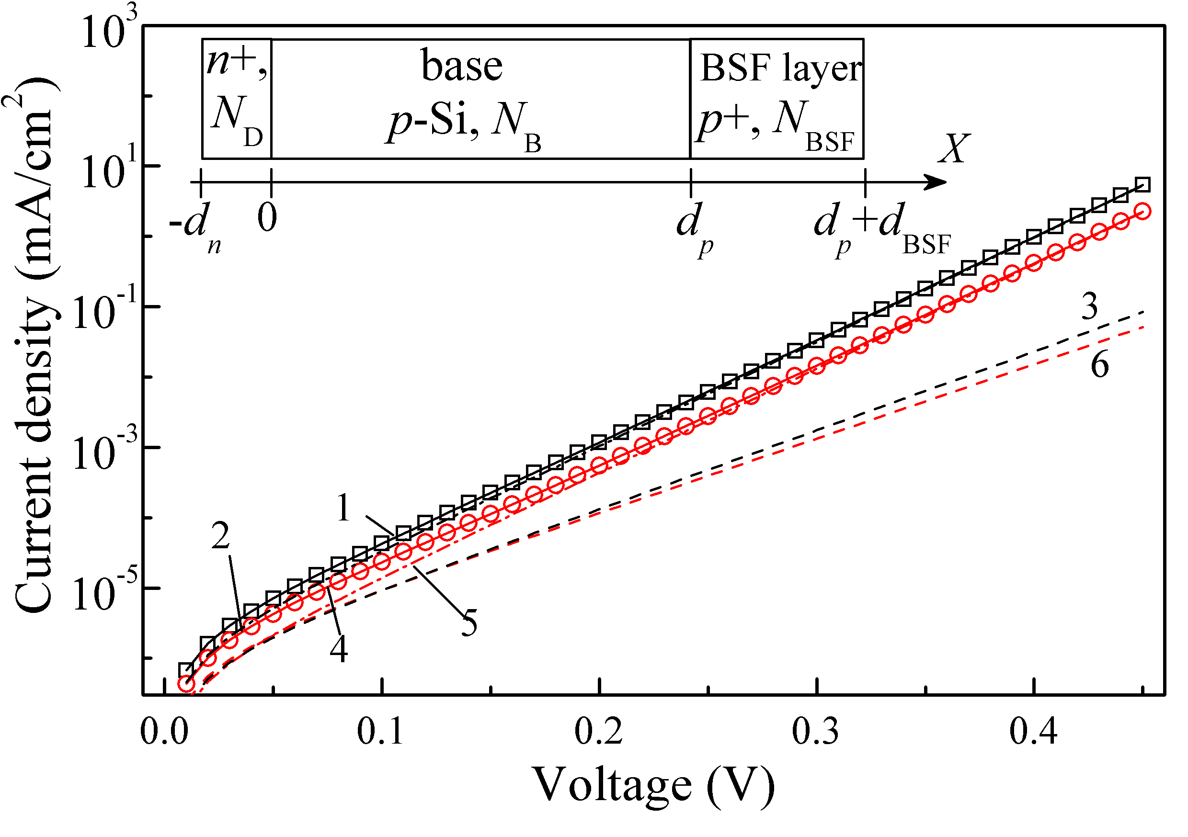
FIGURE 1S. Simulated IV characteristic (marks) and its fitting by Eq. (10) (solid lines 1 and 4). The dashed (3, 6) and dotted-dashed (2, 5) lines represent the recombination diode currents and the “ideal”' diode currents, respectively. N_{B} = 10¹⁷ cm⁻³ , N_{Fe} = 10¹³ cm⁻³ , T = 340 K, d_{p} = 180 μm. The results for “Fe”-case (circles, curves 4-6, red) and “Fe-FeB” case (squares, curves 1-3, black) are presented.
Inset: Solar cell structure, which are used in the simulation

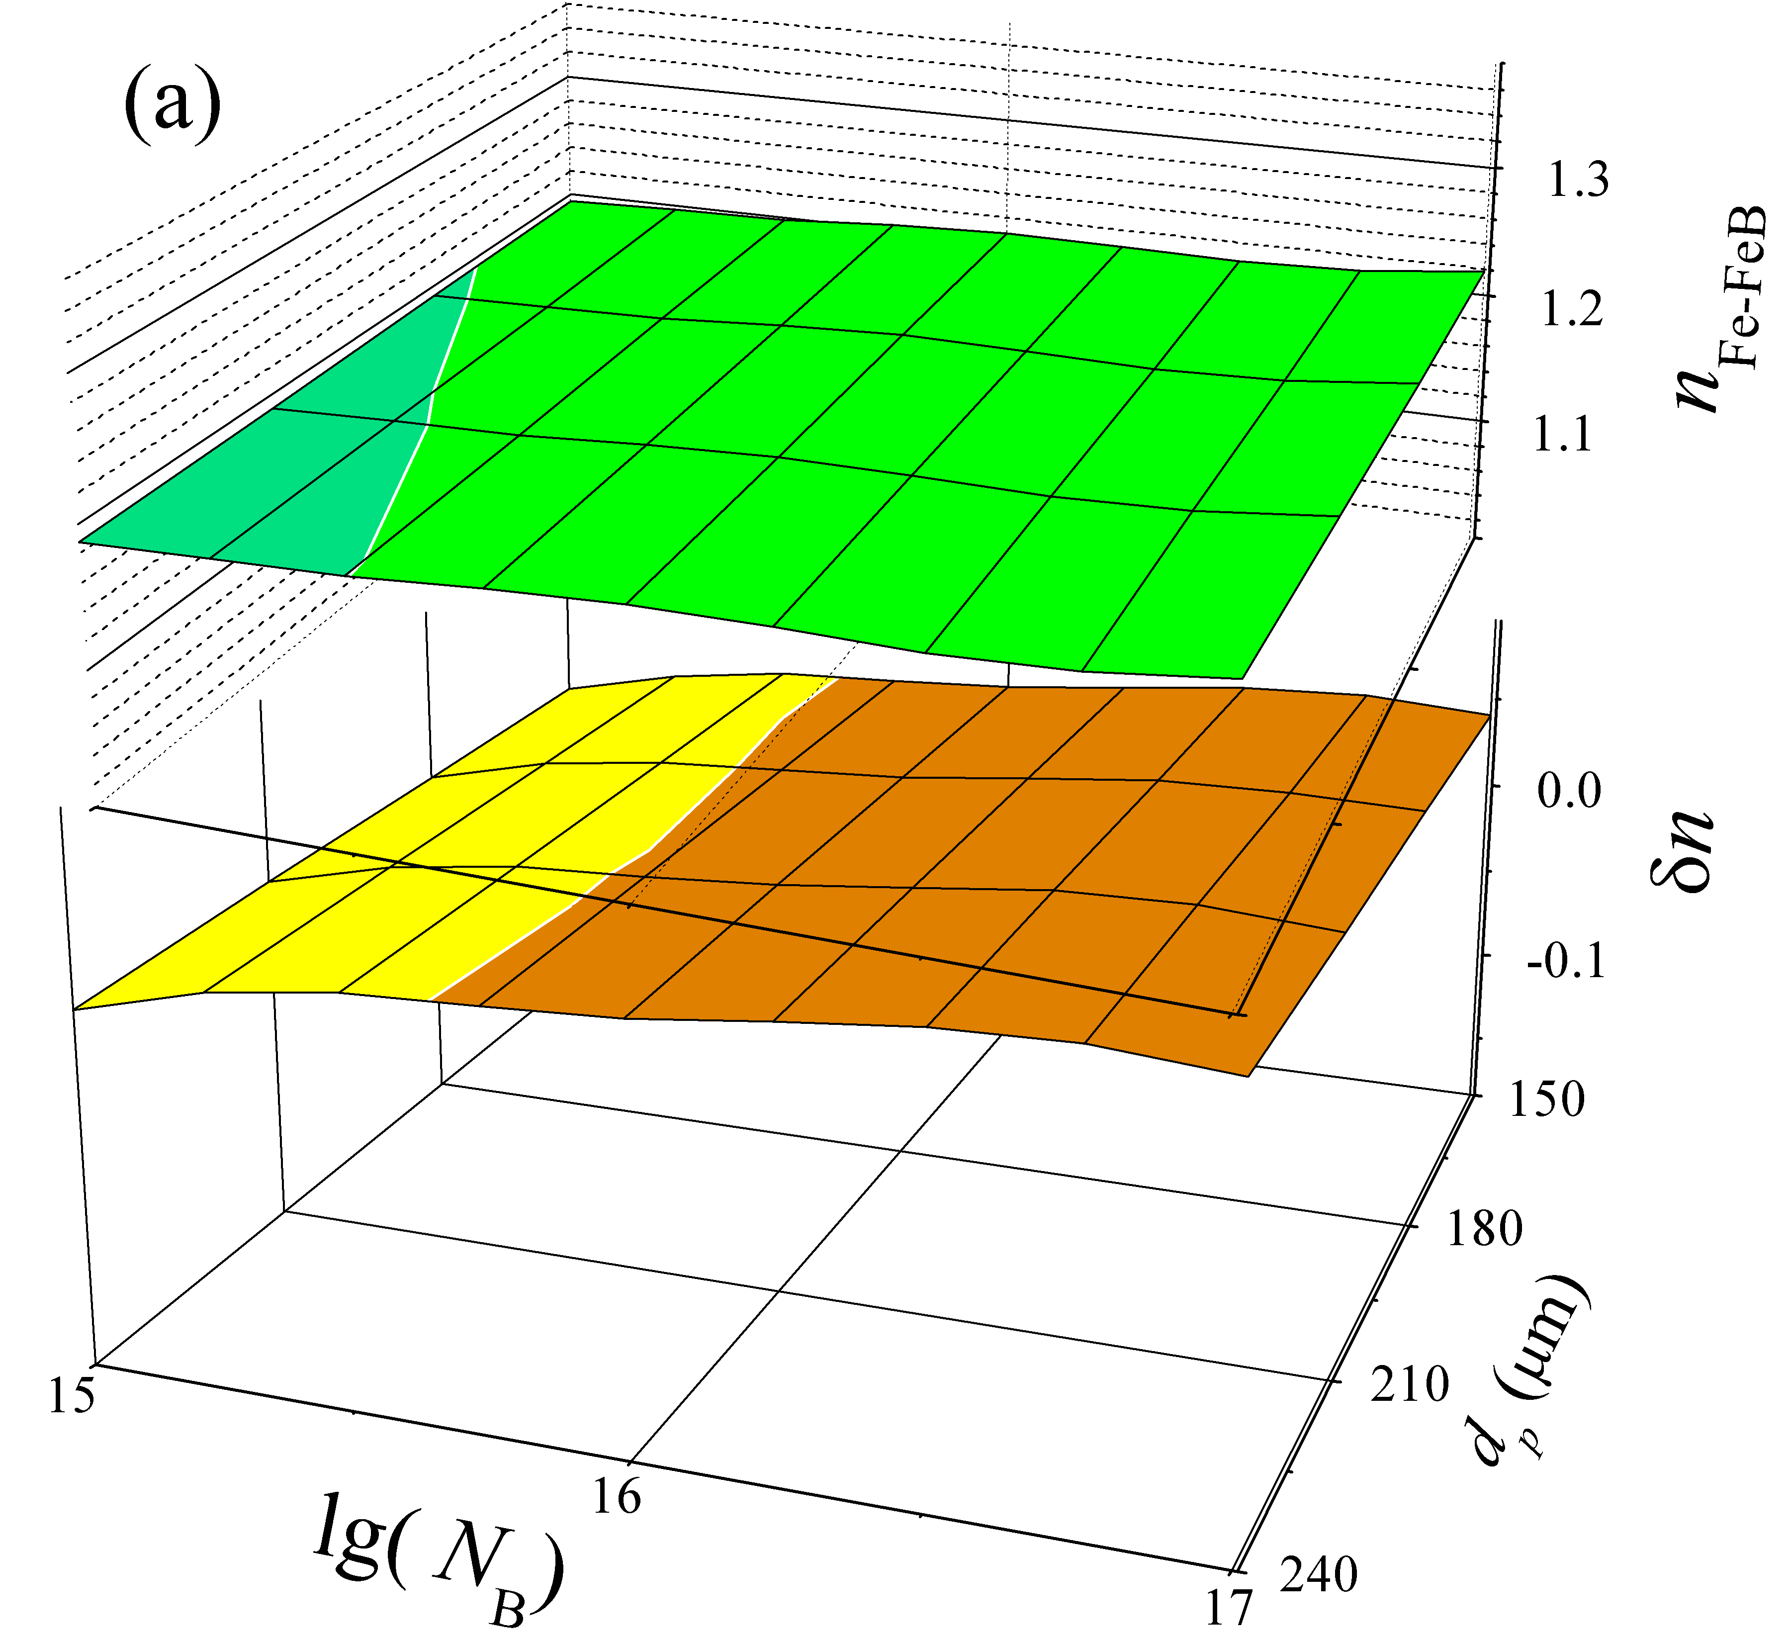 | 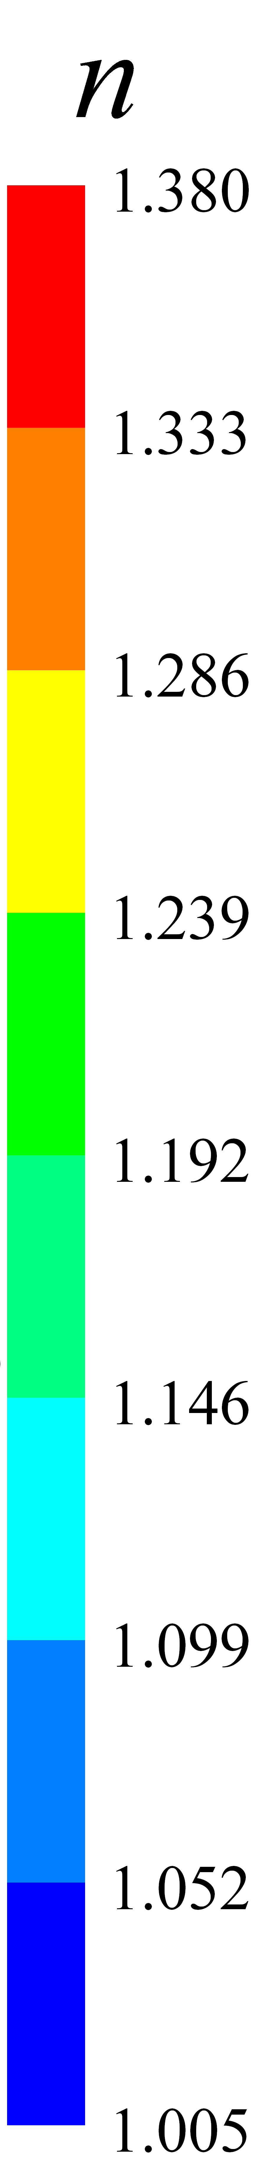 | 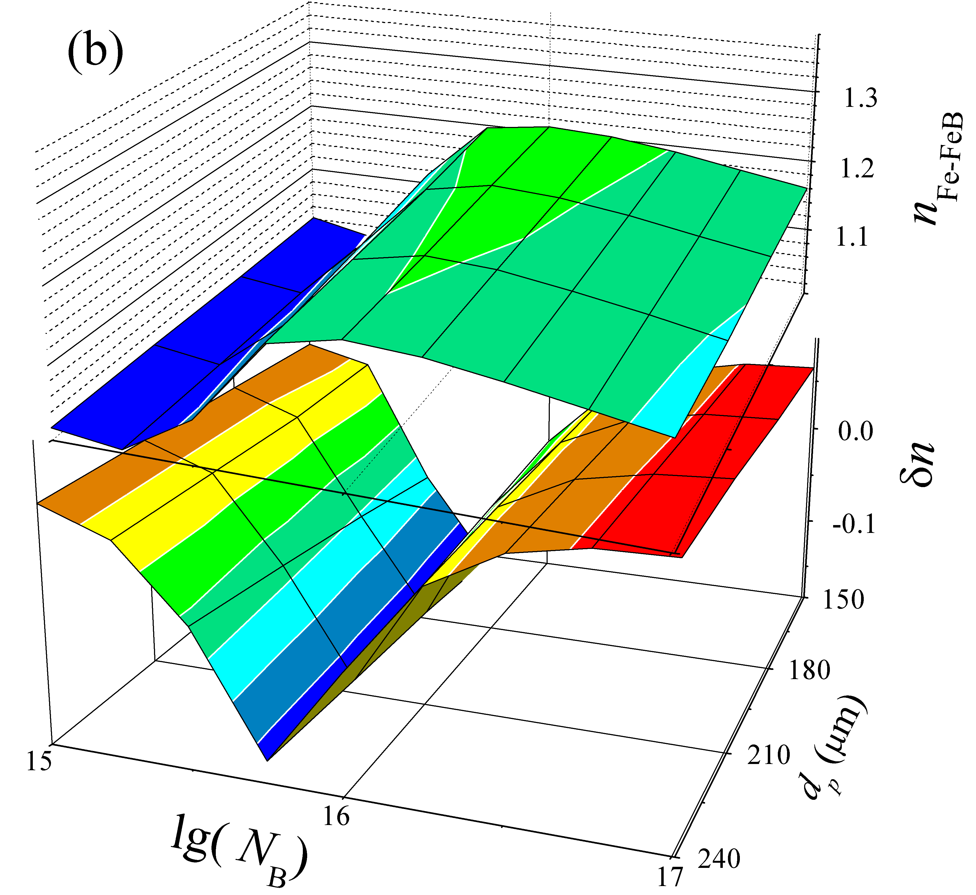
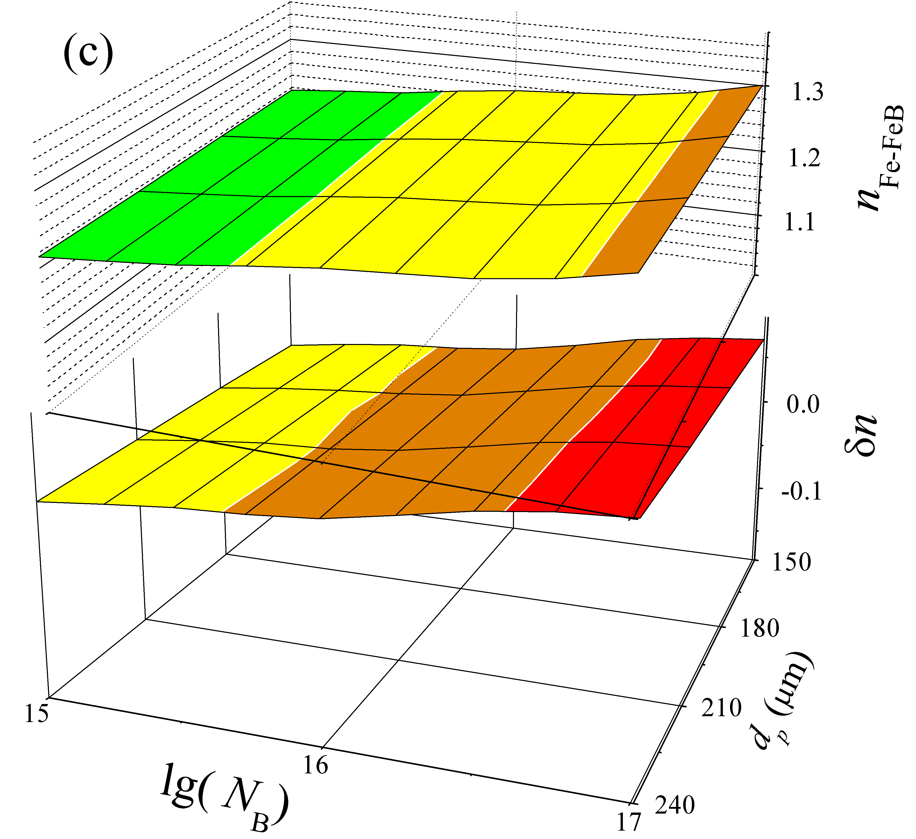 | 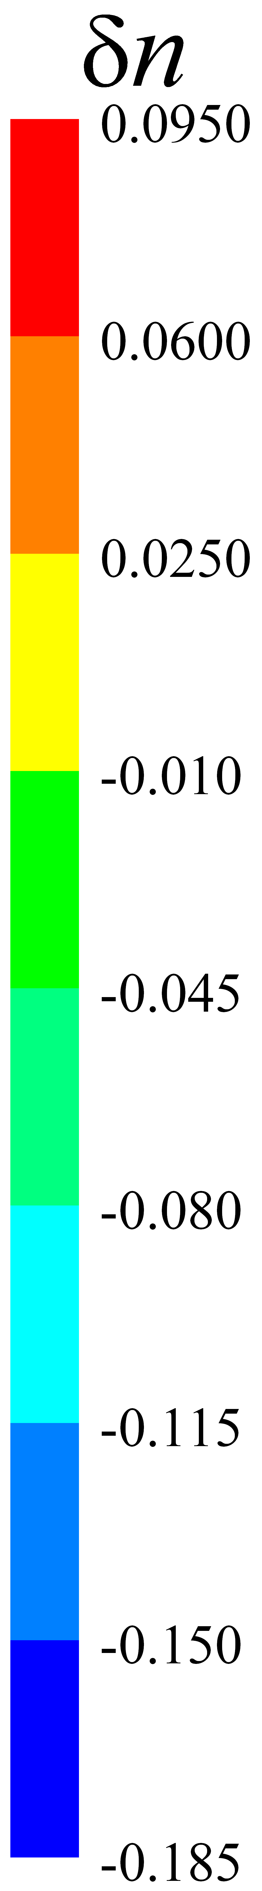 | 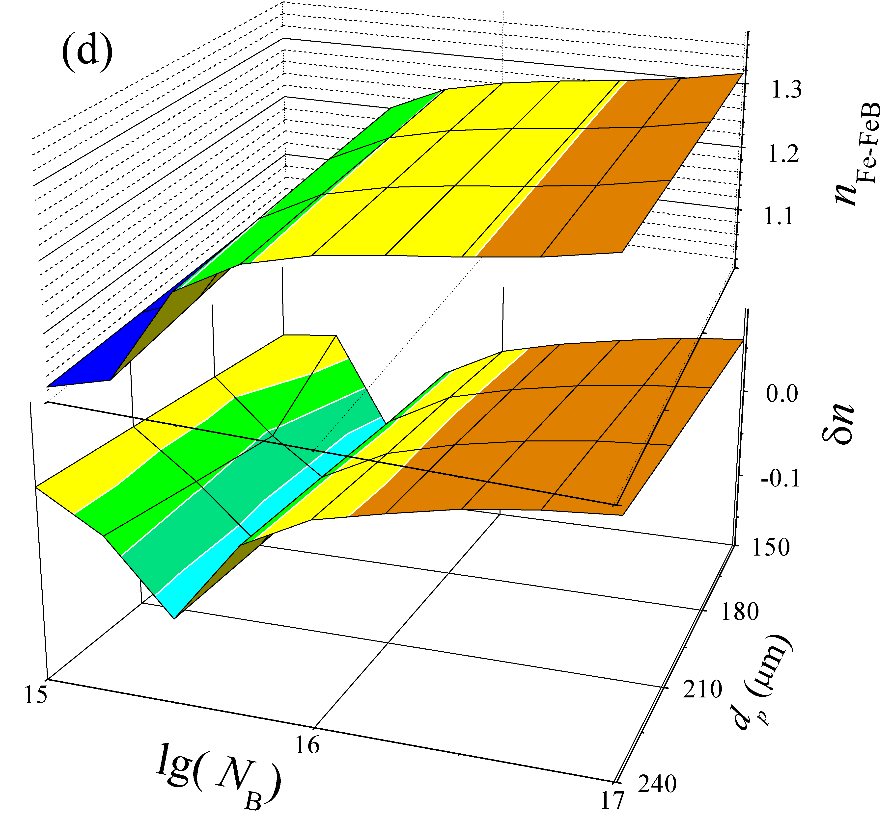
FIGURE 2S. Dependencies of ideality factor in Fe-FeB case (upper parts) and δn = n_{Fe}-n_{Fe-FeB} on doping level and base depth. N_{Fe}, cm⁻³: 10¹⁰ (а,b), 10¹³ (c,d); T, K: 290 (а,c), 340 (b,d)

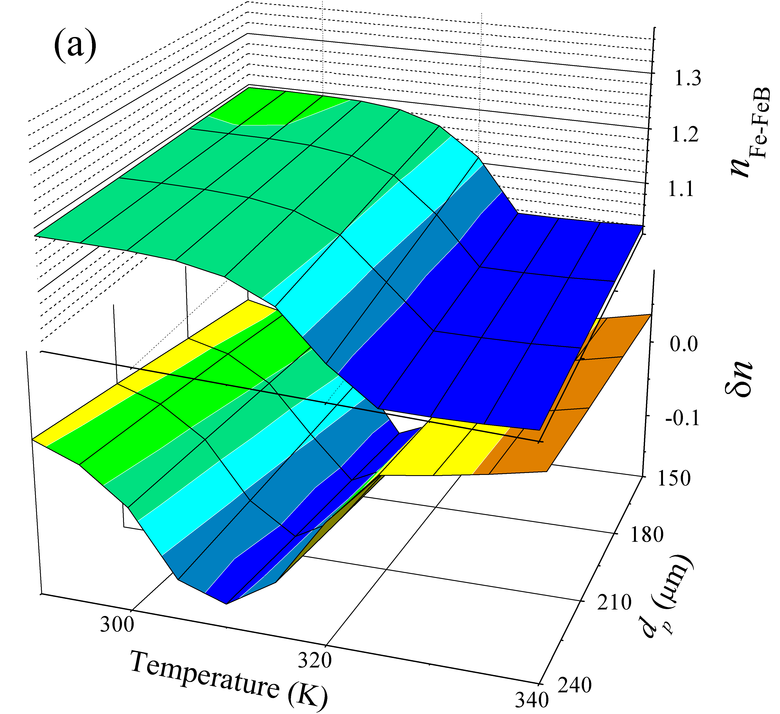 |  | 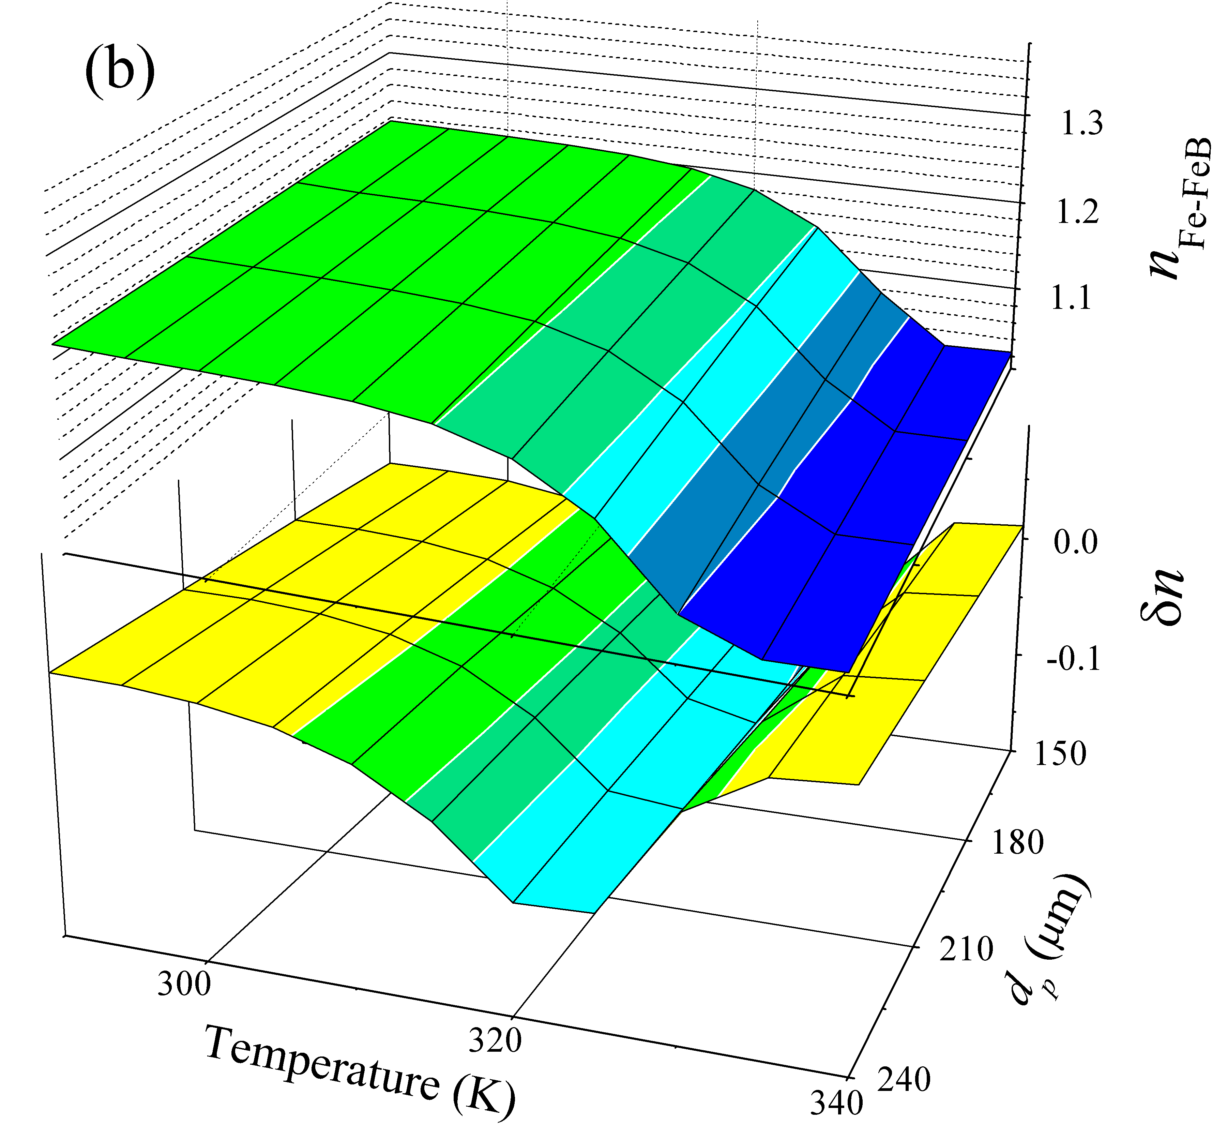
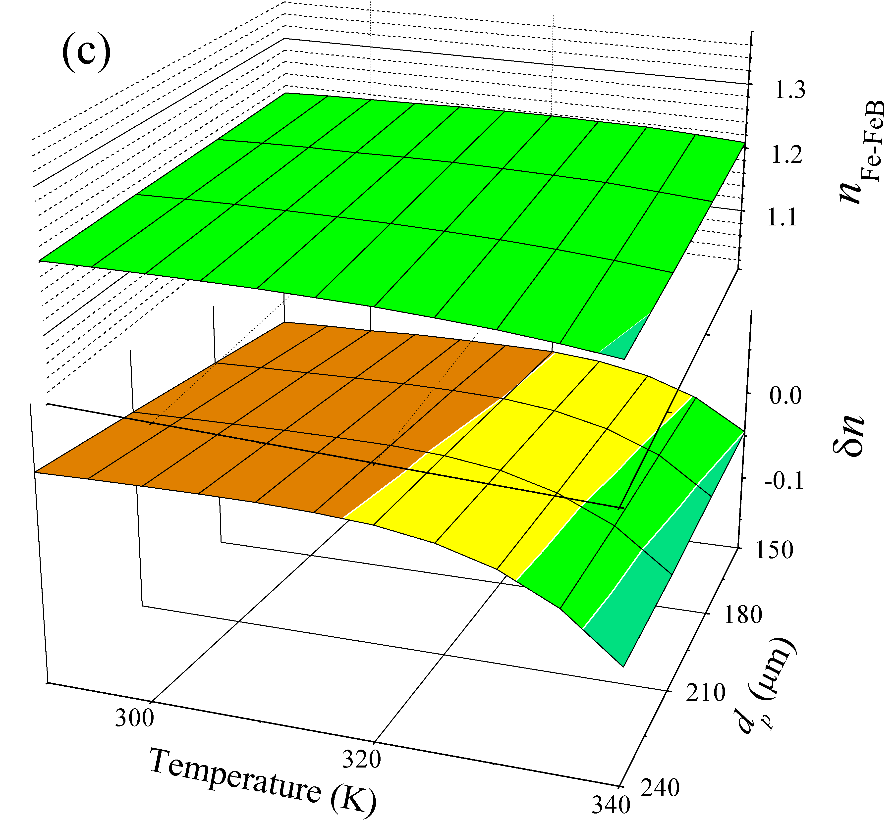 |  | 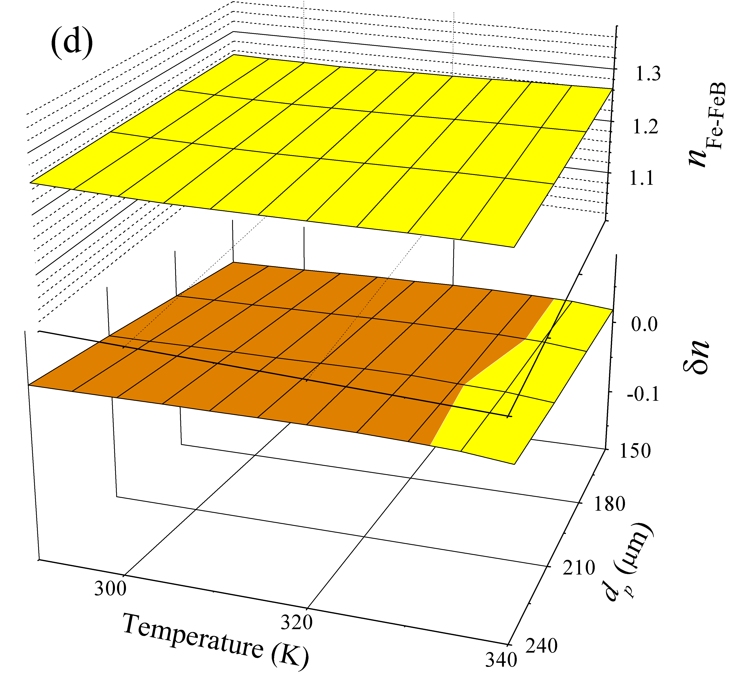
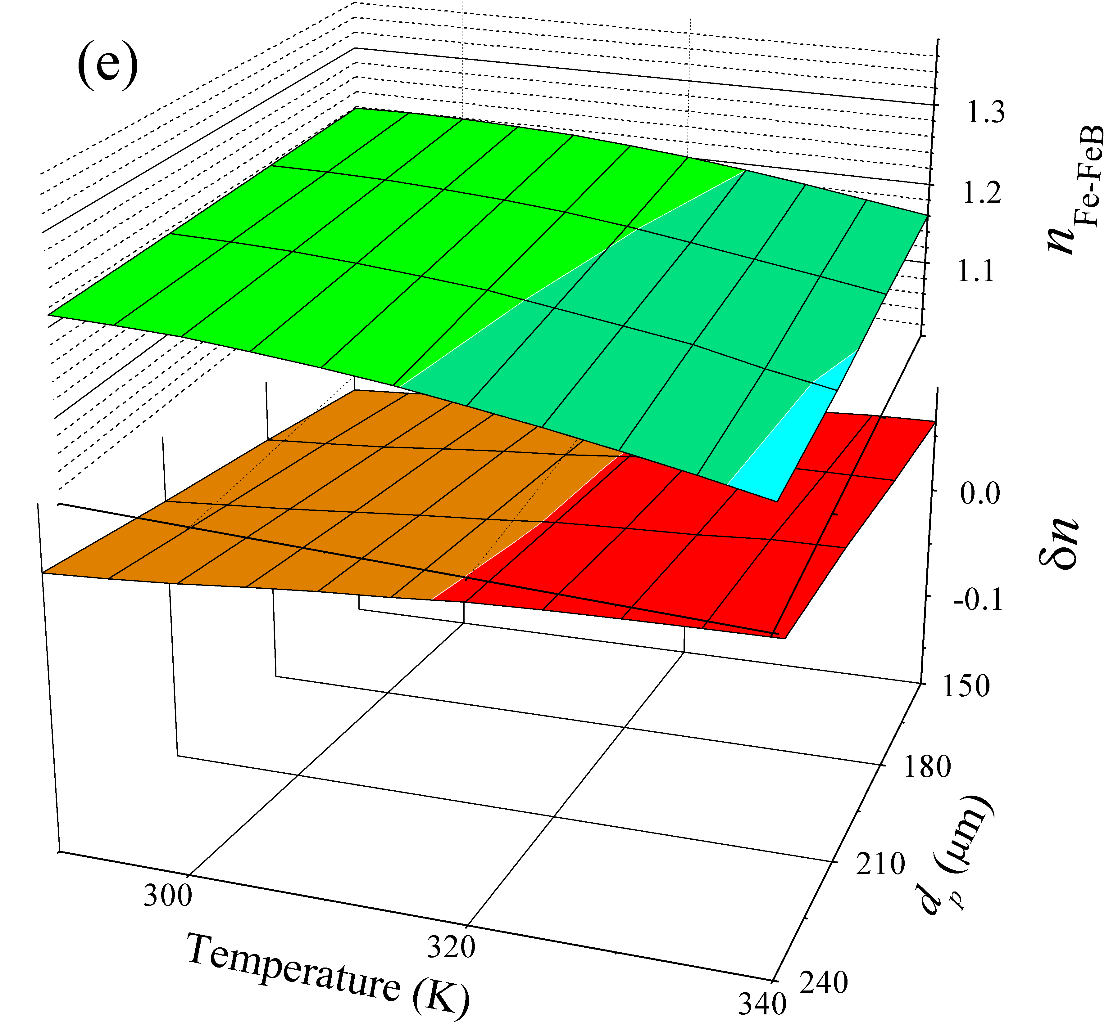 |  | 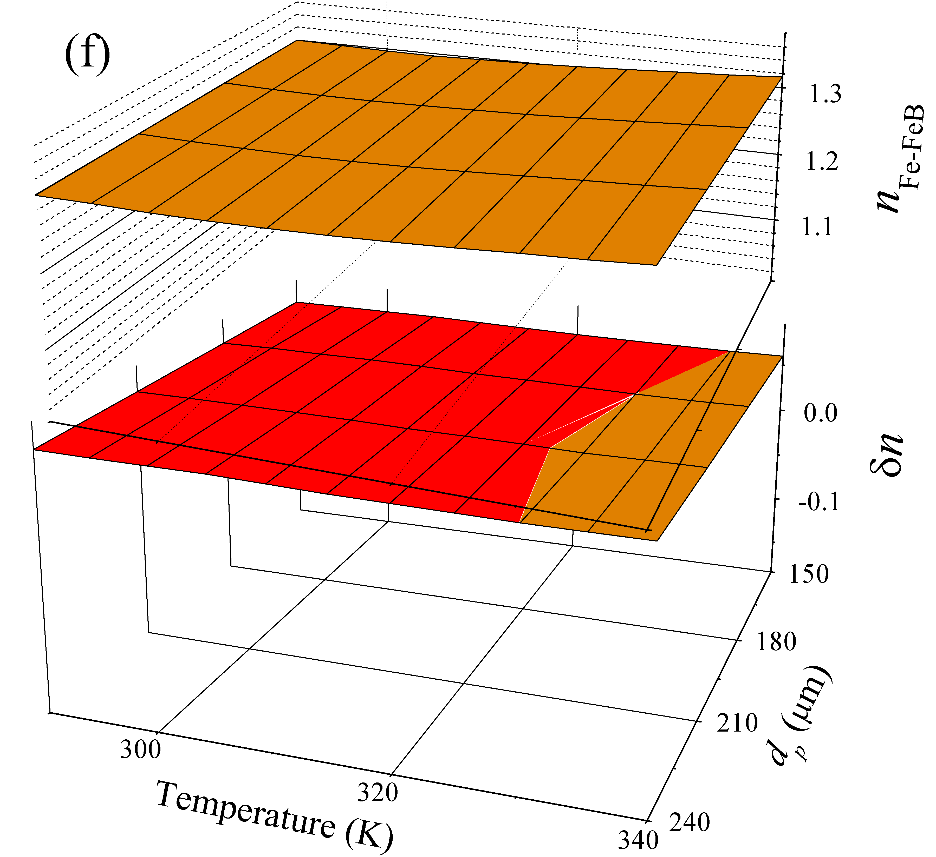
FIGURE 3S. Dependencies of ideality factor in Fe-FeB case (upper parts) and δn = n_{Fe}-n_{Fe-FeB} on temperature and base depth. N_{Fe}, cm⁻³: 10¹⁰ (а,c,e), 10¹³ (b,d,f); N_{А}, cm⁻³: 10¹⁵ (а,b), 10¹⁶ (c,d) , 10¹⁷ (e,f).

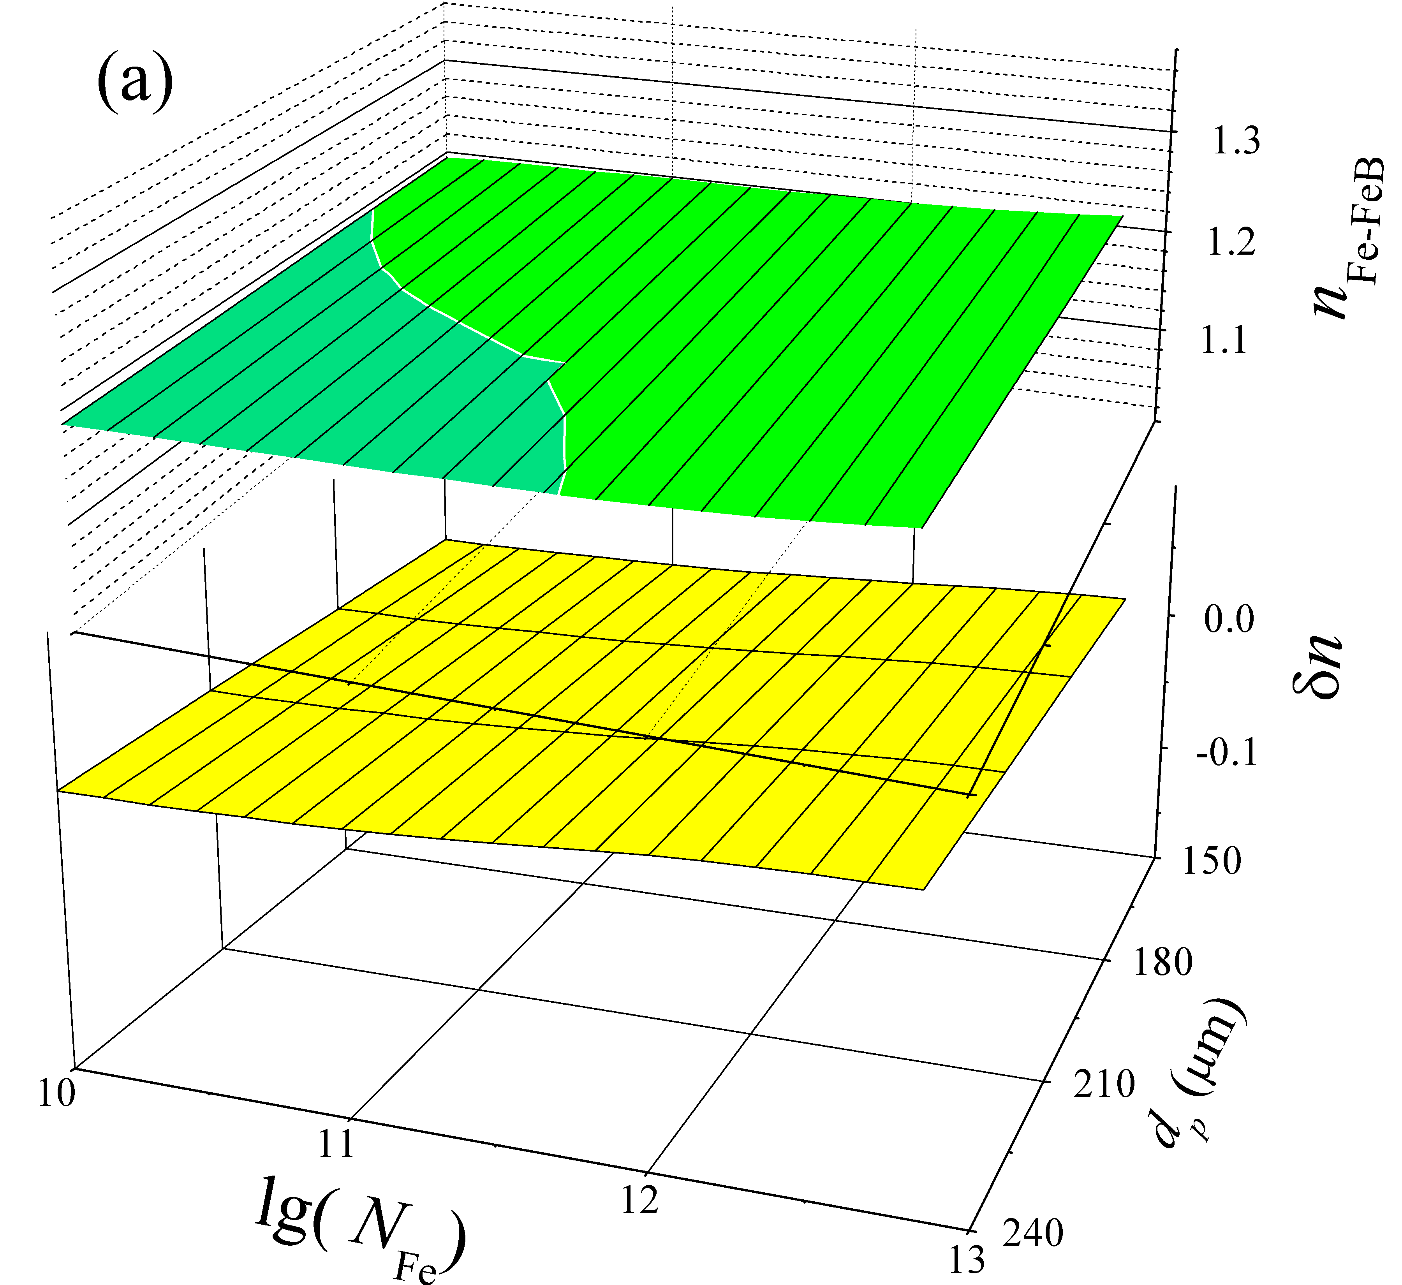 |  | 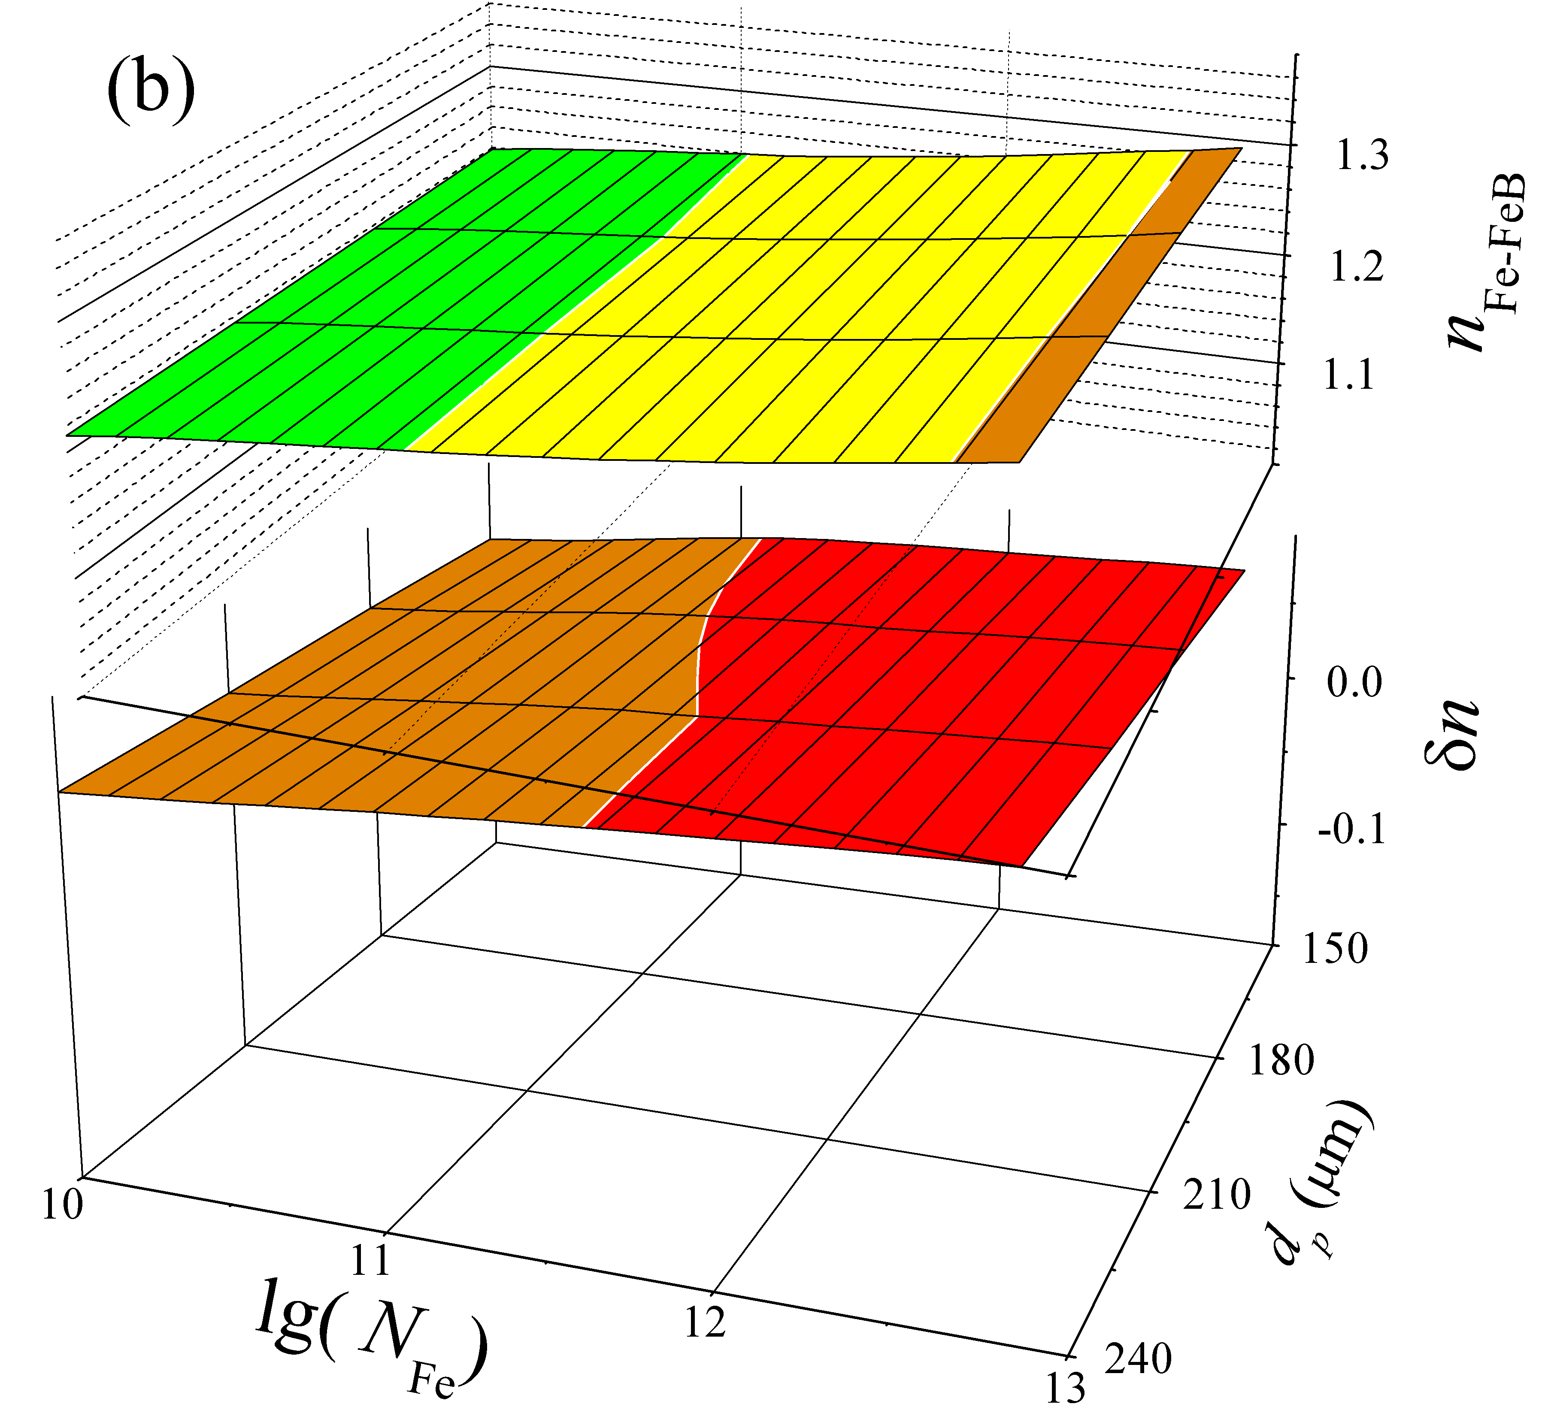
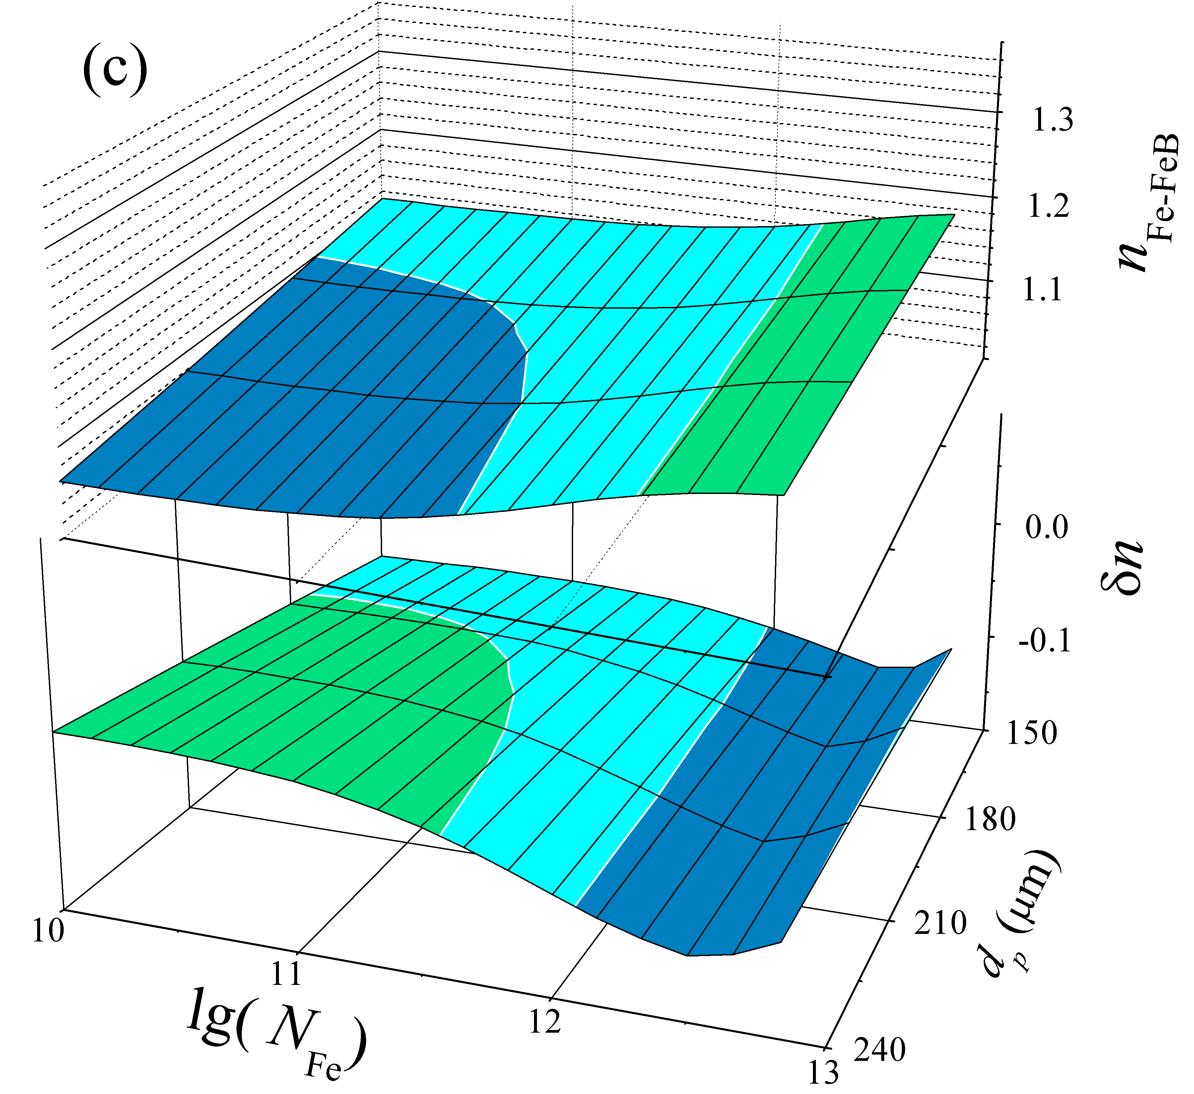 |  | 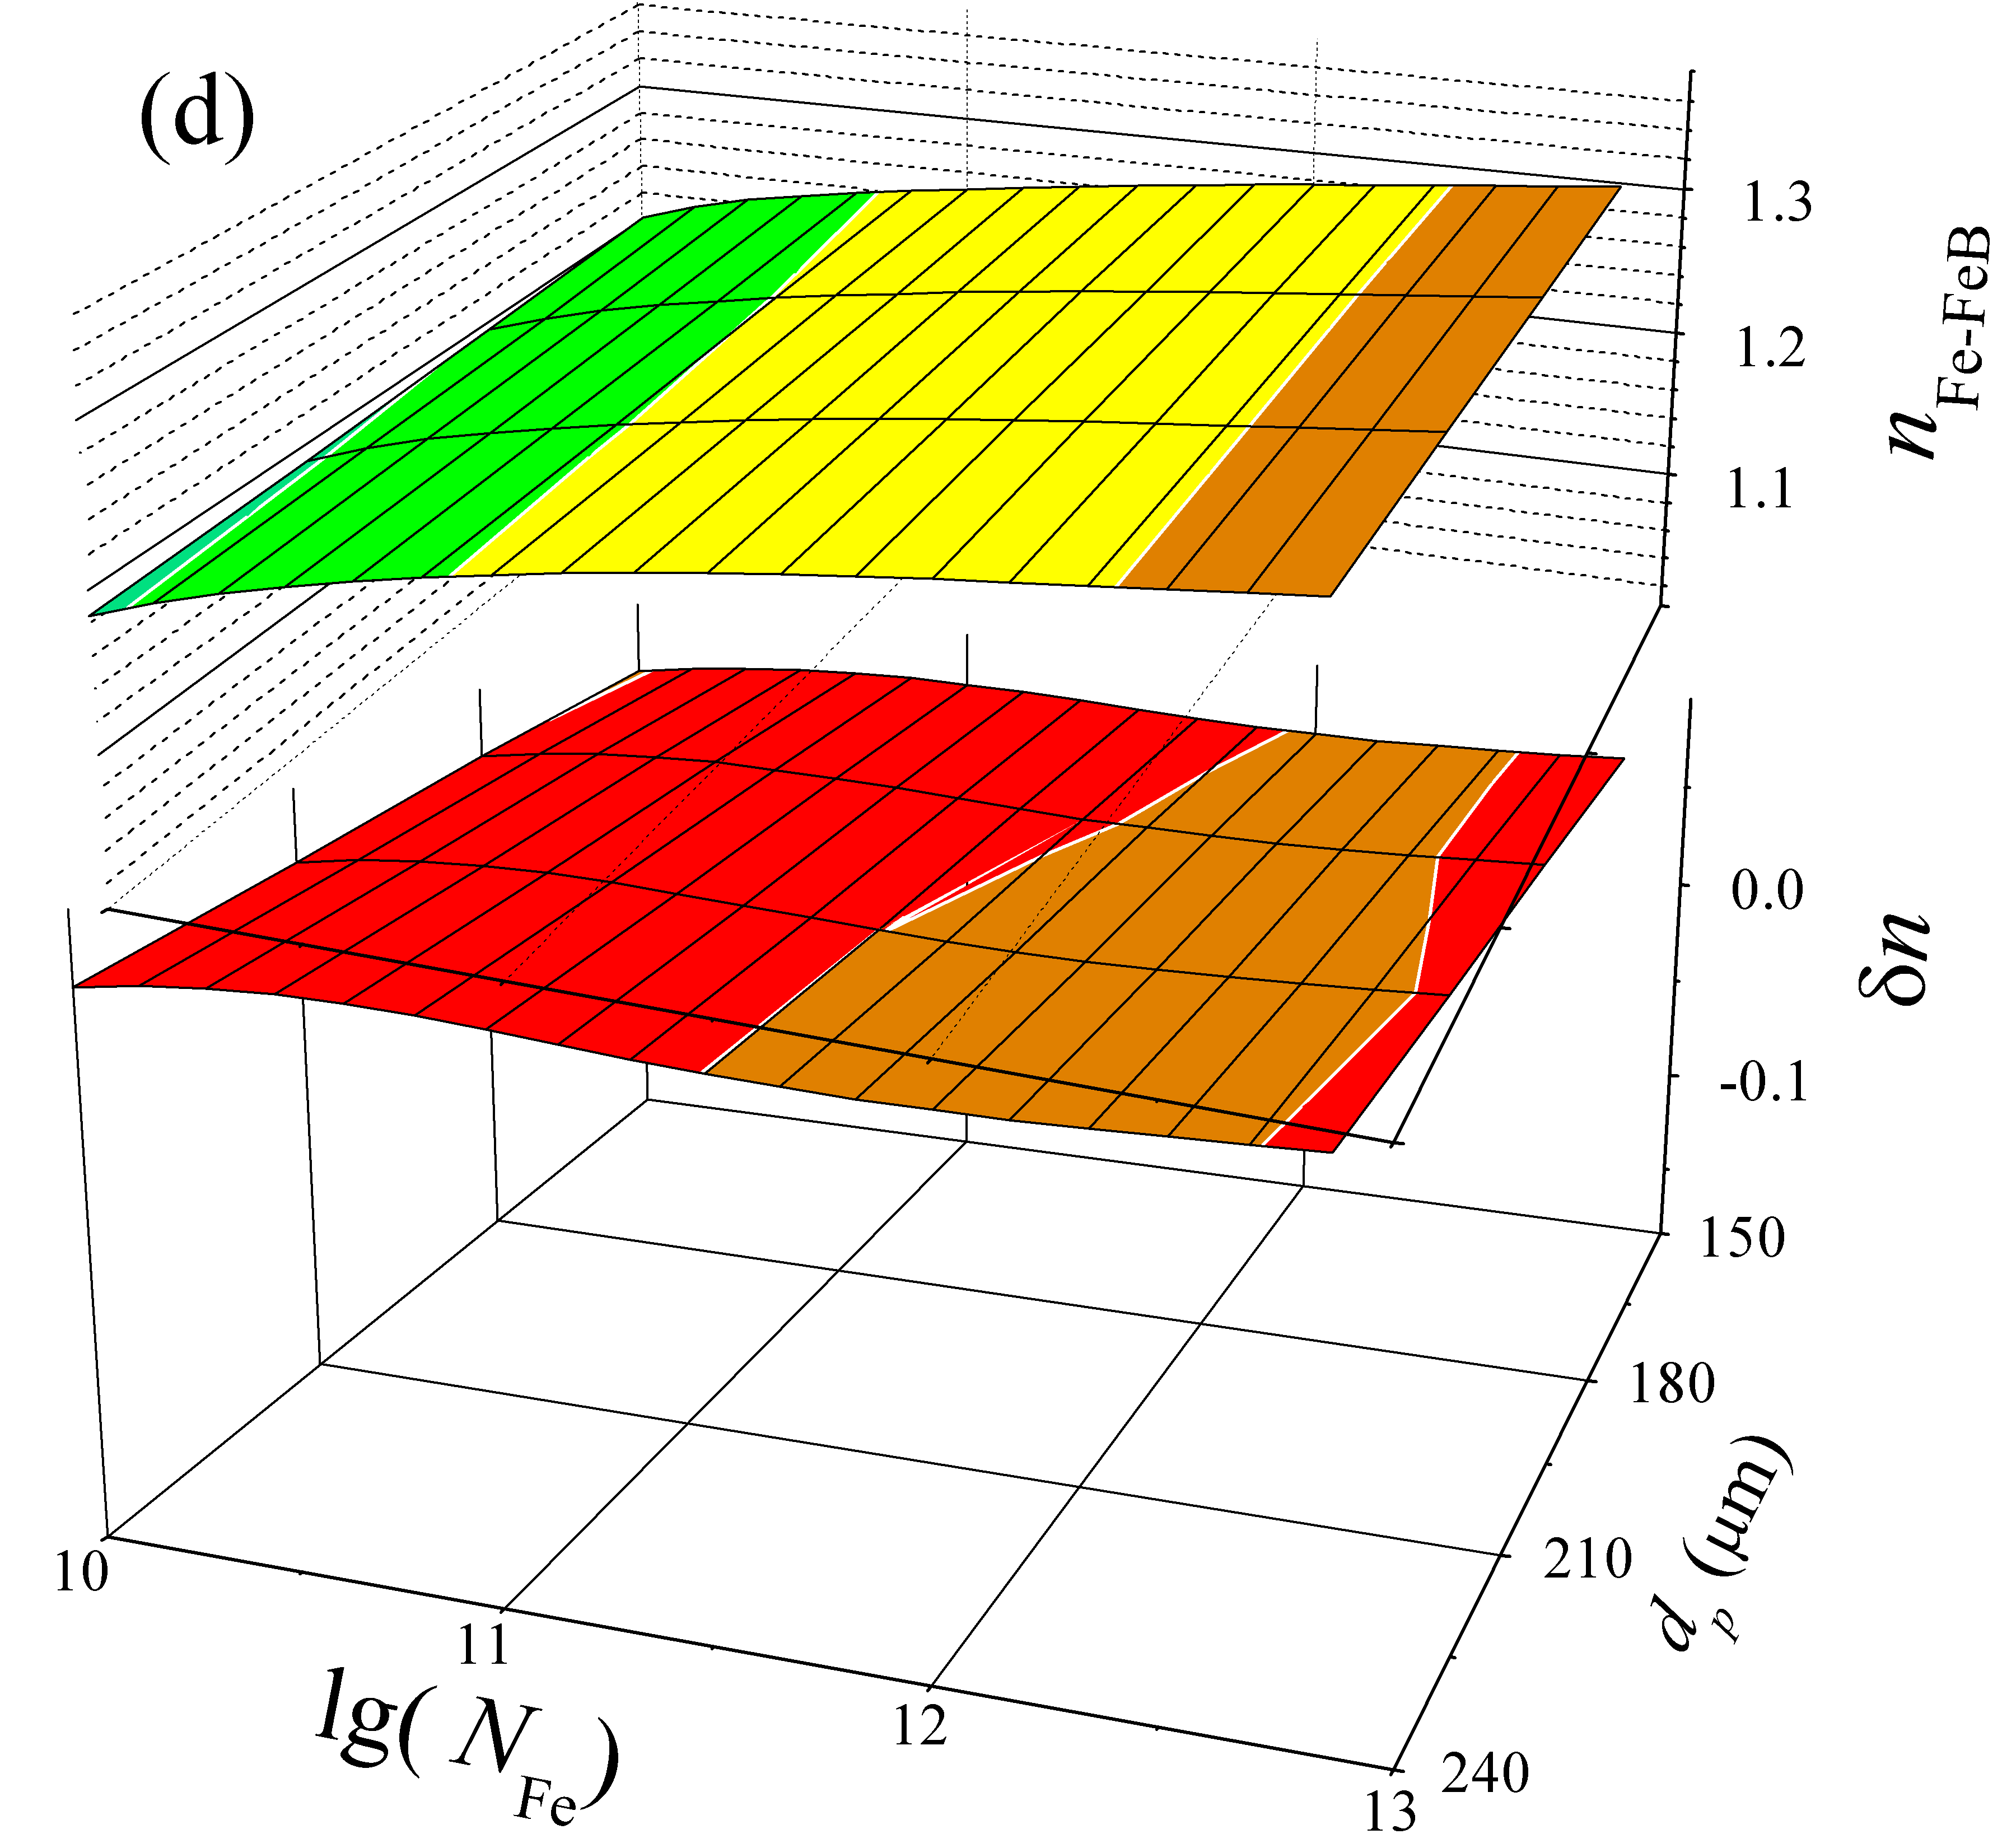
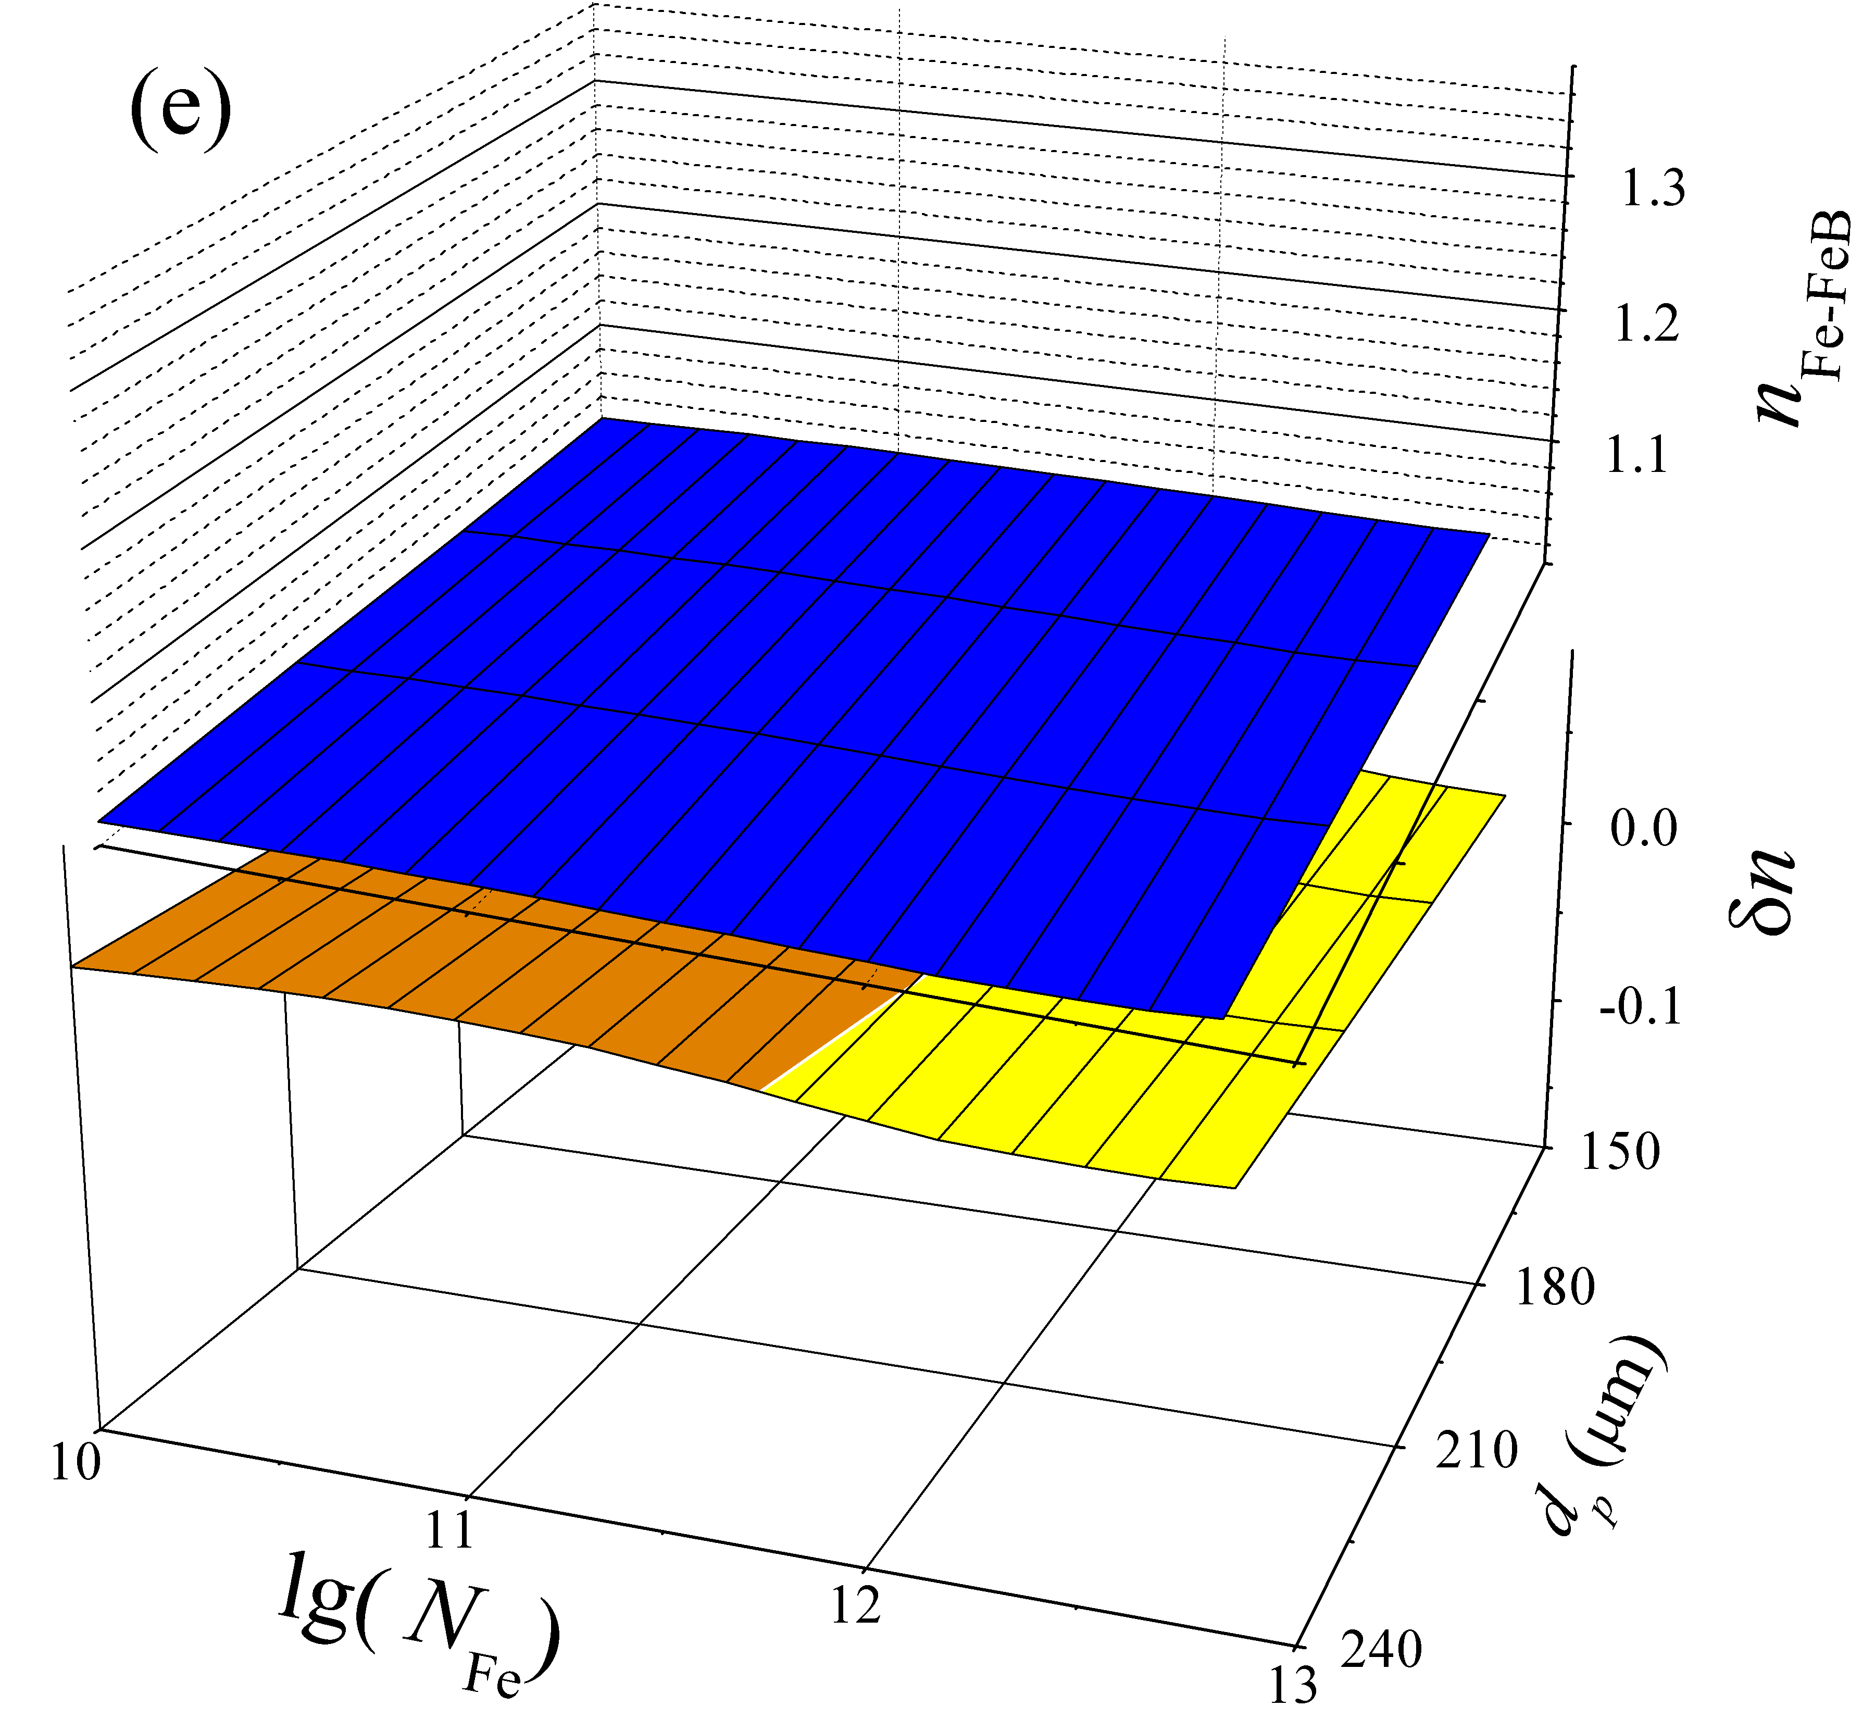 |  | 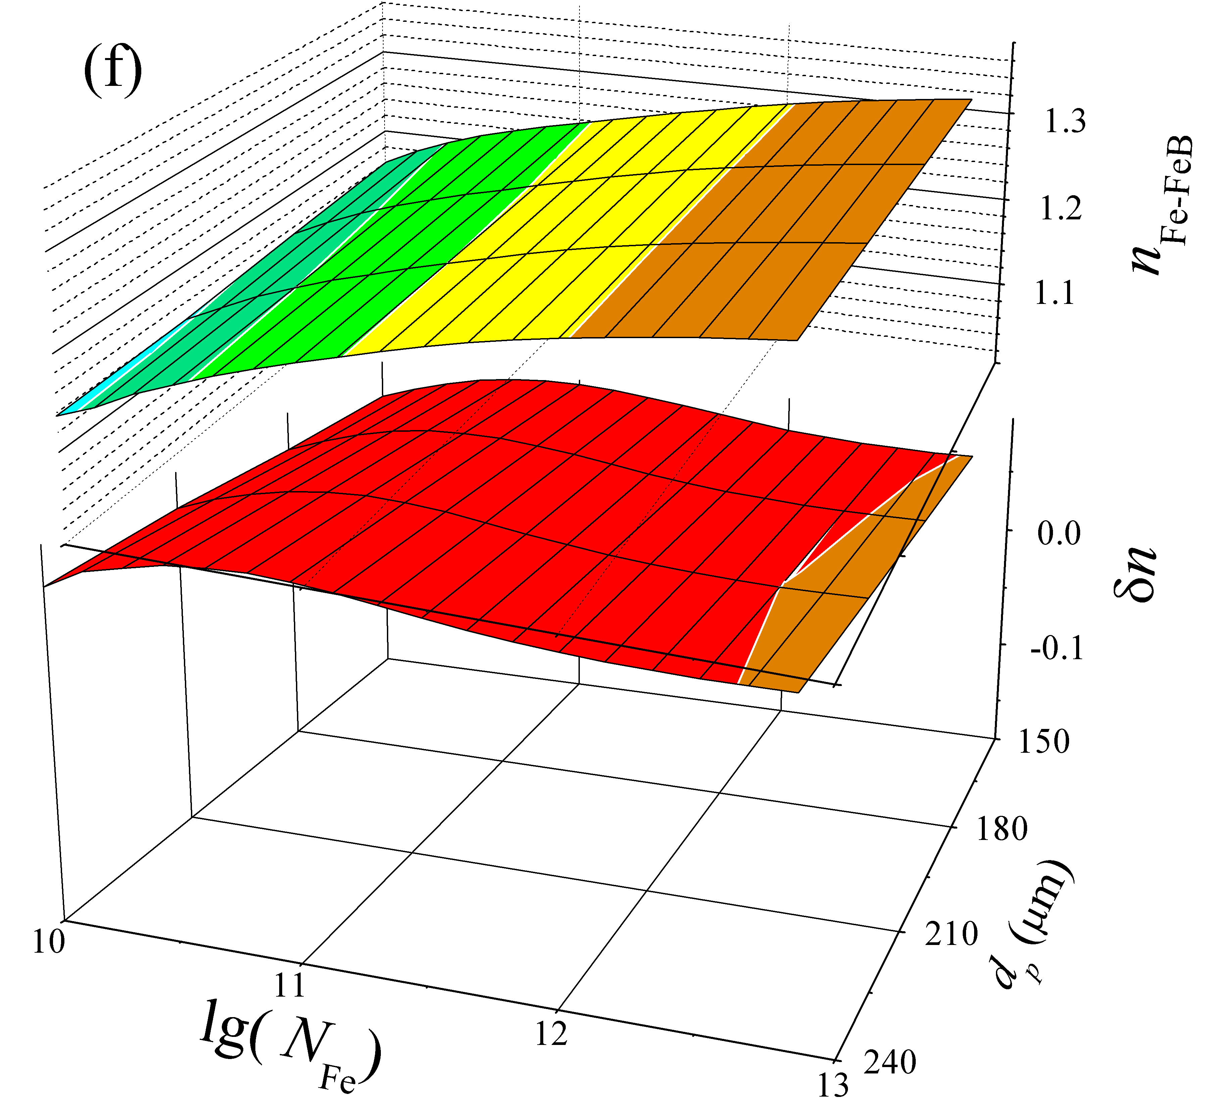
FIGURE 4S. Dependencies of ideality factor in Fe-FeB case (upper parts) and δn = n_{Fe}-n_{Fe-FeB} on iron concentration and base depth. N_{B}, cm⁻³: 10¹⁵ (а,c,e), 10¹⁷ (b,d,f); T, K: 290 (а,b), 320 (c,d) , 340 (e,f).

