Estimation of Iron Concenration in Silicon Solar Cell by Kinetics of Light-Induced Change in Short-Circuit Current

O. Olikh¹, V. Kostylyov²

¹Taras Shevchenko National University of Kyiv,
64/13, Volodymyrska Str., Kyiv, 03028, Ukraine
olegolikh@knu.ua
²V. LashkaryovInstitute of Semiconductor Physic Institute of NAS of Ukraine,
41 Nauky Ave., Kyiv, 03028, Ukraine
vkostylyov@ukr.net

Dear authors,
Your one-page abstracts should describe original work in any conference fields. Both full research reports and work-in-progress reports are welcome!
Please, put the text of your abstract to this template directly.
The abstract should be written in English.
The name of presenting author should be underlined (not required for one author).
The abstract may contain black/white figures, formulas, and tables within the page width. All lines and symbols in figures should be readable for A5 format. Figures captions should have the same size as the main text (12 pt).
Please, save the file of your abstract in *.doc or *.rtf extension and give the file a name consisting of your surname, name, and the number of your topic, for example, kravchenko_oleg_5.
The abstract should be submitted to organizing committee e-mail before the abstract submission deadline.
Please, write the filename of your abstract (for example, kravchenko_oleg_5) in the subject field of your e-mail.
All abstracts will be reviewed by the Program Committee. If there are any questions, you would be contacted additionally. After the procedure you receive the acceptance notification with the invitation letter.

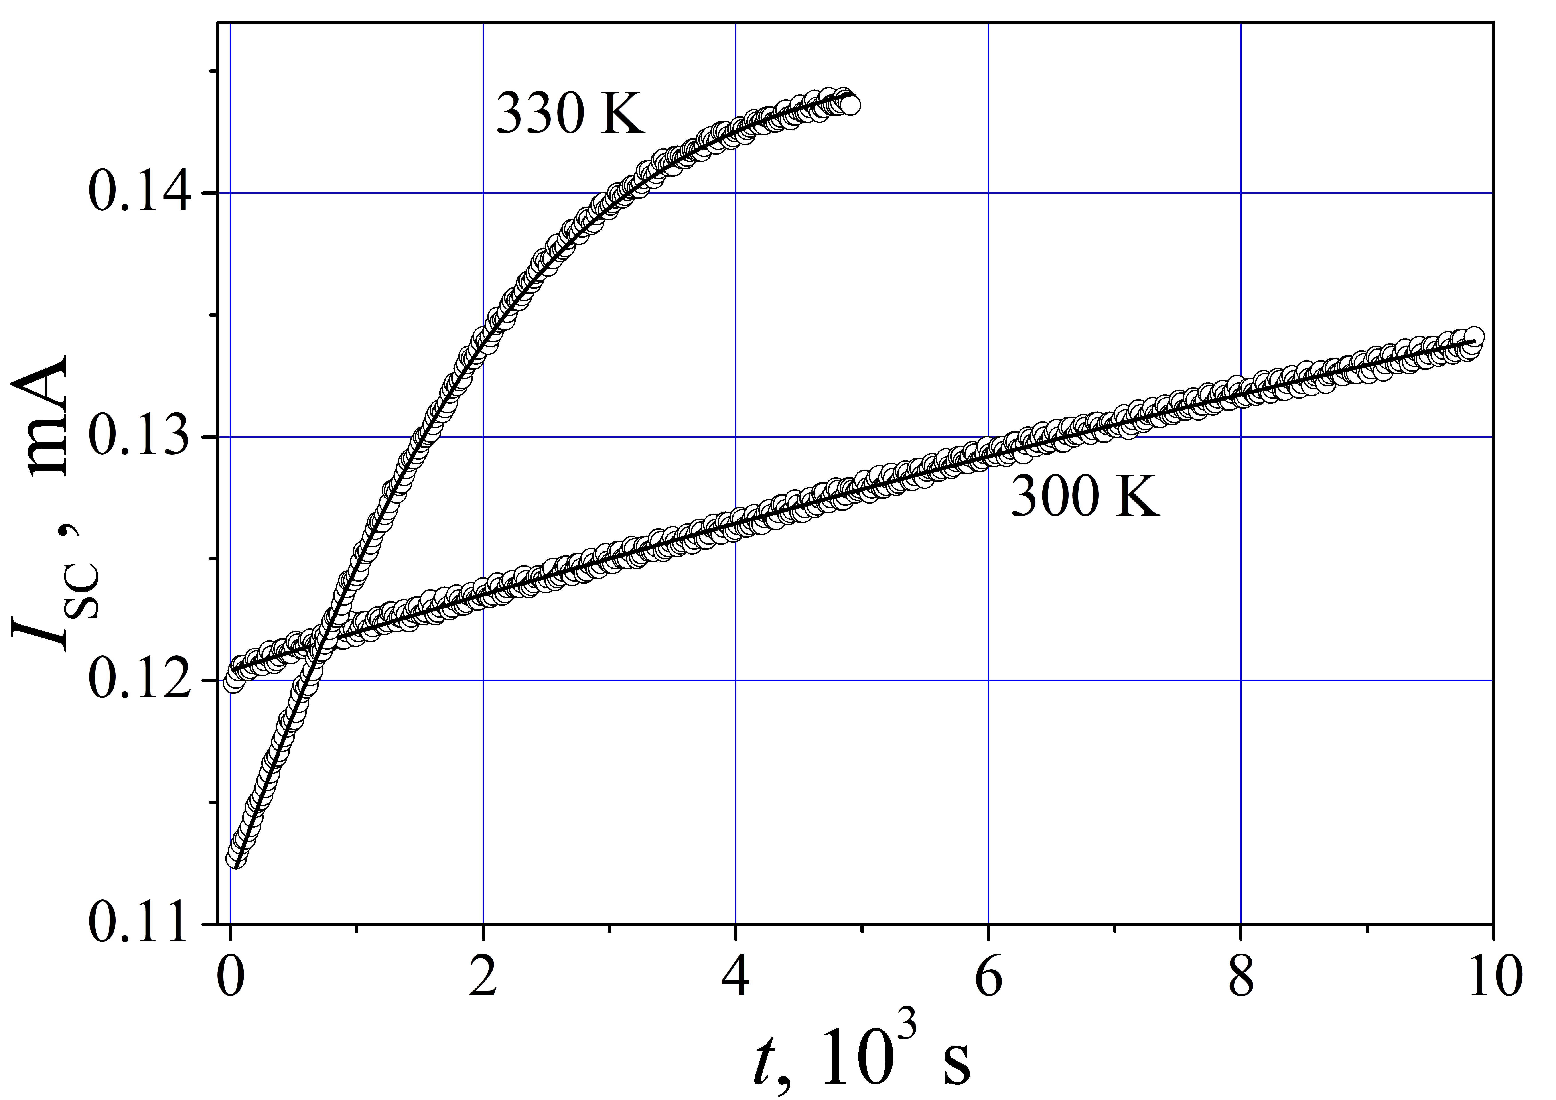
Fig. Time dependence of short-circuit current after halogen lamp illumination (250 mW/cm², 15 s). The marks are the experimental results, and the solid lines are the curves fitted by Eqs. (1)–(5). I_{SC} corresponds to the LED illumination (940 nm, 0.3 mW).

[1] W. Wijaranakula, J. Electrochem. Soc. 140, 275 (1993).

