Acoustically Induced Acceleration of Iron Migration in Silicon Solar Cells
Oleg Olikh¹*, Vitaliy Kostylyov², Victor Vlasiuk², Roman Korkishko²
¹Physics Faculty, Taras Shevchenko National University of Kyiv, Ukraine.
²V. Lashkaryov Institute of Semiconductor Physic of NAS of Ukraine, Kyiv, Ukraine.
* olegolikh@knu.ua
Abstract
It is well known that ultrasound (US) can effectively interact with defects in semiconductors. It was experimentally observed that US can cause atomic diffusion^{[1]}, transformation of native and impurity defects^{[2]}, and annealing of radiation defects^{[3]}. Most acoustically induced (AI) changes in crystal defect subsystem are residual, but reversible AI phenomena are occur as well. The aim of our work is to investigate experimentally the FeB pair association in silicon solar cells under US loading conditions. The n⁺-p-p⁺-Si structure was fabricated from a 2 in. (380 μm thick) p-type boron doped Czochralski silicon wafer with a resistivity of 10 Ω⋅cm. The FeB pair dissociation was made by flash illumination. The short circuit current (I_{SC}) under monochromatic light was used to characterize recombination process in the solar cell base. The iron atom migration energy (E_{m}) was extracted from I_{SC} kinetic after FeB pair dissociation. Ιn the case of US loading, the longitudinal acoustic waves with the frequency of 4.1 MHz, which were excited by using a piezoelectric transducer, were applied to the samples at the base side. The investigation has revealed an acoustically driven reversible decrease in the iron migration energy. The E_{m} alteration value non-linearly depends on US intensity (see Fig.1) and diminishes with temperature decrease. In our opinion, the observed effect is induced by the displacement of impurity atoms with respect to their surroundings. Thus the ultrasound can be effective defect engineering tool in silicon.
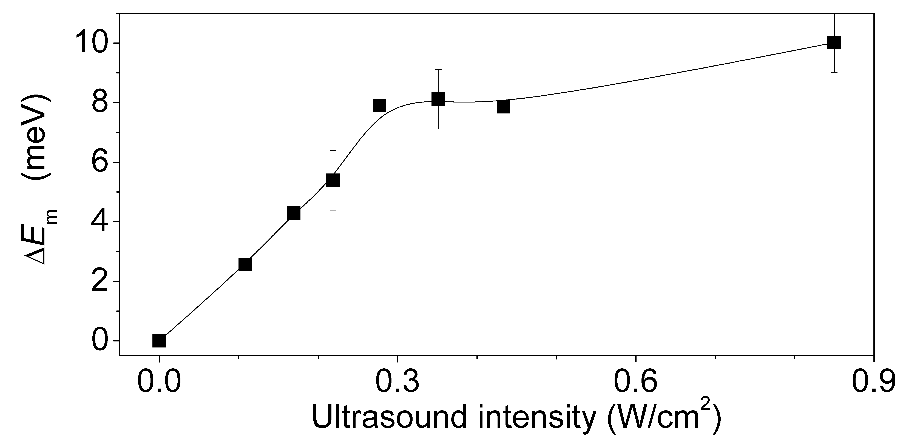

Figure 1. Dependences of iron migration energy change on US intensity. Temperature of US loading is 340 K.
Keywords
Ultrasound loading; Silicon; Fe-B pair dissociation; Acousto-defect interaction; Reversible effect
References
[1] M. Jivanescu, A. Romanyuk, A. Stesmans, J. Appl. Phys. 107 (2010) 114307.
[2] O. Y. Olikh, Semiconductors 43 (2009) 745.
[3] I. Ostrovskii, N. Ostrovskaya, O. Korotchenkov, J. Reidy, IEEE Trans. Nucl. Sci. 52 (2005) 3068–3073.
Acknowledgements
The work was supported by National Research Foundationof Ukraine by the state budget finance (project 2020.02/0036 ”Development of physical base of both acoustically controlledmodification and machine learning–oriented characterizationfor silicon solar cells”).

