Photoacoustic technique
Photoacoustic (PA) methods will be used to study the thermophysical and optical properties of materials. These methods are classified as non-destructive non-stationary (modulated or pulsed) heating techniques. The informative signal can be obtained with gas-microphone or piezoelectric detection.
The main part of the experiments will be carried out in the low-frequency modulation region of laser radiation (from tens of Hz to several kHz, 405 nm - 850 nm). Specifically, an incident modulated radiation periodically heats the sample and subsequently causes acoustic waves which are detected by a microphone or piezoelectric transducer – see Fig. 1. In both cases, by comparing an incident signal with the recorded one, the thermal properties of the sample can be obtained. PA piezoelectric methods belong to the direct PA technique because in this case the acoustic perturbations are formed and registered directly in the sample. Such methods are usually sensitive not only to the thermal and optical but also to the elastic properties of the structure.
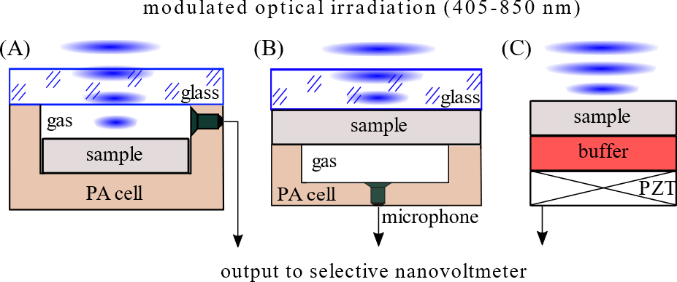
Figure 1. The schematic view of the PA detection configurations employed: gas-microphone PA technique in front surface (A) and rear surface (B) configurations, piezoelectric configuration (C).

The use of PA low-frequency methods will make it possible to estimate the thermal diffusion or/and thermal conductivity coefficients of samples, both at room and at other operating temperatures of the PA cell (from -20 to +100 ° C), depending on the type of the PA response detector (piezoelectric transducer, or microphone), as well as to study phase transitions in a substance in a given temperature range.
A PA microscopy technique is also available, adapted for multimodal (PA, optical, etc.) visualization of an object. For this purpose, focusing the laser beam on the surface of a sample can be achieved down to μm-scale lateral resolution (both the spot and the minimum scanning step size are 10 µm).

Current-voltage technique
The current-voltage characteristic measuring is available. The main features are following:
- Four-quadrant source or sink operation;
- Voltage: ±21 V, ranges: 20 mV – 20 V, 0.012% basic accuracy, source resolution 500 nV – 500 mV, measure resolution 10 nV – 100 μV;
- Current: ±1.05 A, ranges: 10 nA – 1 A, 0.012% basic accuracy, source resolution 500 fA – 50 μΑ, measure resolution 10 fA – 1 μA;
- Rate: >3000 reading/second;
- Temperature: range 200-350 K, stability 0.02 K (proportional-integral-differential controller);
- Illumination condition: dark, AM1.5, monochromatic (400-950 nm), in-door (LED).

Ultrasound as active tool
Ultrasound can be an effective tool for controlling property of silicon-based and other solar cell. The ultrasound treatment mode (the change in properties after the action of ultrasound) and ultrasound loading mode (acousto-induced material medication during acoustic wave propagation) is available. Main features
- Wave type: longitudinal wave, transverse wave;
- Intensity: up to 1 W/cm²;
- Frequency: 0.3-1.0 MHz;
- Loading temperature: 200-350 K.

Finite Element Simulations of Electric and Strain Fields

The governing equations coupling the electrical and mechanical quantities in piezoelectric media are
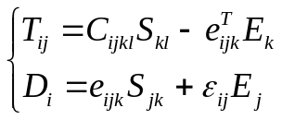, (1)
Here T_{ij} and S_{kl} are the stress and the strain tensor components, C_{ijkl}, e_{ijk} and ε_{ij} are the elastic stiffness tensor, piezoelectric coefficient tensor and permittivity tensor components, the superscript T means transposing the row matrix, D_{i} and E_{k} are the electric displacement and the electric field vector components, respectively. Components of the elastic strain tensor are determined as
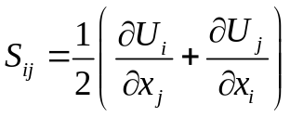, (2)
where U_{i} are the components of the elastic displacement vector. Electric field can be written as
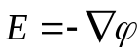, (3)
where φ is the electric potential.
Following the FEM discretization procedure, the structure is divided into small elements and the unknown functions U_{i}; φ inside the element are written as
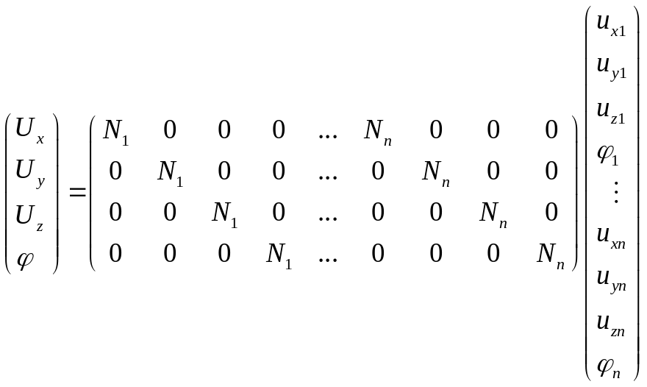, (4)
where n is the number of the node points for each the element, N_{i} are the shape functions in the i-th node point. Based on the resulting finite element mesh, the FEM matrix equation is written as
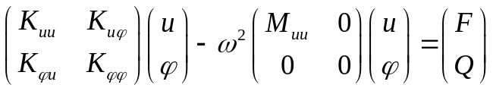, (5)

where K and M are the stiffness and the mass matrices, respectively, and F and Q are the vectors of the mechanical and electrical node loads, respectively. Solving Eq. (5) allows us to find the strain and displacement fields throughout the structure.
Examples of results
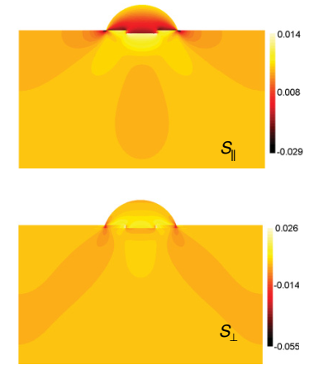
Fig2. Strain distribution at a middle crosssectional [001]-[010] plane, through the center of an uncapped SiGe/Si quantum dot. S_{II} is the in-plane strain, whereas S⊥ is the out-of-plane strain. The negative and positive strain values correspond to compressive and tensile strains, respectively.

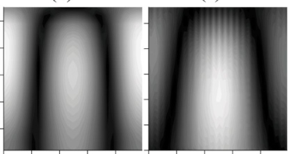
Fig3. Computed (left) and measured (right) distributions of the electrical potential φ in a two-layer Y-cut LiNbO3-GaAs structure.

