Photoacoustic technique

Photoacoustic (PA) methods will be used to study the thermophysical and optical properties of materials. These methods are classified as non-destructive non-stationary (modulated or pulsed) heating techniques. The informative signal can be obtained with gas-microphone or piezoelectric detection.
The main part of the experiments will be carried out in the low-frequency modulation region of laser radiation (from tens of Hz to several kHz). Specifically, an incident modulated radiation periodically heats the sample and subsequently causes acoustic waves which are detected by a microphone or piezoelectric transducer. The non-contact modulation of thermal perturbations in the structure helps to overcome draw-backs associated with the contact and steady-state diagnostic methods, such as thermal contact resistance, or parasitic heat losses. In both cases, by comparing an incident signal with the recorded one, the thermal properties of the sample can be obtained. Lasers with different wavelengths in the UV-IR range (405 nm - 850 nm) will be used as sources of optical radiation for more accurate complex sample studies.
In PA gas-microphone technique the production of acoustic waves appears indirectly in the air that is in contact with the surface of the sample, which is placed inside of a closed non-resonant PA cell. The experiment will be carried out in two different configurations: with front and rear surface irradiation PA cells as shown in Fig. 1.
In the first case, the thermal diffusion length of the sample is analyzed depending on its thickness, optical absorption, structural modifications, etc. The informative bending frequencies obtained from the amplitude and phase-frequency characteristics of the PA signal provide information on the thermophysical properties of the structures under study. In the case of the rear surface configuration, information about the thermophysical properties of the sample mainly depends on the signal amplitude, as well as phase delays determined by the characteristics of the thermal wave that passes through the structure to the back surface.
PA piezoelectric methods belong to the direct PA technique because in this case the acoustic perturbations are formed and registered directly in the sample. Such methods are usually sensitive not only to the thermal and optical but also to the elastic properties of the structure. The PA piezoelectric methods are more sensitive and operate in a wider frequency range compared to the indirect PA gas-microphone methods. This technique is quite simple to implement, as there is no need to place the sample in a closed volume of the gas cell. Thus, it can be used not only as an alternative method but the complementary one for materials characterization.
The use of PA low-frequency methods will make it possible to estimate the thermal diffusion or/and thermal conductivity coefficients of samples, both at room and at other operating temperatures of the PA cell (from -20 to +100 ° C), depending on the type of the PA response detector (piezoelectric transducer, or microphone), as well as to study phase transitions in a substance in a given temperature range.

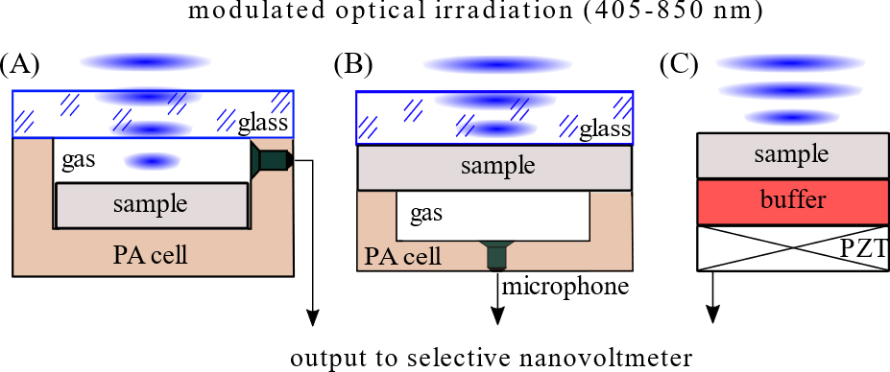
Figure 1. The schematic view of the PA detection configurations employed: gas-microphone PA technique in front surface (A) and rear surface (B) configurations, piezoelectric configuration (C).

A second transport mechanism will be additionally proposed in which there is the direct coupling of the heat energy to the vibrational modes of the material is realized. This is a thermoelastic process governed by the thermal expansion coefficient where a pressure build-up is generated, releasing a stress wave through the sample into a piezoelectric detector. The rate of transfer of this wave is described by the speed of sound in the material. It is generally non-dissipative for solid materials and can be visualized and analysed by means of the PA technique.
A PA microscopy technique is also available, adapted for multimodal (PA, optical, etc.) visualization of an object. For this purpose, focusing the laser beam on the surface of a sample can be achieved down to μm-scale lateral resolution (both the spot and the minimum scanning step size are 10 µm). The sample can be scanned in both low and high areas of radiation frequencies, depending on what tasks will need to be solved (depth of the subsurface scanning area, type of signal detection, etc.).

