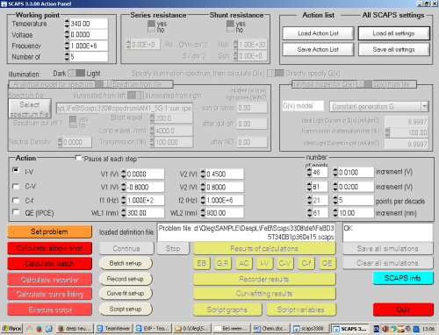
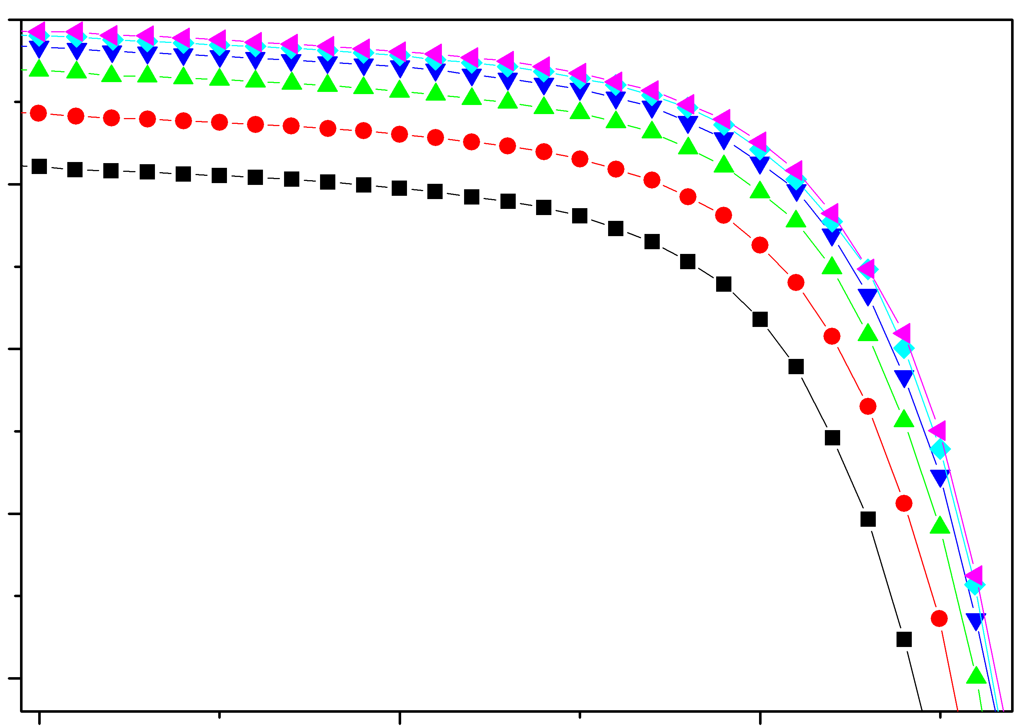
T
d_{p}
N_{B}
N_{Fe, PRED}
V_{OC}
scikit-learn/StandardScaler
...
...
...
...
N_{Fe,TRUE}
StandardScaler⁻¹
current
SCAPS
log
log⁻¹
Input Layer
Output Layer
Hidden Layers
Standardization
Simulation
MRSE
loss function
I_{SC}
voltage

