Structural Phase Transition in Glasses
Ge_{x}As_{y}Se_{100-x-y}

Svitlana Gapochenko
Physics Department
National Technical University
"Kharkiv Polytechnic Institute"
Kharkiv, Ukraine
svitlana.hapochenko@khpi.edu.ua

Olena Lyubchenko
Physics Department
National Technical University
"Kharkiv Polytechnic Institute"
Kharkiv, Ukraine
olena.lyubchenko@khpi.edu.ua

Abstract — Optical properties (refractive index n, optical bandgap E_{go}, slope of fundamental absorption edge W) and density of Ge_{x}As_{y}Se_{100-x-y} (0 ≤ x ≤ 30; 10 ≤ y ≤ 40) chalcogenide glasses were studied at room temperature. The molar refraction of glasses was calculated using the Lorentz-Lorenz formula, and the ionicity of possible chemical bonds was estimated. The results were analyzed depending on the mean coordination number ⟨m⟩ (⟨m⟩ = 2 + 0.01 (2x + y) for Ge_{x}As_{y}Se_{100-x-y} glasses). A different character of the dependences of all investigated physical properties on ⟨m⟩ was established in the ranges 2.1 ≤ ⟨m⟩ ≤ 2.78 and 2.78 < ⟨m⟩ ≤ 3, which may indicate a qualitatively different structure of the corresponding glasses. Glasses of the first group can be classified as molecular solids, which are characterized by a significant van der Waals interaction, which is carried out mainly by lone-pair electrons of As and Se atoms. At ⟨m⟩ ≈ 2.78, a structural phase transition to a continuous three-dimensional glassy network was observed, accompanied by a qualitative rearrangement of the band structure of the alloys.
Keywords — Chalcogenide glasses, optical properties, density, molar refraction, mean coordination number, structure phase transition, molecular clusters, continuous network structure

Introduction
Chalcogenide glasses, in particular, based on arsenic and germanium, are promising materials for infrared (IR) optics. They are characterized by a wide range of transmission in the IR range of electromagnetic waves, are distinguished by high thermodynamic and electrochemical stability, and have unique optical properties. They are widely used in the production of infrared radiation detectors, optical instruments and optical fibers, lasers, photonic integrated circuits, etc.
To date, a lot of hypotheses about the structure of glassy materials and various models of their description have been proposed, differing in the initial premises, the degree of completeness, and level of detail. Among them, theoretical descriptions [1] – [2] based on the quantitative parameter ⟨m⟩, the mean coordination number (⟨m⟩ = 2 + 0,01(2x + y) for glasses of Ge_{x}As_{y}Se_{100-x-y} type), are of particular interest because of the possibility of direct experimental testing. It is assumed that this parameter determines the topology of the glass structure with essentially covalent bonds between the atoms of the components. In [3] – [6], some general regularities for chalcogenide glasses of various compositions were established. In particular, the presence of peculiarities of the dependences of the physical properties of chalcogenide glasses on ⟨m⟩ in the 2.4≤ ⟨m⟩≤ 2.78 range. Therefore, it is of interest to study the structure-sensitive physical properties of the sets of multicomponent glasses of nonstoichiometric compositions in a wide range of ⟨m⟩. Earlier [7], the elastic properties of Ge_{x}As_{y}Se_{100-x-y} glasses (Ge_{x}As_{y}Se_{100-x-y} (0 ≤ x ≤ 30; 10 ≤y ≤ 40; 2,1 ≤ ⟨m⟩ ≤ 3) were studied. It was shown that the peculiarities observed on the dependences of Young's modulus, shear modulus, and Poisson's ratio on ⟨m⟩ may be associated with topological phase transitions from a one-dimensional to a two-dimensional cluster structure at ⟨m⟩ ≈ 2.4 and further to a three-dimensional disordered network at ⟨m⟩ ≈ 2.78.
In this work, we experimentally investigated the dependences of the optical properties (refractive index n, optical bandgap E_{go}, slope of the fundamental absorption edge W), and the density ρ of Ge_{x}As_{y}Se_{100-x-y} glasses on the mean coordination number ⟨m⟩. The compositions of the glasses and their mean coordination numbers are shown in Table 1.
TABLE 1. Compositions of glasses, their mean coordination numbers ⟨m⟩ and density ρ
 | Composition | ⟨m⟩ | ρ, kg/m³
1 | As₁₀Se₉₀ | 2.10 | 4350
2 | Ge_{4.5}As_{14.5}Se₈₁ | 2.24 | 4390
3 | Ge₁₀As₂₀Se₇₀ | 2.40 | 4490
4 | Ge_{13.5}As_{23.5}Se₆₃ | 2.51 | 4480
5 | Ge₁₈As₂₈Se₅₄ | 2.64 | 4470
6 | Ge_{22.5}As_{32.5}Se₄₅ | 2.78 | 4500
7 | Ge₂₇As₃₇Se₃₆ | 2.91 | 4600
8 | Ge₃₀As₄₀Se₃₀ | 3.00 | 4700

II. Experiment And Results
The initial components, which grades are given in Table 2, were weighed on a VLA-220 analytical balance with an accuracy of 2·10⁻⁴ g, poured into specially processed quartz ampoules, which were then pumped out to a pressure of 6.7 kPa, sealed off and placed in a tubular oven T-40/600. The synthesis mode was developed based on the known melting temperatures and vapor pressure of glass components.
TABLE 2. Grades of glass components
 | Ge | As | Se
Grade | B-5 | purissimum speciale -21-5 | purissimum speciale -17-4
The furnace was periodically rotated during the process to ensure the homogenization of the melt. At the maximum synthesis temperature, the furnace was rotated continuously for 3-4 hours, after which the melts were cooled in the cooling furnace mode. All alloys were subjected to X-ray diffraction analysis using X-ray diffractometer DRON-4 and mass-spectrometric analysis using laser ionization mass spectrometer EMAL-2.
The chemical heterogeneity of the alloys was investigated on 2 or 3 samples of each composition cut from different sections of the glass bar. The samples were X-ray amorphous. The scatter in the values ​​of the element concentrations over the samples did not exceed ± 6%.
The transmission of glass samples in the wavelength range of 0.4 – 1.2 μm was measured using a SF-24 spectrophotometer. The spectrophotometer error on the transmission coefficient scale was ±1%, and on the wavelength scale was 0.1 – 0.2 nm in the short-wavelength region of the spectrum, and 1 – 1.5 nm in the near-IR region. It was found that the absorption edge of all investigated compositions was located in this wavelength range. For bulk samples, the position of the absorption edge does not depend on the thickness and approximately determines the value of the optical bandgap E_{go}. The transmission of alloys in the wavelength range of 2.5 – 25 μm was measured by IRS-29 spectrophotometer. The error of the spectrophotometer on the scale of transmittance was ±1% and did not exceed ±1 cm⁻¹ on the wavenumber scale. The results show that the investigated alloys are optically transparent in the wavelength region of 2.5 – 11.75 μm. Using the two-thickness method [8], the refractive indices n were calculated using the transmission spectra. The graph of n(⟨m⟩) dependence is shown in Fig. 1. The graphs of the optical band gap E_{go} and the slope of the fundamental absorption edge W vs. ⟨m⟩ are shown in Fig. 2. The glass densities measured by hydrostatic weighing [9] with a relative error of ±0.1% are shown in Table 1.
III. Discussion
The refractive index is a composed function of the volume, density, coordination number, and polarizability of atoms, and also depends on the nature of chemical bonds [10], which complicates its unambiguous interpretation. However, taking into account the previously obtained results [7], it can be assumed that the flex point on the n(⟨m⟩) curve at ⟨m⟩ ≈ 2.78 indicates a qualitative difference in the structure of alloys with ⟨m⟩ ≤ 2.78 and ⟨m⟩ > 2.78. In this regard, it is of interest to analyze the dependence of molar refraction R_{m} on ⟨m⟩ for glasses, since, according to the Lorentz-Lorentz theory, it is determined by the electronic polarizability of atoms and, as a result, is more unambiguously related to the structural features of materials. Molar refraction was calculated on the Lorentz-
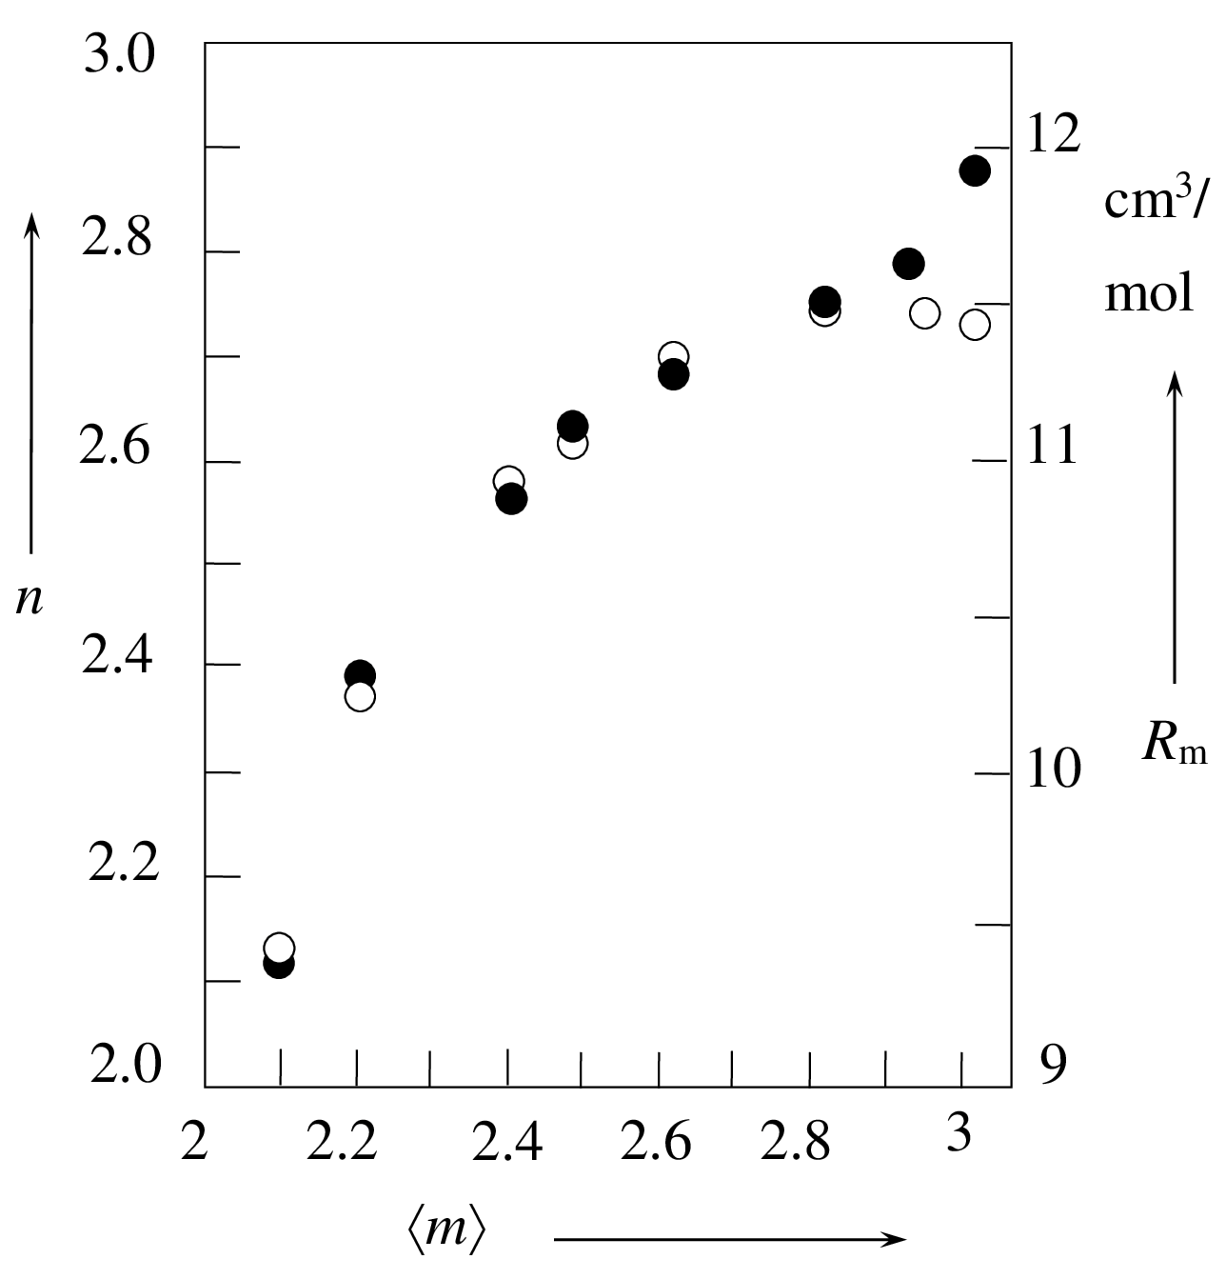
Fig.1 Dependences of refractive index n and molar refraction R_{m} of Ge_{x}As_{y}Se_{100-x-y} glasses on the mean coordination number ⟨m⟩ : - R_{m}(⟨m⟩); – n(⟨m⟩)
Lorenz formula [10] using the refractive index for a wavelength λ = 3 μm. Since the Lorentz-Lorenz formula is valid for covalent materials, the ionicity of bonds was estimated by Pauling's formula [11] using the known values ​​of electronegativities of atoms that form possible chemical bonds for these glasses. It was found that the ionicity of the As-Se, Ge-Se, Ge-As bonds does not exceed 5% that allows the application of this estimation method. Graph of dependence R_{m}(⟨m⟩ is shown in Fig.1. Change in this dependence at ⟨m⟩ ≈ 2.78, which coincides in position on the ⟨m⟩ axis with a peculiarity on the n(⟨m⟩) curve, may indicate a structure-related change in the contribution of the electronic polarizability of atoms to the refractive index. Since the molar refractions of amorphous Ge, As and Se (for example, [12], [13]) differ within 10-20%, we estimated the expected trend in electron polarizability of alloys based on molar refractions of crystalline Ge, As and Se (Table 3). Electronic polarizability of atoms depends, first of all, on the type of chemical bonds between them [10]. Chemical bonds in the studied alloys, as in crystalline compounds containing Ge, As, and Se atoms, are substantially covalent; therefore, even such a qualitative approach to the analysis of R_{m}(⟨m⟩) dependence makes it possible to reveal the effect of the glass structure features on the electronic polarizability of atoms.
Assuming the glass structure is described by a continuous random network model, then according to the data of Table 3 an increase in the concentration of Ge and As atoms should lead to a monotonic change in molar refraction. But, as it can be seen from R_{m}(⟨m⟩) (Fig.1), this assumption does not agree with the data obtained.
TABLE 3. Covalent molar refractions of elementary crystalline Ge, As, Se [10]
Element | Ge | As | Se
R_{m}, cm³ | 11.3 | 10.4 | 10,2
Refraction of lone-electron pairs | - | 4.9 | 3.1

As noted above, our earlier studies of physical properties of these alloys suggest that glasses with ⟨m⟩ ≈ 2.1 – 2.4 have a
predominantly one-dimensional structure, while alloys with 2.4 ≤ ⟨m⟩ ≤ 2.78 have a two-dimensional cluster structure with molecular inclusions. These types of structures (molecular solids) are characterized by a significant Van der Waals interaction mainly due to the lone-electron pairs (LEP) of As and Se atoms. As follows from Table 3, the molar refraction of the LEP of As atoms is greater than that of Se atoms. In addition, the electronic polarizability of a substance grows with an increase in the degree of covalence of chemical bonds [10]. Since the degree of ionicity of bonds in these alloys does not exceed 5% and is practically the same for all possible heteropolar bonds in these alloys, it can be assumed that the nature of R_{m}(⟨m⟩) dependence in the range of 2.1≤ ⟨m⟩ ≤ 2.78 is mainly determined by increasing the LEP concentration of As atoms.
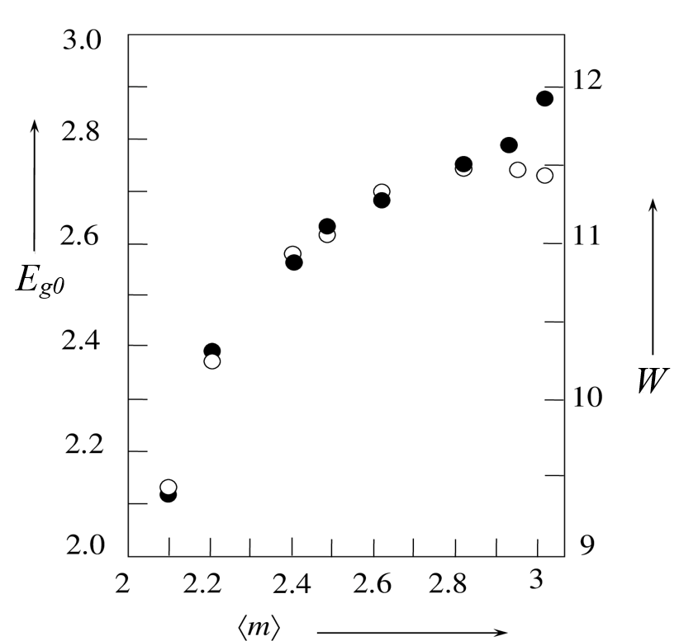
Fig. 2. Dependences of the optical bandgap E_{go} and the slope of the fundamental absorption edge W for Ge_{x}As_{y}Se_{100-x-y} glasses on the mean coordination number ⟨m⟩ : - W(⟨m⟩); - E_{go}(⟨m⟩)
A molar refraction R_{m} decrease at ⟨m⟩ > 2.78 may indicate a change in the type of chemical interaction, which, as we have already noted, largely determines the electronic polarizability of materials. The formation of a three-dimensional network with a predominantly covalent nature of interaction forces between atoms, accompanied by sharp increase in density (Table 1), leads to a decrease in LEP polarizability and, consequently, to a decrease in molar refraction with an increase in the concentration of Ge and As atoms in this range of mean coordination numbers.
A possible change in the structure of the investigated alloys at ⟨m⟩ > 2.78 is also evidenced by the nature of the dependence of the slope of the fundamental absorption edge W on ⟨m⟩ (Fig. 2). According to the theory of interband absorption [14], the value of this parameter depends on the degree of structural disorder. Then the observed monotonic increase in W depending on ⟨m⟩ in the range 2.1≤ ⟨m⟩ ≤ 2.78 may indicate a certain increase in ordering the glass structure on a medium scale. A sharp fall in W for alloys with ⟨m⟩ > 2.78 is consistent with our earlier assumption [7] about the adequacy of the continuous random chemically ordered network for describing the structure of these alloys.
Significantly, that the dependences E_{go}(⟨m⟩) and W(⟨m⟩) correlate over the entire range of mean coordination numbers (Fig. 2). It is assumed [15] that in chalcogenide glasses with a molecular structure, the valence band is formed by LEP states, which wave functions penetrate the intermolecular regions. The optical bandgap depends on the LEP interaction. Thus, the valence band of molecular-type glasses containing significant Se concentration is formed by the p-LEP states of Se atoms. Ge and As atoms form random cross-links between selenium chains, which does not lead to a qualitative change in the alloy structure type at low concentrations of these atoms.
Taking into account the known X-ray diffraction data on glassy Se [15], it can be assumed that the “stacks” of selenium chains can be formed in such alloys due to Van der Waals interaction. Such structural fragments can be considered as medium-order regions of the cluster type. Then the E_{go}(⟨m⟩) dependence observed in this range can be explained as follows. Since the Van der Waals distance between clusters is greater than the Van der Waals distance between selenium chains within clusters, and the bandgap of alloys depends on the degree of overlapping the LEP wave functions, an increase in the concentration of such structural elements can provide an insignificant growth in E_{go} (⟨m⟩) in the range of mean coordination numbers 2.1≤ ⟨m⟩ ≤ 2.4. In the interval 2.4≤ ⟨m⟩ ≤ 2.78, this trend persists but the steepness of E_{go} (⟨m⟩) increases. Earlier, the studies of the Raman spectra of these alloys [16] suggested that the structure of alloys in this ⟨m⟩ range can be formed by two-dimensional clusters of the Ge₆Se₁₅ type and As-containing molecular formations existing in the form of microphases. Microphase separation increases from Ge_{13.5}As_{23.5}Se₆₃ to Ge_{22.5}As_{32.5}Se₄₅ composition and is accompanied by the increase in the volume of intermolecular regions, and possibly, by the growth in intermolecular gaps. Such structural changes, increasing in the range 2.4≤ ⟨m⟩ ≤ 2.78, are accompanied by an observed increase in the bandgap of glasses.
A sharp decrease in E_{go} as a function of ⟨m⟩ for alloys with ⟨m⟩ > 2.78 can reflect a qualitative rearrangement of the band structure of the alloys caused by the formation of a three-dimensional glassy network. Alloys with such a spatially linked structure are characterized by a higher density compared to molecular solids. As a result, the role of LEP in the formation of energy zones decreases. As shown in [17], in a first approximation, the band theory of crystalline semiconductors can be applied to disordered semiconductors. Then, based on the energies of chemical bonds given in Table 4 and the nature of E_{go} (⟨m⟩) dependence in this range of ⟨m⟩, one concludes that p-states of As atoms, which specific content increases with increasing arsenic concentration, should
have a decisive effect on the energy-band structure of glasses of compositions Ge₂₇As₃₇Se₃₆ and Ge₃₀As₄₀Se₃₀.
TABLE 4. Energy of chemical bonds in Ge_{x}As_{y}Se_{1-x-y} glasses [11]
Chemical bond | Bond energy, kJ/mol
Se-Se | 184,0
Ge-Se | 205,4
As-Se | 174,8
Ge-Ge | 157,0
Ge-As | 149,5
As-As | 134,0
IV. Conclusion
Based on the results obtained, the following conclusions can be drawn:
1. Chalcogenide glasses Ge_{x}As_{y}Se_{100-x-y} (0 ≤ x ≤ 30; 10 ≤ y ≤ 40) with mean coordination number 2,1 ≤ ⟨m⟩ ≤ 3 are optically transparent in the wavelength region of 2.5 – 11.75 μm, which makes them promising for practical use in the near-infrared region.
2. The electronic polarizability of the investigated glassy alloys with the mean coordination number of 2.1 ≤ ⟨m⟩ ≤ 2.78 is determined mainly by the polarizability of LEP of As and Se atoms indicating the essentially molecular nature of the glass structure of the corresponding compositions. The decrease in the electronic polarizability of LEP in glasses with ⟨m⟩ > 2.78 is due to the formation of a denser three-dimensional structure. Thus, at ⟨m⟩ ≈ 2.78, a structural phase transition occurs from an essentially molecular structure to a spatially linked structure. This conclusion is confirmed by the nature of the dependence of the slope of the fundamental absorption edge W vs. ⟨m⟩.
3. At ⟨m⟩ ≈ 2.78, a rearrangement of the energy spectrum of the investigated alloys occurs associated with the transition from a molecular-type structure to a three-dimensional glassy network. The energy bands of glasses with 2.1 ≤ ⟨m⟩ ≤ 2.78 are formed by the LEP states of As and Se atoms. The development of microphase separation with an increase in the concentration of As and Ge atoms leads to a decrease in the degree of overlap of the LEP wave functions and, consequently, to an increase in the bandgap depending on ⟨m⟩ in the indicated range of values. The energy-band structure of glasses with ⟨m⟩ > 2.78 is determined by the p-states of As atoms.

References
[1] M.F. Thorpe, “Rigidity percolation in glassy structures”, J. of Non-Cryst. Sol., vol.75, pp. 109-116, November 1985.
[2] J.C. Phillips, “Chemical bonding, internal surfaces, and the topology of non-crystalline solids”, Phys. St. Sol.(b). vol. 101 (2), pp. 473-476, October 1980.
[3] B. Qiao, F. Chen, Y. Huang, R. Lin, X. Zhang, S. Dai, X. Shen, Q. Nie, X. Zhang, and X. Zhang “Correlating structure with threshold behavior of chalcogenide glasses within Ge-Sn-Se ternary system”, J. Am. Ceram. Soc., vol. 100 (1), pp. 108-114, January 2017.
[4] A. I. Isaev, S. I. Mekhtieva, Kh. I. Mamedova and R. I. Alekberov, “The effect of the chemical composition on the structure and physical properties of chalcogenide glassy semiconductors of the As–Ge–Se System”, Phys. Chem. Glas., vol. 46(1), pp. 41-48, March 2020.
[5] M. Saxena, A. K. Kukreti and A. Agarwal, “Study of average coordination number using topological concept in Ge-In-Se glasses”. Adv. Appl. Sci. Res., vol.3 (2), pp. 833-837, 2012.
[6] T. Wang, O. Gulbiten, R. P. Wang, Z. Y. Yang, A. Smith, B. Luther-Davies, and P. Lucas, “Relative contribution of stoichiometry and mean coordination to the fragility of Ge-As-Se glass forming liquids”, J. Phys. Chem. B, vol. 118 (5), pp. 1436-1442, January 2014.
[7] S. Gapochenko and V. Bazakutsa, “Elastic properties of GexAsySe100-x-y glasses”, J. Non-Cryst. Solids, vol. 270, pp. 274-277, May 2000.
[8] O.M. Boretsʹ, “Optychni vlastyvosti napivprovidnykiv”, CH.1., Ukrayna: Vyd. UzhHU, 1972, 97 s.
[9] P.G. Cheremskoy, “Metody issledovaniya poristosti tverdykh tel”, CCCP: Energoatomizdat, 1985, 110 s.
[10] S.S. Batsanov, “Strukturnaya refraktometriya”, SSSR: Vysshaya shkola, 1976, 303 s.
[11] L. Poling, “Obshchaya khimiya”, SSSR: Mir, 1974, 378 s.
[12] Z.U. Borisova, “Khal'kogenidnyye poluprovodnikovyye stekla”, SSSR: Nauka, 1983, 334 s.
[13] L.G. Aio, A.M. Efimov and V.F. Kokorina, “Refractive index of chalcogenide glasses over a wide range of composition”, J. Non-Cryst. Solids, vol. 27(3), pp. 299-307 March 1978.
[14] V.L. Bonch-Bruevich, “Interband optical transitions in disodered semiconductors”, Phys. Stat. Sol., vol.42(1), pp. 35-42 , 1970.
[15] S.H. Wemple, “Refractive – index behaviour of amorphous semiconductors and glasses”, Phys. Rev., vol. B7(8), pp. 3767-3777, April 1973. https://doi.org/10.1103/PhysRevB.7.3767
[16] S. Gapochenko, V.Belozertseva, H. Khlyap and A.Mamalui, Raman spectra of Ge_{x}As_{y}Se_{100-x-y} glasses, Cornell University Library, February 2011. [Online]. Available: arXiv:1102.5507v1 [cond-mat.mtrl-sci]
[17] L. N. Blinov A. V. Semencha, “Halkogenidnyie stekloobraznyie materialyi v Politehnicheskom”, Rossiya, POLITEH-PRESS, 2019, 280s.

