A new method for investigating the kinetics of acoustically induced processes in semiconductors with pulsed ultrasound loading

Yaroslav Olikh
Kinetic Phenomena and Polaritonics Department
V.E. Lashkaryov Institute of Semiconductor Physics
National Academy of Sciences of Ukraine
Kyiv, Ukraine
jaroluk3@ukr.net

Mykola Tymochko
Kinetic Phenomena and Polaritonics Department
V.E. Lashkaryov Institute of Semiconductor Physics
National Academy of Sciences of Ukraine
Kyiv, Ukraine
tymochko@ukr.net

Svitlana Gapochenko
Physics Department
National Technical University
"Kharkiv Polytechnic Institute"
Kharkiv, Ukraine
svitlana.hapochenko@khpi.edu.ua

Olena Lyubchenko
Physics Department
National Technical University
"Kharkiv Polytechnic Institute"
Kharkiv, Ukraine
olena.lyubchenko@khpi.edu.ua

Yaroslav I. Lepikh
Interdepartmental scientific-educational physics
and technical center of MES and NAS of Ukraine

Odessa I.I. Mechnikov National University

Odessa, Ukraine
ndl_lepikh@onu.edu.ua

Oleg Olikh
Physics Faculty
Taras Shevchenko National
University of Kyiv,
Kyiv, Ukraine
olegolikh@knu.ua

Abstract — The use of pulsed ultrasound loading for dynamic modification of current flow processes in semiconductor materials was considered. It was shown that the revealed features of time, temperature, amplitude and frequency characteristics of the acoustoconductivity voltage open new methodical possibilities for studying the defective structure of semiconductors.
Keywords — acoustoconductivity, defects, pulsed ultrasound, conductivity relaxation

Introduction
Direct observation of the relaxation of the conductivity 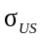 of monocrystalline silicon caused by rectangular pulses of ultrasound (US) was first described in [1]. This mode makes it possible to observe and investigate the dynamic (in-situ) changes in the electrophysical parameters of the material during ultrasonic loading.
This paper shows the possibility of using the study of acoustoconductivity kinetics for the investigation of metastable defects in semiconductors and diagnostics of their state. It is known that some defects in semiconductors are characterized by bi- and metastable behavior [2, 3]. The interest in metastable defects (MD) in practical terms is due to the possibility of dynamic driving of the semiconductor devices by restructuring such complexes. Due to the widespread use of electronic paramagnetic resonance technique, infrared spectroscopy, non-stationary deep level transient spectroscopy (DLTS), etc., significant progress has been made in understanding the mechanism of metastability. It has been shown that the processes of rearrangement of the defect atomic configuration and change of its charge state are often interrelated and intertwined. The reasons for such transformations can be local deformation, temperature change, electromagnetic field, irradiation, as well as ultrasound load [4, 5]. On the other hand, it is assumed that the main mechanism of acoustic-induced changes in electrophysical parameters in dislocation-free crystals is caused by the metastable nature of individual defect complexes. But the complete theory of interaction of US with MD is still absent. In particular, the kinetics of acoustic-induced changes in the electrophysical and photoelectric parameters of semiconductors, which could help to clarify the mechanism of US action, remains unexplored. The difficulties of such studies are related to the traditional use of US waves in a continuous mode [6-9], which makes it impossible to observe the rapid changes that are determined by the transient conditions. This paper presents the results obtained using a new methodical approach, that is, excitation of ultrasound in the form of rectangular pulses, which allows observation and investigation of the dynamic changes in the characteristics of the material during ultrasound loading. The proposed method is complementary to traditional methods of spectroscopy of defective levels of semiconductors, in particular, DLTS.

II. Method of acoustoconductivity pulse investigation
The standard acoustic cell layout for studying electrophysical parameters of semiconductor samples is shown in Fig.1 (shown in the circle). The longitudinal US wave excited by a high-frequency (HF) generator using a piezoelectric transducer (lithium niobate plate of Y+36°-slice) is introduced through the buffer plane-parallel plate along the sample thickness parallel to the <110> crystallographic direction. The study of acoustic conductivity kinetics used pulsed US mode (carrier frequency 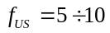MHz, pulse repetition frequency 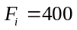Hz, duration of radio pulses 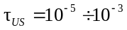s, and their amplitude ≤ 20 V).

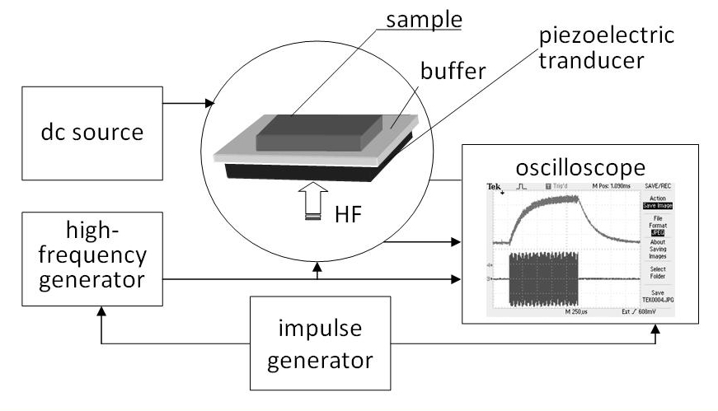
Fig. 1. Flow diagram of the facility for the study of acoustoconductivity kinetics

When the direct current was passing through the sample, the conductivity voltage 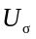 at its potential contacts was measured using a digital oscilloscope (Fig.1). The oscilloscope was synchronized with the pulses from the generator of rectangular pulses. In pulse mode, when the US pulse was applied to the sample against the background of the conductivity voltage 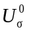, an additional acoustic conductivity pulse 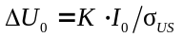 was observed – see Fig. 2. is the geometric coefficient, which determined by the sample size. This pulse had the amplitude 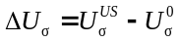and was characterized by both leading and falling edges. It turned out that the pulse edges 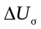, which are determined by pulse rise time and pulse fall time 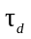of the acoustic-induced changes of , significantly exceed the HF pulse edges duration and, at a fixed temperature, are well described by exponential dependences (1) and (2), respectively:
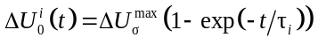, (1)
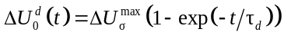. (2)

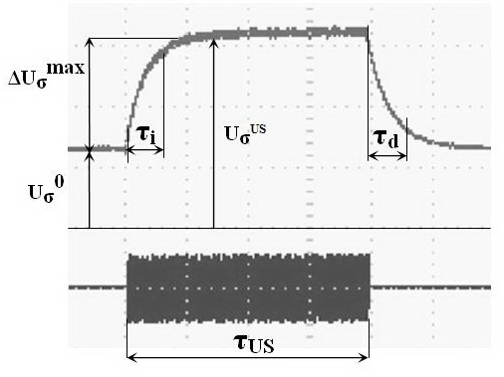

Fig. 2. Oscillograms of the acoustic conductivity pulse 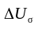on the sample (top) and the HF pulse applied to the piezoelectric transducer (bottom).
III. Experiment and Results
3.1. Samples
The study was performed using the crystals of dislocation-free crucible n-type silicon grown by a floating-zone technique of n-Si:P–Fz; the concentrations of impurity atoms of phosphorus, oxygen, and carbon were: 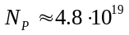m⁻³, 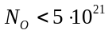m⁻³, 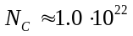m⁻³, respectively. The samples were irradiated with 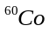 γ-quanta at a dose of 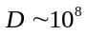rad at room temperature, and then isochronously annealed to T = 553 K (in steps of 40 K and 20 min duration). Measurements of the concentration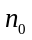and the mobility 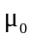of electrons by the acoustic Hall method in the temperature range of 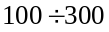K in the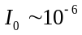A DC mode and the constant magnetic field B = 0.45 T were performed earlier in [6]. It was found that under the action of US load in the continuous mode at the temperatures 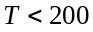K, the slope of the dependence 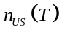increases slightly, and the concentration of free electrons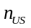decreases, i.e., there is an acoustic-induced decrease in the concentration 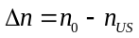. After turning off the ultrasound, returns to its original state. The conductivity 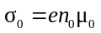 for -irradiated n-Si-Fz:P samples at (100 ÷ 200) K is determined by deep acceptor levels in the band gap with energy 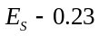eV [1,6].
3.2. Temperature characteristics of relaxation time
Typical temperature changes of acoustic conductivity, "pulse ", are given in Fig. 3. As can be seen, the pulse rise and pulse fall times decrease with a change in the temperature of the sample from 133 K to 170 K. Detailed studies of the "pulse ” performed at a constant intensity of ultrasound in a wide temperature range showed that the dependencies 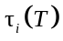 and 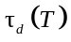 at some temperature areas are thermoactivated, i.e., described in Arrhenius coordinates

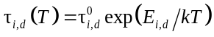, (3)
where 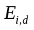 is the activation energy of the corresponding process.

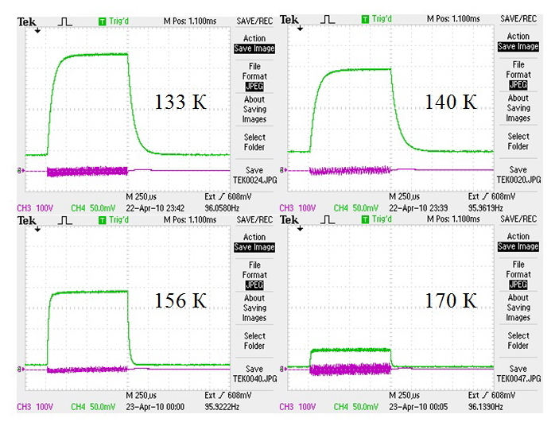

Fig. 3. Oscillograms of the "pulse " on the sample at four different temperatures: top − voltage pulse, bottom − HF pulse applied to the piezoelectric transducer.

Fig. 4 shows the temperature dependencies of relaxation times at increasing and decreasing . It is seen that the dependencies 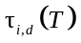are not monotonic. This could be the result that the main contribution to the acoustic conductivity at different temperatures is made by various acoustically sensitive defects. This assumption is confirmed by the temperature dependencies of the acoustic-induced signal amplitude shown in Fig. 5.
3.3. Temperature characteristics of the amplitude of acoustic conductivity
Study of the dependence of acoustic-induced conductivity signal amplitude 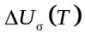 in a wide temperature range at the US frequency of 8 MHz revealed the presence of several peaks (Fig. 5). The dependence of nonstationary capacitive spectroscopy (DLTS) for electron-irradiated silicon similar to our samples is somewhat correlated with the temperature change of the acoustic conductivity amplitude 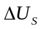. It turns out that each peak of corresponds to a certain defective level of the semiconductor, namely, the level of 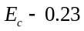eV (double negatively charged divacancy 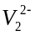) is related to the temperature of 120 K, 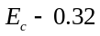eV (A-center 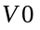) – to 150 K, and 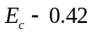eV (negatively charged vacancy 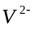) − to 200 K [10].
Thus, the first discovered "multi-peak" character of the temperature dependence of the acoustic conductivity voltage testifies to the predominant contribution of several separate acoustoactive centers to the acoustoconductivity of the sample in different temperature ranges. This conclusion is also confirmed by the investigation of the temperature dependences shown in Fig. 4.
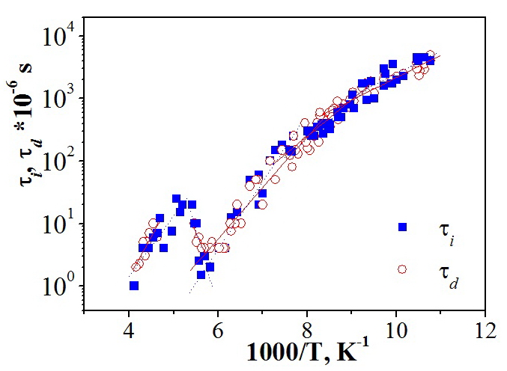
Fig. 4. Temperature dependencies of relaxation times: light circles and solid line are related to increase; dark squares − to decrease. Points correspond to experimental data, lines are the linear approximations according to [5] for separate temperature intervals

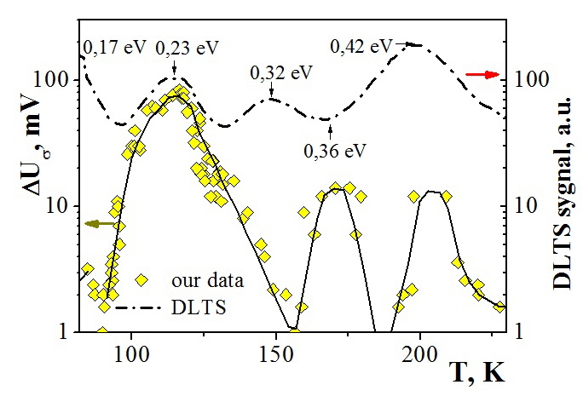
Fig. 5. Amplitude of the "pulse " vs. temperature for the sample exposed to US pulses at a frequency of 8 MHz (the squares correspond to experimental data, the solid lines − to approximation). Top dotted line relates to DLTS data (DLTS spectra of electron-irradiated Si-Fz samples) [10].
3.4. An influence of US frequency on temperature characteristics of acoustic conductivity amplitude
Fig. 6 shows the frequency effects on the temperature dependence of acoustoconductivity amplitude .
The data of time and amplitude characteristics for 8, 31, 55, and 100 MHz frequencies and different temperature ranges, as well as the values of their peak maxima, were used for plotting 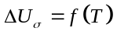.
Oscillograms of the "pulse " were obtained in the same temperature range 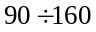K at different frequencies of US loading: 31, 55, and 100 MHz (the highest modes of the piezoelectric transducer). It is seen that when the US pulse frequency rises, the maximum peak amplitude 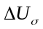is reduced and its shift toward high temperatures is observed. It confirms the frequency-dependent acoustic sensitivity of n-Si-Fz crystal defective structure.
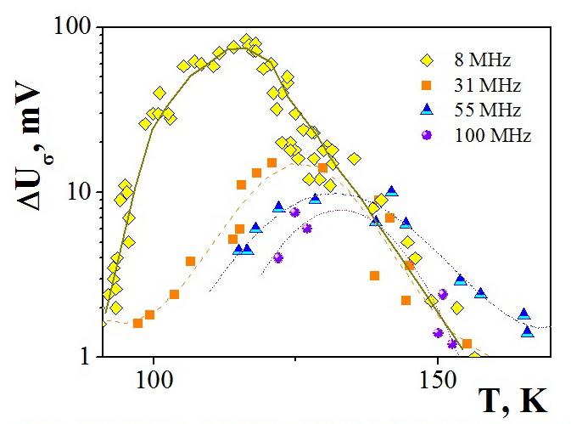
Fig. 6. The "pulse " amplitude vs. temperature under the US pulses action at 8, 31, 55 and 100 MHz frequencies.

3.5. Amplitude characteristics of acoustoconductivity
Fig. 7 shows the oscillograms of the induced voltage of acoustoconductivity as function of the amplitude of applied US pulse 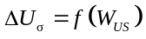 at 133 K. As can be seen, pulse rise and fall edges remain the same at acoustoconductivity amplitude growth at a given temperature.

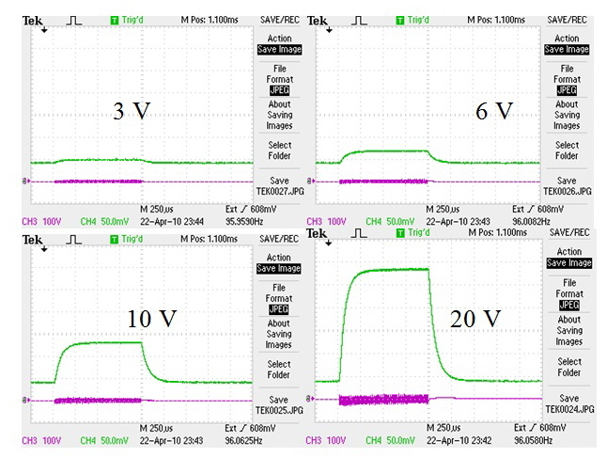
Fig. 7. Oscillograms of the amplitude-time dependencies at 133 K. Top − the pulse of the acoustic conductivity voltage, below − HF pulse applied to the piezoelectric transducer.

For the "peak" considered above, which corresponds to divacancies that determine the acoustoconductivity of the n-Si-Fz sample in the temperature range K, the results of the study of its amplitude dependence are presented in Fig. 8. Taking into account that at a fixed temperature 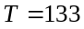K (Fig. 7), 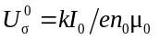and 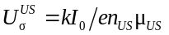, the relative acoustic-induced changes in the concentration of free electrons 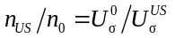 were calculated. It was assumed that 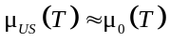 since the predominant mechanism of electron scattering at the temperatures 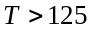K is determined by lattice oscillations; hence the mobility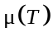is practically independent of ultrasound [1, 6].
Fig. 8 shows that the magnitude of the pulsed acoustic-induced changes in the concentration of conduction electrons 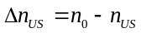 is directly proportional to ultrasound intensity :
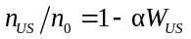, (4)
where the coefficient of proportionality α, which characterizes the effectiveness of US action, is also temperature-dependent (Fig. 8, inset).
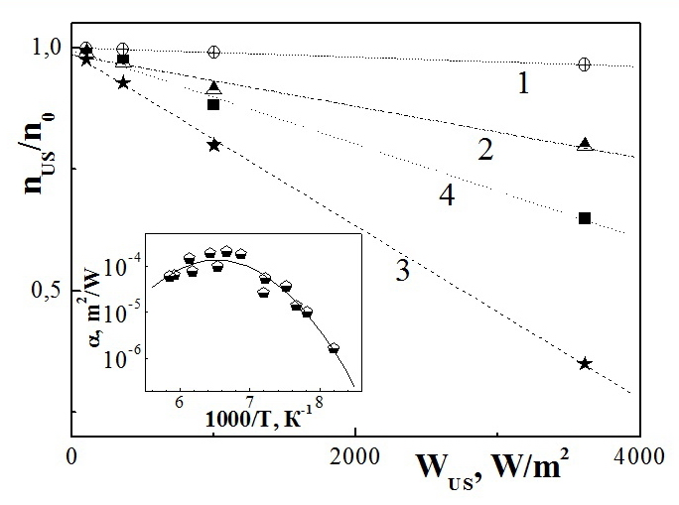

Fig. 8. Amplitude characteristics of relative changes in electron concentration at different temperatures vs. ultrasound intensity  for different temperatures: 1 − 128 K; 2 − 133 K; 3 − 142 K; 4 − 163 K. Inset: the temperature dependence of the efficiency coefficient of US action .

Note, that the maximum acoustically induced change 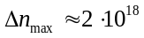m⁻³ is achieved at 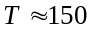K.
IV. Conclusions
1. The inverse change in the electrical conductivity in -irradiated n-Si-Fz exposed to pulsed US was firstly detected. The effect is determined by the deformation change in the distribution of the metastable defect concentration between different configuration and energy states and the corresponding redistribution of the carrier concentration at these levels.
2. It is established that the temperature dependencies of the rise 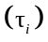and fall 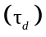times of pulse acoustic- induced changes are described by Arrhenius equations; the slope of the experimental characteristics is determined by the activation energy of the corresponding process.
3. The "multi-peak" nature of the temperature dependence of the acoustoconductivity voltage amplitude, which testifies to the predominant contribution of different acoustic-active centers to the acoustoconductivity of the sample at different temperature ranges, is revealed.
4. The possibility of acoustic spectroscopy of metastable defects in semiconductors using the pulsed mode of US loading is shown.

References
[1] Ya. M. Olikh, and M. D. Tymochko, “In Situ Observation of the Relaxation of Conductivity in γ-Irradiated n-Type Silicon under the Action of Ultrasound Pulses”, Tech. Phys. Lett., vol. 37(1), pp. 37-40, 2011. https://doi.org/10.1134/S106378501101007X.
[2] L. W. Song, X. D. Zhan, B. W. Benson, and G. D. Watkins, “Bistable interstitial-carbon – substitutional-carbon pair in silicon”, Phys. Rev. B Condens. Matter., vol. 42(9), pp. 5765–5783, September 1990. https://doi.org/10.1103/physrevb.42.5765.
[3] B. N. Mukashev, Kh. A. Abdullin, and Yu. V. Gorelkinskii, “Metastable and bistable defects in silicon”, Phys. Usp., vol. 43(2), pp. 139-150, 2000. https://doi.org/10.3367/UFNr.0170.200002b.0143.
[4] B. Romanyuk, V. Kladko, Ya. Olikh et.al., “Enhanced relaxation of SiGe layers by He implantation supported by in situ ultrasound treatments”, Mater. Sci. in Semicond. Processing, vol. 8(4), pp. 171–175, April 2005.
[5] O. Ya. Olikh, "The Variation in Activity of Recombination Centers in Silicon p–n Structures under the Conditions of Acoustic Loading", Semiconductors, vol. 43(6), pp. 745–750, June 2009. https://doi.org/10.1134/S1063782609060116.
[6] Ya. M. Olikh, M. D. Tymochko, and A. P. Dolgolenko, "Acoustic-Wave-Stimulated Transformations of Radiation Defects in γ-Irradiated n-Type Silicon Crystals", Tech. Phys. Lett. , vol. 32(7), pp. 586–589, 2006. https://doi.org/10.1134/S106378500607011X.
[7] P. B. Parchinskii, S. I. Vlasov, and L. G. Ligai, "Effect of ultrasonic treatment on the generation characteristics of irradiated silicon-silicon-dioxide interface", Semiconductors, vol. 40(7), pp. 808-811, July 2006.
[8] O. Olikh, and K. Voytenko, “On the mechanism of ultrasonic loading effect in silicon-based Schottky diodes”, Ultrasonics, vol. 66(3), pp. 1-3, March 2016. https://doi.org/10.1016/j.ultras.2015.12.001.
[9] O. Olikh, A. Gorb, R. Chuprina, and O. Pristay-Fenenkov, “Acousto-defect interaction in irradiated and non-irradiated silicon n+-p structures”, J. Appl. Phys., vol. 123(16), 161573, April 2018. https://doi.org/10.1063/1.5001123
[10] P. Pellegrino, P. Lévêque, J. Lalita, A. Hallén, C. Jagadish, and B. G. Svensson, “Annealing kinetics of vacancy-related defects in low-dose MeV self-ion-implanted n-type silicon”, Phys. Rev. B, vol. 64(10), pp. 195211-1 – 1952111-10, October 2001. https://doi.org/10.1103/PhysRevB.64.195211

