Reviewer 1:
Anonymous comments to the Author
Building on previous works that point at the influence of iron in the ideality factor of silicon solar cells, the authors present a deep neural network that can predict the iron content, and explore its range of validity. They train the network with simulated solar cells, and apply it to a couple of experimental solar cells.
The approach is interesing, and opens a path for further improvement and exploration of machine learning techniques to extract physic parameters from electrical measurements.
Advancing in the reading of the paper is not an easy task I have to say, but it is true that the steps are well justified and one sees that the authors have made an effort to explain them.
In my opinion there are some points that should be clarified for the paper to be published in Progress in Photovoltaics:
-A solar cell with BSF is chosen as the basis of the work, claiming that "BSF is one of the popular designs used for industrial mass production...", but this is no longer the case, BSF solar cells are present in the market due to old manufacturing lines that are still operative, but the standard now is PERC technology. If the training of the network is based on SCAPS simulations, why was not trained with a PERC structure? At least, some hint on how results would be with a PERC structure should be given. (By the way, the BSF in this work is made with B-doping, which is also a minoritary approach at the industrial level, where BSF is of Aluminium).
Досліджені СЕ базуюється на використанні комбінованого - індуковано-дифузійного способу формування роздільних бар’єрів у кремнійових СЕ. При цьому дифузійно-польові бар’єри утворюються як за допомогою дифузії мілких легуючих домішок (фосфору для р-типу бази кремнію), так і завдяки заряду, який вбудовано у шар термічного двоокису кремнію товщиною 30 нм, сформованого на поверхні дифузійного шару. Відносно невисокий рівень легування емітерної області СЕ з дифузійно-польовими бар’єрами забезпечує істотно нижчий рівень генераційно-рекомбінаційних втрат в емітерній області таких структур порівняно з дифузійними СЕ і, в той же час, дозволяє істотно зменшити опір приповерхневого шару, а існування індукованого полем вбудованого заряду бар’єру значно зменшує швидкість поверхневої рекомбінації на межі поділу SiO₂-Si. Контакти до фронтального n+ (у вигляді сітки) і тильного р+ шарів (суцільного) створювалися шляхом магнетронного нанесення алюмінію з наступною термообробкою при 450 °С у атмосфері сухого N₂.
Тобто, досліджені СЕ фактично є СЕ з пасивованим емітером. Від PERC СЕ вони відрізняються лише відсутністю діелектричної пасивації тильної поверхні, коли контактування до р+-шару є локальним через отвори у діелектрику. Оскільки контакт метал-напівпровідник має дуже велику швидкість поверхневої рекомбінації, то значно менша площа контакту метал-напівпровідник у випадку PERC СЕ приводить до значного зменшення швидкості поверхневої рекомбінації. У досліджених СЕ алюмінієвий контакт до тильного р+-шару є суцільним. Дійсно, пасивація тильної поверхні такого СЕ тільки за рахунок формування BSF шляхом створення р+-р переходу є гіршою порівняно з діелектричною пасивацією PERC СЕ. Проте, оскільки довжина дифузії неосновних носіїв заряду у базі легованих залізом СЕ є меншою за товщину (350 нм), то вплив тилової поверхні на рекомбінаційні процеси і відповідно на ефективний час життя буде незначним, тому суттєвої різниці між результатами на досліджених СЕ і PERC СЕ не буде.
Використання дифузії бора замість впікання алюмінію для формування р+-р переходу пояснюється більшою контрольованістю і відтворюваністю процесів дифузії з газової фази.
Дійсно, за технологією виробництва СЕ PERC – найближче майбутнє, проте на даний час їх співвідношення ∼ 1:1.

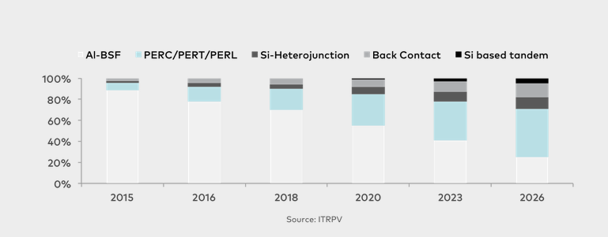
Джерело: 1. https://www.aleo-solar.com/perc-cell-technology-explained/
2. Thorsten Dullweber and Jan Schmidt. Industrial Silicon Solar Cells Applying the Passivated Emitter and Rear Cell (PERC) Concept—A Review. IEEE JOURNAL OF PHOTOVOLTAICS, VOL. 6, NO. 5, SEPTEMBER 2016.

-As far as I understand, the simulation with SCAPS could be improved: emitter and BSF are uniform and this is not the case in reality. There is no mention to the metallization, are there no contacts? There should be, and they will influence the carrier transport and also the surface recombination velocities in the metal-semiconductor interface, among others.
-Why a voltage sweep restricted to 0.45 V? This is rather low when compared to the voltages at the maximum power point of BSF solar cells... Wouldn't it influence in the extraction of the ideality factor values?
? Дійсно, діапазон 0 - 0.45 V мало. Для досліджених СЕ з Fe з низьким ККД 0.45 V – це приблизно точка максимальної потужності.
-I am not sure that I interpret well the results in table 5. In the text the authors state that "the results even exceed expectations". But what I see is that the predictions fail in general, largely for the trained dataset cases, but also for the full dataset. There is some discussion on why DNN_FeFeB-Fe performs worse than DNN_FeFeB and that is Ok... but DNN_FeFeB also fails in many cases, isn't it? (temperatures higher than 300K for the higher Fe content, 100% or more error for the training dataset...).
-In the jargon, we do not talk of surface resistance, but sheet resistance. Also, it is the first time that I read the "anti-recombination isotype barrier" for a high-low junction or a BSF.
Так, загальноприйнятим є sheet resistance.
high-low junction (р+-р, n+-n) зветься також ізотипним бар’єром на відміну від анізотипних (n-p) переходів (A.L. Farenbruch, R.H.Bube . Fundamentals of solar cells. Photovoltaic solar energy conversion. New York, 1983).
-It is mentioned in the paper that there is Suplementary Material, but I have not had the opportunity to read it.
On the other hand, the paper needs a thorough revision of English, preferably by a native or bilingual speaker. English is not my mother tongue, but I think that there are many expressions that are not correct, and make the reading difficult. From the abstract ("The low-cost and express...", "an ideality factor values"...) to the conclusions ("not numerous input parameters can be multiplied and transformed to the picture and apply a vision model..."(?), and a lot in between: "both for microelectronics, logic technologies and solar cells", "the various semiconductor barrier structures", "practical using", "Fours", "SFB", "in our further calculation", "simulated with using", "in comparing with", "more narrow", etc. etc.
Reviewer: 2
Anonymous comments to the Author
Authors developed a methodology to determine iron impurity concentrations with Deep Neural Networks (DNN) from parameters that are rather simple to obtain. This is interesting for the PV research community. The use of drift-diffusion simulations to generate training and test sets is generally clearly explained. Tests results of the DNNs are well presented, and finally the comparison of iron concentrations obtained with the method developed here or from experimental measurements is enlightening.
However, a few points could be explained more clearly in the text, and discussion of some of them might be important.
2 Simulation details
It is assumed that all SRH recombination in the device come from iron impurities and the associated deep level defects. It seems necessary to discuss its validity, and it could be interesting to put it against the fact that Al-BSF devices based on Czochralski silicon wafers are considered. More generally, if another type of defects is present in the solar cell, also inducing SRH recombination, is it possible to estimate to what extend are the DNNs trained here still accurate ?
When Fe-FeB and Fe cases are presented, it could be clearer to provide very few more explanations on both types of defects, and the important fact that iron-boron pairs can be temporarily dissociated, providing the Fe case, through the heat treatment or high illumination already mentioned.
3 Deep neural network models
It is clear how the main training dataset is created, and how the 4 * 9 * 11 * 19 = 7524 IV curves are generated. However, the definition of the test datasets and the values for temperature, base thickness, iron concentration and doping level are not clear for each T-varied, d-varied, etc. test set.
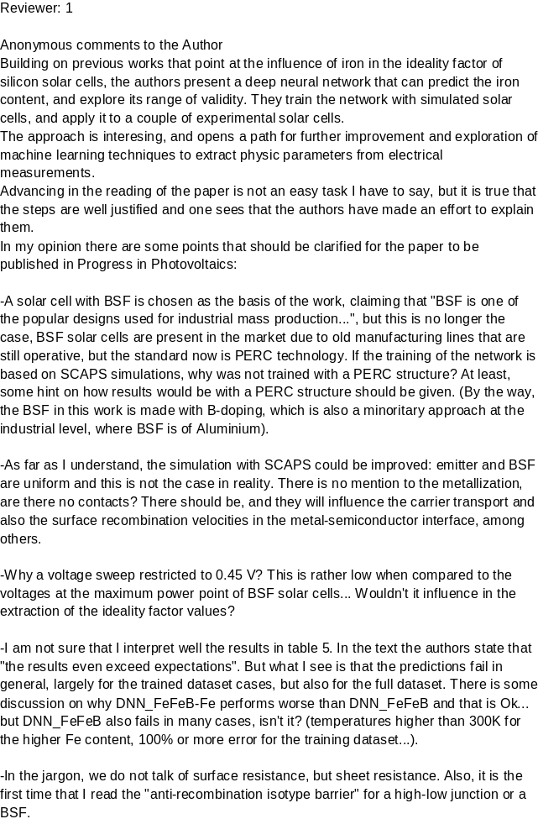For instance, in the case of the T-varied test set, it is mentioned that the same base thickness, iron concentration and doping level values are used as in training dataset. However, 4 * 9 * 19 = 684 and the amount of 894 IVs can’t be explained by multiplying with any number of temperature values. In Supplementary Material, the associated summary table do neither explain this value 894. More generally these tables are difficult to interpret. It is possible that the subset of 144 values for T-varied test has been duplicated.
4 Results and discussion
On figures 4, 5, 6 and 7, very interesting results are presented, and analyses of the dependence of estimation error with temperature, boron or iron densities and base thickness are well done. However, it seems that the same error statistics of results obtained on test datasets (instead of training dataset) would more directly assess the quality of predictions by the DNNs. For instance, the Fe-varied dataset has been identified to be the closest to “real demand” or results obtained with the all-varied dataset would also be most probably very useful. Such results could be showed in Supplementary Material, in the same form as figures 4, 5, 6 and 7.
Reviewer: 3
Anonymous comments to the Author
In this paper, the iron concentration in silicon BSF solar cells was extracted from the ideality factor, base thickness, doping level and temperature values, using deep learning-based approach. The authors have properly used these tools, which are increasingly useful as alternative approaches to conventional techniques in order to solve complex problems in different areas.
The results obtained in this work are very useful to contribute to the manufacturing process of silicon solar cells, based on low cost and non-time-consuming procedures, compared with traditional methods.
In my opinion this manuscript is interesting, original and easy to read.

