Modeling of ideality factor value in silicon solar cells

Olikh O.Ya., Zavhorodnii O. V.

¹ Faculty of Physics, Taras Shevchenko National University of Kyiv, Kyiv 01601, Ukraine
olikh@univ.kiev.ua

Ideality factor (n) is one of a commonly used parameter of solar cell (SC). In the simplest case, n = 2 is used for Shockley-Read-Hall recombination current. But in fact, n depends on ambient conditions and recombination center parameters. The purpose of this work is to evident such dependencies for Si-SC.
The current-voltage characteristics of silicon n⁺-p-p⁺ structure were calculated by using of one-dimensional code SCAPS in the temperature range 290-340 K. The both base depth d and acceptor (boron) concentration Ν_{Α} were varied over 150-240 μm and 10¹⁵÷10¹⁷ сm⁻³ respectively. The iron atoms are suggested to be present in p-layers with N_{Fe} = 10¹⁰÷10¹³ сm⁻³. The case of Fe_{i}B_{s} pairs as well as the case of interstitial Fe_{i} was under consideration. The ideality factor was determined according to the two-diode model. Some results are presented in Fig.1.

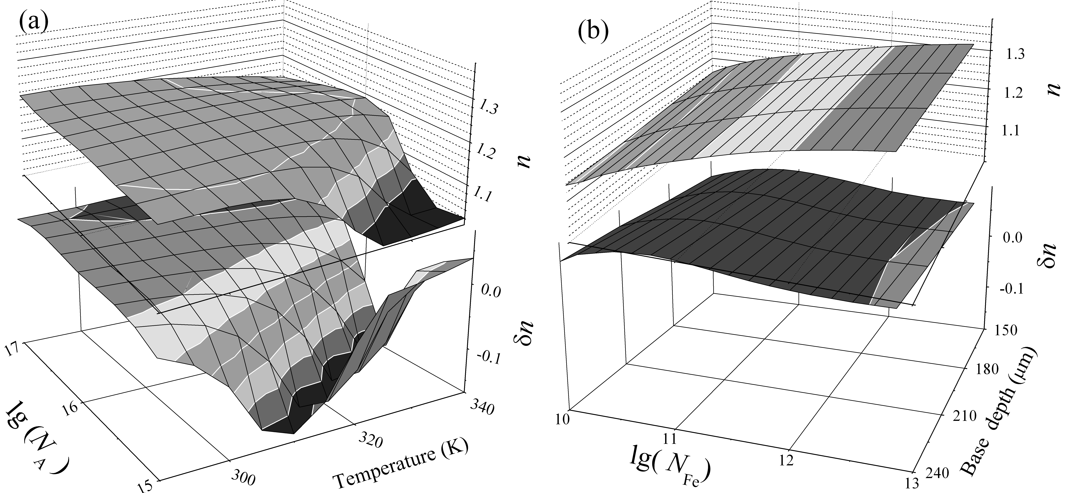
Figure 1: Dependencies of ideality factor in equilibrium state (n, upper surfaces) and alteration in ideality factor after Fe-B pair dissociation (δn, lower surfaces). N_{Fe} = 10¹⁰ cm⁻³, d = 240 μm (a), N_{A} = 10¹⁷ cm⁻³, T = 340 K (b).

It was established that i) the base depth affects the ideality factor value in the case of minority carrier diffusion length L_{n}>>d; ii) the influence of temperature and doping level deals with change in a recombination level population mainly; iii) the dependence of n on the iron concentration is a monotonic function.

