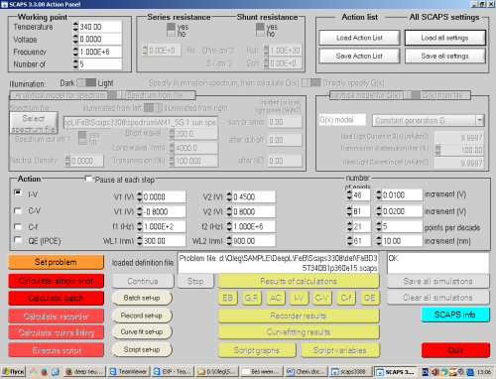
T
d_{p}
N_{B}
N_{Fe, PRED}
n_{Fe}
n_{Fe-FeB}
scikit-learn/StandardScaler
...
...
...
...
N_{Fe,TRUE}
StandardScaler⁻¹
SCAPS
IJAVA
IVCs
log
log⁻¹
Input Layer
Output Layer
Hidden Layers
Fitting
Standardization
Simulation
MRSE
loss function

