Thermal Conductivity of Nanoporous Silicon: Molecular Dynamics Simulations and Machine Learning Prediction
V.V. Kuryliuk, O.Ya. Olikh
Taras Shevchenko National University of Kyiv, 60 Volodymyrska Street, Kyiv, Ukraine, 01033
kuryliuk@knu.ua, olegolikh@knu.ua

Abstract
Text

Introduction
In recent years, nanostructured materials have attracted significant interest for their potential in thermal insulation and heat dissipation applications [1, 2]. For instance, as 3D integration advances in micro- and nanoelectronics, there is a growing need for low thermal conductivity materials that remain compatible with CMOS processes. Furthermore, for energetically autonomous systems, the development of effective nanomaterials exhibiting high thermoelectric conversion efficiency is also crucial [3]. The thermal behavior of nanomaterials is significantly influenced by their structural dimensions and the manner in which phonons propagate through their frameworks [4]. In such materials, thermal phonons are frequently scattered at surfaces and interfaces, thereby significantly lowering overall thermal conductivity [5]. It is noteworthy that nanoporous structures have attracted significant interest due to their large specific surface area and shortened phonon mean free path, which further suppresses heat transport [6, 7].
Nanoporous silicon (p-Si), produced by electrochemical anodization of crystalline silicon, has attracted significant attention because its optical, electrical, and thermal properties can be readily tuned by adjusting the porosity. This controllability enables a wide range of potential applications for p-Si in areas such as highly sensitive sensors [8], lithium-ion batteries [9], optoelectronics, micro- and nanoelectronics [10], as well as MEMS technologies [11]. It has been demonstrated that nanostructured silicon with tailored porosity exhibits thermal conductivity that is two to three orders of magnitude lower than that of bulk crystalline silicon (~140 W⋅m⁻¹⋅K⁻¹) [12]. This renders it an appealing candidate for utilization in thermal sensors [13], thermal insulation and thermoelectric generators in silicon-based microsystems [14]. In order to gain deeper insight into the mechanisms of phonon transport in p-Si, it is crucial to undertake comprehensive thermal characterization. Furthermore, it is imperative to possess precise knowledge of the thermal behavior of this material to ensure its effective integration into practical devices.
Molecular dynamics (MD) simulations have become an indispensable tool for investigating thermal transport phenomena in nanostructured materials, providing valuable atomistic insights that are often inaccessible through experiments alone. In particular, MD methods have been extensively utilized to predict the thermal conductivity of porous silicon and analogous systems, elucidating the profound impact of nanoscale characteristics, such as pore size, shape, and distribution, on phonon scattering and heat conduction [15-18]. The integration of machine learning (ML) approaches with atomistic modelling has emerged as a promising strategy to efficiently predict and optimize the properties of complex materials by uncovering hidden structure-property relationships [19, 20]. Two primary approaches integrate ML with MD. The first one employs machine learning interatomic potentials in simulations, enabling the study of large-scale emergent phenomena in specific materials with accuracy close to that of ab initio MD [o1, o2]. The second approach uses MD simulation results from a limited number of cases as input data to build and train ML models; these models are then applied to a much wider range of predictions [o3, o4]. Both methods have been successfully used to assess the thermal properties of various materials [20, o5, o6, o7, o8], including porous structures [o9]. As previous studies have shown that such integrated frameworks can significantly accelerate the design of advanced nanostructured materials for thermal management and energy conversion applications.
In this study, molecular dynamics and machine learning methods were employed to calculate the thermal conductivity of nanoporous silicon. A series of interatomic interaction potentials were tested to predict heat transport in silicon. The equilibrium molecular dynamics approach was used to determine the dependence of the thermal conductivity on temperature and porosity. The resulting dataset was then processed and generalized using machine learning models, allowing the thermal conductivity of p-Si to be estimated over a wide range of temperatures and porosities.

Methods
The thermal conductivity of the p-Si was calculated via equilibrium molecular dynamics (EMD). All MD simulations were performed using the LAMMPS package [21]. The EMD simulation setup considered in this paper is schematically illustrated in Fig. 1. The simulation box is a cube consisting of L³=10a×10a×10a unit cells, where a is the unit-cell lattice vector in the Si. The porosity of the structure was varied by changing the pore radius R and was calculated as 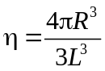. For each temperature and porosity, an initial simulation was performed in the isobaric–isothermal (NPT) ensemble to generate thermally equilibrated configurations. The system was then further equilibrated in an isochoric–isothermal (NVT) ensemble. In both the NPT and NVT simulations, the temperature was controlled using a Nosé–Hoover thermostat. The simulation time for each ensemble was 0.5 ns, and the integration of Newton’s equations of motion was carried out using the Verlet algorithm with a time step of 1 fs. After reaching equilibrium, the system was switched to a constant-volume and constant-energy (NVE) ensemble to determine the thermal conductivity k using the Green–Kubo method. In this method k was estimated by integrating the heat current autocorrelation function (HCACF) as follows:
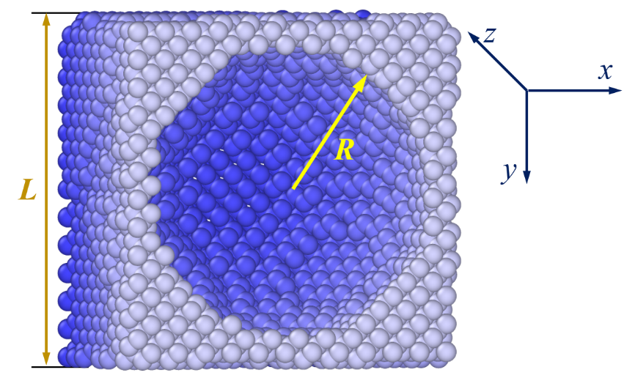
Figure 1. Schematic illustration of the EMD simulation setup: L – size of the Si supercell (cube), R – pore radius.

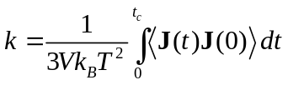, (1)
where V is the volume of the system, t is the time, the brackets 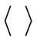 is the ensemble-averaged HCACF and J is the heat current vector that is defined as
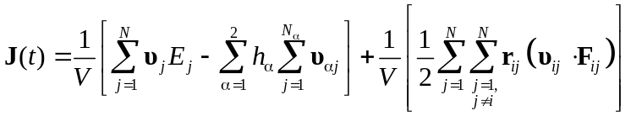, (2)
Here, υ_{j} and E_{j} are the velocity and energy of the j-th particle; r_{ij} and F_{ij} denote the distance and the interaction force between the i-th and j-th particles; N is the total number of particles in the system; and h_{α} is the average partial enthalpy of component α. Obviously, that t_{c} value (the upper limit of the integral or the MD simulation time) must be sufficiently large for the system to reach equilibrium. In essence, the thermal conductivity k was determined as the saturation value of the k ( t_{c} ) curve. To reduce statistical errors, our MD simulations were run for more than 10 ns on average, and five independent simulations were performed for each specific condition. For a structure with a given porosity, calculating (on тут би параметри кластеру) the thermal conductivity at a single temperature required seven ?? days of computation.
The primary goal of applying Machine Learning (ML) methods was to enable the rapid estimation of the thermal conductivity of porous silicon across arbitrary values of porosity p (0 ≤ p < 1) and temperature T. A key consideration when selecting ML approaches is the limited availability of thermal conductivity data – only a few dozen values can realistically be obtained from MD simulations within a feasible timeframe for model development. As a result, conventional ML methods that require training dataset containing tens or hundreds of thousands of samples are not suitable in this context.
As a result, two distinct approaches were used. The first approach employed Symbolic Regression (SR), an algorithm that derives a mathematical expression to describe a given dataset. Unlike conventional regression methods, which require predefined input variables and adjust numerical coefficients to achieve the best fit, SR simultaneously identifies both the structure of the equation and its parameters [o10]. It uses evolutionary algorithms to uncover functional relationships and numerical coefficients between input and output variables. A key advantage of SR is its ability to produce interpretable results in the form of analytical expressions. Moreover, this method does not require large amounts of training data to achieve high predictive accuracy [o10, o11].
SR was implemented in Python using the open-source PySR package. Data preprocessing was limited to normalizing temperature values to 300 K. During training, the loss function was defined as the mean weighted squared error (MWSE) and was minimized:
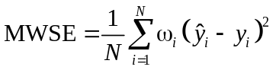. (3)
Here, N represents the number of values in the training set, y_{i} denotes the true thermal conductivity (result of MD simulation), while 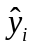 indicates the predicted value; ω_{i} is the weighting coefficient, in this study, statistical weighting was applied, meaning 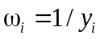.
In the second approach, classical algorithms – specifically Random Forest (RF), Gradient Boosting (GB), and Support Vector Regression (SVR) – were used to build models predicting the k ( t_{c} ) curve. This strategy significantly increased the size of the training dataset. The input descriptor set included porosity, temperature, and simulation time. To standardize the features, they were normalized to have zero mean and unit standard deviation. The models were implemented using Python’s Scikit-learn toolkit. Model parameters were optimized using the Optuna framework, which employed the TPE sampler and Hyperband pruner for efficient hyperparameter selection. A 5-fold cross-validation scheme was applied during model tuning. To determine thermal conductivity, the predicted k ( t_{c} ) curves were processed in the same way as those obtained from MD simulations.
The evaluation metrics used to assess forecast quality were the mean squared error (MSE), mean absolute percentage error (MAPE), and coefficient of determination (R²), as defined in Eqs. (4)-(6).
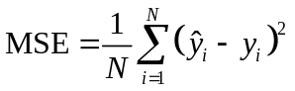, (4)
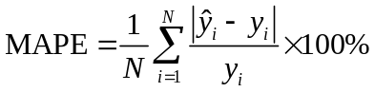, (5)
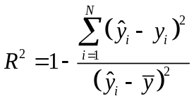, (6)
where is the mean of the true values.

Results and discussion
1. Evaluation and Selection of Interatomic Potentials. The accuracy of MD simulations strongly depends on the choice of interatomic potential. Therefore, the initial stage of this study focused on evaluating several well-known potentials based on two key criteria: (i) computational performance, which is particularly relevant for high-throughput simulations and machine learning dataset generation; and (ii) agreement between simulated and experimental temperature-dependent thermal conductivity of singlecrystalline silicon. The tested potentials included MEAM [22], Tersoff [23], EDIP [24], Stillinger-Weber (SW) [25], modified Stillinger-Weber (SW-mod) [26], and a machine learning-based potential SNAP [27]. The results are summarized in Figures 2 and 3.
As shown in Figure 2, the EDIP potential demonstrated the highest computational performance, reaching nearly 5000 MD steps per second on a 128-core node. Tersoff, SW, and SW-mod potentials achieved approximately 3000 steps per second, while MEAM exhibited ten times lower performance than EDIP. The SNAP potential was the slowest, with only ~30 steps per second under identical simulation and hardware conditions.

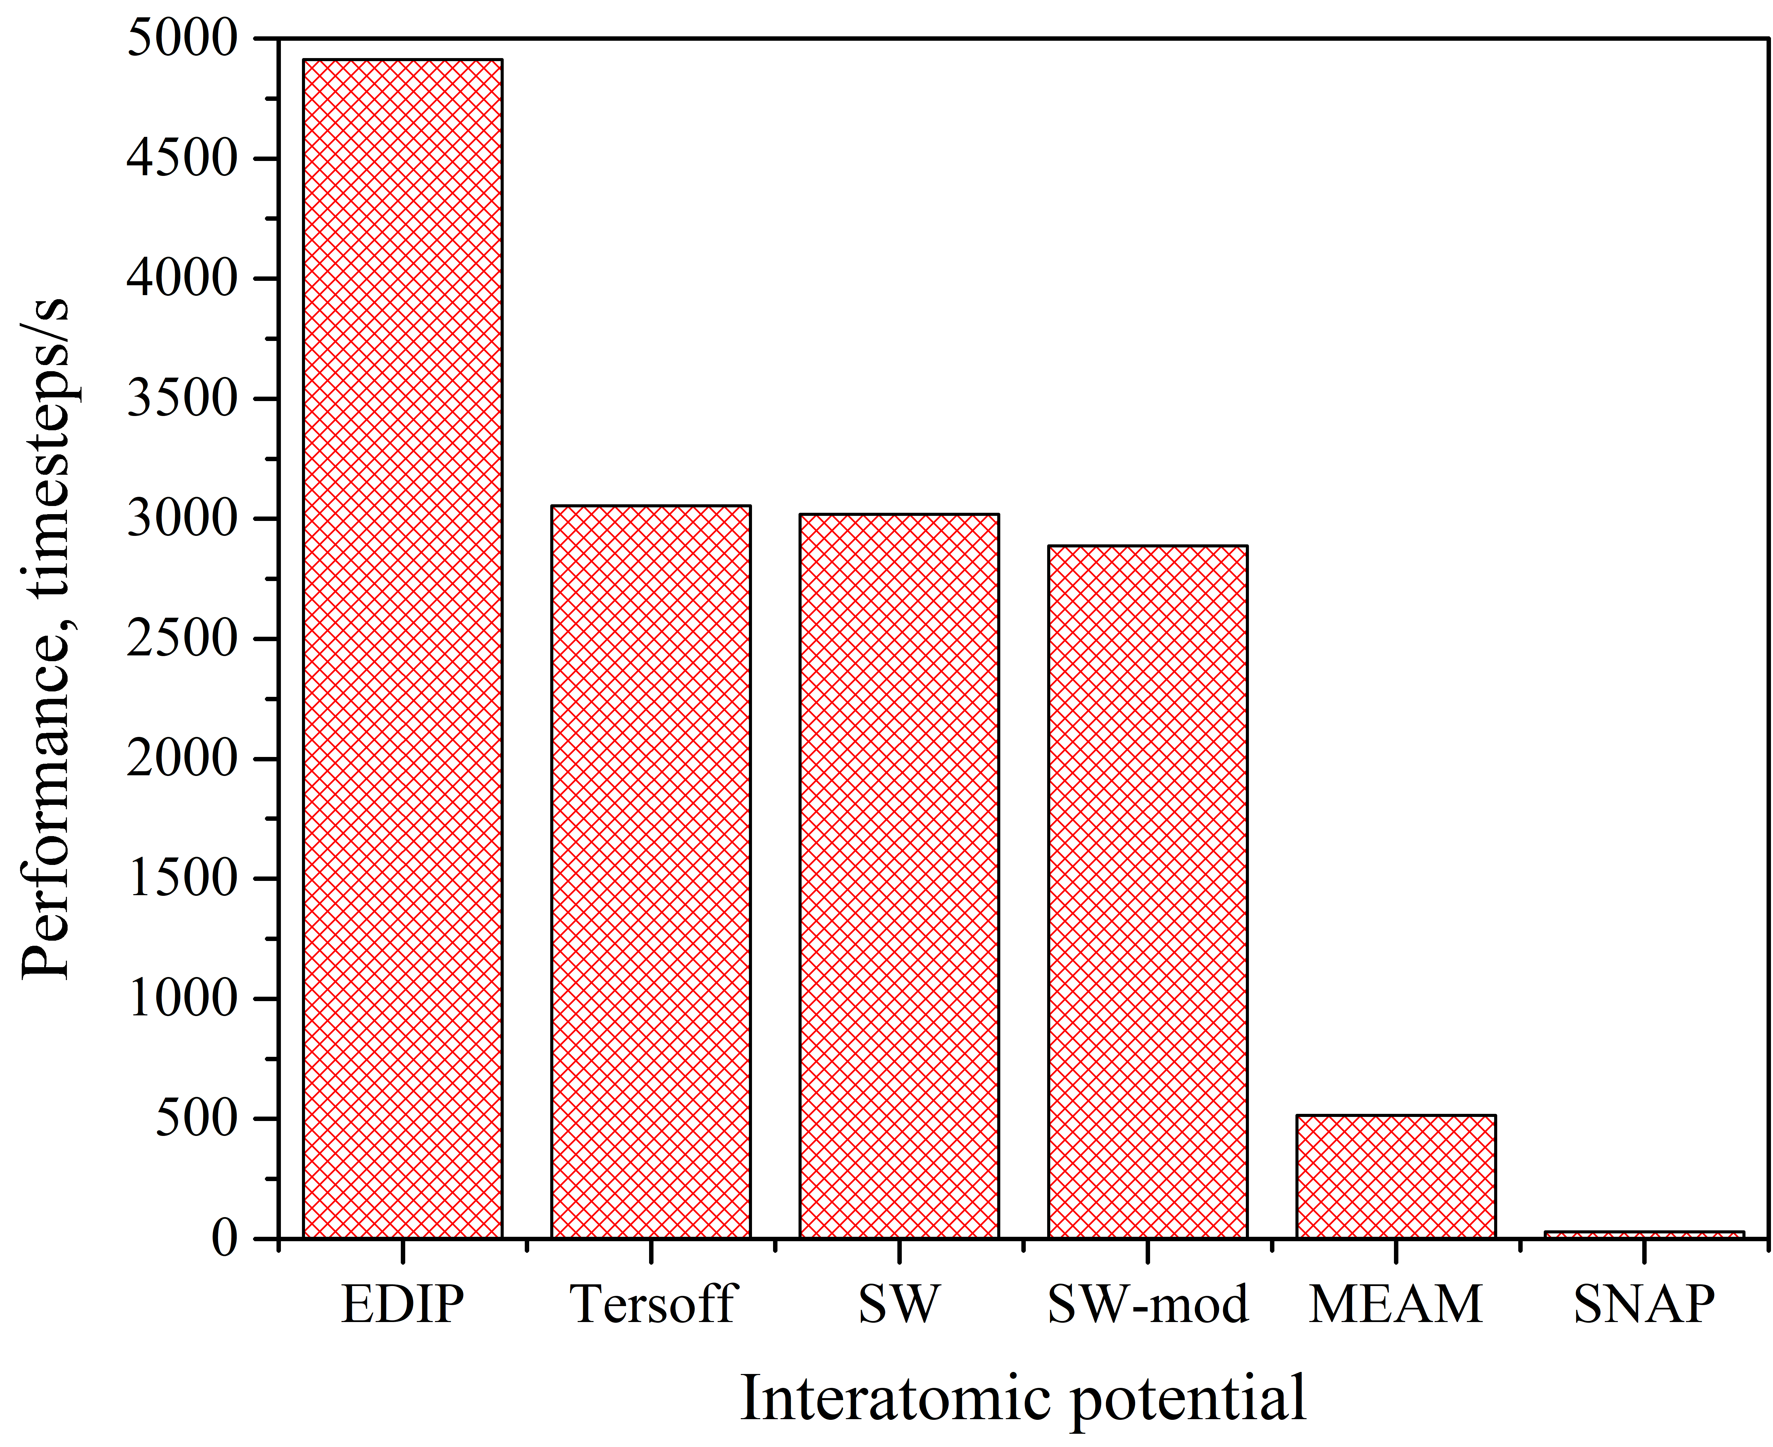
Figure 2. Comparison of the computational performance of various interatomic potentials for calculating the thermal conductivity of singlecrystalline silicon. Structure size: 10a×10a×10a; number of cores per node: 128..

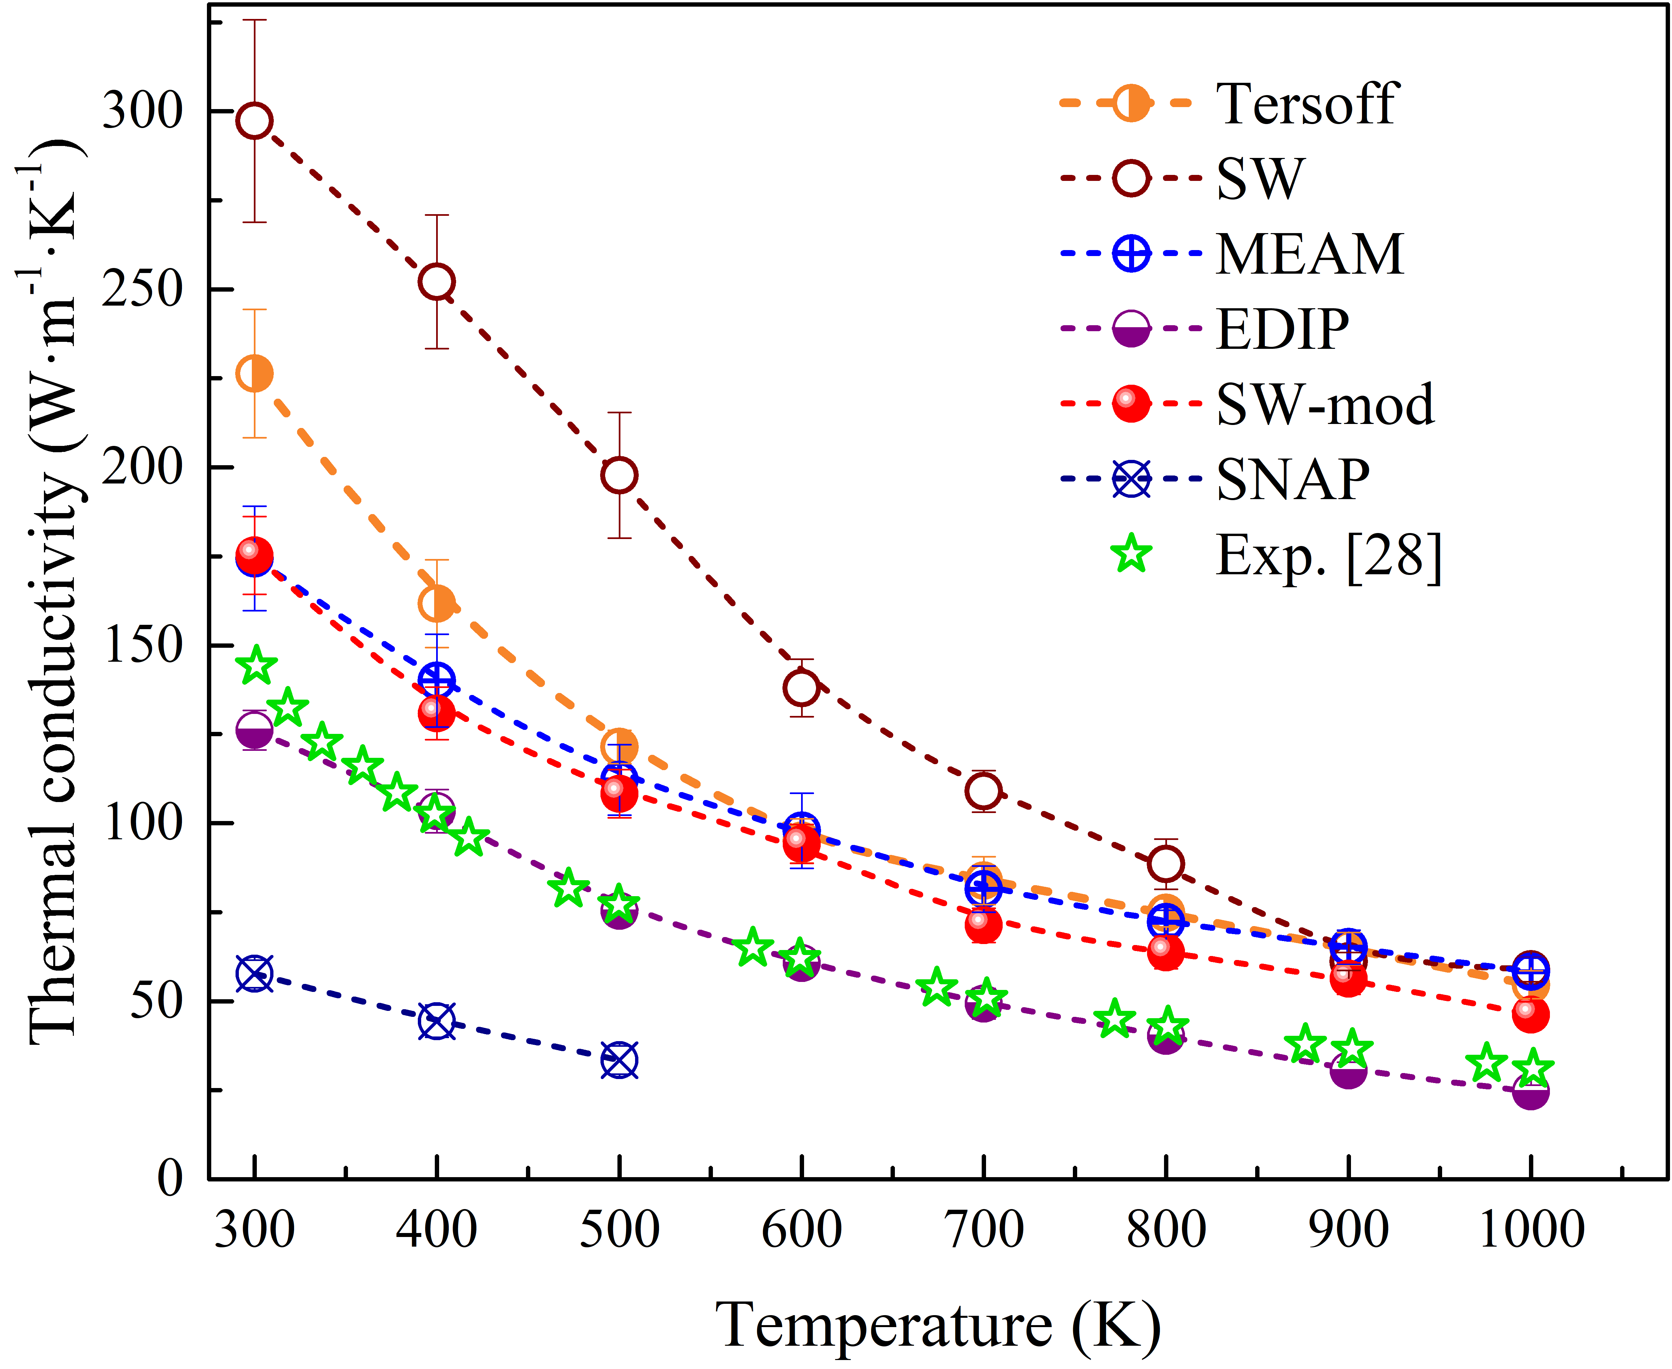
Figure 3. Calculated temperature dependence of thermal conductivity of singlecrystalline silicon using different interatomic potentials, compared with experimental data adapted from [28].

Thermal conductivity values calculated using MEAM, Tersoff, SW, and SW-mod consistently exceeded the experimental results reported in Ref. [28] across the entire temperature range, with deviations ranging from 48% to 106%. These discrepancies are largely attributed to the idealized nature of the simulated structures, which lack defects and isotopic disorder present in real crystals. In contrast, the SNAP potential significantly underestimated the thermal conductivity, indicating inadequate parameterization for heat transport simulations.
Among all tested potentials, EDIP showed the best agreement with the experimental temperature dependence k(T), and given its superior computational efficiency, it was initially selected for further studies of porous silicon. However, subsequent simulations revealed that for highly porous structures and elevated temperatures, the porous architecture (Fig. 1) became unstable, leading to pore collapse and near-amorphous configurations. Similar instabilities were observed with the SW and SW-mod potentials. As a result, the Tersoff potential was chosen for the remainder of the study. An additional argument in favor of Tersoff is that fitting the calculated k(T) dependence for monocrystalline Si with the function k=AT^{−b} yielded a value of b=1.15±0.03, which is close to the theoretical expectation b=1.0 for semiconductors and dielectrics (for EDIP 1.36±0.09, SW 1.5±0.1, SW-mod 1.08±0.05, MEAM 0.92±0.02). Як на мене, не переконливо, чому відмовилися від EDIP. Можна або 1) додати key criteria на початку параграфа (типу стійкість до збільшення поруватості чи очікувана температурна залежність) і тут показати невідповідність EDIP (на кшталт таблички з + або – чи значеннями b) + написати, чому точний збіг з експериментом це погано (розрахункові величини мають бути більшими бла-бла-бла) або 2) взагалі не згадувати про цей потенціал (графіки як в постері)
2. Generation of Molecular Dynamics Data for Machine Learning. The next stage of the study involved generating a dataset of MD simulation results for training machine learning models aimed at predicting the thermal properties of porous silicon structures. Figures 4 and 5 present selected results for the temperature and porosity dependence of thermal conductivity, calculated using the Tersoff potential.

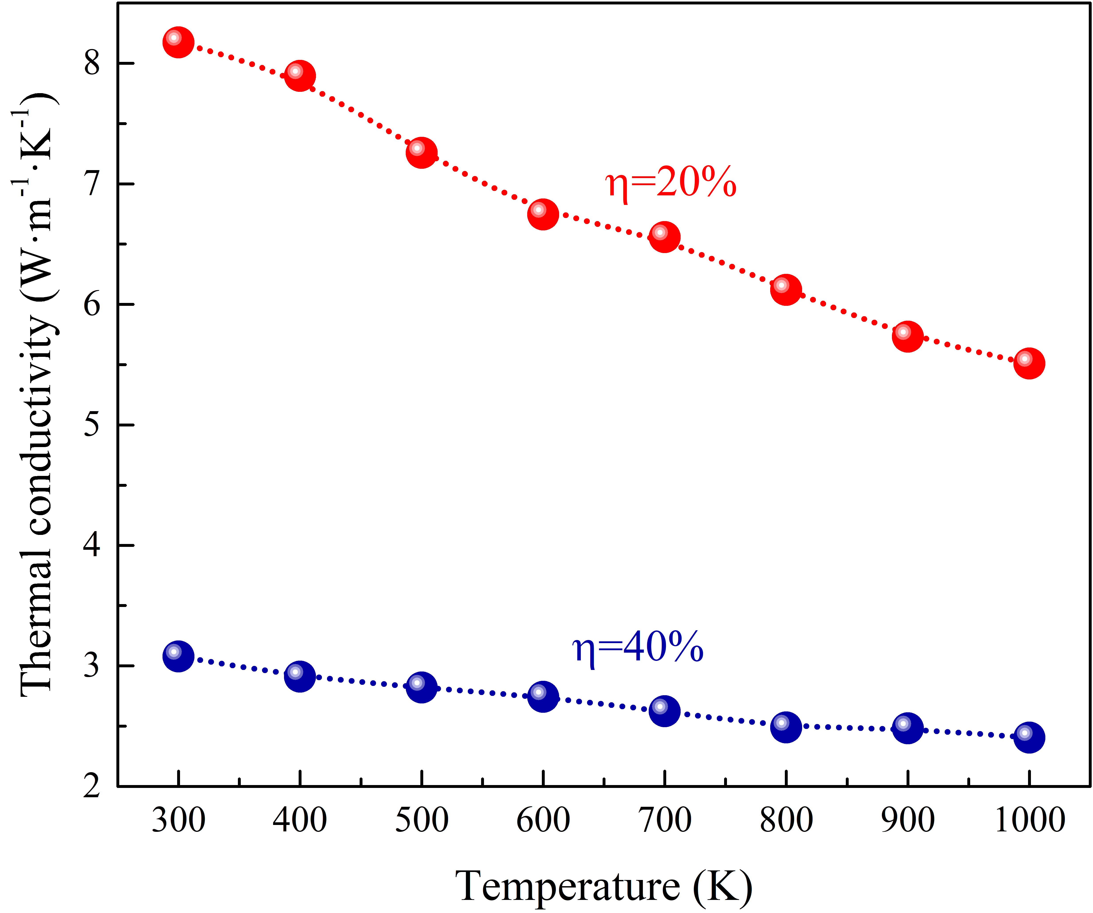
Figure 4. Temperature dependence of thermal conductivity of p-Si with 20% and 40% porosity calculated using the Tersoff potential.

The observed trends are consistent with literature data: thermal conductivity decreases with increasing temperature, and the form of the k(T) dependence evolves as the system becomes increasingly disordered. Specifically, the exponent b in the empirical relation k=AT^{−b} decreases with porosity (0.34±0.02 for p = 0.2 and 0.21±0.01 for p = 0.4), indicating enhanced phonon scattering due to partial amorphization. A monotonic decrease in thermal conductivity with increasing porosity is also observed (Fig. 5), attributed to increased phonon-boundary scattering at pore surfaces.

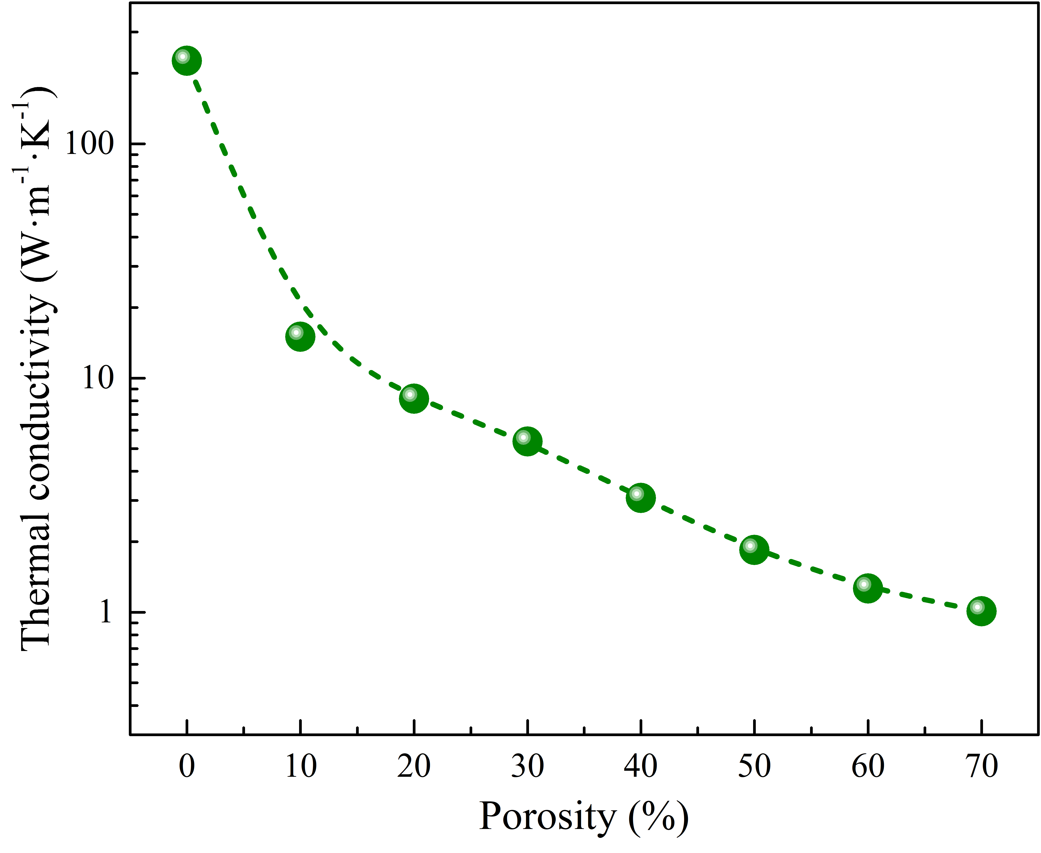
Figure 5. Dependence of thermal conductivity on porosity for p-Si at T=300 K, calculated using the Tersoff potential.

These simulations were performed across a wide range of temperatures and porosities, and the resulting data served as a foundation for the development and training of ML models for predicting the heat transport behavior of porous silicon.

3. Machine Learning-Based Prediction of Thermal Transport Properties in Porous Silicon.

(7)
where 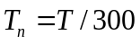.

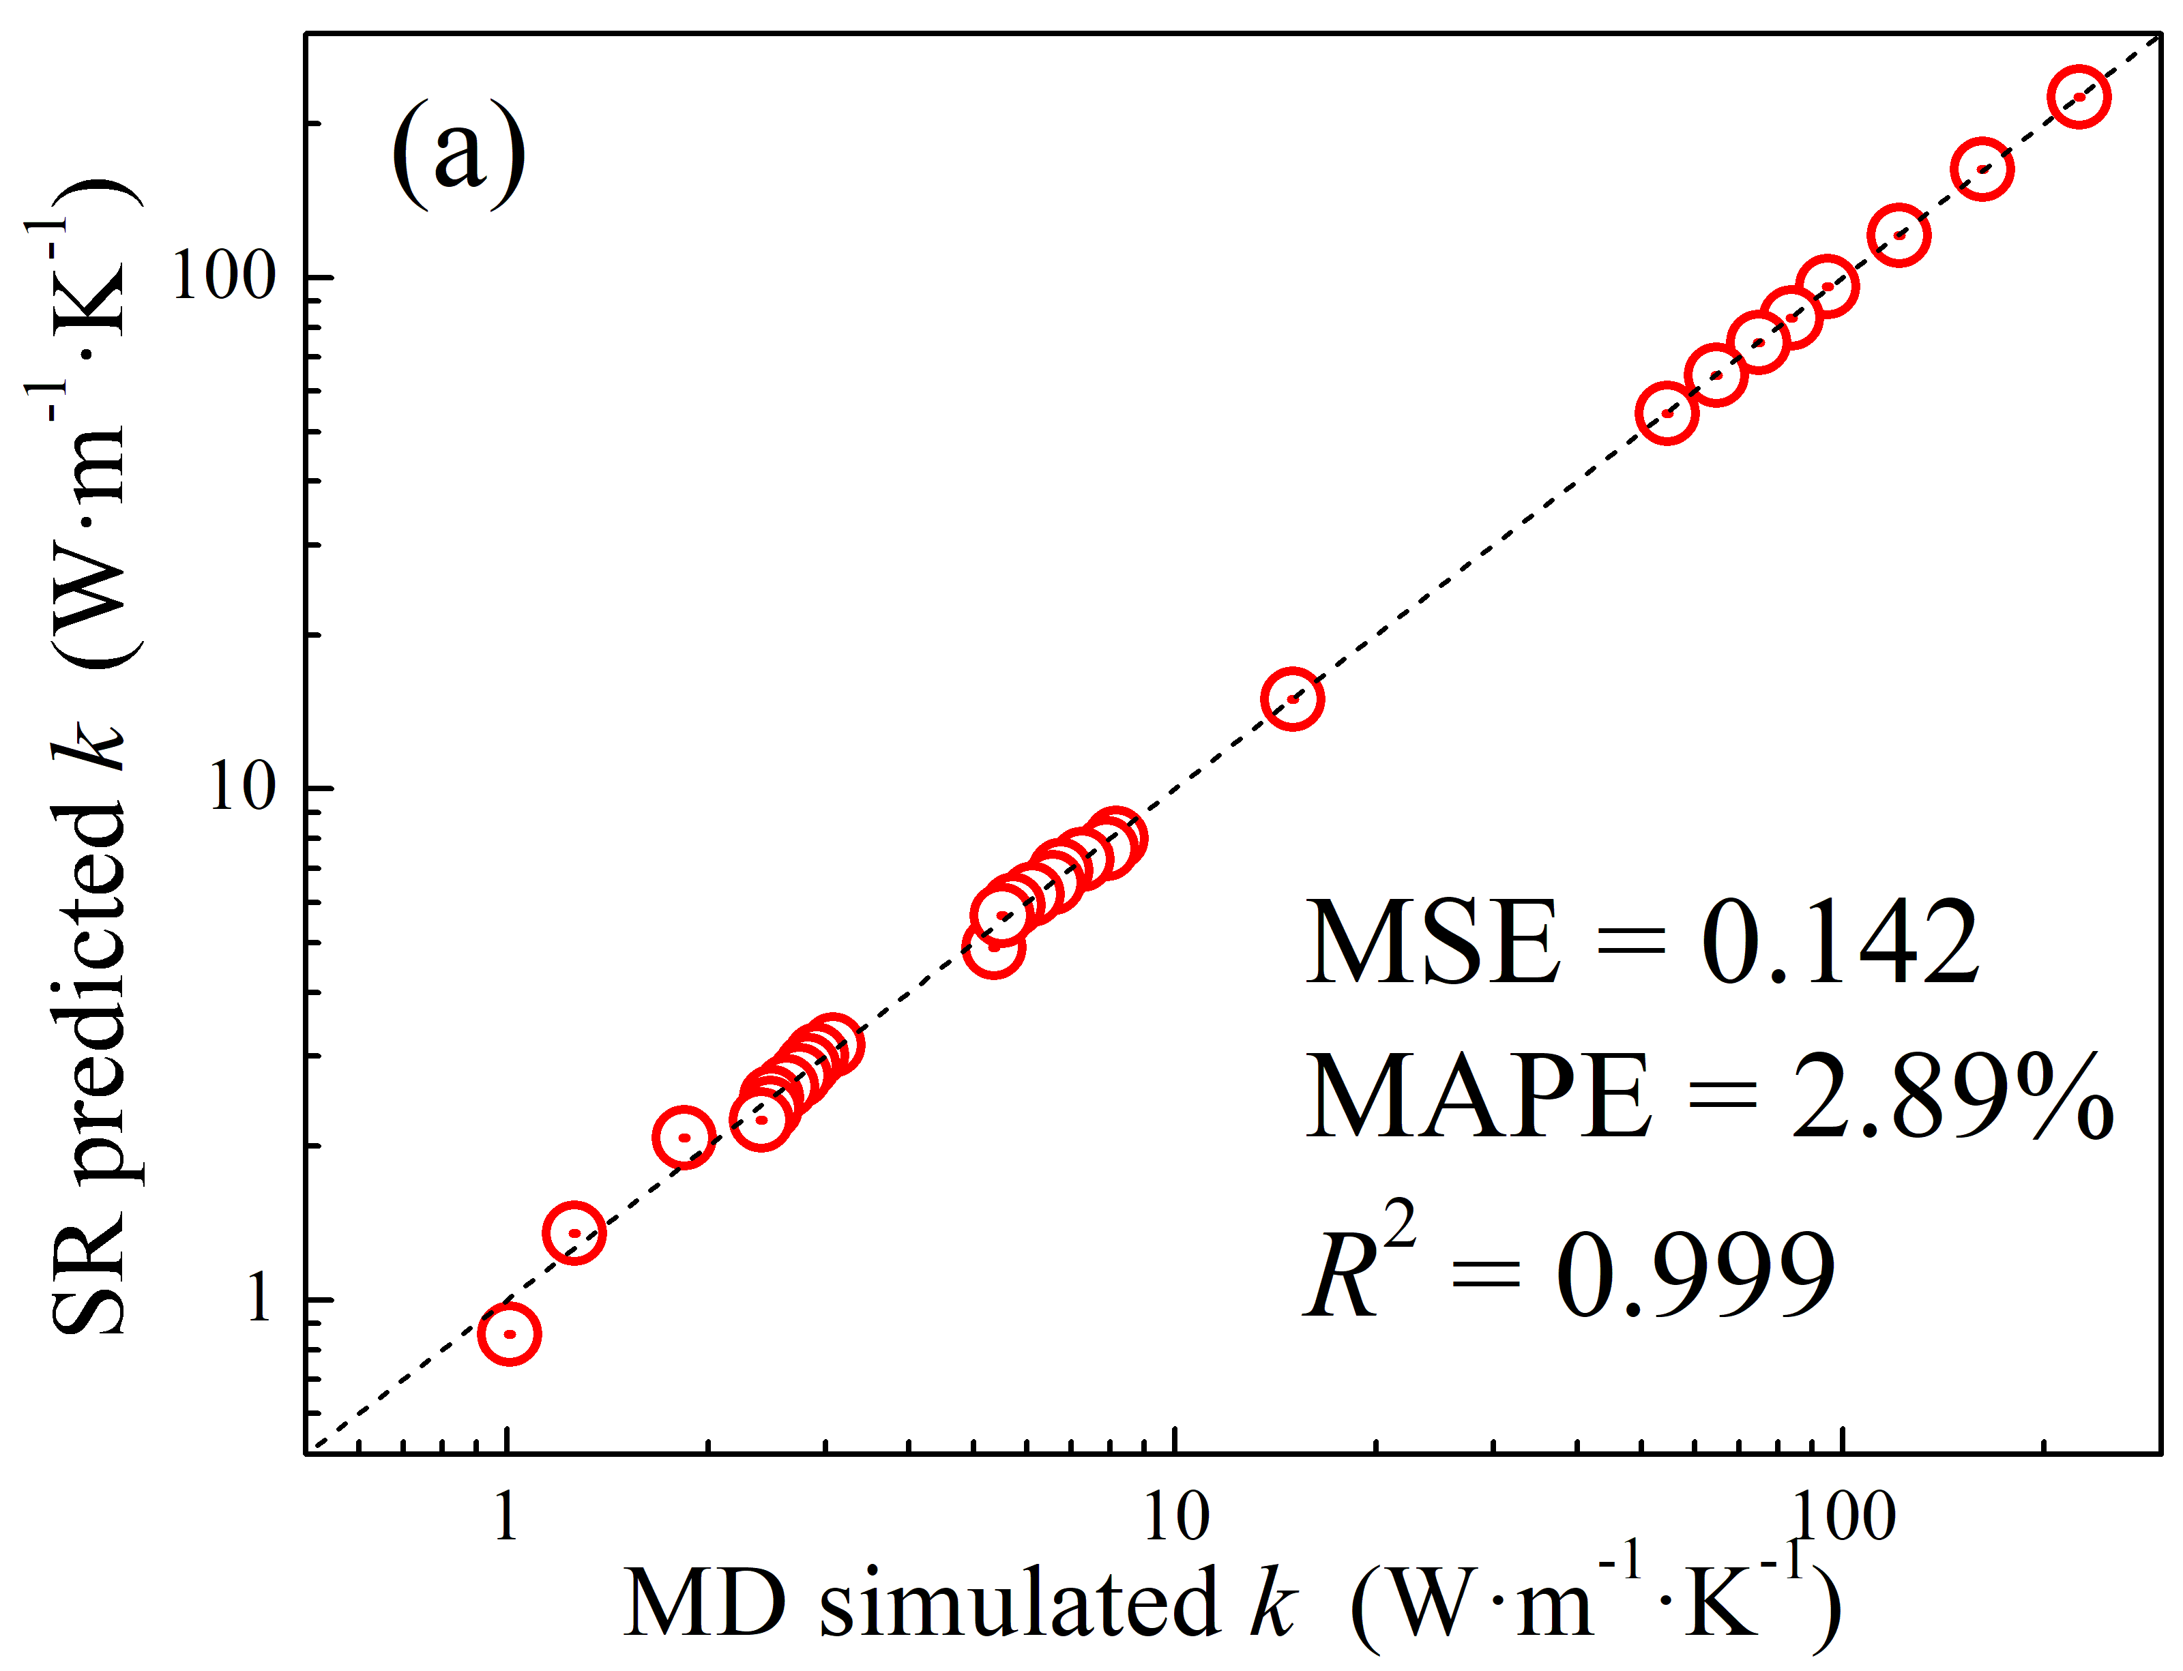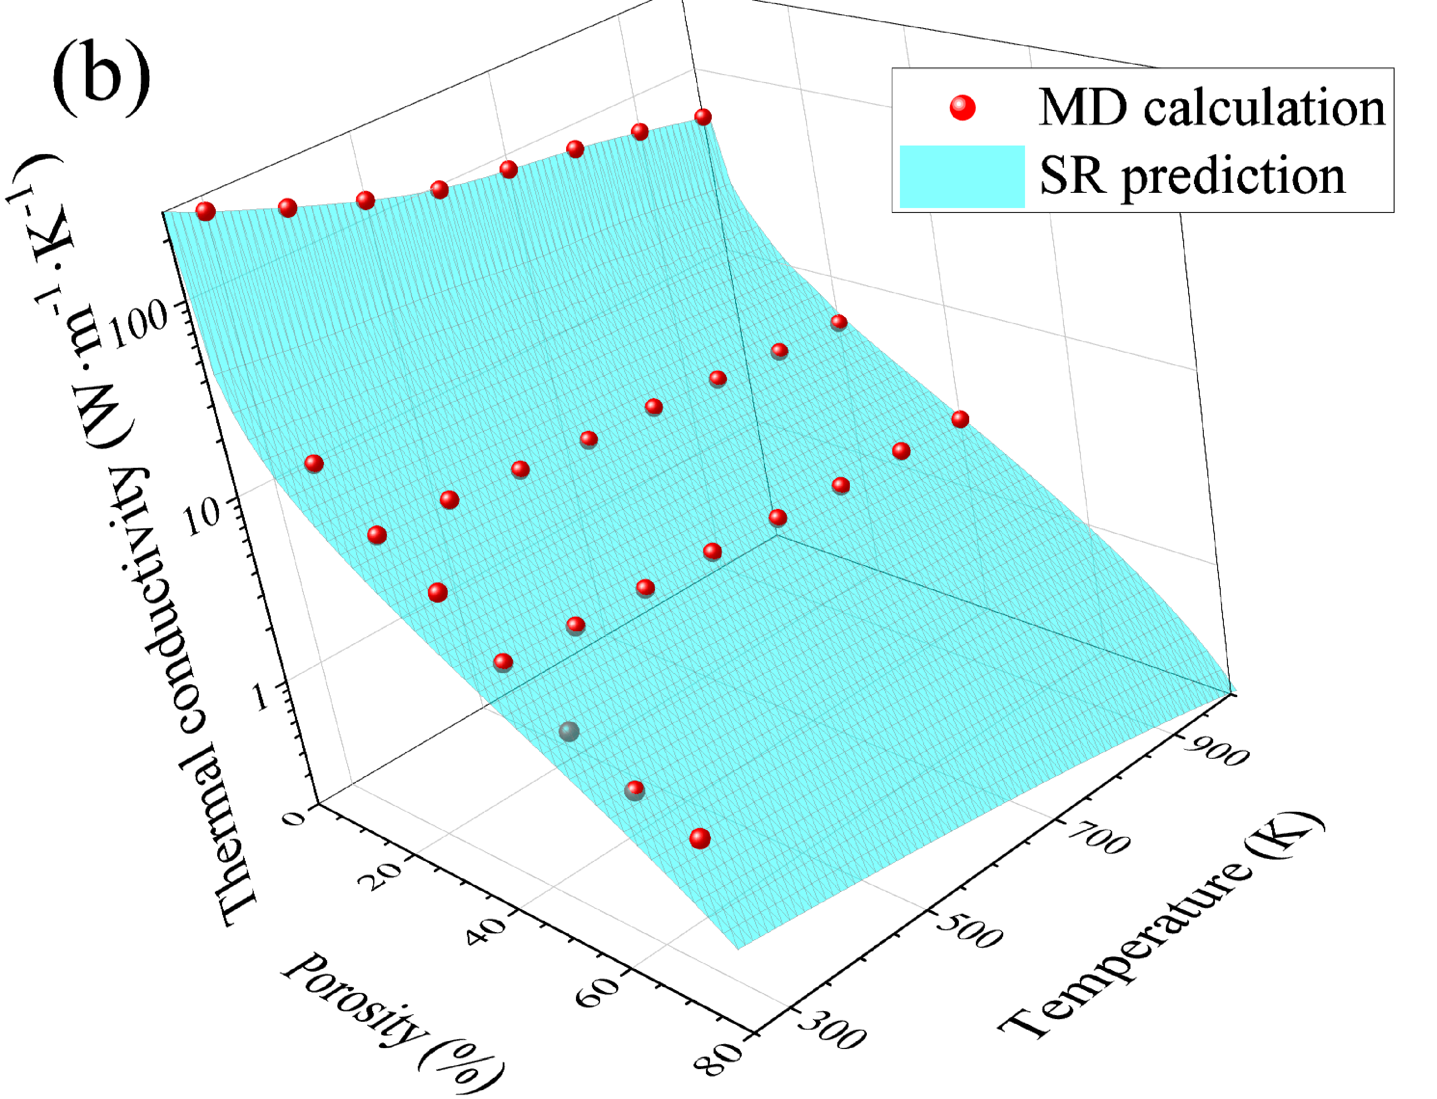
Figure 6. (a) Comparison of SR predicted k and MD calculated k (true value) for p-Si. The black lines are the identified lines serving as the references. (b) Dependence of the thermal conductivity of porous silicon on temperature and porosity. The spheres represent the results of MD simulations, while the surface corresponds to Eq. (7).

References
[1]. Chatterjee S, Paras, Hu H, Chakraborty M. A Review of Nano and Microscale Heat Transfer: An Experimental and Molecular Dynamics Perspective. Processes. 2023; 11(9):2769. https://doi.org/10.3390/pr11092769
[2]. Anto Zacharias, Rajesh Baby, Hanna J. Maria, Sabu Thomas. Preparation, characterization, and selection of nano-assisted phase change materials for thermal management and storage applications. Renewable and Sustainable Energy Reviews. 2025; 210:115195. https://doi.org/10.1016/j.rser.2024.115195
[3]. V. Lacatena, M. Haras, J.-F. Robillard, S. Monfray, T. Skotnicki, E. Dubois. Phononic engineering of silicon using “dots on the fly” e-beam lithography and plasma etching. Microelectronic Engineering. 2014; 121: 131-134. https://doi.org/10.1016/j.mee.2014.04.034
[4]. Siqi Xie, Hongxin Zhu, Xing Zhang and Haidong Wang. A brief review on the recent development of phonon engineering and manipulation at nanoscales. Int. J. Extrem. Manuf. 2024; 6(1); 012007. https://doi.org/10.1088/2631-7990/acfd68
[5]. Kuryliuk, V., Tyvonovych, O., & Semchuk, S. Impact of Ge clustering on the thermal conductivity of SiGe nanowires: atomistic simulation study. Physical Chemistry Chemical Physics. 2023; 25(8): 6263–6269. https://doi.org/10.1039/d2cp05185k
[6]. Mykola Isaiev, Yuliia Mankovska, Vasyl Kuryliuk, David Lacroix. Thermal transport properties of nanoporous silicon with significant specific surface area. Appl. Phys. Lett. 2023; 122 (17): 172201. https://doi.org/10.1063/5.0148434
[7]. D. Lacroix, M. I. Nkenfack, G. Pernot, M. Isaiev. Thermal properties of nanoporous materials, large scale modelling with the use of Monte Carlo phonon transport autocorrelation. J. Appl. Phys. 2023; 134 (2): 025101. https://doi.org/10.1063/5.0155582
[8]. Stephen E. Lewis, John R. DeBoer, James L. Gole, Peter J. Hesketh. Sensitive, selective, and analytical improvements to a porous silicon gas sensor. Sensors and Actuators B: Chemical. 2005; 110(1): 54-65. https://doi.org/10.1016/j.snb.2005.01.014
[9]. Donghyeok Ma, Da Hoon Kim, Mi Yu, Ye Eun Cho, Hansu Kim. Porous silicon layer overlaid graphite anode materials for fast-charging of lithium-ion batteries. Journal of Power Sources. 2025; 645:237199. https://doi.org/10.1016/j.jpowsour.2025.237199
[10]. Dzhafarov, T., Bayramov, A. Porous Silicon and Solar Cells. In: Canham, L. (eds) Handbook of Porous Silicon. Springer, Cham. 2017. https://doi.org/10.1007/978-3-319-04508-5_95-2
[11]. Gerhard Müller, Alois Friedberger, Kathrin Knese. Handbook of Silicon Based MEMS Materials and Technologies. William Andrew Publishing. 2010. https://doi.org/10.1016/B978-0-8155-1594-4.00025-5
[12]. U. Bernini, S. Lettieri, P Maddalena, R. Vitiello and G. Di Francia. Evaluation of the thermal conductivity of porous silicon layers by an optical pump-probe method. J. Phys.: Condens. Matter. 2001; 13: 1141. https://doi.org/10.1088/0953-8984/13/5/327
[13]. Pritam Sharma, John Dell, Giacinta Parish, Adrian Keating. Engineering 1/f noise in porous silicon thin films for thermal sensing applications. Microporous and Mesoporous Materials. 2021;
324: 111302. https://doi.org/10.1016/j.micromeso.2021.111302
[14]. Nguyen Van Toan, Yijie Li, Truong Thi Kim Tuoi, Nuur Syahidah Sabran, Jun Hieng Kiat, Ioana Voiculescu, Takahito Ono. Thermoelectric generator using nanoporous silicon formed by metal-assisted chemical etching method. 2025. Energy Conversion and Management. 2025; 323:119268. https://doi.org/10.1016/j.enconman.2024.119268
[15]. Jin Fang, Laurent Pilon; Scaling laws for thermal conductivity of crystalline nanoporous silicon based on molecular dynamics simulations. J. Appl. Phys. 2011; 110(6): 064305. https://doi.org/10.1063/1.3638054
[16]. Y. He and G. Galli. Microscopic origin of the reduced thermal conductivity of nanoporous Si. Phys. Rev. Lett. 2012; 108: 215901. https://doi.org/10.1103/PhysRevLett.108.215901
[17]. Jin Fang, Laurent Pilon; Tuning thermal conductivity of nanoporous crystalline silicon by surface passivation: A molecular dynamics study. Appl. Phys. Lett. 2012; 101 (1): 011909. https://doi.org/10.1063/1.4733352
[18]. Mykola Isaiev, Nataliia Kyrychenko, Vasyl Kuryliuk, David Lacroix; Features of phonon scattering by a spherical pore: Molecular dynamics insight. Appl. Phys. Lett. 2024; 124 (14): 142202. https://doi.org/10.1063/5.0200817
[19?]. Qingfu Huang, Donghui Hong, Bo Niu, Donghui Long, Yayun Zhang. An interpretable deep learning strategy for effective thermal conductivity prediction of porous materials. International Journal of Heat and Mass Transfer. 2024; 221: 125064. https://doi.org/10.1016/j.ijheatmasstransfer.2023.125064
[20]. Luo Y., Li M., Yuan H. et al. Predicting lattice thermal conductivity via machine learning: a mini review. npj Comput Mater. 2023; 9:4. https://doi.org/10.1038/s41524-023-00964-2
[o1]. Ryan Jacobs, Dane Morgan, Siamak Attarian et al. A practical guide to machine learning interatomic potentials – Statusand future. Current Opinion in Solid State & Materials Science. 2025, 35: 101214. https://doi.org/10.1016/j.cossms.2025.101214
[o2]. Guanjie Wang, Changrui Wang, Xuanguang Zhang, Zefeng Li, Jian Zhou, Zhimei Sun. Machine learning interatomic potential: Bridge the gap between small-scale models and realistic device-scale simulations. iScience. 2024, 27:109673. https://doi.org/10.1016/j.isci.2024.109673
[o3] Hoang-Giang Nguyen, Thanh-Dung Le, Hong-Giang Nguyen, Te-Hua Fang. Mechanical properties of AlCoCrCuFeNi high-entropy alloys using molecular dynamics and machine learning. Materials Science & Engineering R. 2024, 160: 100833. https://doi.org/10.1016/j.mser.2024.100833
[o4] Omarelfarouq Elgack, Belal Almomani, Junaidi Syarif, Mohamed Elazab, Mohammad Irshaid, Mohammad Al-Shabi. Molecular dynamics simulation and machine learning-based analysis for predicting tensile properties of high-entropy FeNiCrCoCu alloys. Journal of Materials Research & Technology. 2023, 25: 5575. https://doi.org/10.1016/j.jmrt.2023.07.023
[o5] Liben Guo, Yuanbin Liu, Lei Yang, and Bingyang Cao. Lattice dynamics modeling of thermal transport in solids using machine-learned atomic cluster expansion potentials: A tutorial. J. Appl. Phys. 2025, 137 (8): 081101. https://doi.org/10.1063/5.0251119
[o6] Xianqing Liu, Fei Liang, Shule Liu, Gechuanqi Pan, Jing Ding, Jianfeng Lu. NaCl-KCl-CaCl2 molten salts for high temperature heat storage: Experimental and deep learning molecular dynamics simulation study. Solar Energy Materials & Solar Cells. 2025, 280: 113275. https://doi.org/10.1016/j.solmat.2024.113275
[o7] Yao Du, Penghua Ying, Jin Zhang. Prediction and optimization of the thermal transport in hybrid carbon-boron nitride honeycombs using machine learning. Carbon. 2021, 184: 492. https://doi.org/10.1016/j.carbon.2021.08.035
[o8] Prabudhya Roy Chowdhury and Xiulin Ruan. Unexpected thermal conductivity enhancement in aperiodic superlattices discovered using active machine learning. npj Comput Mater. 2022; 8:12. https://doi.org/10.1038/s41524-022-00701-1
[o9] Jing Wan, Jin-Wu Jiang, Harold S. Park. Machine learning-based design of porous graphene with low thermal conductivity. Carbon. 2020, 157: 262. https://doi.org/10.1016/j.carbon.2019.10.037
[o10] Dimitrios Angelis, Filippos Sofos, Theodoros E. Karakasidis. Artificial intelligence in physical sciences: symbolic regression trends and perspectives. Archives of Computational Methods in Engineering. 2023, 30:3845. https://doi.org/10.1007/s11831-023-09922-z
[o11] F. Sofos, C. Dritselis, S. Misdanitis, T. Karakasidis, D. Valougeorgis. Computation of flow rates in rarefied gas flow through circular tubes via machine learning techniques. Microfluidics and Nanofluidics. 2023 27:85. https://doi.org/10.1007/s10404-023-02689-6
[o12] Miles Cranmer. Interpretable Machine Learning for Science with PySR and SymbolicRegression.jl. arXiv:2305.01582. https://doi.org/10.48550/arXiv.2305.01582
[21]. A. P. Thompson, H. M. Aktulga, R. Berger, D. S. Bolintineanu, W. M. Brown, P. S. Crozier, P. J. in 't Veld, A. Kohlmeyer, S. G. Moore, T. D. Nguyen, R. Shan, M. J. Stevens, J. Tranchida, C. Trott, S. J. Plimpton. LAMMPS - a flexible simulation tool for particle-based materials modeling at the atomic, meso, and continuum scales. Comp Phys Comm. 2022; 271:10817. https://doi.org/10.1016/j.cpc.2021.108171
[22]. B.-J. Lee. A modified embedded atom method interatomic potential for silicon. Calphad. 2007; 31(1): 95-104. https://doi.org/10.1016/j.calphad.2006.10.002
[23]. J. Tersoff. Modeling solid-state chemistry: Interatomic potentials for multicomponent systems. Physical Review B. 1989; 39(8): 5566-5568. https://doi.org/10.1103/physrevb.39.5566
[24]. J.F. Justo, M.Z. Bazant, E. Kaxiras, V.V. Bulatov, and S. Yip. Interatomic potential for silicon defects and disordered phases. Physical Review B. 1998; 58(5): 2539-2550. https://doi.org/10.1103/physrevb.58.2539
[25]. F.H. Stillinger, and T.A. Weber. Computer simulation of local order in condensed phases of silicon. Physical Review B. 1985; 31(8): 5262-5271. https://doi.org/10.1103/physrevb.31.5262
[26]. Yongjin Lee and Gyeong S. Hwang. Force-matching-based parameterization of the Stillinger-Weber potential for thermal conduction in silicon. Physical Review B. 2012; 85: 125204. https://doi.org/10.1103/PhysRevB.85.125204
[27]. A.P. Thompson, L.P. Swiler, C.R. Trott, S.M. Foiles, G.J. Tucker. Spectral neighbor analysis method for automated generation of quantum-accurate interatomic potentials. Journal of Computational Physics. 2015; 285: 316-330. https://doi.org/10.1016/j.jcp.2014.12.018
[28]. A.V. Inyushkin, A.N. Taldenkov, J. W. Ager, E. E. Haller, H. Riemann, N. V. Abrosimov, H.-J. Pohl, P. Becker. Ultrahigh thermal conductivity of isotopically enriched silicon. J. Appl. Phys. 2018; 123 (9): 095112. https://doi.org/10.1063/1.5017778

