KINETICS OF LIGHT-INDUCED PROCESSES DUE TO IRON IMPURITIES IN SILICON SOLAR CELLS

1st Viktor Vlasiuk
Physical and Technical Fundamentals of Semiconductor Photovoltaics
V. Lashkaryov Institute
of Semiconductor Physics
NAS of Ukraine
Kyiv, Ukraine
viktorvlasiuk@gmail.com
2nd Roman Korkishko
Physical and Technical Fundamentals of Semiconductor Photovoltaics
V. Lashkaryov Institute
of Semiconductor Physics
NAS of Ukraine
Kyiv, Ukraine
romkin.ua@gmail.com
3rd Vitaliy Kostylyov
Physical and Technical Fundamentals of Semiconductor Photovoltaics
V. Lashkaryov Institute
of Semiconductor Physics NAS of Ukraine
Kyiv, Ukraine
vkost@isp.kiev.ua
4th Oleg Olikh
Faculty of Physics
Taras Shevchenko National University of Kyiv
Kyiv, Ukraine
olikh@univ.kiev.ua

Abstract— An approach is proposed that allows to extend the existing techniques of studying the behaviour and properties of iron in silicon wafers to ready-made silicon solar cells (SC) and in case of arbitrary level of injection of excess electron-hole pairs. The kinetics of light-induced processes, namely the kinetics of open circuit voltage and short-circuit current, the kinetics of the effective lifetime and the kinetics of changes in the interstitial iron concentration during iron-boron pair dissociation reactions and their reverse association into pairs were studied.
The total iron concentration in the studied SCs was determined, as well as the time constants of photodissociation the pairs and the inverse association into pairs. It was found that the processes observed experimentally on silicon SC samples are due to iron impurities, because the photodissociation of pairs at room temperatures and the obtained value of the association time constant of the pairing kinetics is the "fingerprint" of iron in silicon.
Keywords— silicon, solar cells, iron, iron-boron pairs, pair dissociation, recombination

Introduction
A characteristic feature of the modern stage of civilization is the constant growth of energy consumption. Growing electricity needs are met mainly through the use of fossil energy sources, such as coal, natural gas, oil, nuclear fuel. However, the XXI century characterized by an increase in the share of renewable energy sources. A special place is occupied by photoelectricity, i.e. the direct conversion of solar energy into electricity. In some countries, the share of electricity generated by photovoltaic plants exceeds 7%. The vast majority of this energy is provided by silicon solar cells (SC).
The main task of research in the field of photovoltaics is to increase the efficiency of photoconversion. This task is primarily related to the need to reduce the level of losses in silicon SC. One of the most significant losses for both laboratory and mass-produced SCs is the loss associated with the recombination of nonequilibrium electron-hole pairs. The determining factor that directly affects the level of recombination losses is the impurity composition and its concentration. Heavy metal impurities (Au, Co, Cr, Mo, Ni, Nb, Ti, Ta, V, W, Zn) in silicon act as recombination centers, thus reducing the lifetime of excess current carriers [1]. One of the most common and at the same time the most harmful impurities in silicon are iron (Fe) atoms.
A large number of works have been devoted to the study of the behavior of iron impurities in silicon and its influence on the recombination characteristics of silicon and SC made on its basis. In particular, various methods for determining the iron concentration have been proposed [1-6].
Most of the work on the study of the behaviour of iron impurities in silicon was performed on silicon wafers.
In all these works, the parameters of the centers due to iron, and their transformation were determined, as a rule, on silicon wafers, from which were then made of SC. This circumstance was due to the use of appropriate methods for determining the concentration of iron by changing the lifetime (diffusion length) after the operations of dissociation-association of FeB pairs - surface photovoltage (SPV) [1,2] and quasi-steady-state photoconductivity (QSSPC) [4-6]. These techniques are suitable for wafers and are not suitable for determining the concentration of iron and its behaviour in finished SC. However, the behaviour of iron in the finished structures of SC may have features compared to wafers, because SC is a multilayer multi-barrier structure in contrast to the wafers, and iron diffusion processes can be affected by potential barriers at the boundaries of regions with different type and level doping. In addition, in the technological process of manufacturing SC, which contains several high-temperature operations, there may be an effect of contamination by impurities (including iron) from technological equipment and equipping, chemical reagents, etc., and the effect of impurities gettering [6]. Thus, the study of the processes caused by iron impurities in finished SCs is important and relevant.
It is known that Fe in silicon can be in two states [[1]-3, 7-10]:
- in the form of FeB pair (energy level Ec - 0.27 eB [10]);
- in the interstitial state Fe_{i} (energy level Ec - 0.735 eB [10) - is formed during the dissociation of FeB pair.
At room temperature and boron concentration >10¹⁴cm⁻³, all Fe bound in FeB pairs is in equilibrium, whereas at temperatures above 200°C and boron concentration <10¹⁶cm⁻³, most Fe is in the interstitial state. Fe_{i} with its relatively deep energy level is a more efficient recombination center than FeB with an energy level close to the edge of the valence band. The decay of FeB pairs can be caused by external factors: temperature, irradiation with a quantum energy greater than the silicon band gap, etc.
Issues of understanding the behavior of defects and research aimed at developing and implementing methods for converting such defects into a recombination-inactive state are fundamental to improving the performance of SC.
Therefore, the purpose of this work was to develop a research technique aimed at determining the concentration of impurity iron atoms in ready-made silicon SCs, their effect on the characteristics of silicon SCs, as well as to study the kinetics of the light-induced dissociation reaction of FeB onto interstitial iron Fei and boron B and the kinetics of the reverse association reaction Fei and B into pairs.

Description of the Test Samples
Experimental studies were performed on samples of silicon SC with geometric dimensions of 1.52 x 1.535 cm², made on the basis of single-crystal p-type silicon wafers KDB-10 with a resistivity of about 10 Ohm∙cm (doping level ∼1.4∙10¹⁵ cm⁻³). The thickness of the wafers was 380 μm. On the front surface, the SCs had a separating n⁺ -p junction formed by phosphorus diffusion. In addition, to reduce recombination losses and increase the conductivity of the contact layer on the rear surface an isotype p⁺ -p barrier was formed by diffusion of boron. Electrical contacts were formed by applying a solid layer of aluminum on the rear surface and a layer in the form of a grid - on the front surface. Layers of 30 nm thick SiO₂ and 40 nm thick Si₃N₄ silicon nitride were formed on the surface of the SC to passivate the surface and reduce optical reflectance.
The choice for experimental studies of SC samples made on the basis of p-type silicon wafers is not accidental and is due to the fact that in silicon SCs with n-type base, the presence of iron, even with a high concentration does not affect recombination. At the same time, in silicon SCs with a p-type base, iron impurities lead to a significant reduction in the lifetime of excess current carriers with an increase in the doping level [11].

Research Methods
For the first time, a technique for determining the concentration of iron in silicon was proposed in [1]. The authors, using the method of deep level transient spectroscopy (DLTS), have shown that heat treatment of silicon in the dark at a temperature of 210 C for 3 minutes leads to the decomposition of FeB pairs and the transition of iron to the interstitial state of Fei. In this case, the parameters of the iron recombination center change. To record these changes, it was proposed to use measurements of the diffusion length of excess current carriers by the method of spectral dependences of surface photovoltage. The technique was calibrated using DLTS spectra and a formula for calculating the iron concentration in silicon was obtained:
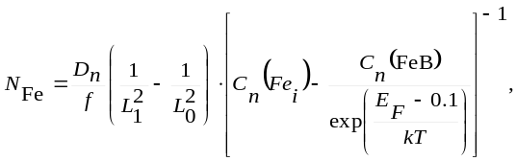 (1)

where D_{n} is the electron diffusion coefficient at room temperature, L₀, L₁ are the diffusion lengths of minority current carriers before and after heat treatment, respectively, Cn (Fei), Cn (FeB) are the electron capture coefficients of Fei, FeB, respectively, f is the coefficient, takes into account incomplete dissociation of FeB pairs, k is the Boltzmann constant, T is the temperature. Formula (1) is still relevant and is used both when conducting research on iron in silicon and in industry, in particular, it is implemented in the Semilab SDI PV-2000 instrument equipment in the form of:
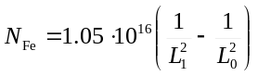, (2)
where the coefficient 1.05∙10¹⁶ has the dimension µm²cm⁻³, and the diffusion length of minority current carriers is expressed in µm.
Subsequently it was proposed to use light with a quantum energy exceeding the width of the band gap of silicon (1.124 eV) [7] for the dissociation of FeB pairs [7], as well as a combination of light + heat treatment [8, 9]. This combined treatment makes it possible to discriminate the contributions to changes in the lifetime of nonequilibrium electron-hole pairs in silicon SCs from the transformation of iron centers and activation-deactivation of boron-oxygen complexes. Below is table 1, which shows the effect of various combinations of light and heat treatment on the light-induced processes in silicon, in accordance with [9].
To develop a technique for studying the kinetics of light-induced processes caused by iron impurities in silicon SCs, we performed theoretical calculations of the dependences of the lifetime of minority current carriers on the excitation level according to the Shockley-Reed-Hall (SRH) model. For solar cells with a p-type base:

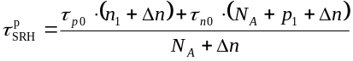, (3)
where N_{A} – is the level of doping, Δn – is the concentration of excess nonequilibrium electron-hole pairs (excitation level), τ_{p0}=(N_{t}σ_{p}v_{th})⁻¹, τ_{n0}=(N_{t}σ_{n}v_{th})⁻¹, N_{t} – is the concentration of recombination centers, σ_{n}, σ_{p} – is the cross sections of the recombination center for electrons and holes, respectively, 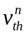, 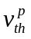 – is the average thermal velocities of electrons and holes were calculated according to [12], 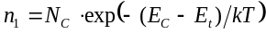, 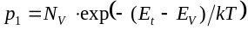, N_{C}, N_{V} – is the effective densities of states near the bottom of the conduction band and the top of the valence band, respectively [12], E_{C}, E_{V} – is the energy positions of the bottom of the conduction band and the ceiling of the valence band, E_{t} – is the energy position of the recombination level due to defect.

Table 1. Influence of different combinations of light-heat treatment on light-induced processes in silicon
Processing modes |  |  | Effect
Temperature | Light | Time | Effect
Heat treatment
200 °С | no | 2 min | Fe_{i}B → Fe_{i} + B
 | no |  | BO_{2i} → B + O_{2i}
FeB Recovery
90 С | no | 3min | Fe_{i} + B → Fe_{i}B
 | no |  | Стан В не змінюється
Light Induced Degradation Activation
120 С | 1 Sun | 5min | Fe_{i}B → Fe_{i} + B
 | 1 Sun |  | B + O_{2i} → BO_{2i}

The results of the calculations are shown in Fig. 1. During the calculations, the values ​​of the level of doping and the concentration of recombination centers due to iron varied.

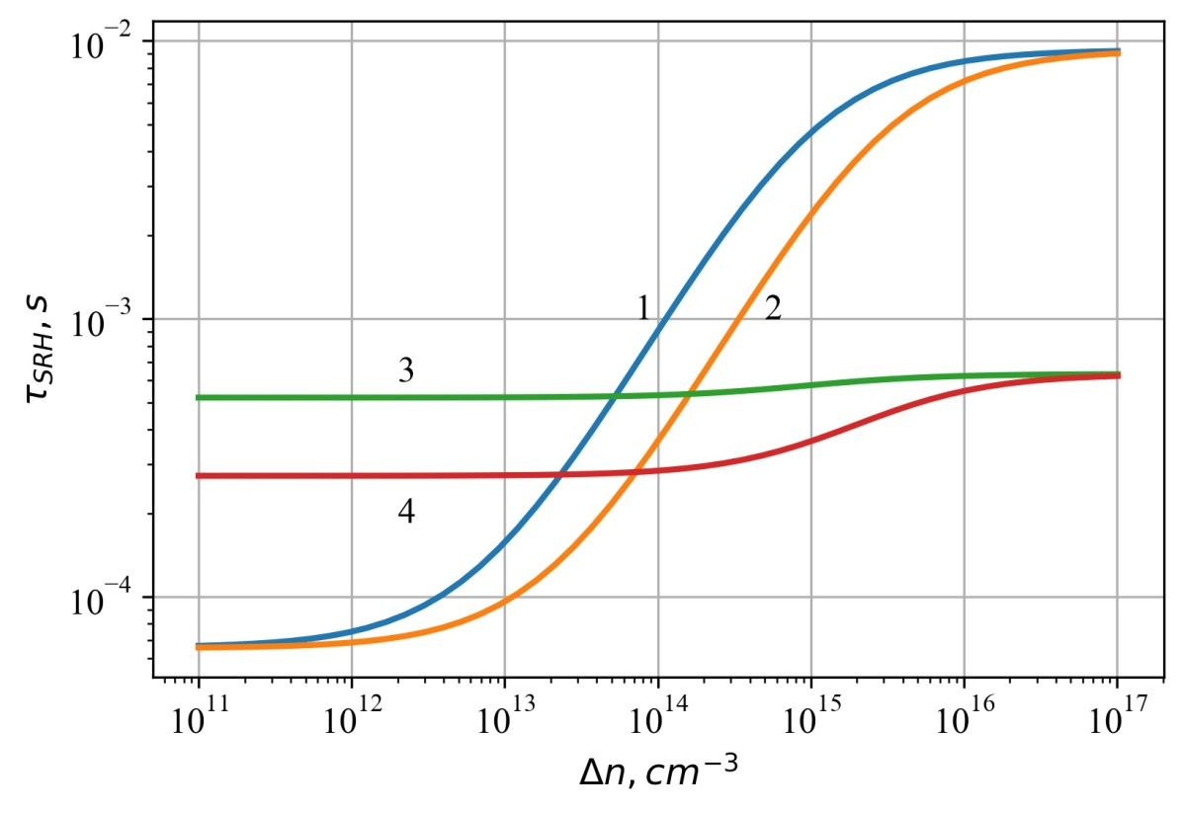
Fig. 1. Dependences of SRH lifetime in the SC base on the excitation level: curves 1, 2 - in the case of the Fe_{i} recombination center, E_{c} - E_{t} = 0.735 eV, σ_{n} = 3.47∙10⁻¹¹∙T^{-1.48}, σ_{p} = 4.54∙10⁻¹⁶ exp(-0.05/kT) [10], curves 3, 4 - in the case of the FeB recombination center, , E_{c}-E_{t} = 0.27 eV, σ_{n} = 5.1∙10⁻⁹∙T^{-2.5}, σ_{p} = 3∙exp(-0.262/kT) [10]. N_{t} = 3∙10¹¹ cм⁻³, N_{A} = 10¹⁵ cм⁻³ (1, 3) and 3∙10¹⁵ cм⁻³ (2, 4), T = 298 К.

As can be seen from Fig. 1, with increasing excitation level, the lifetime of SRH associated with the recombination level of Fei (curves 1 and 2) increases rapidly with the range of doping levels 210¹² - 3∙10¹⁵ сm⁻³ and remains constant at doping levels of 10¹⁶<Δn < 10¹² сm⁻³. While in the case of recombination levels of FeB (curves 3 and 4), the lifetime of SRH remains constant or increases slightly. In addition, as the doping level increases, the dependence of the lifetime of the SRH on the level of excitation in the case of the recombination level of FeB becomes more rapid. So, as can be seen from Fig. 1, there are two basic possibilities for the study of kinetic dependences due to iron impurities: the first is to use excitation levels < 10¹² cm⁻³, the second is to use excitation levels > 10¹⁶ cm⁻³, because in these cases the SRH lifetime dependence in the case of recombination via Fei levels are quite gentle, which allows for high accuracy of the experiment. However, excitation levels > 10¹⁶ cm⁻³ are difficult to provide, especially in samples with short lifetimes. Also, such levels of excitation lead to heating of the sample, which in turn strongly affects its characteristics. In addition, as can be seen from table 1, light treatment with an intensity of even 1 Sun leads to a redistribution of concentrations between FeB and Fei, i.e. the use of high levels of irradiation to achieve high levels of excitation will lead to dissociation of FeB complexes during the experiment, thereby complicating analysis of kinetic dependences. Therefore, the study of the kinetics of light-induced processes due to iron impurities in silicon SC should be performed at a level of excitation not exceeding 10¹² cm⁻³. Also for measurements it is better to choose SC with a doping level of 10¹⁵ - 3∙10¹⁵ cm⁻³, because in this case the dependences of the lifetime of the SRH for the recombination level of FeB are more gentle in the whole range of excitation levels.
To study the kinetics of light-induced processes due to iron impurities, the measurement of light I – V characteristics of the studied silicon SCs was performed. In order to ensure excitation levels not exceeding Δn = 10¹¹ см⁻³, these characteristics were measured by illuminating the test samples with an LED. An infrared LED with a radiation wavelength of 950 nm was chosen to ensure uniform in thickness generation of nonequilibrium electron-hole pairs and which created an irradiation level of 0.4 mW/cm². By varying the LED current, the I – V characteristics for several excitation levels are obtained. To study the kinetics of light-induced dissociation of FeB pairs, these characteristics were measured in stages, namely, on the initial SC samples, then after each stage of sequential illumination of the samples with a halogen lamp (1 Sun = 100 mW/cm²), which leads to dissociation of FeB pairs. This rearrangement of the defective structure leads to a decrease in the effective lifetime of nonequilibrium current carriers (Fig. 1), which can be registered in the study of I – V characteristics.
The time constant τ_{p} of the association reaction into FeB pairs is determined by the formula [1,3]:
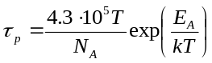 (4)
where N_{A} is the level of boron doping, E_{A} = 0.68 eV is the activation energy of the association reaction Fe_{i} + B → FeB. For room temperature, the value of τ_{p} is more than 8 hours, so the study of the kinetics of the association of interstitial iron Fe_{i} with an boron doping impurity was performed at a temperature T = 90 °C, when τ_{p} decreases to 315 s according to (4). The sample was heated to T = 90 °C, then a halogen lamp (100 mW/cm²) was turned on and the dissociation of FeB pairs was performed for 10 minutes. After switching off the light, the association kinetics into FeB pairs were recorded by measuring the light I – V characteristics similar to that described above. It should be noted that the correspondence of the time constant of the association kinetics of formula (4) with the activation energy of the association reaction E_{A} = 0.68 eV [1], as well as photodissociation of pairs at room temperatures [2] is a "fingerprint" of iron impurities. Thus, the dependences of the open-circuit voltage and short-circuit current on the duration of SC illumination by a halogen lamp (open-circuit voltage and short-circuit current kinetics) ) was obtained during dissociation (FeB → Fei + B) and association (Fei + B → FeB) reactions. Using the equation of the generation-recombination balance for the open circuit conditions (5), the kinetics of the effective lifetime of nonequilibrium electron-hole pairs is obtained.
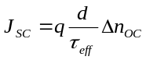, (5)
where J_{sc} is the short-circuit current density, q is the elementary charge, d is the thickness of the SC, τ_{eff} is the effective lifetime of nonequilibrium electron-hole pairs, Δn_{OC} is the excess concentration of electron-hole pairs in the open circuit, which is given by the equation:
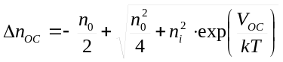, (6)
where n₀ is the equilibrium concentration of electron-hole pairs, for the studied SC it is determined by the doping level, V_{oc} is the open circuit voltage, n_{i} is the intrinsic concentration of electron-hole pairs in silicon, the temperature dependence of which is given by the expression [13]:
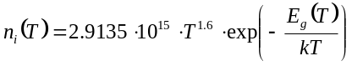, (7)
here 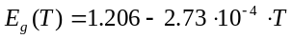 – the temperature dependence of the silicon band gap [12].
From (5) we have:
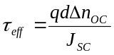 (8)
In addition, using formula (2), the kinetics of the change in the concentration of interstitial iron Fe_{i} due to the dissociation of FeB pairs under the illumination of SC with a halogen lamp and the kinetics of the change in the concentration of FeB in the reverse reaction of the association were obtained. The diffusion length of the minority current carriers L_{d} was determined from the ratio:
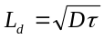, (9)
where D = 32 см²/с – diffusion coefficient of minority carriers (electrons).

Analysis of the Results
The kinetics of open circuit voltage and short-circuit current for several levels of excitation were obtained from measurements of light I – V characteristics first at the initial CE and then after each stage of light processing (halogen lamp lighting, energy illumination 100 mW/cm²). Both dependences have a decreasing character, increasing the duration of light treatment leads to a decrease in both the open circuit voltage and short circuit current. Depending on the level of excitation, the maximum value of the voltage drop of the open circuit as a result of light treatment is greater the lower the excitation level. While the maximum reduction of short-circuit current does not depend on the level of excitation. When the values ​​of the light processing time > 1000 s dependence of the open circuit voltage and short-circuit current go to the shelf and subsequent light processing does not actually lead to a decrease in these values. Having the values ​​of open circuit voltage and short-circuit current obtained from the I – V characteristics and using formulas (5–7), the effective lifetime of nonequilibrium electron-hole pairs was determined, and hence the kinetics of the effective lifetime of excess current carriers was obtained (Fig. 2). As in the case of open-circuit voltage kinetics and short-circuit current, the obtained dependences are decreasing and have an exponential character. The maximum τ_{eff} values ​​obtained at the original SC are in the range from 2.5∙10⁻⁷ to 2.0∙10⁻⁶ s depending on the excitation level. The minimum values ​​are in the range from 1.37∙10⁻⁸ to 1.9∙10⁻⁷ depending on the level of excitation. That is, the maximum decrease in the lifetime of nonequilibrium electron-hole pairs as a result of light treatment is ~ 100% and decreases slightly with increasing excitation level.
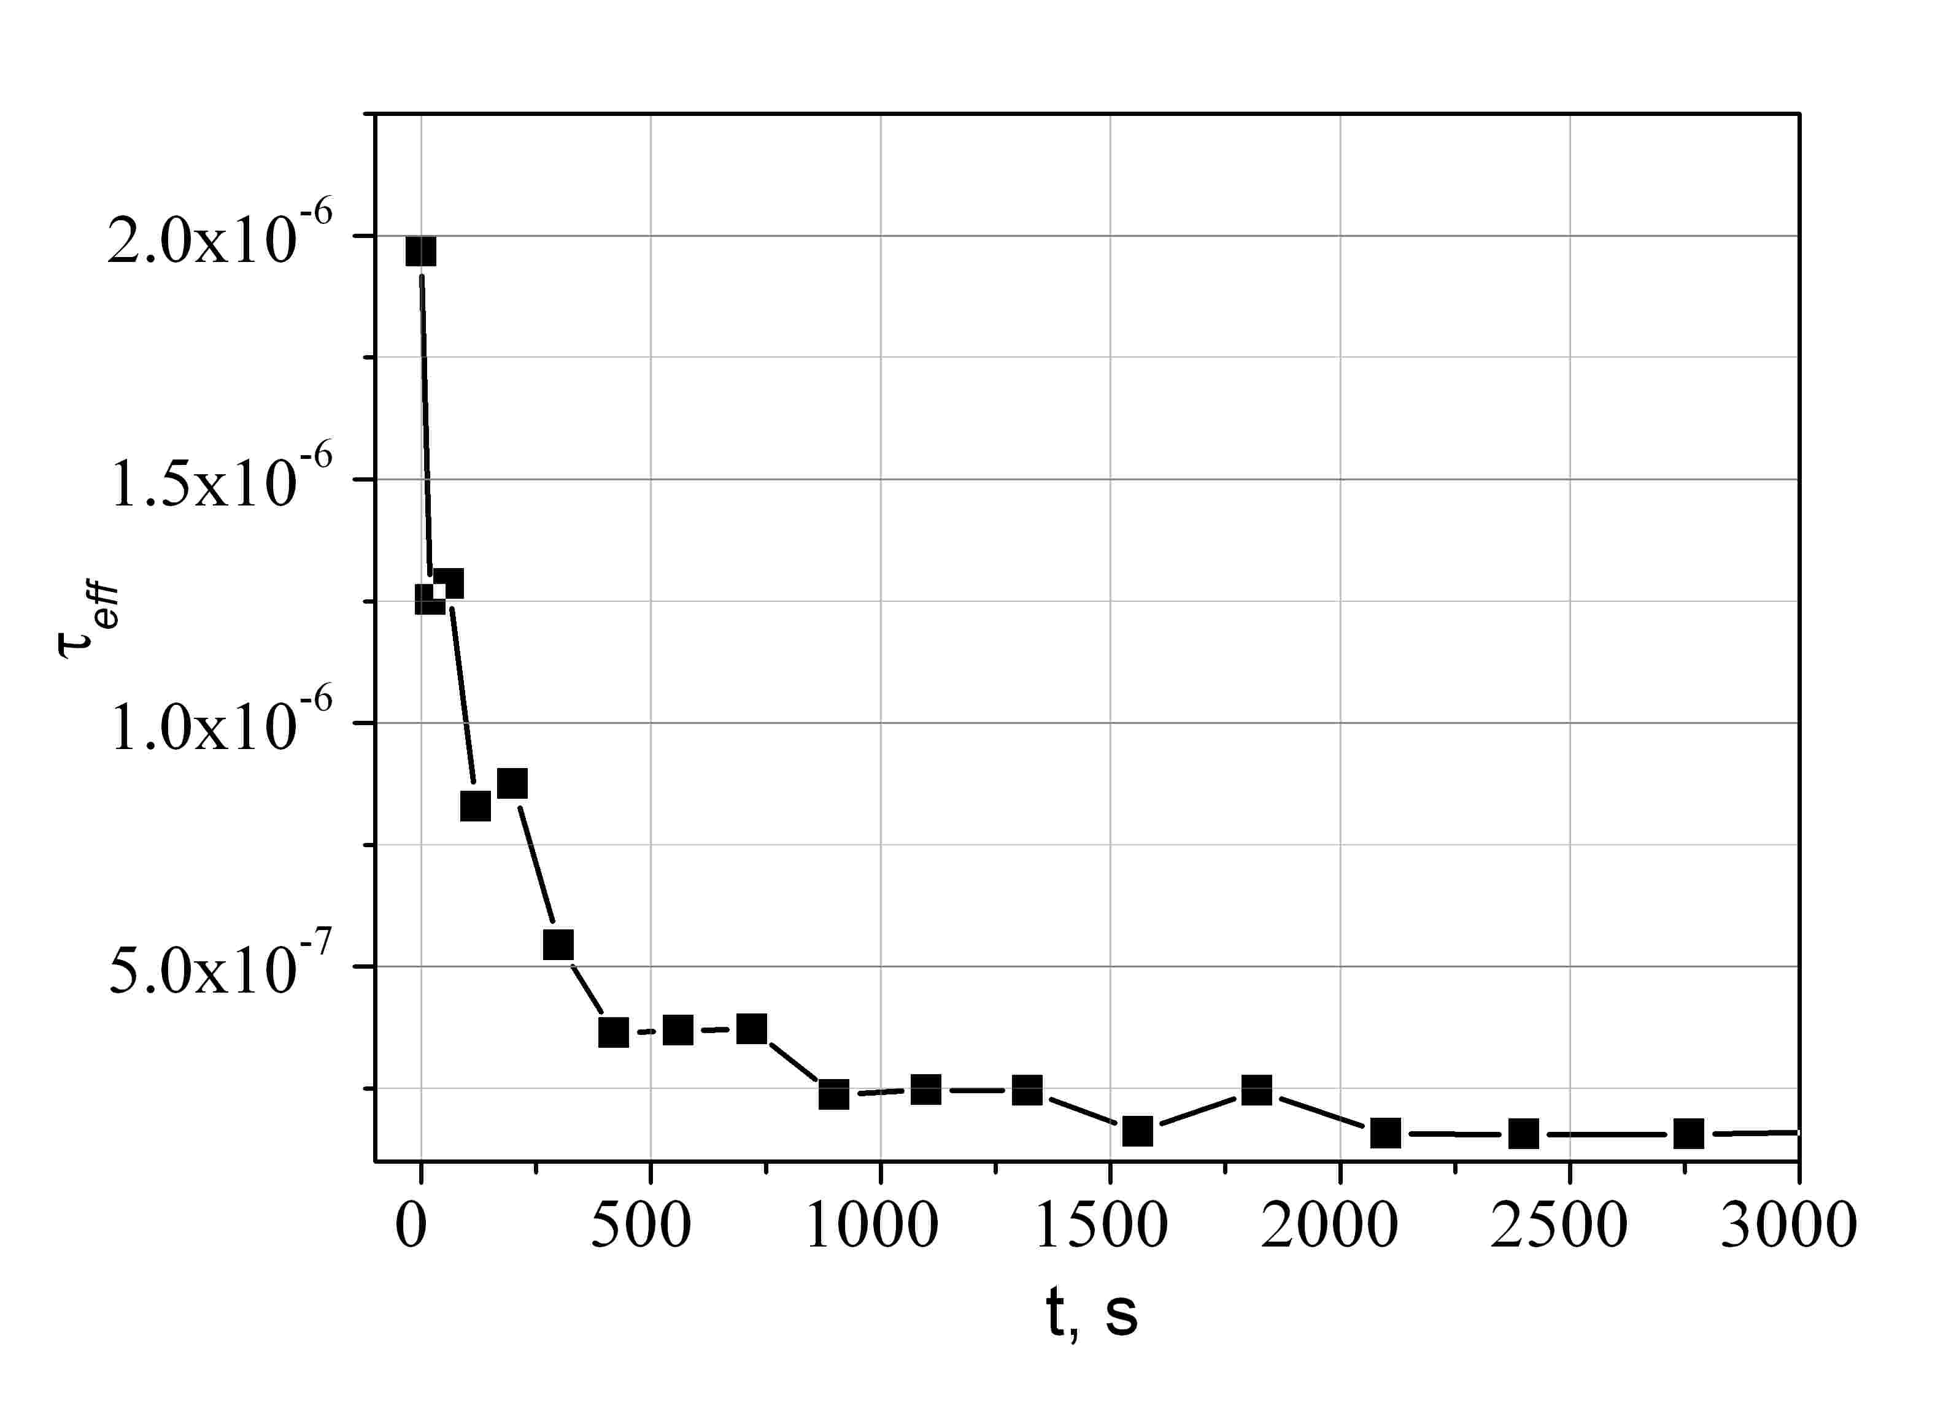
Fig. 2. Kinetics of the effective lifetime of non-equilibrium current carriers under the illumination of a SC with a halogen lamp (100 mW/cm2). Excess pairs concentration (injection level) Δn = 3∙10¹⁰ cm⁻³.

The obtained values of the lifetime were recalculated according to formula (8) into the values of the diffusion length of minority current carriers on the initial SC, and at each stage of research. Using formula (2), the concentration of iron atoms in the Fe_{i} state was estimated at different stages of processing. The calculation results are shown in Fig. 3.
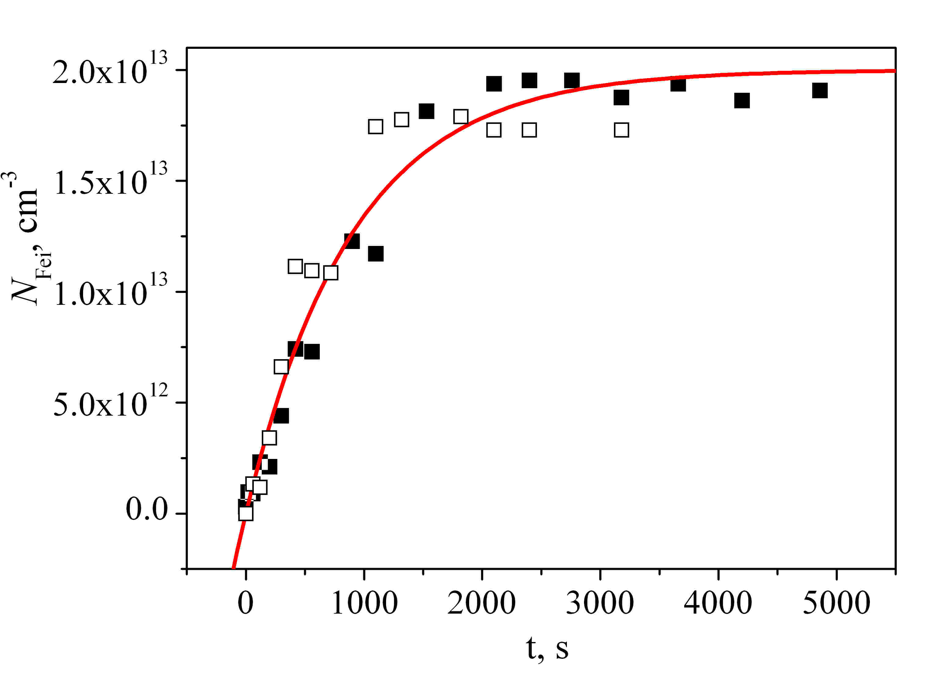
Fig. 3. Kinetics of changes in the concentration of interstitial iron Fei during the dissociation of FeB pairs induced by the light of a halogen lamp (100 mW/cm²). Points - experimental values, line - exponential approximation. Excess vapor concentration (injection level) Δn = 2∙10¹⁰ cm⁻³ (open squares) and 3∙10¹⁰ cm⁻³ (squares).

In the same Fig. 3 the line shows the approximation of the obtained experimental data by an exponential dependence with a time constant of 900 s. One can see a good agreement between the experimental and theoretical dependences, especially for the first half of the kinetic curve. Almost complete dissociation of FeB pairs occurs in 3000 s (50 min.). The obtained value correlates with the time of complete dissociation given in [2]: 15 s at an illumination level 100 times higher - 10 W/cm² for p - Si wafers. Linear extrapolation this value of time to 100 mW/cm² illumination level give 1500 s, which is two times less than what we obtained. The reason for this may be the superlinear effect of the illumination level on photodissociation, as well as the influence of potential barriers in SC. The stationary value of the concentration of interstitial iron N_{Fei} = 2∙10¹³ cm⁻³ is equal to the total concentration of iron in the case of complete dissociation of FeB pairs. Photodissociation at room temperature according to [2] is a characteristic feature of FeB pairs, in contrast to other metals, in particular CrB. To further verify that the obtained kinetic dependences are due precisely to iron impurities, we studied the kinetics of the reverse association reaction in the Fei + B → FeB pair in SC as a “fingerprint” of iron in silicon [1]. The kinetics of association in pairs was observed at a temperature of 90 °C [2,8,9] after photodissociation at the same temperature. The results obtained by the previously described method are shown in Fig. 4, which also shows the approximation of the experimental data by an exponential dependence with the association time constant τ_{p} = 315 s. Note that formula (4) gives exactly the same value τ_{p} for the experimental conditions T = 90 °C, that is, the kinetics of the association reaction of iron with boron in pairs in the studied SC occurs with an activation energy E_{a} = 0.68 eV, which is a “fingerprint” of iron in silicon. Thus, it can be argued that in experiments on the study of the kinetics of the pairs association-dissociation in silicon SCs, processes were observed that were caused precisely by an iron impurity. Additionally, the effect of combined light + heat treatment (Table 2) on the processes of association-dissociation of iron in silicon SCs was investigated.

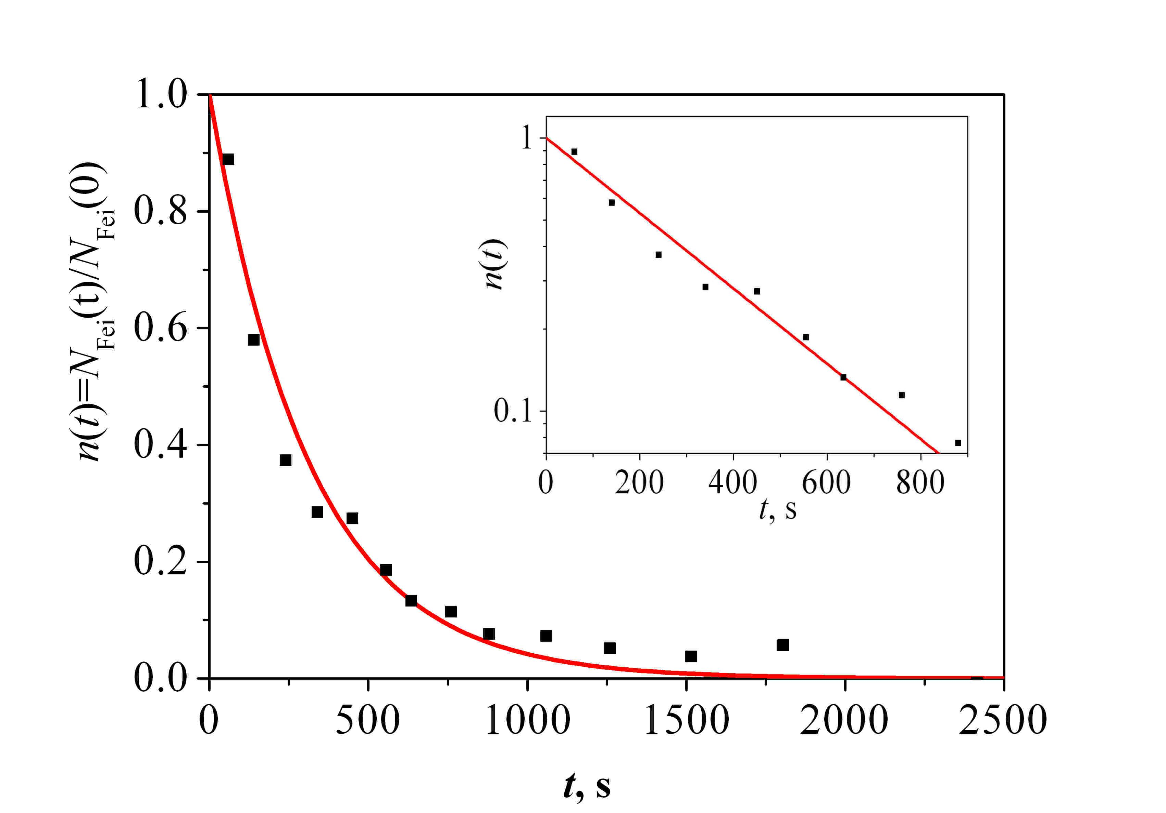
Fig. 4. Kinetics of changes in the concentration of interstitial iron Fei due to its association with B in FeB pairs. Points - experimental values, line - approximation by an exponential dependence with a time constant of 315 s. Inset - a graph on a semi-log scale.

Table 2. Diffusion length of minority current carriers at different stages of research. *Bold letters indicate lifetime decreasing states
Stage | Reaction | L_{d}, mkm
- Initial sample |  | 62
- Thermal treatment 200 °С for 2 min | Fe_{i}B → Fe_{i} + B  BO_{2i} → B + O_{2i} | 37
- Thermal treatment 90 °С for 4х3 min | Fe_{i} + B → Fe_{i}B  B state does not change | 49
- 120 °С and simultaneous illumination with a halogen lamp  (100 mW/cm²) for 5 min | Fe_{i}B → Fe_{i} + B  B + O_{2i} → BO_{2i} | 36

At each stage of the study, the spectral dependences of the short-circuit current were measured at a constant level of irradiation, from which the spectra of the external and internal quantum efficiency were obtained. These characteristics were measured in the wavelength range ∆λ = 800 - 1200 nm. The obtained spectral dependences of the internal quantum efficiency were used to find the values ​​of the diffusion length of minority current carriers at each stage of the study. The diffusion length was determined by a method similar to that described in [14]. The results are also shown in Table 2. Table 2 shows that the difference in the minority carrier diffusion lengths determined in steps 2 and 3 is due to the bonding of Fei and B in FeiB pairs, while the small difference between the minority carrier diffusion lengths determined in steps 2 and 4, indicates an insignificant effect of the BO_{2i} complexes. However, it should be noted that heat treatment at 90 C for 3 min does not lead to a complete return of the SC characteristics to the initial values; this is most likely due to the fact that not all FeiB bonds that were destroyed at stage 2 (heat treatment at 200 °C within 2 min), recovered after stage 3 (heat treatment at 90 °C for 3 min). Our further studies showed that a series of successive heat treatments at 90 °C for 3 min each leads to a gradual return of the SC characteristics to their original values.

Conclusions
An approach is proposed that makes it possible to extend the existing methods of studying the behaviour and properties of iron in silicon wafers to ready-made silicon SCs even in the case of an arbitrary level of injection of excess electron-hole pairs. Using the proposed approach, the kinetics of light-induced processes, namely the kinetics of the open-circuit voltage and short-circuit current, the kinetics of the effective life time and the kinetics of changes in the concentration of iron Fei in the reactions of dissociation of FeB pairs to Fei and B and their reverse association into pairs, have been investigated. The total concentration of iron in the studied SCs, as well as the time constants of the kinetics of photodissociation of pairs (3000 s at 100 mW/cm²) and reverse association in pairs (315 s at T = 90 °C) were determined. It was found that observed experimentally on silicon SC samples processes are caused precisely by iron impurities, since the photodissociation of pairs at room temperatures and the obtained value of the association kinetics time constant is a “fingerprint” of iron in silicon. It is shown that in SCs made on the basis of p-type silicon wafers, iron impurities can lead to a significant decrease in the effective lifetime of excess current carriers, which in turn causes a decrease in the open-circuit voltage and short-circuit current.

Acknowledgment
This work was supported by National Research Foundation of Ukraine by the state budget finance (project 2020.02/0036 “Development of physical base of both acoustically controlled modification and machine learning–oriented characterization for silicon solar cells”).

References
- G. Zoth, W. Bergholz, “A fast, preparation-free method to detect iron in silicon,” J. Appl. Phys. 67(11), pp. 6764-6771 (1990).
- J.Lagowski, P.Edelman, A.M.Kontkiewicz, O. Milic, W. Henley, M. Dexter, L. Jastrzebski, A.M. Hoff, “Iron detection in the part per quadrillion range in silicon using surface photovoltage and photodissociation of iron-boron pairs,” Appl. Phys. Lett. 63 (22) 1993 3043-3045
- W. Wijaranakula, “The Reaction Kinetics of Iron-Boron Pair Formation and Dissociation in P-Type Silicon,” J. Electrochem. Soc., Vol. 140, No. 1, January 1993, p.275-281
- D. H. Macdonald, L. J. Geerligs, A. Azzizi, “Iron detection in crystalline silicon by carrier lifetime measurements for arbitrary injection and doping,” Journal of Appl.Phys. -2004.-V.95, No3.- P.1021-1028.

J. Tan, D. Macdonald, F. Rougieux and A. Cuevas, “Accurate measurement of the formation rate of iron–boron pairs in silicon,” Semicond. Sci. Technol. 26 (5) 055019 (2011)
- D. Macdonald, H. Mäckel, and A. Cuevas “Effect of gettered iron on recombination in diffused regions of crystalline silicon wafers,” Appl. Phys. Lett. 88, 092105 1-4 (2006)
- D. Walz, J.-P. My, G. Kamarinos, “On the recombination behaviour of iron in moderately boron-doped p-type silicon,” Appl. Phys. A: Mater. Sci. Process. 62(4), pp. 345-353 (1996).
- M. Wilson, P. Edelman, A. Savtchouk, J. D’Amico, A. Findlay, J. Lagowski,“Accelerated light-induced degradation (ALID) for monitoring of defects in PV silicon wafers and solar cells,” J. Electron. Mater. 39, pp. 642-647. 31 (2010).
- M. Tayyib, J. Theobald, K. Peter, J.O. Odden, T.O. Sætre, “Accelerated light-induced defect transformation study of Elkem solar grade silicon,” Energy Procedia 27, pp. 21-26 (2012).
- B. B. Paudyal, K. R. McIntosh, D. H. Macdonald, “Temperature dependent electron and hole capture cross sections of iron-contaminated boron-doped silicon,” 34th IEEE Photovoltaic Specialists Conference (PVSC), USA, Philadelphia, 7-12 June 2009.
- A.V. Sachenko, V.P. Kostylyov, M.V. Gerasymenko, R.M. Korkishko, M.R. Kulish, M.I. Slipchenko, I.O. Sokolovskyi, V.V. Chernenko, “Analysis of the silicon solar cells efficiency. Type of doping and level optimization,” Semiconductor Physics, Quantum Electronics & Optoelectronics 19(1), pp. 67-74 (2016).
- M. A. Green, “Intrinsic concentration, effective densities of states, and effective mass in silicon,” J. Appl. Phys. 67(6), pp. 2944-2954 (1990).
- T. Trupke, M. Green, P. Wurfel, P. P. Altermatt, A. Wang, J. Zhao, and R. Corkish, “Temperature dependence of the radiative recombination coefficient of intrinsic crystalline silicon,” J. Appl. Phys. 94(8), pp. 4930-4937 (2003).
- ASTM Standard F391-90a, “Standard Test Method for Minority-Carrier Diffusion Length in Silicon by Measurement of Steady-State Surface Photovoltage”, 1996 Annual Book of ASTM Standards, Am. Soc. Test. Mat., West Conshohocken, PA, 1996.

[1] A. Rohatgi, Rai-Choudhuri, “High-efficiency silicon solar cells: Development, current issues and future directions,” Solar Cells 17, pp. 119-133 (1986).

