Estimation of Iron Concenration in Silicon Solar Cell by Kinetics of Light-Induced Change in Short-Circuit Current

O. Olikh¹, V. Kostylyov², V. Vlasiuk², R. Korkishko²

¹Taras Shevchenko National University of Kyiv,
64/13, Volodymyrska Str., Kyiv, 03028, Ukraine
olegolikh@knu.ua
²V. Lashkaryov Institute of Semiconductor Physic Institute of NAS of Ukraine,
41 Nauky Ave., Kyiv, 03028, Ukraine

The iron is a major contaminant as well as one of the most detrimental metal impurities in silicon photovoltaic devices. Therefore non--destructive methods of iron concentration (N_{Fe}) estimation in solar cells (SCs), are important from an applied point of view. Τo date, a not little collection of both direct and indirect methods has been developed to solve this problem. But almost all of them require special sample preparing or/and specialized equipment. At the same time, the current-voltage curve (IVC) measurement is a common method of SC characterization. Short-circuit current (I_{SC}) is among the fundamental SC parameters, which easy determined from IVC as well as depend on N_{Fe}. The proposed method is based on ability of pair FeB to dissociate under carriers injection and to associate in the dark [1] and involves for the measurement of I_{SC} kinetics after intense illumination.
During the kinetic fit it was assumed, that I_{SC} under monochromatic light described by
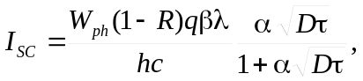 (1)
where W_{ph} is the irradiance, D is the diffusion koefficient, τ is minority carrier lifetime in SC base:
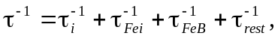 (2)
where τ_{i} describes intrinsic recombination, τ_{Fei} and τ_{FeB} concern to Shockley-Read-Hall recombination on interstitial iron Fe_{i} and FeB pair; τ_{rest} deals with other processes. The time dependence of the Fe_{i} concentration was used from [2] and it was believed that associate characteristic time can be written as
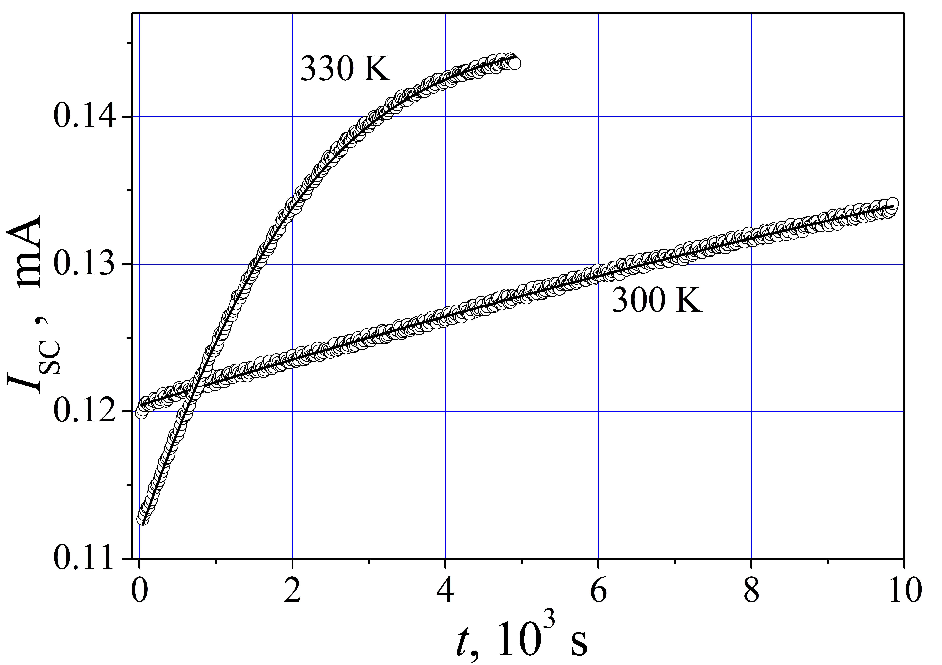
Fig. Time dependence of short-circuit current after halogen lamp illumination (0.25 W/cm², 15 s). The marks are the experimental results, and the solid lines are the fitted curves. I_{SC} corresponds to the LED illumination (940 nm, 0.3 mW).
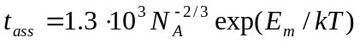, (3)
where E_{m} is Fe_{i} migration energy, N_{A} is the doping level.
The n+-p-p+-Si diffusion-field type SCs were used in experiments. SCs were fabricared by using single-crystal p-silicon wafer with a resistivity of 10 Ω⋅ cm. Some examples of I_{SC} kinetic curve are presented on Fig. We use Eqs. (1)-(3) by taking W_{ph}, E_{m} and N_{Fe} as ﬁtting parameters to ﬁt the experimental data. The obtained values were following: W_{ph} ≈ 0.3 mW; this value is in according with data, obtained by Power Meter Rk-5720 for used light source; E_{m} ≈ 0.679 meV; this value is in according to known [2] Fe_{i} migration energy; N_{Fe} ≈ 2⋅10¹³ cm⁻³; this value is close to one, obtained by long-wavelength spectrum of internal quantum efficiency.
Thus, the proposed method allows to estimate the iron concentration in silicon solar cell.
[1] L. J. Geerligs and D. Macdonald, Appl. Phys. Lett.85, 5227 (2004).
[2] W. Wijaranakula, J. Electrochem. Soc. 140, 275 (1993).

