Physics-Informed Neural Network Prediction of Thermal Conductivity in Clustered Si–Ge Two-Phase Systems

Olikh, O.Ya.

Taras Shevchenko National University of Kyiv, Kyiv, Ukraine, olegolikh@knu.ua
The study of thermal conductivity (TC) in two-phase systems is essential for tailoring thermal properties of advanced materials with complex microstructures. Si–Ge systems are particularly relevant as models of media with strong contrasts in atomic mass and elastic properties between phases.
In this work, TC was evaluated using a Physics-Informed Neural Network (PINN) based on the framework in [1]. The input was a 2D spatial distribution of TC components, while an encoder–decoder architecture predicted the temperature field and heat flux components. The loss function incorporated Fourier’s law, governing equations, and boundary conditions.
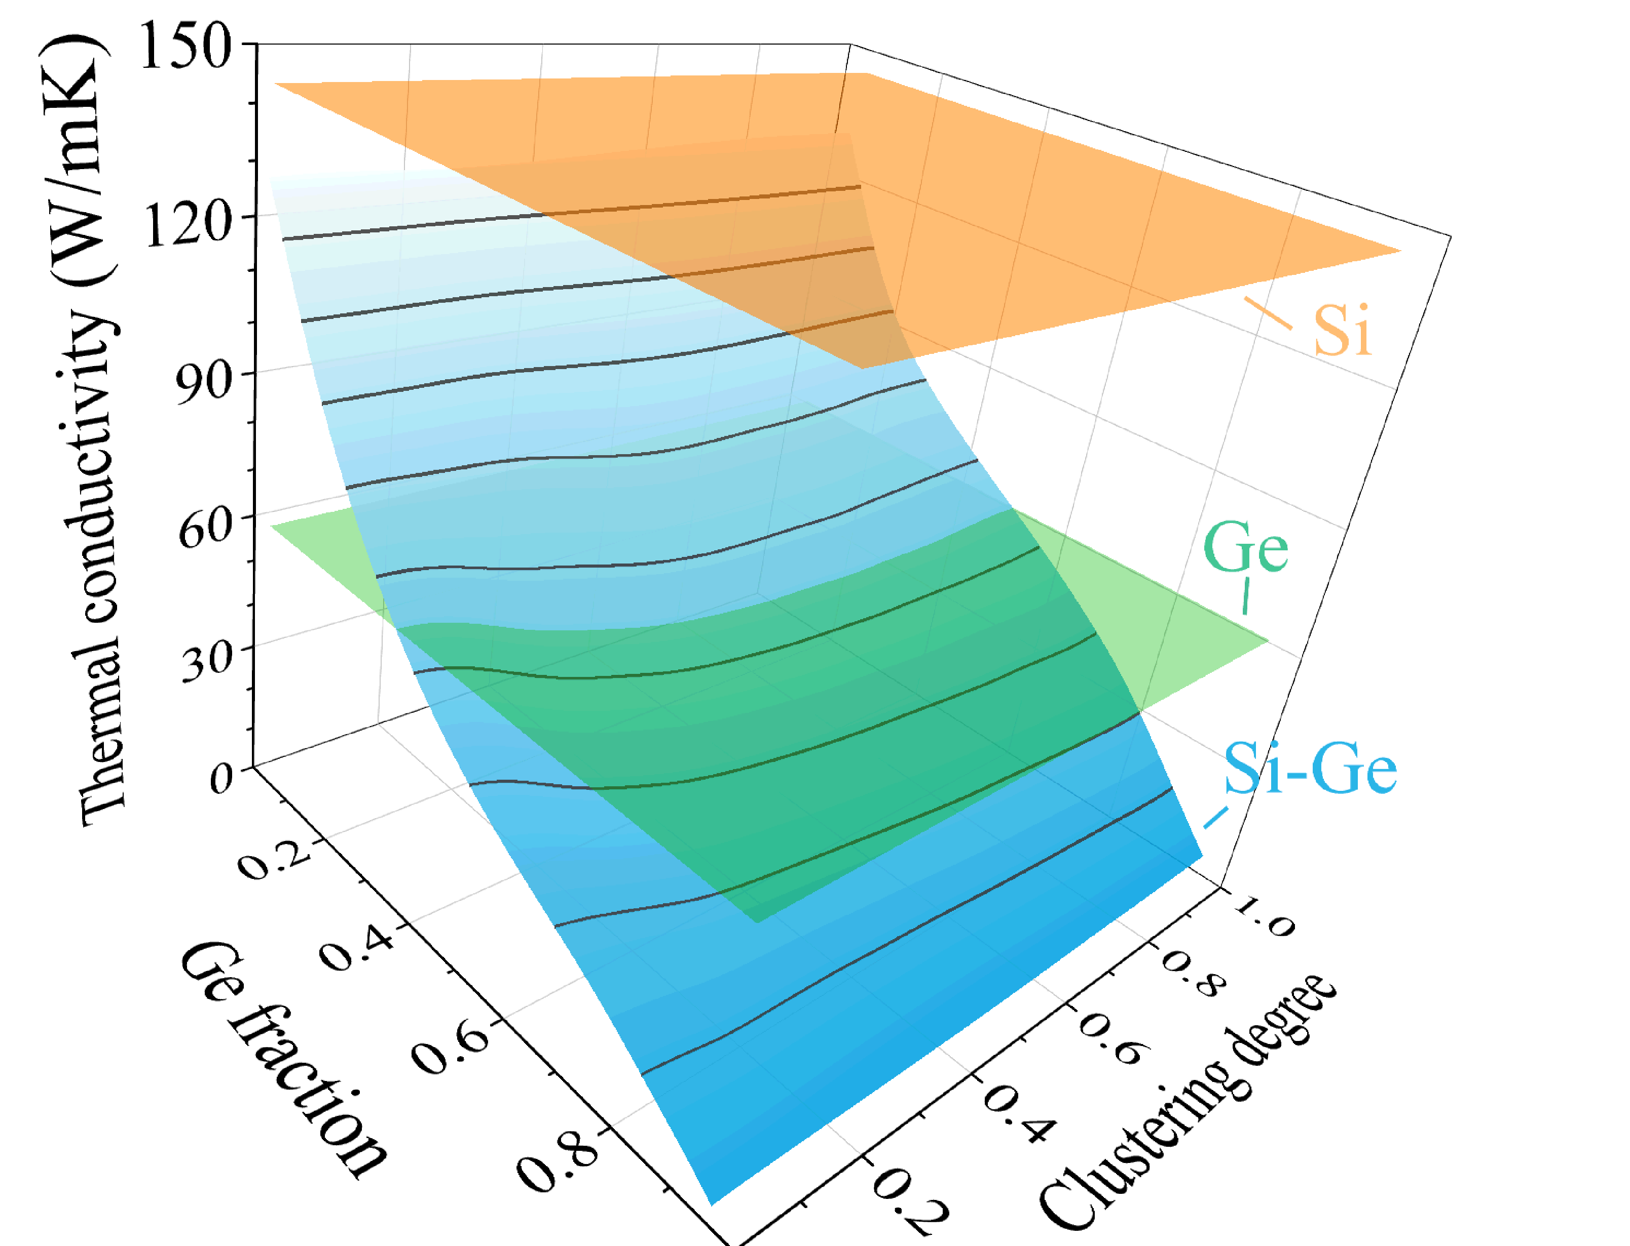
Fig. Dependence of the TC of two-phase Si–Ge system on Ge fraction and clustering degree.
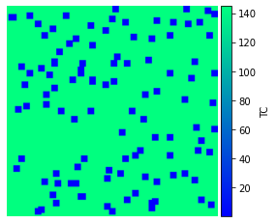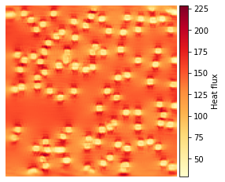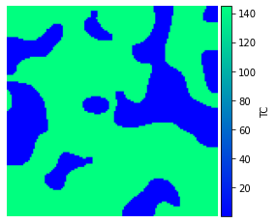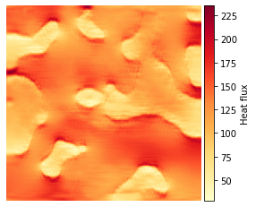
Fig. 1. Initial phase distributions (a, c) and predicted heat flux fields (b, d). (a, b) Ge fraction 0.1, clustering degree 0; (c, d) Ge fraction 0.3, clustering degree 0.5.
(a)
Heat flux (a.u.)
Heat flux (a.u.)
(b)
(c)
(d)
Ge
Si
TC of a two-phase Si–Ge system was investigated as a function of Ge fraction and clustering degree. Fig. 1 shows representative initial morphologies and corresponding heat flux distributions under a temperature gradient between the left and right boundaries. The resulting values are summarized in Fig. 2. The effective TC may fall below that of the constituent phases and exhibits a nonmonotonic dependence on clustering degree at intermediate fraction values.
The work was supported by National Research Foundation of Ukraine (project No. 2023.05/0024).

- Xu J., Wei H., Bao H. Physics-Informed Neural Networks for Studying Heat Transfer in Porous Media. Int. J. Heat Mass Transf. 2023. V.217, 124671.

