Influence of the ultrasound treatment on Au-TiB-n-n⁺-GaAs structure electrical properties
Oleg Ya. Olikh

Faculty of Physics, Taras Shevchenko Kyiv National University, pr. Glushkova 6, 03127, Kyiv, Ukraine, olikh@univ.kiev.ua

Abstract: The effect of ultrasonic treatment on the current–voltage characteristics of Au–TiB–n–n⁺-GaAs diode structures has been studied. The ultrasonic frequency was 4-30 MHz, the ultrasonic intensity was up to 3 W/cm². It is revealed that ultrasonic treatment influences slightly (about 5 %) on Schottky barrier height and current-voltage characteristics ideality factor. The value of a reverse current may be changed by one or two orders of magnitude, and at low-intensity ultrasound the character of changes depends on prevailing mechanism of current tranport whereas at high-intensity ultrasound ( > 2.5 W/cm²) the reverse current increases in all cases. The existence of frequency dependence of ultrasound influence on metal-semiconductor structures’ parameters has been shown. It is revealed that ultrasonic treatment favors a significant increase in the homogeneity of the characteristics of devices manufactured by using integral heat sink technology. The observed effects can be connected with acousto-induced smoothing of the local inhomogeneities of heterostructures’ interfaces and with defects redistribution and generation in ultrasonic field.
Key words: Current - voltage characteristics, GaAs, metal-semiconductor structure, ultrasonic treatment.

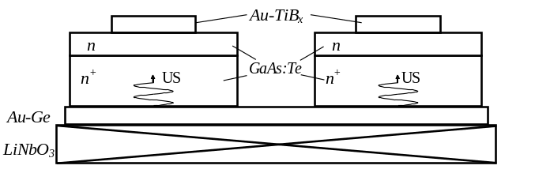Introduction
It is known, that thermal annealing and ionising radiation are the mostly used methods of the influence on defect structure and, accordingly, on electrophysical properties of semiconductors and semiconductor devices. However, these methods have certain drawbacks and, that is why new, more perfect ways of such materials processing are searched. In particular, recent years much attention has been paid to the effect of ultrasonic action [1]-[4]. It was revealed that acoustic oscillations can induce the reconstruction of various defect complexes [1], stimulate the diffusion of impurities [2], cause the transformation of a defect structure of interfaces [3] and lead to a low temperature annealing of radiation defects [4]. However, the complete understanding of the acoustic wave–defect interaction requires further investigation.
This paper is devoted to the investigation of the effect of a ultrasonic treatment (UST) in various intensity and frequency regimes on the current-voltage (I-U) characteristic of Au-TiB_{х}-n-n⁺-GaAs diodes. The choice of the investigation object is caused by two moments: the knowing of the factors, which influence on the properties of such structures (see, e.g., [5], [6]) and the presence of a internal stress fields, which favours the reveal of effects stimulated by the acoustic action [3].

Experiment details
The measured n-n⁺-GaAs structures were grown by gas-phase epitaxy. The n-layer is 3 μm thick, the n⁺-substrate is 350 μm thick. The Te dopant concentration in the epi-layer and substrate were 6×10¹⁵ and 6×10¹⁸ cm⁻³, respectively. Using an AuGe eutectic formed the ohmic contacts, and the TiB_{x} and Au layers were deposited by magnetron sputtering. The Schottky contact was 40 µm in the diameter. The diodes were manufactured by using integral heat sink technology. Each sample contained 20–25 diodes, the I–U curves of which were studied before and after UST. The forward and reverse branches of the I–U curves were measured at room temperature in the dark. The longitudinal acoustic wave was introduced into the samples by using a lithium niobate piezoelectric transducer from the substrate side (see Fig. 1). The UST was performed in various regimes characterized by the frequency f_{US} (4-30 MHz) and power density W_{US} (up to 3 W/cm²). The treatment duration at each W_{US} was 5 h.
Fig.1 The scheme of the ultrasonic treatment of the Au-TiB-n-n⁺-GaAs structures.
For the forward-bias measurements, the experimental I–U curves were approximated by using the following formula [6]:
, (1)
where S is the ohmic contact area, A** is a modified Richardson constant, 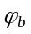 is the effective Schottky barrier height, n is the ideality factor, and U_{F} is the applied bias voltage. The ideality factor was received from an inclination of the experimental curve (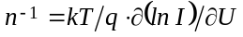),the 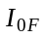 value was defined as the crossing of the approximating curve with the current’s axis, and then was calculated.

Experimental results and discussion
The initial (prior to ultrasonic treatment ) values for the entire set of diodes ranged within 0.730–0.750 eV, and the initial values of n were 1.06–1.08. The obtained values of n, very close to unity, might indicate, that contribution of the generation–recombination processes to the current transport is insignificant. The reverse I-U characteristics does not have similar uniformity, though all structures have been grown in the same technological cycle. All diode’s set can be divided on two groups.
The first group consists of diodes with a small reverse current ( I_{R} < 10⁻⁷ A at reverse bias of U_{R} = 2 V ); it is revealed, that in this case the semilogarithmic plot of 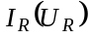 is almost linear (Fig. 2, curve 1). This behaviour is typical for a tunnelling mechanism of current transfer [5]. Calculations show that the field or thermo-field emission in the structures under study can be significant only at T < 10 K. Therefore, the mechanism of tunneling in this case must be different. For example, Evstropov et al. [7] suggested that the excess current through the potential barrier can be determined by electrons transferred via a chain of deep levels located at spatial charge region. In this case, the reverse I–U curves are described by the relation [7]:
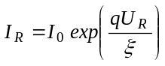, (2)
where 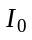 is determined by the concentration of defects creating deep levels, and characteristic energy depends on defect’s type.
Fig.2. The typical I-U characteristics in reverse direction for diodes of the (1, 2) first and (3, 4) second groups, measured before (1, 3) and after (2, 4) ultrasonic treatment. (W_{US}=1.8 W/cm², f_{US}=4.1 MHz) Solid and dashed curves show the approximations by using formulas (3) and (2), respectively.
For the second diodes group the reverse current is greater, I_{R} > 2×10⁻⁷A at U_{R} = 2 V. The plot of 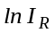 versus U_{R} at small reverse bias (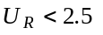V) is substantially nonlinear (Fig.2, curve 3); the experimental curves are well approximated by the relation
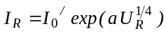. (3)
where 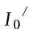 and a are constants. Such dependence ( ln I_{R} ~ U_{R}^{1/4}) is typical for a thermionic mechanism of current transport [5], whereby rather large absolute values of I_{R} can be related to the energy states localized at the semiconductor boundaries [6]. For greater reverse bias the I-U curve’s behavior is typical for the tunneling mechanism.
After ultrasonic treatment changes in the 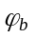 and n values were relatively small, the results are shown on Fig.3. It should be noted that these changes depended non-monotonously on UST intensity. Ultrasonic effect on I-U curves in reverse direction was a much more pronounced.
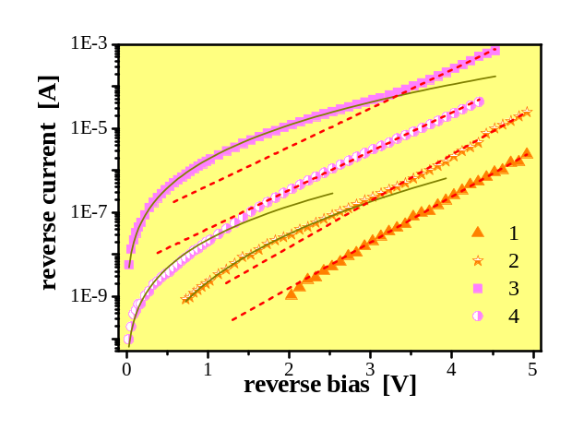
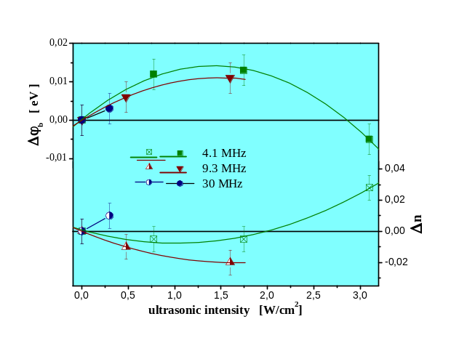
Fig.3. Dependencies of the acousto-induced variations of effective Schottky barrier height (filled points) and ideality factor (transparent points) versus ultrasonic treatment intensity for different frequencies.
In the case of 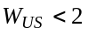W/cm² the UST leads to an increase in I_{R} by one or two orders of magnitude in the first group of diodes (see Fig. 2, curves 1 and 2); in the diodes with predominate thermionic mechanism the decrease in I_{R} by a factor of 10–500 is observed (Fig. 2, curves 3 and 4). Such opposite changes of a reverse current value lead to the approaching of the current-voltage curves of various structures and, hence, to increase of the homogeneity of parameters of the structures manufactured in the same technological cycle (see Fig. 4). We believe that this substantial difference in the ultrasonic-induced changes in I–U curves is related to a difference in the predominating mechanism of current transport through the Schottky barrier for the diodes with different initial states. The high-intensity ultrasonic treatment, W_{US} > 2.5 W/cm² led to a significant (by one or two orders of magnitude) growth in I_{R} and to an increase in the contribution of the thermionic mechanism for both diode’s groups. It worth to mention that character of the acousto-induced variation of a n and changes at the same power density ( Fig. 3).
Besides ultrasonic treatment effect on value of reverse current, some changes of a character of 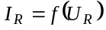 curve were observed. So, diodes of first group upon UST exhibited thermionic processes at small reverse bias ( U_{R} < 2 V), whereas diodes of the second group showed the linear relation between ln I_{R} and U_{R} at somewhat lower voltages – see Fig. 2. Also the variation of inclination of I-U curves with preferable tunneling mechanism occurs (see Fig.5). According to (2) variation of inclination corresponds to variation of parameter ξ, the result, obtained by approximation of experimental dates, are listed in Tab. 1 (variability of every cell’ data concerns to various diodes). According to [7], ξ characterizes defect’s type, hence, revealed alteration of this parameter testifies about acousto-induced variation of defect subsystem of semiconductor. And it is evident that this variation depends essentially on ultrasonic frequency, ultrasonic of higher frequencies influences defects more effectively
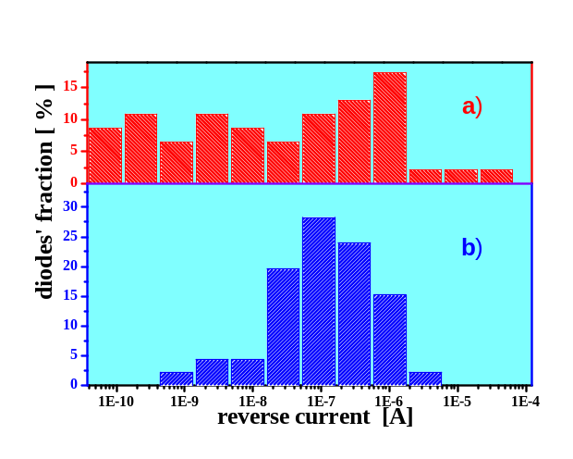
Fig.4. Histograms showing distributions of the reverse current (at U_{R} = 2 V) in Au-TiB_{х}-n-n⁺-GaAs diodes (a) before and (b) after ultrasonic treatment (W_{US} =1.8 W/cm², f_{US} = 4.1 MHz and 9.3 MHz).
Table 1. Parameter of approximation of I-U curves in reverse direction according to (2) before and after ultrasonic treatment
UST characteristic | ξ, meV
UST characteristic | before UST | after UST
4.1 MHz, 2 W/cm² | 350-400 | 350-400
9.3 MHz, 1.5 W/cm² | 340-400 | 380-410
30 MHz, 0.3 W/cm² | 340-380 | 390-460
It is known that the ultrasonic treatment can leads to smoothing of the local inhomogeneities of interfaces [3]. In our opinion, this phenomenon is responsible for a significant decrease in I_{R} in diodes of the second group. The acoustostimulated redistribution of defects in semiconductor depth (similar to observed in [8], [9]) modifies the population of energy levels at the metal-semiconductor interface and influences on the I_{R} of diodes of the first group and changes 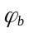 and ideality factor’s values in both group. As the UST intensity exceeds a certain threshold, the acoustic wave causes the generation of defects in the bulk and subsurface regions of the semiconductor [8] and stimulates the reconstruction of a defect structure of the metal-semiconductor interface [3], which leads to a decrease in (due to the Schottky effect) and to an increase n. These changes are accompanied by the growth of thermionic current through the diode and by an increase in I_{R}.

Conclusion
Thus, we have studied the effect of ultrasonic treatment with various intensities and frequencies on the characteristics of Au-TiB_{х}-n-n⁺-GaAs diodes with Schottky barriers. It is established that the character of the ultrasonic action depends on the preferable mechanism of current transport: the ultrasonic treatment causes an increase in reverse current for a tunneling mechanism while decreasing I_{R} in the case of thermionic emission. It is revealed that ultrasonic of higher frequencies influences on semiconductor defect’s subsystem more effectively.
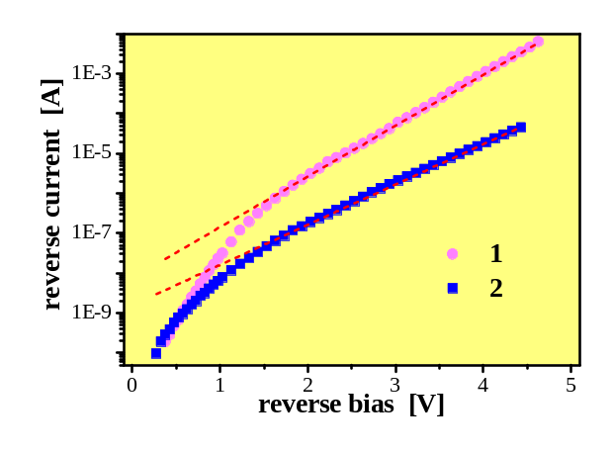
Fig.5. The reverse I–U curves measured before (1) and after (2) ultrasonic treatment, W_{US} =0.3 W/cm², f_{US} =30 MHz. Point s are experimental dates, line are approximations, made by using (2) (for curve (1) I₀ = 7.6×10⁻⁹ A, ξ = 0.34 eV; for curve (2) I₀ = 1.6×10⁻⁹ A, ξ = 0.43 eV)

Aknowledgements
The research was supported by Science and Technology Center in Ukraine (project # 3555).

Literature
[1] O. Ya. Olikh and I. V. Ostrovskii, ” Ultrasound-stimulated increase in the electron diffusion length in p-Si crystals,” Phys. of Sol. State, vol.44, pp. 1249-1253, 2002.
[2] E. B. Zaveryukhina, N. N. Zaveryukhina, L. N. Lezilova, B. N. Zaveryukhin, V. V. Volodarskii, R. A. Muminov, ”Acoustostimulated expansion of the short-wavelength sensitivity range of AlGaAs/GaAs Solar cells,” Tech. Phys. Let., vol. 31, pp. 27-32, 2005.
[3] P. B. Parchinskii, S. I. Vlasov, L. G. Ligai and O. Yu. Shchukina, ”The effect of ultrasonic treatment on the generation characteristics of a Si-SiO₂ interface,” Tech. Phys. Let., vol. 29, pp. 392-394, 2003.
[4] A. A. Podolyan and V. I. Khivrich, ” Room-temperature ultrasonic annealing of radiation defects in silicon,” Tech. Phys. Let., vol. 31, pp. 408-410, 2005.
[5] E. H. Rhoderik, ”Metal-semiconductir contacts”, Oxford: Claredon Press, 208 p., 1978.
[6] A. Singh, P. Cova, and R. A. Masut, ” Reverse I-V and C-V characteristics of Schottky barrier type diodes on Zn doped InP epilayers grown by metalorganic vapor phase epitaxy,” J. Appl. Phys., vol. 76, pp. 2336-2342, 1994.
[7] V. V. Evstropov, M. Dzhumaeva, Yu. V. Zhilyaev, N. Nazarov, A. A. Sitnikova\and L.M. Fedorov, ”The dislocation origin and model of excess tunnel current in GaP p-n structures”, Semiconductors, vol. 34, pp. 1305-1310, 2000.
[8] B. N. Zaveryukhin, N. N. Zaveryukhina and O. M. Tursunkulov, ” Variation of the reflection coefficient of semiconductors in a wavelength range from 0.2 to 20 μm under the action of ultrasonic waves,” Tech. Phys. Let., vol. 28, pp. 752-756, 2002.
[9] I. V. Ostrovskii, A. B. Nadtochii and A. A. Podolyan, ” Ultrasonically stimulated low-temperature redistribution of impurities in silicon,” Semiconductors, vol. 36, pp. 367-369, 2002.

