Influence of the ultrasound treatment on Au-TiB-n-n⁺-GaAs structure electrical properties
Oleg Olikh
Faculty of physics, Taras Shevchenko Kyiv National University, Kyiv, Ukraine

ABSTRACT

The effect of ultrasonic treatment on the current–voltage characteristics of Au–TiB – n – n⁺ -GaAs diode structures has been studied. The ultrasonic frequency was 4-30 MHz, the ultrasonic intensity was up to 3 W/cm². It is revealed, that ultrasonic treatment influences on Schottky barrier height and nonideality factor slightly (about 5 %). The value of a reverse current may be changed by one or two orders of magnitude, and at low-intensity ultrasound the sign of changes depend on prevailing mechanism of current transfer whereas at high-intensity ultrasound (>2.5 W/cm²) the reverse current increases in all cases. The existence of frequency dependence of ultrasound influence on metal-semiconductor structures’ parameters has been shown. It is revealed that favors a significant increase in the homogeneity of the characteristics of devices manufactured using integral heat sink technology. The observed effects can be connected with acousto-induced smoothing of heterostructures’ interface and with defects redistribution and generation in ultrasonic field.

INTRODUCTION

The most widespread methods of the influence on defect structure and, accordingly, electrophysical properties of semiconductors and semiconductor devices are a thermal annealing and a radiating irradiation. However, these methods are not deprived the certain lacks and consequently the search of a new, more perfect ways of a such materials processing is conducted. In particular, in recent years, much attention has been devoted to the effect of ultrasound (US) [1-4]. It was established that acoustic oscillations can induce the reconstruction of various defect complexes [1], stimulate the diffusion of impurities [2], cause the transformation of a defect structure of interfaces [3] and low temperature annealing of radiation defect [4]. However, the perfect understanding of the acoustic wave–defect interaction requires further investigation.
This paper is devoted to the investigation of the effect of a US treatment (UST) in various intensity and frequency regimes on the current-voltage (I-U) characteristic of Au-TiB_{х}-n-n⁺-GaAs diodes. The choice of the investigation object is caused by as well the well knowning of the factors influencing the properties of such structures (see, e.g., [5,6]) as the presence of a internal stress fields favoring the manifestation of effects stimulated by the acoustic action [3].

EXPERIMENT DETAILS

The measured n-n⁺-GaAs structures were grown by means of gas-phase epitaxy. The n-layer is 3 μm thick, the n⁺-substrate is 350 μm thick. The dopant (Te) concentration in the epi-layer and substrate was 6×10¹⁵ and 6×10¹⁸ cm⁻³, respectively. The ohmic contacts were formed using an AuGe eutectic, and the TiB_{x} and Au layers were deposited by magnetron sputtering. The Schottky contact had a diameter of 40 µm. The diodes were manufactured using integral heat sink technology. Each sample contained 20–25 diodes, the I–U curves of which were studied before and after UST. The forward and reverse branches of the I–V curves were measured at room temperature in the dark. The longitudinal acoustic wave was introduced into the samples by using a lithium niobate piezoelectric transducer from the substrate side – see figure 1. The UST was performed in various regimes characterized by the frequency f_{US} (4-30 MHz) and power density W_{US} (up to 3 W/cm²). The treatment duration at each W_{US} was 5 h.
For the forward-bias measurements, the experimental I–U curves were approximated using the following formula [6]:
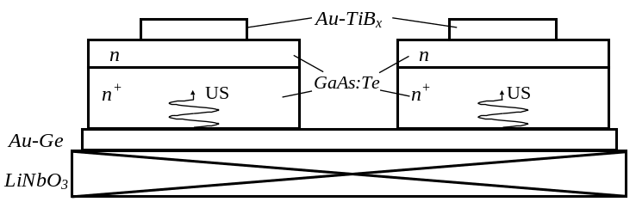
Figure 1. The scheme of the ultrasonic treatment of the Au-TiB-n-n⁺-GaAs structures.
, (1)

where S is the ohmic contact area, A** is a modified Richardson constant, 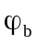 is the effective Schottky barrier height, n is the nonideality factor, and U_{F} is the applied bias voltage. The definition of the nonideality was occurred by an inclination of the received curve (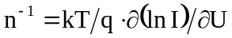), the 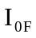 value was defined by an approximating curve crossing with an current’s axis, and then was calculated.

EXPERIMENTAL RESULTS AND DISCUSSION

The initial (prior to UST) values for the entire set of diodes ranged within 0.730–0.750 eV, and the initial values of n were 1.06–1.08. The obtained values of n being very close to unity might be indicative of an insignificant contribution of the generation–recombination processes to the current transfer. The reverse I-U characteristics does not have similar uniformity, though all structures have been grown in the same technological cycle. All diode’s set can be divided on two groups.
The first group consists of diodes with a small reverse current (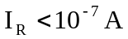 at reverse bias voltage of 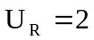 V); it is revealed, that in this case the semilogarithmic plot of 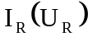 is almost linear (figure 2, curve 1). This behavior is characteristic of a tunneling mechanism of current transfer [5]. Calculations show that the field or thermo-field emission in the structures under study can be significant only at T < 10 K. Therefore, the mechanism of tunneling in this case must be different. For example, Evstropov et al. [7] suggested that the excess current through the potential barrier can be determined by electrons transferred via a chain of deep levels located at spatial charge region. In this case, the reverse I–V curves are described by the relation [7]:
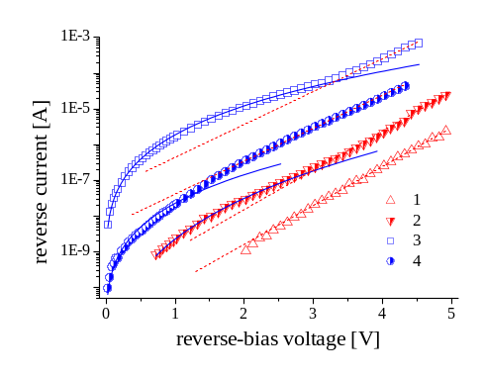
Figure 2. The typical reverse branches of I–U curves for diodes of the (1, 2) first and (3, 4) second groups measured (1, 3) before and (2, 4) after UST. (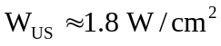, 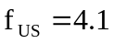 MHz). Solid and dashed curves show the approximations using formulas (3) and (2), respectively.

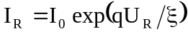 (2)

where 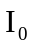 is determined by the concentration of defects creating deep levels, characteristic energy depends on defect’s type.
For the second diodes group the reverse current is more, 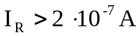 at V. The plot of 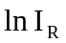 versus 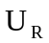 at small reverse bias voltages (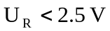)is substantially nonlinear (figure 2, curve 3); the experimental curves are well approximated by the relation
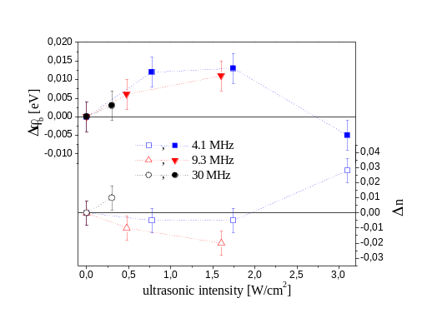
Figure 3. Dependencies of an acousto-induced variations of effective Schottky barrier height (filled points) and nonideality factor (transparent points) versus UST power density for different frequencies.

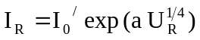. (3)

where 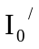 and a are constant quantities. Such dependence (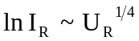) is characteristic of a thermionic mechanism of current transfer [5], whereby rather large absolute values of 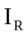 can be related both to the energy states localized at the semiconductor boundaries [6]. For greater reverse bias the I-U curve’s behavior is typical of the tunneling mechanism.
After UST changes in the 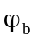 and n values were relatively small, the results is shown on figure 3. It should be noted that these changes were non- monotonous depending on UST power density. US effect on reverse branches of I-V curves was a much more pronounced.
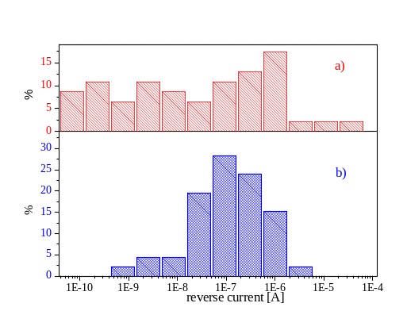
Figure 4. Histograms showing distributions of the reverse current (at 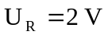) in Au-TiB_{х}-n-n⁺-GaAs diodes (a) before and (b) after UST (, MHz) .
In the case of 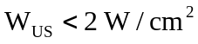 the UST lead to an increase in by one or two orders of magnitude in the first group of diodes (see figure 2, curves 1 and 2); in the diodes with predominate thermionic mechanism the decrease in 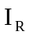 by a factor of 10–500 is observed (figure 2, curves 3 and 4). Such opposite changes of a reverse current value lead to similarity of the various structures I-U curves and, hence, to increase in the homogeneity of parameters of the structures manufactured in the same technological cycle– see figure 4. We believe that this substantial difference in the UST-induced changes in I–U curves is related to a difference in the predominating mechanism of current transfer through the Schottky barrier for the diodes with different initial states. The high-intensity UST, 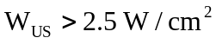 led to a significant (by one or two orders of magnitude) growth in and to an increase in the contribution of the thermionic mechanism for both diode’s groups. The character of the acousto-induced variation of a n and 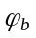 changes at the same power density – see figure 3.
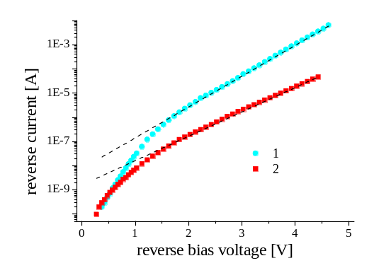
Fig. 5. The reverse branches of I–U curves measured (1) before and (2) after ultrasonic treatment W_{US}=0.3 W/cm2, f_{US}=4.1 MHz. Point – experimental dates, line - approximations using (2) (for curve (1) I₀=7.6×10⁻⁹ A, ξ=0.34 eV; for curve (2) I₀=1.6×10⁻⁹ A, ξ=0.43 eV)
Besides effect on value, some changes of a 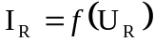 curve character were observed after UST. So, diodes of the first group upon UST exhibited thermionic processes at small reverse bias voltages (<2 V), whereas diodes of the second group showed the linear relation between and at somewhat lower bias voltages – see figure 2. Also the variation of inclination of I-U curves with prevailing tunneling mechanism took place – see Fig.5. According to (2) variation of inclination corresponds to variation of parameter ξ, the result obtained by approximation of experimental dates are listed in Table 1 (variability of every cell’ data concerns to various diodes). According to [7] ξ characterize defect’s type, hence, revealed alteration of this parameter testify acousto-induced variation of defect subsystem of semiconductor. And it is evident that this variation depend on ultrasonic frequency essentially, ultrasonic of higher frequencies influences defects more effectively
It is known that the ultrasonic treatment can produce smoothing of the local inhomogeneities of interfaces [3]. In our opinion, this is a phenomenon that is responsible for a significant decrease in I_{R} in diodes of the second group. The acoustostimulated redistribution of defects in semiconductor depth (similar to observed in [8], [9]) modifies the population of energy levels at the metal-semiconductor interface and influences the I_{R} of diodes of the first group and changes 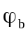 and n values in both group. As the UST intensity exceeds a certain threshold, the acoustic wave induces the generation of defects in the bulk and subsurface regions of the semiconductor [8] and stimulates the reconstruction of a defect structure of the metal-semiconductor interface [3], which leads to a decrease in (due to the Schottky effect) and to an increase n. These changes are accompanied by the growth of thermionic current through the diode and by an increase in I_{R}.
Table 1. Parameter of approximation of reverse branches of I-U curves according to (2) before and after UST
UST characteristic | ξ, meV
UST characteristic | before UST | after UST
4.1 MHz, 2 W/cm² | 350-400 | 350-400
9.3 MHz, 1.5 W/cm² | 340-400 | 380-410
30 MHz, 0.3 W/cm² | 340-380 | 390-460

CONCLUSIONS

Thus, we have studied the effect of UST with various intensities and frequencies on the characteristics of Au-TiB_{х}-n-n⁺-GaAs diodes with Schottky barriers. It is established that The character of the ultrasonic action depends on the predominating mechanism of current transfer: the UST causes an increase in I_{R} for a tunneling mechanism while decreasing I_{R} in the case of thermionic emission. It is revealed that ultrasonic of higher frequencies influences semiconductor defect’s subsystem more effectively.

Работа выполнена при поддержке фонда STCU (проект # 3555).

REFERENCES

- Olikh O. Ya., Ostrovskii I. V. Phys. of the Solid State, 2002, 44, p.1249
- B.N. Zaveryukhin, N.N. Zaveryukhina and all, Tech. Phys. Let. 31, 54 (2005)
- Парчинский П.Б., Власов С.И., Лигай Л.Г. и др. // Письма в ЖТФ. 2003. Т. 29. В. 9. С.83-88. - Parchinskii P. B. and all. Tech. Phys. Let., 2003, 29, p.392
- Подолян А.А., Хиврич В.И. // Письма в ЖТФ. 2005. Т. 31. Вып. 10. С.11-15.
- Родерик Э.Х. Контакты металл-полупроводник. М.: Радио и связь, 1982. 209 с.
- Singh, A.; Cova, P.; Masut, R. A. // J. Appl. Phys. 1994. V. 76. I.4. P.2336-2342.
- V.V. Evstropov, Yu.V. Zhilyaev, M. Dzhumaeva and all, Semiconductors 31, 115 (1997); 34, 1305 (2000).
- Заверюхин Б.Н., Заверюхина Н.Н., Турсункулов О.М. // Письма в ЖТФ. 2002. Т. 28. № 18. С.1-12.
- Островский И.В., Надточий А.Б., Подолян А.А. // ФТП. 2002. Т.36. № 4. С. 389-391.

