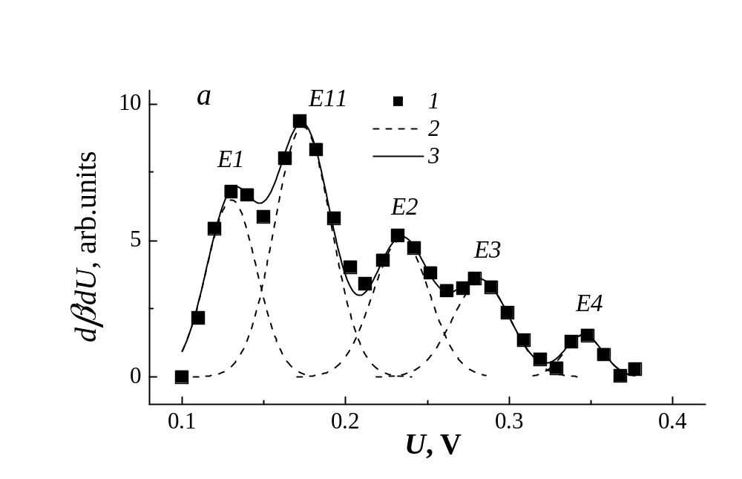
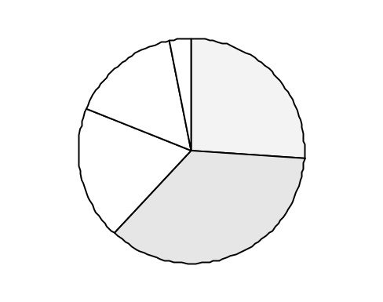
η₃
16%

η₂
19%

η₁
26%

η₁₁
36%

η₄, 3%

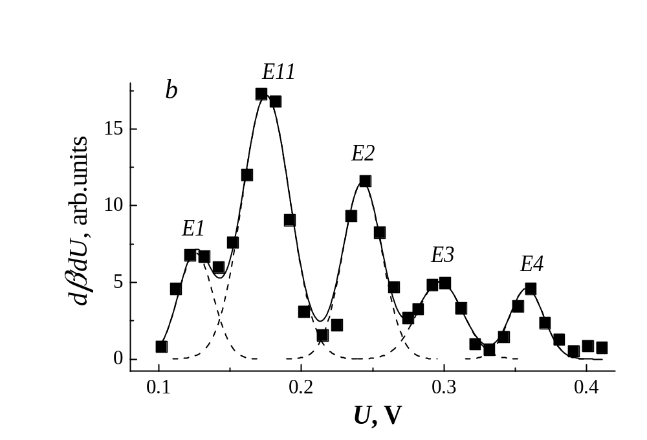
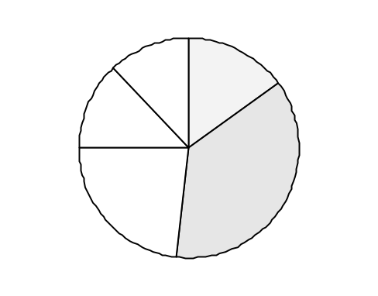
η₄
12%

η₃
13%

η₁
15%

η₁₁
37%

η₂
23%

