Influence of the ultrasound treatment on characteristics of the γ-irradiated metal-silicon structure

Gorb A .M., Korotchenkov O.O., Olikh O.Ya., Podolyan A.O.
Taras Shevchenko Kyiv National University, Volodimirska 64, Kyiv, 01601, Ukraine

The results of the experimental study of the ultrasound influence on electrical properties of the irradiated silicon m-s structures are presented. The current mechanisms for ⁶⁰Co γ-ray irradiated structures are considered. It has been revealed those reverse current decreases as well as rectification factor and charge currier lifetime increase due to ultrasound treatment. It is shown that these effects might be connected with both ultrasound annealing of the recombination centres and acoustostimulated redistribution of the mobile radiation defects.

Introduction
It is known that elecrophysical characteristics of the diode structures are sensitive to high energy irradiation [1-3]. As a result, the operation parameters of the structures used as radiation detector or worked into radioactive environment degrade essentially. The formation of the various type radiation defects is the dominant cause for degradation because those defects act as centres of the trapping and recombination of the charge carriers. Therefore the development of the method of the influence on defects in the semiconductor structures is the important task in practice. The methods based on thermal annealing are more widespread. However both desirable and undesirable processes might take place in the defect subsystem under long-term high temperature action. For example, the second ones are the semiconductor contamination due to diffusion of the contact material, the interpenetration of the different area dopant etc. Simultaneously, it was reported early about ultrasound (US) influence on Si radiation defects at a near-room temperature [4-6], on current-voltage (I-U) characteristics of the Schottky-barrier structures [7]. The purpose of this work was to study experimentally the possibility of the recovery of the electric characteristics of the γ-ray irradiated silicon-metal structures with help of the US treatment (UST) and to clarify the possible mechanism of the US influence. By the same token, the precondition for development of the new method for increase of the diode structure radiation stability was created.

Experimental detail
The Fz-n-Si samples (conductivity about 4000 Ohm⋅cm, thickness of 1.13 mm) was initial material in this work. They were irradiated by ⁶⁰Co γ-ray at a temperature (Т) 300 К; the γ-ray dose was 5×10⁶ or 5×10⁷ rad depend on a sample. The sample conductivity remained n-type and reduced down to 2 times approximately after irradiation with dose 5×10⁷ rad; it indicated that radiation defects influence essentially on effective doping level and on charge carrier recombination. One sample surface was oxidized at a T = 300 K and then aurum layer (30 μg/cm²) was deposited for formation of the Schottky contact. The ohmic contact was made on opposite side by GaZn eutectic. The contact surface S was equal to 100 mm² approximately.
Then the samples were treated by US. The LiNbO₃ piezoelectric transducers were used for excitation of the acoustic waves. The US frequency (f_{US}) was equal to 3-4.1 MHz; the US intensity (W_{US}) was up to 2 W/cm². The UST was carried out by consecutive series, the duration each of them was 30 min. The sample surface temperature did not exceeded 350 K.
The structure operation characteristic was controlled by I-U characteristic measurements. The measurements were carried after γ-irradiation as well as after each UST. Additionally, in order to receive helpful information, the measurements of the photocurrent decay kinetics were carried out before and after UST for samples without Schottky contact. The methods of the UST, I-U characteristic and photocurrent decay measurements were described detailed elsewhere [5, 7].

Results and discussion
The characteristics of the irradiated structures
It is obviously, that for the precise analysis of the influence of external factors (and US as well) on the Schottky structure operation characteristics it is necessary to know structure charge transfer mechanisms. In order to solve this problem, analyze of the I-U characteristic of the irradiated structures in temperature 290-330 K was carried out. Figure 1(a) shows the forward I-U characteristics of the irradiated samples. The dependence of forward current I_{F} on forward-bias voltage U_{F} for small bias (U_{F} < 1 V) is well described by equation:
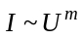; (1)
the exponent m is temperature-depend, increases with U_{F} rise and is equal to 1-1.8. It should be noted that such dependence correspond to conditions of the space charge limited current through barrier [8, 9]. The m value indicates that the transition between linear ohmic mode and quadratic trap mode is observed in this case and the quantity of injected carriers is more than the quantity of thermo-activated carriers [8, 9]. In fact, if one estimates the width of the space charge region according to the Schottky theory (~30 μm for barrier height 1 eV) and concedes, that all bias-voltage drop is on this region, then current density of the thermo-activated carriers must be about 5 mA/m², where observed density is about 10 mA/m². The some current jump was observed when forward bias increase and non-trap quadratic mode was realized at U_{F} ≈ 2 V; the concentration of the injected carrier is greater than concentration of the initial unoccupied trap and it is a reason for current mode changing [8]. The semiconductor series resistance dominated at U_{F} > 2.5 V.
The activating energy of the current at U_{F} < 1 V was determinated from I_{F} temperature dependence (figure 2(a)) and was equal to 0.33 eV. This value corresponds to the trap activation energy located it the depleted layer [9]. It is shown [10] than this level might connected with the Si-atom unsaturated valence bond appeared due to stressed bond breakage on Si-SiO₂ interface under γ-ray irradiation with dose (1÷5)×10⁶ rad. The coincidence of the activating energy value and the necessary dose irradiation is evidence of the possibility of the formation just that defects in our case. Subsequently, these defects influence essentially on current in silicon-metal structure.
The reverse current I_{R} depend on reverse bias U_{R} linear at |U_{R}| < 1 V (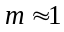) – see figure 1(b). The quantity of the injected from contact carriers decreases with U_{R} increase and dependence 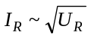 (m = 1/2) is observed at |U_{R}| > 1 V and the current activating energy is equal to 0.68 eV at that (figure 2(b)). This is an evidence of the predominance of the generation-recombination process in the current mechanism. Therefore [11]
I_{R} = q S n_{i} W / 2τ , (2)
where n_{i} is the charge carrier concentration of the intrinsic semiconductor, W is the depleted region width (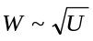), τ is the carrier life time in depleted region.
Figure 3 shows, that γ-ray irradiation reduced essentially the lifetime of the nonequilibrium charge carrier: it was equal to 500 μs for non-irradiated samples (curve 1) and to 77 μs immediately after immediately (curve 2). It is known [12, 13] that E-center (vacancy and phosphorus complex) and divacancy are the main recombination centers in high-resistance Fz-Si. The isochronal annealing shown, that it was present two stage of the defect annealing: about 60% of the defect anneal in the first stage (125÷200°C), the rest – in the second stage (225÷250°C). The first stage correspond to the E-center annealing [12], the temperature of the second stage is slightly lower than the standard temperature of the divacancy annealing 250÷300°C [14]. However, it was reported [15, 16] early, that divacancy annealing temperature was decreased due to stress field created by dislocations and by impurity-defect aggregates of the radioactive origin. Therefore, in our opinion, second stage connected with divacancy annealing in presence of the elastic stress, created by growth crystal imperfection. It is known that basic part of the divacancy created in the neighborhood of such growth defect due to both the directed migration and the aggregation of the primary vacancies. Additionally, samples surface etching by the selective etchant [17] detects the flat-bottomed pits corresponded to the growth microdefects [17, 18], and therefore it confirms the possibility divacancy annealing during second stage.

Influence of the UST
The experiments shown that UST had an essential effect on value of the forward as well as reverse current and had no effect practically on dependence I(U) character (figure 4). One can summarized and marked out result from UST as follows: (i) The forward resistance of the structure decreased considerably, by an order of magnitude practically; (ii) The section corresponded to non-trap quadratic mode was observed only on forward I-U characteristic after long-term UST (figure 4(a), curve 3); (iii) The reverse I-U characteristic transformation to dependence occurred at a large bias; (iv) The reverse current decreased by several times; (v) The exponent m increased slightly at initial stage of the reverse I-U characteristic.
The results of the p.(i) and p.(iv) leaded to significant increasing of the structure rectification factor – see table 1. Additionally, according to eq.(2), the reverse current magnitude is inversely proportional to τ for case, therefore the relation of the current at constant bias before and after UST is determined by lifetime changing. In other words, p.(iv) indicated of τ increase as a result of UST – see table 1. The UST-induced lifetime increase is confirmed indirectly by p.(v), it testifies of the approaching of the τ and the electron transit time through depleted layer [8]. Additionally, p. (ii) confirms reduce of the trap concentration [8] for the structures subjected by acoustic action. The expansion of the bias range of the space charge limited current mode (p.(iii)) might be explained by growth of an effective doping level, it results in increase of the reverse bias requisite for generation-recombination mode realizing.

Table 1. UST-stimulated modifications of the rectification factor 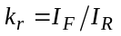 (at U = 0.35 V) and carrier lifetime τ.
Parameter | UST duration, min
Parameter | 0 | 30 | 60
k_{r} | 0.3 | 1.6 | 85
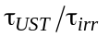* | 1 | 1.2 | 1.4
* τ is the carrier lifetime for irradiated structure, τ_{UST} is the carrier lifetime for irradiated and UST subjected structure.

Based on above-mentioned it is expected that acousto-induced rebuilding of the defects (which are the center of the recombination) can be able to restore essentially the photocurrent decay kinetics, which is accelerated by incorporation of the radiation centers. The obtained results confirm this assumption – see figure 3, curves 2-5. It is shown that rate of the photocurrent decay decreases in fact, the minority charge carrier lifetime increases from 77 μs after irradiation immediately (curve 2) up to 157 μs after all UST series (curve 5).
Thus it may be supposed that the observed features of I-U characteristic variation due to UST connect with the modification of the silicon defect subsystem in acoustic field. The obtained experimental results might be explained according to the general approach [19-21] based on acousto-induced processes of the migration, rearrangement and rebuilding of the charged point defects; these processes, in their turn, result both reduce of a concentration of the radiation centres (having an influence on effective doping level) and increase of the charge carrier lifetime.

Conclision
The experimental investigation of the UST influence on electric characteristics of the irradiated structures silicon-metal was carried out. The possibility of such characteristics improvement (recovery) due to acoustic action was shown. Based on analysis of the current mechanism it is pointed out that observed effects connect with an acousto-induced rebuilding of a defect subsystem. The contributed results might be used for development of the method of the parameter recovery and the useful life duration of both silicon radiation detector and diverse type photoelectric device.

References
[1] Chin M.R., Ma T.P. // Appl. Phys. Lett. 1983. V. 42. N 10. P. 883.
[2] Karataş Ş., Türüt A., Altındal Ş. // Nuc. Instr. and Meth. A. 2005. V. 555. N 1-2. P. 260.
[3] Jayavel P., Udhayasankar M., Kumar J., Asokan K., Kanjilal D. // Nuc. Instr. and Meth. B. 1999. Vol. 156. N 1-4. P. 110-115.
[4] Островский И.В., Коротченков О.А., Лысых В.А. // ФТТ. 1987. Т. 29. № 7. С. 2153.
[5] A. A. Podolyan and V. I. Khivrich, ” Room-temperature ultrasonic annealing of radiation defects in silicon,” Tech. Phys. Let., vol. 31, pp. 408-410, 2005.
[6] N. A. Guseynov, Ya. M. Olikh and Sh. G. Askerov Ultrasonic treatment restores the photoelectric parameters of silicon solar cells degraded under the action of ⁶⁰Co gamma radiation // Technical Physics Letters, Volume 33, Number 1, 2007, т.33, в.1, p.18-21.
[7] O. Ya. Olikh and T. N. Pinchuk Acoustic wave corrected current-voltage characteristics of GaAs-based structures with Schottky contacts Tech. Phys. Let., vol. 32, N6, pp. 517-519, 2006.
[8] Lampert M.A., Mark P. Current injection in solids. New York and London, Academic Press, 1970.
[9] Шерченков А.А., Бугадян Б.Г., Мазуров А.В. // ФТП. 2005. Т. 39. № 8. С. 964.
[10] Парчинский П.Б., Власов С.И., Насиров А.А. // ФТП. 2004. Т. 38. № 11. С. 1345.
[11] Sze S.M. 1985 Semiconductor Devices, Physics and Technology (NewYork:Wiley)
[12] Конозенко И.Д., Семенюк А.К., Хиврич В.И. Радиационные эффекты в кремнии. Киев: Наукова думка, 1974. 200 с.
[13] Лугаков П.Ф., Лукашевич Т.А. // ФТП. 1989. Т.23. № 3. С. 581.
[14] Markevich V. P., Peaker A. R., Lastovskii S. B. et. all // J. Phys.: Condens. Matter. 2003. V. 15. N 39. P. S2779.
[15] Лугаков П.Ф., Лукьяница В.В. // ФТП. 1983. T.17. № 9. С.1601.
[16] Kazakevich L.A., Lugakov P.F. // Рhys. stat. sol (a). 1982. V. 74. N 1. P. 113.
[17] Yang K. H. // J. Electrochem. Soc. 1984. V. 131. N 5. P. 1140.
[18] Secco D`Aragona F. // Phys. stat. sol (a).- 1971.- V. 7. N 2.- P.577.
[19] Островский И.В., Рожко А.Х. // ФТТ. 1984. Т. 26. № 12. С. 3718.
[20] Ya. M. Olikh, M. D. Tymochko and A. P. Dolgolenko, ”Acoustic-wave-stimulated transformations of radiation defects in γ-irradiated n-type silicon crystals,” Tech. Phys. Let., vol. 32, pp. 586-58932, 2006.
[21] O. Ya. Olikh and I. V. Ostrovskii, ” Ultrasound-stimulated increase in the electron diffusion length in p-Si crystals”, Phys. of Sol. State, vol.44, pp. 1249-1253, 2002.

Figure caption
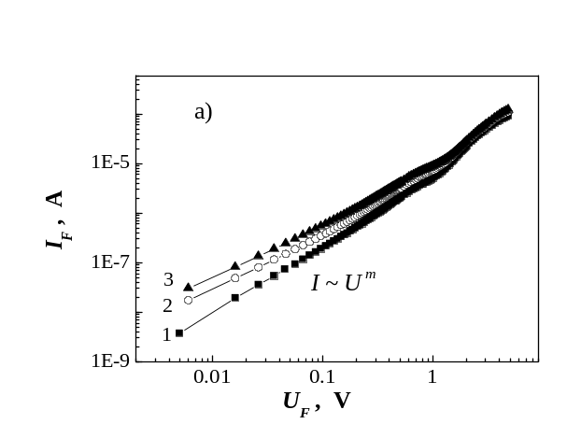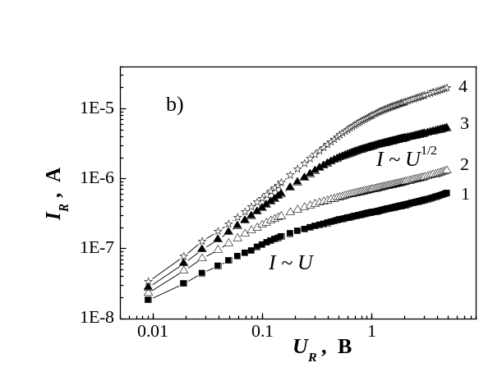

Figure 1. Forward (a) and reverse (b) I-U characteristic of the irradiated samples (dose is 5×10⁷ rad) for different temperature.
T, К: 302 (1), 312 (2), 326 (3), 339 (4).
The exponent m for forward bias is equal to 1.3÷1.8 (1); 1.2÷1.6 (2); 1.0÷1.5 (3).

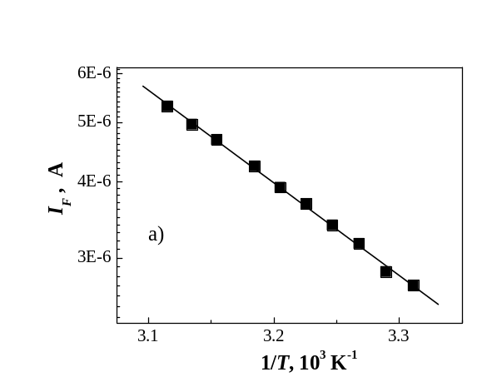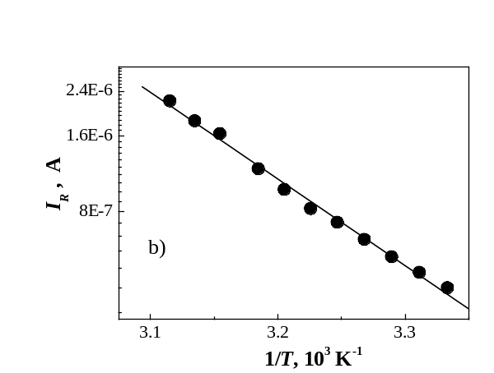

Figure 2. Dependence of forward (а, U_{F} = 0.6 V) and reverse (b, U_{F} = 2.5 V) current on temperature. Points are experiment, lines are fitting according to 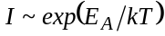, where Е_{А} is the activation energy.

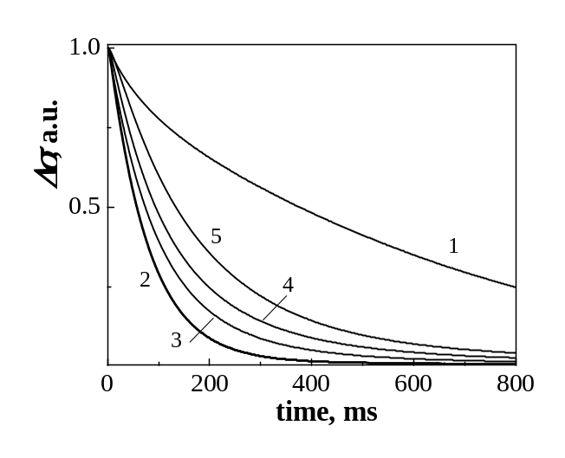

Figure 3. Dependencies of photocurrent (Δσ) on time before (1) and after (2-5) irradiation. Dose is 5×10⁶ rad. UST duration, min: 0 (2), 60 min (3), 120 min (4), 240 min (5). f_{US} = 3 MHz. The surface recombination velocity was constant and was equal to about 10³ cm/s.

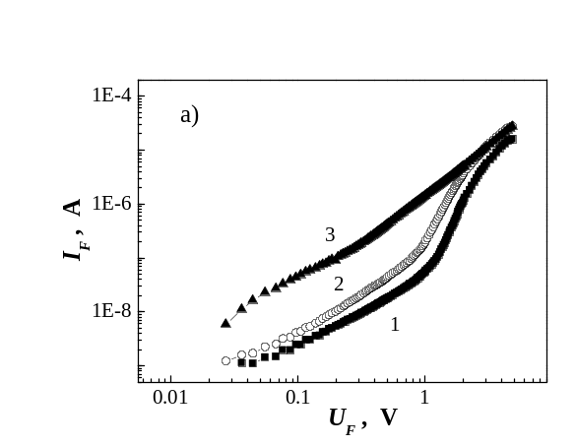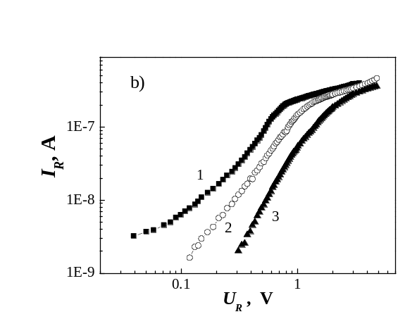

Figure 4. Forward (a) and reverse (b) I-U characteristic before (1) and after (2 и 3) UST.
UST duration, min: 30 (2), 60 (3). f_{US} = 4.1 MHz.

