Space charge region recombination, non-radiative exciton recombination, and the band-narrowing effect in high-efficiency silicon solar cells
A.V. Sachenko¹, V.P. Kostylyov¹, V.M. Vlasiuk^{1*}, I.O. Sokolovskyi¹, M. Evstigneev², D.F. Dvernikov¹, R.M. Korkishko¹, V.V.Chernenko

¹ V. Lashkaryov Institute of Semiconductor Physics, NAS of Ukraine, 03680 Kyiv, Ukraine
² Memorial University of Newfoundland, St. John’s, NL, A1B 3X7, Canada
*Corresponding authors: viktorvlasiuk@gmail.com

Abstract. An expression for finding the dependence of the narrowing of the bands in silicon ΔE_{g} on the level of illumination from the intrinsic absorption band (or short-circuit current) has been proposed. The proposed expression is used to find experimental values of ΔE_{g} in high-efficient silicon solar cells. The dependence ΔE_{g} (J) or dependence ΔE_{g} (J_{I}), where J_{I} is the short-circuit current density, is rebuilt into the ΔE_{g} (Δn_{OC}) dependence, where Δn_{OC} is the excitation level in open-circuit conditions.
For this, the generation-recombination balance equation was solved taking into account six recombination mechanisms in silicon, including Shockley–Reed–Hall recombination, radiative recombination, interband Auger recombination, surface recombination, non-radiative exciton recombination, and recombination in the space charge region. The latter two recombination terms are not taken into account in studies of the key parameters of silicon solar cells and in programs for simulating the characteristics of these solar cells.
Therefore, in the work, their correct definition was performed, their contribution was compared with the contribution of other recombination mechanisms, and it was shown that the description of the characteristics and key parameters of silicon SC without taking them into account is insufficiently correct. The experimental dependences ΔE_{g} (Δn_{OC}) obtained in the work were compared with Schenck’s theory. It is shown that there is good agreement between them.

Keywords: silicon solar cell, recombination mechanisms, Schenk’s theory.

1. Introduction
For semiconductors, an important parameter is the concentration of intrinsic charge carriers n_{i} (T), which significantly depends on the temperature T. The concentration of intrinsic charge carriers n_{i} (T) is a fundamental quantity in semiconductor physics. It is included in almost all calculations related to the injection of charge carriers. The value n_{i} (T) largely shapes the density of minority charge carriers and significantly affects the recombination properties of semiconductors. Therefore, an accurate determination of n_{i} (T) is of primary importance both for better understanding of physics and for the design of semiconductor devices.
Diode and transistor semiconductor structures, as well as solar cells (SC) have heavily doped regions with electron and hole conductivity in their composition. In these regions, there is significant narrowing of the width of the band gap of semiconductor ΔE_{g} (of the order of tens or hundreds of meV), connected, in particular, with the correlation and exchange interaction of charge carriers, which affects the value n_{i} (T). There are several models for calculating the effect of band narrowing, both empirical and analytical, and quite a large number of works related to their experimental verification.
Among the theoretical works, one of the most famous is Schenk’s model [1]. It is a quantum mechanical calculation at a finite temperature with taking into account a number of effects, in particular, the correlation and exchange interaction of charge carriers, in the random phase approximation. It should be noted that although the band-narrowing effect is primarily manifested in heavily doped regions, it also exists in weakly doped regions, primarily due to bipolar injection in diode structures or illumination from the intrinsic absorption band.
In this case, the effect of band narrowing is manifested due to the appearance of a sufficiently large concentration of excess electron pairs Δn, the so-called strong excitation level. Although in this case the typical values ΔE_{g} are of the order of several meV, but even such values of band narrowing in silicon significantly affect the magnitude of the intrinsic concentration of charge carriers and must be taken into account.
For the case of strong doping or excitation, there are many experimental works in which the band-narrowing effect is measured and compared with different theories. Experimentally, in this case, as a rule, the optical properties of silicon are investigated. Most of these works were performed for doping or excitation levels greater than 10¹⁷ cm^{–3}. Green’s work [2] summarizes the results of works in which the experiment was conducted in the interval of lower values of doping or injection levels, from 10¹⁴ to 10¹⁷ cm^{–3}.
But the optical characteristics of silicon were also measured in these works. This paper proposes an approach that allows experimentally determining the magnitude of the band-narrowing effect that appears due to illumination or bipolar injection in weakly doped regions. In this case, the current (dark or short-circuit current) is experimentally measured.
The obtained results were compared with Schenk’s theory [1]. It was ascertained that there is a sufficiently good correlation between the experiment and the theory. For a better agreement between them, it is desirable to obtain experimental characteristics with greater accuracy, as well as to ensure good thermal stabilization of the studied structures during measurements, since, as noted, the intrinsic concentration strongly depends on temperature.

2. Experimental results on the study of the band-narrowing effect and basic expressions for finding values of the band-narrowing effect in silicon
In works and programs devoted to modeling the parameters of solar cells, the effect of band narrowing, calculated in the Schenck model [1], is taken into account. In [1], when writing the obtained expressions, the notations n_{e} and n_{h} are used, which correspond to the full values of the concentrations of electrons and holes in the volume of semiconductor.
Let’s rewrite them as follows: 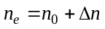, 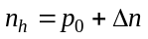, where n₀ and p₀ are the equilibrium concentrations of electrons and holes in semiconductor, and Δn is the excess concentration of electron-hole pairs that occurs due to injection or illumination with light from the intrinsic absorption band. At sufficiently high temperatures T, on the order of room temperature, in doped silicon we have 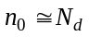 in semiconductor with electron conductivity and 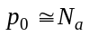 in semiconductor with hole conductivity. Here, N_{d} and N_{a} are the concentrations of shallow donors and acceptors.
Almost all works devoted to the study of the zone narrowing effect, with some exceptions, describe the results of the dependence of the value ΔE_{g} on the level of doping. Much less attention is devoted to the study of its value from the excitation level Δn. So, for example, in the work by Altermatt and Schenk [3] Fig. 1 shows dark I-V characteristics for silicon SC only up to applied voltage values not exceeding 0.65 V. And in Fig. 2 shows the dependence of the concentration of intrinsic charge carriers only on the level of doping. This is correct only under the condition when Δn is less than n₀, that is, at sufficiently small values of the applied voltage.
At the same time, at the values of the applied voltage greater than those given in [3], the excitation level becomes greater than the doping level, and the value of the intrinsic concentration of charge carriers will also depend on the value Δn. That is, if you do not limit the value of the applied voltage, then the effect of band narrowing and, accordingly, the effective concentrations of intrinsic charge carriers will depend on both the doping level and the excitation one.
Next, we will set the problem of determining the value ΔE_{g} depending on the level of excitation. For this, it is convenient to use the dependence of the short-circuit current density of SC J_{L} (I) on the open-circuit voltage V_{OC} (I) at various values of the illumination level I. According to the work [4], the open-circuit voltage is found from the expression
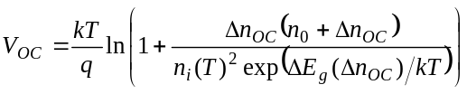, (1)
where Δn_{OC} is the excitation level under open-circuit conditions, and ΔE_{g} (Δn_{OC}) is the reduction of the band gap depending on Δn_{OC}, i.e. the band-narrowing effect.
The following expression for the dependence of ΔE_{g} (Δn_{OC}) can be obtained from formula (1):
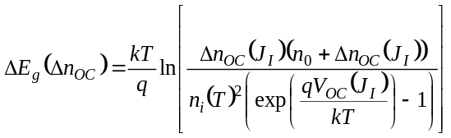 . (2)
Here 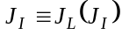.
The dependence of Δn_{OC}(J_{I}) in the case of high-efficient silicon SC can be found from the equation of the generation-recombination balance in the form
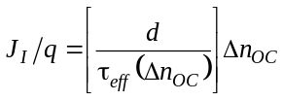, (3)
where d is the SC thickness, and τ_{eff} (Δn_{OC}) is the effective lifetime of non-equilibrium charge carriers in silicon, which was determined in [5] with taking into account such recombination mechanisms as Shockley–Reed–Hall recombination with the lifetime τ_{SRH}, non-radiative exciton recombination according to the Auger mechanism with the participation of a deep impurity level with a lifetime τ_{nr} [6], surface recombination occurring on the front and back surfaces of SC with recombination rates S₀ and S_{d}, radiative recombination τ_{r} [7], interband Auger recombination [8] and recombination in space charge region (SCR) with the time τ_{SCR}.
It should be noted that in works devoted to modeling the characteristics of high-efficient silicon solar cells, such recombination mechanisms as recombination in SCR and non-radiative exciton recombination by the Auger mechanism with the participation of a deep impurity level are not taken into account. However, they can play a significant role along with other recombination mechanisms and therefore should be taken into account. Since they take part in the formation of the value Δn_{OC}, it is first necessary to justify their importance in determining the dependence of Δn_{OC}(J_{I}).
Let’s start with recombination in SCR.

3. Recombination in the space charge region
In this work, to calculate the recombination rate in SCR, an approach modified in comparison with our previous works for finding this rate was used. The value of the recombination rate in SCR S_{sc} was calculated using the expression
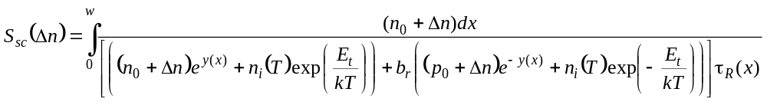. (3)
Here, 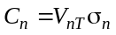, 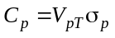 are the coefficients, and σ_{n} and σ_{p} – capture cross-sections of electrons and holes by the deep level, V_{nT} and V_{pT} – average thermal velocities of electrons and holes, 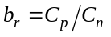, 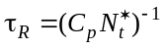 – lifetime in SCR, 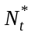 – concentration of the deep level in SCR, p₀ – equilibrium volume concentration of holes, y(x) – dimensionless electrostatic potential (band bending) in SCR, E_{t} – energy of the deep level in silicon SCR, calculated from the middle of the band gap, n_{i} (T) – concentration of intrinsic charge carriers, and w – thickness of SCR.
In the case when τ_{R} = const, passing from the integration over the x coordinate to the integration over the dimensionless potential 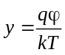, we obtain
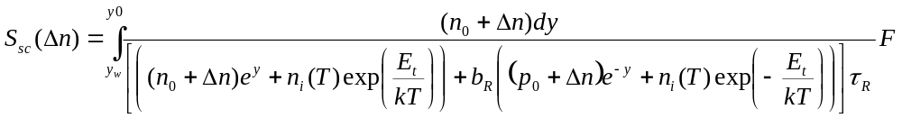, (4)
where
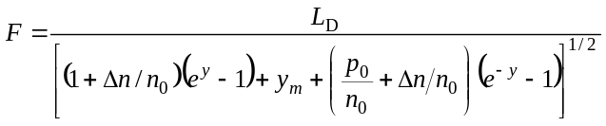. (5)
Here, 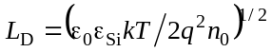 is the Debye length, q – elementary charge, y₀ – is the non-equilibrium dimensionless bending of bands on the surface of the weakly doped area, which depends on the excitation level Δn and is found from the equation of integral neutrality, y_{w} is the non-equilibrium dimensionless potential at the boundary of SCR near the quasi-neutral area.
To find the dependence of the non-equilibrium dimensionless potential y on the coordinate x, it is necessary to use the solution of the Poisson equation (the second integral) that has the following form
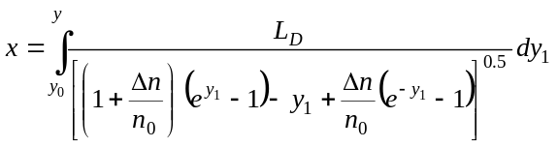. (6)
The value of the non-equilibrium dimensionless potential y₀ at x = 0 is found from the solution of the integral electroneutrality equation that has the form
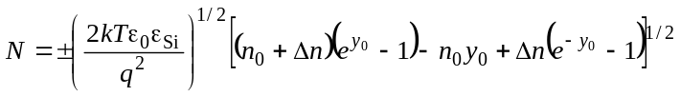, (7)

Where qN is the surface charge density of acceptors in the p-n junction or in anisotypic heterojunction.
When calculating the recombination rate in SCR, it was assumed that the recombination level responsible for recombination is located near the middle of the band gap (E_{t} ≈ 0). In this case, the second terms in square brackets in the denominator (4) can be neglected.
The results of calculating the dependences of the recombination rate in SCR according to the above formulas coincide with the results obtained in the dissertation [9].

In the case when the layer thickness with the lifetime τ_{R} coincides with the SCR thickness at a very low level of excitation Δn w(Δn ≈ 0), as the value Δn increases due to the decrease of the value w, part of it becomes quasi-neutral and recombination according to the Shockley–Reed–Hall mechanism with lifetime τ_{R} occurs in it. In this case, the total recombination rate in SCR and the recombination rate in the resulting quasi-neutral area should be taken as the effective recombination rate in SCR.
Its value is equal to
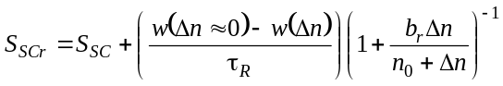. (8)

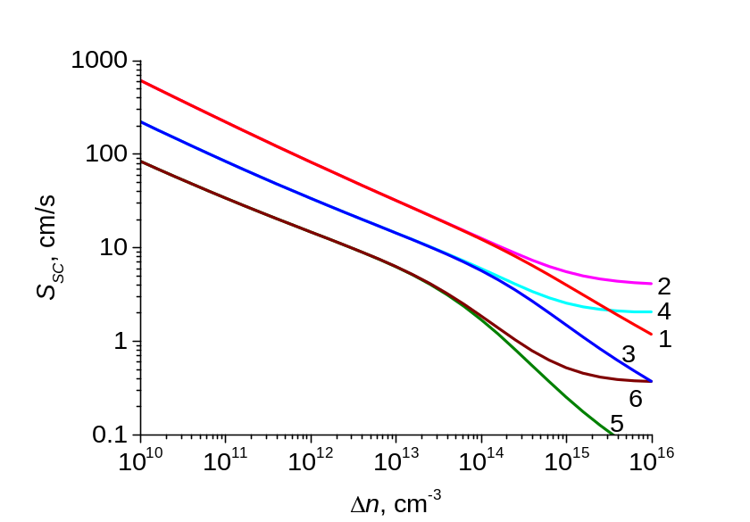
Fig. 1a. Theoretical dependences S_{SC}(Δn) and S_{SCr}(Δn). The used parameters: τ_{R} = 10^{–5} s, n₀ = 10¹⁵ cm^{–3}, b_{r} = 0.1 (1, 2), b_{r} = 1 (3, 4), b_{r} = 10 (5, 6).
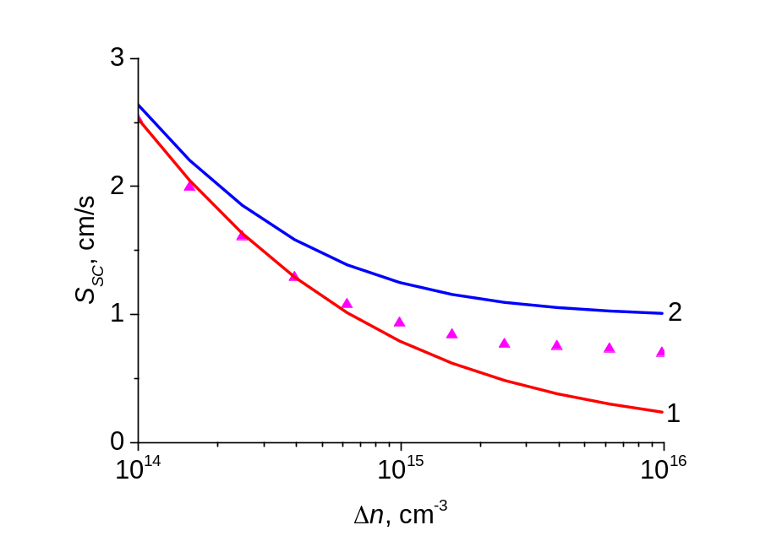
Fig. 1b. Lines – theoretical dependences S_{SC}(Δn) (1) and S_{SCr}(Δn) (2) built using the parameters of silicon SC with the record-breaking photoconversion efficiency described in [10]. Triangles –experimental curve.

Fig. 1a shows the theoretical dependences S_{SC}(Δn) and S_{SCr}(Δn). The parameter of the theoretical dependences is the value of the ratio of the hole capture cross-section to the electron capture cross-section with the recombination center b_{r}. It was assumed equal to 0.1, 1 and 10. As can be seen from the figure, the smaller the values b_{r}, the larger the values S_{SC} and S_{SCr}. The figure also shows that in the region Δn > 10¹⁵ сm^{–3} the S_{SCr} values decrease slowly and eventually saturate.
Fig. 1b shows the theoretical dependences of S_{SC} and S_{SCr}, constructed using the parameters of silicon SC with the record-breaking photoconversion efficiency described in [10]. The same figure shows the experimental dependence of the effective recombination rate on Δn for this SC, as well as the agreed with it theoretical dependence obtained in [11]. When obtaining the latter, it was assumed that the inverse lifetime in SCR is described by Gaussian 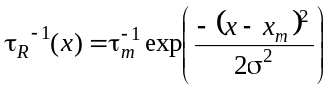, where τ_{m} is the lifetime at the maximum point, x_{m} is the position of the maximum, and σ is the dispersion.
In [11], dependences were constructed using the Gaussian at the following parameter values: τ_{m} = 1.4·10^{–5} s, x_{m} = 2.5·10^{–5} cm, σ =4.5·10^{–6} cm, b_{r} = 0.1. As can be seen from Fig. 1b, the theoretical dependence S_{SCr}(Δn) constructed in [11] matches well with the experimental one shown in Fig. 1b. The experimental dependence of the effective recombination rate in SCR in the work [11] was determined as follows. The contribution related with all other recombination mechanisms was subtracted from the total effective lifetime of charge carriers in the bulk determined in the work.
The above examples demonstrate the complexity of the recombination processes in SCR of silicon high-efficient SC, which must be taken into account when considering it.
And in general, as our previous works showed, without taking into account the recombination in SCR, a sufficiently accurate agreement of the experimental characteristics of high-efficiency silicon SC with the theory cannot be obtained. This applies, in particular, to calculations of dependences V_{OC} (J_{I}), ΔE_{g} (J_{I}) та Δn_{OC} (J_{I}). It is especially important to take into account the recombination in SCR in the area of small and medium excitation levels.

4. Non-radiative exciton recombination by the Auger mechanism with the participation of a deep level
Next, we proceed to justify the importance of taking into account the mechanism of non-radiative exciton recombination by the Auger mechanism with the participation of a deep impurity level.
A large number of works are devoted to the study of the influence of radiative recombination and interband Auger recombination in silicon on the volume lifetime in silicon. Sufficiently complete results of the analysis of the indicated problem are given in the work by Richter and co-authors [8]. In the same work, numerous bibliography on this topic is given. However, despite the fact that at doping and excitation levels greater than 10¹⁶ cm^{–3}, good agreement between the experimental results and theory is achieved, in our opinion, until recently, it remains unclear what happens in the area 10¹⁵ сm^{–3} ≤ n ≤ 10¹⁶ сm^{–3} (here, 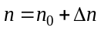).
Thus, in the monograph [12] it was noted that in this area, an additional recombination mechanism related with the introduction of uncontrolled impurities operates. In Fossum’s work [13], with references to experimental results in silicon of n- and p-type conductivity, it was noted that there is an additional recombination mechanism that leads to a decrease in the volume lifetime τ_{v} (n) in silicon, and the law of this the decrease is described by an empirical dependence
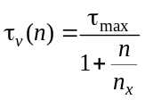, (8)
where n_{x} = 7.1·10¹⁵ сm^{–3}. At the same time, it is said that the value n_{x} is the same for n- and p-type semiconductors.
This means that in addition to the Shockley–Reed–Hall recombination mechanism, the non-radiative quadratic recombination mechanism is described by the law as follows
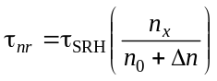. (9)
Finally, the PC1D program and its subsequent versions provide an empirical expression of the form 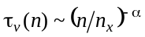, which takes into account, as the authors of the program claim, the influence of the material growth technology on the effective lifetime in silicon. The list of the above shows that the matter here is quite complicated. If we are talking about recent works, in particular, the work [8], then such an explanation is not correct, because the authors of this work guarantee that there are no these uncontrolled technological factors.
We will show below that although the section described by the empirical dependence (8) is not in a graphical scale in the figures given in the work [8], it is realized with sufficiently careful processing the results of the measurements of the dependences given in the works [14, 15]. Its presence or absence is determined by the value of the Shockley–Reed–Hall lifetime τ_{SRH}. Even in the case when the value of τ_{SRH} is equal to 30 or 40 ms, such a section is implemented in the dependences shown in Fig. 2 to 4 below (at least in the range of doping or excitation level 10¹⁵ – 10¹⁶ сm^{–3}).
Next, it will be shown that the indicated area is determined by the non-radiative recombination of excitons through the recombination channel on a deep impurity according to the Auger mechanism, considered in the Hangleiter work [15].

4.1. Analysis of literary data by dependences 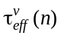
Analyzing the existing works, first of all the work [6], we will proceed from the fact that the dependence of the volume lifetime in silicon on the doping and excitation levels is described by the following expression
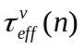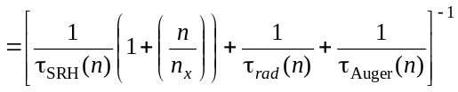, (10)
where is the volume lifetime in silicon, taking into account both removable and non-removable recombination mechanisms. The removable mechanisms include Shockley–Reed–Hall recombination and quadratic nonradiative recombination τ_{nr}, and the non-removable ones include interband radiative recombination and interband Auger recombination.
For the recombination lifetime τ_{SRH} in the case of n-type silicon, the expression is used
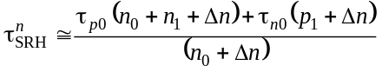, (11)
where 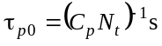, 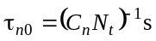, C_{p} and C_{n} are coefficients of the hole and electron captures with the recombination center, N_{t} – concentration, n₁ and p₁ – electron and hole concentrations for cases when the energy position of the recombination level coincides with the Fermi level. For the lifetime of radiative recombination, we will use the relations given in [7].
As for the lifetime of interband recombination 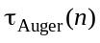, the empirical expression obtained in [8] is used for it.
Before proceeding to the analysis of dependences, we note that the Shockley–Reed–Hall lifetime, depending on the position of the recombination center and the electron and hole capture coefficients, with an increase in the doping and excitation levels, changes between the two positions and can increase, decrease, or remain practically unchanged in a certain range of doping and excitation levels. Next, we will mainly analyze the cases when in the relevant range of doping and excitation levels (from 10¹⁴ to 10¹⁷ сm^{–3} for the doping level and from 10¹⁴ to 10¹⁶ сm^{–3} for the excitation level), the τ_{SRH} value is constant.
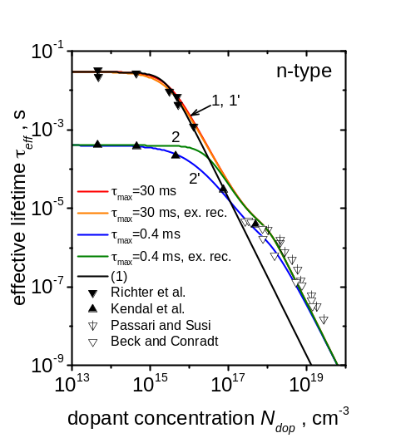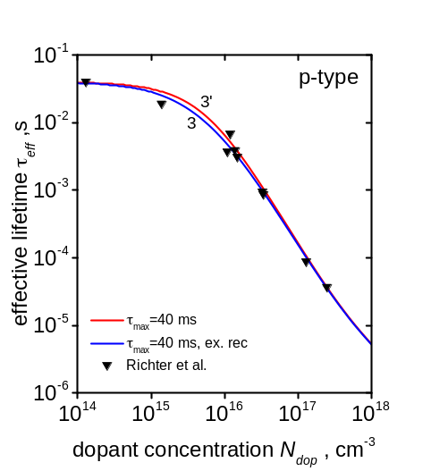
Fig. 2. Experimental dependences of the effective volume lifetime on the concentration of doping impurity in n- and p-type silicon. Points – experiment, lines – theoretical calculation. Curves 1, 2, 3 are built with taking exciton non-radiative recombination into account, curves 1′, 2′, 3′ – without it. The used parameters: τ_{SRH}, ms: 30 (1), 0.4(2), 40 (3); n_{x} = 8.2·10¹⁵ сm^{–3}.

Fig. 2 shows the experimental dependence of the effective volume lifetime on the doping level in n- and p-type semiconductors, taken from the work [8], as well as from the works [16–18]. The theoretical dependences were constructed using expressions (10), (11), as well as using dependences (18) and (19) for taken from the work [8]. For agreement of the theoretical and experimental dependences, in our case, two parameters were varied. One of them is the concentration of the deep center, which determines the value τ_{SRH}, and the second one is the value n_{x}. In principle, they can be separated. This requires measurements in the area of doping levels ≤ 10¹⁴ сm^{–3} (at least two points must be measured).
Fig. 2a describes the dependences in semiconductor of n-type, and Fig. 2b – in p-type semiconductor. As can be seen from Fig. 1a, the experimental dependences 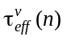 taken from Richter’s work [8], as well as from the works [16–18], agree well with the calculation at n_{x} = 8.2·10¹⁵ сm^{–3}. It should be noted that graphic accuracy is not enough to find the value of n_{x}. Therefore, its value was determined by the method of regression analysis (least squares).
Let’s move on considering the dependences for p-type semiconductor shown in Fig. 2b. In this case, the calculated curves differ very slightly from the experimental ones both with and without taking into account the additional channel of non-radiative recombination, just like the curve for τ_{max} = 30 ms in Fig. 2a (τ_{max} is actually the value τ_{SRH}).
However, the theoretical dependence taking into account the non-radiative quadratic recombination channel shown in Fig. 2a for the case when τ_{max} = 0.4 ms in the range of doping levels from 10¹⁵ to 10¹⁷ сm^{–3} differs significantly from the dependence for which the non-radiative quadratic recombination channel was not taken into account. Experimental points in this case agree with the first dependence. The difference between the two cases, when τ_{max} is large (30 or 40 ms) and small (0.4 ms), becomes clear, if the dependences are plotted in both figures.
As can be seen from Figs 2a and 2b, for the case of large τ_{max}, the dependences τ_{nr}(n) calculated by formula (9) are much higher than . Therefore, they practically (with graphic accuracy) have almost no effect on . At the same time, in the case when τ_{max} = 0.4 ms, in the range of doping levels from 10¹⁶ tо 10¹⁷ сm^{–3}, the dependence τ_{nr}(n) passes to the left of the dependence constructed without taking non-radiative quadratic recombination into account, and in the range of doping levels from 10¹⁵ tо 10¹⁷ сm^{–3}, the dependence τ_{nr}(n) has a rather strong influence on the dependence .
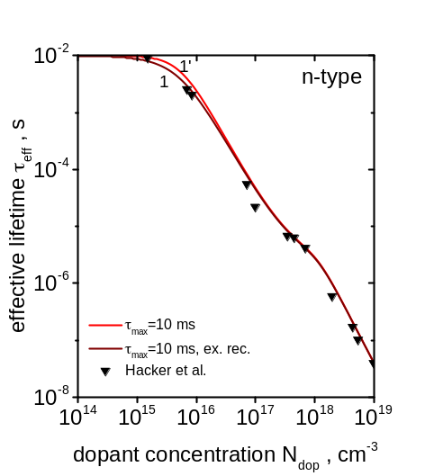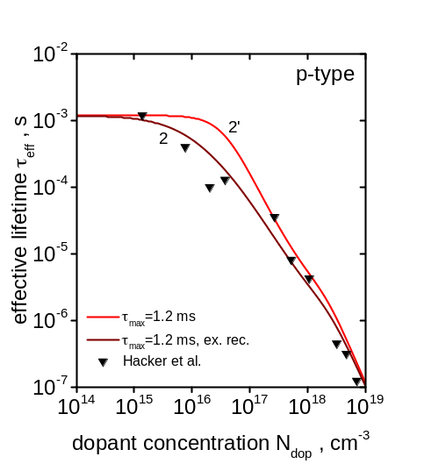

Fig. 3. Dependences of the effective volume lifetime on the doping level in n- and p-type silicon. Points – experiment, lines – theoretical calculation. Curves 1, 2 are built with taking exciton non-radiative recombination into account, curves 1′, 2′ – without it. The used parameters: τ_{SRH}, ms: 10 (1), 1.2(2); n_{x} = 8.2·10¹⁵ сm^{–3}.

In Fig. 3, the experimental dependences , obtained in the work by Hecker and Hangleiter [19] are built. Their comparison with the theoretical dependences with and without taking into account the non-radiative recombination channel gives a small difference for the case of n-type semiconductor and a much larger one for p-type semiconductor. The reason is that the value τ_{SRH} for n-type semiconductor is 30 ms, and for p-type one – 1.2 ms. In this case, the value n_{x} was also found using regression analysis (the method of least squares) and turned out to be equal to 8.2·10¹⁵ сm^{–3}.

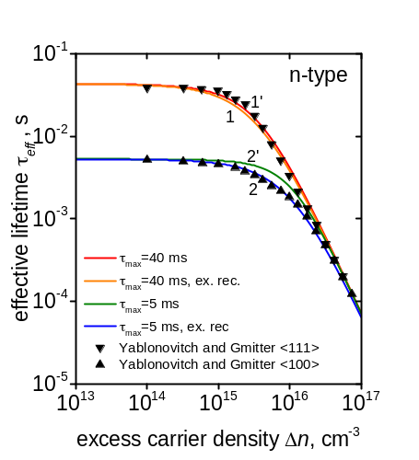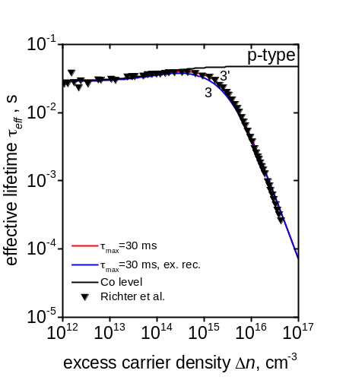
Fig. 4. Dependences of the effective volume lifetime 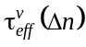 on the doping level on the excess electron-hole pairs concentration in n- and p-type silicon. Points – experiment, lines – theoretical calculation. Curves 1, 2, 3 are built with taking exciton non-radiative recombination into account, curves 1′, 2′, 3′ – without it. Curve 4 describes dependence τ_{SRH}(Δn) for the cobalt level. The used parameters: τ_{SRH}(Δn), ms: 40 (1), 5 (2), 30 (3); n_{x} = 8.2·10¹⁵ сm^{–3}.

Finally, in Fig. 4 the dependences are plotted. Experimental points were taken from the works [8, 13]. As before, the difference between the dependences 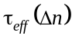 constructed with and without taking into account non-radiative quadratic recombination is small when τ_{SRH} is equal to 30 or 43 ms, and much larger when τ_{SRH} = 5.2 ms. The value n_{x} equaled to 8.2·10¹⁵ сm^{–3} was found from the experiment by means of regression analysis.
In this case, the experimental curves for p-type semiconductor (Fig. 4b) cannot be agreed with the theory without taking into account the dependence of τ_{SRH}(n). To agree the theory with the experiment, we assumed that in the case of p-type semiconductor, the dependence τ_{SRH}(n) is determined by the cobalt level with the energy 0.38 eV with τ_{p0} and τ_{n0} equal to 3·10^{–2} and 2.2·10^{–1} s, respectively. At the same time, it was possible to agree well the theory with the experiment, both with and without taking into account the additional channel of quadratic recombination.
Thus, as can be seen from Figs 2 to 4, the influence of quadratic non-radiative recombination on the dependence 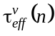 or is smaller, the larger the value τ_{SRH}. With graphical accuracy, it can be neglected when τ_{SRH} ≥ 40 ms. It should be noted that in modern high-efficiency silicon solar cells typical Shockley–Reed–Hall lifetimes are of the order of 10 ms.
In this case, the error in determining the effective volume lifetime in the area of maximum power selection in AM1.5 conditions equals from 20 to 30%. This is a rather significant error, and therefore it is incorrect to neglect the consideration of the quadratic non-radiative recombination channel when modeling the parameters of high-efficient silicon solar cells.
As can be seen from the above figures, as the Shockley–Reed–Hall lifetime decreases to values of the millisecond order and less, the influence of the quadratic non-radiative recombination channel increases significantly. This is evidenced, in particular, by the results shown in Fig. 2a for the case when τ_{SRH} = 0.4 ms. In this case, there is a sufficiently long region described by dependence (8), which does not fit into the theory that takes into account only radiative recombination and interband Auger recombination. Therefore, a physical explanation of dependences should be sought.
This explanation was proposed at one time in the work [20]. Therefore, let’s proceed to a brief summary of its results.

4.2. Exciton non-radiative recombination of silicon
In the work [20], it was taken into account that when silicon is illuminated with light of sufficient intensity, in addition to excess electron-hole pairs Δn, excitons with concentration n_{ex} appear, i.e., there are two subsystems – electron-hole and exciton. It is significant that excitons recombine along the exciton channel, both radiatively and non-radiatively. Although their concentration is low as compared to the value Δn, the value of the non-radiative lifetime of excitons τ_{nr} related with the Auger recombination of excitons on deep impurities can be sufficiently smaller than the Shockley–Reed–Hall lifetime τ_{SRH} in a number of cases.
This leads to the fact that excess electron-hole pairs bind into excitons and recombine through the channel of Auger recombination, which occurs with the participation of deep levels. This process was considered at one time by Hangleiter [15], and he showed that both in the recombination of excitons by the Auger mechanism and in the Shockley–Reed–Hall recombination, the same deep level can participate in them. In the work [20], a phenomenological theory was proposed, it connected τ_{nr} and τ_{SRH} between itself. It was based on these positions. First, it was believed that the non-equilibrium concentrations of electron-hole pairs and excitons in silicon are related by the following equation
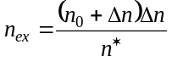, (12)
where 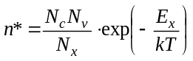, N_{c}, N_{v} and N_{x} are the effective densities of states in the conduction, valence, and exciton band, respectively, and E_{x} is the binding energy of the exciton ground state in silicon. The calculation n∗ for silicon parameters at T = 300 K far from the Mott excitonic transition gave the result 8·10¹⁷ сm^{–3}.
The second position is related to the fact (see [15]) that in exciton, electron and hole are spatially correlated. This leads to a significant increase in the probability of Auger recombination, in particular, with the participation of impurity centers. The degree of spatial correlation of electron and hole in exciton can be estimated if we enter the value of the characteristic concentration of electron-hole pairs in exciton, n_{L}, that is equal to 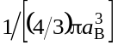, where a_{B} is the Bohr radius of exciton. Substituting the a_{B} value for silicon equal to 4.2 nm, we get n_{L} ≈ 3.3·10¹⁸ сm^{–3}. This value is large enough for Auger recombination to occur.
Let’s accept that
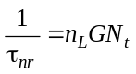, (13)
where G is the parameter of Auger recombination with the participation of an impurity, and n_{t} is the concentration of the impurity level.
Let us compare the recombination fluxes related with the recombination of electron-hole pairs according to the Shockley–Reed–Hall mechanism (Δn /τ_{SRH}) and with the recombination of excitons (n_{ex} /τ_{nr}). Summarizing them and assuming that 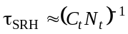, taking into account relations (12) and (13), we obtain the following expression for the recombination flux involving the Shockley–Reed–Hall recombination and non-radiative exciton recombination
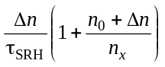, (14)
where 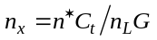.
Estimates made in [20] for the case when the deep level is the gold level give a value that is not significantly different from 8.2·10¹⁵ сm^{–3}.
Thus, the above summary of the results of the work [20] shows that the experimental dependence 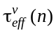 is explained if we take into account the channel of non-radiative exciton recombination according to the Auger mechanism with the participation of a deep impurity level. But the main thing is that the non-radiative exciton recombination channel in silicon with the time τ_{nr} is more efficient than the radiative recombination one.

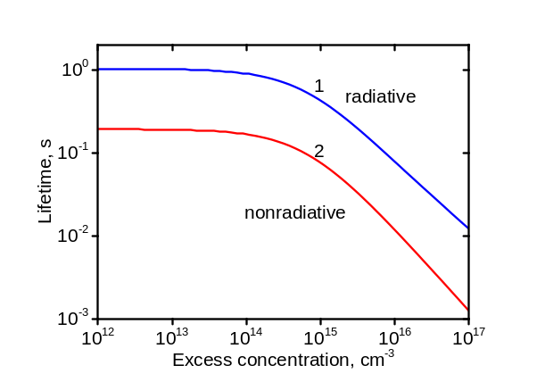
Fig. 5. Theoretical dependences of lifetime of radiative recombination (1) τ_{r} and non-radiative recombination (2) τ_{nr} on Δn for SC described in the work [10]. The used parameters: τ_{SRH} = 15.2 ms, base thickness – 200 μm, n₀ = 6.5·10¹⁴ сm^{–3}, τ_{R} = 55 μs, S₀ = 0.0037 cm/s – surface recombination rate at low excitation level, b_{r} = 0.1, b = 1.8. Here, b is the coefficient in the dependence 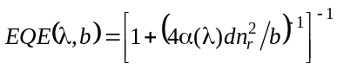, where EQE – external quantum yield, α(λ) – absorption coefficient of silicon depending on the wavelength λ, n_{r} – refractive index of silicon.

In Fig. 5, the dependences 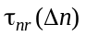 and 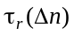 are plotted for the parameters of the silicon SC, which correspond to the experimental data given in [10]. As can be seen from Fig. 5, the value exceeds the value by more than five times in the whole range Δn. As the analysis of the corresponding dependences for textured silicon SC shows, the inequality always 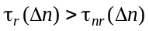 holds. Therefore, when considering radiative recombination it is logical to always take into account non-radiative exciton recombination by the Auger mechanism with the participation of a deep impurity level.

5. Finding the experimental value for the case of silicon
Let’s move on to the solution of the main problem of this work, namely, the determination of experimental dependences ΔE_{g} (Δn_{OC}). To obtain the experimental dependence V_{OC} (J_{I}), we used the value I (V_{OC}), given in [10] in Fig. 4b. Here, I is the relative intensity of the light flux (the ratio of the light flux to its value at AM1.5). The indicated dependence can be rebuilt into a dependence V_{OC} (J_{I}).
To find Δn_{OC}(J_{I}), we used the results of the work [11], in which theoretical modeling of optical and photoelectric characteristics was performed for SC studied in the work [10]. The calculation of the dependence Δn_{OC}(J_{I}) was performed taking into account the effect of band narrowing in the Schenk model.
If the band narrowing is not taken into account in this calculation, then the obtained dependence V_{OC} (Δn_{OC}) turns out to be unphysical (negative, with a significant amplitude).
Fig. 6 shows the results of calculating the dependence ΔE_{g} (Δn_{OC}) using expression (2) and the experimental dependence V_{OC} (J_{I}) from the work [10]. The doping level of the SC base in this work was 6.5·10¹⁴ сm^{–3}.

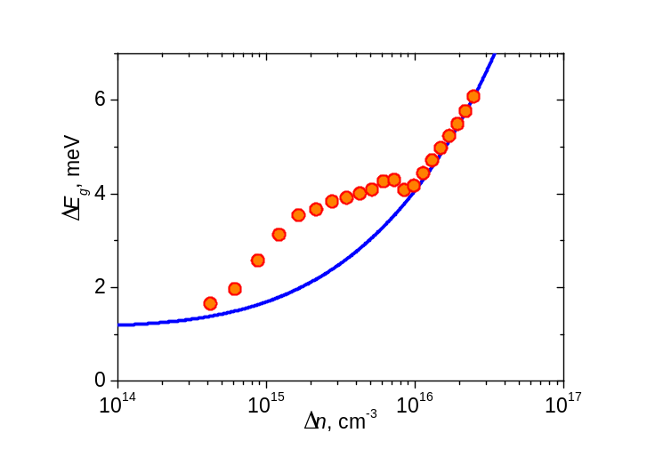
Fig. 6. Experimental (circles) and theoretical dependence ΔE_{g} (Δn_{OC}) (line). The theoretical dependence is calculated in the Schenk model. Circles are obtained using experimental dependence V_{OC} (J_{I}) smoothed by the least-squares method.

The experimental dependence was obtained for the values Δn ranging from 4·10¹⁴ up to 3·10¹⁶ сm^{–3}. The agreement between experiment and theory is satisfactory. The maximum deviation of experimental values from theoretical ones in the direction of larger values is about 57%.
Next, we will use to obtain the experimental values of the dependence of the dark current density ΔE_{g} (Δn_{OC}) of silicon SC on the applied voltage obtained in [21]. The doping level in this work was 10¹⁵ сm^{–3}.

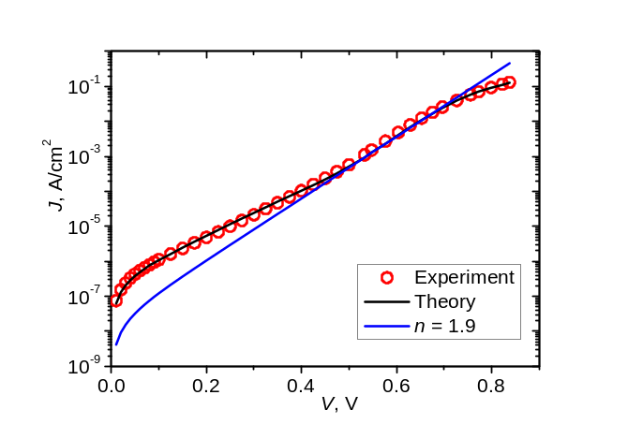
Fig. 7. Dependences of the dark current on the applied voltage obtained in [21], n is a factor of non-ideality.

The behavior of the dependences J_{T}(V) differs from the dependences J_{I} (V_{OC}) in that in the first case, the series resistance effects on the dark I–V characteristics.
According to the work [21], the value of the series resistance in this case is 0.65 Ω·cm². Having constructed the theoretical dependence 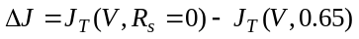 using the parameters obtained in [21] and adding this value to the experimental value J_{T}(V), it can be assumed that the obtained dependence is equivalent to the dependence J_{I} (V_{OC}). It was used for finding ΔE_{g} (Δn_{OC}). The obtained result is presented in Fig. 8.
As can be seen from the comparison of Figs 6 and 8, in the second case the experimental dependences, with the exception of two points, agree with Schenk’s theory even better than in the first case.
This, in our opinion, is probably due to the fact that thermal stabilization in the cryostat, in which the measurements were performed, is better than thermal stabilization using a measuring table in the case of SC from work [10]. It should be noted, however, that this is primarily true at Δn < 10¹⁶ сm^{–3}, when the influence of series resistance on the dependence is still small, because at higher values Δn the term ΔJ dominates.
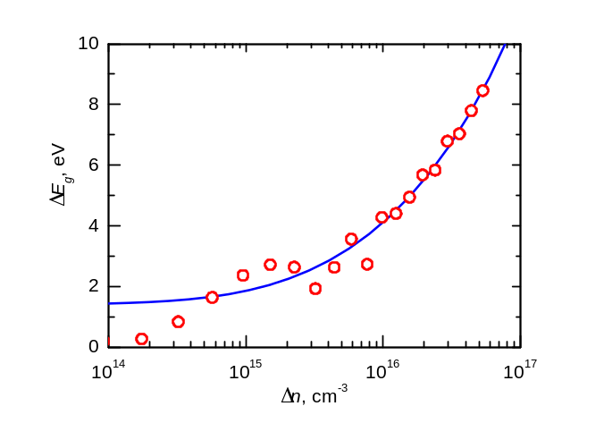
Fig. 8. Experimental (points) and theoretical dependence ΔE_{g} (Δn_{OC}) (line). The theoretical dependence is calculated in the Schenk model.

To calculate the dependence ΔE_{g} (Δn_{OC}), we also used the dependences J_{I} (I) and V_{OC} (I) given in [22] for SC based on high-resistance silicon under concentrated illumination, when the maximum illumination power reached almost 100 W/cm² (light flux 1000^{X} AM1.5). The level of doping in this case was 4.43·10¹³ сm^{–3}. Using the parameters given in the works [22, 23], we calculated the dependences Δn_{OC}(J_{I}), which allowed us to obtain the experimental dependence ΔE_{g} (Δn_{OC}). It is presented in Fig. 9.
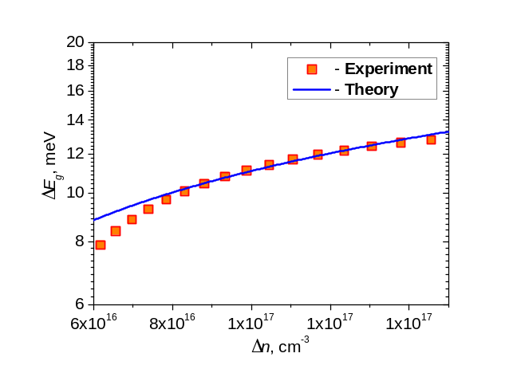
Fig. 9. Experimental (points) and theoretical dependences ΔE_{g} (Δn_{OC}) (line). The theoretical dependence is calculated in the Schenk model.

As can be seen from the figure, the obtained dependence in the region of excitation levels from 9·10¹⁶ up to 1.3·10¹⁷ сm^{–3} is in good agreement with Schenk’s theoretical calculation. As for larger values Δn, as is known, in the area of lighting powers of ≥ 100 W/cm², mechanisms that ensure a decrease in the growth rate of the short-circuit current begin to operate, but they are not taken into account in the theoretical calculation.
In general, the above results indicate that the experimental dependences ΔE_{g} (Δn_{OC}) agree with Schenk’s theory. We also note that, unlike the experimental dependences ΔE_{g} (n₀) given in many works, we succeeded in obtaining experimental values ΔE_{g} (Δn) for smaller values Δn.

Conclusions
An approach to finding the experimental dependences of the band-narrowing effect on the short-circuit current or light intensity from the intrinsic absorption band in solar cells based on monocrystalline silicon has been proposed. From the solution of the generation-recombination balance equation, the dependence of the short-circuit current density on the excess concentration of electron-hole pairs in the open-circuit mode J_{I} (Δn_{OC}) has been obtained.
This made it possible to obtain an experimental dependence ΔE_{g} (Δn_{OC}), that is, the dependence of the value of band-narrowing on the excitation level. The obtained experimental values ΔE_{g} lie in the range from 2 up to 14 meV, which corresponds to the excitation levels from 10¹⁵ to 10¹⁷ сm^{–3}. The obtained experimental values agree with Schenk’s theory. These values are significantly smaller than in the case of experimental dependences of the value ΔE_{g} on the doping level.
The paper also presents results that confirm the legality of using in calculations of effective lifetime of non-equilibrium charge carriers in silicon such components of the recombination of the recombination current as recombination in the space charge region and non-radiative exciton recombination at a deep volume level with the participation of the Auger mechanism τ_{nr}.
The theoretical dependences 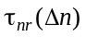 and 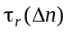. Their comparison shows that the value of time of radiative recombination in the whole range Δn is approximately five times greater than that of non-radiative exciton recombination , that is, the intensity of recombination along the exciton channel is five times greater than that of radiative recombination.
As the calculations show, the relation 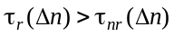 is typical for the case of textured silicon solar cells. This provides an additional basis for using the component of the recombination current in the theoretical modeling of the characteristics of silicon solar cells.
A comparison of the experimental dependences ΔE_{g} (Δn_{OC}) obtained in the work with Schenk’s theory has been performed. It has been shown that there is a correlation between them, and in some cases – good agreement. To finally solve the question of the degree of agreement between the indicated values, more accurate measurements of the initial experimental dependences with sufficiently good thermal stabilization of the SC samples are needed.

References
1. Schenk A. Finite-temperature full random-phase approximation mode of band gap narrowing for silicon device simulation. J. Appl. Phys. 1998. 84. P. 3684–3695. https://doi.org/10.1063/1.368545.
2. Green M.A. Improved silicon optical parameters at 25°C, 295 K and 300 K including temperature coefficients. Prog. Photovolt. Res. Appl. 2022. 30, No 2. P. 164–179. https://doi.org/10.1002/pip.3474.
3. Altermatt P.P., Schenk A., Geelhaar F. et al. Reassessment of the intrinsic carrier density in crystalline silicon in view of band-gap narrowing. J. Appl. Phys. 2003. 93. P. 1598. https://doi.org/10.1063/1.1529297.
4. Sachenko A.V., Kostylyov V.P., Vlasiuk V.M., I.O. Sokolovskyi, M. Evstigneev, A.I. Shkrebtii, D. Johnston, P. Michael, and T. Missimer. Characterization of highly efficient silicon-based textured solar cells: theory and experiment. 2021 IEEE 48th Photovoltaic Specialists Conference (PVSC). https://doi.org/10.1109/PVSC43889.2021.9518764.
5. Sachenko A.V., Kryuchenko Yu.V., Kostylyov V.P. et al. Method for optimizing the parameters of heterojunction photovoltaic cells based on crystalline silicon. Semiconductors. 2016. 50, Issue 2. P. 257–260. https://doi.org/10.1134/S1063782616020226.
6. Sachenko A.V., Kostylyov V.P., Vlasyuk V.M., Sokolovsky I.O., Evstigneev M. The influence of the exciton nonradiative recombination in silicon on the photoconversion efficiency. Proc. 32 European Photovoltaic Solar Energy Conf. and Exhib., Germany, Munich, 20–24 June, 2016. Р. 141–147. https://doi.org/10.4229/EUPVSEC20162016-1BV.5.14.

7. Sachenko A., Kostylyov V., Sokolovskyi I., Evstigneev M. Effect of temperature on limit photoconversion efficiency in silicon solar cells. IEEE J. Photovolt. 2020. 10, No 1. P. 63–69. https://doi.org/10.1109/JPHOTOV.2019.2949418.

8. Richter A., Glunz S.W., Werner F., Schmidt J., and Cuevas A. Improved quantitative description of Auger recombination in crystalline silicon. Phys. Rev. B. 2012. 86. P. 165202. https://doi.org/10.1103/PhysRevB.86.165202.
9. Dauwe S. Low-temperature surface passivation of crystalline silicon and its application to the rear side of solar cells. PhD thesis, Universität Hannover, 2004.
10. Yoshikawa K., Yoshida W., Irie T. et al. Exceeding conversion efficiency of 26% by heterojunction interdigitated back contact solar cell with thinfilm Si technology. Sol. Energy Mater. Sol. Cells. 2017. 173. P. 37–42. https://doi.org/10.1016/j.solmat.2017.06.024.
11. Sachenko A.V., Kostylyov V.P., Vlasyuk V.M., Sokolovskyi I.O., and Evstigneev M. Analysis of the recombination mechanisms in silicon solar cells with the record 26.6% photoconversion efficiency. 2021 IEEE 48th Photovoltaic Specialists Conference (PVSC). https://doi.org/10.1109/PVSC43889.2021.9519055.

12. Solar Energy Conversion: Solid-State Physics Aspects. Topics in Applied Physics. 1979. 31. Eds B.O. Seraphin and J. Aranovich.
13. Fossum J.G. Solid State Electron. Computer-aided numerical analysis of silicon solar cells. 1976. 19, No 4. P. 269–277. https://doi.org/10.1016/0038-1101(76)90022-8.
14. Yablonovitch E. and Gmitter T. Auger recombination in silicon at low carrier densities. Appl. Phys. Lett. 1986. 49, No 10. P. 587–589. https://doi.org/10.1063/1.97049.
15. Hangleiter A. Nonradiative recombination via deep impurity levels in silicon: Experiment. Phys. Rev. B. 1987. 35, No 17. P. 9149–9161. https://doi.org/10.1103/physrevb.35.9149; Hangleiter A. Nonradiative recombination via deep impurity levels in semiconductors: The exiton Auger mechanism. Phys. Rev. B. 1988. 37, No 5. P. 2594–2604.

16. Beck J.D., Conradt R. Auger-rekombination in Si. Solid State Communications. 1973. 13, No 1. P. 93–95. https://doi.org/10.1016/0038-1098(73)90075-6.

17. Passari L., Susi N. Recombination mechanisms and doping density in silicon. J. Appl. Phys. 1983. 54, No 7. P. 3935–3937. https://doi.org/10.1063/1.332568.
18. Kendal D. Conference on the Physics and Appllication of Lithium Diffused Silicon, NASA-Goddard Space Flight Center, December 1969.
19. Häcker R., Hangleiter A. Intrinsic upper limits of the carrier lifetime in silicon. J. Appl. Phys. 1994. 75, No 11. P. 7570–7572. https://doi.org/10.1063/1.356634.
20 Sachenko A.V., Prima N.A., Gorban A.P., Serba A.A. Effect of excitons on the upper limit of conversion efficiency in silicon solar cells. Proc. 17-th European Photovoltaic Solar Energy Conference, Munich, Germany, 2001, vol. 1. P. 230–233.
21. Sachenko A.V., Kostylyov V. P., Sokolovskyi I.O. et al. Specific features of current flow in α-Si:H/Si heterojunction solar cells. Tech. Phys. Lett. 2017. 43. P. 152–155. https://doi.org/10.1134/S1063785017020109.
22. Altermatt P.P., Sinton R.A., Heiser G. Improvements in numerical modelling of highly injected crystalline silicon solar cells. Sol. Energy Mater. Sol. Cells. 2001. 65, No 1–4. P. 149–155. https://doi.org/10.1016/S0927-0248(00)00089-1.
23. Sinton R.A. and Swanson R.M. Recombination in highly injected silicon. IEEE Trans. Electron Devices. 1987. 34, No 6. P. 1380–1389. https://doi.org/10.1109/T-ED.1987.23095.
Authors and CV
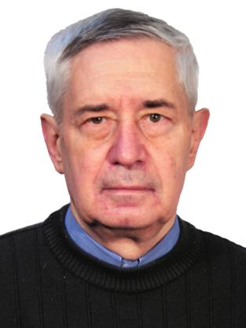 | Sachenko A.V. Professor, Doctor of Physics and Mathematics Sciences, Chief Researcher at the Laboratory of Physical and Technical Fundamentals of Semiconductor Photovoltaics at the V. Lashkaryov Institute of Semicon-ductor Physics. He is the author of more than 300 scientific publications. His main research interests include analysis, characterization, and modeling of silicon solar cells.  E-mail: sach@isp.kiev.ua;  ORCID ID: 0000-0003-0170-7625
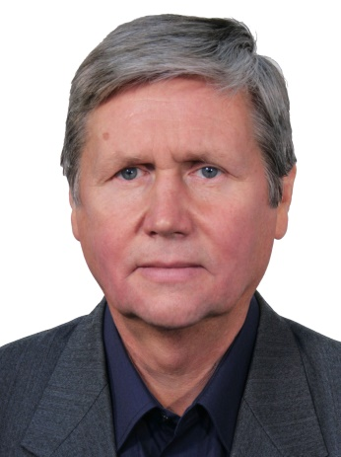 | Kostylyov V.P. Professor, Doctor of Physics and Mathematics Sciences, Head at the Laboratory of Physical and Technical Fundamentals of Semi-conductor Photovoltaics at the V. Lash-karyov Institute of Semiconductor Physics. He is the author of more than 300 scientific publications. The area of his scientific interests includes photovoltaics and betavoltaics, research, analysis and modelling of solar cells, characterization and testing the solar cells, as well as characterization of the optical and recombination properties of photovoltaics materials.  E-mail: vkost@isp.kiev.ua;  ORCID ID: 0000-0002-1800-9471
 | Vlasiuk V.M. PhD, Senior Researcher at the Laboratory of Physical and Technical Fundamentals of Semiconductor Photovoltaics at the V. Lashkaryov Institute of Semiconductor Physics. The area of his scientific interests includes research, analysis of silicon solar cells.  E-mail: viktorvlasiuk@gmail.com;  ORCID ID: 0000-0001-6352-0423
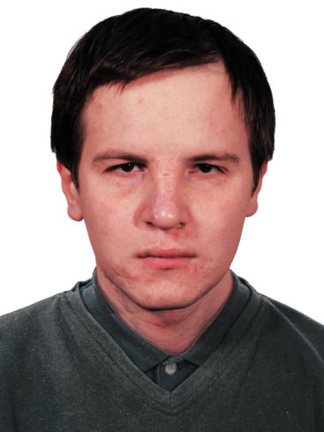 | Sokolovskyi I.O. PhD, Senior Researcher at the Laboratory of Physical and Technical Fundamentals of Semiconductor Photovoltaics at the V. Lashkaryov Institute of Semi-conductor Physics. He is the author of more than 70 scientific publications. His main research interests include modeling of silicon solar cells.  E-mail: falcon128@gmail.com;  ORCID ID: 0000-0002-7072-6670
 | Evstigneev M.A. Assistant Professor of the faculty of Physics and Physical Oceanography at the Memorial University of Newfoundland. His research areas are non-equilibrium statistical physics, biophysics, surface science.  E-mail: mevstigneev@mun.ca;  ORGCID ID: 0000-0002-7056-2573
 | B.F. Dvernokov, Researcher at the Laboratory of Physical and technical fundamentals of semiconductor photovoltaics at the V. Lashkaryov Institute of Semiconductor Physics. The area of his scientific interests includes manufacturing of equipment for silicon solar cells testing.  E-mail: dvernikov@isp.kiev.ua;  ORGCID ID: 0000-0003-2917-8948
 | R.M. Korkishko, PhD, Researcher at the Laboratory of Physical and technical fundamentals of semiconductor photovoltaics at the V. Lashkaryov Institute of Semiconductor Physics. He is the author of more than 46 scientific publications. The area of his scientific interests includes research, analysis of silicon solar cells.  E-mail: romkin.ua@gmail.com;  ORGCID ID: 0000-0002-4568-574X

Рекомбінація в області просторового заряду, безвипромінювальна екситонна рекомбінація та ефект звуження зон в високоефективних кремнієвих сонячних елементах

А.В. Саченко, В.П. Костильов, В.М. Власюк, І.О. Соколовський, М.О. Євстігнєєв, Б.Ф. Дверніков, Р.М. Коркішко

Анотація. Запропоновано вираз для знаходження залежності величини звуження зон в кремнії ΔE_{g} від рівня освітленості зі смуги власного поглинання I (чи струму короткого замикання). Запропонований вираз застосовано для знаходження експериментальних значень величини ΔE_{g} в високоефективних кремнієвих сонячних елементах. Залежність 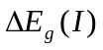 чи залежність ΔE_{g} (J_{I}), де J_{I} – густина струму короткого замикання, перебудовані в залежність ΔE_{g} (Δn_{OC}), де Δn_{OC} – рівень збудження в умовах розімкненого кола.
Для цього було розв’язано рівняння балансу генерації-рекомбінації з врахуванням шести механізмів рекомбінації в кремнії, що включають рекомбінацію Шоклі–Ріда–Холла, випромінювальну рекомбінацію, міжзонну рекомбінацію Оже, поверхневу рекомбінацію, безвипромінювальну екситонну рекомбінацію та рекомбінацію в області просторового заряду. Два останні рекомбінаційні доданки в роботах по дослідженню ключових параметрів кремнієвих сонячних елементів та в програмах по симуляції характеристик цих сонячних елементів не враховуються.
Тому в роботі виконано їх коректне визначення, проведено порівняння їх внеску з внеском інших рекомбінаційних механізмів та показано, що описання характеристик та ключових параметрів кремнієвих СЕ без їх врахування є недостатньо коректним. Виконано порівняння отриманих в роботі експериментальних залежностей ΔE_{g} (Δn_{OC}) з теорією Шенка. Показано, що між ними існує непогане узгодження.

Ключові слова: кремнієвий сонячний елемент, механізми рекомбінації, теорія Шенка.

