Although in gamma irradiations, the densities of the primary defects are small compared to the densities that occur in neutron and protons irradiations at the end of a PKA cascade, produced electrons can generate considerable divacancies and vacancy complexes in silicon bulk. In contrast to the radiation damage introduced by high energy hadrons, an irradiation with Co-60 gammas can only create point defects. This provides an opportunity to investigate the isolated point defects without having to face the problems caused by the cluster effect [16,17]
In the present study, gamma radiation effects on silicon PIN photodiodes based on an analytical model has been investigated. The model is based on a numerical solution of partial differential equations with appropriate boundary conditions and parameters. Defects caused by Co-60 gamma radiation in silicon have been formulated in terms of the damage constant for the minority carriers’ lifetime.
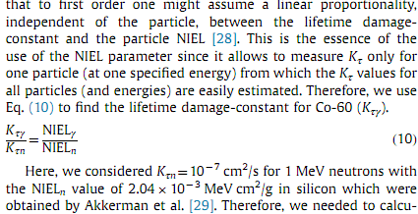
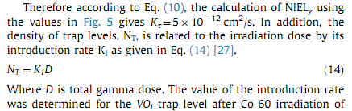
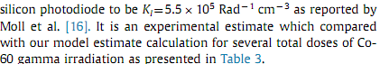
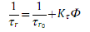
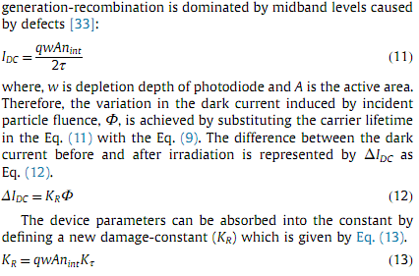
__________________________________________________________
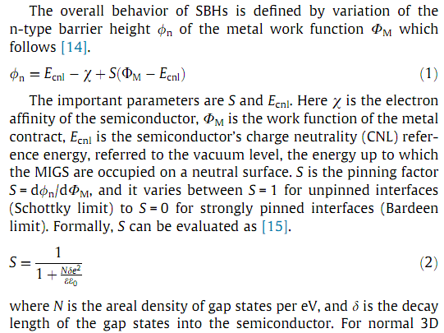_
_____________________________________________________________

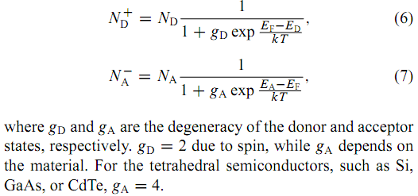
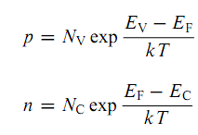
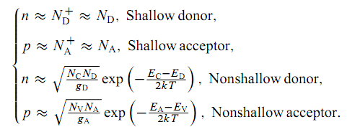
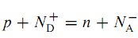
______________________________________________________________
Mechanisms related to shunt resistance are comprised of a multistep tunneling and thermal trapping-detrapping of carriers within the defect states in thespace-charge region [23].
_________________________________________________________
Phys. Status Solidi A 212, No. 8, 1731–1734 (2015)
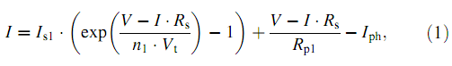
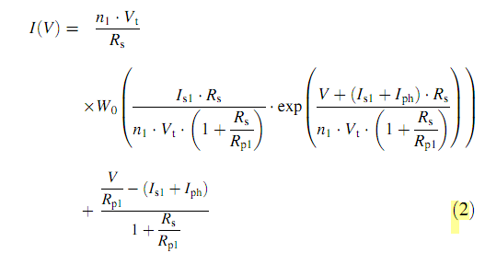
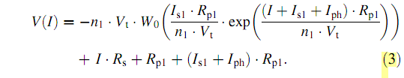
Iteration schem
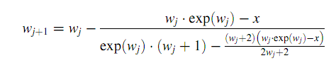
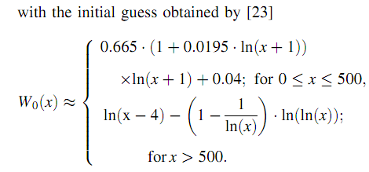
Phys. Status Solidi C 12, No. 8, 1071–1076 (2015)
The drain current enhancement is caused by a higher concentration and higher mobility of holes through dislocations. It is shown that mixed dislocations possess uniaxial compressive strain components in resulting in alterations of the band structure. The upper valence bands (heavy holes, light holes) are shifted upward and result in in the formation of a quantum wire. The formation of the quantum wire forces hole confinement along the dislocations and generates a one-dimensional hole gas. The interpretation of dislocations as quantum wires explains most of the experimental results.
______________________________________________________________
PHYSICAL REVIEW B 92, 115309
The effects of various elastic strain modes, namely hydrostatic, uniaxial, and shear strains, on the formation energies of Fe impurities were investigated in detail. Surprisingly, the stability of the most favorable conﬁguration, an interstitial Fe atom at a tetrahedral site, is not signiﬁcantly affected by any of the strain modes. However, the strain affects the formation energies of other defect conﬁgurations as well as the diffusion behavior of Fe in Si.
It was found that tensile and shear strains can signiﬁcantly enhance the Fe diffusion at room temperature, whereas compressive strains result in diffusion impediment.
______________________________________________________________
Phys. Status Solidi RRL 9, No. 12, 692–696 (2015)
Light-induced degradation in p-type Si was found to proceed in a two-stage exponential process indicating the formation of two defect components on different timescales: a fast-formed recombination center (FRC) formed within some 100 s and a slow-formed recombination center (SRC) formed over several 10 h [5]. Studies found of both components to be linearly dependent on the net doping concentration Nnet = [B_{s}–]-[P_{s}⁺] and have a quadratic relation to the concentration of interstitial oxygen [O_{i}] [2, 5, 6]. Thus, the BO-defect was believed to involve one substitutional boron atom and dimeric interstitial oxygen. Recombination activity of the BO-defect in p-type Si has been described by single-level Shockley–Read–Hall (SRH) parameterizations determined from [1,3, 4,5].
Studies [9] [8] concluded from their results that the BO-defect in n-type Si forms slower than in p-type and in a single-step process, excluding formation of both FRC and SRC. [13] found a kinetic model and developed a modified SRH parametrization for the fast BO-defect. In this work we studied the LID in compensated n-type Si with widely varying material parameters. Our measurements provide experimental proof of the formation of both FRC and SRC in n-type silicon. The resulting parameterization confirms the energetic position Et1 = EC – (0.41 ± 0.02 eV) and locates the second energy level at Et2 = EV + (0.26 ± 0.02 eV).
After annealing in the dark for 30 minutes at 250 °C the samples exhibited good lifetimes in the range of 1–5 ms.
______________________________________________________________
PROGRESS IN PHOTOVOLTAICS, VOL 1, 93-106
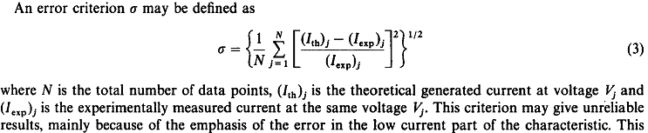
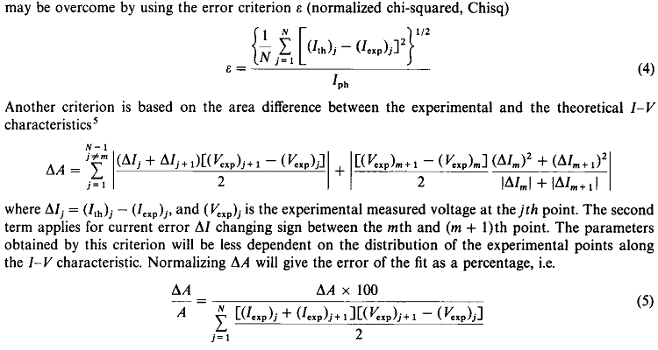
______________________________________________________________
PROGRESS IN PHOTOVOLTAICS, VOL 9, 249
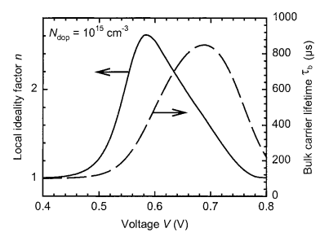
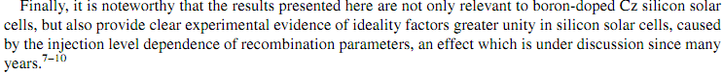
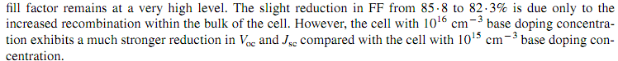
ВАХ будувалась з вискористанням PC1D. Потім є результати експериментального дослідження ВАХ до і після LID, які співпадають з симуляцією.
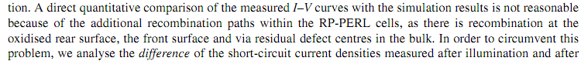
______________________________________________________________
Prog. Photovolt: Res. Appl. 2004; 12:155–176
Solar cell operation, either crystalline or thin ﬁlm, can be described by identifying loss mechanisms. These can be divided into three categories. First are recombination losses which limit the open-circuit voltage. Second are parasitic losses, such as series resistance, shunt conductance, and voltage-dependent current collection, which primarily impact the ﬁll factor (FF), but can also reduce short circuit current J_{SC} and V_{OC}. Finally, there are optical losses which limit generation of carriers and, therefore, J_{SC}.
______________________________________________________________
Prog. Photovolt: Res. Appl. 2005; 13:287–296
When the concentration of lifetime-killing metal-related impurities, such as iron, iron–boron or chromium–boron pairs, can be neglected, the lifetime is ultimately controlled by a metastable boron- and oxygen-related defect complex.^{1,2} This defect is always formed due to illumination³ or, more generally, due to minority-carrier injection if boron and oxygen are simultaneously present in crystalline silicon.^{4,5}
______________________________________________________________
Phys. Status Solidi C 12, No. 8, 1108–1110 (2015)
Dissociation of iron–boron pairs in crystalline silicon solar cells leads to a degradation in most cell parameters. In particular, short-circuit current and efﬁciency show a pronounced degradation, whereas the open-circuit voltage can increase by up to ~5% for certain iron contamination levels. This phenomenon, which is particularly pronounced for high-efﬁciency cells, can be attributed to the strongly changing injection-dependent lifetime due to the iron–boron dissociation. The threshold iron contamination level of the open-circuit voltage degradation, marking the starting point of the degradation, is about one to two orders of magnitude higher than the threshold iron levels of the remaining cell parameters. Hence, up to relatively high iron concentrations only a degradation in short-circuit current, ﬁll factor and efﬁciency may be observed, whereas the open-circuit voltage is constant or even increases, depending on the cell structure.
______________________________________________________________
Prog. Photovolt: Res. Appl. 2010; 18:511–515
Fischer et al. [3] showed by simulations that the distributed character of the series resistance can cause severe deviations of the model parameters and misinterpretation of the measurements when ﬁtting the two-diode model to measured J(U) curves
A ﬁll factor analysis can have these advantages. No ﬁt is needed and ﬁll factor and efﬁciency losses are directly obtained. By shifting the sunsVoc curve along the current density axis by JSC (1 sun) the pseudo illuminated curve and the virtually series resistance free pseudo ﬁll factor pFF are obtained. The difference between FF and pFF then gives the ﬁll factor losses due to the series resistance (RS) [4]. The ideal ﬁll factor FF0 is free from losses due to series resistance and free from losses due to recombination in the space charge region (References [5] (p. 96) and [1] (p. 138)). It is calculated numerically from the ideal J(U)curve:
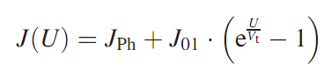
The two parameters JPh and J01 can be determined from two points of the illuminated J(U) curve, e.g. under open circuit and under short circuit conditions since the inﬂuence of J02 on VOC is small. The difference between FF0 and pFF quantiﬁes the FF-losses due to recombination in the space charge region (J02).
In case of high recombination under the front side metallisation of a solar cell and high series resistance, the ﬁt of the two-diode model yields erroneous ﬁt parameters. In such a case as well, the difference between ﬁll factor FF and pseudo ﬁll factor pFF and the difference between pFF and ideal ﬁll factor FF0 are misleading measures of series resistance losses and space charge region recombination losses, respectively. The advanced method for characterising J(U) curves that is presented here overcomes these difﬁculties. It includes ﬁtting the two-diode model to those parts of the dark current voltage curve with small current densities. This yields the averaged saturation current densities J01 and J02 even if the network character dominates. Using these ﬁt parameters and the two-diode model, reliable measures for ﬁll factor losses due to series resistance and non-ideal J02-like recombination can be obtained.
______________________________________________________________
Prog. Photovolt: Res. Appl; 21:490
recombination terms (which deﬁnes the saturation current) varies with injection level and applied voltage
In the dark, the voltage bias is applied through the solar cell from an external source, and current is injected through the device via the lowest resistive path. This cause the current to ﬂow in a different pattern across the device (metallization and within the cell), thus causing a difference between Rs-dark and Rs-light. Other illumination-dependent factors that will affect the resistivity between light and dark condition is the change in the behaviour of the p–n junction under illumination and also the conductivity of the semiconductor when illuminated.
In order to ﬁt the J–V curve of the elongate cells, Equation 14, which is an extended version of the double exponential model with a resistance limited high recombination centre, is applied [24] (там 3-діодна модель)
modelling with a ﬁxed Rs value can lead to erroneous evaluations, and a model with Rs(J) should be used when there is signiﬁcant distributed resistance effects.
______________________________________________________________
Prog. Photovolt: Res. Appl; 21:884
Nishioka et al. [4], for example, proposed a three-diode equivalent circuit model taking into account the inﬂuence of the grain boundaries and leakage current through the edges for multicrystalline silicon cells. Ddouble-diode model, which usually provides good results when applied in the mathematical representation of crystalline silicon PV curves. However, applied to curves of amorphous devices and other thin ﬁlm technologies, the double-diode model may not be so good for describing I–V curves.
______________________________________________________________
Prog. Photovolt: Res. Appl; 22:494
Since the two-diode model for the solar cell equivalent circuit has been introduced in 1963 [1], it has become a valuable standard tool in the area of solar cell characterization. It contributed signiﬁcantly to a better understanding of the processes inside the cells and related efﬁciency loss mechanisms [2–5]. Compared with the simpler one-diode model, the two-diode model provides better accuracy, especially in the vicinity of the maximum power point of conventional Si solar cells (see e.g., [6] and references therein).
______________________________________________________________
Prog. Photovolt: Res. Appl; 22:949
The European Photovoltaic Industry Association (EPIA) has reported that the global solar photovoltaic (PV) installations reached 29.7GW in 2011 [1].
Prog. Photovolt: Res. Appl; 24:517
The number of PV system installations has been increasing rapidly in the last several years, reaching a global cumulative installed capacity of 138.9GW at the end of 2013 [1].
______________________________________________________________
Prog. Photovolt: Res. Appl; 24:517
Dark I–V characterization is a very accurate tool for determining the electrical parameters of solar cells and modules [32], and it has several advantages over light I–V characterization: it is not affected by variations in the light intensity; it does not require a fast measurement process; and it is not affected by shading or other optical factors that usually create distortions in the light I–V characteristic.
В роботі запропоновано ряд параметрів для характеризації фото-вольтаїчних модулів (насамперед) та сонячних елементів. Ці параметри розраховуються на основі темнових і, частково, світлових ВАХ. Досліджено як ці параметри (а також стандартні на кшталт Voc, Vm, FF тощо) змінюються при збільшенні оптичних втрат, появі механічних порушень, порушень конкактів чи PID модулів. Загалом, цікаво, можна якості ці параметри і використати… треба думати ☺
______________________________________________________________
Radiation Physics and Chemistry 123 (2016) 103–108
It was observed that the space solar I_{SC}, V_{OC}, P_{MAX}, FF and η decrease linearly with the logarithm of the ﬂuence. However, in some silicon solar cells, the short circuit current does not strictly follow this behavior. Instead, it initially decreases, then at a certain ﬂuence it slightly increases before decreasing again sharply. This slight recovery of the short circuit current is usually attributed to a type conversion of the base (from n to p-type for example) – і є посилання на роботи (у тому числі і Каржанова), які я вже читав.. див раніше, ручний запис..
В самій роботі проведено симуляція ВАХ при різних ступенях електронного (1 МеВ) опромінення з врахуванням утворення дефектів як донорних так і електронних. Показано, що аномальне зростання струму короткого замикання не супроводжується зміною типу провідності бази. As the ﬂuence, corresponding to the region where the short circuit current shows the anomalous behavior, increases the depletion region width increases since the hole density decreases. This will lead to an increase in the short circuit current according to Eq. (3).
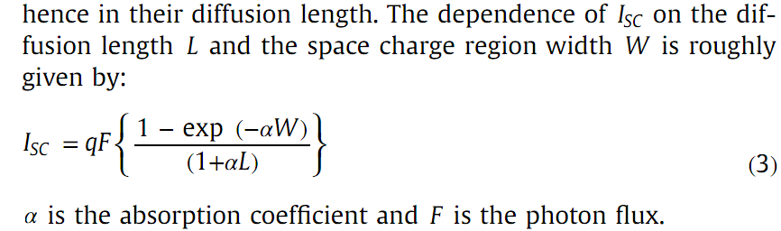
______________________________________________________________
Radiation Physics and Chemistry 125 (2016) 220–226
Usually, one to two displacements with an introductory rate of the order of 1cm⁻¹ are produced due to electrons in the range of 0.1 to several MeV (Corbett, 1966). On the average, a ﬂuence of 10¹⁶ cm⁻² is important to create a homogeneous distribution of displacements with 10¹⁶ cm⁻³ concentrations (Bourgoin and De Angelis, 2001).
The decrease in carrier concentration was due to the presence of radiation induced defects, which play a dominating role in charge carriers trapping or forming recombination centres (Summers et al., 1993).
Enhancement (after electron irradiation) in the trap time constant is an evidence that the free carriers decrease with irradiation. This phenomenon might be attributed to the longer capture time for radiation induced defect centres corresponding to the charge transfer rate for the centres to efﬁciently trap the carriers (Miller et al., 2000).
______________________________________________________________

Physica B 407 (2012) 3034–3037
Quite recently, however, some evidence was found to indicate that dislocations in silicon could be emitted and mobile, even at room temperature [6,7].
Because the mobility of dislocations is also known to be inﬂuenced by dopants [10] that produce different Fermi levels relative to the level of dislocation [11], changes in the mechanical properties due to humidity may also be accompanied by changes in the electronic properties
______________________________________________________________
Physica B 480 (2016) 68–71
Розглядаються ВАХ гетероструктур
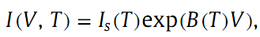
If B is temperature dependent, the dominant transport mechanism is either diffusion in the case of n=1 or recombination when 1<n<= 2. <≤ If parameter B is constant, tunneling is considered to be the dominant transport mechanism. В роботі другий варіант, припускається що multistep-trap assisted tunneling process. Для Is спостерігається термоактивована залежність, причому в різних температурних діапазонах різний нахил. Еhe double slope observed in this study, together with temperature independence of B, is an indication that tunneling via at least two types of defects are involved in the multi-step tunneling capture/emission processes [19]
______________________________________________________________
Solar Energy Materials & Solar Cells 147 (2016) 115–126
Review of light-induced degradation in crystalline silicon solar cells
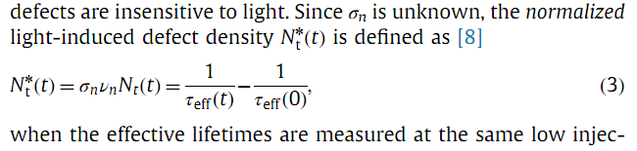
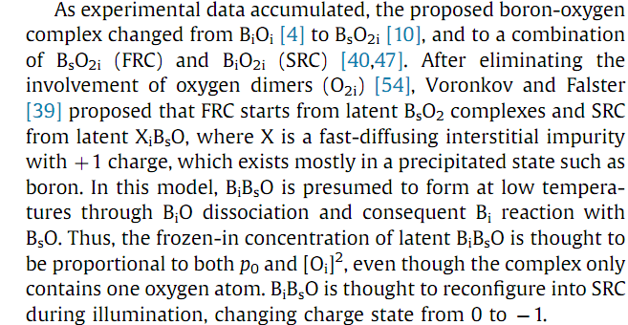

Recently, fast and slow LID was observed in aluminum-doped Cz-Si, in addition to indium-doped Cz-Si and FZ-Si, with full recovery at 200 °C [12,13]. Instead, Möller and Lauer [12,13] propose that BO-LID is caused by a charge-state change (from +1 to 0 to -1) of a near-substitutional acceptor and silicon self-interstitial pair (A_{Si}Si_{i}). However, those studies are inconclusive
Є ще Cu-LID – в кремнії, де є мідь. Cu-LID is observed as a single exponential degradation (детальніше див. статтю). During illumination, copper appears to act as either a catalyst for Cu-LID defect formation or an active part of the defect itself. The Cu-LID defect is likely to contain copper, since copper forms several recombination-active energy levels in the silicon bandgap. ight-induced bulk recombination has been suggested to stem from copper precipitation [82] or the release of substitutional copper (Cu_{s}) through pure copper complex dissociation [15,76].
Storage in the dark at RT leads to a minority carrier lifetime decrease in contaminated B-doped Cz-Si. A lifetime decrease during storage at 25 and 50 °C was also observed by Arumughan et al. [155] in p-type Cz-Si.
______________________________________________________________

Solar Energy Materials & Solar Cells 148 (2016) 87–98
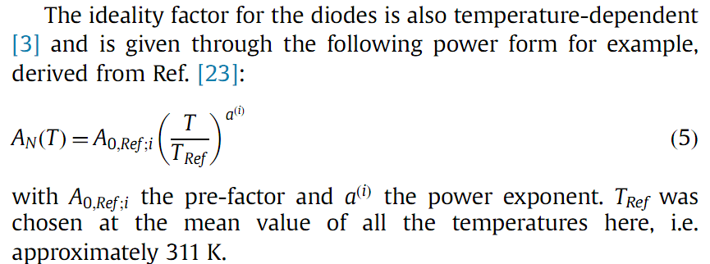
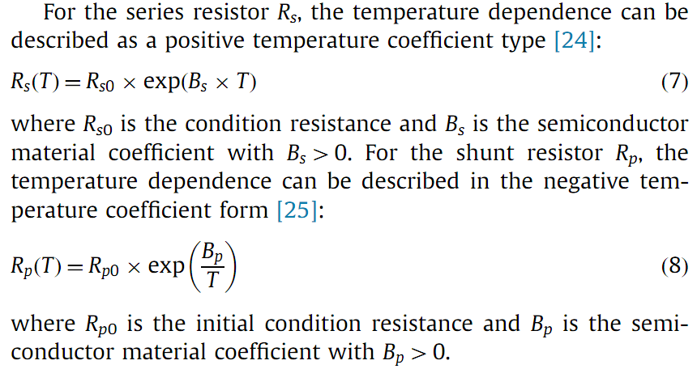
______________________________________________________________
Semiconductor Physics, Quantum Electronics & Optoelectronics, 2015. V. 18, N 3. P. 259-266
БАГАТО КОРИСНИХ ФОРМУЛ ПО ТЕМПЕРАТУРНІЙ ЗАЛЕЖНОСТІ ПАРАМЕТРІВ СЕ
______________________________________________________________
Microelectronic Engineering 133 (2015) 73–77
Робота по застосуванню AFM до вивчення контакту Шотки… щось на кшталт нового методу досліджень
______________________________________________________________

Silvaco ATLAS simulations
solar cell are calculated using the software SCAPS

SULA DLTS spectrometer
automated deep level transient spectrometer - DLS-83D

Sinton Instruments WCT-120 QSSPC lifetime tester
lifetime tester (WCT-120TS from Sinton Instruments)

C-V and dark I-V were carried out by using Keithley Model 4200-SCS
Keithley 2400 source meter
I- V characteristics Agilent 4156C precision semiconductor parameters analyzer
Keysight U3606B

solar simulator from Solaronix (class AAA)
Wacom WXS-90S-L2
simulator Leios IV SolarCT

C–V --- LCR meter Agilent4284 A
C-V characteristics at 1MHz with an Agilent 4980A LCR meter
At 1MHz with a Boonton 7200 capacitance meter
C–V–f data of these diodes were measured with 4192A LF impedance analyzer

PASAN Sun Sim 3C ﬂash tester for measurement under illumination

PhysTech FT-1230 HERA DLTS system
PhysTech FT 1030 HERA-DLTS
APPLIED PHYSICS LETTERS 110, 042403 (2017)
experimentally demonstrated optical spin orientation at the indirect gap of Si at room temperature. Electron spin lifetime15 ns at the Δ-valley
_______________________________________________________
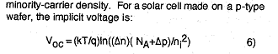
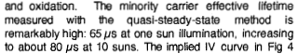
________________________________________________________
Nevertheless, INTEL announced in March 2016 that “Moore’s law” is coming to a halt, because the resistivity of Cu interconnects—the metal used by the electronic industry over the last two decades to connect the transistors in an IC—turns out to increase with shrinking dimensions (and is dominated by quantum effects), when the width and/or the height of the metallic connector becomes smaller than 38 nm, the intrinsic electronic mean free path in crystalline Cu at 300K arising from electron-phonon scattering.

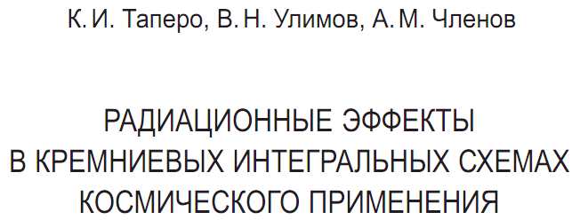
Флюенс (перенос) частиц Ф — отношение числа ионизирующих частиц (ИЧ) dN, проникающих в элементарную сферу, к площади dS центрального сечения данной сферы:
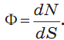
Флюенс также называют интегральным потоком частиц и подразумевают при этом общее число частиц, падающих на единицу площади поверхности облучаемого образца.
Поглощенная доза ИИ (доза излучения) D — отношение средней энергии dw, переданной ионизирующим излучением веществу в элементарном объеме, к массе dm вещества в этом объеме:
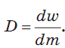
В системе СИ – грей: 1 Гр = 1 Дж/кг.На практике часто используется единица 1 рад = 0,01 Гр. Ионизирующее излучение в различных материалах теряет свою энергию по-разному.
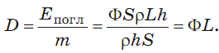
L - «линейные потери энергии» (ЛПЭ) (1 Дж·м2/кг)
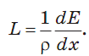
dE - энергия, теряемая заряженной ИЧ.
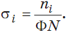
ni – число взаимодействий (i-го типа) ИЧ и частиц-мишеней в элементарном объеме, Ф - флюенс ИЧ, N – число частиц-мишеней в этом объеме:
Для Si при их облучении гамма-квантами 60Co наиболее существенный вклад в образование смещений атомов вносят электроны, образующиеся в результате Комптон-эффекта. Энергия квантов 1,25 МэВ. При облучении полупроводников равномерно по объему кристаллов генерируются Комптон электроны (достаточно высокоэнергетические, ~860 кэВ), производящие смещения атомов.

d-керма kd показывает, какая поглощенная доза, обусловленная потерями энергии частиц на структурные повреждения (смещения), приходится на единицу флюенса частиц.
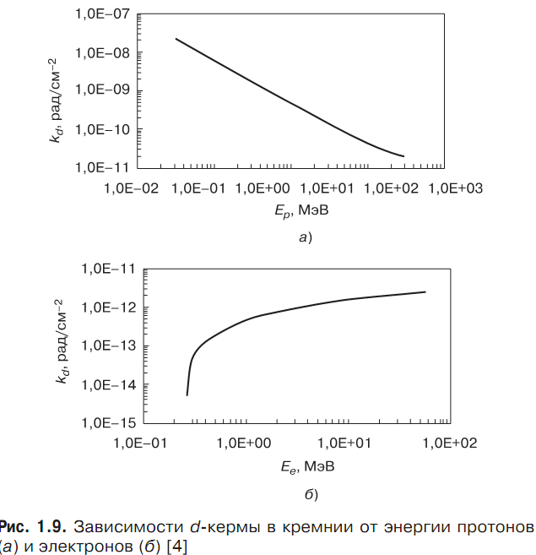

i-керма k i показывает, какая поглощенная доза, обусловленная ионизационными потерями энергии частиц, приходится на единицу флюенса частиц. Из рис. видно, что d-керма в кремнии в диапазоне энергий нейтронов 1–14,5 МэВ меняется незначительно. Среднее значение d-кермы в указанном диапазоне энергий нейтронов составляет kd≈ 4,4⋅10^{–11} рад/см^{–2}. Значение i-кермы при энергиях нейтронов до 3–4 МэВ практически совпадает с величиной d-кермы. Далее наблюдается значительный рост величины ki, и при энергии нейтронов 14,5МэВ даннаявеличина уже составляет 125 ⋅10^{–11} рад/см^{–2}.

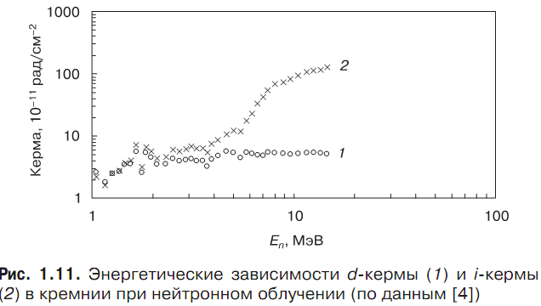

Учитывая связь L_{D}² = Dτ времени жизни ННЗ с диффузионной длиной L_{D}, где D—коэффициент диффузии ННЗ:
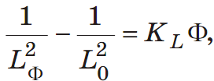
где K_{L} — константа радиационного изменения диффузионной длины ННЗ.
Величина KL зависит от ряда факторов: скорости образования радиационных центров и их рекомбинационных свойств (сечения захвата электронов и дырок), а также степени заполнения центров электронами. Последняя определяется положением уровня Ферми по отношению к энергетическим уровням радиационных центров [3]. Существенное влияние на изменение времени жизни могут оказывать температура, технологические процессы производства ПП и ИС, исходное состояние поверхности и поверхностные радиационные эффекты. В частности, в [3]
приводятся значения Kτ=K_{L}D для образцов кремния с удельным сопротивлением в диапазоне 0,06–50 Ом·см, полученных различными методами, при облучении различными видами ИИ: 10^{–11}–10^{–6} см²/с.
Линейная зависимость наблюдается при облучении кремния различными видами радиации и может нарушаться при увеличении потоков облучения. Это можно объяснить влиянием компенсации материала и смещением уровняФерми к середине запрещенной зоны, в результате чего в рекомбинационном процессе могут участвовать другие, более глубокие уровни.
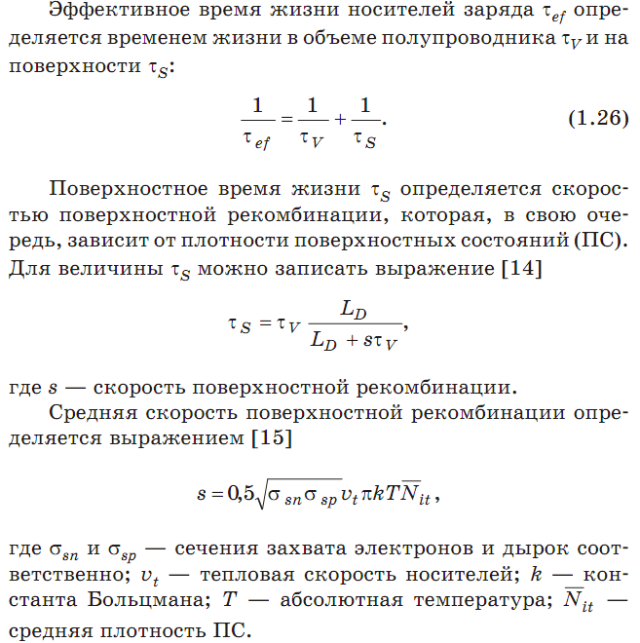

При малых дозах облучения, когда процессы в объеме полупроводника еще не начали проявляться, поверхностное время жизни уменьшается, так как возрастает плотность ПС, что ведет к увеличению скорости поверхностной рекомбинации. Таким образом, при малых дозах уменьше ние эффективного времени жизни обусловлено уменьшением времени жизни на поверхности полупроводника. При больших дозах уменьшение времени жизни определяется спадом как объемного, так и поверхностного времени жизни носителей заряда.

При облучении меняются концентрация и подвижность носителей заряда, что приводит к изменению удельного сопротивления (удельной электропроводности).
При облучении в полупроводниках образуются устойчивые радиационные центры, которые могут действовать не только как центры рекомбинации, но и как ловушки, эффективно удаляющие носители из процесса электропереноса. В результате при облучении наблюдается смещение уровня Ферми к середине запрещенной зоны, уменьшение концентрации основных носителей заряда и, как следствие, рост удельного сопротивления. Экспериментальные данные показывают [3], что концентрация носителей заряда в полупроводниках при облучении вначале уменьшается экспоненциально, а затем при высоких потоках стремится к значению, определяемому предельным положением уровня Ферми при облучении.
Однотипной зависимости ρ(Ф) дляширокого класса полупроводников не существует [3]. Наиболее простой вид этой зависимости реализуется в кремнии (в определенном диапазоне значений флюенса Ф):
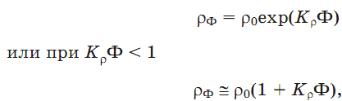
Kρ константа, характеризующая скорость роста удельного сопротивления при облучении, так же как и Kτ, определяется условиями облучения и исходным состоянием облучаемого материала.
В Si вне зависимости от типа проводимости удельное сопротивление при облучении растет, стремясь к значению, характерному для собственного кремния (2·10⁵ Ом·см при 300 К) [2, 3, 10, 11]. По сравнению с изменением времени жизни заметные изменения удельного сопротивления проявляются при существенно больших значениях интегрального потока облучения. В частности, при облучении электронами с энергией порядка нескольких МэВ изменение ρ начинает заметно проявляться при флюенсе порядка 10¹⁴–10¹⁵ см^{–2}; при облучении быстрыми нейтронами эти изменения начинают проявляться при флюенсе порядка 10¹³ см^{–2}; при гамма-облучении для заметного изменения нужно набирать поглощенную дозу порядка 10⁷–10⁸ рад.
Радиационные центры могут действовать и как дополнительные центры рассеяния, снижающие подвижность носителей заряда. Однако экспериментальные данные показывают, что снижение подвижности играет значительно меньшую роль в росте ρ при облучении германия, кремния и арсенида галлия, чем захват носителей заряда радиационными центрами [3]. Это связано в первую очередь с тем, что в рабочем диапазоне температур современныхПП и ИС основным механизмом рассеяния носителей заряда, определяющим их подвижность, является рассеяние на тепловых колебаниях решетки. Рассеяние на радиационных дефектах будет заметно влиять на величину подвижности при более низких температурах (менее 200 К). Однако если энергия излучения достаточна для образования областей разупорядочения, то изменения подвижности могут заметно влиять на ρ и при комнатной температуре. Поверхностная подвижность при облучении меняется значительно сильнее, чем подвижность в объеме полупроводника. Это связано с тем, что при облучении интенсивно протекает процесс образования ПС, что ведет к появлению дополнительных центров рассеяния. Поверхностная подвижность также зависит от флуктуаций поверхностного потенциала [15]:
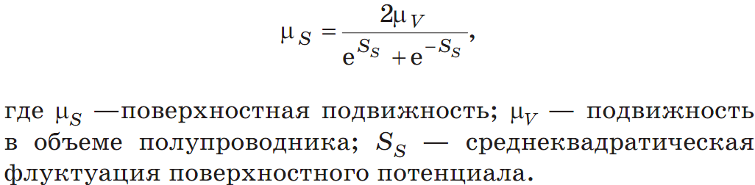

При исследованиях восстановления прямого падения напряжения кремниевых диодов [3], облученных реакторными нейтронами и гамма-квантами, при отжиге в диапазоне температур ≤ 400 С были отмечены четыре стадии отжига с возрастанием энергии активации каждой последующей стадии и отсутствие полного восстановления значения Uпр при температуре 400 С. В то же время имеются данные о большей устойчивости в диодных структурах «глубоких» радиационных центров, ответственных за снижение времени жизни: на облученных электронами диодных матрицах после отжига при температуре 220–300 С при практически полном восстановлении значения Uпр уровень τ_{восст} был в 20 раз ниже исходного (до облучения и отжига) [3]. Рассмотренные данные показывают, что отжиг радиационных изменений параметров ПП и ИС происходит в несколько стадий, и полный отжиг наблюдается при температурах, значительно превышающих рабочие температуры приборов.

Дефекты на границе раздела Si/SiO2, отвечающие за накопление заряда. Основным видом точечных электрически активных дефектов на границе раздела Si/SiO2, является Pb-центр [8, 13, 16]. Он может быть представлен как атом кремния на границе, связанный с тремя другими атомами кремния и имеющий одну оборванную связь. Химическое обозначение Pb-центра записывается в виде •Si≡Si₃.
На поверхности кремния (111) оборванная связь ориентирована перпендикулярно границе, Pb-центр располагается в пределаходного атомного слоя от границы в сторону Si или SiO2.
На поверхности (110) оборванные связи Pb-центра ориентированы вдоль двух тетраэдрических направлений [111], причем оборванных связей, лежащих в плоскости границы, обнаружено не было [16].
Наиболее сложную структуру Pb-центры имеют на поверхности кремния (100). Здесь было идентифицировано два различных типа Pb-центров, каждый из которых может иметь оборванные связи, ориентированные в двух направлениях. Первый вид — Pb0-центр, представляющий собой соединение •Si≡Si₃, оборванная связь которого может быть ориентирована вдоль двух направлений [111]. Второй — Pb1-центр, представляющий собой частично окисленное соединение •Si≡Si₂O с оборванной связью, ориентированной в тех же направлениях [16].
Во многих работах указывается, что величина плотности ПС, коррелирует с плотностью Pb-центров в пределах погрешности, равной коэффициенту 2. Остальные ловушки, возможно, представляют собой напряженные связи, углы и длины которых немного отличаются от присущих неповрежденному кремнию, что приводит к разбросу по энергии. Но, в отличие от этих ловушек, Pb-центры наблюдались даже в образцах с очень низкой плотностью ПС [16]. Обычно энергетическое распределение Pb-центров имеет пик в середине запрещенной зоны и спадает по мере приближения к зоне проводимости или валентной зоне [13]. Это распределение согласуется с предположением о том, что в середине запрещенной зоны ПС парамагнитны или нейтральны. В верхней части запрещенной зоны ПС акцептороподобны (могут принять электроны), отрицательно заряжены и содержат два электрона, причем Pb-центры — диамагнитные. В нижней части запрещенной зоны ПС донороподобны (могут отдавать электроны), положительно заряжены, не содержат электронов и диамагнитны. В середине зоны ПС нейтральны, содержат один электрон и парамагнитны. Следует, однако, отметить, что далеко не всегда пик распределения плотности Pb-центров приходится на середину запрещенной зоны кремния. В частности, в [16] указывается, что максимальная плотность приходится на энергетические уровни Ev + 0,38 эВ и Ev + 0,8 эВ.
Расчеты, проведенные с помощью метода молекулярных орбиталей, показали, что Pb-центр имеет пространственную конфигурацию в виде тетраэдра [16].

МОП-транзистор:
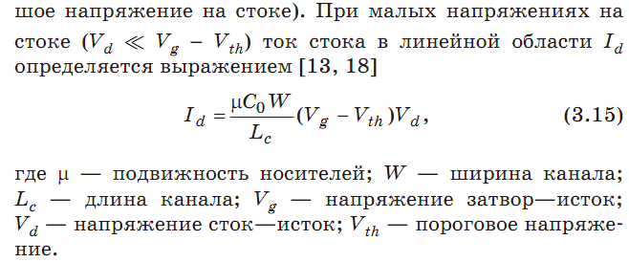
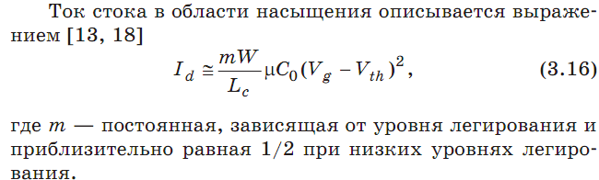
Одним из распространенных альтернативных диэлектриков является диоксид гафния HfO₂, который имеет более высокую диэлектрическую константу (25) по сравнению с SiO2 (3,9). Он в меньшей степени, по сравнению со многими другими рассматриваемыми диэлектриками, вступает в реакции с поликремнием

В большинстве случаев чувствительность изделий МОП и КМОП к дозовым эффектам ионизации существенно выше при низких значениях мощности дозы облучения, характерных для космических условий (10^{–2}–10^{–3} рад/с), по сравнению с мощностью дозы, обычно используемой при радиационных испытаниях (50–300 рад/с). В литературе этот эффект часто обозначают в сокращенном виде ELDRS — Enhanced Low Dose Rate Sensitivity.
Очевидно, что при уровнях облучения, когда начинают проявляться эффекты ELDRS (до 100–200 крад), изменения параметров БТ (биполярного транзистора) связаны не со структурными повреждениями, а с дозовыми ионизационными процессами встраивания заряда в пассивирующем (защитном) оксиде в области базы и объемного заряда эмиттерного перехода [71]. Авторы [81], предложили одну из возможных моделей кинетики встраивания заряда, образования поверхностных ловушек и деактивации акцепторов в подложке (база n–р–n-БТ). С их точки зрения процессы связаны с дрейфом ионов водорода H+ в оксид и слои Si и наличием дырок в обедненной области Si. Это приводит к нейтрализации акцепторов и увеличению рекомбинации в областях базы, прилегающих к поверхности. Нейтрализация мелких акцепторов может проходить по двум механизмам:
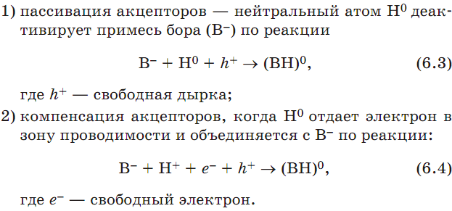
Процесс (6.3) требует свободных дырок. Процесс (6.4) может проходить в области, где нет свободных носителей. Так как оба процесса выравнивают концентрации дырок и электронов в базе n–р–n-БТ, они усиливают рекомбинацию, т. е. приводят к увеличению тока базы. Описанные механизмы логично объясняют повышение рекомбинации в базе, однако до сих пор нет общего мнения по вопросам: какие дефекты являются источником водорода, при каких условиях возникают ионы Н⁺ (протоны), а при каких — нейтральный водород и т. д.?
Аналитических моделей, с приемлемой степенью адекватности описывающих эффекты низкоинтенсивного облучения БТ, до настоящего времени не предложено. Считается, что в приборах n–p–n-типа основное влияние на поверхностную рекомбинацию оказывает объемный заряд в оксиде, а в p–n–p—заряд на поверхностных состояниях у границы раздела Si/SiO2 [71].
«Родственная» рекомбинация относится к рекомбинации вновь созданных электронов и дырок. В тех областях, где создаются низкие концентрации электронно-дырочных пар, носители, образовавшиеся в одной паре, или будут рекомбинировать друг с другом, или не будут рекомбинировать вообще вследствие разделения сгенерированных радиацией электронов и дырок внешним полем. Из-за низкой концентрации пар здесь нет взаимодействий с какими-либо другими носителями. Впервые теория родственной рекомбинации была разработана в 1915 г. для описания свойств рекомбинации в газах. Данная модель была успешно адаптирована применительно к оксидам. В полупроводниках при создании низких концентраций электронно-дырочных пар доминирует другой процесс рекомбинации, поэтому данный механизм применительно к полупроводникам обычно не обсуждается.

Колонная рекомбинация имеет место при очень высоких концентрациях электронов и дырок, но при локальной ионизации какого-то объема [12]. В основном она относится к оксидам, однако была исследована и в полупроводниках. Интенсивность рекомбинации зависит от концентрации электронно-дырочных пар. В приведенном ниже уравнении непрерывности, описывающем скорость роста концентрации электронов (или дырок), последнее слагаемое учитывает колонную рекомбинацию:
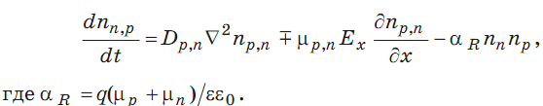
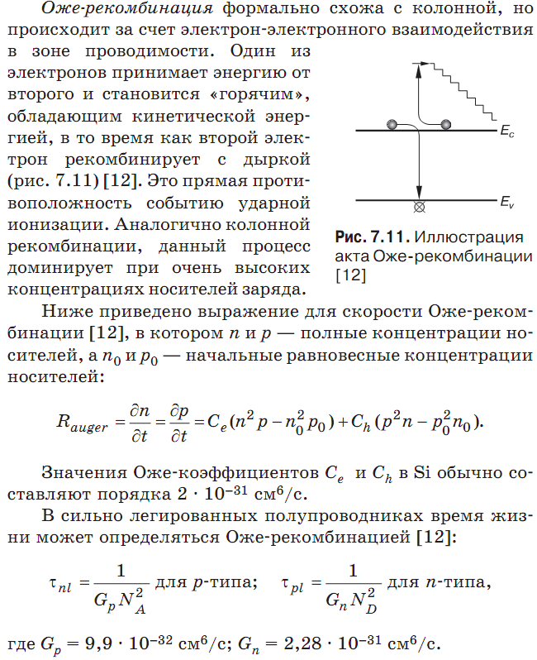
Основное различие между Оже- и колонной рекомбинацией состоит в том, что для акта Оже-рекомбинации необходимо три носителя заряда, а для колонной рекомбинации третий носитель не требуется. Кроме того, для колонной рекомбинации не требуются горячие носители, а только высокая концентрация носителей заряда. Обычно при моделировании физических процессов в полупроводниках в условиях высокого уровня инжекции учитывается Оже-рекомбинация, а колонная рекомбинация не рассматривается. Однако данный вопрос до сих портребует подробных исследований [12].
Межзонная рекомбинация представляет собой переход электрона из зоны проводимости на состояние в валентной зоне. Отдавая свою энергию, электрон может высвободить фотон, если электрон не меняет импульса, или высвободить фонон, если электрон меняет импульс при
заполнении состояния в валентной зоне. В первом случае рекомбинация называется излучательной, а во втором — безызлучательной. В прямозонных полупроводниках фотон может быть снова поглощен в кристалле. Излучательная рекомбинация помогает рассеивать энергию от области локальной ионизации. При безызлучательной рекомбинации локальные фононы поглощают энергию, обусловливая таким образом локальный нагрев. В непрямозонных полупроводниках (таких как Si и Ge) требуется изменение импульса возбужденного электрона. В прямозонных полупроводниках (таких как GaAs, InР) для изменения импульса не требуется участия фононов. Таким образом, беспримесные прямозонные полупроводники имеют меньшие значения времени жизни носителей, чем беспримесные непрямозонные.
В полупроводнике р-типа при низком уровне инжекции скорость межзонной рекомбинации R_{band to band} и время жизни τn аппроксимируются выражениями [12]
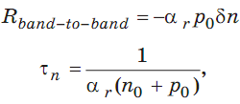
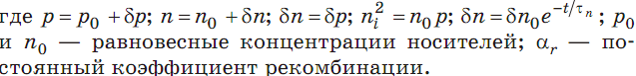

Рекомбинация Шокли—Рида—Холла осуществляется путем перехода электронов и/или дырок на промежуточные состояния в запрещенной зоне. Эти состояния в запрещенной зоне обусловлены дефектами в кристалле.
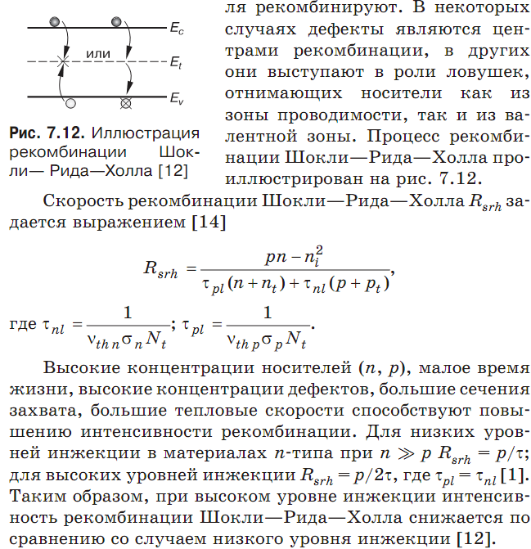

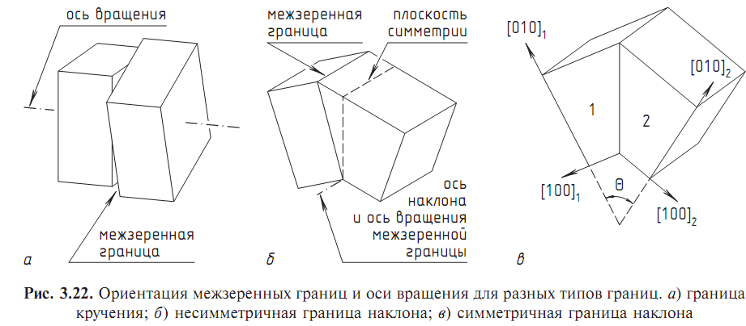

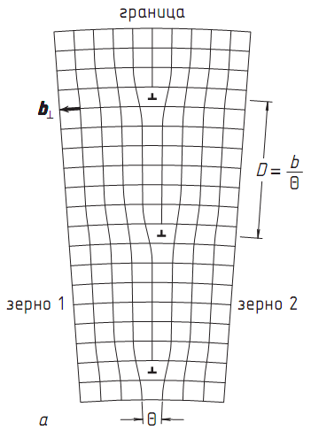

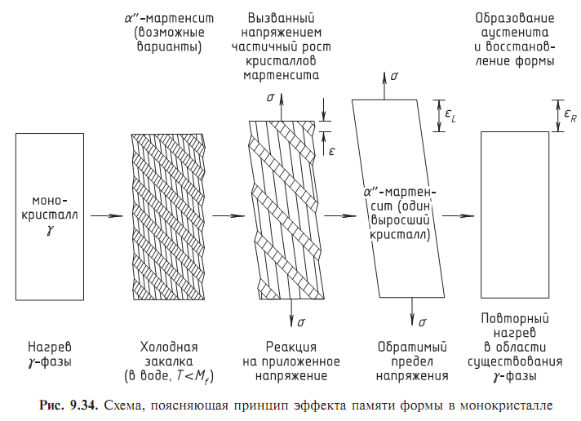
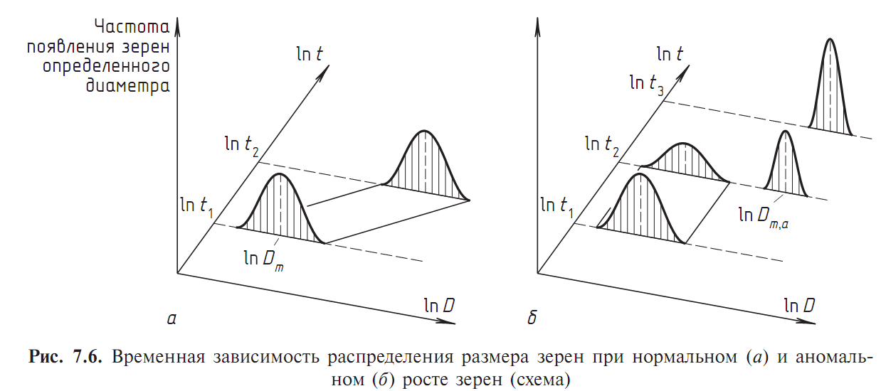
Нормальный рост зерен обычно прекращается, если их размер становится сравним с наименьшим размером образца, например, с толщиной листа. В некоторых случаях, особенно для тонких листов, дискретный рост неко торых зерен прекращается после окончания непрерывного. Путем выбора соответствующей газовой атмосферы во время отжига можно добиться активации или полного подавления этого процесса. Вследствие его дискретности и отличия причин его энергетики от энергетики дискретного роста зерен, его называются
третичной рекристаллизацией. (дикретне зростання – вторинна рекристалізація)

При смещении элемента области межзеренной границы dA на бесконечно малое расстояние dx изменение энергии составит
dG =−pdAdx =−pdV, (7.1)
где dV —объем, изменяющийся при движении межзеренных границ.
p=−dG/dV. (7.2)
Движущая сила может быть определена как свободная энергия на единицу объема (Дж/м3) или как сила, действующая на единицу площади межзеренной границы (Н/м2),т.е. давление на нее.
В случае первичной рекристаллизации действующей силой является накопленная энергия дислокаций. Энергия дислокаций на единицу длины E_{d} = ½ 2Gb². Для плотности дислокаций ρ движущая сила первичной рекристаллизации может быть выражена (при условии, что остающаяся плотность дислокаций настолько мала, что ей можно пренебречь) как p=ρE_{d} = ½ ρGb².
При ρ=10¹⁶ м⁻², G =5⋅10⁴ МПа и b=2⋅10⁻¹⁰ м движущая сила составит около p=10 МПа.
Движущая сила роста зерен—это результат исчезновения границ. Если большие зерна прорастают внутрь окружающих малых со стабильным размером зерен d
Предполагается, что зерна кубические, γ энергия границ, Коэффициент 3—следствие того, что каждая из шести граней куба являет ся общей для двух соседних зерен. При d =10⁻⁴ м и γ≈1 Дж/м2 – p=0,03 МПа.
Произвольный элемент площади перемещающейся границы, в общем, не «ощущает» существования удаленных межзеренных границ, порождающих движущую силу. Возникновение движущей силы для данного элемента поверхности связано с механическим равновесием на стыке границ, приводящего к их искривлению. Однако для искривленных границвозникает сила, направленная на снижение кривизны последних и уменьшение их площади. Таким образом, движущей силой для граничного элемента является давление на искривленную поверхность. Для расчета величины этой силы предположим, что изменение поверхности и объема всей сферы можно описать выражением
Движущая сила в (7.6) похожа на (7.5), если радиус кривизны R близок к размеру зерен. Однако обачно кривизна межзеренных границмала, и, соответственно, радиус кривизны существенно больше размера зерен (в 5—10 раз). Таким образом, движущая сила для непрерывного роста зерен (уравнение (7.6)) будет в 5—10 раз меньше, чем для дискретного (уравнение (7.5)). Следовательно, непрерывный рост зерен будет протекать гораздо медленнее, чем дискретный рост или вторичная рекристаллизация.
Причиной возникновения движущей силы для третичной рекристаллизации является зависимость свободной энергии от ориентации. Зерна, расположенные на поверхности, ограничены в росте за счет соседних, в случае если их поверхностная энергия γ0 (из-за кристаллографических особенностей поверхности) минимальна. Для тонкого листа с шириной B и размером зерен, сравнимым с толщиной листа h, т. е. когда межзеренные границы простираются по всей толщине листа и расположены перпендикулярно его плоскости (рис. 7.9), движущая сила составит
