PHYSICAL REVIEW B 92, 075124 (2015)
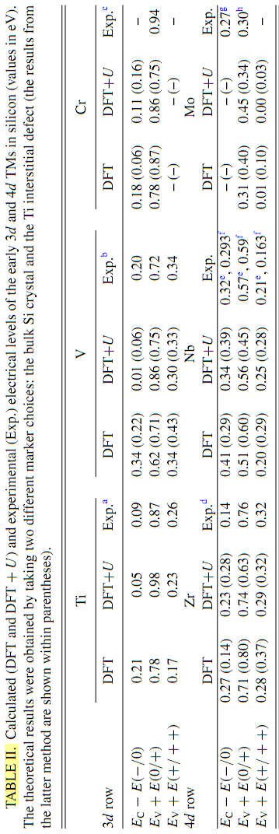

The wafers were implantedwith 4 MeV protons
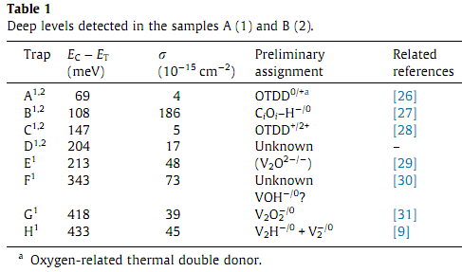
low energy electrons may stimulate an simultaneous reduction of vacancy related defects similar to the annealing effect of electron currents in PN junctions; (ii) passing ions in dielectric surface near regions of a device may alter the charge state and eventually change defect structures [6]
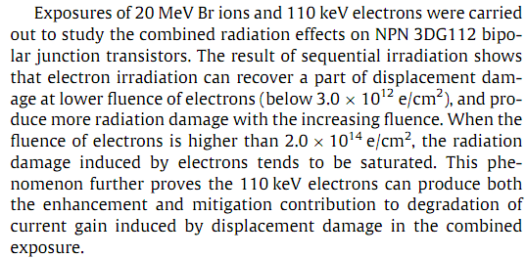
The vacany-oxygen (VO) pair, double negatively charge state of divacancy V₂(=/-), and single negatively charge state of divacancy V₂(-/0) are associated with levels at 0.18, 0.23 and 0.43 eV, respectively [10].
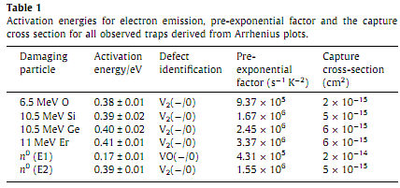
The shift of the V₂(-/0) related DLTS peak maxima to the higher temperatures (which subsequently leads to an increase of the activation energy, Table 1) with the increasing ion mass
Broadening of the DLTS peak originating from V₂(-/0) defects formed in the single heavy ion implanted silicon is ascribed to divacancy perturbed by local environments of close lying point defects.
______________________________________________________________
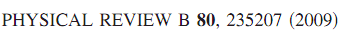
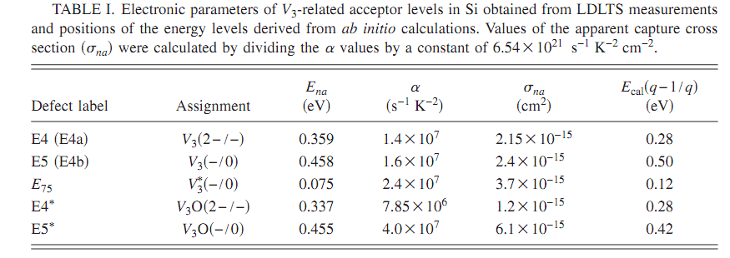

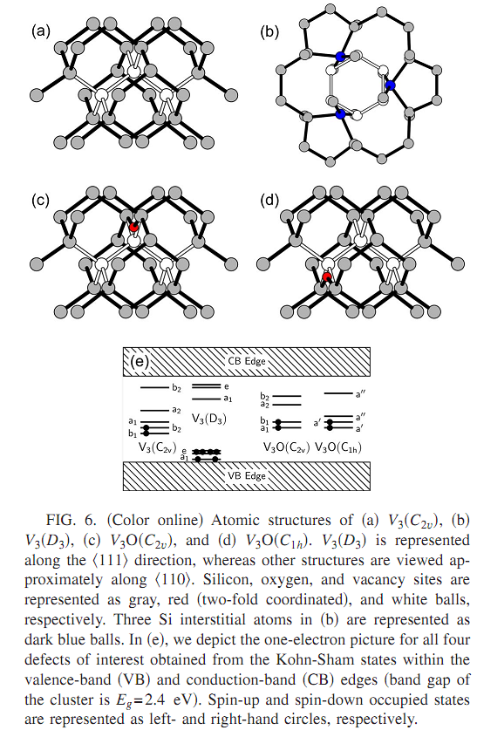
______________________________________________________________
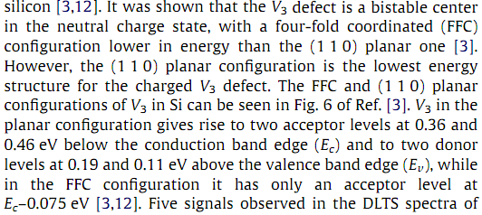
Physica B 407 (2012) 3013–3015
The neutron irradiation
The two deep acceptor levels E4 at EC-0:39 eV and E5 at EC-0:45 eV have been proven to be the doubly and the singly charged state of the tri-vacancy (V3). At temperatures above 200 C and depending on the oxygen concentration of the material, the V3 transforms into the tri-vacancy–oxygen complex (V3O).
______________________________________________________________
Physica B 407 (2012) 2981–2984
C_{i}C_{s}-A is the stable conﬁguration in the + and - charge states and has two inequivalent C atoms. It resembles Ci (a split- 100 interstitialcy) trapped near Cs. It has a donor (acceptor) level at Ev+0.09 eV (Ec-0.17 eV).
C_{i}C_{s}-B is the stable conﬁguration in the 0 charge state. It has two equivalent C atoms located near substitutional sites but separated by a self-interstitial [1,9,11]. The activation energy for the A-to-B transformation is 0.2 eV. CiCs-B has C1h symmetry at low temperatures, but ISi easily rotates around (or moves through) the trigonal axis above 30 K and the symmetry of the defect becomes C3v [12].CiCs-B has a donor (acceptor) level at Ev+0.07 eV (Ec-0.11 eV)
CiCs-NN (nearest-neighbor) has two equivalent C atoms aligned along a 100 direction sharing one substitutional site. The CiCs-A and CiCs-B pairs have been identiﬁed experimentally, but CiCs-NN has not. Yet, its stability is very close to that of CiCs-A.
The C_{s}C_{s} pair only forms in irradiated material when C_{i}C_{s} traps a vacancy (CiCs⁰+V⁰→CsCs⁰+3.28 eV) or in as-grown Si which contains above solubility concentrations of C (Cs⁰+Cs⁰→CsCs⁰-1.70 eV). The CsCs pair has an acceptor level close to the conduction band, Ec–0.07 eV. DFT-based calculations in the Si₄₄H₄₂ cluster [14] predict that CsCs has an acceptor level at Ec-0.3±0.2 eV.
A new defect is predicted, the CiCi pair. Its formation probability is low, but it is very stable and electrically inactive. The donor (acceptor) level is below the top (above the bottom) of the valence (conduction) band, and CiCi is electrically inactive and always in the 0 charge state.
______________________________________________________________
Physica B 407 (2012) 2998–3001
P-on-n diodes were irradiated with 2 MeV electrons as well as with reactor neutrons using ﬂuences in the range of 10¹²–10¹⁷cm⁻².
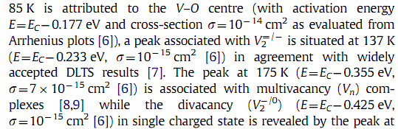
______________________________________________________________
Physica B 407 (2012) 3016–3019
Planar n⁺–p–p⁺ diode structures. Irradiations with alpha-particles of a Pu-239 surface source were performed at about 290 K or slightly less. The alpha-particle energies were 5.144 and 5.157 MeV.
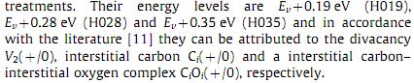
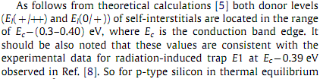
_________________________________________________________
Physica B 480 (2016) 206–208
p-type Si <111> grown on p+-Si substrate was investigated.
Electron beam deposition:
– Ev+0.55, 6.6⋅10⁻¹⁴cm², I-defect (in [10] observed a similar energy of 0.545 eV with an apparent capture cross-section of 9.0⋅10⁻¹⁴cm²)
- Ev+0.59, boron related defect
Alpha-particle irradiated:
– Ev+0.16,
– Ev+0.33, 1.6⋅10⁻¹⁹cm², interstitial carbon (C_{i}) related defect
– Ev+0.52, boron impurity related defect.
_________________________________________________________
Phys. Rev.B, 15, p.3836
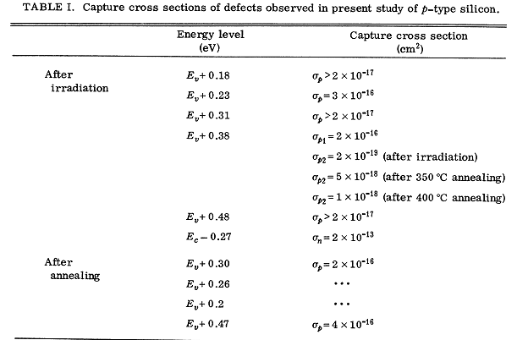
irradiated with 1-MeV electrons at room temperature.
The errors in these values are about + 0.02 eV
Two different defects have a level at E_{V}+0.38 eV:one defect (-80%of the signal) is a neutral trap, and the other (-20%) is positively charged when
the Fermi level is below the trap level.
E_{C}—0.27eV, E_{V}+0. 38 eV-, and E_{V}+ 0.23 eV levels are associated with the interstitial oxygen-boron complex, the vacancy-carbon-oxygen complex, and the divacancy, respectively. TheE_{V}+0.30eV level, which appears upon the disappearance of the E_{C}-0.27 eV level at 170 C, may arise from the vacancy-oxygen-boron complex.
_________________________________________________________
PHYSICAL REVIEW B 77, 125214
new donor level at Ev +0.184 eV, attributed to a Fe-divacancy complex. This defect is stable up to at least 400 °C
Ev +0.33 eV, omplex involving Fe and several O impurities
Ec −0.36 eV, (FeOV) complex was proposed
The single and double acceptor levels of the isolated divacancy are known⁶⁰ to be at Ec −0.42 eV and Ec −0.23 eV, respectively.
- це був огляд експериментальних даних, далі – розрахунки First-principles theory is used to calculate (в дужках з якими експериментальними даними вони порівнюються)
- isolated Fe_{i} has only a donor level ³ at Ev +0.37 eV (measured² Ev +0.39–0.45 eV)
- The {Fe_{i}V} pair has a donor and an acceptor level in the gap, which we calculate to be at Ev +0.35 eV and Ec−0.71 eV, respectively
- Fe_{s} is stable at the ideal substitutional site with Td symmetry, E_{C}−0.41 eV (Kaminski et al.¹⁵ - 380 meV)
- The {Fe_{s}B_{s}} defect has no donor level but a deep acceptor level at Ec−0.84 V. For comparison, the {Fe_{i}B_{s}} pair has a donor and an acceptor level³ at Ev +0.11 eV and Ec−0.29 eV, respectively (the calculated and measured values coincide for this defect).
- The {Fe_{i}V₂} complex has a donor and an acceptor level in the gap, which we calculate to be at Ev +0.25 eV and Ec−0.75 eV, respectively. The position of the donor level is consistent with the DLTS center at Ev+0.184 eV reported by Komarov .
- {VFeV} has a single and a double acceptor levels at Ec−0.73 eV and Ec−0.55 eV, respectively.
- The {Fe_{s}O_{i}} defect has an acceptor level at Ec−0.36 eV.
- The donor and acceptor levels of the {Fe_{i}C_{i}} pair are at Ev+0.67 eV and Ec−0.44 eV, respectively.
_________________________________________________________
Phys. Status Solidi C 12, No. 8, 1108–1110 (2015)
phosphorus doped [100] Cz-Si crystals
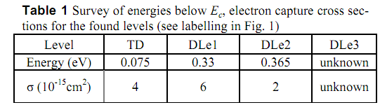
TD - to shallow state
“DLe1” and “DLe2” - We tentatively ascribe these deep levels to the embryos of oxygen precipitate in silicon matrix. “DLe2” take part in the formation of recombination-active centers (oxygen precipitates)
_________________________________________________________
Radiation Physics and Chemistry 123 (2016) 103–108
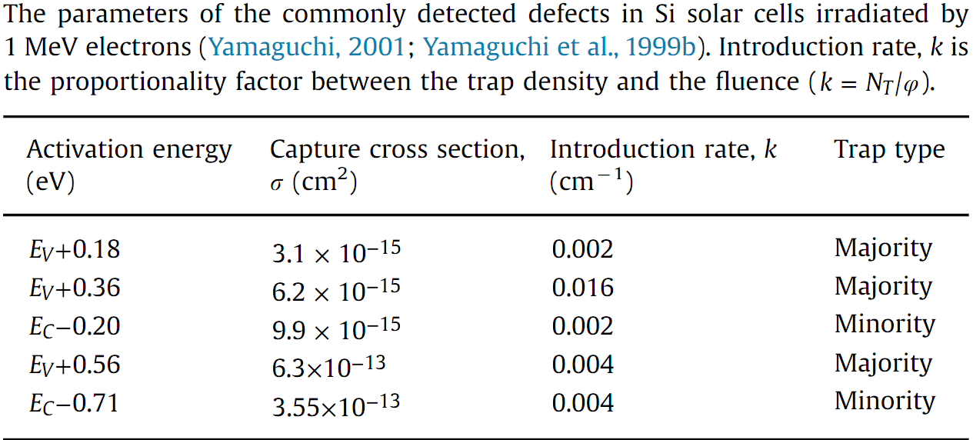

Physica B 407 (2012) 3034–3037
n-Si single crystal [2,3]. The trap level at approximately Ec-0.52 eV was attributed to dislocation in those studies.
В самій роботі :
p+–n junctions. The trap level, originally found at Eс-0.50 eV (в середньому), shifted to a shallower level at E_{C}-0.23 eV (в середньому) after a heat treatment at 350 K in an inert environment. The shift in the trap level was probably caused by the desorption of gas molecules present in lab air that had been adsorbed before the heat treatment, not including nitrogen.
hypothesis that the intrinsic trap level of the dislocation is Ec-0.23 eV, and it shifts to a deeper level (Ec-0.50 eV) when gas molecules from lab air are captured.
_________________________________________________________
Prog. Photovolt: Res. Appl. 2005; 13:325–331
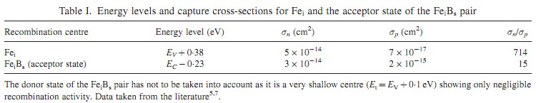
_________________________________________________________
Solid State Commumcations, Vol. 21, pp. 109-111
a negative charge state of the divancy) at Ec- 0 40 eV
positive charge state of the divacancy at Ev + 0 25eV
carbon-silicon interstitial pair: Ev+0.30± 0.02 eV, the hole capture cross-section >~ 10⁻¹⁷ cm² supporting assumption that the center is mostly at the neutral charge state,
(Ev + 0,39), σp = 2⋅10⁻¹⁶cm² - [V + C + O] complex
(Ev + 0,39), σp = 7⋅10⁻¹⁹cm² -[Cs-Cl] pair
[vacancy-carbon-oxygen] complex, positive charge state, Ev + 0 30 eV and anneals at 400°C.

Solar Energy Materials & Solar Cells 147 (2016) 115–126
Повільна LID зв’язана з energy level at Eс-0.41 eV [43] with the carrier-capture cross-section ratio of /σ_{p}= 10 [43,44]. (σ_{n}~10-¹⁷cm²). З відповідними дефектами ще пов’язуються рівні Ev+ 0.37 eV (σp= 10¹⁸cm²) та Ev+0.26 eV (останіій вимагає ще підтвердження)
Для швидкої LID
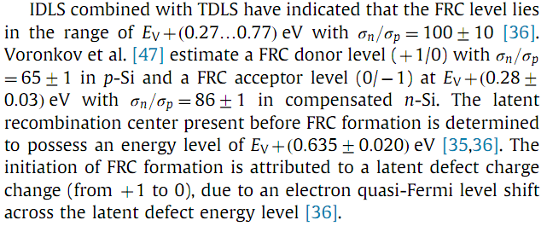
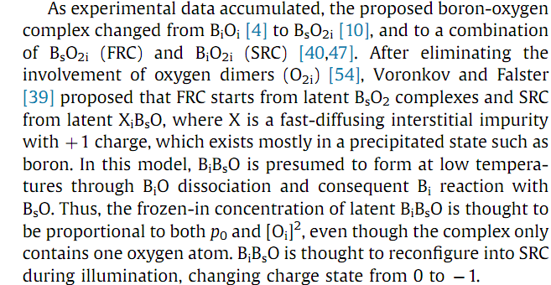
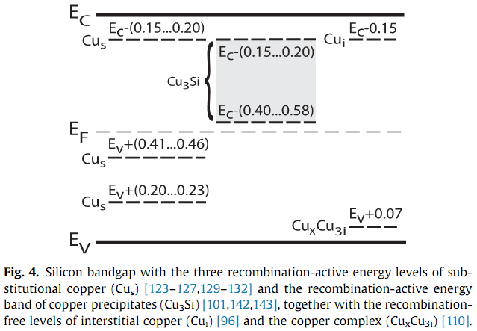
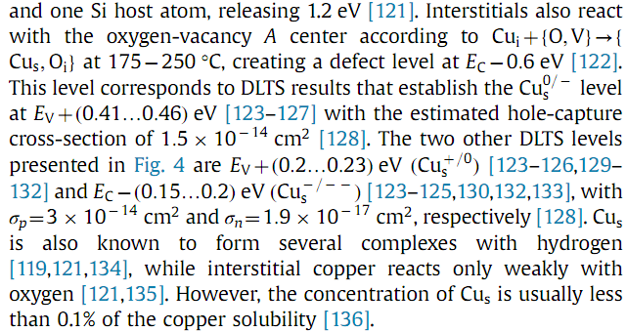
_________________________________________________________
Semiconductor Physics, Quantum Electronics & Optoelectronics, 2016. V. 19, N 1. P. 67-74
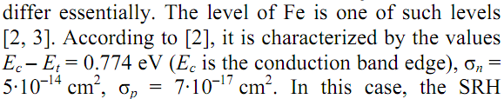
APPLIED PHYSICS LETTERS 110, 092106 (2017)
