Title

Automated CVE Intelligence Alerts for SOC Teams using Python

Abstract
This project focuses on automating the daily tracking, extraction, comparison, and reporting of newly published and updated CVEs. Cybersecurity professionals often rely on manual browsing of CVE feeds, which is time-consuming and prone to missed updates. This system automates the entire workflow by fetching CVE records from the API, comparing them with previously stored data, identifying newly published and updated vulnerabilities, extracting critical fields such as CVSS score, severity, CWE, and affected products, and generating a structured email notification. The solution ensures that users receive accurate and timely updates only when necessary—avoiding duplicate or empty emails. The project is designed to be lightweight, modular, and extensible, enabling future integration with AI components such as NLP summarization, RAG-based querying, and automated prioritization.

Introduction
A Common Vulnerabilities and Exposures (CVE) entry identifies publicly disclosed cybersecurity vulnerabilities. Organizations must monitor CVE activity to stay informed about emerging threats, especially those affecting their software stack. However, manually checking CVE feeds is inefficient and does not scale with growing daily volumes. This project solves the problem by creating a fully automated CVE tracking and notification pipeline.
The system automatically identifies:
- New CVEs published today
- CVEs updated today
- Differences between old and new versions
- Critical fields such as CVSS score, severity, CWE, exploit status, and affected vendors
The objective is to build a reliable automation tool used by SOC teams, blue team analysts, penetration testers, and researchers to maintain awareness of emerging vulnerabilities.

Approach: Delta-Based Client Synchronization
My script uses a common method for synchronizing large datasets efficiently, often called delta synchronization.
- Source of Truth: The primary data source is the CVEProject/cvelistV5 GitHub repository, specifically accessed via the delta.json file.
  - https://github.com/CVEProject/cvelistV5/blob/main/cves/delta.json
  - which gets updated before in the NVD database.
- Change Detection (Delta): Instead of downloading the entire CVE list every time (which would be massive and slow), the script downloads the small delta.json file. This file acts as a manifest, listing only the new and updated CVE files since the last release.
- Incremental Fetching: For each item listed in the delta, the script performs a targeted requests.get() call to fetch the individual, full JSON file from GitHub using the provided githubLink.
- Data Pipeline: The fetched raw JSON passes through two key stages:
  - Fixing: The fix_multi_json function handles non-standard, concatenated JSON structures that may sometimes be present in the raw GitHub files, ensuring valid data input.
  - Extraction/Transformation: The extract_important_fields function acts as an Extraction, Transformation, and Load (ETL) step, paring down the verbose CVE 5.0 format to a smaller, application-specific structure.
- Deduplication/Persistence:
  - The load_json_list function acts as the Load step, retrieving the previously processed data.
  - The code uses existing_ids sets (for both new and updated lists) to prevent adding the same CVE identifier multiple times, ensuring idempotence for each run.
  - The save_json_list function overwrites the local JSON files (new_cves.json and updated_cves.json) with the complete, updated list, maintaining a valid JSON array structure.

System Architecture
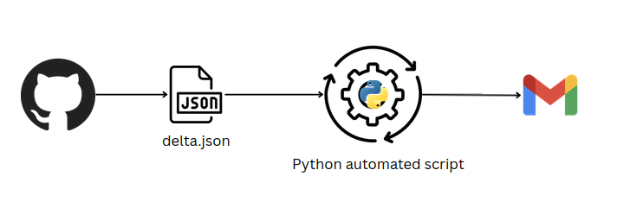

Detailed Architecture Flow
- Trigger - A scheduled job (cron or task scheduler) runs the script daily.
- Data Fetching - The script makes a GET request to the CVE feed (NVD or CVE.org).
- Raw JSON Storage - The fetched JSON is saved as new_cves.json
- Load Previous Database - The script loads new_cves.json for comparison.
- Comparison Logic -
  - If a CVE ID exists today but not yesterday → New CVE
  - If CVE exists but fields changed → Updated CVE
- Field Change Detection
The system checks changes in:
  - CVSS score
  - Severity
  - Description
  - CWE list
  - Affected products
  - References
  - Exploit status

- Extraction of CVSS & Severity
For updated CVEs, the system extracts:
  - cvssMetricV31.baseScore
  - cvssMetricV31.baseSeverity
  - If missing, checks CVSSv2 fallback.
- Email Content Creation
Emails contain sections for:
  - New CVEs
  - Updated CVEs
  - Severity level
  - Scores
  - CWE mappings
  - CISA links
- Conditional Email Sending
Email will be sent only if:
New CVEs | Updated CVEs | Send Email?
❌ None | ❌ None | ❌ No email
✔️ Some | ❌ None | ✔️ Send email
❌ None | ✔️ Some | ✔️ Send email
✔️ Some | ✔️ Some | ✔️ Send email

Code samples :
email :
def send_email(sender_email, sender_password, recipient_email, subject, body):
msg = MIMEMultipart()
msg['From'] = sender_email
msg['To'] = recipient_email
msg['Subject'] = subject
msg.attach(MIMEText(body, 'plain'))
try:
server = smtplib.SMTP('smtp.gmail.com', 587)
server.starttls()
server.login(sender_email, sender_password)
server.send_message(msg)
print("Email sent successfully!")
except Exception as e:
print(f"Failed to send email: {e}")
finally:
server.quit()

github scraping:
DELTA_URL = "https://raw.githubusercontent.com/CVEProject/cvelistV5/main/cves/delta.json"
delta = requests.get(DELTA_URL).json()
print(delta) # displays the new , updated cves

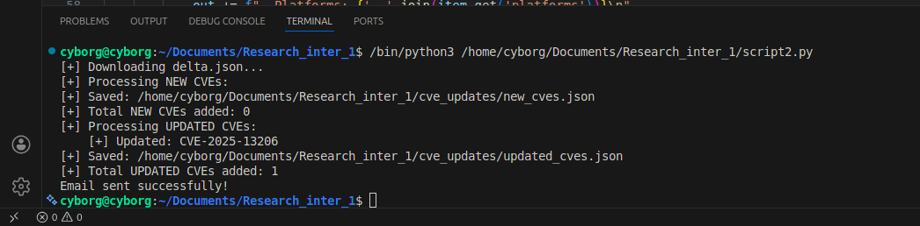

Sample outputs :
1. updated_cve
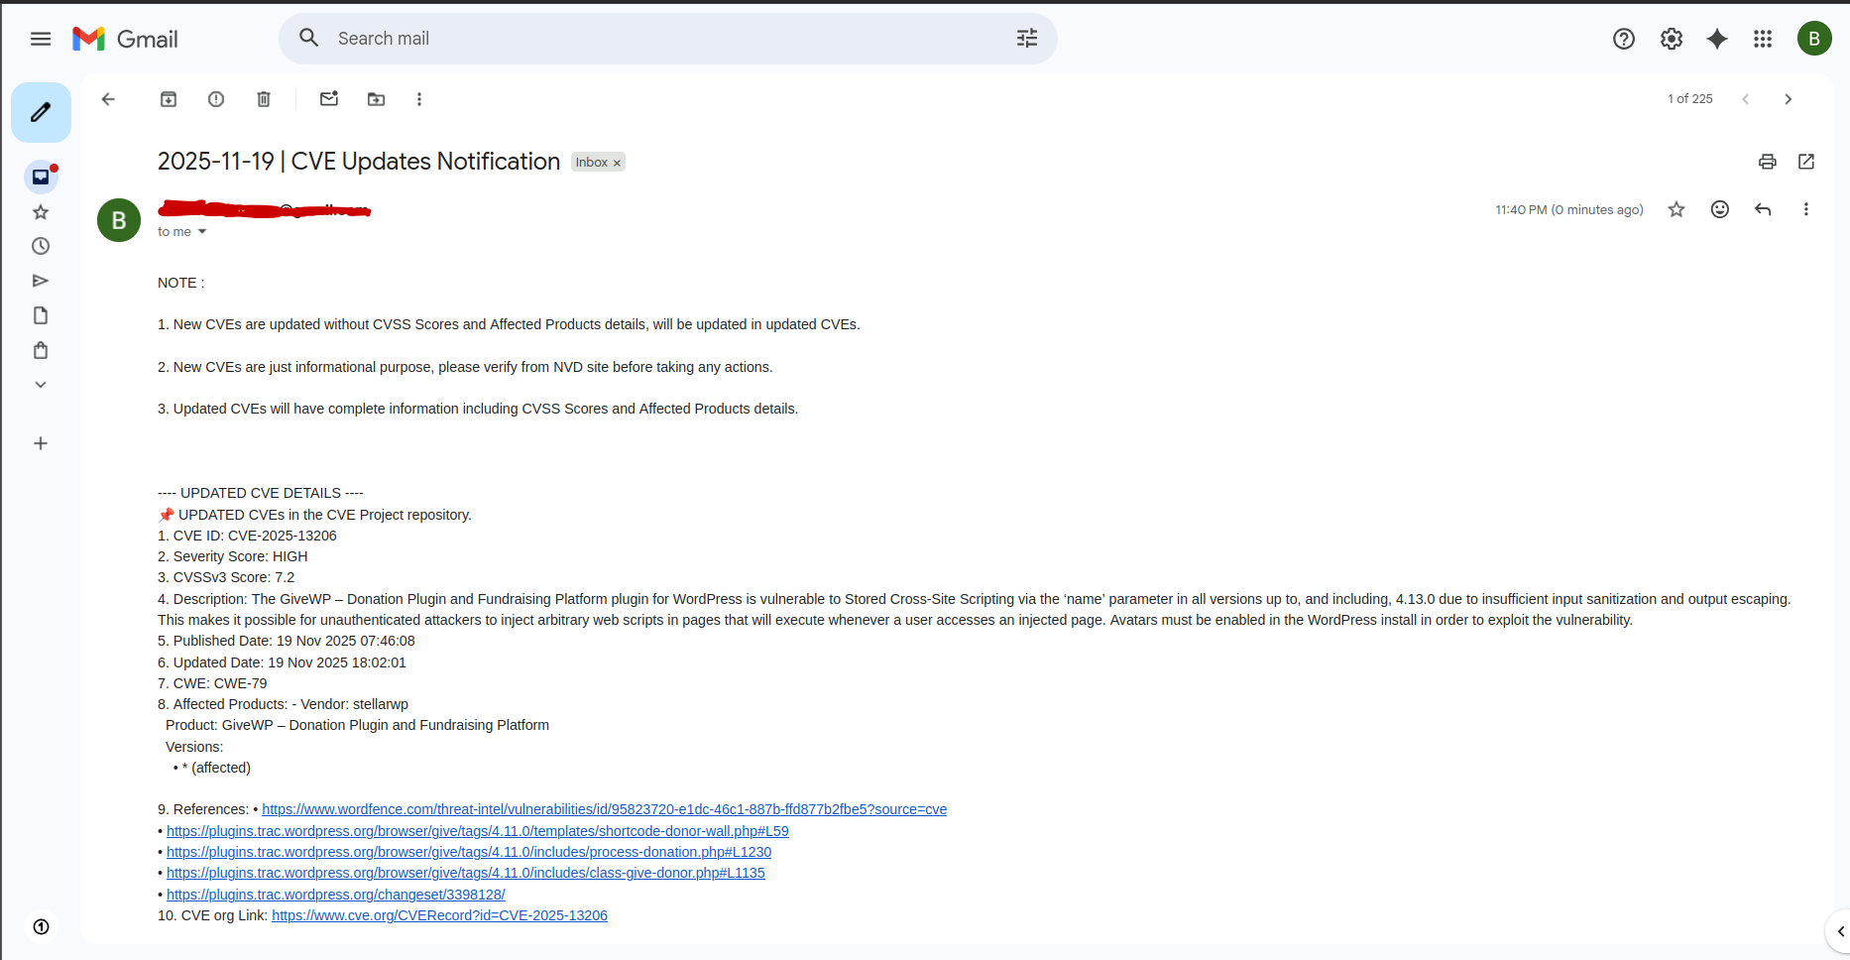
2. new_cves
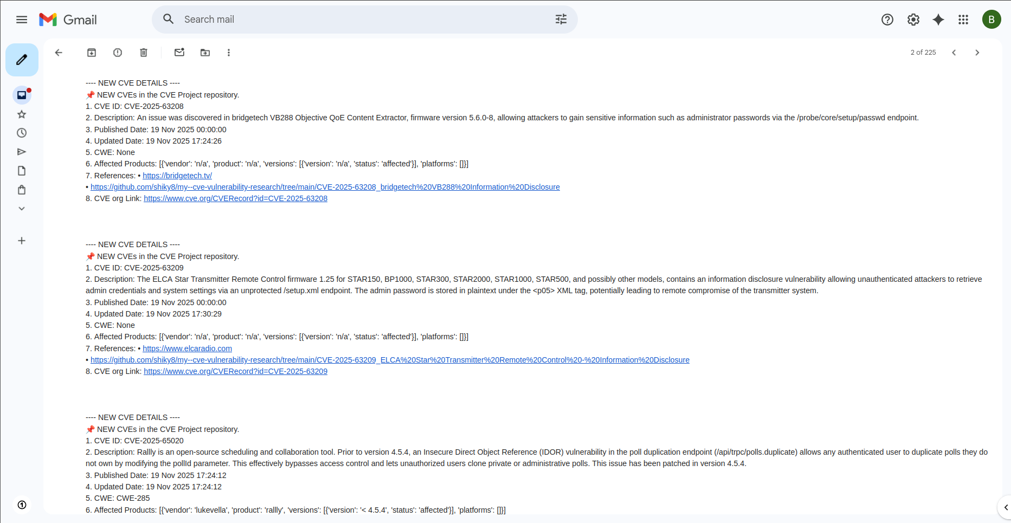
Optional AI Integration (beginner level takes time to integrate)
Possible AI-enhanced features:

Summarization
Use GPT to convert lengthy CVE descriptions into short summaries.

Prioritization
AI can rank vulnerabilities based on:
- Exploit availability
- Affected vendor
- Product popularity
- Attack vector

RAG-based Search
Store CVE data in vector DB → allow queries like:
- “Show all RCE vulnerabilities from the last 7 days.”
- “List high severity CVEs affecting Apache.”

Threat Context Generation
AI can explain:
- Attack flow
- Real-world exploit impact
- MITRE ATT&CK mapping
This makes the tool a mini threat-intelligence assistant.

