Theremino System

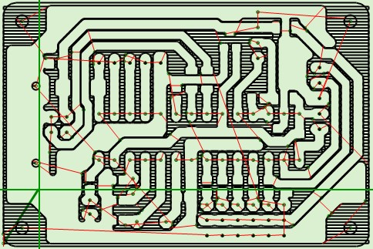
Theremino CNC - V4.4
Instructions

Table of Contents
Theremino CNC 4
Start without reading the instructions 5
What if Theremino CNC does not start 6
Display Settings 7
Re-size the two halves of the main window 7
Hardware controls 7
Choose colors 8
The DPI setting in the Windows screen 8
GCode 9
Gcode panel 9
GCode context menu 10
Modify the GCode 11
Toolpath 12
Toolpath panel 12
Keyboard Controls (manual JOG) 13
Mouse Controls 13
Touchpad Controls 14
Gamepad Controls 15
Toolpath Views 16
Initial reset 17
Controls and Settings 18
Control Panel 18
Motor Panel (left side) 19
Motor Panel (right) 20
Insert manually a coordinate 21
Make small corrections during processing 21
Axes A and B 22
Calibration Panel 23
Tuning of calibration parameters 24
The application Menu 25
The options Menu 26
Tool Bar 27
Status Bar 27
Motor settings in Theremino HAL 28
Adjusting values in the numerical boxes 29
Multiple applications 30
Tips for less obvious functions 31

Appendix 1 - Machining speed 32
Appendix 2 - The calculation of the trajectory 33
Appendix 3 - Processing times 34
Appendix 4 - Implemented Functions 35
Appendix 5 - Not Implemented Functions 37
Appendix 6 - The circular interpolations G02 and G03 38
Appendix 7 - HOME Controls (G28 and following) 39
Appendix 8 - Theremino CNC Adapter 40
Appendix 9 - Input / Output Slots 42
Master Module InOut PIN 43
Output signals 44
Input signals 45
Wiring diagrams for all ON-OFF inputs 46
Appendix 10 - Rules for electrical connections 47
Appendix 11 - opto-couplers 48
Appendix 12 - Motor driver connections 49
Appendix 13 - The “Stepper Sound” 50
Appendix 14 - Double coordinates 51
Appendix 15 - Settings to zero 52
Appendix 16 - The probes 53
Appendix 17 - Interpolation in 5 dimensions vectors 54
Appendix 18 - Control over control 55
Appendix 19 - Asynchronous operation 56
Appendix 20 - Accuracy of the forward speed 57
Appendix 21 - Gcode generation for Theremino CNC 58
Appendix 22 - PCB built with Eagle and Fast Gcode 59
Appendix 23 - 3D Printers 61
Appendix 24 - Temperature sensors 62
Appendix 25 - Temperature tables 63
Examples of temperature tables 64

Theremino CNC
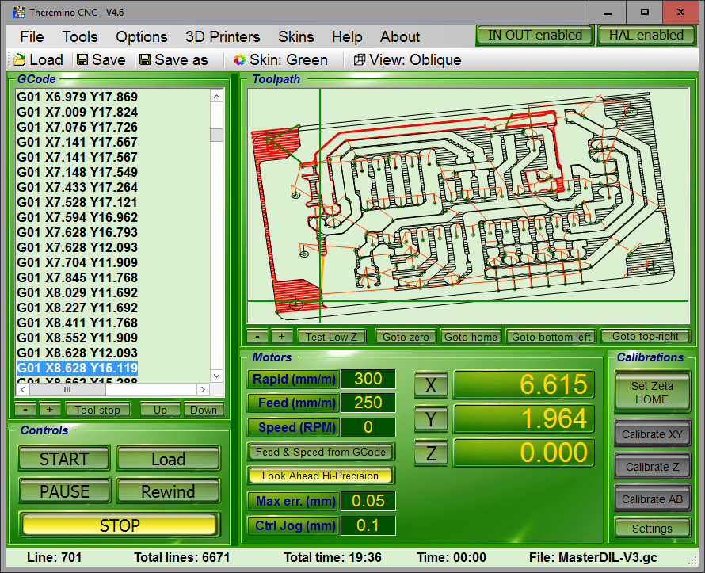
A really simple application
Theremino CNC has only one coordinate system. No work coordinates and machine coordinates. One brings the tool at the starting point, reset the axes and press START.

Those who find Theremino CNC too simple, could use Mach3 or LinuxCNC, and write a plugin application, to send the coordinates (in millimeters), to the Slots. Thus it would be possible to exploit the accuracy of the pulses, generated by our master.
Why only one coordinate system?
The double coordinate system could save time. But it is not our case. The Theremino system is designed for teaching and DIY, not for production, every time you make different processes. In this context, the double coordinate system not only is not necessary, but it is also a complication, which slow down processing and drives to errors. Similar to ride two bicycles.

It would be better to implement all ?
We wrote Theremino CNC in order to have a CNC easy to understand and easy to use. And you can not "Throw inside everything, that more is better". However it is all Open Source, so other people will complicate it.

Start without reading the instructions

Check the parameters of the motors
The main conditions are that the value of "Rapid" must not be greater than the "Maximum speed" of the slowest motor and the settings "Max acc." and "Steps per mm" of all motors must be adjusted, tested and optimized. Also the Slot numbers have to match.

If the motors are not well regulated, as explained in the "Motor setting in the HAL", we advise to do only brief tests, without tools, with the tip held high "to eat air" and standing ready to press the START button again, or the SPACE bar.

Load a GCode
Theremino CNC reads all extensions: .gc, .tap, .nc, .ncc, .dnc, .iso, and also .txt

If the loading is done without error messages, you can start working immediately. Otherwise you have to control codes "G" and "M" indicated and find a way to get rid of them. Or you can program the CAM not to use them (configure the post-processor). In all the cases, but especially when running GCode made by others, it is good rule holding the Z axis very high and "work in air", until you are definitely sure that the tool path is right.

Move the tool at the start point
Deciding the starting point (zero processing) is a controversial practice. Some people consider to be zero, the leftmost and bottom position the machine can reach, when it hits the limit switches. Then prepare all GCode, with distances far from zero, so as to working, approximately in half range. And finally, fixing the work-piece, where the GCode will go to work. This way to reset is inaccurate and dangerous. Just wrong calculations, or wrong position, can break the tool or scratch the work-piece. What is more, you can not make more pieces, in different positions, using the same GCode.

It is better establishing zero point related to the work-piece (not related to machine) and "reset" all GCode. Thus, the zero values of GCode should indicate the point in the lower left of the work piece, not the zero of the machine. All GCode that are used, should follow this rule, you have to trust that the GCode. Possibly pass it all with the "Translate to zero" of the "Tools" menu.

Reset axes
After the piece has been fastened and the tool tip taken manually exactly in the work-piece zero, press the zero axis. It is also possible to adjust a single coordinate, and then reset it (this is often done on the vertical axis Z). The alignment with the machine remains valid, even after turning off the machine and PC. If the position of the work-piece remains the same, you can interrupt the machining, and continue the next day. It is not necessary to repeat the zeroing at every start-up.

Start
Press START and immediately press it again to stop. This way you do a short test. If you feel something strange (eg spindle motor that does not start), stop and check all the settings.

Starting again with START and be prepared to press it again, until you are sure, that the processing proceeds regularly.

What if Theremino CNC does not start

DotNet and DirectX may not be installed (to save memory on the disk). In these cases Theremino CNC does not start and appears an error message similar to the following:

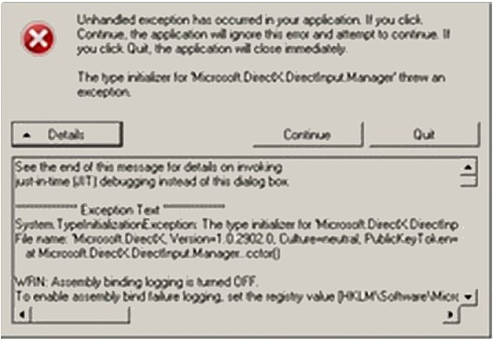

Even if they are already installed, you must install them again. Sometimes contain errors, they are incomplete or contain some DLL with the wrong version.

Do not send us these errors, you only lose time. The only thing that matter of these messages is if it is DotNet or DirectX.

If it's installed DotNet this:
http://www.theremino.com/files/dotnetfx35SP1_ENG.exe (Local copy) (Note 1)

If it comes to DirectX, install one of the following two (they are the same - choose the fastest):
http://www.theremino.com/files/directx_Jun2010_redist.exe (Local copy) (Note 1) (Note 2)
https://www.microsoft.com/en-us/download/details.aspx?id=8109 (Download from Microsoft) (Note 2)

(Note 1) Unfortunately Microsoft frequently move files, and hides installers "off-line", to encourage those "on-line" (which sometimes does not contain all the files). So, for easy browsing, we made local copies.

(Note 2) The DirectX installer does not start on its own. you must unpack from ZIP in a temporary folder (Choose an empty folder or create a new one). Then you have to launch DxSetup.exe, follow the instructions and give all the necessary OK.

- - - - - -

Do not worry about these components, they are signed by Microsoft and can not harm the system. All Microsoft installers are smart, if they feel something is wrong they simply do not install.

More information in this page:
http://www.theremino.com/downloads/notes-on-software

Display Settings

Re-size the two halves of the main window
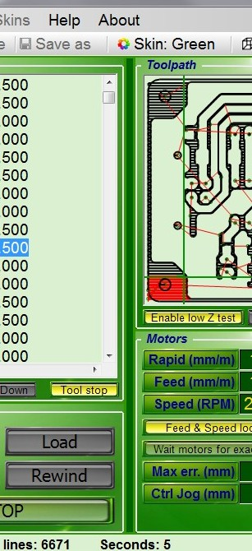

The line that divides vertically the application, can be shifted to allow more room to GCode, or Toolpath panel. Place the cursor on the line until a double arrow appears. Press the left mouse button and hold it. Move the line to the right or to the left and then release the button.

Hardware controls
IN OUT enabled - Enable and disable IN-OUT signals and start or stop the enable signal of the whole machine. The machine turns on only if Theremino CNC is active and that key is pressed. With this control you can do tests with the software only (without moving the motors). When you re-enable this key, the coordinates of the software will be realigned automatically to the machine ones.

HAL enabled - Keep always enabled. Disable only in test applications.

CAUTION: Making movements without "HAL enabled" causes misalignment between Theremino and the CNC machine. Instead the key "IN OUT enabled" can be used to make tests without motors. If one works properly the settings and the calibrations remain valid over time, even closing the application, turning off the motors, and then restarting the PC.

Choose colors
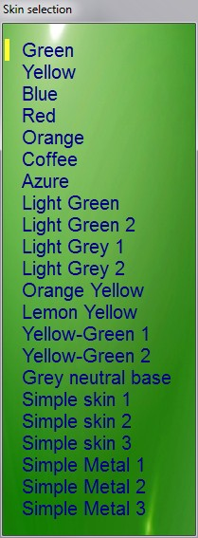
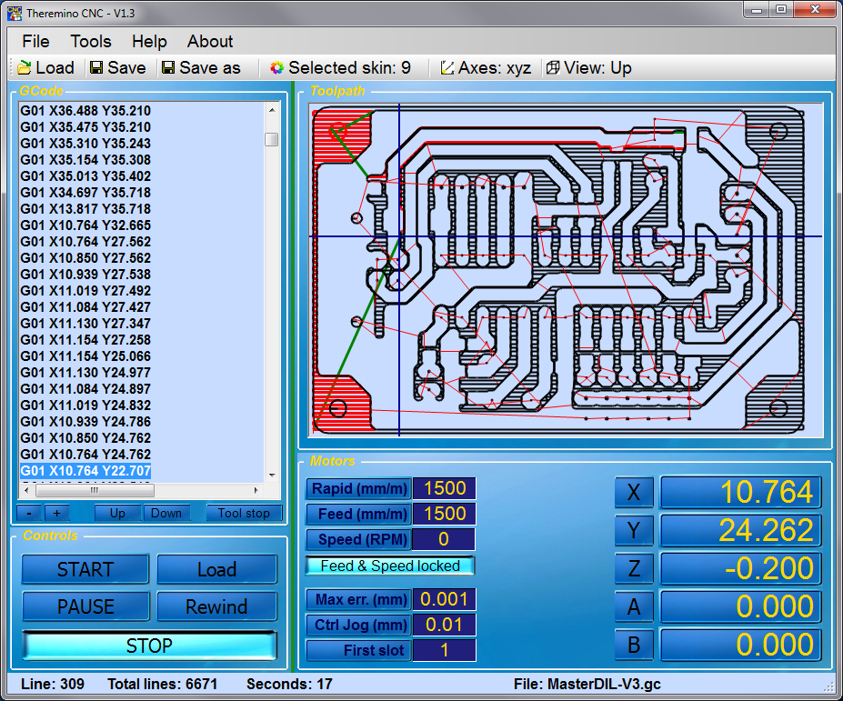
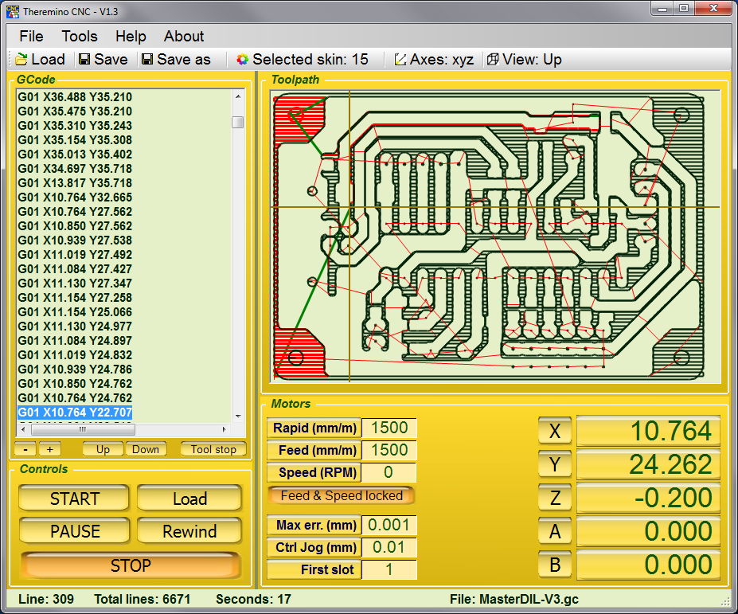
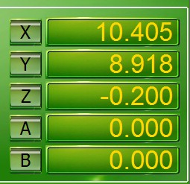
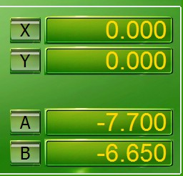
The feeling of the colors and brightness, changes from one person to another. Choosing the colors that appear more pleasant can improve visibility and reduce eye strain.

Even the shape of controls could be changed with a "Skin" choice, but the position of the controls remains the same.

The possible disappearance of some controls does not depend on "Skin" choice, but on other settings. In this image, for example, you can see the disappearance of the Z axis, which is not used in the current GCode.

The DPI setting in the Windows screen
Theremino CNC is optimized for these characters size: 100%, 125% and 150%
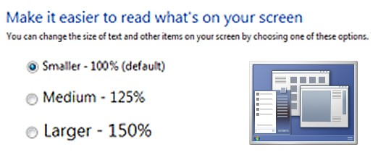
With screen resolutions too high (compared to the size of the monitor) the text becomes difficult to read. If you do not want to lower the resolution, you can enlarge the font size in Windows.
To open the panel for the size adjusting of the text:
- Right-mouse on the screen
- Customize
- Screen

GCode

Gcode panel

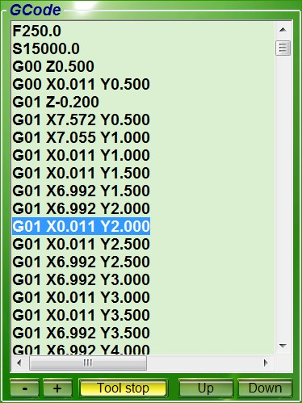
The G-code (Also known as RS-274), with many variations, is the common name for the more widespread CNC programming language. It is mainly used in automated production and for the machine tools control. The G-code is also called: programming language G.

The G-code is a language for computerized machine tools, which describes how to do something. This is defined by the instructions on where to go, how fast and the way to move through the path.

The most common situation is that, inside of a machine tool, a cutting tool, moves in accordance with these instructions, through a "toolpath", taking away the excess material, leaving only the finished piece. The same concept also extends to tools such as the "forming", the etching methods and additives, such as 3D printing.

- / +
With these commands you can re-size the text.

Tool stop
With this command you enable the stop at the command M06, in order to be able to change manually the tool.

Up / Down
With these commands you move the execution point of GCode, up and down, until the next point (break codes and tool change).

Change the Gcode
The text of GCode can be modified, and then saved with the commands "Save" and "Save as". Any modification is immediately displayed in the Toolpath image. You can also scroll through the text with the arrow keys, and with Page UP and Page Down commands. You can also use the vertical scroll bar and click on a line. In the Toolpath part already processed is highlighted in a contrasting color.

CTRL-Z and CTRL-Y
When the Gcode panel is selected, you can use these commands to move back and forward in the Gcode modifications. When back at the beginning the modified part is canceled.

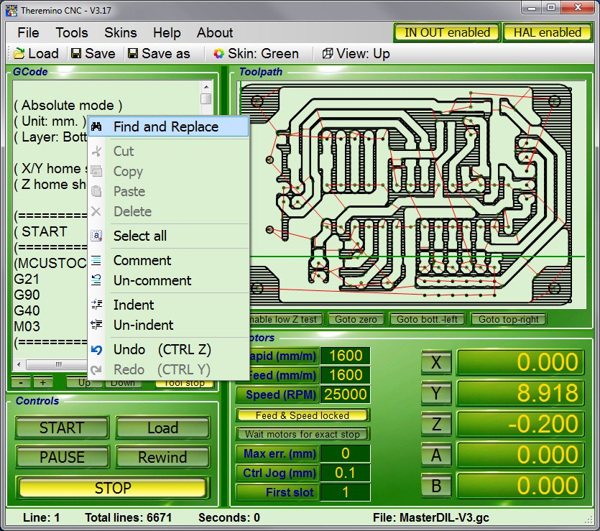
GCode context menu

To open this menu, click the GCode, with the right mouse button.
These operations are useful in doing small modifications in the GCode. The real changes should be done in the CAD and CAM, to keep aligned, the whole chain of the project.
All operations on this menu act only on the selected text.

Modify the GCode
Theremino CNC is a simple application, but has advanced commands (Find, Replace, Convert, Rotate, Translate, Normalize). With other CNC without these operations, you must use the "rotated work-piece coordinate system" or other methods, which involve the exchange of the axes with the resulting confusion. (eg the Zero X acting on the Y axis).

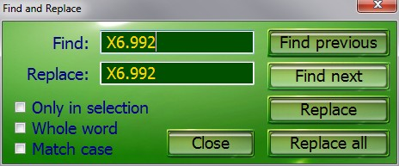
These commands are used to find text, and replace it if necessary. To open this panel, select "Find and replace" in the menu on the previous page.
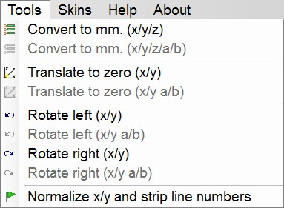

The operations of this menu, are performed throughout the GCode, and not only on the area of ​​Gcode selected.

There are operations useful to adjust the GCode, but it would be better to make them in the CAD and CAM, to keep “aligned” the whole chain of the project.

Reset GCode
All GCode should be reset in order to avoid the processing of the GCode “some where”.

But some GCode does not respond to reset command, even with the "Translate to zero", because they are written in a way doubly evil, with a displacement which plans to place the piece, roughly half machine. But even with some coordinates which are zero, leading the tip to slam, bottom left, against the limit switches of the machine, and lowering the tool until it touches the part.

To clear the GCode not able to be reset, you must manually delete (carefully) all the lines, which lead the coordinates to zero (usually at the beginning and at the end). Finally you use "Translate to zero" and check in the Toolpath, that zeroing is correct. If you make a mistake use "Undo" and try again.

Toolpath

Toolpath panel
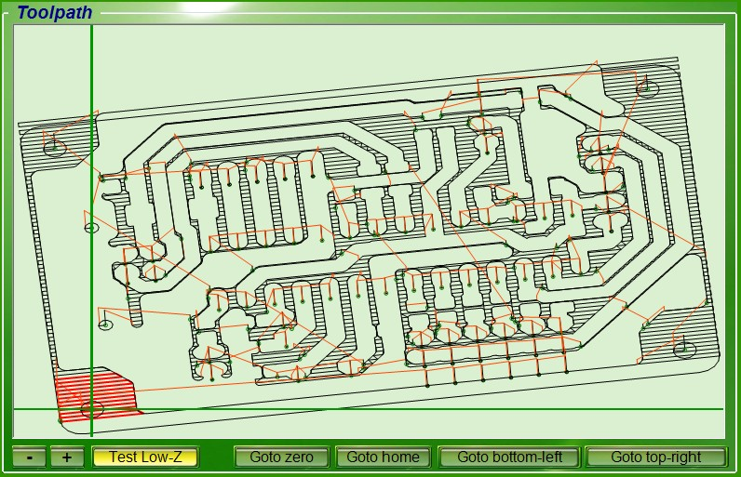

This panel displays the path of the tool (Tool-path) and the position of the tool during machining. This is not a real 3D (with DirectX or OpenGL) but of a schematic representation (perspective). Rather than impress with 3D images, we privileged the visibility, manageability and some not common characteristics, like the automatic tracking tool (When you zoom and GCode brings out the tool from the visible area).

The Tool-path also allows check Gcode without moving the motors. CAUTION: To disable the motors you should not turn off the HAL, but use the button "IN OUT enabled". So when restarting "IN OUT enabled" the coordinates of the software are realigned to the machine ones.

- Double-clicking on Toolpath, with the mouse left button, the Gcode is placed on the closest segment.
- Clicking the Toolpath, Right Mouse, runs an automatic JOG, to the point indicated by the cursor.
- With the mouse wheel zooms the image and then moving the mouse, you move the display area to explore the details and also to follow the tool during machining.

- + - With these commands, you can reduce and expand the text.
Test Low-Z - You are prompted for confirmation to the movements with Z less than 1 mm.
Goto zero - All axes go to their ZERO positions.
Goto home (first phase) - The Z axis goes to the HOME position (to clear also X and Y axes press again)
Goto home (second phase) - If Z is already in the HOME, then the X and Y axes go to ZERO.
Goto bottom-left - The axes X and Y move down to the lower left corner of the work piece.
Goto top-right - The axes X and Y move up to the top-right of the work piece.
In the "Goto" commands the motors move with speed "Rapid". The movement can be interrupted with STOP and can be changed, even before the end, with any movement command.

Keyboard Controls (manual JOG)

RIGHT and LEFT Arrows = Jog axis X
UP and DOWN Arrows = Jog axis Y
PAGE-UP and PAGE-DOWN = Jog axis Z
Letters Z and X = Jog axis Z <-- For keyboards without Page Up / Down
Letters A and S = Jog axis A
Letters B and N = Jog axis B
SHIFT + previous keys = Jog with speed “Jog speed SHIFT”
CTRL + previous keys = Individual steps, specified in the "Ctrl Jog (mm)"
ALT + previous keys = Thousandths of a millimeter, with auto-repeat

Arrows and letters used alone move with "Jog speed normal" rate (see the Options Menu)
While holding down SHIFT, the speed is determined by "Jog Speed SHIFT" (see the Options Menu)
Jog and SHIFT + Jog movements also act on several axes, those with CTRL and ALT only one axis at a time.

If the GCode panel is active, then the keyboard acts on GCode.
To enable the Jog instead of GCode, you click with the mouse in the frame of the Toolpath.
Prerequisite for the "JOG" is that "Rapid" is not greater than the slowest motor (settings "Max speed" motor HAL) and the settings of the motors (HAL) are correct.

Mouse Controls

Click on GCode
Select the line to be executed and the part already performed is highlighted in the graphics window.

Double click the left mouse button on the Toolpath
The Gcode is placed on the closest segment.

Click on the Toolpath with right mouse button
Jog is performed automatically to the point indicated by the cursor.
The axes which move depend on the type of view (perspective) currently selected and are always only two (XY, XZ, YZ, AB, AZ, BZ).
Be careful that the parallax can sometimes deceive (Z may be higher or lower than it seems).

Mouse wheel
Magnification of the graphic and, moving the mouse, shifting the displayed area.
Prerequisite for the movements, is that "Rapid" is not greater than the motor slower (settings "Max speed" motor HAL) and the settings of the engines (HAL), are correct.

Touchpad Controls
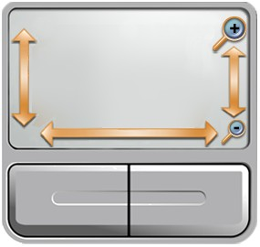
The right side of the pad, which simulates a mouse wheel, can act on the Toolpath zoom.

On some notebooks, especially with XP, this simulation does not work well (works only on the text of GCode and not on the graphics window).

In these cases go to:
Control panel
Mouse
Hardware
Property
Driver
Update Driver

And finally, use the search and automatic installation of the driver: "Allow the connection to Windows to search for software"

If you can not enable zooming on the pad, you can use the buttons “-” e “+” situated under the Toolpath window.

Adjust the zoom speed with the touchpad

Open:
Control panel
Mouse
Device settings
Settings
Virtual Scrolling
Scrolling long paths
Sliding speed

Finally adjust the slider. It is advisable to adjust it at about halfway.

Gamepad Controls
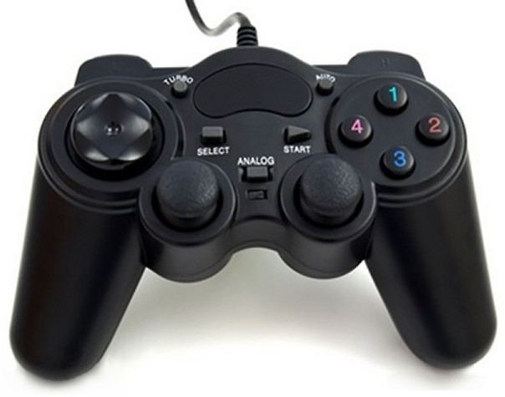

A GamePad may be useful on very large machines, when the distance between the keyboard and the tool makes it difficult to control the position of the tip.
There are also wireless GamePad, which can be carried comfortably, hung to the belt, when operating and setting the work pieces.
The GamePad is recognized only when the application starts. If you plug in after the start, you will have to close it and restart it.
- The "Stick" to the left moves the axes X and Y.
- The "Stick" to the right moves the Z axis (Or axes A and B, if they are present in GCode).
- The Stick follow a exponential law, For a better control the low speed.
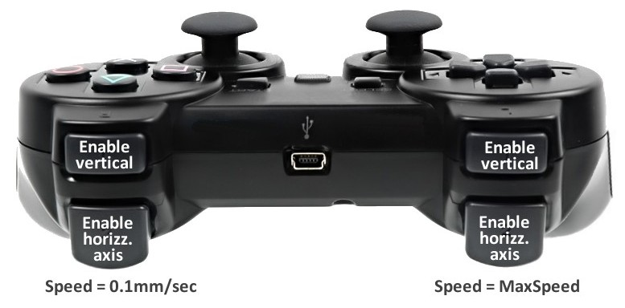
Enabling movements
For safety reasons the movements must be "enabled" pressing the rear buttons.
With the buttons on the left, the top speed is "Max-speed". With the buttons to the right, it is a tenth of a millimeter per second (precision movements).
The lower buttons enable the horizontal axes (X, E, A, U), the upper ones enable the vertical axes (Y, Z, B, V). To move both the horizontal and vertical axes, you have to press two buttons together. By pressing all four rear buttons you send a "Goto home" command.
Commands for controlling the operation
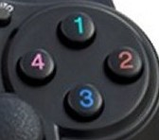
- The "1" button switch on and off the machine, via "IN OUT enabled".
- The "2" button activate "START" or puts it in "PAUSE".
- The "3" button makes a "STOP".
- The "4" button performs a "REWIND".
- The UP and DOWN buttons on the left (Point of View) magnify the Toolpath.
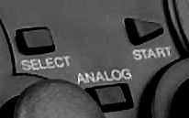
- The center left button, "SELECT" or "BLACK", select the "dead zone" of "Stick". The new value (from 0% to 20%), is indicated in the Toolpath. Not all Gamepad respect this regulation.
- The center right button, "START" or "GREY", overturn the axes of the second "Stick". The new value (from Type 1 to Type 3), is indicated in the Toolpath.
Which Gamepad ?
If possible a Wireless model, with four rear button and with small and precise dead zone. Make sure that it is PC compatible with USB or Wireless USB adapter. In eBay searches it is better to look for "Joystick" (there are more models). On this page we list some models and we prepared a test application :
http://www.theremino.com/downloads/uncategorized#gamepadtester

Toolpath Views
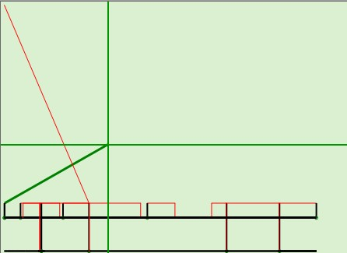
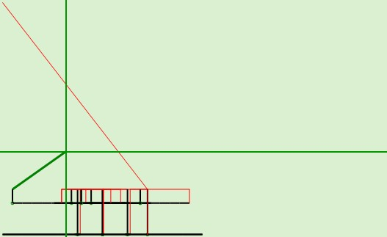
Up - Top View Front - Front View Side - Side View
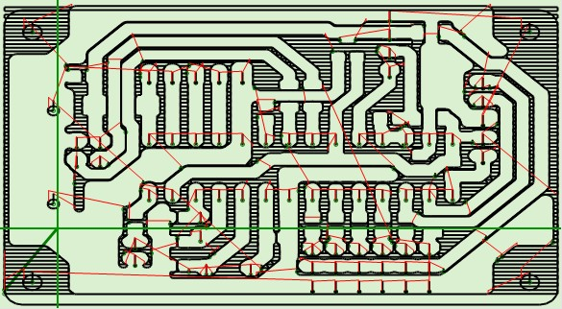
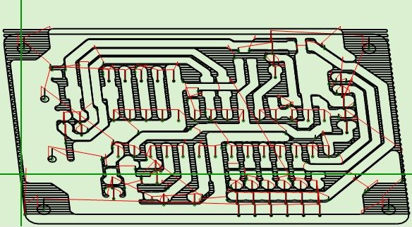
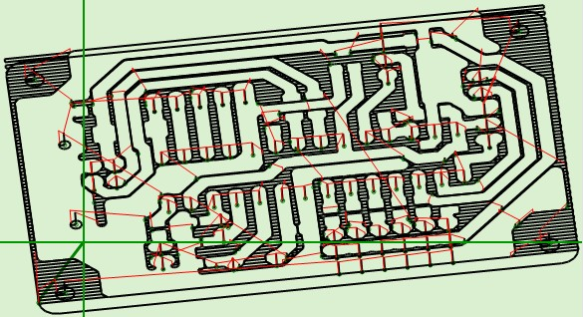
Frontal - From Above Isometric - 3D isometric Oblique - oblique 3D

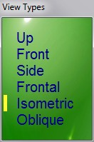

With this menu, you can choose the type of display.

If GCode includes axes A and B then three other views will appear (not shown here) :
- AB_Up
- AB_Isometric
- AB_Oblique

- - - - - - -

Because the toolpath is not a true 3D?

Short answer: Because the 3D should be done in CAD, not in CAM and let alone in the CNC.

Long answer: Even before publishing the first version, many people asked this question. So we carefully considered the pros and cons. Definitely a good thing would be the visual impact. But we are not here for “show” and we are not interested in selling. Rather we want to see clearly the path during processing and that the software would be valid also for educational purposes. So easy to use and easy to understand and with all trigonometric functions clearly written without calling DirectX or OpenGL.

These are not justifications. When the 3D is to be used we know how to, here are some of our achievements:
http://www.theremino.com/downloads/uncategorized#3D
http://www.fastvr.com/web/it/about_Gallery.htm
http://www.fastvr.com/web/it/downloads_Demos.htm
www.spray3d.it/new

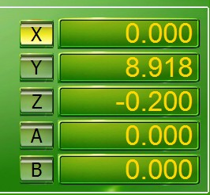
Initial reset

Pressing the buttons X, Y, Z, A and B, the numerical value of the corresponding axis is set to zero. By resetting the numerical values, the motors do not move.
Before resetting the axes, you move manually the tool tip, with the arrow keys and the Page Up and Page Down, in the position which will be the new zero.
Read in the previous page, how to make movements with the keyboard (manual JOG).
Prerequisite for the "JOG" is that "Rapid" is not greater than the slowest motor (settings "Max speed" motor HAL) and the settings of the motors (HAL) are correct.

Reset axes before pressing START
1) Move manually the tool to reach the position zero of the work piece.
2) set to zero the axes (usually X, Y and Z), with the buttons located to the left of the numerical boxes.
3) Raise the Z axis with Page Up, of a few tens of millimeters (not really necessary but it is better)
4) Check that "Feed & speed" and "Look Ahead" are properly set
5) Press the START (being ready to press it again if you have done something wrong)

Axis Z Reset
The axis Z usually requires special precision. It is advisable to use a sheet of aluminum or plastic 2/10 mm as a thickness gauge:
1) Lower the Z, with the right hand, slowly, with the Page Down
2) When the tip is very close, making the last step with CTRL - Page Down.
3) The gauge is held with the left hand, slightly tilted.
4) You will hear when the tip touches the gauge and then blocks it.
5) Raise the Z of one tenth, step by step, with CTRL - Page Up, until it is released.
6) Take off the gauge, lower the Z two-tenths, with two shots on CTRL - Page Down.
7) The axis Z is reset.

When you get used to the operation, you will find it fast and precise. Alternatively you could use the Auto Clear "Calibrate probe with Z", which is on the panel "Calibrations".

Retention of Reset Settings
A unique and very useful feature of Theremino CNC is the ability to remain aligned, even after turning off the machine, the software and the PC. If the position of the work piece remains the same, it is not necessary to repeat the zeroing at every start up.

Thus a skilled user, for example, can interrupt the machining and continue the next day.

Controls and Settings

Control Panel
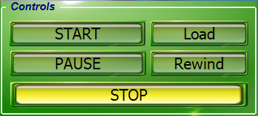

START
Starting execution.
Pressed again it switches to pause condition.
Double click on start lead to processing the smallest possible part of GCode.
This is very useful to make short test, a sort of "taste", before start working.

PAUSE
Suspension of processing.
The spindle motor continues to run and the signal of the refrigerant remains active.
But the signal ON-OFF, which could drive a laser, is disabled.

STOP
This command stops the machining.

Load
Opens the selection window to upload a GCode file.
This command has the same effect of the load command located in the menu and in the toolbar.

Rewind
This resets the execution point on the first line of GCode.
The execution point is the line which will be processed int the next start (START) and you can move it, even manually, both at the beginning and at every line of GCode.

Motor Panel (left side)
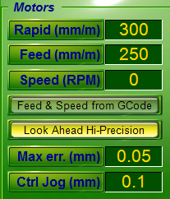
Rapid (mm / m)
This value is always specified manually. There are no codes of GCode amending it.

The value "Rapid" is used in the "fast" shifts (specified with G00). It is also used for the manual movements.

CAUTION: The "Rapid" should not be greater than the maximum speed of the slowest motor. If you exceed the speed specified in Theremino HAL, the firmware still protects motors from losing steps. However, the motors will remain late and manual movements will become difficult.

Feed (mm / m)
This value is the speed when moving to "work" (Feed). It may follow the GCode commands or it may be manually adjusted, depending whether the "Feed locked" is enabled or not.
Read also the appendix on processing speeds and trajectories.

Speed (RPM)
This value specifies the rotation speed of the spindle. It can follow the GCode commands or it can be manually adjusted, depending on whether "Speed locked" is enabled or not. You can also specify negative speed to turn the spindle counterclockwise (if the hardware allows it).

Feed & Speed locked
"Locked" means that the values of feed and speed can be adjusted only manually and not by Gcode. The command has four positions, to specify individual cases.

Look Ahead
- Look Ahead Disabled When you need to go very quickly, cutting the curves and jumping entire segments, to meet the MaxError established by the user.
- Look Ahead Enabled This is the normal operation mode, fast and accurate.
- Look Ahead Hi-Precision It follows exactly the path for all curves of 90 degrees and beyond.
- Stop every segment It is similar to the "Exact stop" of Mach3, it slows down the processing.
Read also the appendix on processing speeds and trajectories.

Max err. (Mm)
This value specifies the maximum error, reducing it lead an increase of the processing time.
Read also the appendix on processing speeds and trajectories.

Ctrl Jog (mm)
This value adjusts the pitch (in mm) of the micrometric manual movements. Micrometric displacements are obtained by holding down Ctrl and pressing the arrow keys Left, Right, Up, Down, keys Page Up, Page Down and the keys A, S, B, N.

Motor Panel (right)

Only the axes used in GCode are enabled to have the corresponding commands. To enable every axes, for example to test the motors, you can write a line without coordinates : "xyzab" among the first lines of GCode. In some GCode axes A and B can be called U and V. In GCode for 3D printers axis U is called E.

X, Y, Z, A, B
With these buttons you set the zero axis. You set the value 0.000 without moving the motor. Axes A and B may have different names depending on how they are called in GCode.

Numerical fields
The axis numerical fields show the position of the tool tip.

The numerical fields show three decimal positions after the decimal point with the aim to facilitate the reading but the calculations are made in "floating point double precision" (with 5D vectors). Also the GCode coordinates are read with all the available decimal positions (up to 16 decimal). (Note 1)

Values ​​are always in millimeters and they refer to the "Relative zero", also called "work piece Zero" (The position where the coordinates had been reset, either with buttons X, Y, Z, A, B or with automatic resets)

By clicking the left mouse button you can change the axis value, without moving the motors.

By clicking the right mouse button you can make small corrections, even during processing.

The next page shows the setting values and corrections panels.

(Note 1) Working with floating point numbers, (instead of fixed point numbers) is considered by some programmers like working in a uncertain, non-deterministic and therefore inaccurate manner. We think that the opposite is true. With float numbers precision is very high (around millionths of a micron). Instead the CNC which is working with fixed point numbers takes huge blunders when working on very small details. As an example, see the last picture of this article: building-a-low-cost-micro-milling-machine

Insert manually a coordinate
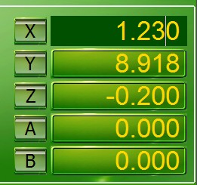

- Stop working with PAUSE or STOP
- Press the left mouse button
on the coordinate you want to changed
- Write the number with the keyboard
- Press ENTER (ENTER) key

Make small corrections during processing
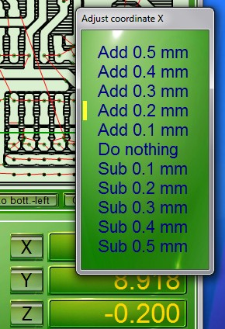

- Stop working with PAUSE, or STOP
- Press the right mouse button
on the coordinate you want to change
- Choose a correction value
- Press the left mouse button
- Restart processing with START

Axes A and B
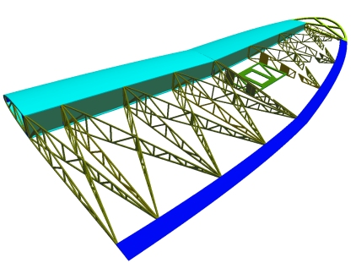

Image courtesy DevWing
www.profili2.com - www.devcad.com

Some people adopt the convention that the axes A and B are rotary axes, others use U and V instead of A and B, but also K and R (which are mixed with other parameters of GCode).

For simplicity, in Theremino CNC, axes have always the same names X, Y, Z, A and B, and all of them are equal to each other. If the GCode contains U and V, buttons A and B change their names in U and V.

In Theremino CNC, the axes A and B are not necessarily the axes of rotation. There are machines for cutting of the wings of aircraft, which have two axles on one side and two on the other. These machines could use the axes as in the following table:

X = horizontal left
Y = vertical left side
A = horizontal right side (or U)
B = vertical right side (or V)

Other machines, such as those for spraying concrete, that have only two axes. Other machines have five axes, and some of them rotate.

Thus, for Theremino CNC, all the axes are equal, and they are only numbers. Theremino CNC interpolates all axes, in a five-dimensional space. No matter whether they are linear or angular values, everyone will move at the right speed, and it will arrive at destination at the same time.

For the rotary axes the coordinate values are not millimeters but degrees, and the speed is not millimeters per minute, but degrees per minute.

This behavior does not prevent you from using rotary axes "indexed." Just type GCode appropriately, move only the indexed axis, then stop and move only other axes.

Calibration Panel
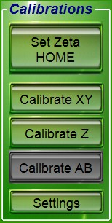
Set Zeta HOME
This command sets the position of the axis Zeta HOME to the current position. The axis Z is the only one which has, in addition to the zero position, also the HOME position. Usually you set the location of HOME at the top, and you use the "Goto home" at the end of processing, or to change the tool.

Calibrate XY
With this command the axes are moved, one by one, until they touch the limit switch. If in this space the tip does not meet the sensor zero then the zero cycle is interrupted. This ion order to avoid that, in case of error, the tip continues to descend without stopping. If you want to get down again, just press the button again. After activating the contact, the axis retracts to disable it and then retracts to another millimeter, for safety.

To stop the operation, just press the button again, or STOP, or the external emergency button, or the SPACE bar on the keyboard.

The direction of movement is always toward negative values, then left and bottom. The limit switch must be connected and functioning, otherwise the trolleys beat on the mechanical front stops and they will continue to push, until the distance "Max travel" is reached (Note 1).

(Note 1) Some authors wrote that stopping motors mechanically, they draw more current and they will be damaged or that may damage the controller. This is absolutely not true! The current does not increase, even decrease a little because the motor being stopped, does not generate over-voltage. So both the motors and the controller heat a little less and can keep pushing indefinitely against the mechanical front stops. This happens in machines which have the structure strong enough not to be bent.

Calibrate Z
By pressing this button, the vertical axis drops by a certain amount. If in this space the tip does not touch the zero sensor, then the zero cycle is interrupted. If you want to get down again, just press the button again. After activating the contact, the axis retracts to disable it and then retracts to another millimeter, for safety.
To stop the operation, press the same button again, or STOP.
The plate must be connected and working (see the appendix on the input signals), otherwise the tool tip will beat on the piece or on the table.

Calibrate AB
Virtually identical to the "Calibrate XY" command, but for the axes AB.

Settings
This button opens the adjustment panel of calibration parameters.
The calibration parameters are explained on the next page.

Tuning of calibration parameters
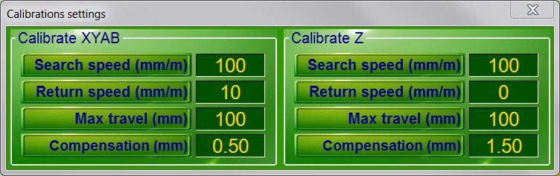

- The first panel adjusts the values for the calibration of the XY axes and AB axes

- The second panel adjusts the values for the calibration of the Z axis

Search speed
Speed of movement during the first phase of calibration. During the first phase the axes move, one by one, in the negative direction (coordinates that decrease) up to touch the limit switch or the zero plate. If you set the value "0" then the command is disabled.
Return speed
Speed of movement during the second phase of the calibration. During this phase, the axes make a slow back movement to pinpoint the exact point of detachment from the switch or from the plate. If you set the value "0" then the command is disabled.
Max travel
Maximum search distance. This is in order to avoid that, in case of error, the tip continues to descend without stopping. If the distance is not enough, the command is interrupted and you will hear a sound and an error message, just press the button calibration. If you set the value "0" then the command is disabled.
Compensation
At the end of the calibration this compensation values are taken into account.
- For the axes XYAB this value normally sets the tool radius in millimeters.
- For the axis zeta this value sets the width of the reset plate.
- - - - - -
Microswitch and / or plates of zeroing
The contact condition is signaled with one of the two following methods:
- A chain of microswitch, or magnetic contacts, connected in series and "normally closed". They are the same that are used to switch the end of emergency stroke. If you have good switches you can also overcome several millimeters and then you can set a "Search speed" rather high.
- One or more plates of zeroing, connected in parallel, which are connected to the tool. In this case the "Search speed" must always be very low.
Also read the section of Input signals, in the appendix pages.

The application Menu
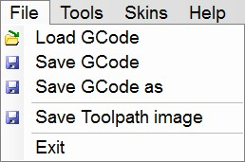
Menu "File"
Load Gcode - Loading of a processing file.
Save Gcode - Save the file.
Save as Gcode - Save the file with a new name.
Save Toolpath image - Save the image of the tool path.
Exit - Close the application. You can also use the white cross on a red background, in the upper right of the window.

Menu "Tools"
Convert to mm. - Converts any GCode from inches to millimeters. Version x / y / z / a / b, also converts the axes A and B.
Translate to zero - Move all coordinates, so as to bring the minimum coordinate to zero. The version a / b, also moves the coordinates A and B.
Rotate Left and Rotate Right - Rotate all the coordinates of 90 degrees, left or right.
The versions a / b, also rotate the coordinates A and B.
Normalize - Corrects the GCode to make it more readable, and easier to modify.
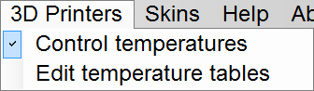
Menu “3D Printers”
This menu is explained in the last pages of this document (3D Printers appendix)

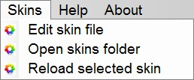
Menu "Skins"
Edit skin file - Open the color files.
Open skins folder - Open the button images folder.
Reload selected skin - Reload the file.

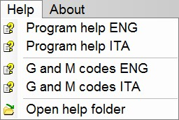
Menu "Help"
Program help - The manual in Italian and English.

G and M codes - These files show, in yellow, the implemented codes and explain the meaning of all codes.

Open help folder - In the Help folder you will find other useful information, including some links, to GCode sites and CNC machines.

The options Menu

The new “Options” menu, from version 4.4 upward, collects the less used commands.
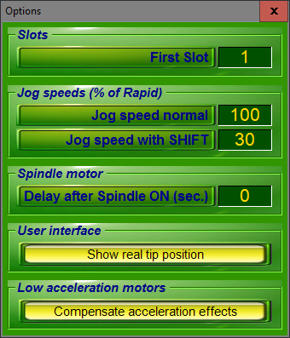
First Slot
This is the first slot to be used for the inputs and outputs. See the Appendix 9 - Input / Output Slots.

Jog speed normal
This is the “Jog” moving speed, see the Keyboard Controls. The range is from 1% to 100% of the “Rapid” speed.

Jog speed with SHIFT
This is the “Jog + SHIFT” moving speed, see the Keyboard Controls. The range is from 1% to 100% of the “Rapid” speed.

Delay after spindle ON
This value is a pause time in seconds and fractions. The pause is applied each time the spindle motor (Slot 11) and serves to allow time for slow motors to reach the working speed. Note that every time you switch to Rapid (G00), the spindle motor stops and then resuming machining there is a new pause. If you want a different behavior you set this value to zero and specify pauses (G04) at the desired points of the GCode.

Show real tip position
By enabling this option the toolpath the cross-hairs and the axes numerical coordinates show the actual position of the engines. Then you can visually check the path failure. To see the actual position of the motors the HAL must be active and connected to the Master. If you do not want to move the motors you can switch off the driver power supply.

Under normal conditions the position requested by the software and the real one are very similar for which the effect of this command is not very visible. But in some cases the motors are "left behind" and you can see significant differences between the location specified by GCode and the real one. To avoid these path errors you have to increase the acceleration or reduce the maximum speed in the HAL application (Max Speed no more than five or at most ten times Max Acc). It is also important to reduce the segment max lenght in the Cam post-processor.

Compensate acceleration effects
This option enables the compensation of the path errors, caused by low acceleration engines. See the Appendix 26 - Low accelerations compensation.

Tool Bar

Load
With this command you load a file.

Save
With this command you save the file.

Save as
With this command you save the file with a different name.

Skins
Since it is hard to please everyone, we added the possibility to change both the colors and the shape of the controls. Theremino CNC has already twenty Skins. To change skins (even during machining), just press the "Skins" button. If you are not yet satisfied with this menu you can even change the color files. What is more even the images of the Skins folder can be changed. And finally, you can also add new images and new skins.

View
With this command you select the display mode of the toolpath.

Status Bar
Line
Selected or running Gcode Line.

Total lines
Total number of Gcode lines.

Total time
Estimated time for processing. Very useful for experimenting with different parameter settings. This value does not take into account the starting position of the tip and the acceleration and braking of the motors. Normally the real-time processing is slightly higher, but it depends very much on the HAL acceleration set and how you adjust the Look Ahead parameter.

Time
The seconds used in the processing since the last START.

File
Currently loaded GCode File.

Motor settings in Theremino HAL
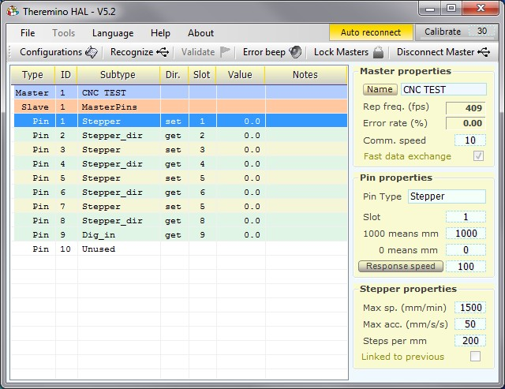
Checklist and motor adjustments:
- Control the frequency of repetition (at least 200 fps, but better 500 and over). If necessary increase the parameter CommSpeed (or decrease it to reduce the load on the CPU).
- Set the Pin-type "Stepper", they usually are 3, and they have to be in positions 1, 3 and 5.
Its "Stepper_dir" are automatically set and do not require any adjustment.
- Normally Slots for "Stepper" and "StepperDir" are left with the values 1, 2, 3, 4, 5 and 6 (check it)
- Check all Pin-type "Stepper". Select them one by one and check that the three values of the panel "Pin properties", are 1000, 0 and 100, and that the "Response speed" is disabled.
- For all Pin "Stepper", set the "Steps per mm" that depend on the number of steps per revolution of the motor (usually 200), multiplied by the number of microstep (1, 2, 4, 8, 16 or 32) and finally multiplied, for the pitch of the worm screw, or the ratio of the pulleys (usually x1, x2 or x4)
- For every Pin "Stepper", raise (try and test) "MaxSpeed", trying out the motors with the Slot Viewer (without tool). Up to detect the speed that makes "shelling" the motor (the motor sounds wiiiii and does not move), and after decrease of 20% to have a safety margin.
- For every Pin "Stepper", raise (try and test) "MaxAcc". Up to detect the acceleration that makes "shelling" the motor, and after decrease of 20% to have a safety margin. Normal values range from 20 ( heavy machines) to 200 (light and fast equipment).
To reverse the direction of movement of an axis swap values "1000" and "0" for the numerical fields "1000 means mm" and "0 means mm".
Finally we add some Pin of type "Dig_Out", "Pwm_8", "Pwm_16", "Dig_In" or "Dig_In_Pu", for the output signals and the input and set their Pin. As explained in the appendix on the InOut signals.

Adjusting values in the numerical boxes

The numerical fields of Theremino CNC (in general all Theremino applications), have been developed with the aim to be more comfortable and flexible than the original TextBox Microsoft (Note 1).

Example of numerical fields used in CNC Theremino

The numerical values are adjustable in several ways
- By clicking and holding down the left mouse button and moving the mouse up and down.
- With the mouse wheel.
- Using the arrow keys on the keyboard.
- Writing numbers with the keypad.
- Selection and copy-paste.

- Move the mouse up and down lead to large and fast regulations.
- The mouse wheel achieve an immediate and comfortable setting.
- Fine adjustments can be done with the arrow keys.

(Note 1) Like all our software, the source files are available (Freeware and open source licensed under the Creative Commons) and can be downloaded from here: www.theremino.com/downloads/uncategorized (See "Custom controls") These controls can be used freely in any project without mentioning name or source. The sources "Open" also serve as a guarantee that we have not included malware.

Multiple applications
Despite its simplicity Theremino CNC can do things that are usually not implemented in other CNC. For example, you can control more CNC machines, without interfering with each other.
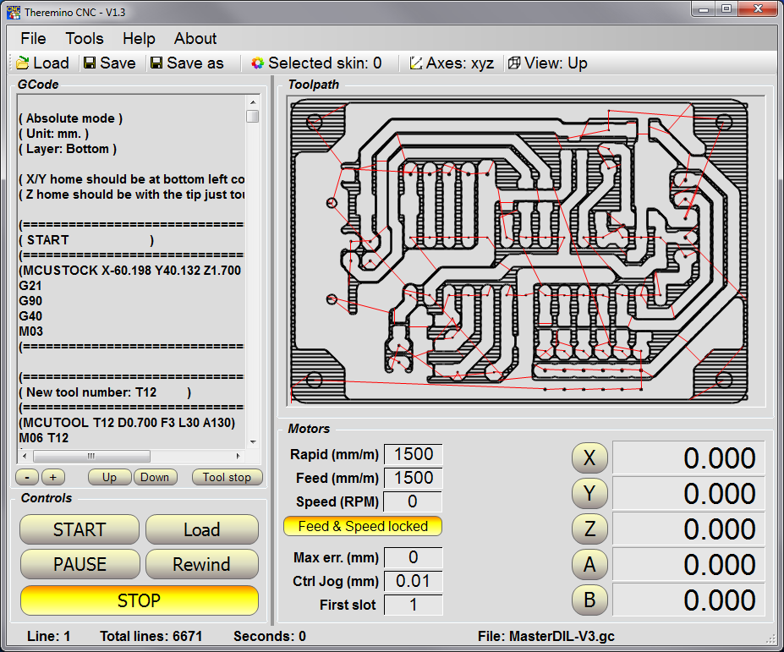
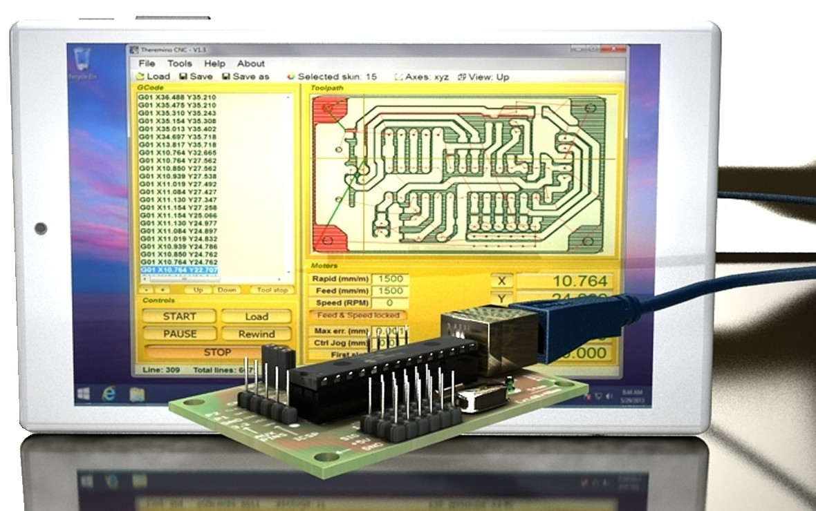
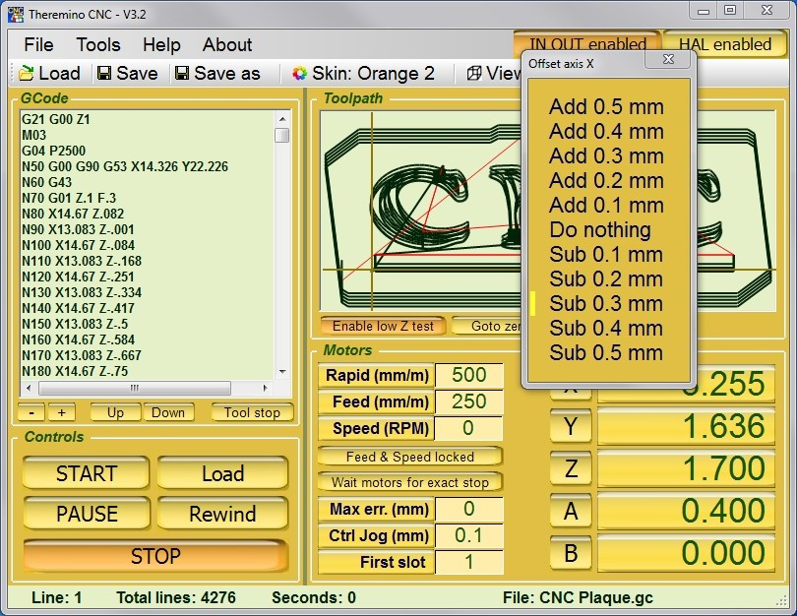
You can, for example, control a machine that processes wood, and simultaneously control a 3D printer. At the same time you could move manually a CNC milling machine using the JOG, reset it, upload new files and start the processing of a printed circuit board. Trying to do this with other CNC is virtually impossible. This is not due to troubles in parallel managing (Windows would bear even eight parallel threads) but mainly to their own drivers, which were written in a single thread.
Theremino CNC controls the motors by means of hardware, so it use the system CPU very little. There is practically no limit to the number of concurrent applications.
To keep the applications more independent from each other, each Theremino CNC must reside in its own separate folder, with its separate HAL and every HAL should be set to use a different Master. The Master should have different names and should use different Slots to communicate. Finally, HAL must have the "Lock masters" enabled, so that each of them can connect only to their Master.

Tips for less obvious functions
Start, Stop and Emergency
- The alignment of the machine remains valid even after turning off the machine and PC. It is not necessary to repeat the zeroing at every start up.
- Double clicking on the START button, the processing is started and immediately after paused. What you obtain is a step by step operation (it is performed only one line of Gcode or even only a part of the movement, in the case of long shifts).
- Doing double-click on the start button is useful in short tests and to be sure that everything is working well. For example to check that the spindle motor can start.
- During processing you can put the machine in pause, pressing START again. This allows you to keep the focus on the work without the need to move the mouse cursor.
- As emergency button you can also use the space bar on the keyboard.
- The emergency stop is not a normal STOP : the motors stop without slowing. So you lose the actual position and you will have to redo the zeroing axis.
- You can change the tip and then start again from every point in GCode (it is enough to click on a line of GCode and press START)
- STOP button shows the reasons for the stop.

Toolpath (toolpath)
- Double-clicking on the tool path, you can locate the GCode corresponding line (better enlarge first, with the mouse wheel)
- Clicking the GCode, the performed parts are highlighted (in contrasting color), in the frame that displays the toolpath.
- Unlike other CNC, the image of the tool path reminds performed areas (in contrasting color) and they are shown even after a perspective or size change.

Motion commands
- Goto bottom-left and Goto top-right does not move the Z axis
- Goto Home and Goto Zero also move the Z axis
- The difference between Goto Zero and Goto Home is only the vertical position of axis Z

Slots and First Slot
- First of all you have to match the HAL Slots, with those of Theremino CNC. If they do not match anything can happen.
- Make sure that "First Slot" corresponds to the first Slot on the HAL.
- The Slots are in a fixed sequence in CNC Theremino but they can be modified and sent by HAL to any PIN hardware.
- A same Slot can also control different motors (eg two motors in gantry).

Appendix 1 - Machining speed
The movement speed, "Rapid" and "Feed", can be set with any value, even very high value. The actual speed and acceleration of the motors, are then limited by the firmware (adjustments in the HAL application), because of this you can be sure that the motors never loose steps. But you should not set Rapid and Feed Speed to higher values than those set in the application HAL for the slowest motor.
At the beginning it is normal to have all the parameters not correctly adjusted. You have to test a lot in order to find a right balance. This balance depends on both the machine and the motors, on the HAL adjustments and the type of work that they do.
For a quick and accurate process, on normal machines, you should set:
- Rapid and Feed speed no more higher than slowest motor (normally from 100 to 3000)
- Feed as required by the processing (normally from 100 to 1000)
- Look Ahead enabled
- Max err = 0.05

Accelerations
The maximum acceleration has to be set in HAL, be very careful that the motors work well and take a safety margin. But it might be a good idea to set quite a low acceleration values (50 or less), in order to make the feed rate more stable. However it has to be in proportion to the maximum speed. On very fast machines (with toothed belt drive) you could set accelerations more than 500.
Rapid and Feed
You must not set Rapid and Feed Speed to higher values than those set in the application HAL for the slowest motor.. Otherwise the motors are not able to follow the speed and you lose control during the "Jog" (manual movements with the keys). Rapid should be set to move well with the Jog, while Feed should be set (manually or by GCode), according to the needs of the machining and the tool.
Max Err
MaxErr acts in two ways, depending on whether the LookAhead is disabled or enabled.
With LookAhead disabled, and very high MaxErr, It dramatically speeds up processing by cutting curves and even jumping lines GCode, if their segments are short.
With Look Ahead enabled (and this is the normal mode of operation), It specifies the maximum error, compared to the established route in GCode, and MaxErr is never exceeded.
If you set MaxErr = 0, then the path is exactly what is specified in GCode, but the processing time will increase a lot.
Look Ahead and Look Ahead Hi-Precision
By enabling the look-ahead, you can be sure that MaxErr will never be exceeded. The software will wait forever, that the motors slow down enough, cutting curves with error less than MaxErr. Hi Precision with sharp curves (90 degrees and up) are met with total accuracy (the tip passes exactly on the specified coordinate GCode).
Stop every segment
The motors are stopped always at the end of each segment, although the following segment proceeds straight.
The path is exactly what is specified in GCode, but the machining time will increase a lot.

Appendix 2 - The calculation of the trajectory
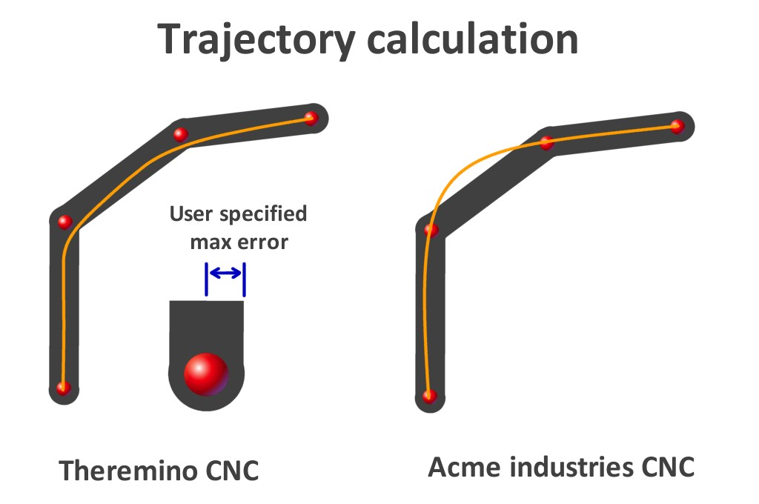
Theremino CNC uses the method shown in the image on the left: bend as soon as possible, as fast as possible, but without leaving the specified tolerance. In practice, before bending, it slows down the bare minimum and then "cut" the curve.
Others CNC calculate the trajectory in different ways. Some of them make a calculation called "Spline", they always pass in the centers of coordinates (image top right). This method does not guarantee to be always within the tolerance. The exact path depends on how the control parameters are adjusted.
Others, under a certain angle (user defined), do not make any control and above that angle apply a full stop, or slow proportionally to the change of angle.
Others, based on the maximum acceleration of each axis, calculate the speed up and slow down ramps and distribute these variations over the entire segment length. This lead to a continuously variable speed (not only the acceleration and deceleration parts as happens in other cases).
Theremino CNC MaxError zero
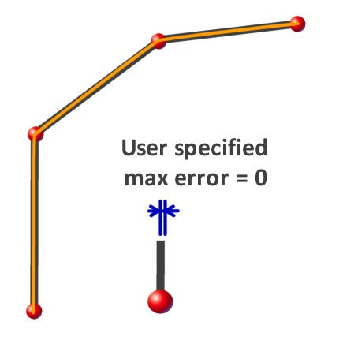

This image shows the path that you get, by setting to zero the MaxError parameter.
In this case, Theremino CNC guarantees that the trajectory passes exactly on the end points of the segments.
Of course if you set MaxErr to zero (or "Stop every segment" that has a similar effect), processing will be very slow.

Appendix 3 - Processing times
The processing time "Total time" is continuously updated, based on loaded GCode and on settings of "Rapid", "Feed" and "Feed locked" (but does not take into account the preparatory movements).
If the motors are turned off or disconnected or if you set "Look Ahead disabled" then the software waits for acceleration and deceleration. In these conditions the processing time is equal to the calculated "Total time" (or even lower if you rise a lot the "MaxErr").
If motors are connected and you use the "Look Ahead", then the processing time increases, with some tuning it could even double.
Some examples of machining times
Times measured on file "AdapterSplit5V.gc", with Rapid = 300, Feed = 300, Feed locked enabled, Max err. = 0.05 and accelerations = 50 mm/sxs
- Look Ahead Disabled: 60 seconds (exactly equal to the calculated "Total Time")
- Look Ahead Enabled: 64 seconds (+ 6%)
- Look Ahead Hi-Precision: 68 seconds (+ 13%)
- Stop every segment: 87 seconds (+ 45%)

Times measured on file "AdapterSplit5V.gc", with Rapid = 500, feed = 500, Feed locked enabled, Max err. = 0.05 and accelerations = 50 mm /sxs
- Look Ahead Disabled: 34 seconds (less than 36 sec calculated - Note 1)
- Look Ahead Enabled: 47 seconds (+ 30%)
- Look Ahead Hi-Precision: 51 seconds (+ 42%)
- Stop every segment: 74 seconds (+ 120%)
Note 1 - With "Look Ahead disabled" and "Max Err" greater than zero, you cut the corners and you can get processing times even lower than the calculated ones.

Which Look Ahead use
- Look Ahead Disabled - To be used rarely and carefully. If you increase MaxErr processing time will be shortened considerably, cutting the curve and jump whole segments. But the position and speed errors can become intolerable and you can even break the tools.

- Look Ahead Enabled - Fast processing and adjustable accuracy. Raising MaxErr and accepting small errors in position and velocity can greatly shorten the time. Adjust MaxErr rather low, usually 0.05 or 0.1 mm.

- Look Ahead Hi-Precision - This might be a good choice for all processes. The processing time increases only a little, but the feed speed is set with precision and the tool passes exactly at the coordinates in tight bends (angles of 90 degrees or more). Adjust MaxErr rather low, usually 0.05 or 0.1 mm.

- Stop every segment - This setting is seldom used. For each line of GCode stop all the motors. MaxErr is disabled and the tool follows exactly the coordinates.

Appendix 4 - Implemented Functions
G00 = Rapid mode
G01 = Work mode
G02 = Clockwise circular interpolation
G03 = Counterclockwise circular interpolation
G04 = Dwell time specified by prefixes or U P (U = seconds, P = milliseconds)
G05 = Progress Stop (Pause)
G09 = Exact Stop - not modal (manual in Theremino CNC)
G17 = Working on the X / Y level
G21 and G71 = Millimeters mode
G28 = Goto HOME (Meaning different in some machines. Read the appendix on the G28)
G40 = Cancellation of tool compensation
G49 = Cancellation of tool length compensation
G61 ... G64 = Enable and disable exact stop
G62 = Automatic corner override (automatic in Theremino CNC)
G80 = Erase "canned" cycles
G90 = Absolute coordinates
G91.1 = Return to normal incremental mode for parameters I / J / K
G92 Enn = Set the extruder to valore nn (without moving the motor)
G93 = "Inverse time" mode (F = 1 / duration of the motion in minutes)
G94 = Back to normal feed mode (F = mm / min)

M00 = Program Stop (Stop)
M01 = Optional Program Stop (Pause)
M02 = End of program (Stop)
M03 M04 = Spindle Rotation clockwise (M03) and counterclockwise (M04)
M05 = Stop spindle rotation
M06 = Tool change
M07 = Refrigerant 1
M08 = Refrigerant 2
M09 = Stop refrigerant
M10 M11 = Work piece Locking and unlocking
M13 M14 = Activation refrigerant 1 and spindle rotation clockwise (M13) or anticlockwise (M14)
M19 = Spindle orientation, in degrees, defined by the letter "C"
M30 = End of program (Stop)
M31 = Suspension (Pause)
M41 ... M44 = Speed ranges
M50 = Refrigerant 3
M51 = Refrigerant 4
M84 = Machine disable (acts on the “IN-OUT enabled” button)
M99 = End of subroutine (Stop)

() = Comment
F = Feed speed
S = Spindle rotation speed
N = Number of line
I, J, K, R = Circular interpolations parameters
X, Y, Z, A, B = Destination for each axis (are also valid U and V that are translated into A and B)
C = Rotation Z axis (in degrees) for spindle orientation.
Implemented functions - 3D printers specific functions

M 82 - Set extruder to absolute mode (default for 3D printers - does nothing)
M 84 - Disable motors

M 105 - Read the current temperature (system implemented - does nothing)

M 106 - Fans ON
M 107 - Fans OFF

M 104 - Set the selected extruder temperature (Example: M104 S190 - temperature = 190°C)
M 109 - Set the selected extruder temperature and wait (Example: M109 S215 - temperature = 215°C)
M 140 - Set print bed temperature (Example M140 S190 - temperature = 190°C)
M 141 - Set chamber temperature (Example: M141 S90 - temperature = 90°C)

- - - - - - - - - - -

The temperature control tables are in the file “TemperatureTables.txt”, acccessible by the menu “3D Printers”.

Instructions for temperature sensors and tables are in the Appendix 23

Appendix 5 - Not Implemented Functions

As stated in the presentation, Theremino CNC implements only the basic functions. We do not want it to become, like other applications, so complex to need to to ask for help to “San Gennaro” in order to use it.
All not implemented codes could be replaced by only G00 and G01, just instruct the CAM post-processor. Twenty years ago there were floppy disks, but today in 2015 no longer makes sense risking errors just to save something like 100K in the memory occupation of the file.
In the Theremino system it is possible to use an automation programming language which is more advanced than GCode. The hardware and software modularity allows you to program complex systems and write complex algorithms, virtually not possible in GCode. For example read the Web-cam or program a PID with analogue sensors. (Note 3)
G53 G54 (and all codes that indicate machine coordinates and work piece coordinates) - Theremino CNC always works in relative coordinates (work piece coordinates). No machine coordinates.
Codes from G41 to G59 - The tool diameter compensation (from G41 to G52) is done in the CAM (Note 1). With Theremino CNC the zero offset (G54 to G59) are performed manually with JOG (Note 2). Using inches or incremental programming, coordinates GCode are different from the actual coordinates of the tool, with all the difficulties that come with it. Drilling cycles (G81 to G 89) work, but Theremino CNC does not consider them different from other processing cycles.
Codes from G61 to G83 - For example the G83 specify that the tip must go down a number of times and each time trace a little "backed off a bit", http://linuxcnc.org/docs/html/gcode/gcode.html#sec:G83-Drilling-Peck. But this "a little" of a machining operation, may be a "too" for another. Also allowing the G83, would open the door to a Pandora's jar of possible bugs, because then you enqueue the G82, G81, G76, G73, G64, G61, which are also different on different machines. It is better to tell the CAM to replace everything with G00 and G01. This will make the CAM itself to be the owner of any movement and can adjust the "a little" in the best way, for each job.
Backlash compensation - A "patch" that creates more troubles than it solves - By Mach3 manual: ".... Compensation is a "last resort" when the mechanical design of your machine .... can not overcome problems with the machine in continuous cutting .... by using the constant speed is lost .... Mach3 does not respect most parameters of acceleration and you risk losing steps ". From the original manual Mach3: "Backlash compensation is a "last resort" when the mechanical design of your machine .... it can not overcome problems with the machine in continuous cutting. ... Using Generally it will disable the "constant velocity" features at "corners". ... Mach3 Able you is not fully honor the axis acceleration parameters .... When compensating for backlash so stepper systems Generally will have to be detuned to avoid risk of lost steps. "
(Note 1) A CNC application does not know the size of the tool and not even the shape and position of the work piece. Writing parameters disguised as comments is a distortion of the meaning of GCode that, rightly, not provides for them.
(Note 2) Place pieces side by side depends on the size of the raw part that is available. Fixed positions in GCode do lose more time than they save. When you make a habit to use the JOG manual, make more pieces in different locations is easy and immediate.
(Note 3) GCode is not a good programming language, it is not structured and uses commands like GOTO, well known for generating “spaghetti code”. In Theremino system the automation software is written in modern languages, objects and structured (VB6, VBNET, C ++, CSharp, Python, Theremino Script, Theremino Automation, MaxMSP etc ..)

Appendix 6 - The circular interpolations G02 and G03
We have implemented the circular interpolations because many have asked. But we have never liked them and still we do not like them. They are implemented well and work exactly how they should work, but our advice is not to use them. They have inherent flaws in the definition of the command:

- It is not possible to use them on machines with 3, 4 or 5 axes, if not with a "indexed" functioning. In other words, G02 and G03 move up to two axes at the same time, and the other axes must necessarily stand still. Instead, G00 and G01 movements are true multidimensional and can move a single axis, two, three, four or even all five axes simultaneously.
- G02 and G03, being limited to only two axes, are operated separately, and disturb the smooth functioning and the multidimensional calculations of Look Ahead. The movements on several axes is necessarily split across several Gcode lines and then it will be performed indexed (an euphemism not to say "jerky"). With G02 and the G03 the indexed operation is inevitable, it happens on any CNC, not only on Theremino CNC.
- The parameters that defines the circle arc are inconsistent. For example it is possible that the destination contradicts as specified by the origin and by the center of rotation. So what should you do? Discard the command? Ask the user what to do? Stop processing and ruin the piece? Run the same command and scratch the piece? Some may say that a warning is enough and let the user correct the command. But usually it is just inaccuracies due to rounding. And the user should do difficult trigonometric calculations. It is better to avoid them and use only commands that are internally consistent.
- There is also a version of G02 and G03 that specifies the radius, instead of the center of rotation. The intention of those who designed this version of the command was to eliminate the inconsistency of the parameters. It is a pity that with this version you can not do a full circle, and that to do is to break the circle in three lines, or use the inconsistent version of the command.
- On some CNC it is not possible to make a circle, not even with the version of G02 and G03 which specifies the center of rotation.
- In the command definition the rotation direction is not clearly established. The direction is defined as "clockwise" or "counterclockwise", but what does "clockwise" mean in a multidimensional environment? Where is the observer compared to the bow, in front, behind, above or below? We solved this problem by copying exactly the behavior of METACUT and Mach3. But we found some GCode examples which are run by Mach3 in a certain direction and by METACUT in the opposite direction.
- We also found cases of G02 which METACUT performs regularly but Mach3 not. Probably the parameters have minimal inconsistencies, due to rounding, but Mach3 instead of giving an error, simply skip them and go to the next line.
- Internet is full of cases of problems caused by codes G02 and G03. Look for "G02 errors" and you will find that they have caused any kind of defect. And these are not small flaws, the tool may break or do even worse damages, because it is in a completely different position than the calculated one.
In conclusion, G02 and G03 are born evil and are not essential. Just tell the post-processor of the CAM not to use them and the only disadvantage is that you have files a bit 'longer. When you used the floppy disk from 700k, 100k savings could be useful, but now it no longer makes sense.

Appendix 7 - HOME Controls (G28 and following)
Caution: Do not trust HOME command. They may be performed differently from how you are used to. In some GCode you may need to add one or more preparatory movements.
Since Theremino CNC is a generic application (for cutters, 3D printers, cutting polystyrene, laser cutting, engraving and special machines) preparatory movements, useful in some cases, may be arbitrary and dangerous in others. So Theremino CNC does not perform preparatory movements, when it meets a G28 code it goes directly to the home point.
To avoid interference with the work piece it may be necessary to precede the G28 with:
- G00 ZNN (to lift the tip up to a security level)
- G00 X0 Y0 (if you want that the movement to zero X and Y precedes the movement Z)
- - - - - - -
Implementations variables command from G28 to G32
We have implemented the command G28 because it is widely used, but its implementation will change on different machines.
- G28 - Go to Predefined Position (Linux CNC)
- G28 - Goto Home (Machine for 3D printing trade)
- G28 - Machine zero, aka machine reference point (Wikipedia)
- G28 - Goto Home Location coordinates (Manual Mach3)
- G28 - Moves to the supplied axis back to the zero end stops as quickly as it can (RepRap wiki)
As you can see it is not always the same point, it may be the "Machine zero", or a predefined point by another GCode, or a point that you specify in certain fields of the application (Mach3).
Also there are no rules whether the route should be performed in 3D, or if some axis must be moved before others. And in this case which axis you must move first. And what the axes A and B have to do for machines cutting polystyrene.

The G28.1 that means Home position on some machines, is instead starting a scan of the reset switches on other machines.

The commands of the secondary HOME (from G30 to G32) are even more variables (test of the printing level on some machines, skip the measurement functions on others).
- - - - - -
We verified what they do in practice some machines and found very different behaviors.
For example, a Cubex (3D printer trade) when process a G28 makes these movements:
- Moves the plan down to 10 mm
- It moves the X and Y together until X = zero and Y = zero
- Move the floor up to Z = zero
The preparatory movement of 10 mm (which is safe for a 3D printer) could instead be dangerous (or worthless or not enough) for a cutter. And before moving X and Y of Z, it could cause a collision with the work piece.

Appendix 8 - Theremino CNC Adapter
Caution: This adapter does not work with Linux or with Mach3 CNC, unless someone will write a Plug-In. We will not do it, both because we prefer the simplicity of Theremino CNC and because we have not enough knowledge of Linux and Mach3 CNC.
The machines prepared for Mach3 CNC or Linux, normally are connected via the "Parallel" port. Today the parallel ports are virtually extinct and you have to simulate it with expensive PCMCIA adapters. In addition creating the steps, one by one, directly with PC, leads to a large instability of the pulses.

To connect the machine via USB port, you could redo the wiring and provide it with a Master and a USB port. Or you can unplug the cable from the parallel, connect it to a "Theremino CNC Adapter", and start working immediately.

On the Theremino site is explained how to build this adapter. We report here some information for ease of reading.

Adapter for CNC machines
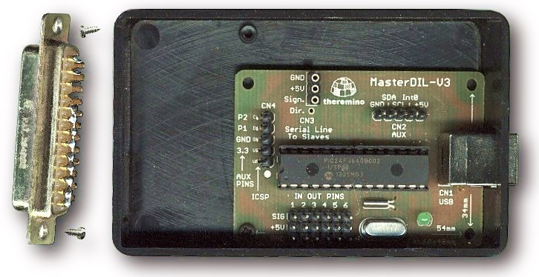
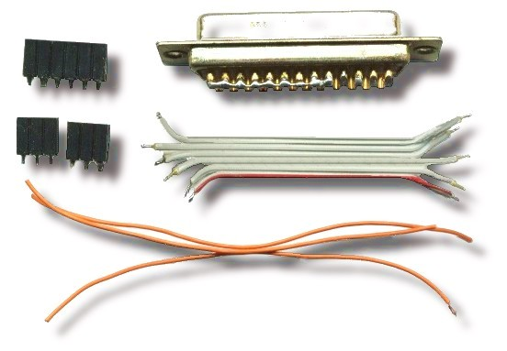

Here we see the preliminary stages of the adapter construction.

You need some wire (small and soft), a DB25 female connector, two small screws, three female connectors at 2.54 (two three-pin and one six pin), a master module (with firmware version 3.2 or later) and a small plastic box.

The box of these images is a Teko 10011 (Size 90 x 56 x 23 mm), you can find it for 2 Euro, including VAT, for example from Webtronic. The venue for the DB25 connector, is a rectangle 41 mm wide and 11 mm high.

The wires should not be directly welded to the Master but instead to the connectors. Use only good quality connectors. The connectors are of good quality when they are turned and have round holes. The connectors with rectangular holes are not reliable. Do not be fooled by sellers, who sell them for Arduino. The strips of connectors with square holes make contact by miracle when they are new. But as the time goes by they oxidize, lose elasticity and no longer make contact in a reliable manner, as explained here.

Before starting the wiring, all the wires and the connectors must be stripped and welded with care, with good tin alloy, with lead and flux, as explained here.
Connections between Master and DB-25 connector
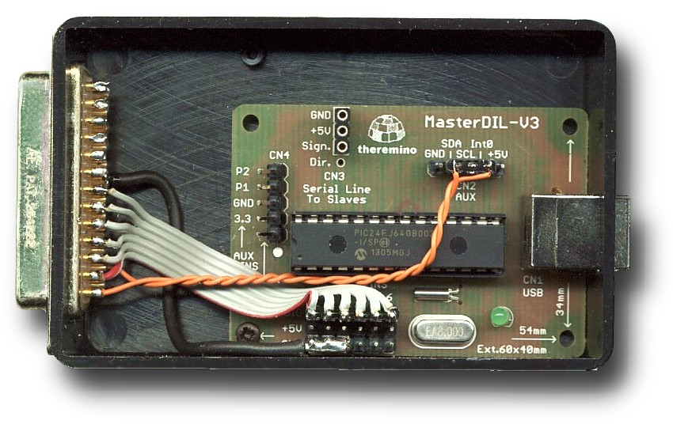

In this example, in addition to the classical signals for the axes X, Y and Z, we have connected two wires (orange) for the emergency stop and for the speed control of the spindle motor.

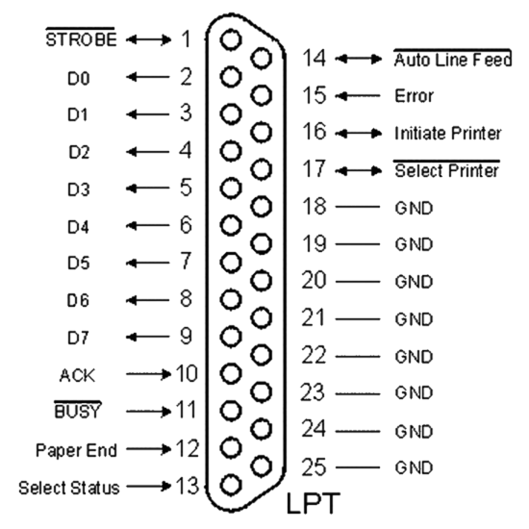
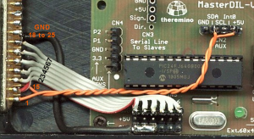

These pictures show the connections between Master and DB-25 connector.

Master Pin for X, Y and Z :
X = 1 (step)
2 = X (direction)
3 = Y (step)
4 = Y (direction)
5 = Z (step)
6 = Z (direction)
7 = A (step)
8 = A (direction)
9 = B (step)
10 = B (direction)
Warning:
- The STEP and DIR output are fixed (not modifiable by software).
- The parallel port pin for the axes X, Y and Z, ranging from 2 to 7 and not from 1 to 6, as on the Master.

Appendix 9 - Input / Output Slots
The numbers in the first column are the Slot and it is assumed that you set "First Slot = 1".
The same Slot must be set in Theremino HAL, in In and Out connection pin.

01 OUT - Axis X - Destination (mm)
02 IN - Axis X - Distance from destination (mm)
03 OUT - Axis Y - Destination (mm)
04 IN - Axis Y - Distance from destination (mm)
05 OUT - Axis Z - Destination (mm)
06 IN - Axis Z - Distance from destination (mm)
07 OUT - Axis A - Destination (mm)
08 IN - Axis A - Distance from destination (mm)
09 OUT - Axis B - Destination (mm)
10 IN - Axis B - Distance from destination (mm)

11 OUT - Spindle motor or laser (1000 = ON / OFF = 0) - ON in the phases of work
12 OUT - Spindle motor speed (RPM from -99000 to +99000) - Specified by "S"
13 OUT - Spindle CW (= 1000 ON / OFF = 0) - M03 M13 (ON) M05 (OFF)
14 OUT - Spindle CCW (1000 = ON / OFF = 0) - M04 M14 (ON) M05 (OFF)
15 OUT - Tool number (0, 1, 2, 3 ...) - M06 (T = tool number)
16 OUT - Cooling1 (1000 = ON / OFF = 0) - M07 (ON) M09 (OFF)
17 OUT - Cooling2 (1000 = ON / OFF = 0) - M08 (ON) M09 (OFF)
18 OUT - Cooling3 (1000 = ON / OFF = 0) - M50 (ON) M09 (OFF)
19 OUT - Cooling4 (1000 = ON / OFF = 0) - M51 (ON) M09 (OFF)
20 OUT - Pallet Clamp (1000 = ON / OFF = 0) - M10 (ON) M11 (OFF)
21 OUT - Orientation of the spindle (in degrees) - M19 (C = degrees)
22 OUT - Gear speed range (1, 2, 3, 4) - M41 M42 M43 M44
23 OUT - General enable of the machine - M84 and button "IN OUT enable"
24 OUT - Enable accessory devices - ON with START / OFF with STOP

31 IN DigIn - Emergency Stop (0 = OK / 1000 = Emergency)
32 IN DigIn - Chain Limit (0 = OK / 1000 = limit)
33 IN DigIn - Sensors for zeroing (1000 = open / 0 = contact)
34 IN DigIn - Sensor for the line SKIP (0 = normal / 1000 = skip the line) (Note 1)

Any unused Input Slot must be left free (No associated pin in HAL).
Slots for the 3D printers
41 OUT - SlotHoldingForce Pressure fixing - M142 (S = pressure)
42 OUT - SlotCoolingFans Cooling fans - M106 (ON) M107 (OFF)
43 OUT - SlotHeaterAmbient Heater air ambient - (Note 3)
44 OUT - SlotHeaterChamber Heater air chamber - M141 (S = temp.) (Note 3)
45 OUT - SlotHeaterPrintBed Heater printing table - M140 (S = temp.) (Note 3)
46 OUT - SlotHeaterExtruder1 Extruder heater 1 - (Note 2) (Note 3)
47 OUT - SlotHeaterExtruder2 Extruder heater 2 - (Note 3) (Note 3)

51 ADC IN - SlotTempAmbient Room temperature sensor - (Note 3)
52 ADC IN - SlotTempChamber Sensor chamber temperature - (Note 3)
53 ADC IN - SlotTempPrintBed Sensor temperature of the platen - (Note 3)
54 ADC IN - SlotTempExtruder1 Extruder temperature sensor 1 - (Note 3)
55 ADC IN - SlotTempExtruder2 Extruder temperature sensor 2 - (Note 3)

(Note 1) If the Slot 34 value is more than 500, and the present movement is linear, then the movement is interrupted and the execution jumps to the next line. This function acts one time only and will be 'rearmed' when the Slot value decreases below 500.
(Note 2) The temperatures of the extruders 1 and 2 are determined by the commands M104 (s) and M109 (s) acting on the previously selected extruder (with the T command). M104 not wait while M109 does waits.
(Note 3) The temperature control tables are in the file “TemperatureTables.txt”, acccessible by the menu “3D Printers”. Instructions for temperature sensors and tables are in the Appendix 23

Master Module InOut PIN
Pin position in the Master up to version 3
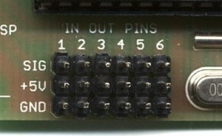
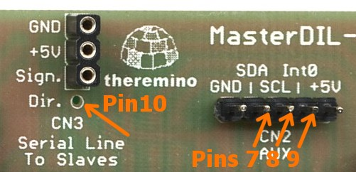
The first image shows the first six and the second the Pin 7, 8, 9 and 10.

In the version 4 Master the Pin are more visible
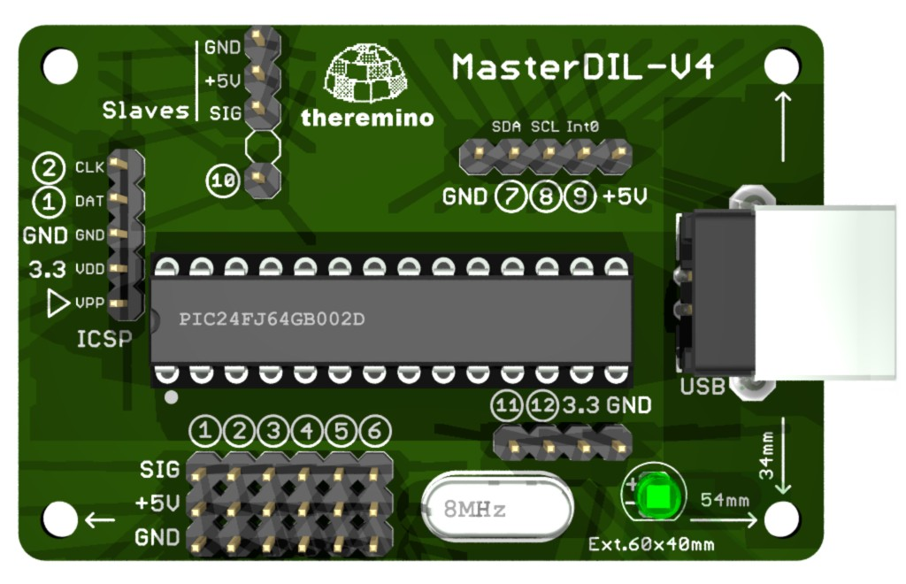
All have the Pin number and are marked with a circle.

Requirements for the Pin-type Stepper
- HAL version 5 (or higher): http://www.theremino.com/downloads/foundations#hal
- Master with updated firmware: http://www.theremino.com/technical/schematics#master
- Check in HAL the list of "Master Pins", it must has 10 items. If it appears only 6 pin, the Master has the old firmware, without stepper.

Output signals

The output signals are valid even if the process starts from an intermediate GCode line. At the Start time the control codes are searched backwards in GCode and the most recent is used. If a code is not found its output signal is turned off ( Slot value = 0).

The signal of the Slot 11 is controlled only by the application and during work is always on. It serves to control laser and similar tools, it is turned on during processing and switched off during rapid movements.

With some CNC every time you press START, you are living a moment of fear: "The spindle motor will turn on? Or maybe in GCode is missing the code to start it, so it will not move and I will break the tool?". But Theremino CNC has this signal, which is turned on by the application and not by GCode. So (if you prefer) you can configure the hardware, for the lighting of the spindle, not be dependent on GCode. With appropriate AND and OR (hardware or software), the ON-OFF signal with the other output signals, you can generate suitable signals for machines of any type (laser, cutting, spray, etc ...)

The signal of the Slot 12 is controlled by the "Speed RPM" filed and also from GCode if "Feed locked" is disabled.

The signals of the Slots from 13 to 20 are controlled by M codes:
- 1 output tool change, with the number (Tnn) tool (M06)
- 4 separate outputs for refrigerants (M07 M08 M50 M51) (M09 and to turn off)
- 1 output for locking and unlocking of the piece (M10 and M11)
- 1 out of spindle orientation in degrees (M19)
- 1 output for 4 speed ranges (gear) (M41 M42 M43 M44)

Auxiliary connections
A single Master, in addition to the axes X, Y and Z, can control other four signals, with Pin 7, 8, 9 and 10. These signals can be generic IN-OUT or can control other two motors (in Theremino CNC they are called A and B). The special connection, for controlling the spindle speed, for the power of the laser, for the emergency button and switches for end stroke, are to be studied from time to time. Follow the links, which were made by Mach3, the list "Ports and Pins" in Mach3, and InOut table on the previous page.
ENABLE signal of the motors
The controllers have always an "Enable" input and it is natural to ask where to connect it. We recommend that you DO NOT connect to the software. This saves a Pin, which might be more useful for other functions, it also increases the security of maintaining alignment with the motors.

Theremino CNC remains aligned to the motors and it does not require constant resets. Even after turning off the machine and after turning off and restarting the PC, it remains aligned. You can do tests with power off, using the button "IN OUT enabled", which restores the coordinates when it is enabled again.

But if you disable the HAL or if you turns off the power of the machine and perform a movement the alignment is lost. So we recommend this sequence: (1) Turn on the machine, (2) Start Theremino CNC, (3) Work without turning off the machine or motors, (4) Turn off Theremino CNC, (5) Turn off the machine.

To check GCode, edit and execute it without motors it is better to prepare a copy of Theremino CNC, in a separate folder and use it with the buttons "IN OUT enabled" and "HAL enabled" always off.

Input signals
Emergency Button
The machine emergency button should act directly on the power supply of the machine, so it will work even if the computer is off or software is not running. If you really want to connect it to the software, it must be "normally closed", and you should set its Slot as 31. For wiring see the diagrams on the next page.
WARNING: The emergency button should be used only for true emergencies, because it stops instantly the motors and it makes losing the position reference (the zeroing and calibration). Normally PAUSE and STOP buttons should be used, which maintain valid motor locations, thus allowing to restart without redoing the zeroing.
Limit Switches
The limit switches must be connected in series and "normally closed". You have to set their Slot as 32. For wiring see the diagrams on the next page.

The switches are connected in series, in a single chain (Note 1). There are no reasons to waste three (or even six) inputs for these functions. Double it is even more pointless , as some suggest, and allocate a series of switches to the end of stroke and other emergencies (Note 2) (Note 3).
(Note 1) The software always knows which way each motor is running so separate connections are not needed.
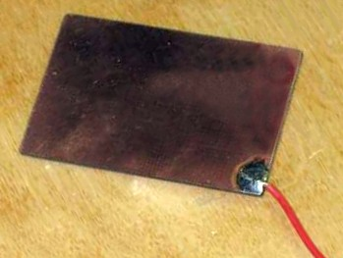
(Note 2) When the software is zeroing it comes to be end stroke, when it is working it comes to be emergency.
(Note 3) If you have precision switches for zeroing, they can also be used for the emergency.
Sensor zeroing Zeta
The sensor consists of a rectangle of epoxy glass, copper on the upper face. On one side of copper a long wire is welded, the wire goes to an input Pin.
To make accurate and fast zeroing, the sensor is positioned manually on the work piece surface. Then you get off the tip with Page Down, up to about five millimeters from the surface of the sensor, and finally, you press the "Calibrate Z".
Pressing the "Calibrate Z", the Z axis is moved down (towards negative coordinates), until the tool establishes an electrical contact with the plate of zeroing.
This type of sensors may not be exceeded (at most a tenth of a millimeter). You must then set a low search speed and go down with the tip close to the sensor, to shorten the search.
For the operation of this sensor, it is necessary that the spindle motor and thus the tool also are connected to ground. Normally this is so but it is better to check it.
This type of sensor is "normally open" and must be addressed to Slot 33. For wiring see the diagrams on the next page.
Sensors axis zeroing Zeta also used for X, Y, A and B
A sensor with two vertical walls could do the "zero point" for the axes X and Y.
With more sensors (connected in parallel to the same wire input) you could also reset the axes A and B.

Wiring diagrams for all ON-OFF inputs
The machine can produce strong electrical noise and handling the Z-axis reset plate can cause static discharges. The Master is protected and never breaks, but in rare cases it could happen to interrupt the serial or USB connection.
The output connections (for example, the signals for stepper motors or opto-couplers or relays) do not need these expedients, only the input signals might need it.
So we will show two possibilities, a direct connection (for small machines) and a connection through the resistors, which eliminate every problem, even in the most difficult cases.
Easy connection
WARNING: In this case, the Pin must be configured as "Dig_In_PU" (with pull-up).
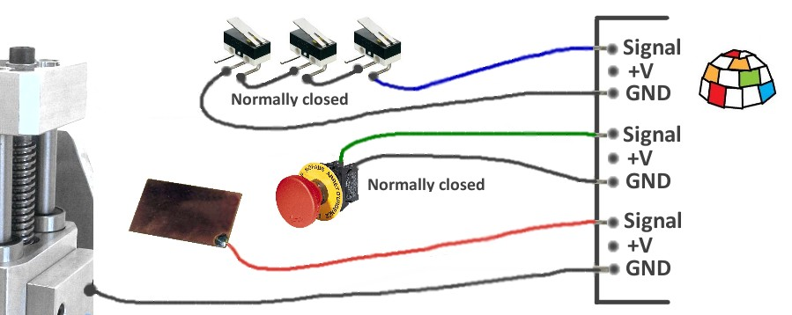
The wires from the reset button, the limit switches chain and the reset plate, connect directly to the SIGNAL Pin. The second thread of the buttons and of the switches chain, must be connected to ground (either to the GND of Pin or to the mass of the machine). The mass of the machine (set of mechanical parts) is to be connected to GND of a Pin (preferably through a resistor of 10 ohms - 2.1 Watt).
Over-voltage proof Connection
WARNING: In this case, the Pin must be configured as "Dig_In" (no pull-up).
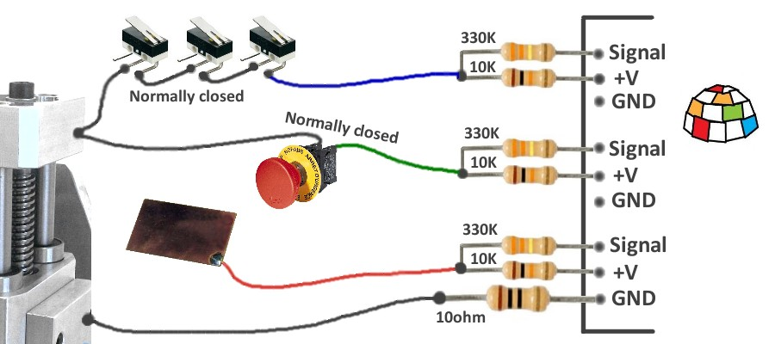
The wires from the reset button, from the limit switches chain and the reset plate, are connected to Pin with two resistors: A resistor 10K - 1 / 4Watt, which goes to + 5Volt and a resistor 330K - 1 / 4Watt, which goes to SIGNAL (resistors must be close to the Pin input). The second thread of the buttons and the switches chain must be connected to ground (either to the GND of Pin or to the mass of the machine). The mass of the machine (set of mechanical parts) must be connected to GND of a Pin, through a resistor 10 ohm - 1/2 Watt (this resistor limits the current, that may take the masses of the Theremino Master and the USB, in case of high noise coming from the start up of large motors).

Appendix 10 - Rules for electrical connections
When using high power motors and high power supplies, the power lines and earthing lines should be arranged professionally, otherwise you may experiment communication interruptions at each motor starting.
The grounding should always be arranged star like, so as to provide paths that do not pass through the electronic circuits.
The earthing paths of both high inrush currents and powerful power supplies should never go through the Master, the Slave serial line or through USB line. This is not because electronics weakness, but instead because every device must be wired according to these rules.

Even the micro of the very expensive professional controller would crash if the grounding were done badly but of course in professional appliances electrical connections are made as they should.

An easy way, which does not require much and work for sure is to keep completely separate grounding and power supplies of motors from power and grounding of PC. Doing so there is no galvanic connection with the Master, with the USB and the PC and consequently, driving all that it is NOT powered by the USB, through opto-couplers.

An example of problems caused by the inrush current
In the milling cutter that we have in the laboratory, the two suction motors were driven with a mosfet, from a 24 V dc power supply. The ground was in common with the Master and the PC.

The trouble was that the steppers did “ghost” steps when the vacuum were turned on and sometimes even when the fluorescent lamps were switched on.

We have blamed the controller of the stepper motors for a long time before finding out what it was.

Now the motor supply has an opto-coupler and its power supply is completely separate, with no galvanic connection with the PC. With this solution the problem has been completely solved.

Appendix 11 - opto-couplers

The opto-couplers are not necessary, as you may think, to protect the Master or the PC. The Master is very sturdy and never breaks and the PC is still protected by PIC which is located on the Master. In really severe cases the PIC acts as a fuse and you can change it with only three euro.

Insulation with opto-couplers has the aim to avoid ground loops which can lead to extremely high instantaneous currents, in the motors and relays switching time.

Strong currents on the ground pass along the entire chain from the machine to the PC towards the ground of the electrical system (so it is better to use notebooks without ground connection).

Strong currents along the ground can cause false steps and also can cause communication errors or even interrupt the communication with the PC. This situation gets worse when it comes to drive powerful motors and could be negligible if it is just to drive the stepper.

One thing not to do is go to the spindle motor with two wires (signal and ground) connected to the Master. It is better to connect the ground of the control spindle (negative reference) to the mass of the machine and from there also the mass of the PC, and finally bring the signal wire from the Master to the controller of the spindle.

For safety it would be good to add a 10K resistor along the signal wire (Assuming that the controller has a high input impedance)
- - - - - -
Using opto-couplers can only give advantages, but the PCB of the driver becomes much larger and expensive. We are planning to design a separate module with opto-couplers. In this way you could start without and add them only if really needed.

In fact it is a module that anyone would know how to do in 10 minutes on a prototype PCB, so we postpone it.
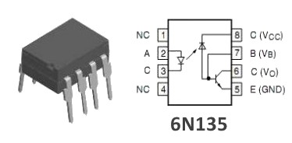
In any case you must use fast opto-couplers, 6N135 type or similar. The fast opto-couplers require a supply voltage.

In case of parallel Adapter there is not the 5 Volt on side parallel. So you can not (or would be very complex) add the opto-couplers.

In the case of small cutters (more or less all those for hobby) and provided that the spindle motor is opto-coupled and that the motor of the suction is too opto-coupled and that the disposition of grounding is well done ... then the stepper opto-couplers may be omitted.
The Proxxon we have in the laboratory has been running for a month with Theremino CNC and also the prototype with four motors, on a wooden board, is working without opto-couplers and the Master never lost communication (but of course the grounding is well-done and star shaped).

Appendix 12 - Motor driver connections

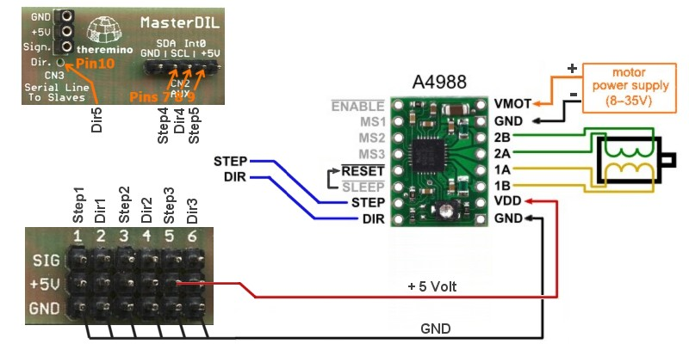
On the Theremino website is explained how to connect the Driver. We report here the information for ease of reading.

One Theremino Master can control up to five motors. The two red and black wires, "+ 5V" and "GND", go to the first driver and can feed the other driver.
Always connect at least the wire GND between the Master and drivers. Remember to connect the "Reset" with "Sleep" and connect a capacitor of 50 or 100 uF between "VMOT" and "GND".
The capacitor must be electrolytic, with the positive connected to "+", and must be close to the driver module (maximum of a few centimeters). If possible use capacitors with low series resistance (low ESR). The working voltage of the capacitor, must be at least 5 volts greater than the power supply voltage of the motor.
Before switching on ALL should be reliably connected. If you disconnect a motor wire or a GND connection, the driver A4988 will be damaged. If turning the trimmer with the screwdriver you make a short-circuit the driver breaks out instantly. In some cases the chip explodes and begins to smoke. The Theremino Master should withstand these tortures, but avoid putting it to the test.
This does not mean that the drivers are unreliable. If you do not make mistakes they never break.
However we recommend to connect drivers always with male and female, in order to be able to easily replace them. It is recommended to buy five or ten, to get a bit of spare, and bring down the price.

Appendix 13 - The “Stepper Sound”
Expert drivers will realize that with Theremino CNC motors "sing" in a slightly different way. The differences are small, they do not affect the machining. Nevertheless they are audible because the ear is extremely sensitive to small differences in the frequency of sounds.
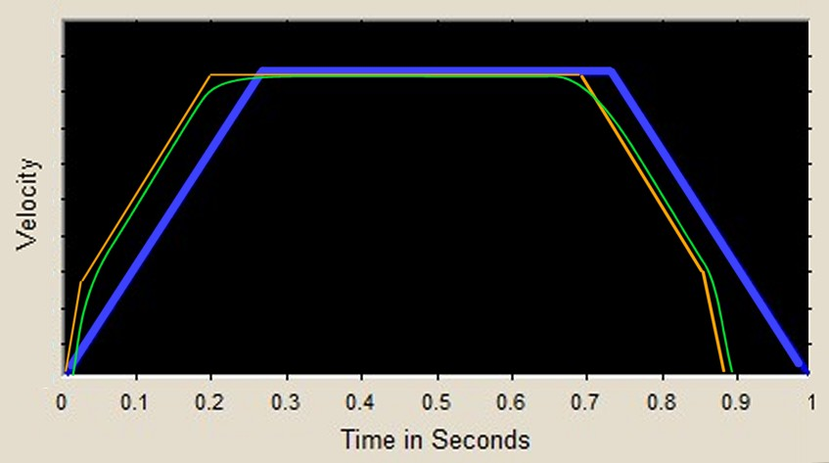
The software Theremino CNC continuously calculates new destinations (hundreds of times per second) and the firmware change continuously the speed to reach these destinations. The result is a less "rigid" path. Acceleration is smooth, not rigidly "trapeze" and speeds are always recalculated and tend asymptotically to the final speed.
In Blue - The control motor of a known CNC, with form "trapeze".
In Orange - The modified, dual slope, trapezoid, generated by Theremino Master firmware, allows faster acceleration and deceleration. The change consists in an increase of acceleration at low speeds. This change is made possible by the fact that at low speed, stepper motors have more torque. For more information on this technique, read Chapter 5 of this page: Society of Robots - Stepper Motor Control Techniques - Chapter 5 - Beyond Trapezoids
Green - The final path from the interaction of Theremino CNC software and Master module firmware. Note that the actual position is always "tending" to the destination, but actually remains behind by a small amount. In each moment the motors are kept back by exactly the braking distance in order to always have the confidence to brake in time. Or rather "In order to ensure that the tolerance prescribed by the user, with the value MaxError, will always be respected, even in case of unexpected events and instant stop ".
The final result is a softer movement which causes less vibrations and resonances in the machine. However it allows faster acceleration and deceleration. The accuracy is increased and the processing time diminishes.

Appendix 14 - Double coordinates

The term "Double coordinates" means: "the machine coordinate" and "work piece coordinates." Some drivers are so accustomed to seeing the cutter going to “home position” at start up, that consider this operation obvious and have not ever wondered if they are actually using the machine coordinates.
We have thought a lot and it turned out that only machines that make production (doing the same piece every day) and have an accurate piece loader can take advantage of the machine zero. But none of us will connect Theremino CNC to these machines that cost more than 50,000 Euros. In fact we take the opportunity to remind that the big professional machines can be dangerous and require certifications and legal guarantees. In this document we always refer to simple machines, without automatic mechanisms and quite slow, intrinsically safe.

- - - - -

Whereby in Theremino CNC there is no zero machine and neither a second coordinate system. This simplifies everything:

Take for example the processing of a piece starting from a reference, which indicates the part zero:

With double coordinates :
- You will reset the machine coordinates by starting the reset procedure.
- Moves with the JOG to the point of reference
- Read the numbers shown, for example, X =Y = Z = 234.05 137.00 05.15
- Write the three numbers X =Y = Z = 234.95 137.00 05.15 in Gcode
- Press Start. And since the X was 234.05 and not 234.95, throw away the piece

One Coordinate :
- Moves with the JOG to the point of reference
- Reset axes
- Press Start

Take for example, measuring the distance between two points:

With double coordinates it does so:
- Go to the first point
- Read the coordinates (distances from the machine zero)
- Write the coordinates, for example X = Y = 234.05 137.00
- Go to the second point
- Read the coordinates (distances from the machine zero), for example X = Y = 244.05 157.00
- Calculate for each axes and you get X = 20 mm Y = 20 mm

Coordinate with each:
- Go to the first point
- Resets
- Go to the second point
- Read the result: X = 20 mm Y = 20 mm

Appendix 15 - Settings to zero
Z Zero
The work piece zero in Z axes is done with thickness gauge, feeling when it gets hard enough, this method is very accurate, better than optical control with side camera. The accuracy is better than a tenth of mm. But just move ten centimeters in X or Y axes and vertical alignment is no longer safe (the pieces themselves are not perfectly planar, the cutter itself is not perfectly orthogonal, we are not at Ferrari or at NASA, but in the laboratory of a hobbyist). So the part zero must be done every time you change the piece. A zero piece done far away from the piece is not valid. Even if you tight the piece, this operation can move it in a significant amount.

A good way to do zeroing Z, is to use the automatic "Z Calibrate with probe", explained in the instructions of the panel "Calibrations".

X and Y Zero
This is done quite easy, with the camera placed at 45 degrees, very close with high zoom. Another good method is to look closely, with eyepiece that magnifies a lot (for example the eyepiece of an old projector). Approaching the tip very close to the surface and focuses a point with the JOG (precision CTRL-JOG). Then you get off the tip of two tenths, with CTRL-PageDown, go up with CTRL-PageUp, and check that the notch is centered.

Many times it is not possible to start from a "raw piece", measuring slightly larger, and then take it to precise measure. In this case the zero must be done on the piece itself and not from the machine zero.

What is the utility of Z precision ?
To peel a layer of precise thickness from a surface. In mechanical machining of pre-machined pieces. In printed circuit boards, two-color labels with thin surface layer and in other similar processes. In the PCB the copper layer is thin and 5 hundredths of a millimeter can be seen very well. If you “eat” little, copper lines remain where they should not remain. If you “eat” too much, the stripped part is too dug, too "rough" and the edges are jagged and ugly. If you “eat” too much you can also break the tool tip. To do a good job, you have to reset the Z mid-piece, or the "sacrifice piece" should be taken to plan each time, AFTER it has been fixed, because even the tighten operation could lead to little deformations.

What is the utility of X / Y precision ?
For each operation that has to be done on pre-machined or partially worked pieces. For example punctures on a piece which was formed with the drill but not by other means. For example photoengraving or manual operations on a container.

The X / Y zero should be remade for each clone flanked horizontally and vertically. This is because the zero, made in the lower left corner of the first piece, is not quite accurate for the last piece in upper right corner, and the holes would be visibly moved.

Appendix 16 - The probes
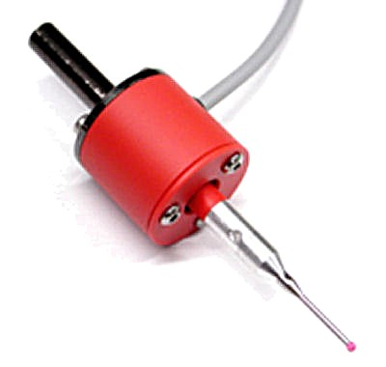
The probes are beautiful and attractive, but are of little use in a CNC. You must remove the tool and mount the probe (and there is also a cable that always is annoying). Then you have to wait for the contact. Finally you can remove the probe and remount the tool. It not only takes a lot of time, but you loose precision, because every time you tight the spindle, on the big stem of the probe, and then on the tool, the relative positions change slightly. The zeroing should be done with tool mounted.

Use a probe to extract 3D
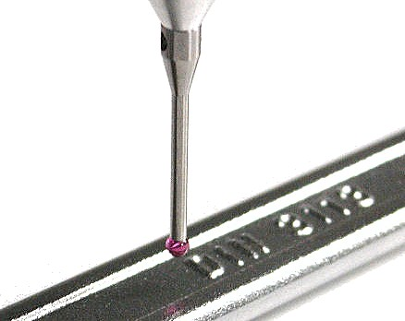

Derive the 3D from a physical piece, is not for a CNC, more features are added to the CNC and more complex become the equipment, difficult to use and unreliable.

The 3D is extracted with better programs written specifically for this function. When we have time we will write the application and we will name it Theremino Probe3D.

Calibrate the Z axis with a probe
They asked if the command "z Autocalibrate with probe" could be used with a probe. This confusion is from the word "probe", which in English is also used for the probes. But in the "Autocalibrate" command the word "probe" stands for "flat plate" not for "probe".

The flat plate, allow to reset the zeta axis, without disassembling and reassembling the tool. So the reset is faster and more precise.

Appendix 17 - Interpolation in 5 dimensions vectors
Theremino CNC just runs the GCode. If in GCode it is written "B30" then it writes the value 30 in the Slot corresponding to axis B . If then reads "B40", it interpolates in coordination with the other axes up to 40. Whether these values are right or wrong, or whether they are degrees or something different, it does not matter for the CNC. It does not matter if the unit is mm or degrees, just interpolate all in 3, 4 or 5 dimensions.
In other words the only important thing is that the speed of each axis is calculated in the multidimensional space, so that they all arrive to the destination at the same time. For arcs (G02 and G03) there is no problem because the same GCode limits them to two dimensions (Note 1)
In well designed software the functions are split in layers: CAD - CAM - CNC - HAL. If one of the layers begin to do the work of others, it messes up the whole architecture.

CAD - Design in 3D. 3D visualization with every tool (mechanical annotations, dimensions etc ...)

CAM - Transformation of the 3D tool path (taking into account the dimensions of the tools, the size of the work piece, any possible "interference", the mechanical characteristics of the machine, width compensation tool, route optimization, speed of feed, strategies processing ...)

CNC - Pure execution of the route (none knowledge of how the tool or the work piece are made, because of this no interference control nor compensation). "Wire frame" type display of the tool center path (no machined surfaces).

HAL - Transformation of numbers in hardware movements, taking into account step per millimeter etc ... (the Mach3 motor panel or the HAL system Theremino)

(Note 1) An important aspect which has to be considered is that if you really want to work with 3, 4 or 5 simultaneous axes you can not use the circular interpolation G02 and G03. The circular interpolations G02 and G03 always work on two axes (X / Y, X / Z or Y / Z) and the other axes are still during the interpolation (function indexed). Instead, the G00 and G01, can move all five axes together, just write G01 Xnn Ynn ZNN Ann Bnn. This was one of the reasons why we wanted to eliminate G02 and G03

Appendix 18 - Control over control
Theremino CNC does not control the "interference", just runs the GCode. Theremino CNC knows the dimensions of the tool, the size of the blank to be machined and its location on the machine.
The GCode must be right and the controls must have been made before. Only the CAM or rather its post-processor (or better yet the driver), may do well these controls.
The CNC software knows nothing but the path of the tool. The Gcode not provide commands regarding the size of the work piece. Some CNC are informed (in a particular way) about the tool diameter and make some operations, which would be granted to the CAM (and that only the CAM can do well), for example, the compensation of the tool diameter. Always with tricks (for example using the comments) other considerations are made, to show the interference with the blank, with the fastenings of the work-piece and with the work area.
With our approach, these operations are located in CAD or in CAM. For someone Theremino CNC could not fit. But for lovers of simplicity (like us) this way minimizes the settings to be performed (no need to set the size of the tools, the work plan, the hardware, the limit switches etc ...)
In other words no controllers, everything is just manual, one gets used to it and it works fine.

Check processing and interference
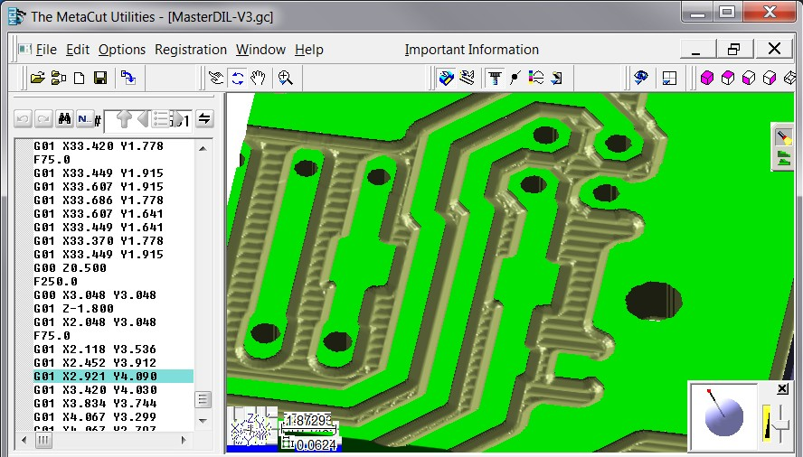
To check processing in 3D, view the actual cut caused by the tool, and check interference and errors, not using a CNC, but applications written specifically.
Among the best applications we mention METACUT: http://www.nwdesigns.com/MachinistStart.html
Some versions should be free: http://www.nwdesigns.com/Content/MiscDownloads.htm
We are preparing Theremino_GCodeViewer (who works in 3D with DirectX) but we do not know when we will have time to finish it. Basically METACUT works very well and is quite cheap.

Appendix 19 - Asynchronous operation
Theremino CNC, as all other Theremino applications, is based on totally asynchronous communications. For details read here: http://www.theremino.com/contacts/the-theremino-mission
In the specific case of CNC, you can identify five independent layers, deliberately NOT synchronous with each other:
- The application Theremino CNC sends the values of the axes to the Slot every 5 milliseconds.
- The application reads the HAL Slot, turns data in hardware format (Hardware Abstraction) and sends them via the USB system. This process is not synchronous with Theremino CNC, and occurs every one or two milliseconds.
- The numerical values of the axes are read from the firmware layer, at each USB exchange (one or two milliseconds)
- The firmware, according to the continuously variable destination, recalculates the displacement parameters exactly once each millisecond, with high precision. To accurately calculate accelerations and speeds, these calculations are managed by an interrupt handler and therefore are asynchronous, with respect to both USB and Theremino CNC and the STEP of the motors.
- Hardware PWM module produce the STEP to the motors, with skidding of less than 20 nano seconds (depending on the quartz clock at 48 MHz). Therefore this layer is completely independent and asynchronous with respect to the previous layers.

Many people feel more comfortable with completely deterministic systems and consider inferior, if not "completely wrong", our working principles.
http://www.theremino.com/contacts/the-theremino-mission#precision
We do not want to start a discussion about this. Just explain that, though willing it would be impossible to transform the system Theremino in a synchronous system. To do that you should redesign the whole system, a new communication protocol with the hardware, Master and Slave firmware modules, much of HAL (which is really big) and all Input Output Theremino CNC. Finally, you may no longer use the Slot, as we understand them now, because the Slots do not include commands, but only numeric values, and no synchronization mechanism.
A job like this, it could take years, even for us that we designed the system (as it took years to design as it is now) and still we are not willing to do that, because it would be exactly the opposite direction, compared to our vision :
http://www.theremino.com/contacts/the-theremino-mission#inout
With regard to gifts, we remember that our work is totally Nonprofit and we can not do any kind of favoritism. That is, donations are to be totally disconnected from our work. Otherwise they would be not "donations" but "compensation". To explore this topic read here:
http://www.theremino.com/contacts/copyrights#donations

Appendix 20 - Accuracy of the forward speed
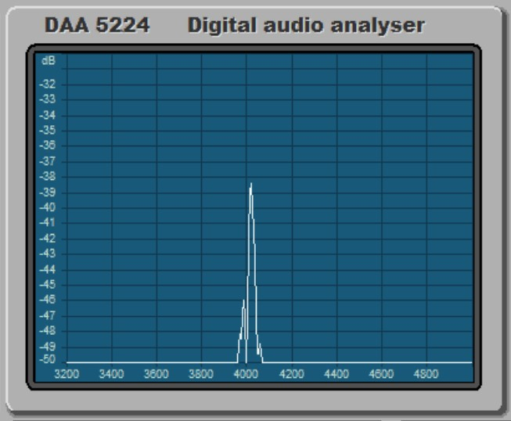
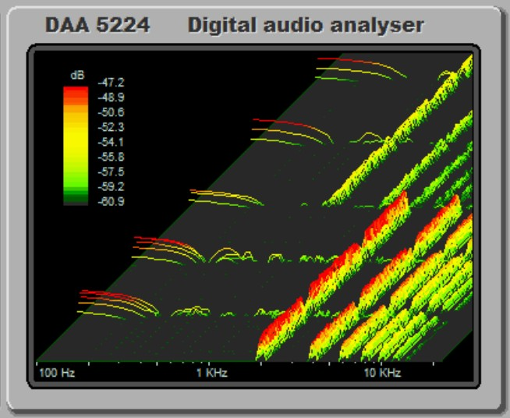
The firmware of the Master controls the motor steps with high precision (variations less then 20 nS) and ensures that the variations between one pulse and the next, never exceed the specified acceleration. This ensures that the motors never lose steps.
But, since the timing of the advancements is done in real time from an application on the computer, some users have expressed concerns, on the speed accuracy and stability. The argument they make is that when the computer is busy it becomes slower. But by requiring the Windows scheduler a granularity of 1 mS and with a Real-Time thread, we have obtained a remarkable stability and precision that (according to us) is more than enough for each type of processing. In the latest versions of Theremino CNC (from 3.31), we have also added a stabilizer algorithm, which has greatly improved precision.
Result test without stabilizer - Speed accuracy: 3% - Wow and Flutter: +/- 1.5%
Result test with stabilizer latest version, from 3.31 version- Speed accuracy: 0.5% - Wow and Flutter: +/- 0.2%
Download videos of test
http://www.theremino.com/files/ThereminoCNC_V3.31_Without_Stabilizer.avi
http://www.theremino.com/files/ThereminoCNC_V3.31_With_Stabilizer.avi
For those wishing to repeat the measurements, the following ZIP files also include test and configuration.
http://www.theremino.com/files/ThereminoCNC_SpeedSpectrums.zip
http://www.theremino.com/files/ThereminoCNC_SpeedSpectrums_Stabilized.zip
Conditions of measurement
The tests have been done with the CPU under load (two CPU from 3 GHz to more than 50%). This was due to the simultaneous execution of the CNC, the spectrum analyzer DAA, and the program CamStudio to capture video. Without DAA and CamStudio, signals were audibly more stable. This is a safety margin, for the declared characteristics.
Configuration parameters
Max Speed(hal) = 900
Max Acc (hal) = 50
Steps per mm (hal) = 400
Feed (cnc) = 100 / 300 / 700
Comments
With stabilizer Wow and Flutter are reduced to levels not audible. If you set low acceleration (for large and heavy machines) values of Wow and Flutter also fall below 0.1%. These are excellent results which are valid for any type of processing.
Principle of operation speed stabilizer
- Even using a real time Thread, when the Windows scheduler is overloaded it becomes late.
- In worst times the loop time increases by a few milliseconds, and it is not possible to stabilize it.
- Being not possible to stabilize it, it is better to measure it and compensate by varying the length of the interpolate micro-segments.
- This stabilizes the "driving"speed on firmware ..
Even without this fix the work would be enough good. But eliminating the "mewling" effect is important because it could give a bad impression.

Appendix 21 - Gcode generation for Theremino CNC

With a CAD - CAM
It would be good to create a new post-processor in CAM, name it Theremino CNC, and set it to generate the right codes.

The main things to check in the CAM post-processor :
- Using millimeters (Metric mode)
- Use absolute coordinates (Absolute mode)
- Use only G and M codes listed in the table "Codes implemented"
- G02 and G03 are implemented, but we advise not to use them (see the relevant page)

When in doubt, just Load Gcode and check it for invalid codes

With an Eagle project or other editor of printed circuit boards
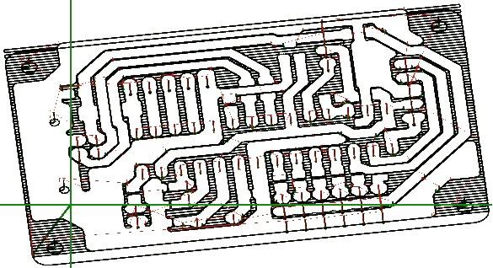

We recommend Eagle for PCB, with our libraries, and with our "Fast Gcode" post processor which is not exactly a post processor but rather a ULP (User Language Program).
Fast Gcode creates optimized GCode (minimizes the movement) and creates all the PCB examples, like the examples of Theremino CNC.
http://www.theremino.com/downloads/uncategorized#eagle

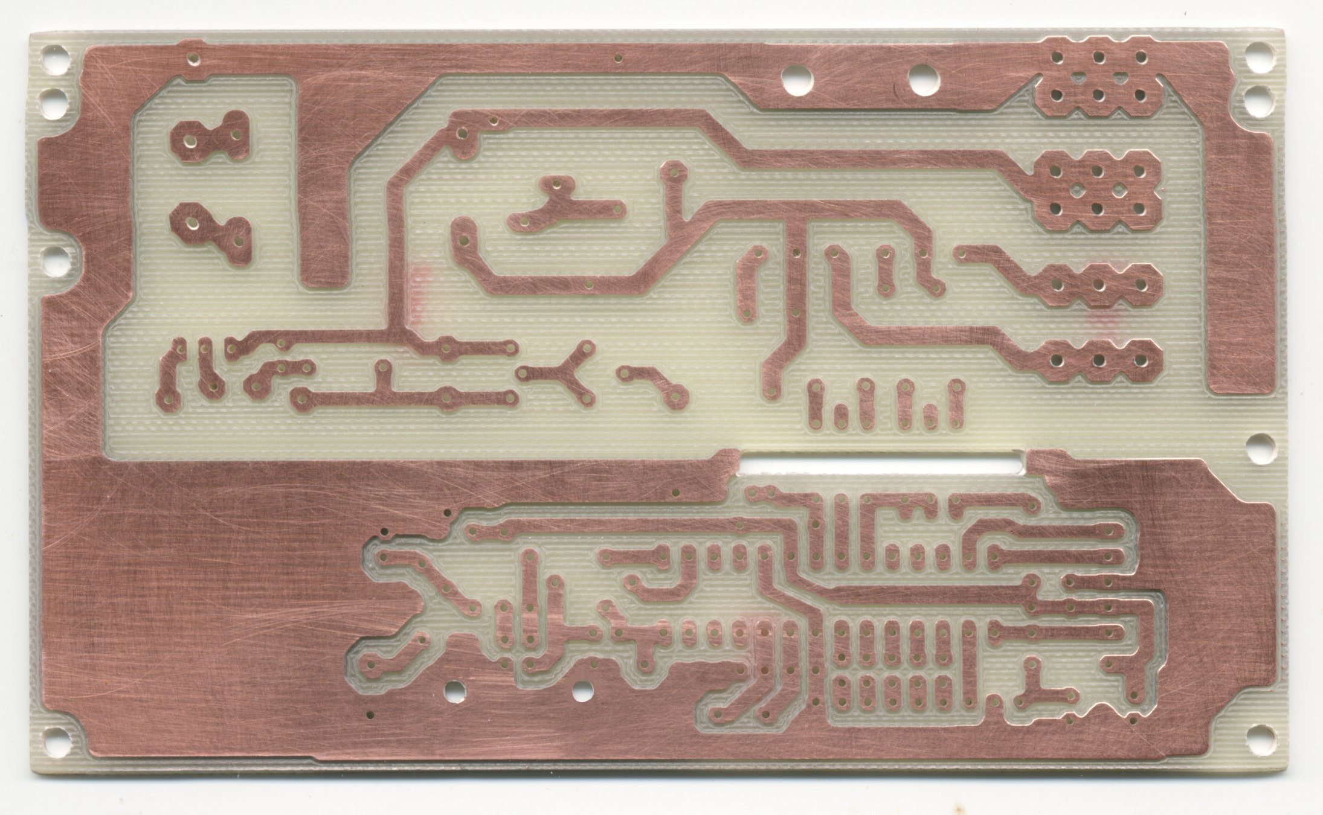
Appendix 22 - PCB built with Eagle and Fast Gcode
The circuit is done in a single process, with the external cutting and drilling, all is done without changing tool (normally use a drill Proxxon 0.8 Tipped V)
Example of complex PCB, with large and small holes, made in half an hour, already cut and drilled. All in a single process, without changing the tool.
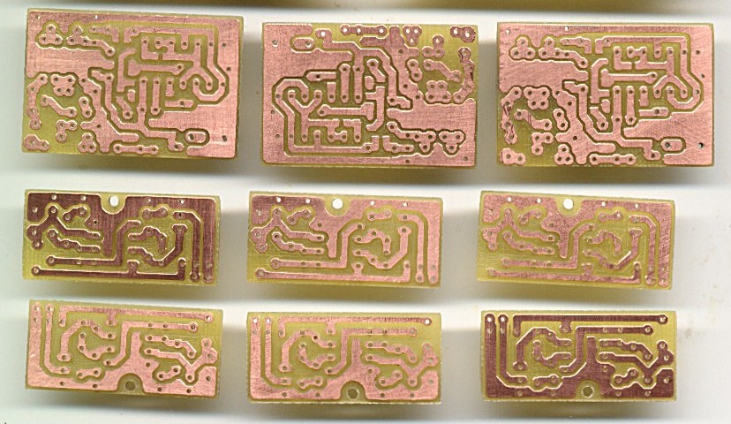
Other examples of small PCB, made in 5 minutes. Examples are old, made with CNC we used before. Now, with Theremino CNC, they are even better, as you can see on the next page:

CAUTION
Here we do not want to prove that Theremino CNC is superior to other CNC.
It suffices to prove that it is not worse. And many would think it without this page.
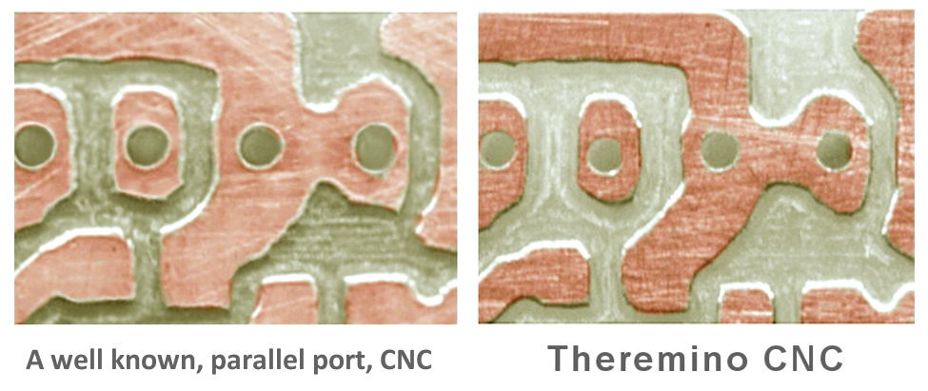

Highly magnified image of a PCB, worked with a well-known CNC (left) and with Theremino CNC (right)

- The same machine (Proxxon MF70)
- Same controller, same motors without microstep
- Same GCode
- Same machining speed
- The same rotation spindle speed
- Same computer as Host
- Same tool (a drill Proxxon 0.8 mm)

To be honest, the improvement it is not all about Theremino CNC. But it is largely due to the stability of signals, produced by the Theremino Master. Furthermore, the Proxxon has no linear bearings, but mechanical guides, which suffer more relative movement, and are sensitive to vibration. And the vibrations were strong, because the motors were working without microstep.

Using microstep controllers would greatly reduce the visible defects. But working in the toughest conditions is a good demonstration of CNC Theremino and Theremino Master precision.

Appendix 23 - 3D Printers
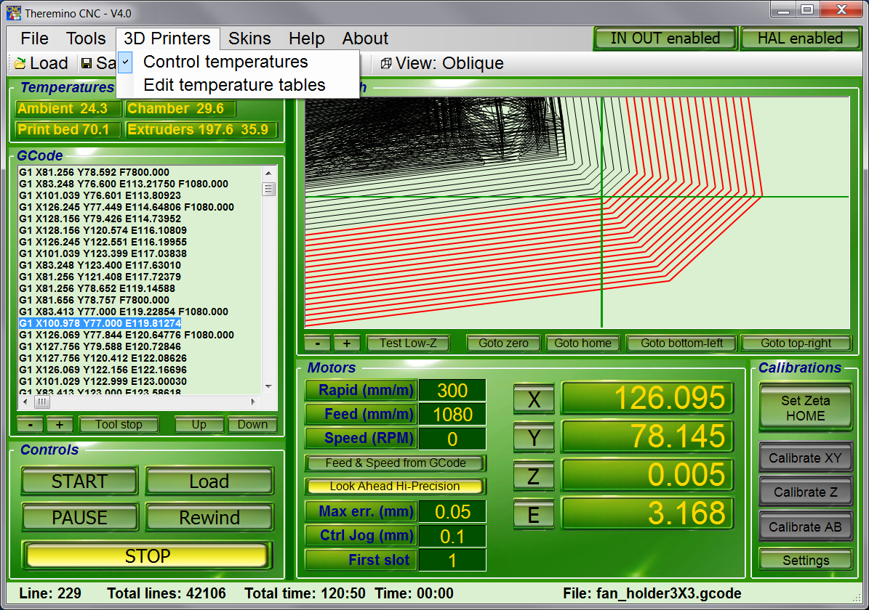
To control a 3D Printer is very similar to control a Mill Machine. For the 3D printers you use some specific “G” and “M” code (listed in the Appendix 4), some specific Slot (listed in the Appendix 9) and the special axis “E” (extruder - explained in the Motor panel of the Controls and Settings section).

A 3D printer also require to control some temperatures.

The temperature control system is enabled with the appropriate menu.

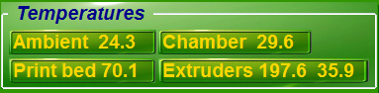

The "temperatures" panel is visible, when the temperature control system is enabled.

This panel shows the temperatures measured by sensors and interpreted by the tables of the file "Temperature tables". Depending on how they are written, temperatures are in degrees Celsius or Fahrenheit. Although specific names for 3D printers, these are generic thermostatic controls, usable also for different machines (for example for cutting polystyrene).

Appendix 24 - Temperature sensors
For low temperatures (up to about 100 degrees Celsius) you can use the integrated circuits AD592, LM35, TMP36 or 501F. These sensors are very linear. On this page you can find their features and other explanations: http://www.theremino.com/en/hardware/inputs/meteorology-sensors#ambient
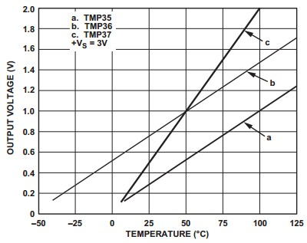

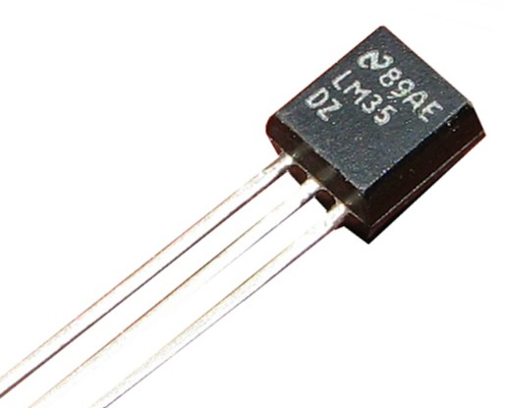

For high temperatures (up to about 250 degrees Celsius) are normally used the "Thermistors" (resistances that change in value by varying the temperature). The thermistors are divided into two categories: NTC and PTC, depending on whether the resistance decreases, or increases, increasing the temperature. How to connect the thermistors, is explained in this page (the page talks about the PT1000 but are considerations that apply to all thermistors):
http://www.theremino.com/en/hardware/inputs/meteorology-sensors#pt1000

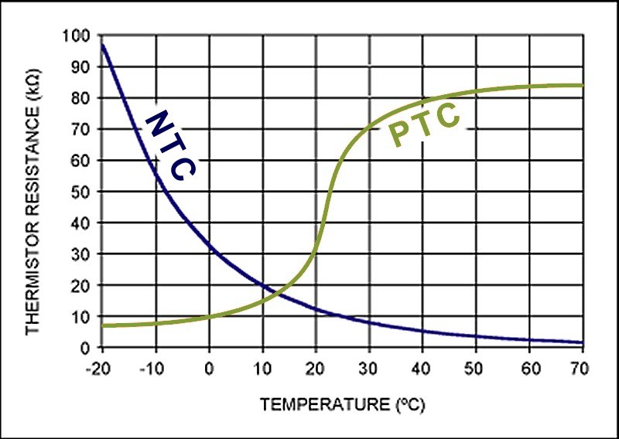
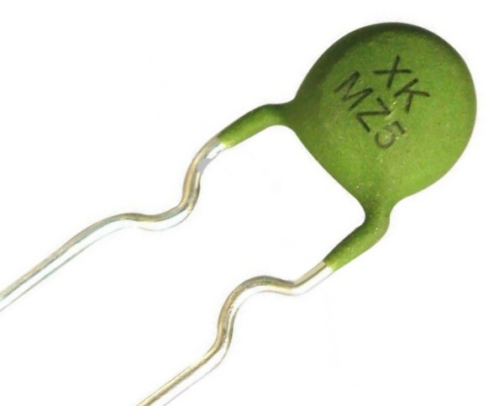
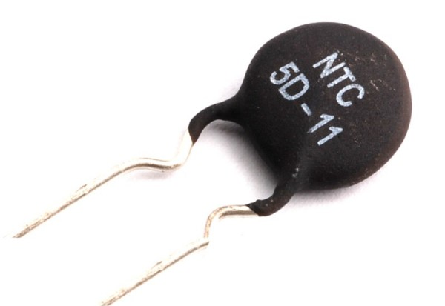
Depending on the sensor used and how it is connected, the raw value that is measured can be more or less linear.

Appendix 25 - Temperature tables
To transform from raw values to temperatures, we use the "Temperature Tables”
For linear sensors we need a lookup-table, with just two values well apart (for example, 20 degrees and 90 degrees). For the PTC and NTC, longer tables are required. In general this will take about ten values, but may suffice even less, if they are concentrated in the normal use temperature range.
The tables are created manually by measuring value pairs:
- The first value is the raw ADC reading (the value ranging from 0 to 1000, visible in the HAL application)
- The second value is the temperature of the sensor (to detect with a thermometer)
WARNING: The raw numbers, of the first column, must be in ascending order. Instead the values of temperature, of the second column, have no constraints.
File syntax - Each table starts with the keyword: "Sensor". Blank lines or lines containing only spaces and tabs, or beginning with a comment character ('), are unused. The characters, lowercase or uppercase, are considered equal. Numbers can be integers or decimal. The decimal point can be either the point that the comma.
Sensor names - Each table starts with the keyword "Sensor", then you must write one of the five predefined names: "TempAmbient" - "TempChamber" - "TempPrintBed" - "TempExtruder1" - "TempExtruder2"
Deactivating a sensor - If a table is not defined, or empty, or contains less than two lines, then its sensor is disabled. The temperature control is not performed for that sensor. Its output Slot is not changed and the temperature value is displayed with three dashes "---".
DefaultTemp - This is the temperature to be used as a "default" when the applicaton is started and the GCode is not running, or not specifying a temperature. The "DefaultTemp" must appear after the line "Sensor". The keyword "DefaultTemp" must be followed by a number from 0 to 999.
PidGain - This is the gain of the temperature regulating circuit. The keyword "PidGain" must appear after the line "Sensor" and must be followed by a number. When using On-Off temperature controllers (DigOut Pin type), we set a high number (for example, ten thousand). If using proportional regulators (PWM Pin type), the usual values are from 100 to 1000. With proportional regulators, a too high gain may cause oscillations. While a gain too small may stabilize with little accuracy.
How to collect the values of the table - Check the sensors at two or more different temperatures. Better if the temperatures are far apart, for example 20 and 80 degrees. Each line should contain the raw value, read by the HAL (in ascending order), and its temperature.
How many rows each table? - The minimum number of rows is two. The maximum is unlimited, but usually not convenient exceed a few dozen lines. Two rows are sufficient for the linear sensors. With more lines you can correct the linearity of any sensor.
Interpolation - Temperatures intermediate between two values, are interpolated linearly. Temperatures outside of the margins are extrapolated linearly.

Examples of temperature tables
The values of the following examples have been calculated starting from the theoretical characteristics of the sensors. The precision should be within a fraction of a degree. To obtain a more precise calibration, you will have to slightly touch up the values.
This is an example of a complete table, which reads the temperature of the air inside the chamber. The temperature values are calculated for a sensor LM35.
'=========================
Sensor TempChamber
DefaultTemp 20
PidGain 100
'=========================
'HAL_Value Temperature
'-------------------------
0 0
455 150
Values calculated for a sensor LM35, powered at 5 Volts.
'HAL_Value Temperature
'-------------------------
0 0
455 150
Values calculated for a sensor TMP36, powered at 5 Volts.
'HAL_Value Temperature
'-------------------------
15 -50
530 125
Values calculated for a sensor 501F, powered at 5 Volts.
'HAL_Value Temperature
'-------------------------
43.3 0
303 60
Values calculated for a sensor AD592, powered at 5 Volts, with a 8.2k resistor from output to ground.
'HAL_Value Temperature
'-------------------------
678.4 0
939.3 125
The following example was used with an NTC thermistor, connected with a resistor to 3.3 volts.
For thermistors you can not use these values, but you will have to write specific tables for each sensor. Note that the values of the left column should always be growing.
'HAL_Value Temperature
'-------------------------
87 250
122 200
176 150
312 100
560 50

Appendix 26 - Low accelerations compensation
Normally the stepper motors acceleration (Acc.max parameter in the HAL application), is adjusted about one-tenth of the maximum speed (Vel.max parameter, always in the HAL). In these conditions, the acceleration time is negligible and has minimal effect on the tool path.
But the machines with small engines and heavy trucks need very low accelerations, sometimes even less than a hundredth of the maximum speed. In these cases, the acceleration time becomes longer, compared to that calculated and displayed in the status bar of the application, also the engine that has to do more road arrives late and the tool path differs from the ideal one. The movements broken into small segments and the horizontal, vertical movements and to 45 degrees are not affected by this defect. But in some cases, with intermediate slopes, errors can also get to a few millimeters.
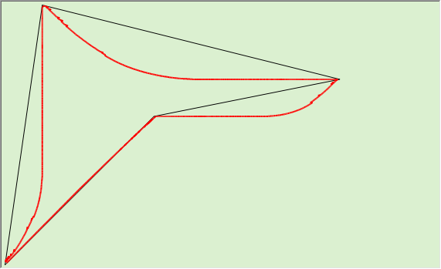
In this and the following images you see the path errors on "Test_LowAccCorrector.gc", setting a very low acceleration, Acc.max = 5 and Vel.max = 700.
In these conditions the errors (distance between the red and the black line) are approximately one millimeter and in some points exceeding it.
The running time is 8 seconds, in large part caused by the low acceleration of the motors.
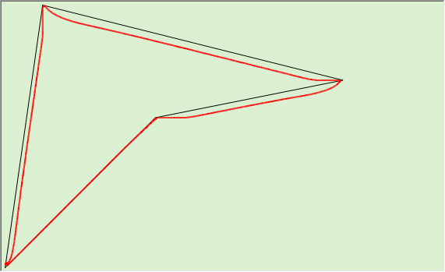
In this second picture we see the effect of the option "Compensate acceleration effects".
The errors are limited to three tenths of a millimeter, setting "Max err. (Mm) = 0.3 ".
With this accuracy the running time increases slightly and went from eight to nine seconds.

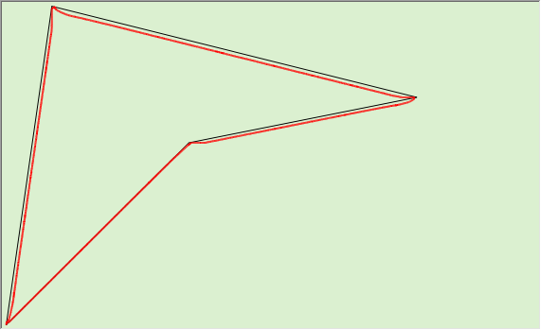
In this image we see the effect of the option "Compensate acceleration effects" with errors limited to one-tenth of a millimeter, with "Max err. (Mm) = 0.1 ".
In this case the running time is increased from eight to twelve seconds.
Further reducing the "Max err. (mm)" parameter, a greater accuracy is obtained, at the expense of a progressively longer time. With five cens of a millimeter the time increases to 14 seconds and with three cents to 17 seconds.
It is advisable to do experiments and not to exaggerate the precision so as not to increase times too much.
With "normal" accelerations this compensation is not required. It is best to enable it only if required by your machine and your jobs.

