Git and Git Flow myGUI.

GuitHub.

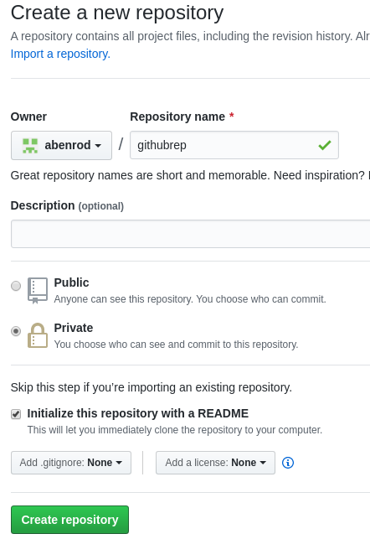

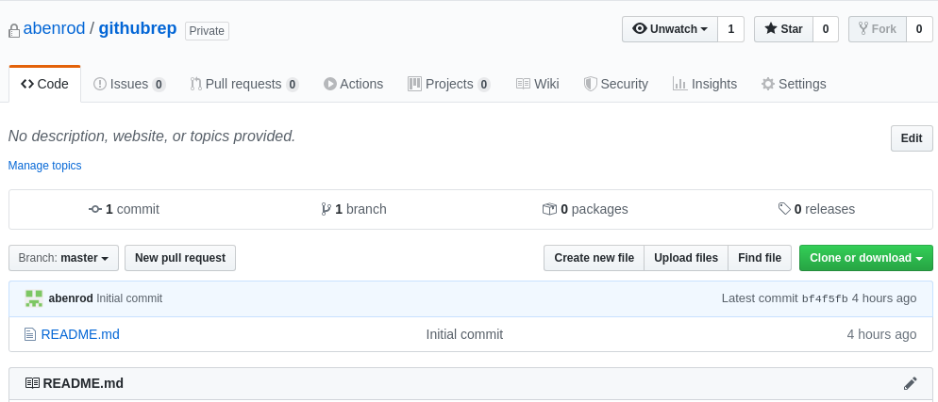

First of all:

1.- create essential structure of branches :

master
|
dev
| |
| feature
|
release

acording with GitFlow.
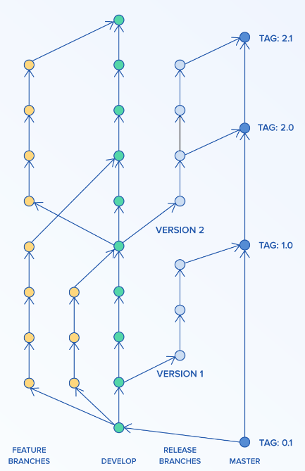

GitHub.

Creating dev branch from master branch on gitHub.

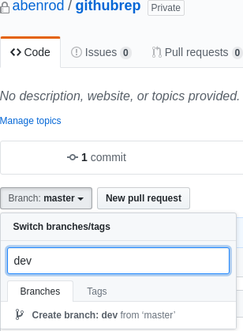

Creating feature branch from dev branch on github.

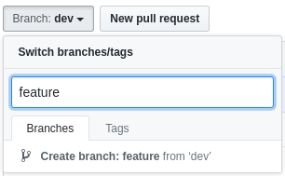

Finally:
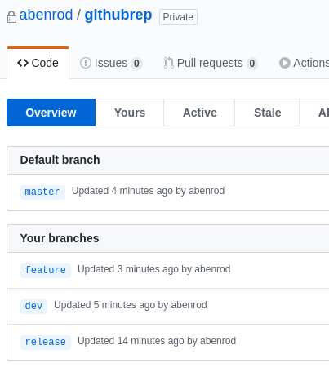

Git ( fedora local )

on machine: to identify operations

git config --global user.name "abenito"
git config --global user.email "alberto.benitor@gmail.com"

to save my inittial credentials in local file store, the first operation under github, git request me the credentials user/password after that, in the future operations you wont need pass the credentials one more time.

git config --global credential.helper store –file=/working/rep/.my-credentials

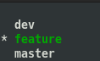

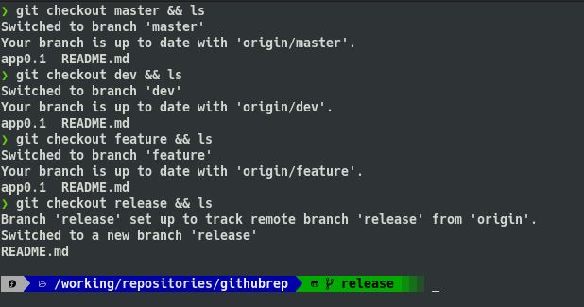

To progress to master is neccesary generate a new release.

Gitg ( fedora local )

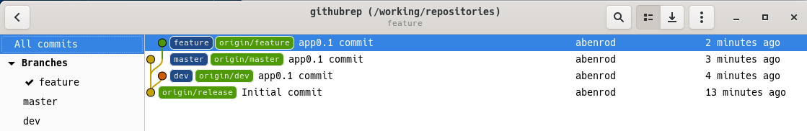

1.1 create a new version app1.0 on dev branch.

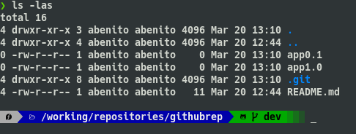

To progress to master is neccesary generate a new release.

1.2 generating a release app1.0 on release.

Once the project coordinator verifies that the development is correct, the release is issued:

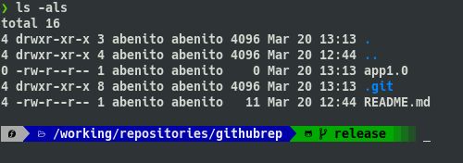

Local Gitg view:

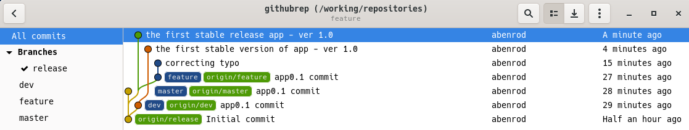

On GitHub:

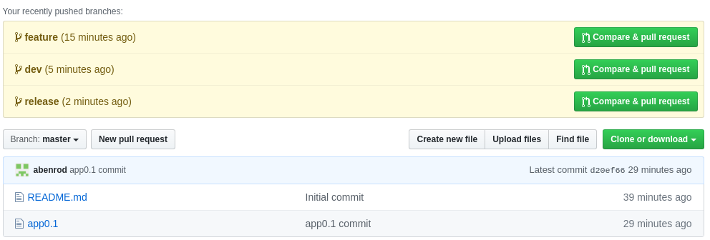

Under master branch view, as you can see, there are pull request in the rest branches.

Dev branch view:

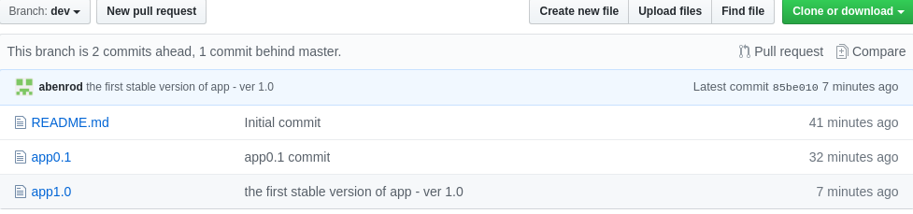

Release branch view:

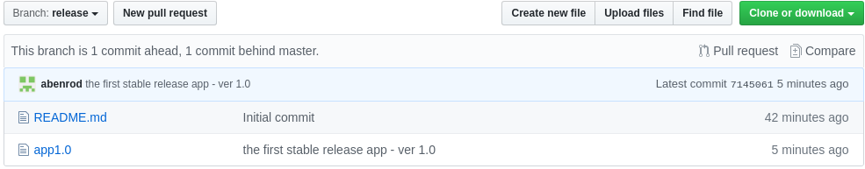

1.3 to master ( production ) app1.0.

Once the application passes the tests and homologation it starts to be deployed in production on master branch, the deployment process will be carried out by the continuous deployment process.
The application goes from release to master via pull request.
On gitHub:
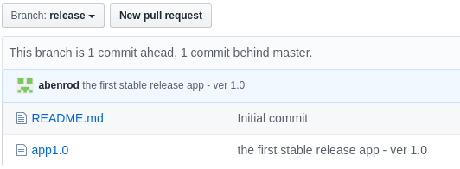

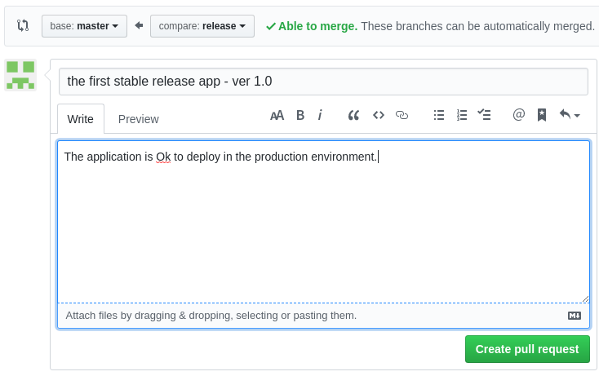

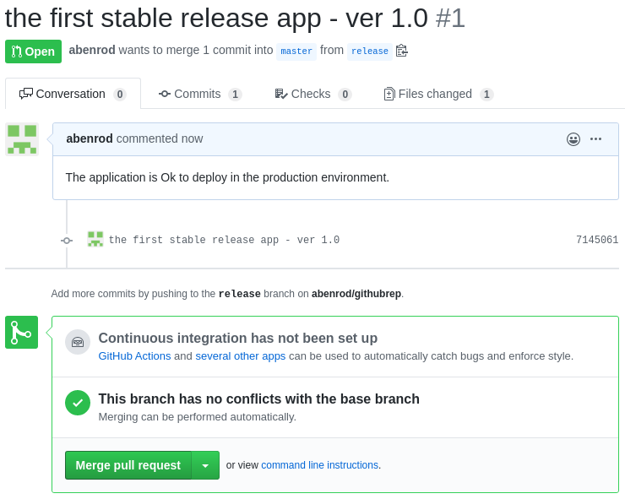

The application is on the master branch and :

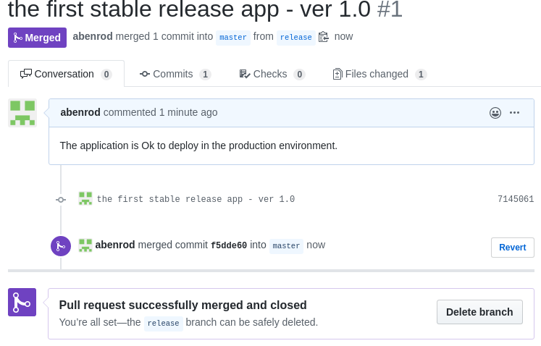

The release branch is deleted.



Have a look the real state of repo:

master branch contains the new app version:
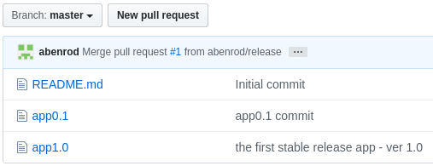

and the repository has three branches only, because release has been close.
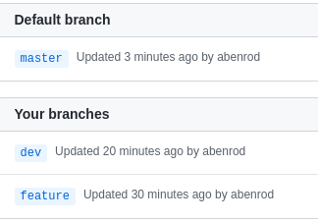

However the developers in his local copy of the repository may have a local release branch intact.
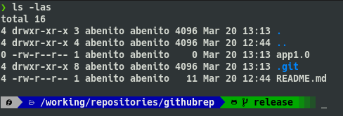

Checkout master:

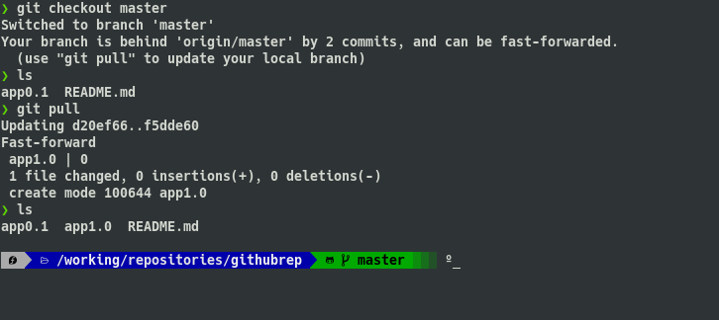
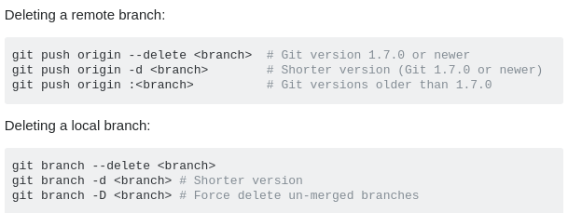

To remove old local release branch: git branch -D release
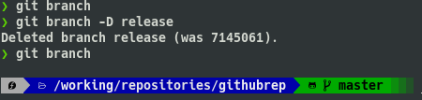

________________________________________________

In paralell the new features is going implemented in the feature branch, after that , a new important but not too large feature will be included under app1.0 constituting the new app1.1 version of app.

After that the amount of numerous features will form the new release app2.0.

extra notes, others operattions.
------------------------------------------------------------------------------------------------------------------------

First of all → clean de old rep.

❯ git clone https://github.com/abenrod/abenrodrep
Cloning into 'abenrodrep'...
remote: Enumerating objects: 29, done.
remote: Counting objects: 100% (29/29), done.
remote: Compressing objects: 100% (20/20), done.
remote: Total 29 (delta 8), reused 20 (delta 4), pack-reused 0
Unpacking objects: 100% (29/29), done.
❯ cd abenrodrep
❯ ls
b README.md

This is the content of local Master branch.

❯ git rm b
rm 'b'
❯ git commit -m "rm b file"
[master 1530076] rm b file
1 file changed, 0 insertions(+), 0 deletions(-)
delete mode 100644 b
❯ git push
Enumerating objects: 3, done.
Counting objects: 100% (3/3), done.
Delta compression using up to 4 threads
Compressing objects: 100% (1/1), done.
Writing objects: 100% (2/2), 228 bytes | 228.00 KiB/s, done.
Total 2 (delta 0), reused 0 (delta 0)
To https://github.com/abenrod/abenrodrep
cc4860a..1530076 master -> master
❯ ls
README.md

Change to dev branch:

❯ git checkout dev
Branch 'dev' set up to track remote branch 'dev' from 'origin'.
Switched to a new branch 'dev'
❯ ls
1.txt 2.txt 3.txt aaaaa Jenkinsfile newFile.txt pullrequest.txt README.md
❯ git rm *.txt
rm '1.txt'
rm '2.txt'
rm '3.txt'
rm 'newFile.txt'
rm 'pullrequest.txt'
❯ ls
aaaaa Jenkinsfile README.md
❯ git rm aaaaa
rm 'aaaaa'
❯ ls
Jenkinsfile README.md
❯ git commit -m "delete all files on dev branch"
[dev 205e695] delete all files on dev branch
6 files changed, 3 deletions(-)
delete mode 100644 1.txt
delete mode 100644 2.txt
delete mode 100644 3.txt
delete mode 100644 aaaaa
delete mode 100644 newFile.txt
delete mode 100644 pullrequest.txt
❯ git push
Enumerating objects: 3, done.
Counting objects: 100% (3/3), done.
Delta compression using up to 4 threads
Compressing objects: 100% (2/2), done.
Writing objects: 100% (2/2), 280 bytes | 280.00 KiB/s, done.
Total 2 (delta 0), reused 0 (delta 0)
To https://github.com/abenrod/abenrodrep
d72f71b..205e695 dev -> dev

❯ git checkout release.01
Branch 'release.01' set up to track remote branch 'release.01' from 'origin'.
Switched to a new branch 'release.01'
❯ ls
1.txt 2.txt 3.txt a aaaaa Jenkinsfile newFile.txt pullrequest.txt README.md

In that case, Im going to delete de local and remote release.01 branch.

❯ git checkout dev
Switched to branch 'dev'
Your branch is up to date with 'origin/dev'.

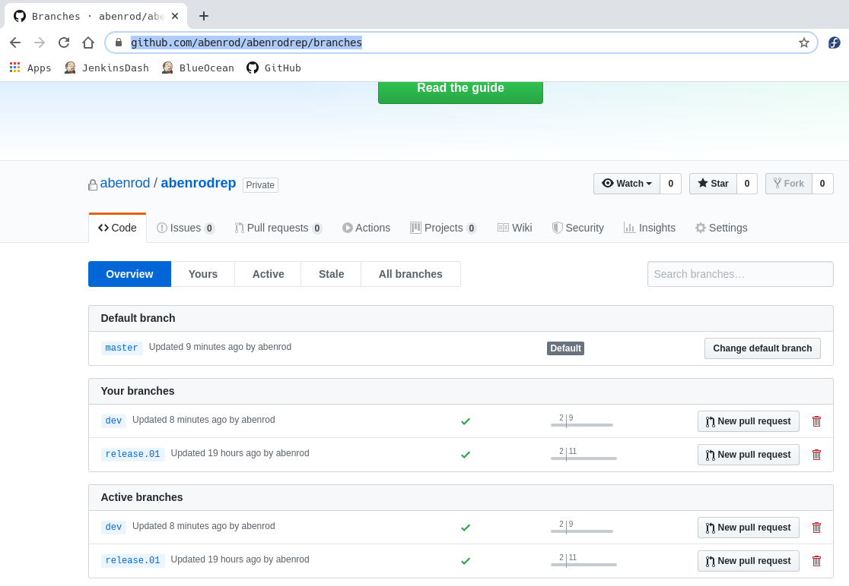

Delete branch remotely: ( origin is remote repository from gitHub )

❯ git push origin --delete release.01
To https://github.com/abenrod/abenrodrep
- [deleted] release.01

Delete branch local:

❯ git branch -D release.01
Deleted branch release.01 (was 680983a).

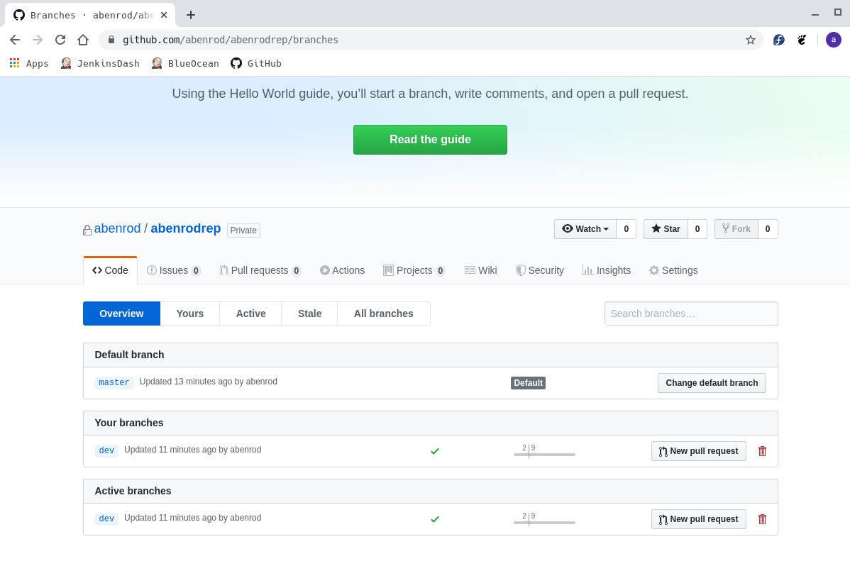
---

I have two branches, Master ( Production ) and dev ( develop ).

Git Flow → Vincent Driessen.

https://github.com/petervanderdoes/gitflow-avh → Peter van der Does

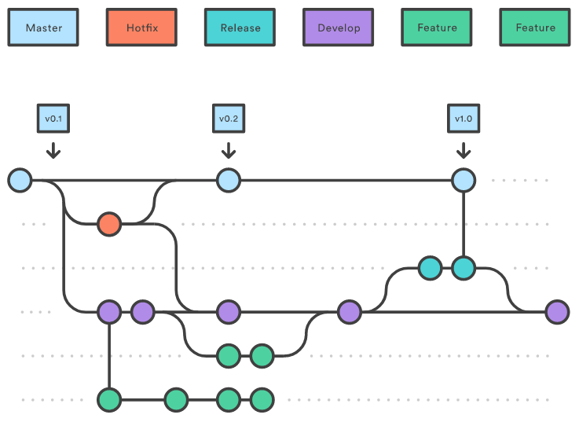
I’m going to create two branches more.

Feature from dev branch, which “contains” dev content branch.

And… Release, initially empty, but more later will contain the first release.01

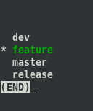

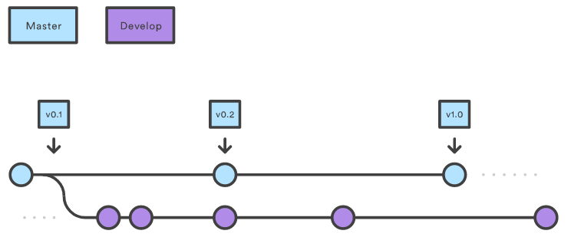
❯ ls -rtl
total 8
-rw-r--r-- 1 abenito abenito 12 Mar 20 06:00 README.md
-rw-r--r-- 1 abenito abenito 469 Mar 20 06:01 Jenkinsfile
❯ vi OriginalCode.txt
❯ ls -rtl
total 8
-rw-r--r-- 1 abenito abenito 12 Mar 20 06:00 README.md
-rw-r--r-- 1 abenito abenito 469 Mar 20 06:01 Jenkinsfile
-rw-r--r-- 1 abenito abenito 0 Mar 20 06:28 OriginalCode.txt
❯ git add OriginalCode.txt
❯ git commit -m "Uploading Original Code"
[dev 3936610] Uploading Original Code
1 file changed, 0 insertions(+), 0 deletions(-)
create mode 100644 OriginalCode.txt
❯ git push
Enumerating objects: 4, done.
Counting objects: 100% (4/4), done.
Delta compression using up to 4 threads
Compressing objects: 100% (2/2), done.
Writing objects: 100% (3/3), 330 bytes | 330.00 KiB/s, done.
Total 3 (delta 0), reused 0 (delta 0)
To https://github.com/abenrod/abenrodrep
205e695..3936610 dev -> dev

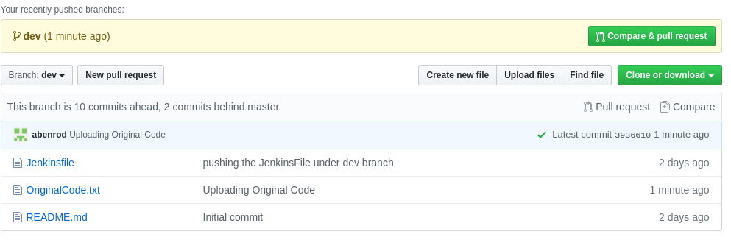

---

Feature.

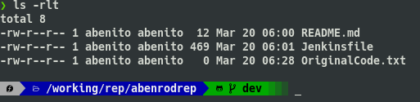

❯ git checkout -b feature
Switched to a new branch 'feature'

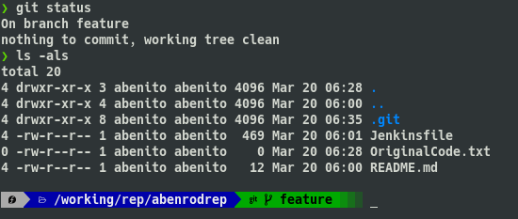

Extends from dev branch.

When you have finished with your enhances, you have a new version of the code, called release.

❯ git commit -m "The app_0.1 its ready"
[feature 1118722] The app_0.1 its ready
1 file changed, 0 insertions(+), 0 deletions(-)
create mode 100644 app_0.1
❯ git push
fatal: The current branch feature has no upstream branch.
To push the current branch and set the remote as upstream, use

git push --set-upstream origin feature

❯ git push --set-upstream origin feature
Enumerating objects: 3, done.
Counting objects: 100% (3/3), done.
Delta compression using up to 4 threads
Compressing objects: 100% (2/2), done.
Writing objects: 100% (2/2), 265 bytes | 265.00 KiB/s, done.
Total 2 (delta 1), reused 0 (delta 0)
remote: Resolving deltas: 100% (1/1), completed with 1 local object.
remote:
remote: Create a pull request for 'feature' on GitHub by visiting:
remote: https://github.com/abenrod/abenrodrep/pull/new/feature
remote:
To https://github.com/abenrod/abenrodrep
* [new branch] feature -> feature
Branch 'feature' set up to track remote branch 'feature' from 'origin'.

