Índice

Act 1 – Horas, minutos y segundos

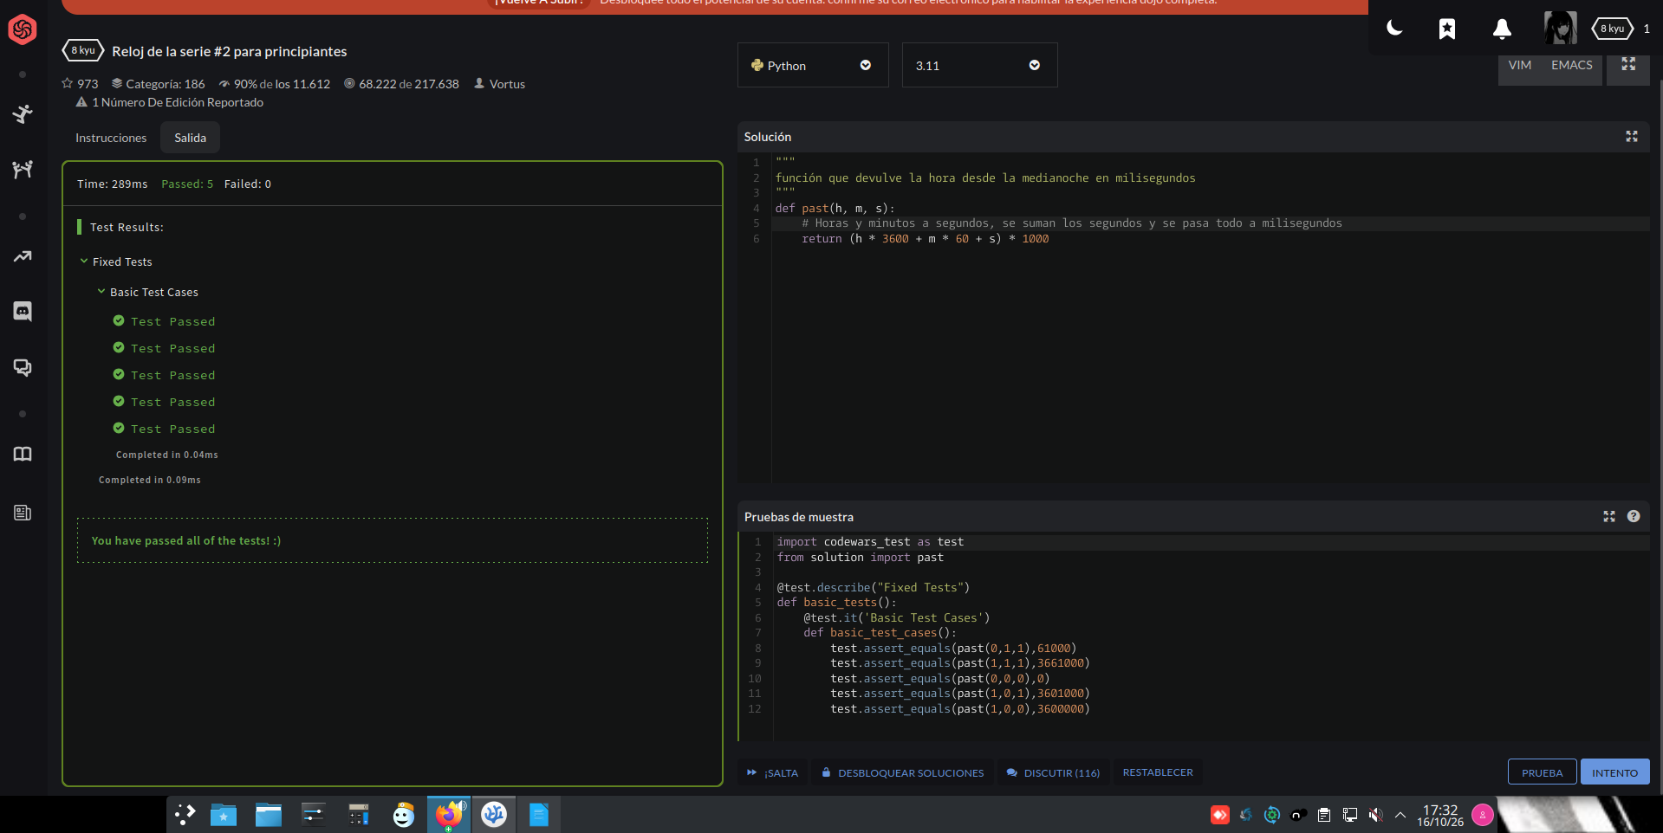

Act 2 – Pasar numero a String

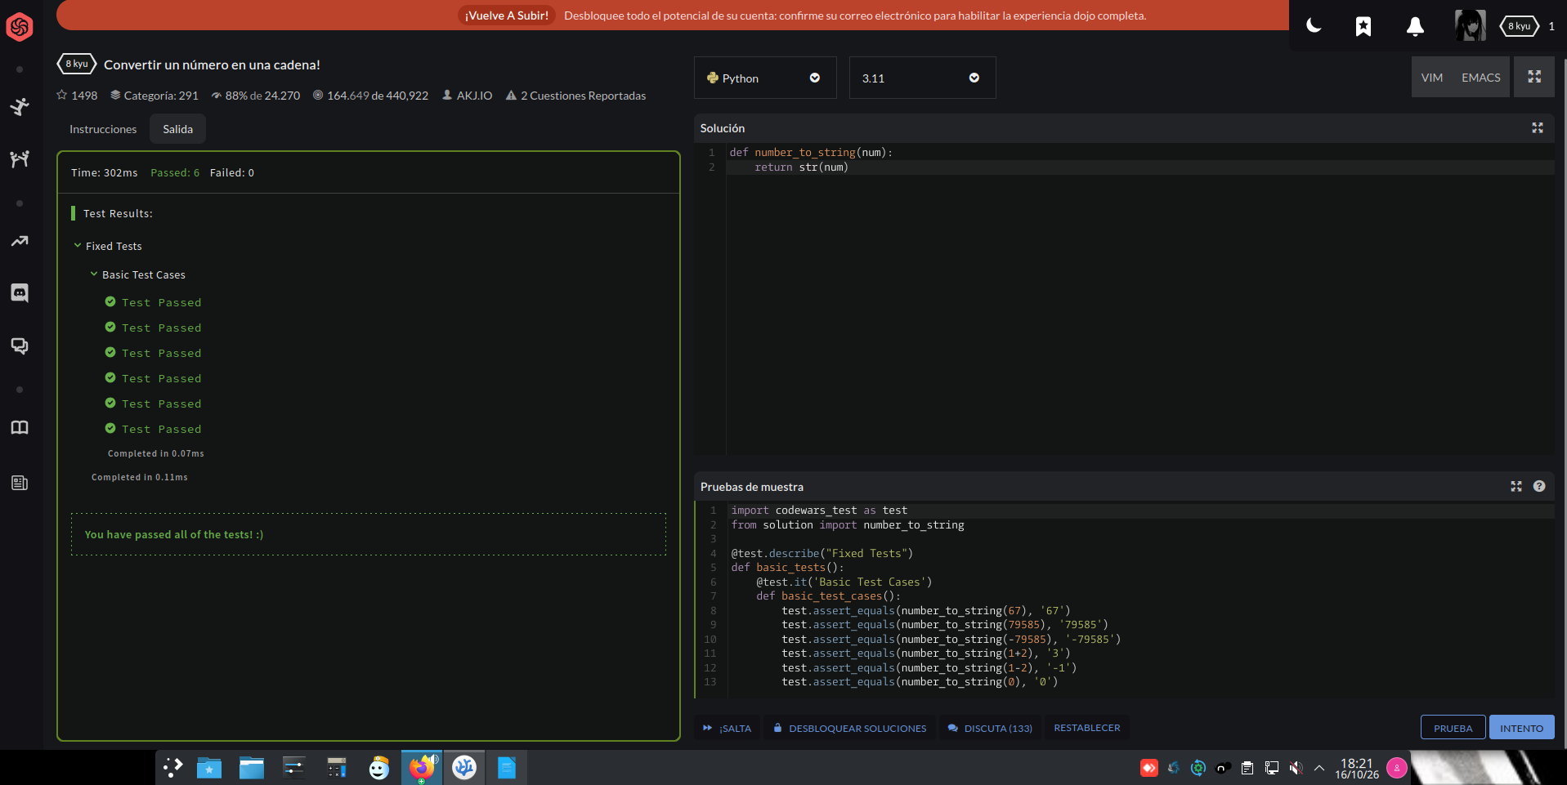

Act 3 – Boolean que devulve Yes o No

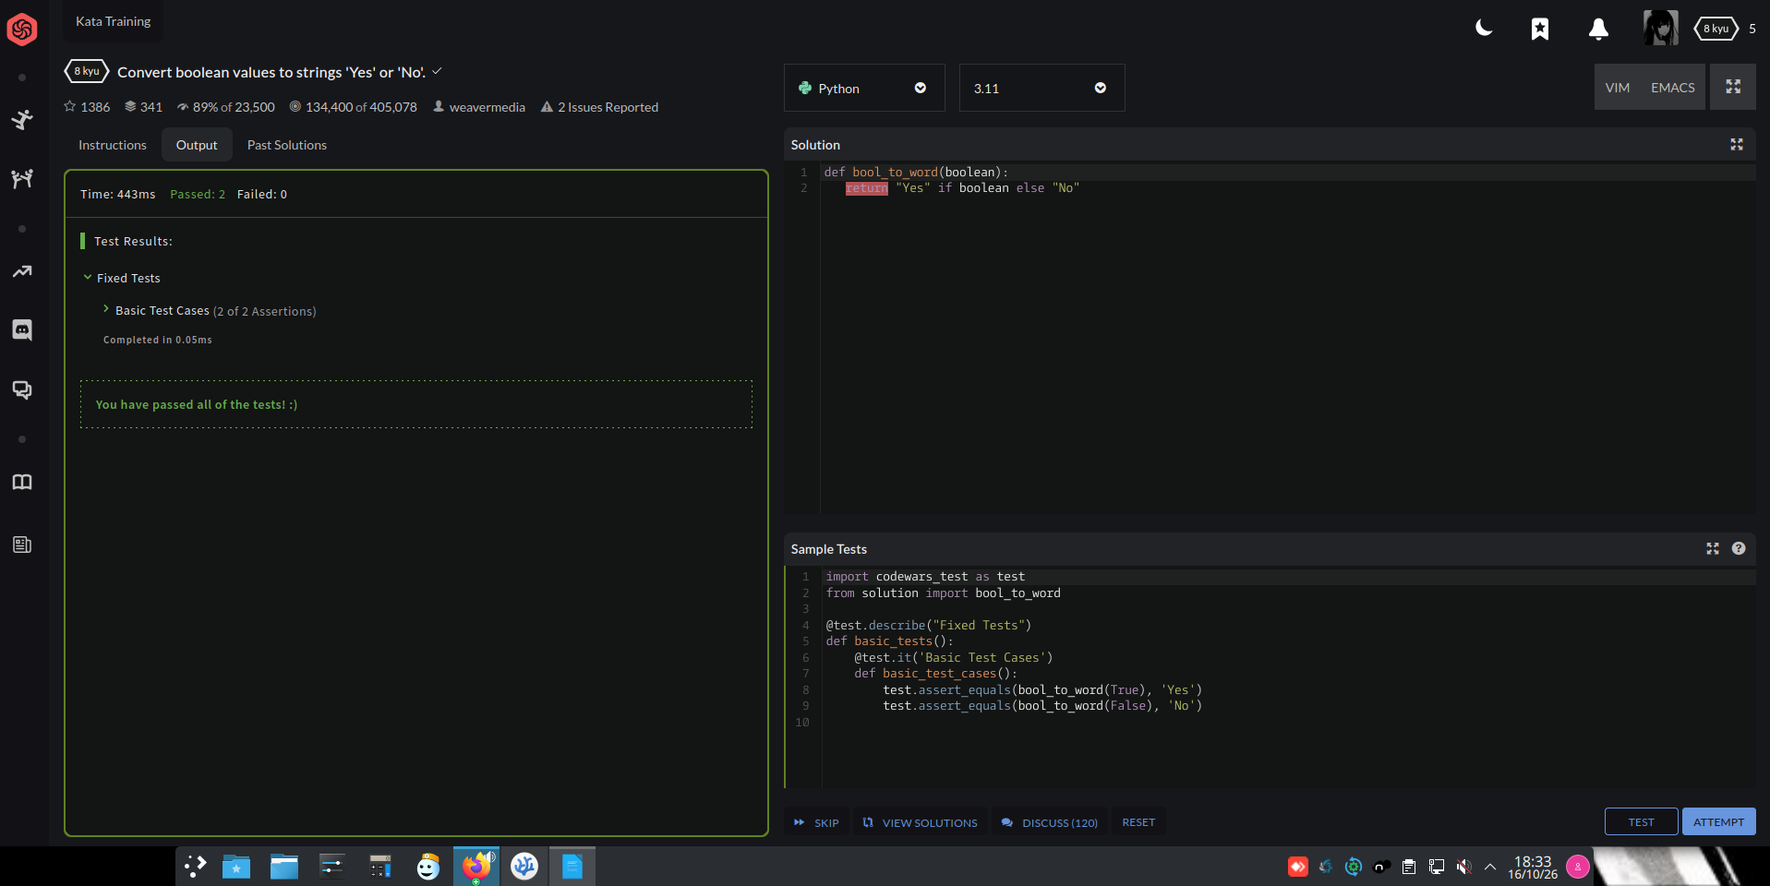

Act 4 – Suma de números positivos

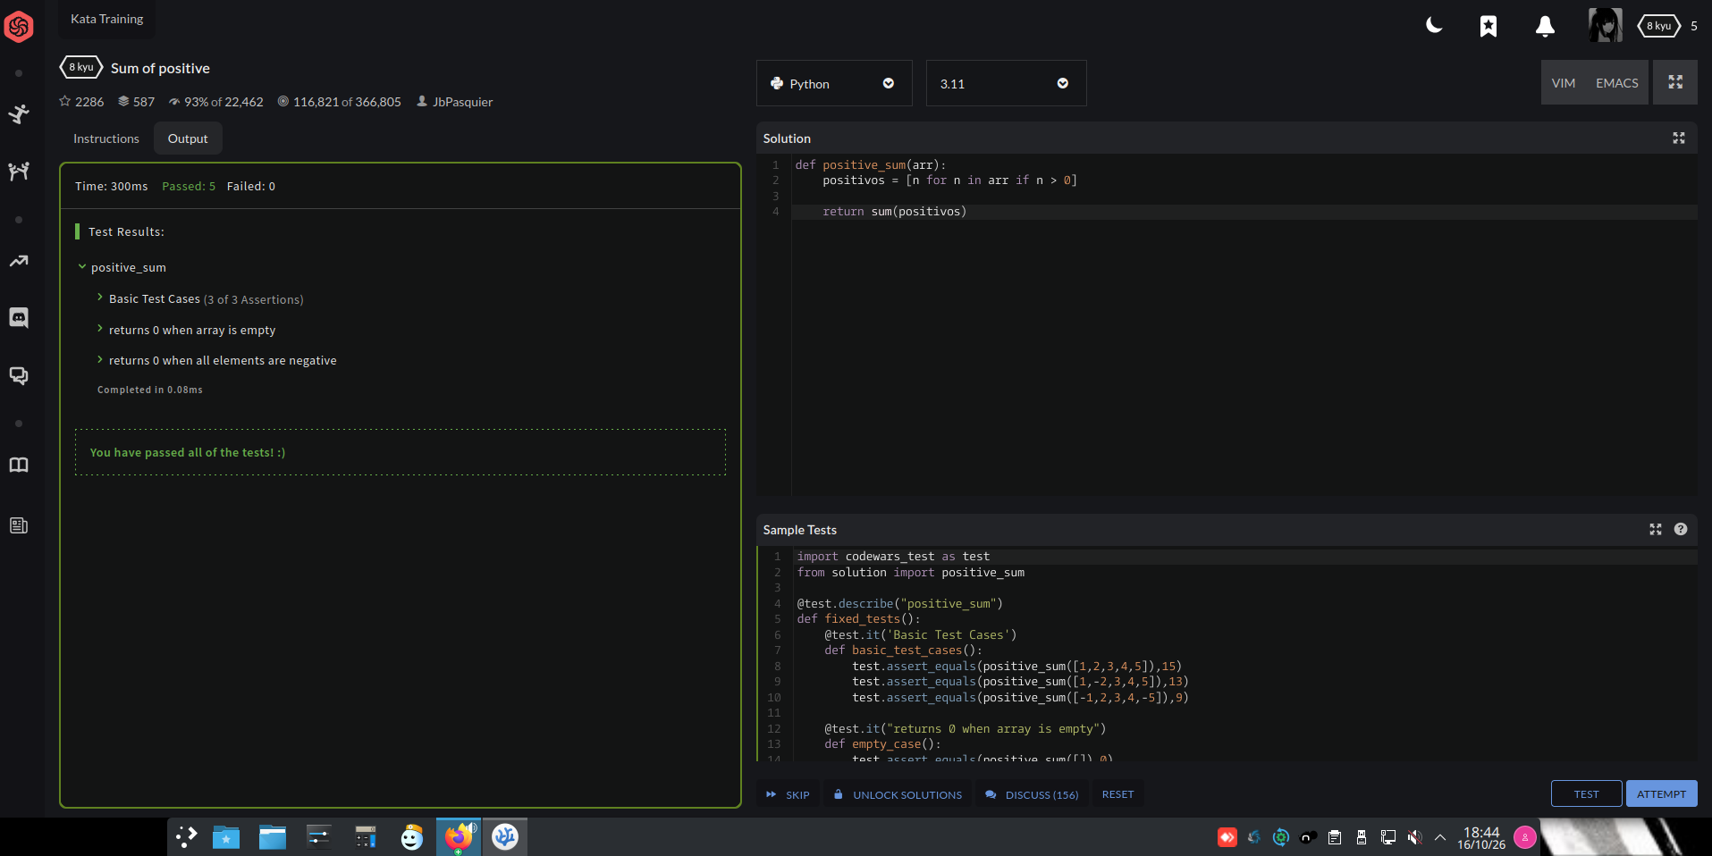

Act 5 - Doble

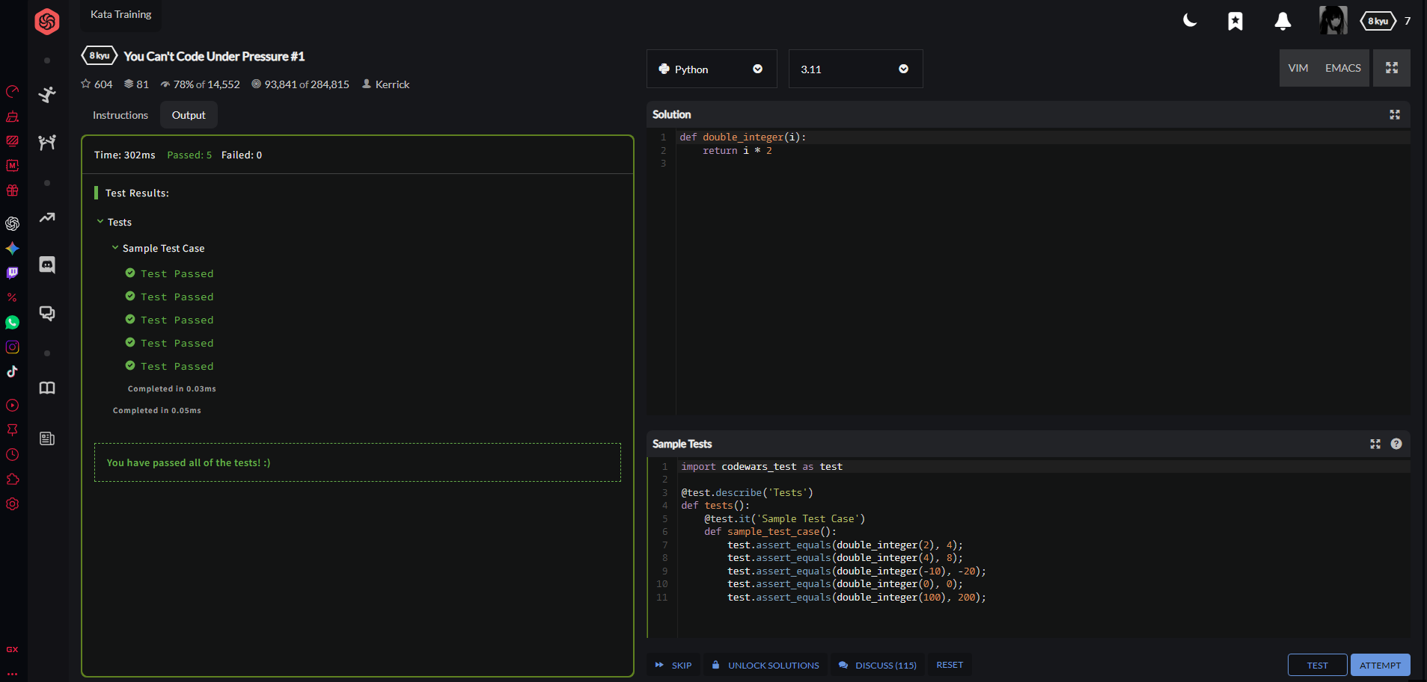

Act 6 – Upper Case

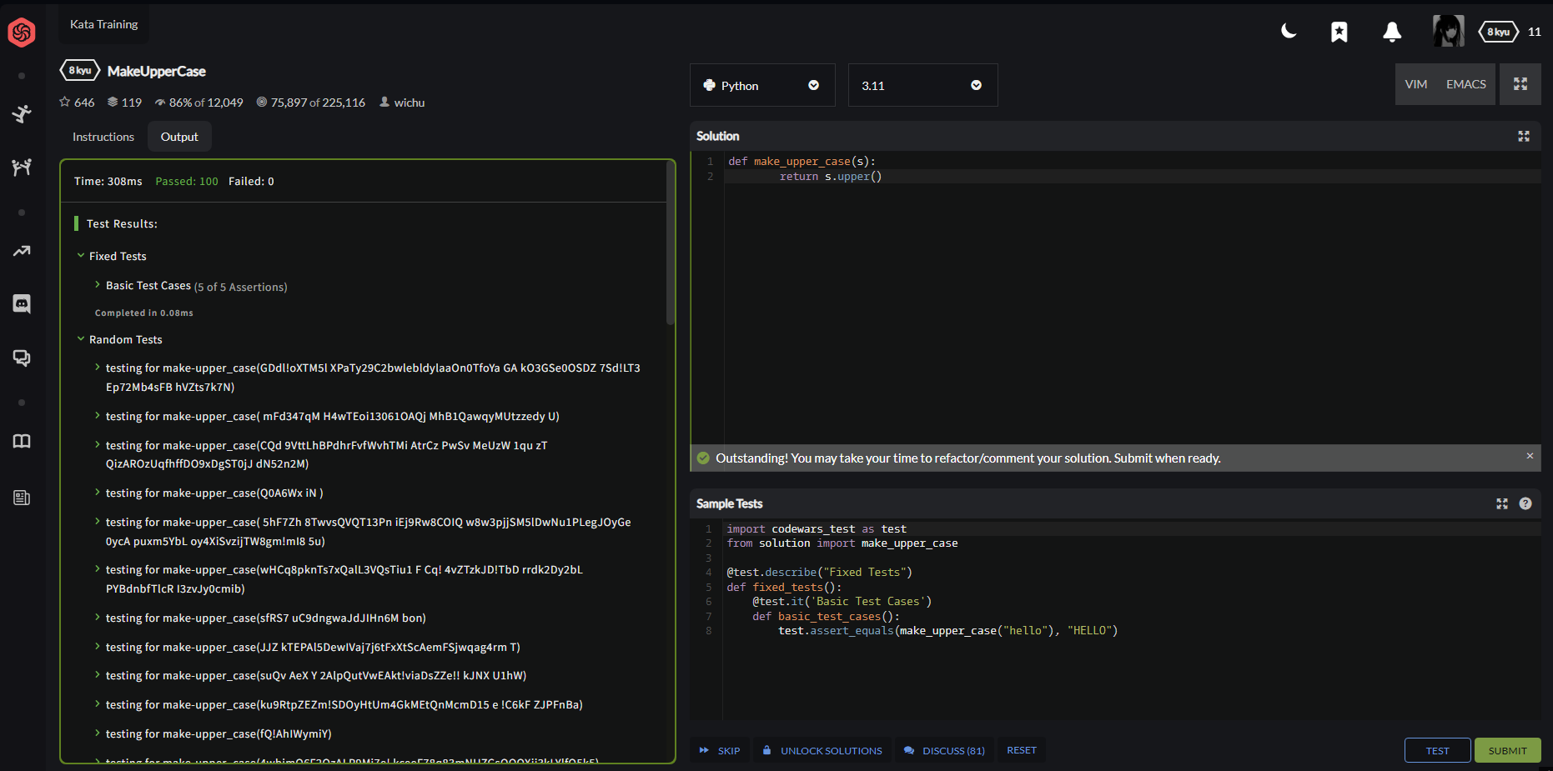

Act 7 – Repeat String

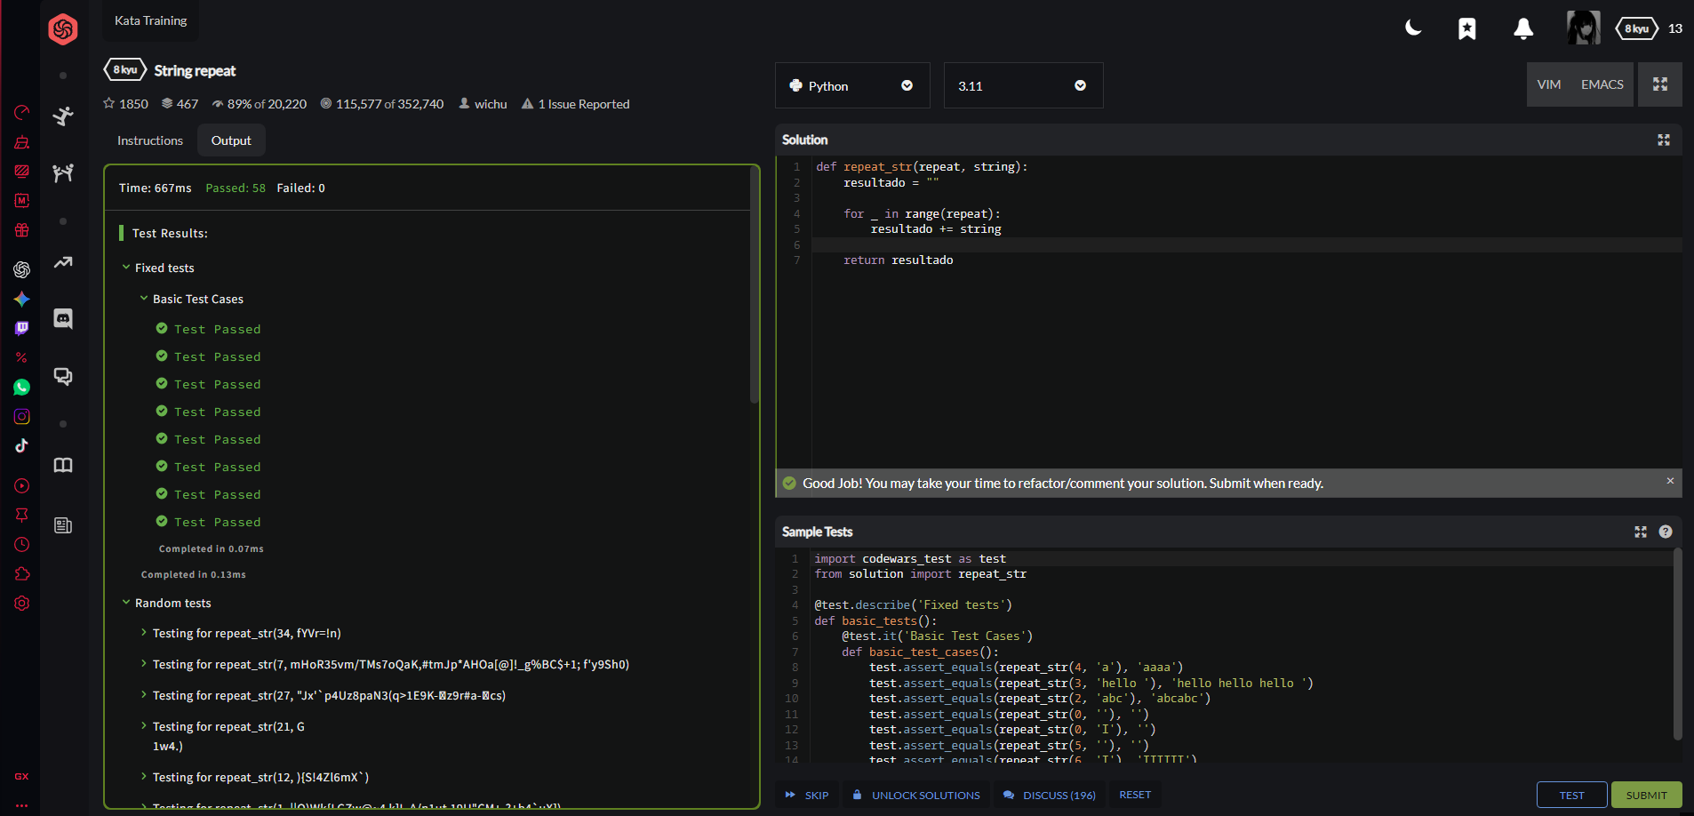

Act 8 - Century From Year

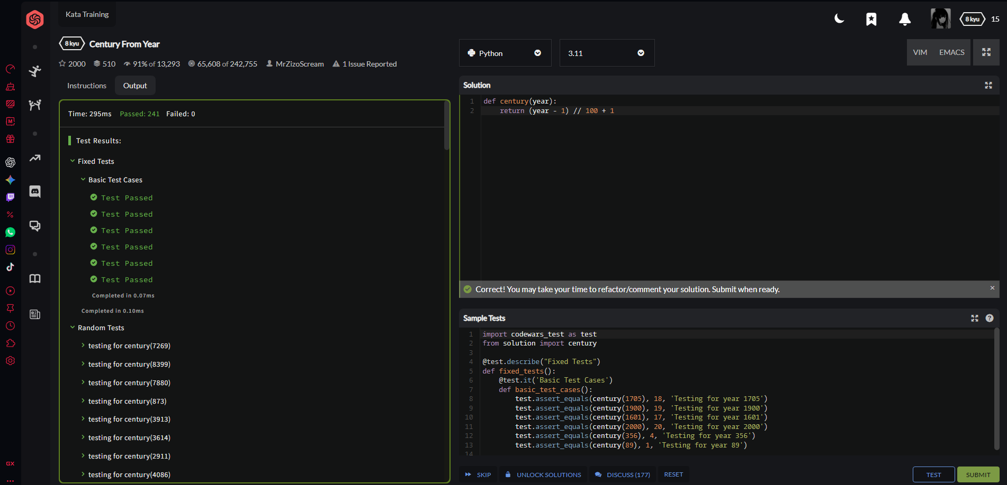

Act 9 – Num sumation

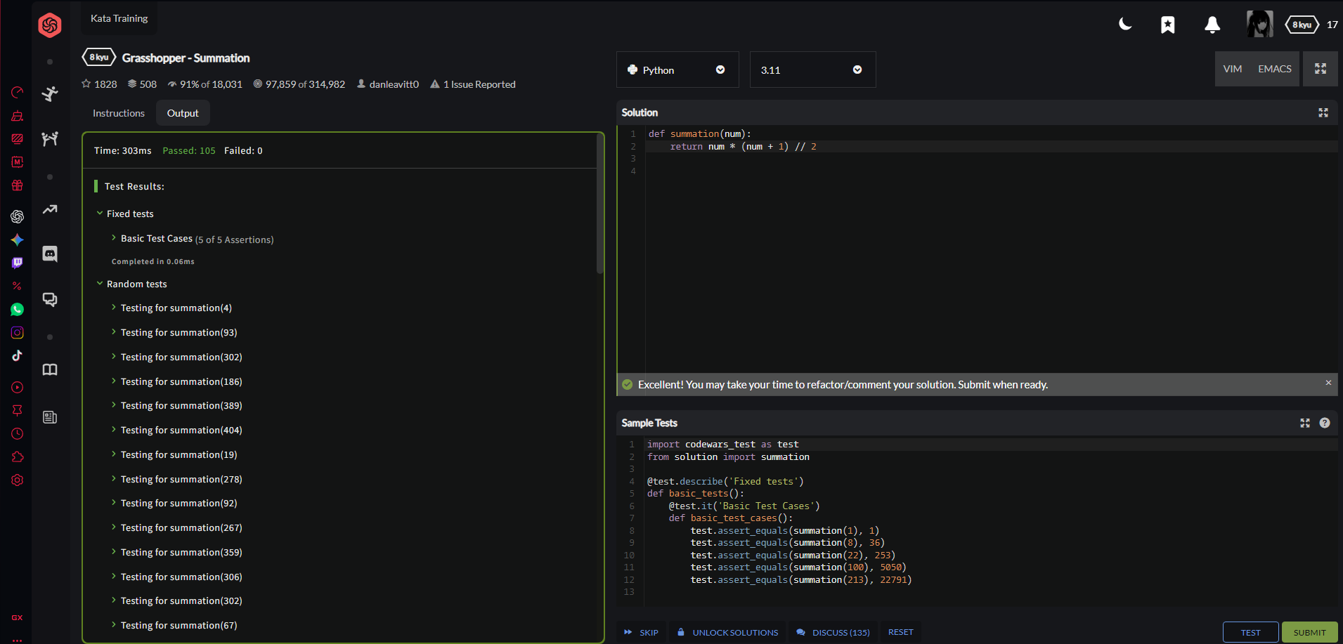

]

Act 10 - Square(n) Sum

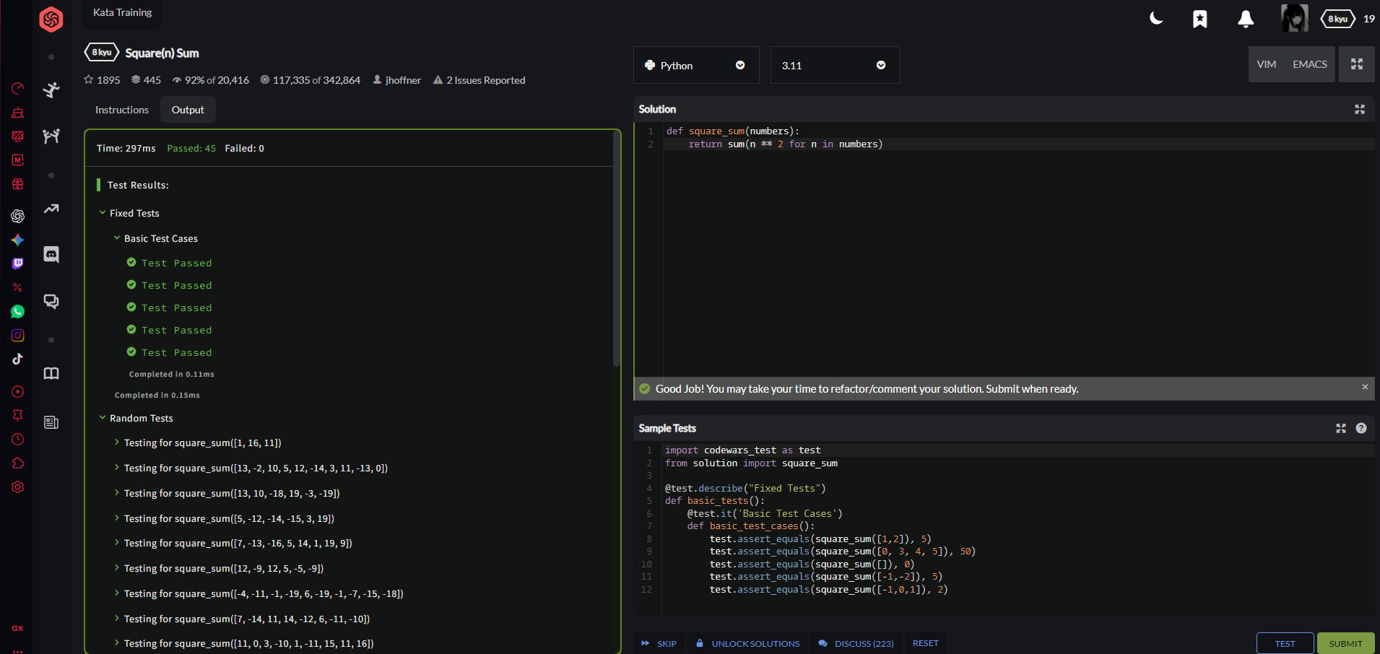

Act 11 - Sum of two lowest positive integers

Kata 7

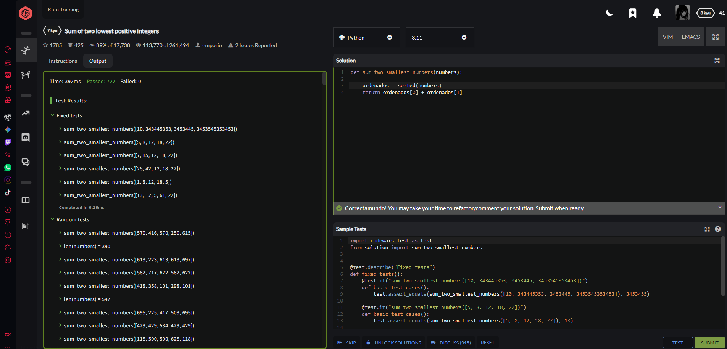

Act 12 - Shortest Word

Kata 7

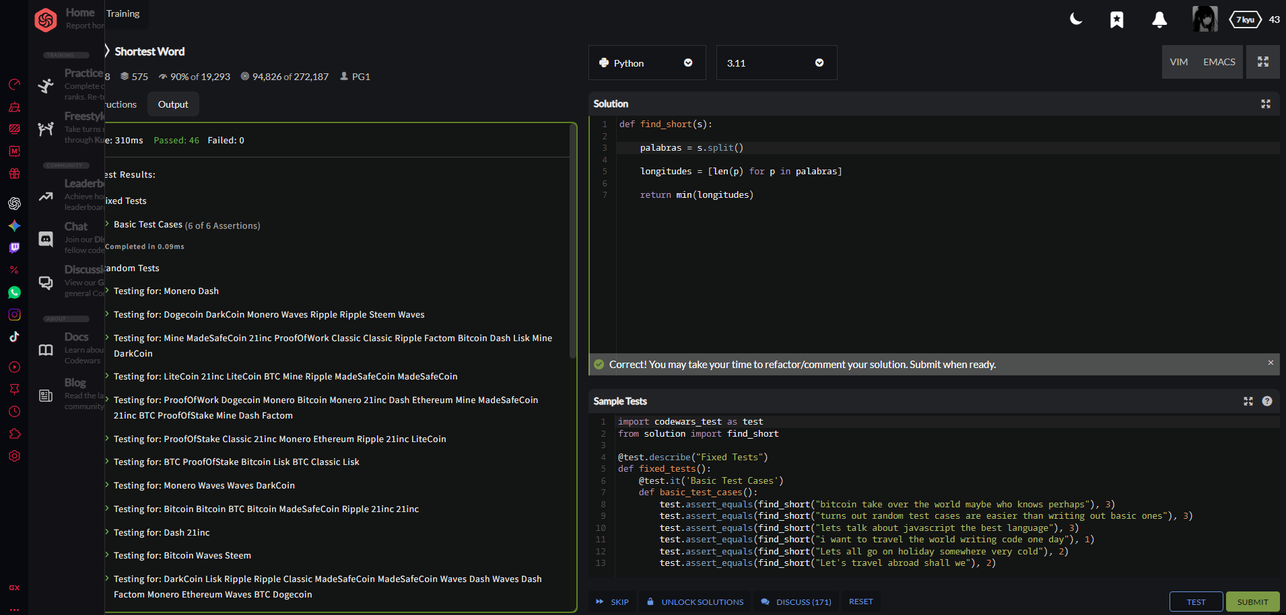

Act 13 - List Filtering

Kata 7
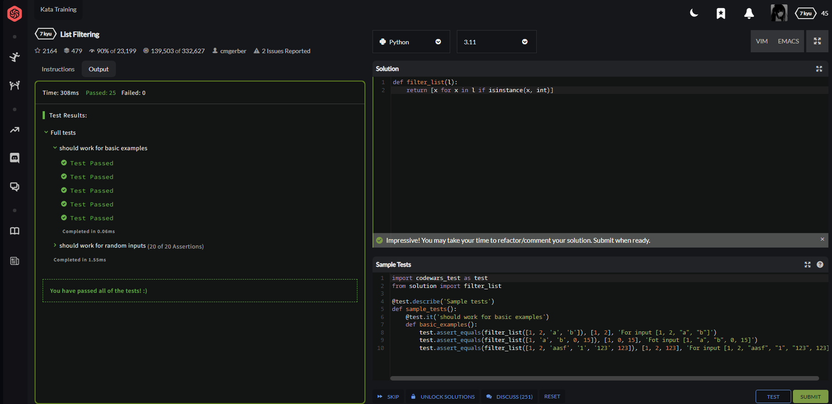

Act 14 - Remove the noise from the string

Kata 7

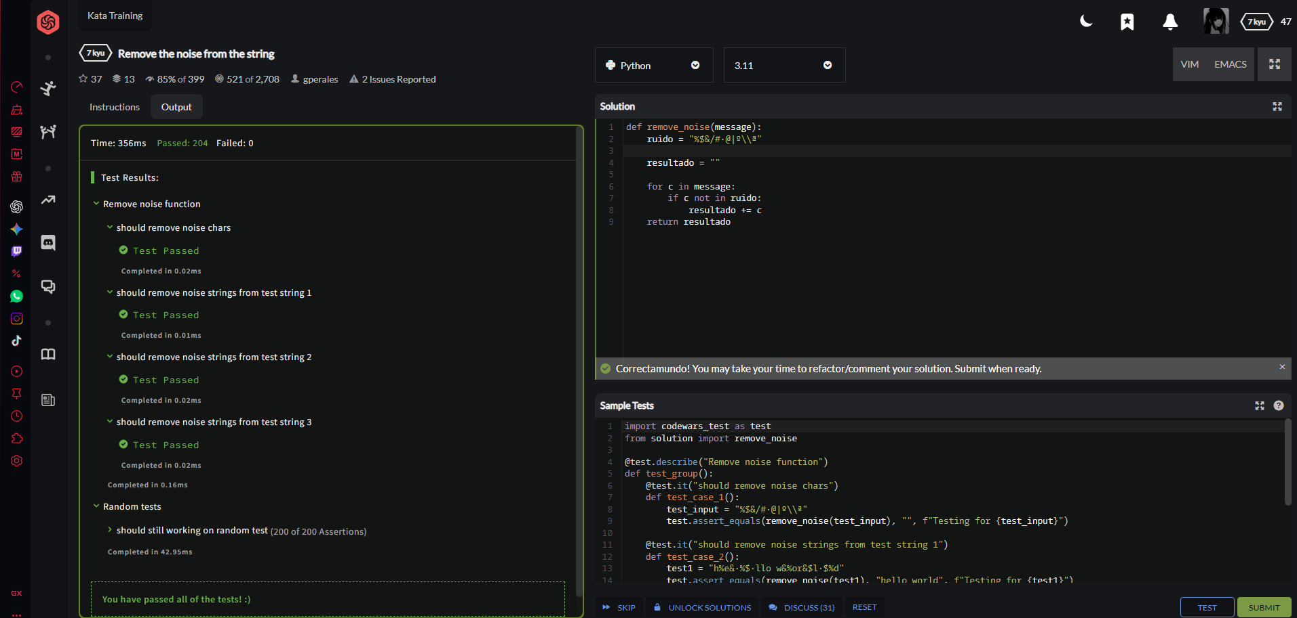

Act 15 - Shift Left

Kata 7

