|  |
| --- |
| Development Impact Evaluation |
| Burkina Faso Baseline Report |
| [Document subtitle] |

|  |
| --- |
| May 2018 |

# Socio-demographic characteristics

This section discusses socio-demographic and economic characteristics of the participating households with respect to age, gender, education, primary occupation, income and forest management group membership.

|  |  |  |  |  |  |  |
| --- | --- | --- | --- | --- | --- | --- |
| **Table. Summary statistics of demographic characteristics** |  |  |  |  |  |  |
| **Variable** | **N** | **Mean** | **S.D.** | **Median** | **Min** | **Max** |
| **L'age du participant** | 630 | 39.2 | 10.8 | 39.0 | 16.0 | 73.0 |
| **Nombre de membres de menage** | 630 | 13.0 | 7.8 | 11.0 | 0.0 | 45.0 |

The mean age of survey participants is 39 years and households have on average 13 members. Looking at the age distribution by forest in the graph below we observe that at least 95 percent of respondents are between 18 and 64 years of age across all forests whereas those age 35-44 account for the highest proportion in 8 out of 10 forests.

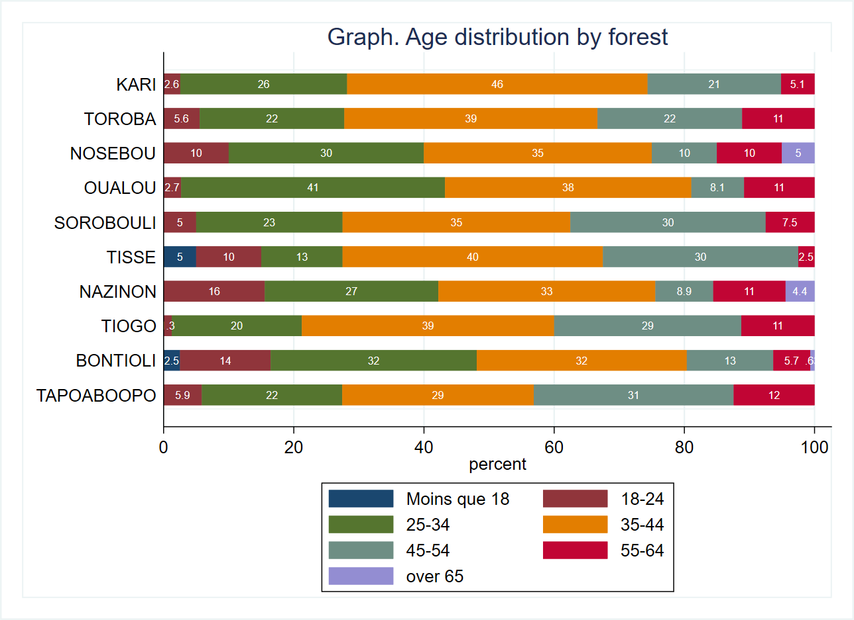

The survey respondents are predominantly male, and women make up just about 16 percent of the whole sample.

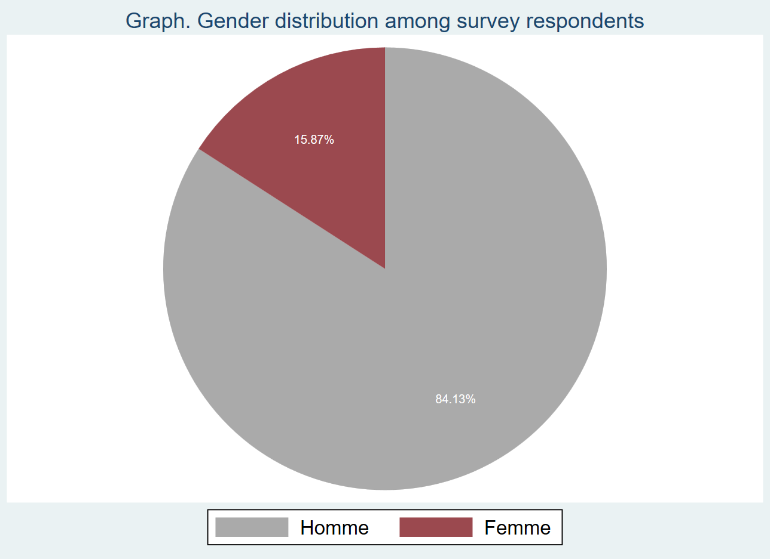

The literacy level of survey participants is relatively low. According to the graph below, over 80 percent have never been to school and 12 percent have primary school education. Less than 7 percent of all respondents pursued further studies beyond primary school.

|  |  |  |
| --- | --- | --- |
| **Table. Education level of survey respondents** |  |  |
| **N’a jamais été a l’école** | 513 | 81.4% |
| **Primaire** | 75 | 11.9% |
| **Secondaire premier cycle général** | 37 | 5.9% |
| **Secondaire premier cycle technique et professionnel** | 3 | 0.5% |
| **Secondaire second cycle général** | 2 | 0.3% |
| **Total** | 630 | 100.0% |
| **N** |  | 630 |

The distribution of the survey respondents with no education is fairly consistent across all forests ranging from 75 percent in Nosebou and Tisse to 88 percent in Tapoaboopo. Nosebou (20 percent), Tisse (18 percent) and Toroba (17 percent) have the highest proportions of respondents with primary education. Over 15 percent of respondents in Nazinon have education beyond primary school.

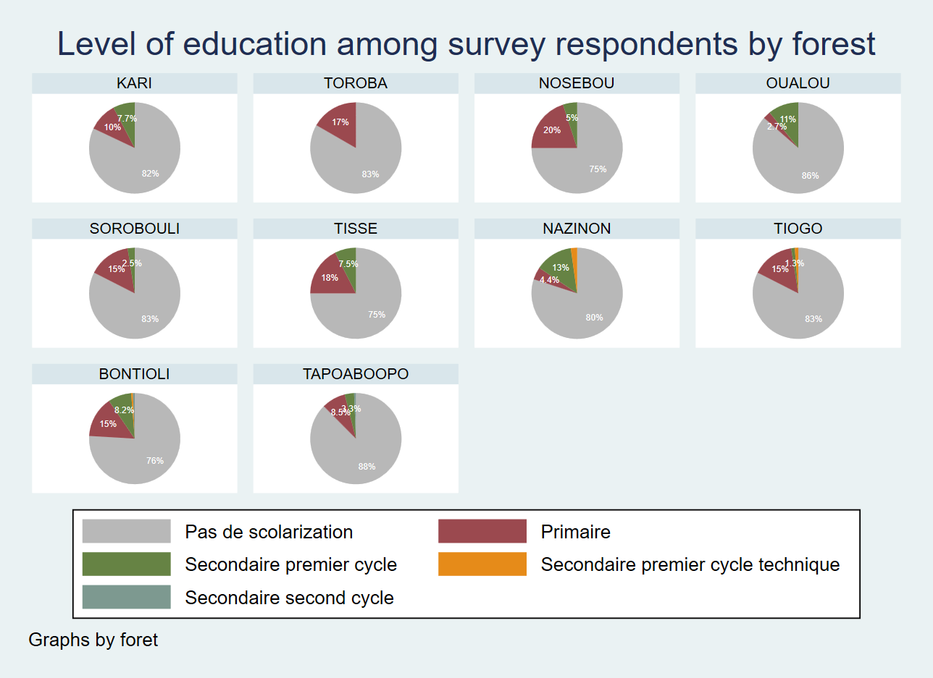

Farming is by far the main occupation of survey respondents (90 percent) followed by animal breeding (6.3 percent). About 2 percent reported having no primary occupation.

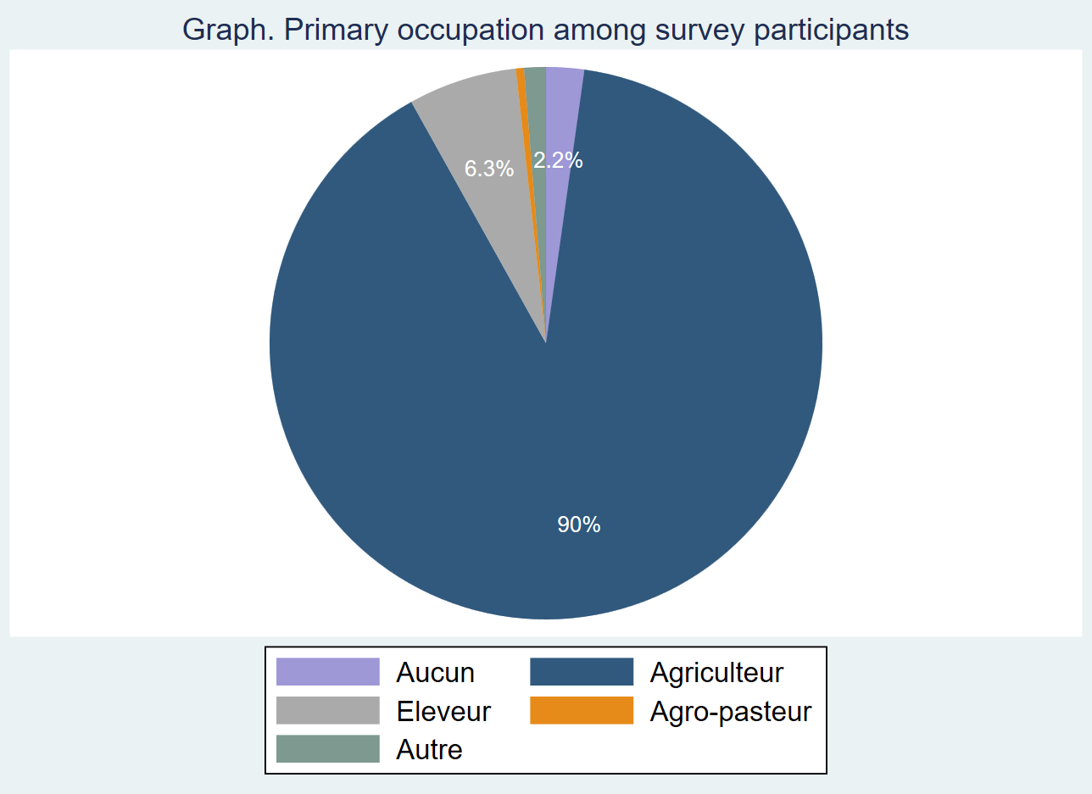

The proportion of respondents engaging in farming as the primary activity is consistently high throughout, according to table above. Virtually all survey participants residing in Toroba and Oualou, and over 95% in Kari, Tisse and Tiogo indicated farming as primary occupation. Tapoaboopo (16 percent) and Nazinon (11 percent) account for the highest proportions of animal breeders. Sorobouli (13 percent) and Nosebou (10 percent) have the highest proportions of respondents that reported having no primary occupation.

|  |  |  |  |  |  |  |
| --- | --- | --- | --- | --- | --- | --- |
| **Table. Primary occupation by forest** | | | |  |  |  |
| **Foret** | **Aucun** | **Agriculteur** | **Eleveur** | **Agro-pasteur** | **Autre** | **Total** |
| **KARI** | 2.6% | 97.4% | 0.0% | 0.0% | 0.0% | 100.0% |
| **TOROBA** | 0.0% | 100.0% | 0.0% | 0.0% | 0.0% | 100.0% |
| **NOSEBOU** | 10.0% | 85.0% | 0.0% | 0.0% | 5.0% | 100.0% |
| **OUALOU** | 0.0% | 100.0% | 0.0% | 0.0% | 0.0% | 100.0% |
| **SOROBOULI** | 12.5% | 80.0% | 5.0% | 0.0% | 2.5% | 100.0% |
| **TISSE** | 0.0% | 97.5% | 2.5% | 0.0% | 0.0% | 100.0% |
| **NAZINON** | 4.4% | 84.4% | 11.1% | 0.0% | 0.0% | 100.0% |
| **TIOGO** | 1.3% | 96.3% | 1.3% | 1.3% | 0.0% | 100.0% |
| **BONTIOLI** | 1.9% | 92.4% | 3.8% | 0.0% | 1.9% | 100.0% |
| **TAPOABOOPO** | 0.0% | 80.4% | 16.3% | 1.3% | 2.0% | 100.0% |
| **Total** | 2.2% | 89.7% | 6.3% | 0.5% | 1.3% | 100.0% |
| N | 14 | 565 | 40 | 3 | 8 | 630 |

The average income calculated as the sum of incomes derived from primary and secondary occupations is roughly 500,000 FCFA.

|  |  |  |  |  |  |  |
| --- | --- | --- | --- | --- | --- | --- |
| **Table. Income** |  |  |  |  |  |  |
| **Variable** | **N** | **Mean** | **S.D.** | **Median** | **Min** | **Max** |
| **Revenu total au cours des 12 derniers mois, en 1000s FCFA** | 616 | 507.8 | 614.4 | 275.0 | 0.0 | 3100.0 |

Glancing over the income distribution by forest we observe that Nosebou and Sorobouli have by far the highest annual average incomes at 1,353,000 FCFA and 1,268,000 FCFA. With an average of 149,000 FCFA and 287,000 FCFA per annum, Tiogo and Nazinon are at the lower end of the income distribution.

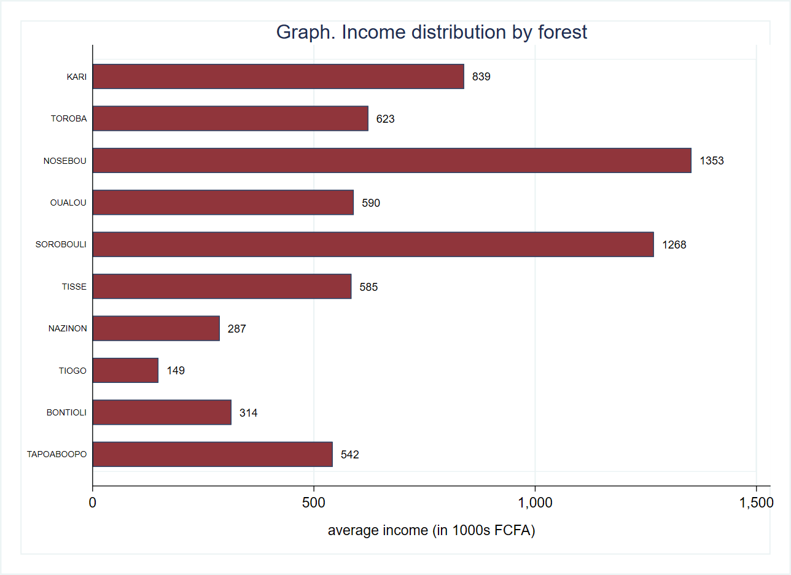

Digging further into the income distribution by gender and primary occupation reveals huge gender-based income disparity. Men are high earners across the board with agro-pastoralist occupations (800,000 FCFA) being the most lucrative followed by other occupations such as miner and mechanic. Women animal breeders (350,000 FCFA) have the highest annual average incomes followed by women farmers (approx.. 220,000 FCFA).

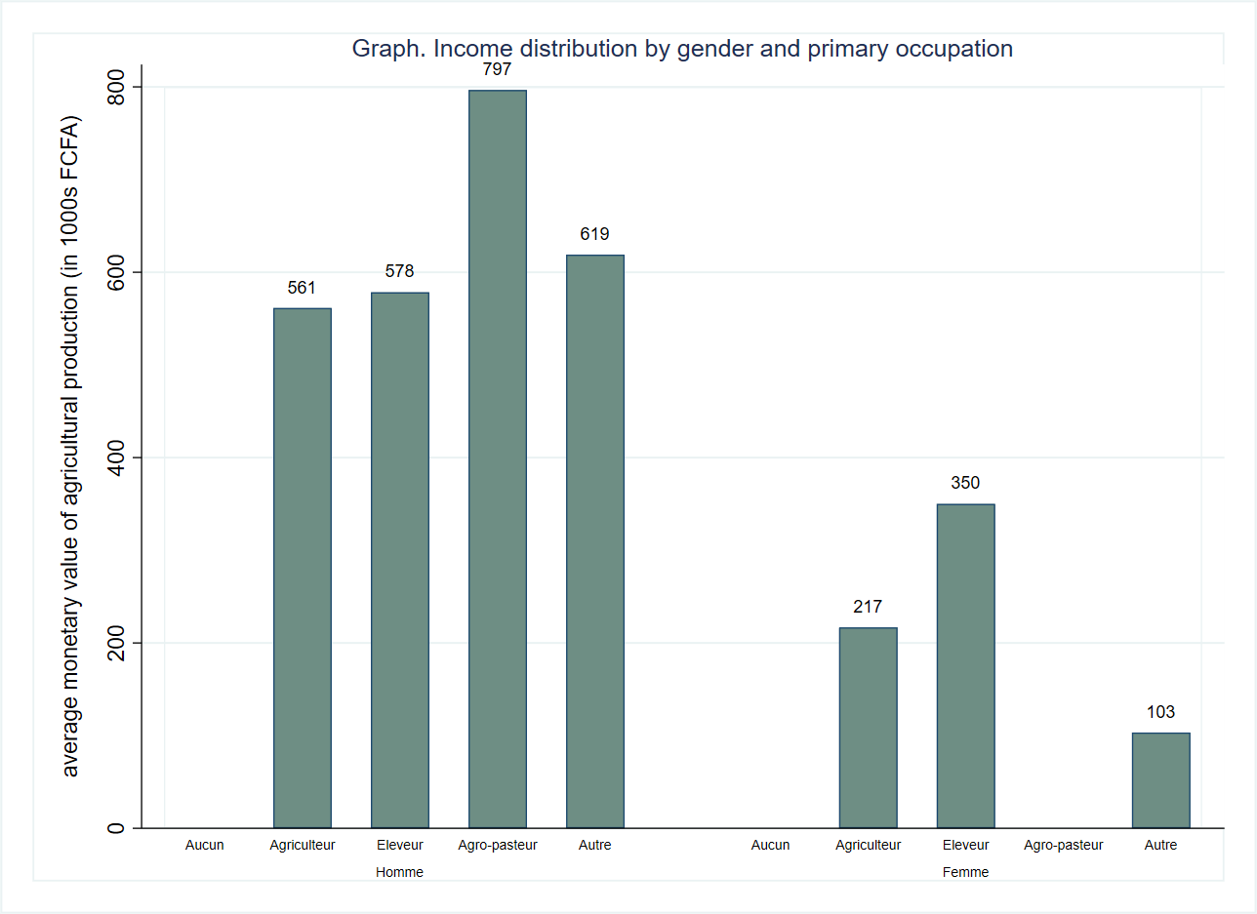

Nearly 6 out of 10 survey respondents reported being a member of a forest management group.

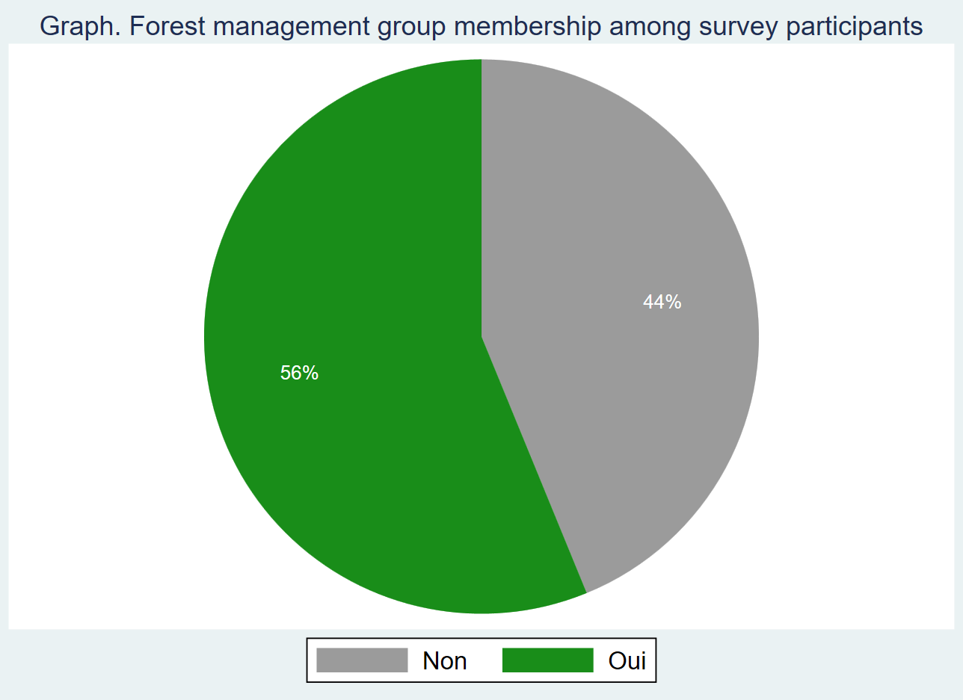

The graph below illustrates the differences in the forest management group membership by forest. Nearly all respondents residing in Oualou are a member of a forest management group. About 90 percent in Toroba and 4 out of 5 respondents in Nosebou and Tapoaboopo reported having a forest management group membership. Nazinon(18 percent), Tiogo (30 percent) and Bontioli (32 percent) account for the lowest proportions of respondents that are members of a forest management group.

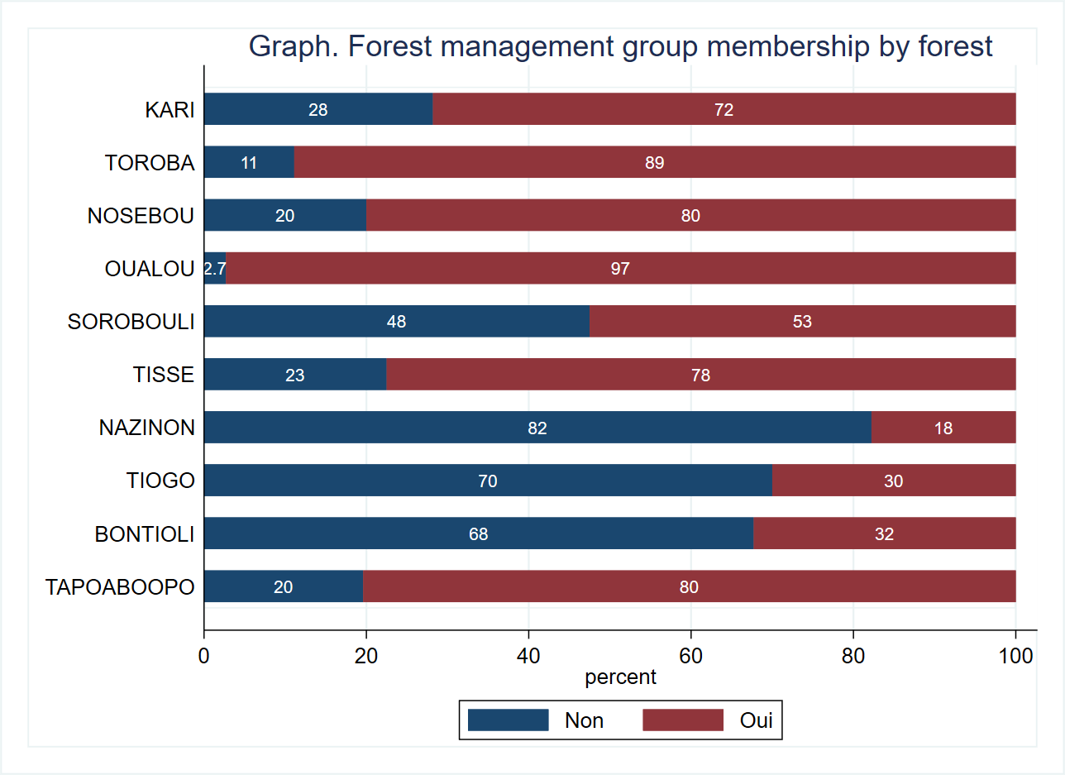

The balance tables below indicate that both control and treatment groups are strongly balanced with respect to age, household size, literacy level, forest management group membership and income. We observe significant differences at the 5% level between the two groups with regards to gender and whether the survey participant is the household head.

|  |  |  |  |  |  |
| --- | --- | --- | --- | --- | --- |
| **Table. Balance tables** |  | **(1)** |  | **(2)** | **t-test** |
| **Variable** |  | **Control** |  | **Treatment** | **Difference** |
|  | **N** | **Mean/SE** | **N** | **Mean/SE** | **(1)-(2)** |
| **Age** | 307 | 38.544 | 323 | 39.78 | -1.236 |
|  |  | [0.625] |  | [0.596] |  |
| **Sexe** | 307 | 0.192 | 323 | 0.127 | 0.065** |
|  |  | [0.023] |  | [0.019] |  |
| **Household head?** | 307 | 0.583 | 323 | 0.675 | -0.092** |
|  |  | [0.028] |  | [0.026] |  |
| **Household size** | 307 | 12.739 | 323 | 13.254 | -0.514 |
|  |  | [0.468] |  | [0.407] |  |
| **Membre d'un groupement de gestion forestiere (GGF)** | 307 | 0.531 | 323 | 0.591 | -0.06 |
|  |  | [0.029] |  | [0.027] |  |
| **Total Income (in 1000s FCFA)** | 300 | 507.804 | 316 | 507.854 | -0.05 |
|  |  | [37.476] |  | [32.661] |  |
| **The value displayed for t-tests are the differences in the means across the groups.** |  |  |  |  |  |
| **\*\*\*, **, and * indicate significance at the 1, 5, and 10 percent critical level.** |  |  |  |  |  |

# Assets

This section employs the asset index and livestock index to investigate differences by forest and differences between the control and treatment groups.

We construct the asset index using principal component analysis, a tool that helps summarize the variability within the set of assets in our data. We construct an individual index for each forest.

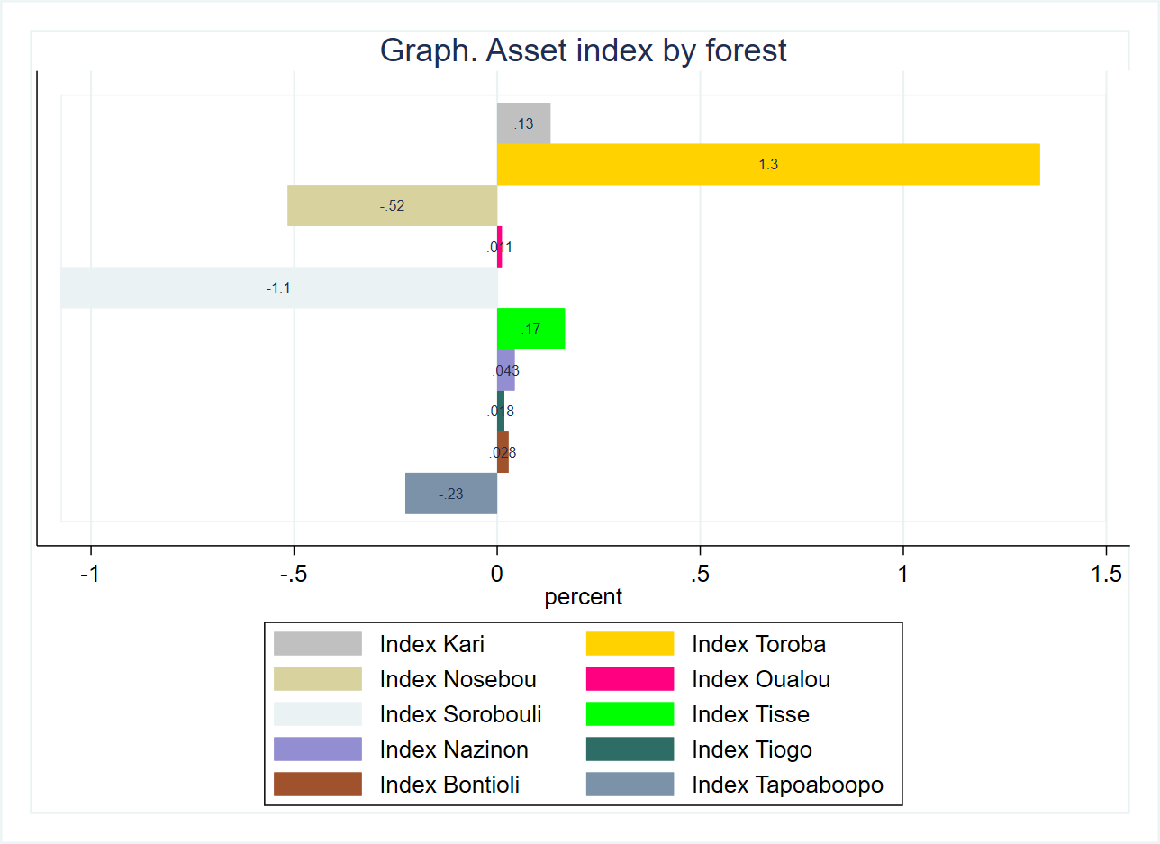

|  |  |  |  |  |  |
| --- | --- | --- | --- | --- | --- |
| **Table. Balance tables** |  | **(1)** |  | **(2)** | **t-test** |
| **Variable** |  | **Control** |  | **Treatment** | **Difference** |
|  | **N** | **Mean/SE** | **N** | **Mean/SE** | **(1)-(2)** |
| **Index Kari** | 307 | 0.176 | 323 | 0.089 | 0.087 |
|  |  | [0.050] |  | [0.052] |  |
| **Index Toroba** | 307 | 1.309 | 323 | 1.362 | -0.053 |
|  |  | [0.121] |  | [0.117] |  |
| **Index Nosebou** | 307 | -0.533 | 323 | -0.499 | -0.034 |
|  |  | [0.078] |  | [0.075] |  |
| **Index Oualou** | 307 | 0.004 | 323 | 0.019 | -0.015 |
|  |  | [0.056] |  | [0.055] |  |
| **Index Sorobouli** | 307 | -1.095 | 323 | -1.056 | -0.039 |
|  |  | [0.089] |  | [0.086] |  |
| **Index Tisse** | 307 | 0.165 | 323 | 0.168 | -0.003 |
|  |  | [0.036] |  | [0.028] |  |
| **Index Nazinon** | 307 | 0.094 | 323 | -0.006 | 0.1 |
|  |  | [0.057] |  | [0.071] |  |
| **Tiogo** | 307 | 0.096 | 323 | -0.057 | 0.154* |
|  |  | [0.036] |  | [0.075] |  |
| **Index Bontioli** | 307 | 0.055 | 323 | 0.002 | 0.052 |
|  |  | [0.058] |  | [0.055] |  |
| **Index Tapoaboopo** | 307 | -0.151 | 323 | -0.298 | 0.147 |
|  |  | [0.087] |  | [0.124] |  |
| The value displayed for t-tests are the differences in the means across the groups. |  |  |  |  |  |
| ***, **, and * indicate significance at the 1, 5, and 10 percent critical level. |  |  |  |  |  |

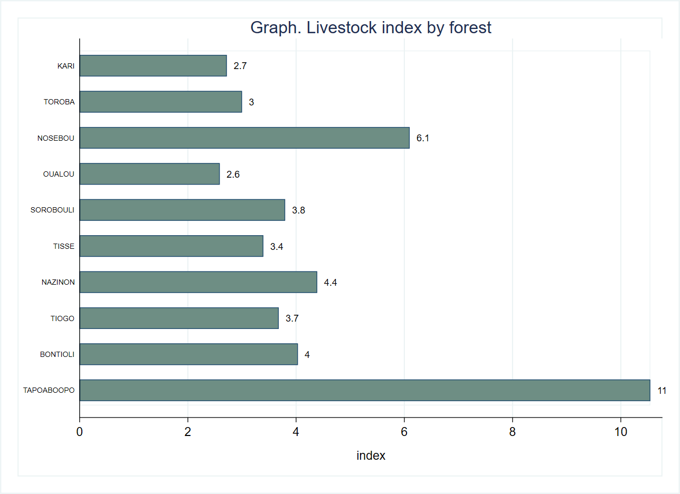

|  |  |  |  |  |  |
| --- | --- | --- | --- | --- | --- |
| **Table. Balance tables** |  | **(1)** |  | **(2)** | **t-test** |
| **Variable** |  | **Control** |  | **Treatment** | **Difference** |
|  | **N** | **Mean/SE** | **N** | **Mean/SE** | **(1)-(2)** |
| **Livestock Index** | 307 | 6.133 | 323 | 4.722 | 1.411 |
|  |  | [1.023] |  | [0.367] |  |
| **The value displayed for t-tests are the differences in the means across the groups.** |  |  |  |  |  |
| **\*\*\*, **, and * indicate significance at the 1, 5, and 10 percent critical level.** |  |  |  |  |  |

# Agricultural production

The section on agricultural production includes variables that denote the total area of land, total area of cultivated land and the expenditure on agricultural inputs such as improved seed varieties, chemical and organic fertilizer, pesticide products, cost of labor and the total value of agricultural production.

Graph below evaluates the use of agricultural inputs. Pesticides (55 percent) followed by chemical fertilizers (52 percent) are the most popular agricultural inputs among survey respondents. Roughly 30 percent use improved seed varieties while organic fertilizers are the least popular input among survey respondents (about 15 percent).

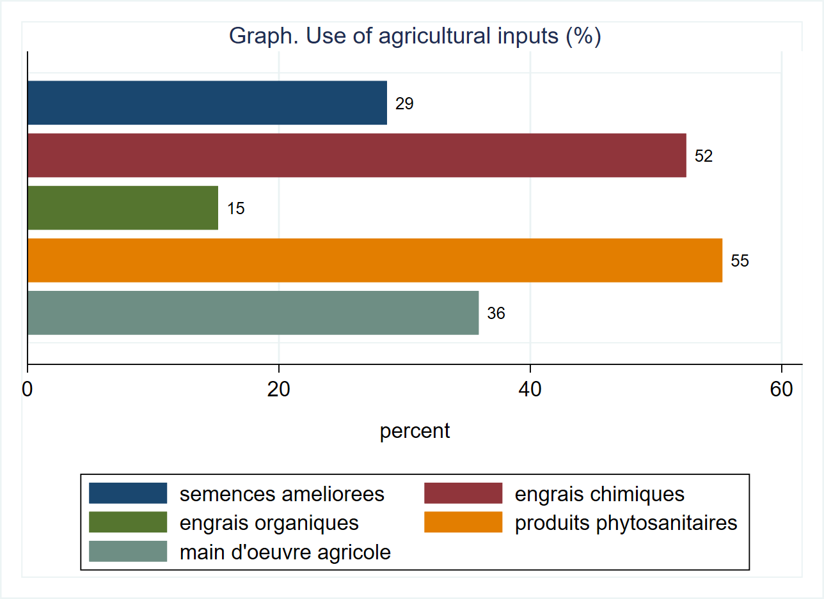

The respondents own on average 6 hectares of land and cultivate about 80 percent of their land holdings. With regards to agricultural inputs, the highest average expenditure is on chemical fertilizers (nearly 90,000 FCFA) and pesticide products (40,000 FCFA). These findings indicate that objectives like keeping pests off crops and raising the level of yields are high on the agenda. By contrast, respondents tend to spend a lot less on organic fertilizers and improved seed varieties. One possible reason may be the low dissemination and/or adoption of new technology. Another may be related to the perceptions of organic fertilizers as being too scarce, expensive or less efficient.

|  |  |  |  |  |  |  |
| --- | --- | --- | --- | --- | --- | --- |
| **Table. Agricultural inputs** |  |  |  |  |  |  |
| **Variable** | **N** | **Mean** | **S.D.** | **Median** | **Min** | **Max** |
| **Superficie totale de terres, en ha** | 521 | 5.7 | 4.4 | 5.0 | 1.0 | 18.0 |
| **Superficie total cultivee, en ha** | 521 | 4.5 | 3.1 | 4.0 | 1.0 | 12.0 |
| **Valeur totale des semences ameliorees achetees, en 1000s FCFA** | 149 | 14.2 | 20.5 | 5.1 | 0.1 | 120.0 |
| **Valeur totale des engrais chimiques achetes, en 1000s FCFA** | 273 | 88.8 | 125.9 | 50.0 | 1.0 | 1000.0 |
| **Valeur totale des engrais organiques achetes, en 1000s FCFA** | 79 | 32.5 | 82.3 | 5.0 | 1.5 | 450.0 |
| **Valeur totale des produits phytosanitaires achetes, en 1000s FCFA** | 288 | 41.4 | 68.4 | 25.0 | 1.0 | 800.0 |
| **Valeur totale de la main d'oeuvre achetee ou louee, en 1000s FCFA** | 187 | 38.4 | 60.8 | 15.0 | 0.0 | 450.0 |

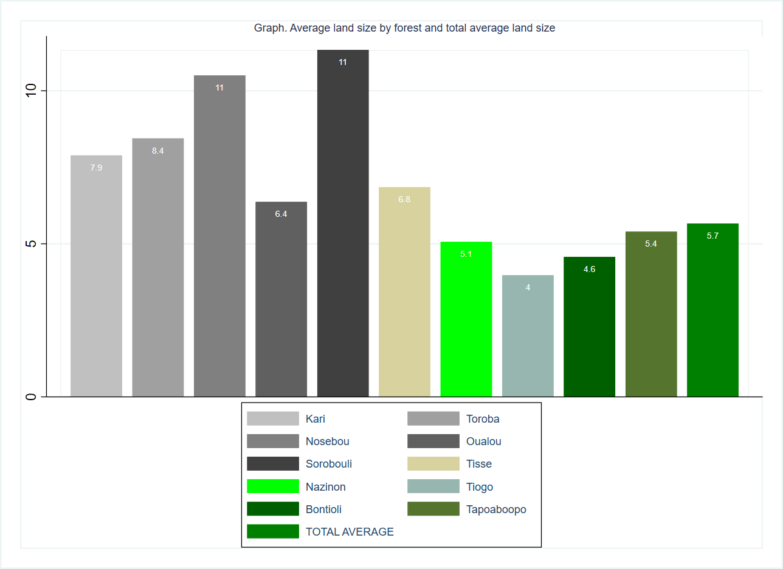

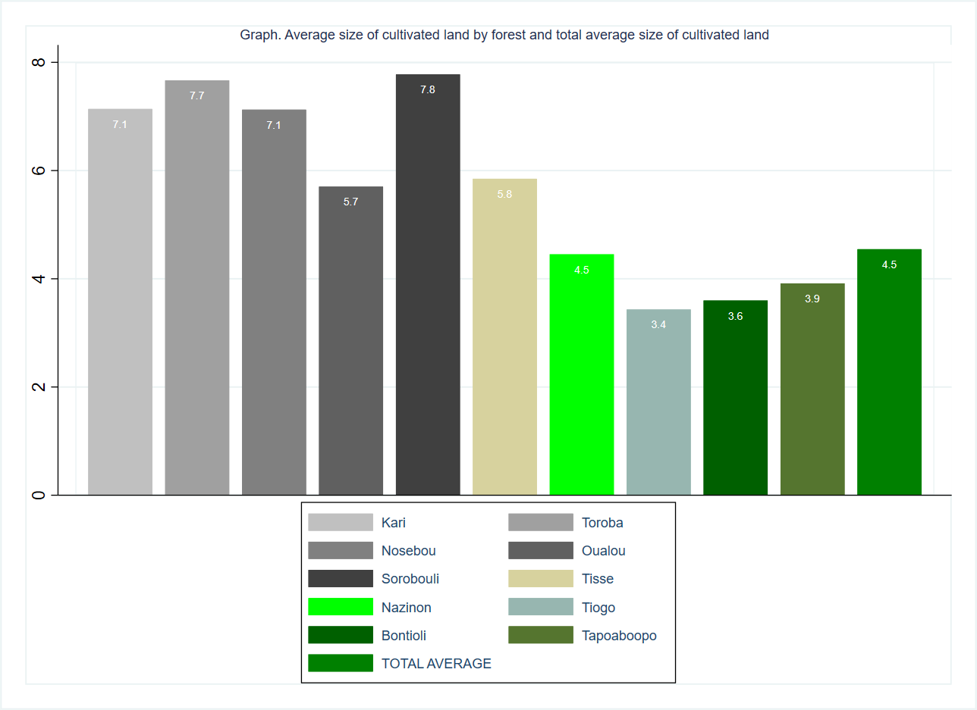

**Average expenditure on agricultural inputs by forest type**

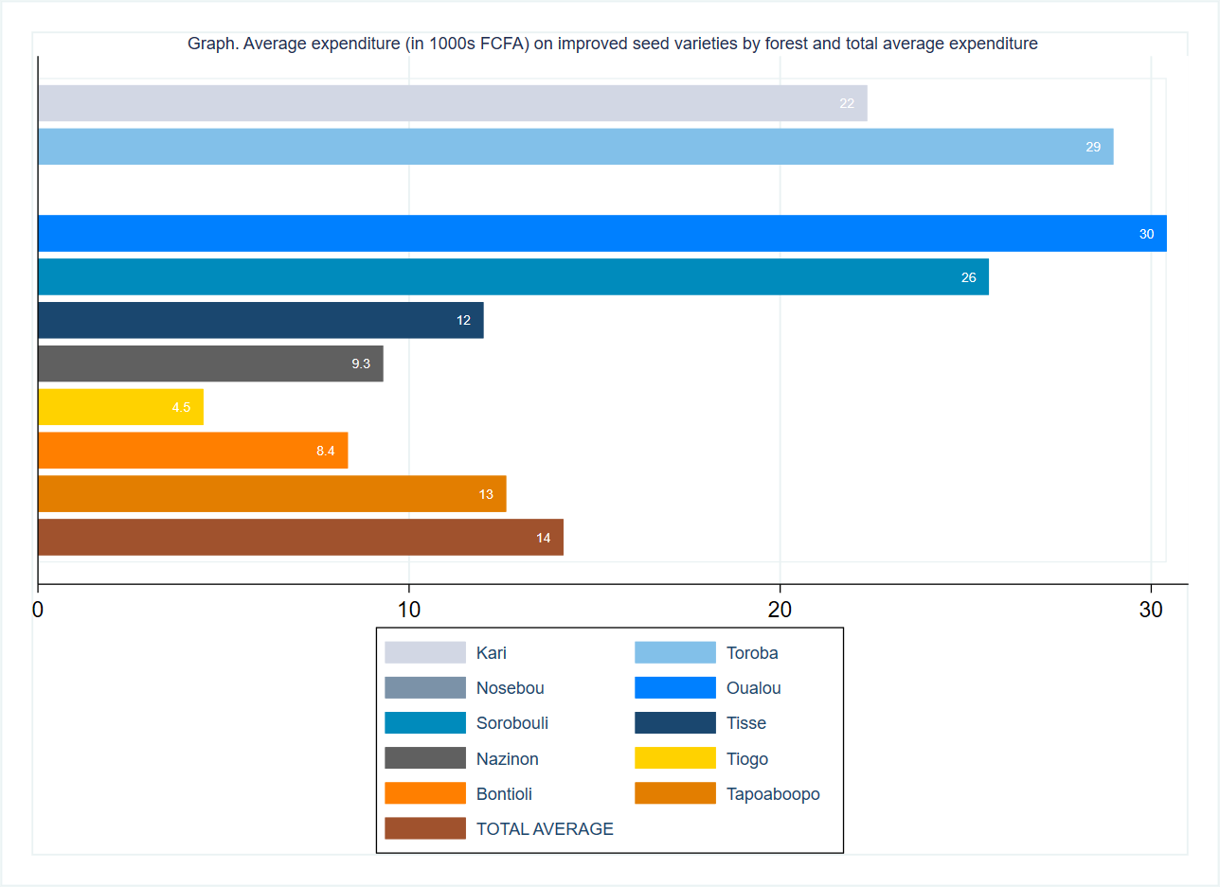

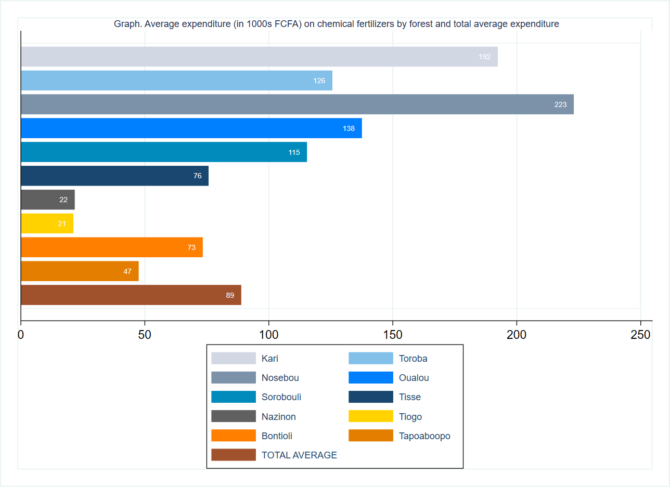

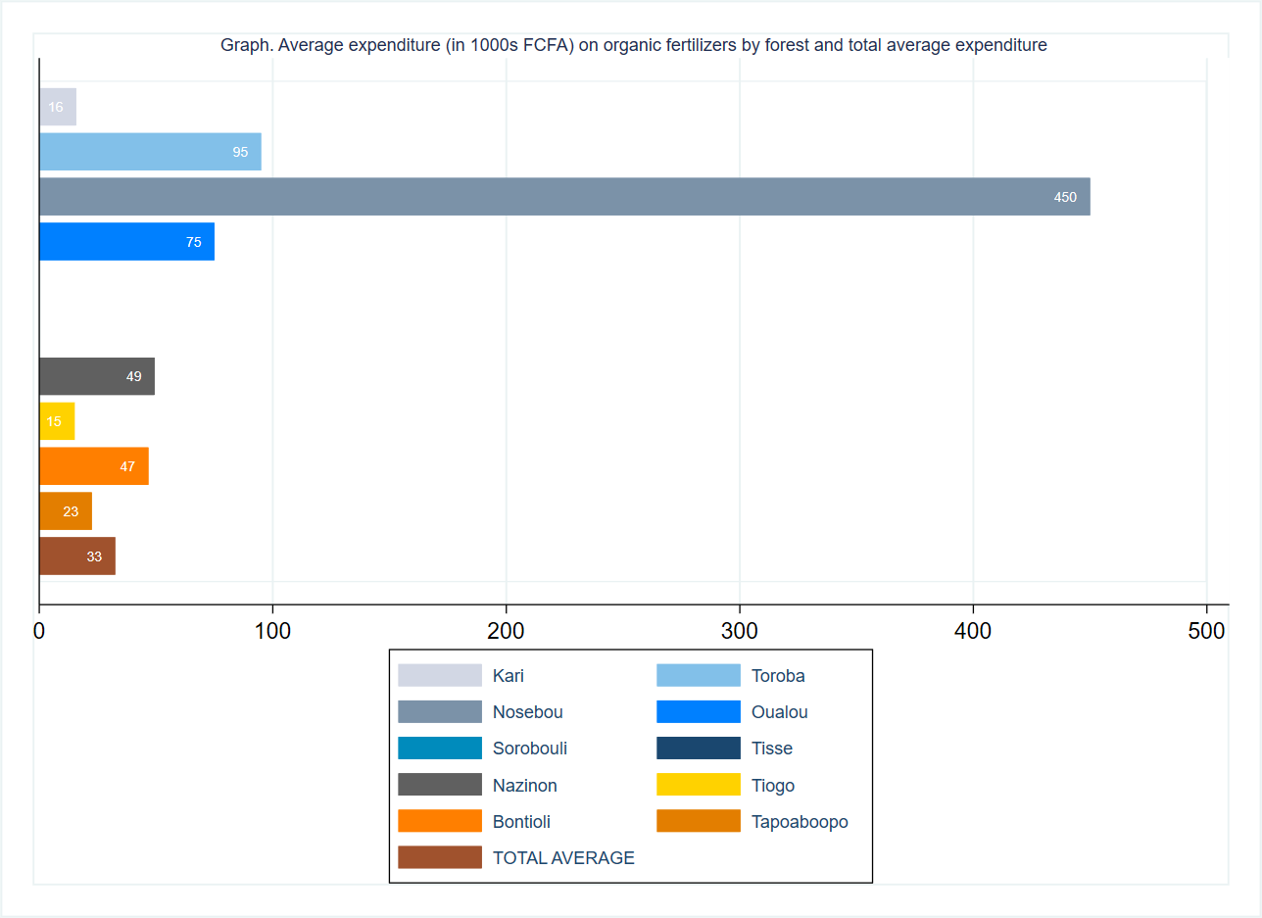

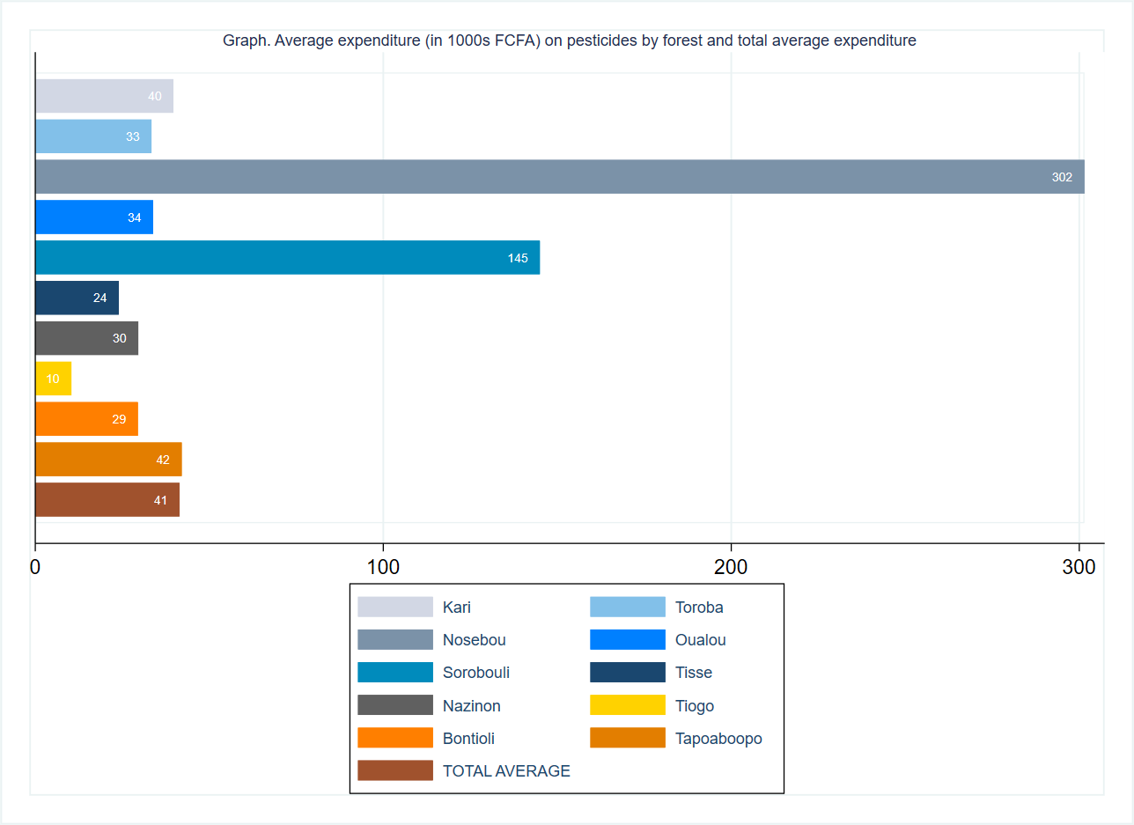

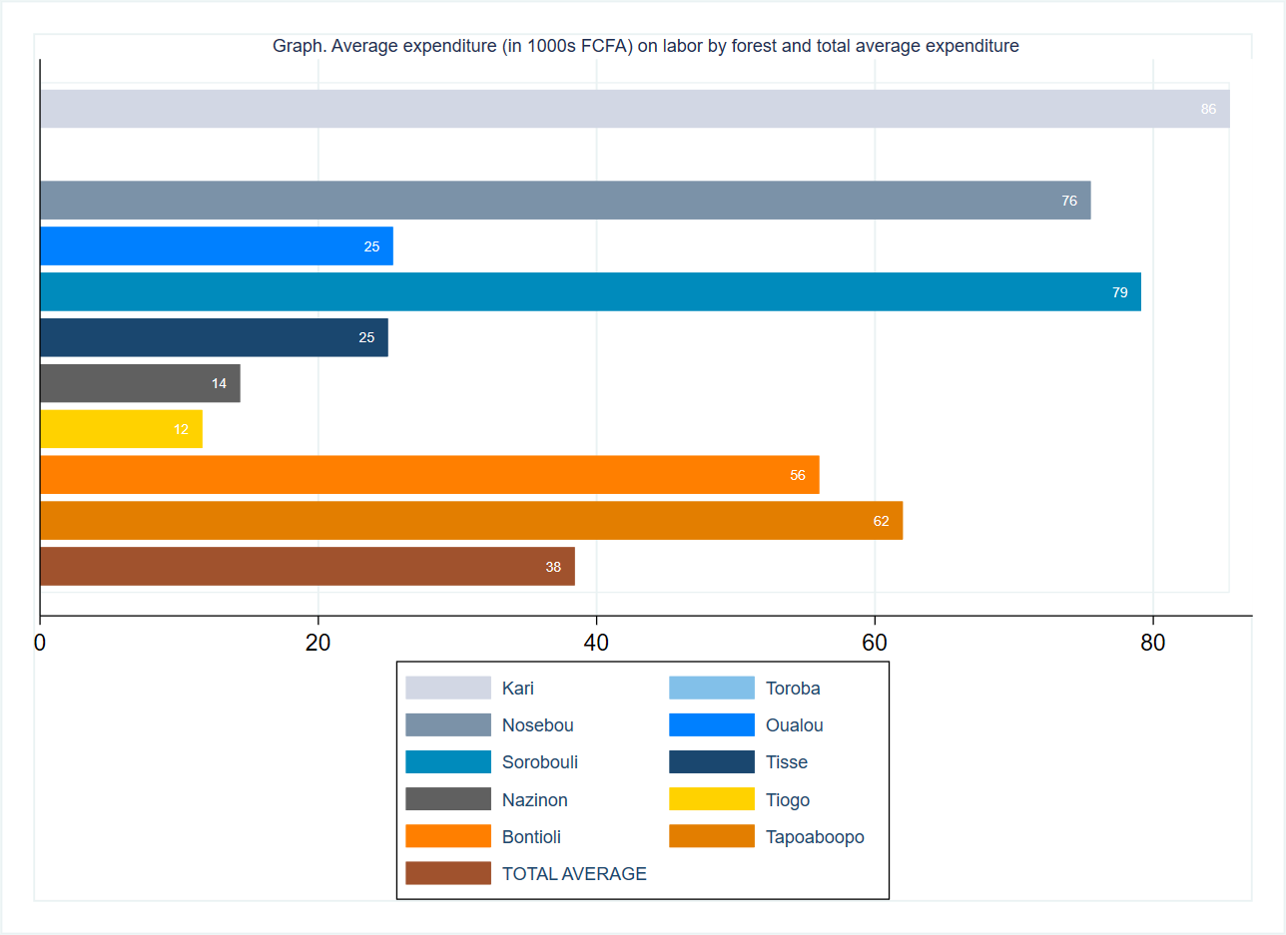

|  |  |  |  |  |  |
| --- | --- | --- | --- | --- | --- |
| **Table. Balance tables** |  | **(1)** |  | **(2)** | **t-test** |
| **Variable** |  | **Control** |  | **Treatment** | **Difference** |
|  | **N** | **Mean/SE** | **N** | **Mean/SE** | **(1)-(2)** |
| **Superficie de terre totale, en ha** | 259 | 5.67 | 262 | 5.66 | 0.01 |
|  |  | [0.278] |  | [0.262] |  |
| **Superficie de terre cultivee, en ha** | 259 | 4.476 | 262 | 4.616 | -0.141 |
|  |  | [0.189] |  | [0.191] |  |
| **Valeur totale des semences ameliorees achetees** | 74 | 16.384 | 75 | 11.966 | 4.419 |
|  |  | [2.537] |  | [2.204] |  |
| **Valeur totale des engrais chimiques achetes** | 134 | 82.671 | 139 | 94.789 | -12.118 |
|  |  | [8.352] |  | [12.628] |  |
| **Valeur totale des engrais organiques achetes** | 42 | 24.833 | 37 | 41.284 | -16.45 |
|  |  | [9.631] |  | [16.509] |  |
| **Valeur totale des produits phytosanitaires achetes** | 147 | 35.565 | 141 | 47.562 | -11.997 |
|  |  | [3.390] |  | [7.420] |  |
| **Valeur totale de la main d'oeuvre achetee ou louee** | 92 | 36.152 | 95 | 40.621 | -4.469 |
|  |  | [5.254] |  | [7.144] |  |
| **The value displayed for t-tests are the differences in the means across the groups.** |  |  |  |  |  |
| **\*\*\*, **, and * indicate significance at the 1, 5, and 10 percent critical level.** |  |  |  |  |  |

|  |  |  |  |  |  |  |
| --- | --- | --- | --- | --- | --- | --- |
| **Table. Agricultural production** |  |  |  |  |  |  |
| **Variable** | **N** | **Mean** | **S.D.** | **Median** | **Min** | **Max** |
| **Valeur totale de la production agricole, en 1000s FCFA** | 521 | 479.4 | 540.3 | 300.0 | 0.0 | 2000.0 |
|  |  |  |  |  |  |  |

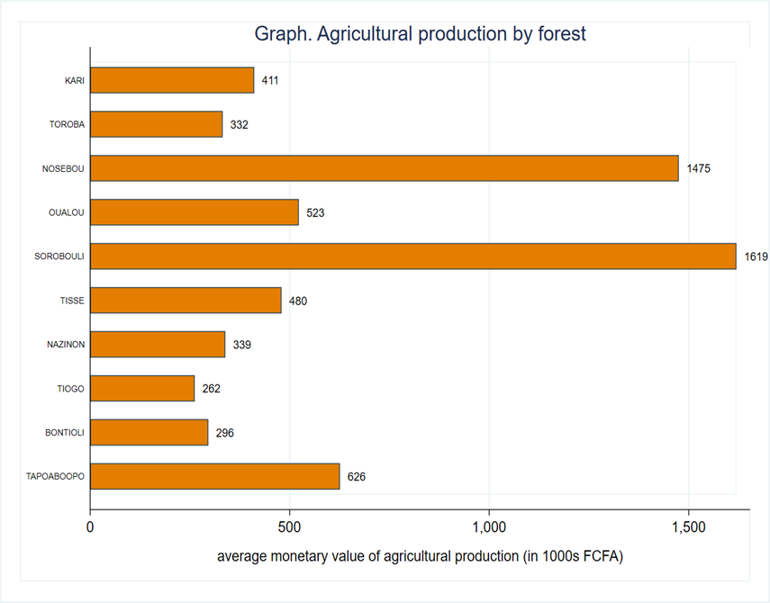

Change this title to by forest and gender

