|  |
| --- |
| Development Impact Evaluation |
| Burkina Faso Baseline Report |
| [Document subtitle] |

|  |
| --- |
| May 2018 |

# Introduction

The baseline report will have the following parts:

* Introduction
* Sampling and data collection procedures
* Descriptive analysis of the Tree planting baseline data
  + This part will be a simple description of the number of tree planted per forests and blocs, supported by some nice maps that we have produced before
* Descriptive analysis of the Household baseline data (module by module)
  + This is what you are already doing.
* Discussion and next steps
* Conclusion

# Baseline Household Survey

# Data Collection

The Burkina Faso baseline household survey consists of modules on (i) identification of survey participants, (ii) socio-demographic characteristics, (iii) assets, (iv) agricultural production and (v) patterns of food expenditure with a recall period of 7 days.

The data collection activities took place in the field between August 15, 2017 and October 21, 2017.

# Identification of survey participants

The total number of interviewed participants was 630 and the survey implementation was carried out at the region, foret and bloc levels. The chosen four regions in Burkina Faso were Boucle du Mouhoun, Centre Ouest, Est, and Sud Ouest. Next, 10 forets were then selected within the four regions and finally, the households were randomly selected from 33 blocs from within the forets.

The graph below shows survey participants by region. Boucle du Mouhoun and Sud Ouest account for about 56 percent of the total sample size. One in 5 survey participants reside in Centre Ouest.

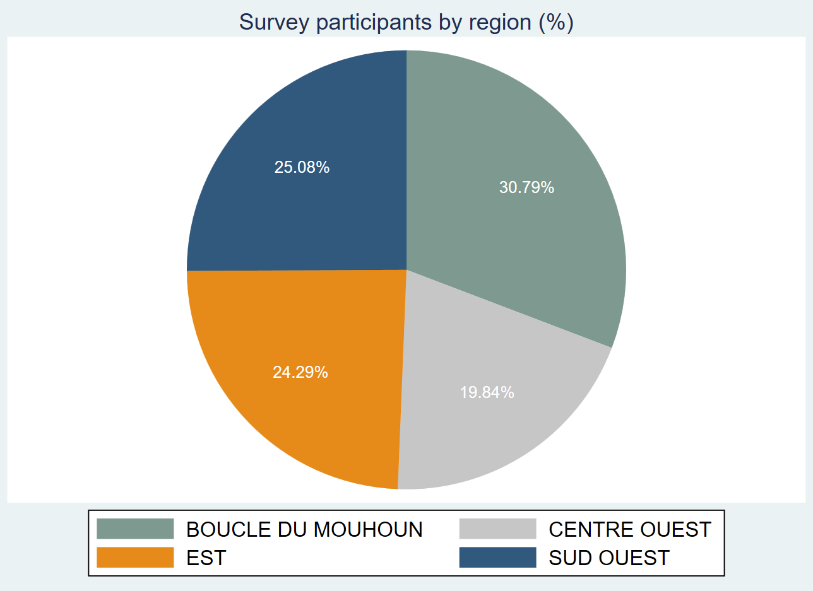

The table below indicates the classification of survey participants by bloc and forest. We observe that Bontioli and Tapoaboopo are the forests with the highest survey participation.

|  |  |  |  |  |  |  |  |  |  |  |  |
| --- | --- | --- | --- | --- | --- | --- | --- | --- | --- | --- | --- |
| Survey participants by bloc and forest | | | | |  |  |  |  |  |  |  |
|  | **KARI** | **TOROBA** | **NOSEBOU** | **OUALOU** | **SOROBOULI** | **TISSE** | **NAZINON** | **TIOGO** | **BONTIOLI** | **TAPOABOOPO** | **Total** |
| **BANOUBA** |  |  |  | 17 |  |  |  |  |  |  | 17 |
| **BARO** |  |  |  |  |  |  |  |  | 2 |  | 2 |
| **BISSANDEROU** |  |  |  |  |  | 2 |  |  |  |  | 2 |
| **BONTIOLI** |  |  |  |  |  |  |  |  | 2 |  | 2 |
| **BOROMISSI** |  |  |  |  | 2 |  |  |  |  |  | 2 |
| **BOUROUM** |  |  |  |  |  |  |  |  | 2 |  | 2 |
| **DANKOTNAZOU** |  |  |  |  |  |  |  |  | 18 |  | 18 |
| **DASSA** |  |  |  |  |  |  |  | 2 |  |  | 2 |
| **DIDIE** |  |  |  |  |  | 2 |  |  |  |  | 2 |
| **ETOUAYOU** |  |  | 2 |  |  |  |  |  |  |  | 2 |
| **GALO** |  |  |  |  |  |  | 9 |  |  |  | 9 |
| **HEMKOA** |  |  |  |  |  |  |  |  | 2 |  | 2 |
| **KARI** | 2 |  |  |  |  |  |  |  |  |  | 2 |
| **KOENA** |  |  |  |  |  |  |  |  |  | 19 | 19 |
| **KOGUINI** |  |  |  |  |  |  |  |  |  | 2 | 2 |
| **KYON** |  |  |  |  |  |  |  | 2 |  |  | 2 |
| **MATIACOALI** |  |  |  |  |  |  |  |  |  | 19 | 19 |
| **NADONO** |  |  |  |  |  |  | 16 |  |  |  | 16 |
| **NANSOUGOU** |  |  |  |  |  |  |  |  |  | 18 | 18 |
| **OUALOU** |  |  |  | 2 |  |  |  |  |  |  | 2 |
| **OUGAROU** |  |  |  |  |  |  |  |  |  | 19 | 19 |
| **OULA** | 19 |  |  |  |  |  |  |  |  |  | 19 |
| **SAKOANIE** |  |  |  |  |  |  |  |  |  | 18 | 18 |
| **SILIMBA** |  |  |  |  |  |  | 2 |  |  |  | 2 |
| **SOUHO** |  |  |  |  | 2 |  |  |  |  |  | 2 |
| **TCHALBONGA** |  |  |  |  |  |  |  |  |  | 2 | 2 |
| **TENADO** |  |  |  |  |  |  |  | 2 |  |  | 2 |
| **TIANKOURA** |  |  |  |  |  |  |  |  | 2 |  | 2 |
| **TIOGO** |  |  |  |  |  |  |  | 2 |  |  | 2 |
| **TOABILI** |  |  |  |  |  |  |  |  |  | 2 | 2 |
| **TOROBA** |  | 18 |  |  |  |  |  |  |  |  | 18 |
| **TOVOR** |  |  |  |  |  |  |  |  | 2 |  | 2 |
| **ZAMBO** |  |  |  |  |  |  |  |  | 2 |  | 2 |
| Total | 39 | 18 | 2 | 37 | 4 | 4 | 45 | 8 | 158 | 153 | 63 |
| N | 39 | 18 | 2 | 37 | 4 | 4 | 45 | 8 | 158 | 153 | 63 |

The objective of the sampling strategy is to sample an equal number of households into the treatment and control groups. The table and both graphs below provide solid evidence of this balance. The number of control and treatment groups is relatively even by bloc, forest and region.

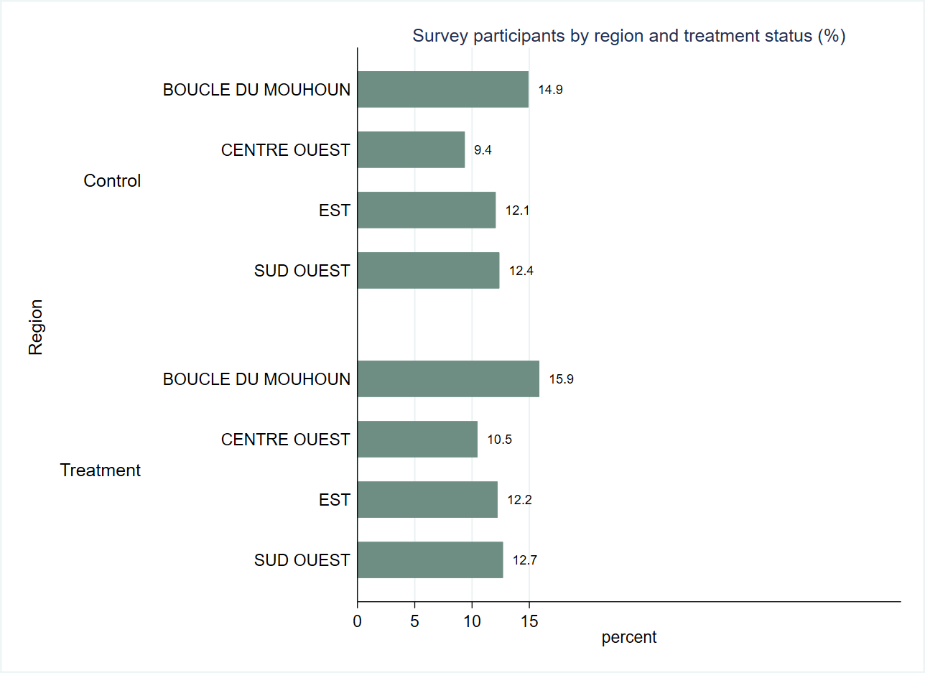

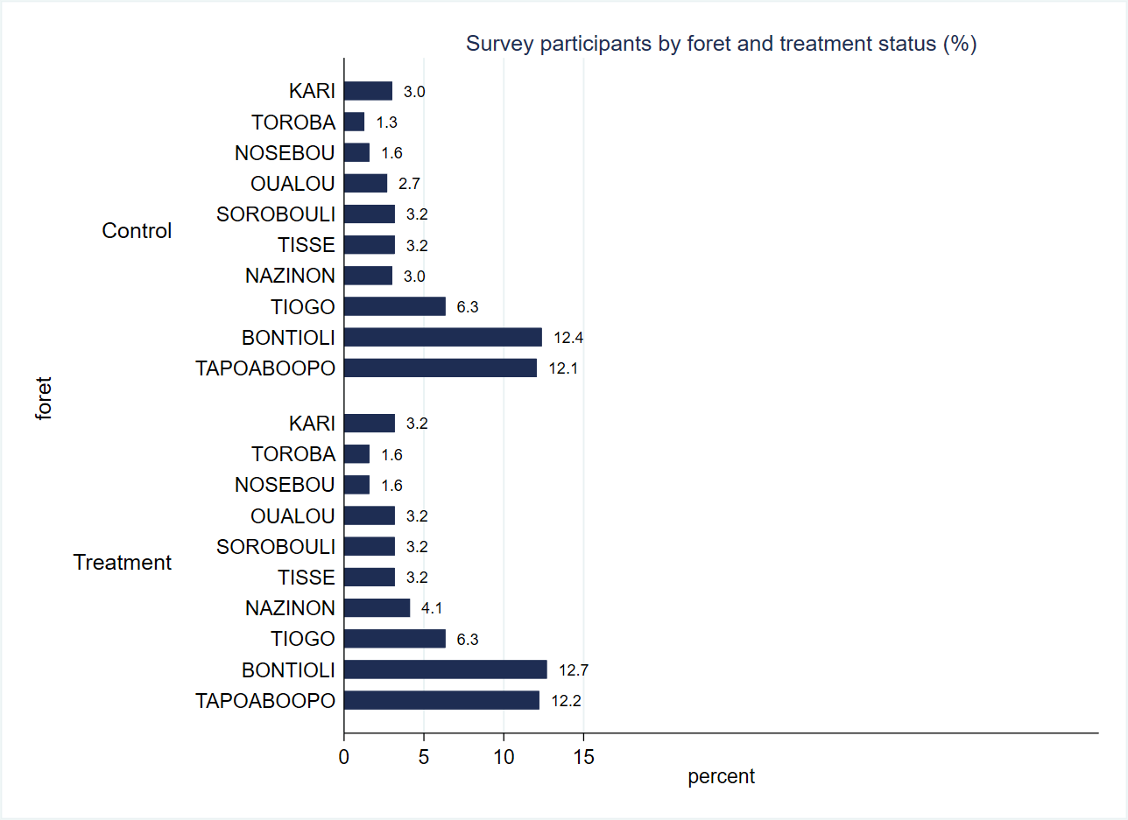

|  |  |  |  |  |  |  |
| --- | --- | --- | --- | --- | --- | --- |
| Sample size by forest and bloc | |  |  |  |  |  |
| **Numero du bloc** | **Control** | **Treatment** | **Total** | **Control** | **Treatment** | **Total** |
| BANOUBA | 7 | 10 | 17 | 41.2% | 58.8% | 100.0% |
| BARO | 10 | 10 | 20 | 50.0% | 50.0% | 100.0% |
| BISSANDEROU | 10 | 10 | 20 | 50.0% | 50.0% | 100.0% |
| BONTIOLI | 10 | 10 | 20 | 50.0% | 50.0% | 100.0% |
| BOROMISSI | 10 | 10 | 20 | 50.0% | 50.0% | 100.0% |
| BOUROUM | 10 | 10 | 20 | 50.0% | 50.0% | 100.0% |
| DANKOTNAZOU | 8 | 10 | 18 | 44.4% | 55.6% | 100.0% |
| DASSA | 10 | 10 | 20 | 50.0% | 50.0% | 100.0% |
| DIDIE | 10 | 10 | 20 | 50.0% | 50.0% | 100.0% |
| ETOUAYOU | 10 | 10 | 20 | 50.0% | 50.0% | 100.0% |
| GALO | 2 | 7 | 9 | 22.2% | 77.8% | 100.0% |
| HEMKOA | 10 | 10 | 20 | 50.0% | 50.0% | 100.0% |
| KARI | 10 | 10 | 20 | 50.0% | 50.0% | 100.0% |
| KOENA | 9 | 10 | 19 | 47.4% | 52.6% | 100.0% |
| KOGUINI | 10 | 10 | 20 | 50.0% | 50.0% | 100.0% |
| KYON | 10 | 10 | 20 | 50.0% | 50.0% | 100.0% |
| MATIACOALI | 10 | 9 | 19 | 52.6% | 47.4% | 100.0% |
| NADONO | 7 | 9 | 16 | 43.8% | 56.3% | 100.0% |
| NANSOUGOU | 9 | 9 | 18 | 50.0% | 50.0% | 100.0% |
| OUALOU | 10 | 10 | 20 | 50.0% | 50.0% | 100.0% |
| OUGAROU | 10 | 9 | 19 | 52.6% | 47.4% | 100.0% |
| OULA | 9 | 10 | 19 | 47.4% | 52.6% | 100.0% |
| SAKOANIE | 8 | 10 | 18 | 44.4% | 55.6% | 100.0% |
| SILIMBA | 10 | 10 | 20 | 50.0% | 50.0% | 100.0% |
| SOUHO | 10 | 10 | 20 | 50.0% | 50.0% | 100.0% |
| TCHALBONGA | 10 | 10 | 20 | 50.0% | 50.0% | 100.0% |
| TENADO | 10 | 10 | 20 | 50.0% | 50.0% | 100.0% |
| TIANKOURA | 10 | 10 | 20 | 50.0% | 50.0% | 100.0% |
| TIOGO | 10 | 10 | 20 | 50.0% | 50.0% | 100.0% |
| TOABILI | 10 | 10 | 20 | 50.0% | 50.0% | 100.0% |
| TOROBA | 8 | 10 | 18 | 44.4% | 55.6% | 100.0% |
| TOVOR | 10 | 10 | 20 | 50.0% | 50.0% | 100.0% |
| ZAMBO | 10 | 10 | 20 | 50.0% | 50.0% | 100.0% |
| Total | 307 | 323 | 630 | 48.7% | 51.3% | 100.0% |
| **Foret** |  |  |  |  |  |  |
| KARI | 19 | 20 | 39 | 48.70% | 51.30% | 100.00% |
| TOROBA | 8 | 10 | 18 | 44.40% | 55.60% | 100.00% |
| NOSEBOU | 10 | 10 | 20 | 50.00% | 50.00% | 100.00% |
| OUALOU | 17 | 20 | 37 | 45.90% | 54.10% | 100.00% |
| SOROBOULI | 20 | 20 | 40 | 50.00% | 50.00% | 100.00% |
| TISSE | 20 | 20 | 40 | 50.00% | 50.00% | 100.00% |
| NAZINON | 19 | 26 | 45 | 42.20% | 57.80% | 100.00% |
| TIOGO | 40 | 40 | 80 | 50.00% | 50.00% | 100.00% |
| BONTIOLI | 78 | 80 | 158 | 49.40% | 50.60% | 100.00% |
| TAPOABOOPO | 76 | 77 | 153 | 49.70% | 50.30% | 100.00% |
| Total | 307 | 323 | 630 | 48.70% | 51.30% | 100.00% |
| **N** |  |  |  | **307** | **323** | **630** |

# Socio-demographic characteristics

This section discusses socio-demographic and economic characteristics of the participating households with respect to age, gender, education, primary occupation, income and forest management group membership.

|  |  |  |  |  |  |  |
| --- | --- | --- | --- | --- | --- | --- |
| **Table. Summary statistics of demographic characteristics** |  |  |  |  |  |  |
| **Variable** | **N** | **Mean** | **S.D.** | **Median** | **Min** | **Max** |
| **L'age du participant** | 630 | 39.2 | 10.8 | 39.0 | 16.0 | 73.0 |
| **Nombre de membres de menage** | 630 | 13.0 | 7.8 | 11.0 | 0.0 | 45.0 |

The mean age of survey participants is 39 years and households have on average 13 members. Looking at the age distribution by forest in the graph below we observe that at least 95 percent of respondents are between 18 and 64 years of age across all forests whereas those age 35-44 account for the highest proportion in 8 out of 10 forests.

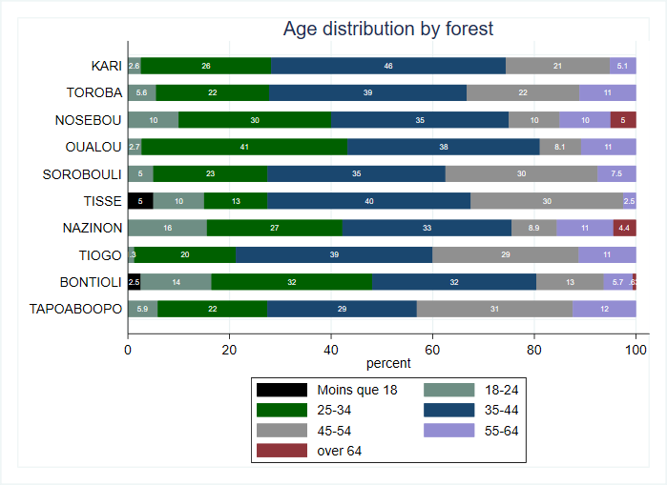

The survey respondents are predominantly male, and women make up just about 16 percent of the whole sample.

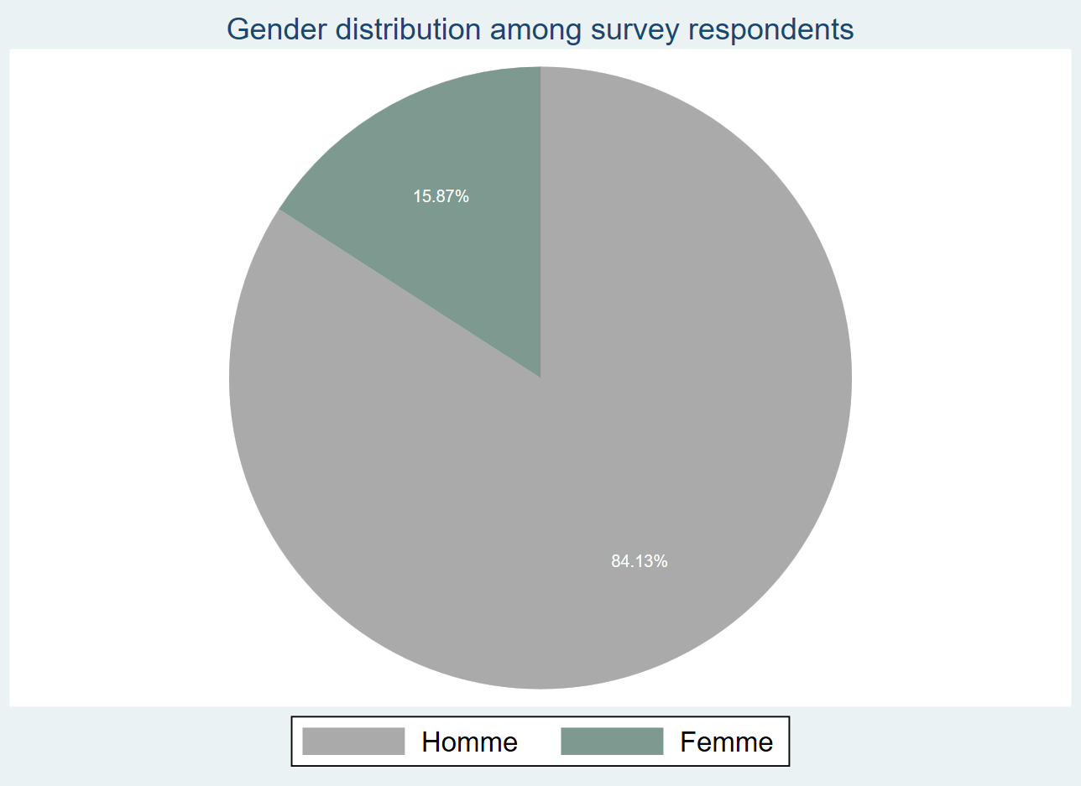

The literacy level of survey participants is relatively low. According to the graph below, over 80 percent have never been to school and 12 percent have primary school education. Less than 7 percent of all respondents pursued further studies beyond primary school.

|  |  |  |
| --- | --- | --- |
| **Table. Education level of survey respondents** |  |  |
| **N’a jamais été a l’école** | 513 | 81.4% |
| **Primaire** | 75 | 11.9% |
| **Secondaire premier cycle général** | 37 | 5.9% |
| **Secondaire premier cycle technique et professionnel** | 3 | 0.5% |
| **Secondaire second cycle général** | 2 | 0.3% |
| **Total** | 630 | 100.0% |
| **N** |  | 630 |

The distribution of the survey respondents with no education is fairly consistent across all forests ranging from 75 percent in Nosebou and Tisse to 88 percent in Tapoaboopo. Nosebou (20 percent), Tisse (18 percent) and Toroba (17 percent) have the highest proportions of respondents with primary education. 11 percent of survey respondents in Oualou and about 15 percent in Nazinon have education beyond primary school.

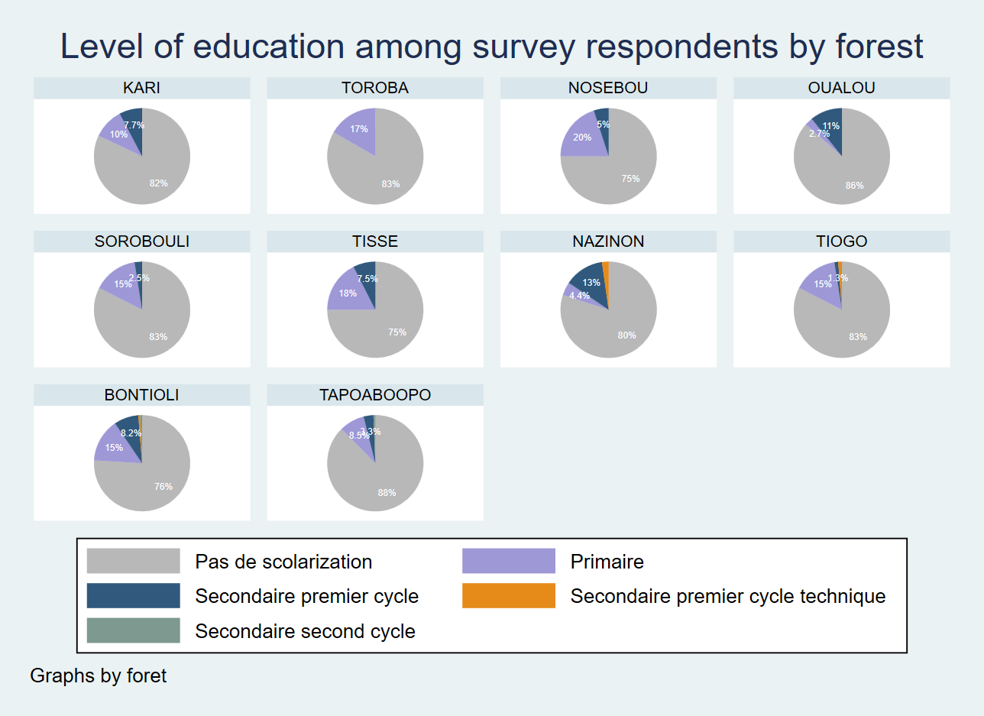

Farming is by far the main occupation of survey respondents (90 percent) followed by animal breeding (6.3 percent). About 2 percent reported having no primary occupation.

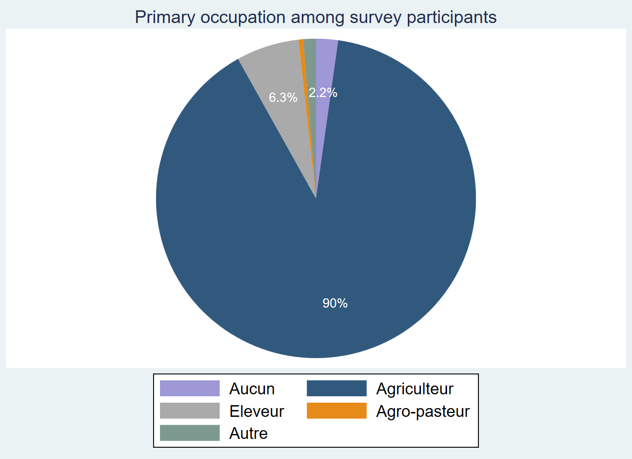

The proportion of respondents engaging in farming as the primary activity is consistently high across all 10 forests, according to table above. Virtually all survey participants residing in Toroba and Oualou, and over 95% in Kari, Tisse and Tiogo indicated farming as primary occupation. Tapoaboopo (16 percent) and Nazinon (11 percent) account for the highest proportions of animal breeders. Sorobouli (13 percent) and Nosebou (10 percent) have the highest proportions of respondents that reported having no primary occupation.

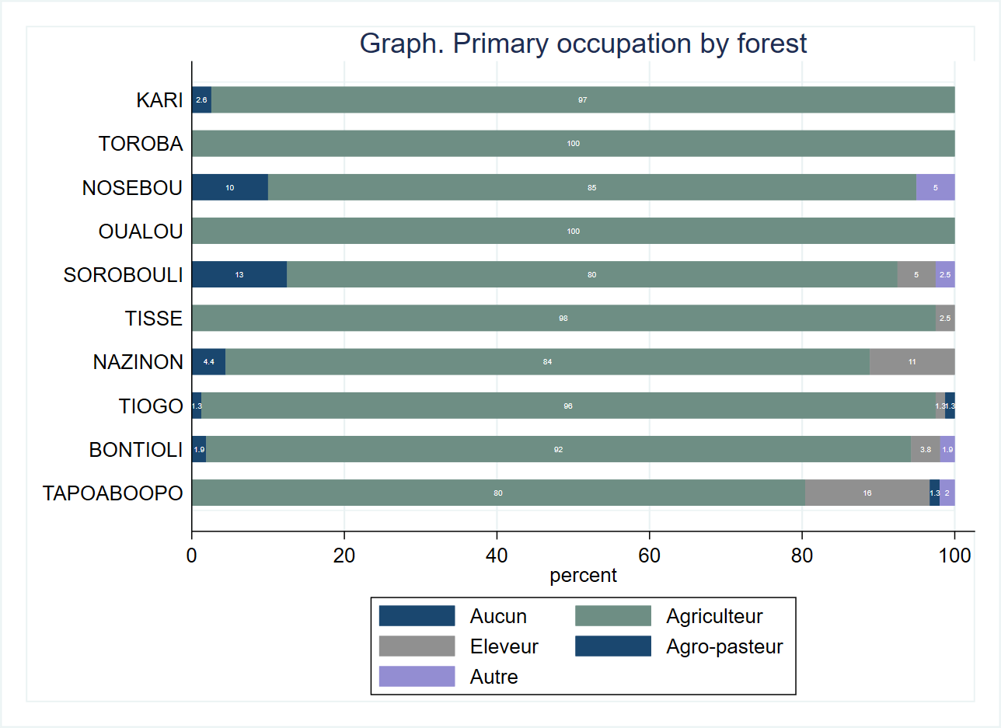

The annual average income calculated as the sum of incomes derived from primary and secondary occupations is roughly 500,000 FCFA.

|  |  |  |  |  |  |  |
| --- | --- | --- | --- | --- | --- | --- |
| **Table. Income** |  |  |  |  |  |  |
| **Variable** | **N** | **Mean** | **S.D.** | **Median** | **Min** | **Max** |
| **Revenu total au cours des 12 derniers mois, en 1000s FCFA** | 616 | 507.8 | 614.4 | 275.0 | 0.0 | 3100.0 |

The kernel density plot below reveals that the distribution of the income variable is right skewed with the median income (275,000 FCFA) being far below the average income value.

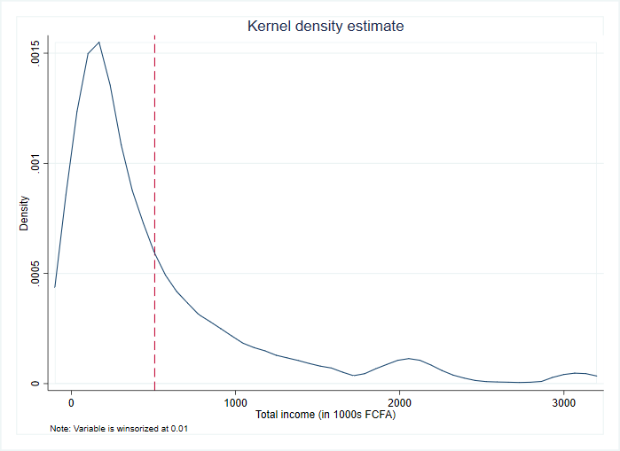

Glancing over the income distribution by forest we observe that Nosebou, Sorobouli and Kari have by far the highest annual average incomes at 1,353,000 FCFA, 1,268,000 FCFA and 839,000 FCFA respectively. With an average of 149,000 FCFA and 287,000 FCFA per annum, Tiogo and Nazinon are at the lower end of the income distribution.

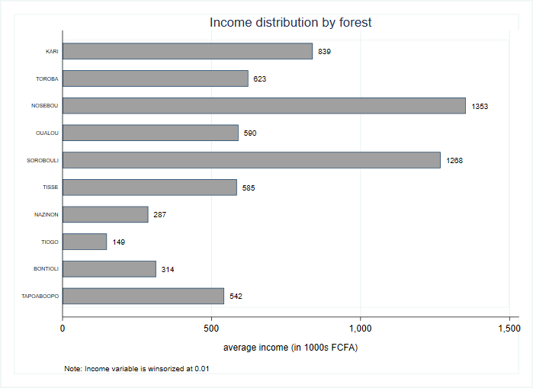

Among survey respondents the agro-pastoral households reported the highest average incomes (797,000 FCFA) followed by livestock breeders (573,000 FCFA) and farmers (505,000 FCFA).

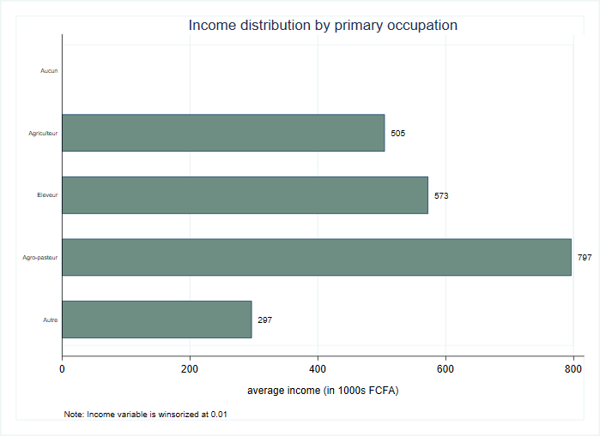

The kernel density plot below indicates that the distribution of income earned by male and female respondents is skewed to the right and there is a huge gender gap in earnings. On average, female respondents earn an annual income that is less than 40 percent of the income earned by their male counterparts.

Graph. Kernel density estimate for total income by gender

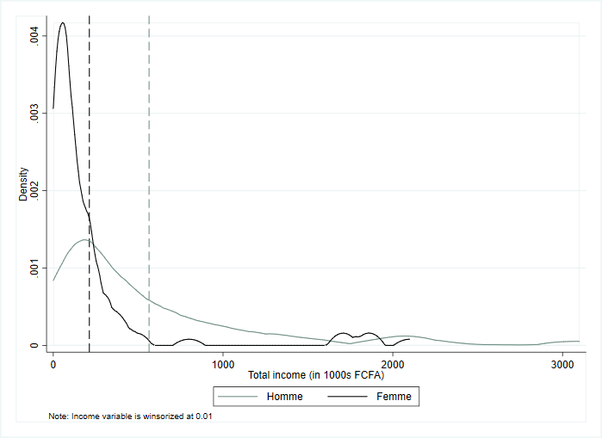

Digging further into the income data by gender and primary occupation we uncover further evidence of gender-based disparity. Men are high earners across the board with agro-pastoralist occupations (800,000 FCFA) being the most lucrative followed by other occupations such as miner and mechanic. Women animal breeders (350,000 FCFA) have the highest annual average incomes followed by women farmers (approx. 220,000 FCFA).

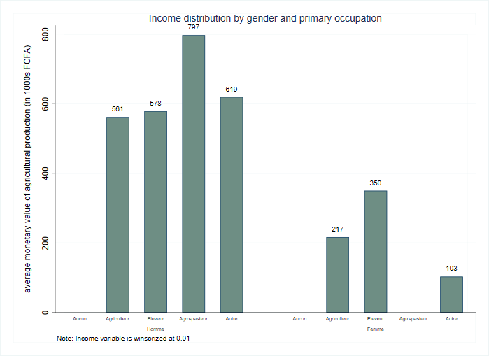

Nearly 6 out of 10 survey respondents reported being a member of a forest management group.

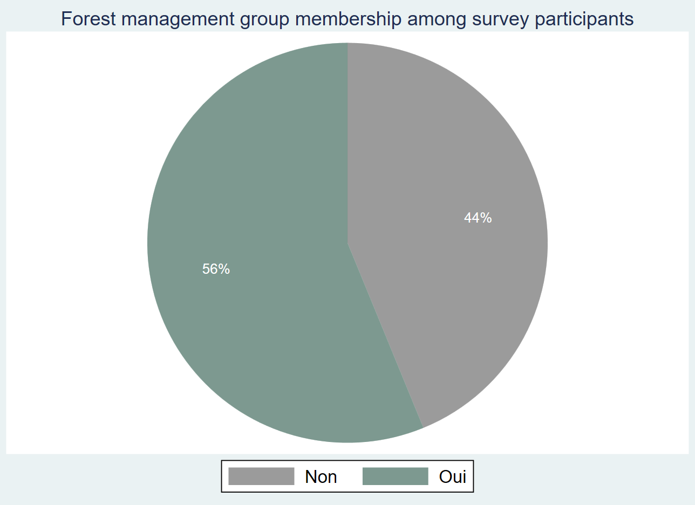

The graph below indicates the differences in the forest management group membership by forest. Nearly all respondents residing in Oualou are a member of a forest management group. About 90 percent in Toroba and 4 out of 5 respondents in Nosebou and Tapoaboopo reported having a forest management group membership. Nazinon(18 percent), Tiogo (30 percent) and Bontioli (32 percent) account for the lowest proportions of respondents that are members of a forest management group.

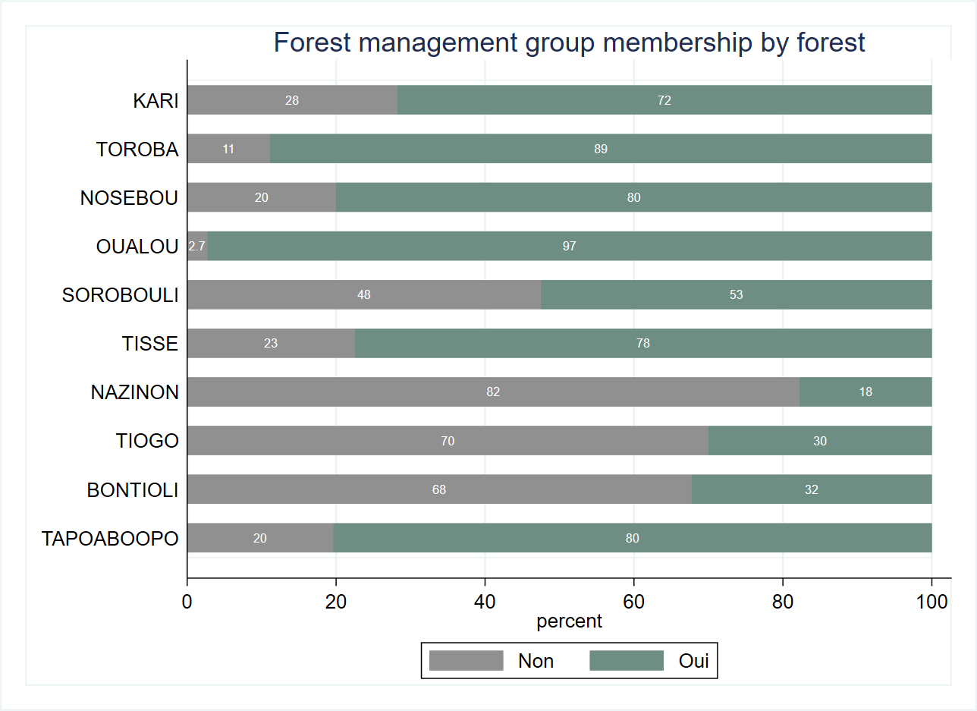

The balance tables below reveal a strong balance between the control and treatment groups with respect to age, household size, literacy level, forest management group membership and income. We observe significant differences at the 5% level with regard to gender and whether the survey participant is the head of the household.

|  |  |  |  |  |  |
| --- | --- | --- | --- | --- | --- |
| **Table. Balance tables** |  | **(1)** |  | **(2)** | **t-test** |
| **Variable** |  | **Control** |  | **Treatment** | **Difference** |
|  | **N** | **Mean/SE** | **N** | **Mean/SE** | **(1)-(2)** |
| **Age** | 307 | 38.544 | 323 | 39.78 | -1.236 |
|  |  | [0.625] |  | [0.596] |  |
| **Sexe** | 307 | 0.192 | 323 | 0.127 | 0.065** |
|  |  | [0.023] |  | [0.019] |  |
| **Household head?** | 307 | 0.583 | 323 | 0.675 | -0.092** |
|  |  | [0.028] |  | [0.026] |  |
| **Household size** | 307 | 12.739 | 323 | 13.254 | -0.514 |
|  |  | [0.468] |  | [0.407] |  |
| **Membre d'un groupement de gestion forestiere (GGF)** | 307 | 0.531 | 323 | 0.591 | -0.06 |
|  |  | [0.029] |  | [0.027] |  |
| **Total Income (in 1000s FCFA)** | 300 | 507.804 | 316 | 507.854 | -0.05 |
|  |  | [37.476] |  | [32.661] |  |
| **The value displayed for t-tests are the differences in the means across the groups.** |  |  |  |  |  |
| **\*\*\*, **, and * indicate significance at the 1, 5, and 10 percent critical level.** |  |  |  |  |  |

# Assets

The asset index and livestock index indicate the household assets accumulation and thus they serve as good proxies for wealth.

We construct the asset index by forest using principal component analysis, a tool that helps summarize the variability within the set of assets in our data. The calculation of the asset index is based on the variables denoting consumer durable goods. The calculation of the livestock index uses the global unit conversions for Sub-Saharan Africa to assign a weight to each livestock variable available in the survey.

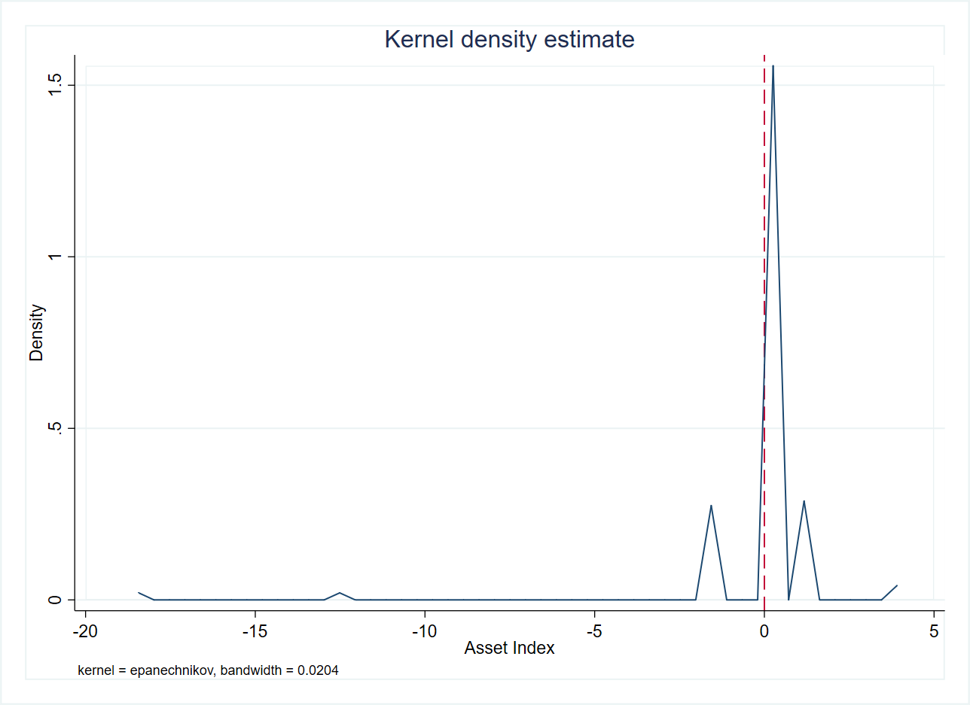

If the asset index is a proxy for wealth, then households with positive mean asset indices would most likely be better off than households with negative mean asset indices. The graph bar below indicates that households with survey respondents without a defined primary occupation have a higher positive asset index and households engaging in animal breeding are worse off in terms of asset accumulation.

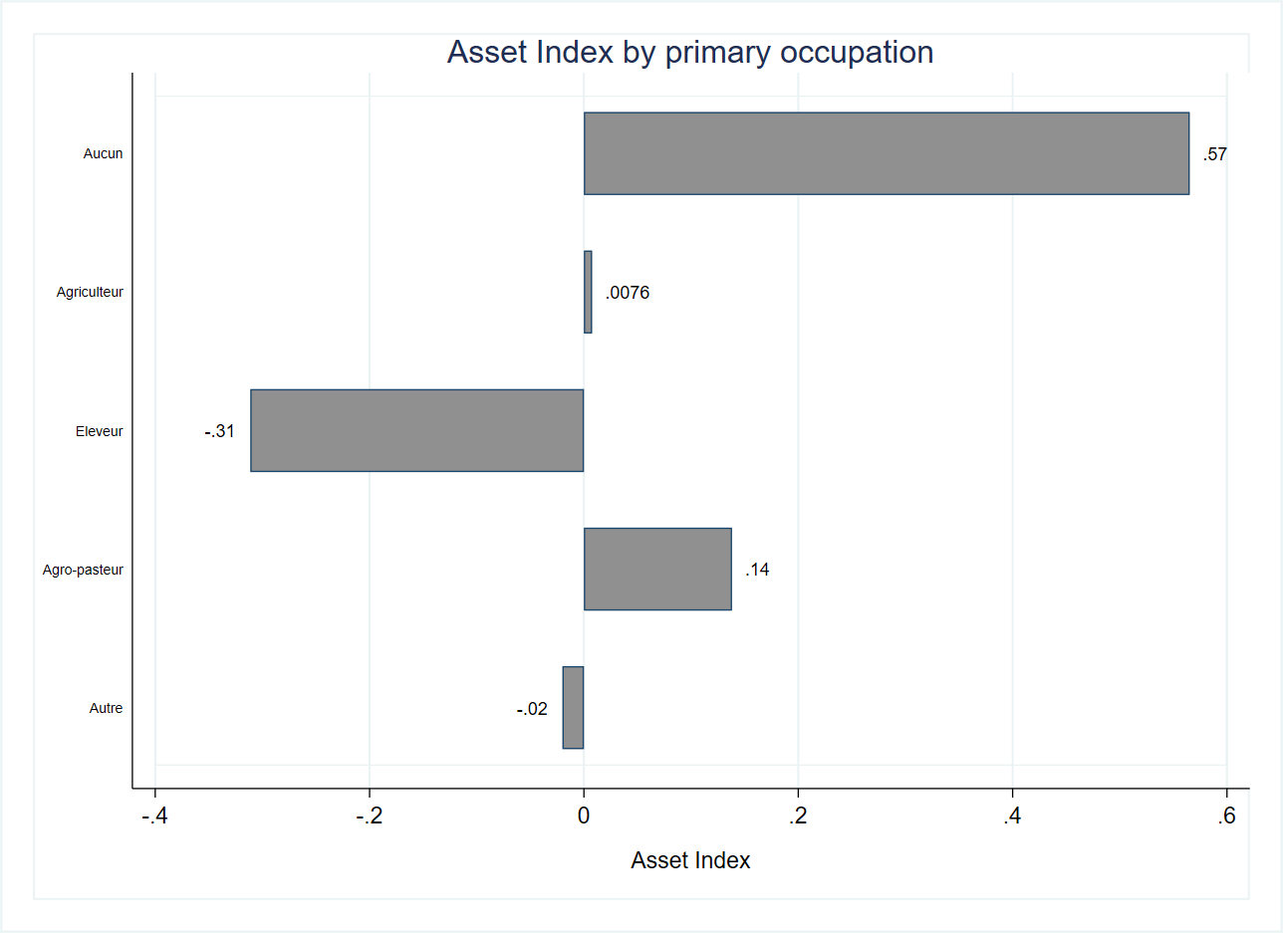

The kernel density plot below reveals no substantial discrepancy in the average asset index by gender implying that both men and women respondents in the sample appear to be similar in their asset accumulation.

Kernel density estimate of asset index by gender

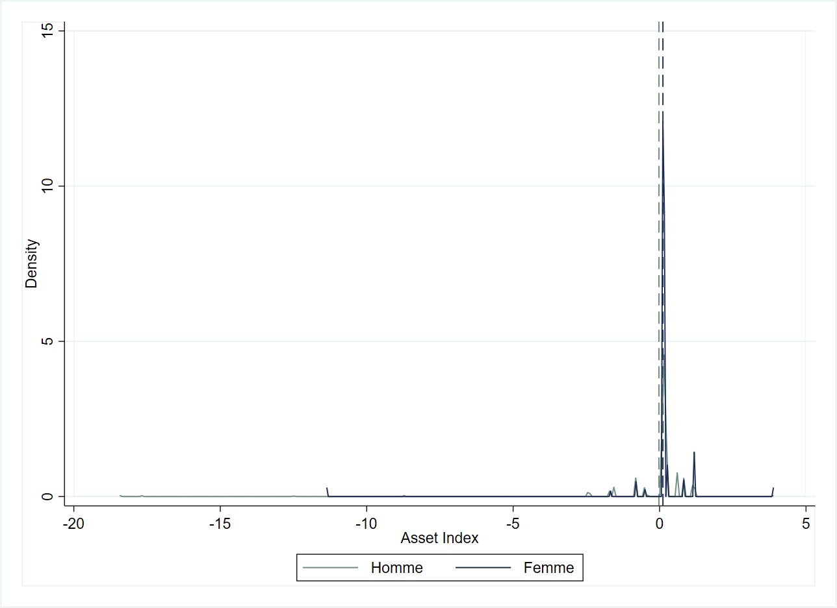

The asset index by gender and primary occupation shows the male livestock breeders and male farmers as worse off than the remaining categories. The values of the asset index for women are positive across all occupations except ‘other’.

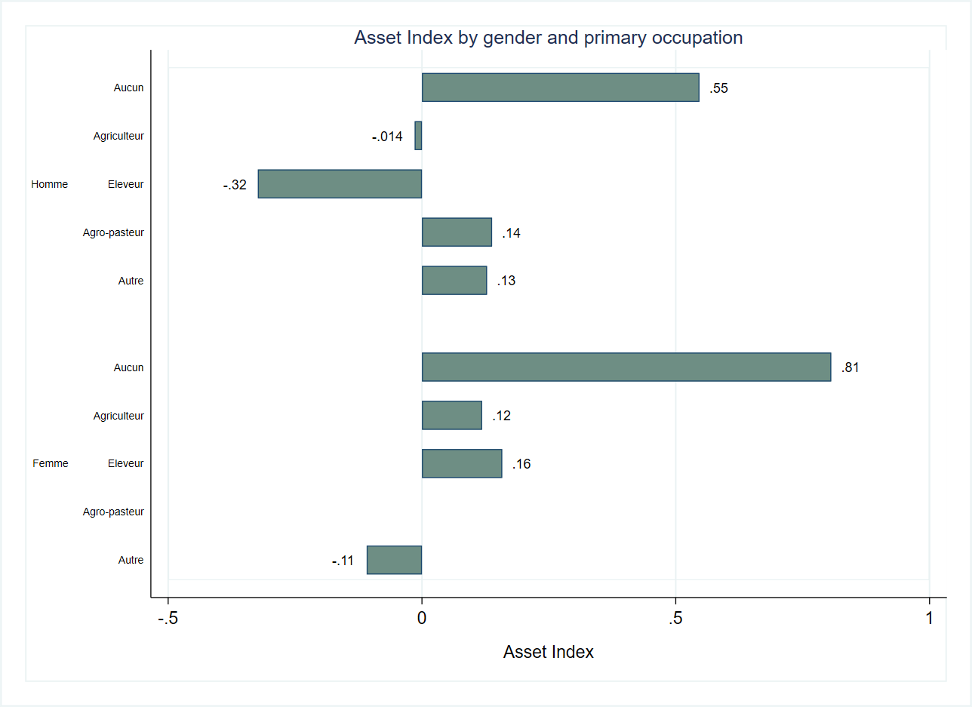

|  |  |  |  |  |  |
| --- | --- | --- | --- | --- | --- |
| Table. Balance Tables |  | (1) |  | (2) | t-test |
| Variable |  | Control |  | Treatment | Difference |
|  | N | Mean/SE | N | Mean/SE | (1)-(2) |
| Asset Index | 307 | -0.042 | 323 | 0.04 | -0.081 |
|  |  | [0.082] |  | [0.077] |  |
| The value displayed for t-tests are the differences in the means across the groups. |  |  |  |  |  |
| ***, **, and * indicate significance at the 1, 5, and 10 percent critical level. |  |  |  |  |  |

According to the balance table above, there is no significant difference between the control and treatment groups with respect to asset accumulation.

Livestock Index

The kernel density plot below reveals that the distribution of the livestock index is skewed to the right and the mean livestock index is closer to 0.

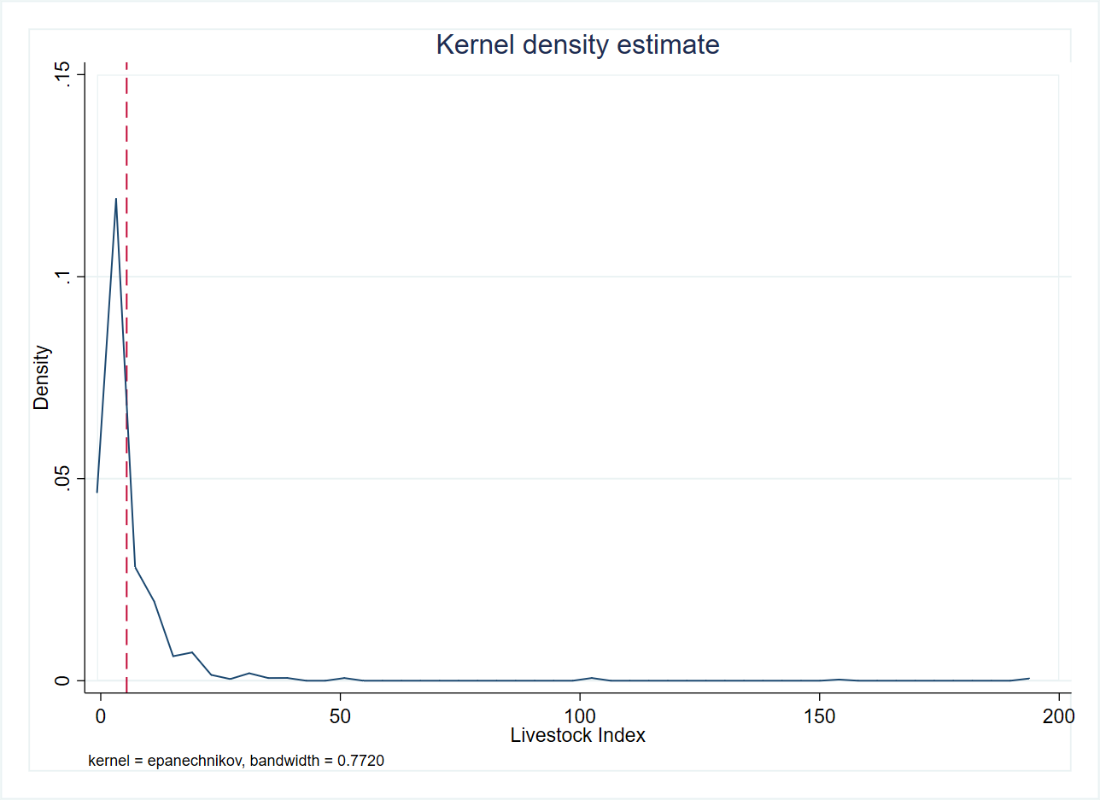

Households residing in Tapoaboopo have the highest livestock index (11) while Oualou (2.6), Kari (2.7) and Toroba (3) have the lowest livestock index values.

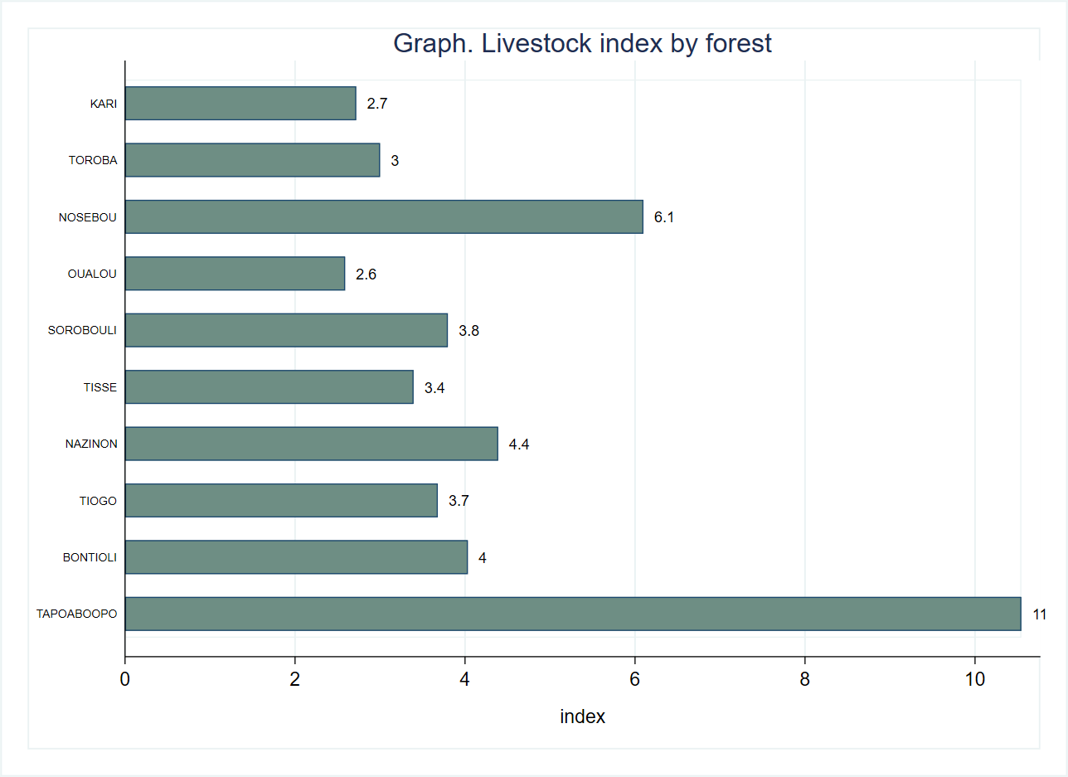

Quite predictably, the households reporting animal breeding as primary occupation account for the highest livestock index (18).

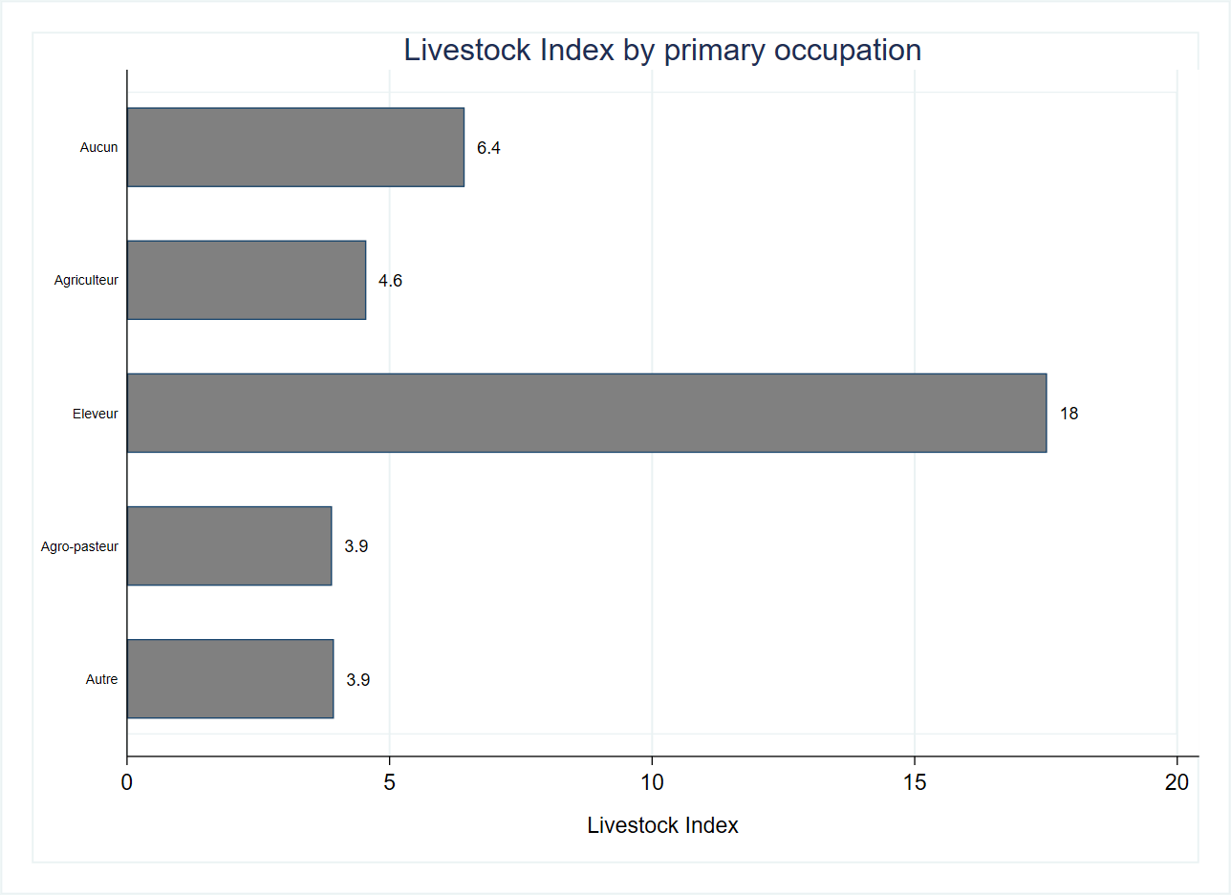

The kernel density plot below illustrates gender-based discrepancy in the livestock index. Men have a far higher average livestock index than women justified by the extremely high index values (nearly reaching 200) available for men in the distribution.

Kernel density estimate of Livestock Index by gender

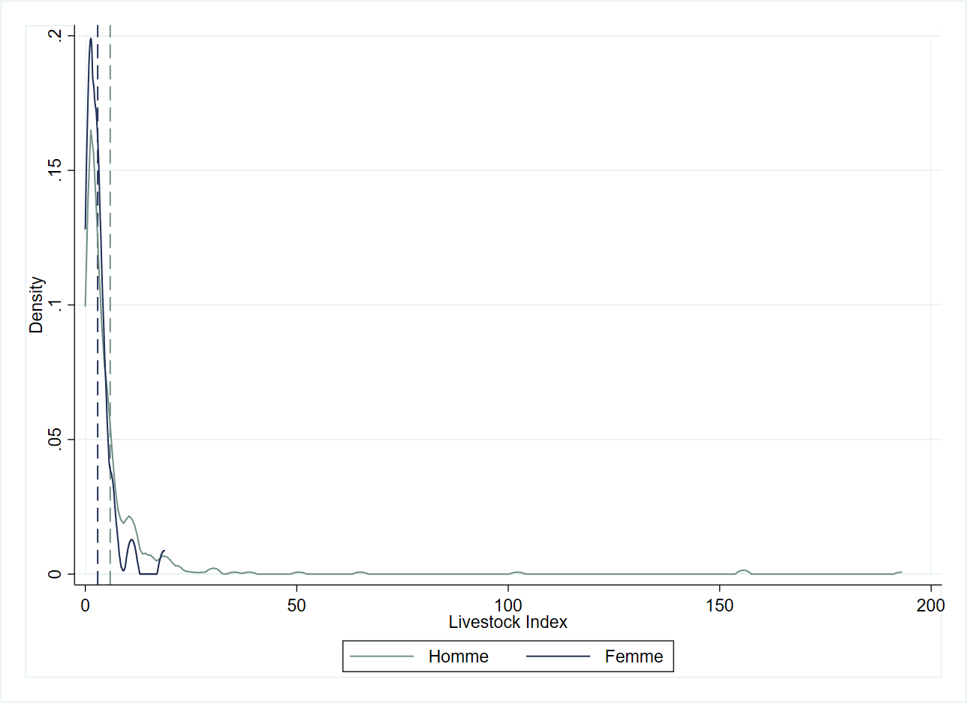

Both male and female livestock breeders have high livestock index values compared to other occupations however, male breeders (18) have on average a higher livestock ownership than female breeders (11)

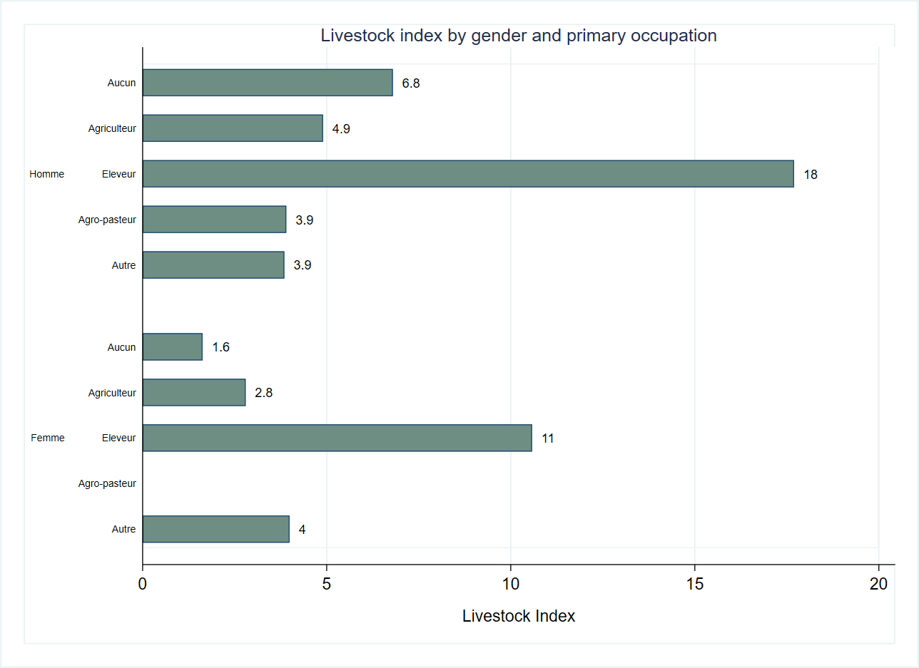

The balance table below shows a strong balance between the control and treatment group in terms of livestock ownership.

|  |  |  |  |  |  |
| --- | --- | --- | --- | --- | --- |
| **Table. Balance tables** |  | **(1)** |  | **(2)** | **t-test** |
| **Variable** |  | **Control** |  | **Treatment** | **Difference** |
|  | **N** | **Mean/SE** | **N** | **Mean/SE** | **(1)-(2)** |
| **Livestock Index** | 307 | 6.133 | 323 | 4.722 | 1.411 |
|  |  | [1.023] |  | [0.367] |  |
| **The value displayed for t-tests are the differences in the means across the groups.** |  |  |  |  |  |
| **\*\*\*, **, and * indicate significance at the 1, 5, and 10 percent critical level.** |  |  |  |  |  |

# Agricultural production

The section on agricultural production includes variables that denote the total area of land, total area of cultivated land and the expenditure on agricultural inputs such as improved seed varieties, chemical and organic fertilizer, pesticide products, cost of labor and the total value of agricultural production.

The respondents own on average 6 hectares of land and cultivate about 80 percent of their land holdings. The highest average expenditure is on chemical fertilizers (nearly 90,000 FCFA) and pesticide products (40,000 FCFA). These findings point to objectives such as keeping pests off crops and raising the level of yields as being high on the respondents’ agenda. The average expenditure on improved seed varieties is relatively low. Possibly, new technologies experience a low degree of adoption and/or dissemination in the targeted areas.

|  |  |  |  |  |  |  |
| --- | --- | --- | --- | --- | --- | --- |
| **Agricultural inputs** |  |  |  |  |  |  |
| **Variable** | **N** | **Mean** | **S.D.** | **Median** | **Min** | **Max** |
| **Superficie totale de terres, en ha** | 521 | 5.7 | 4.4 | 5.0 | 1.0 | 18.0 |
| **Superficie total cultivee, en ha** | 521 | 4.5 | 3.1 | 4.0 | 1.0 | 12.0 |
| **Valeur totale des semences ameliorees achetees, en 1000s FCFA** | 149 | 14.2 | 20.5 | 5.1 | 0.1 | 120.0 |
| **Valeur totale des engrais chimiques achetes, en 1000s FCFA** | 273 | 88.8 | 125.9 | 50.0 | 1.0 | 1000.0 |
| **Valeur totale des engrais organiques achetes, en 1000s FCFA** | 79 | 32.5 | 82.3 | 5.0 | 1.5 | 450.0 |
| **Valeur totale des produits phytosanitaires achetes, en 1000s FCFA** | 288 | 41.4 | 68.4 | 25.0 | 1.0 | 800.0 |
| **Valeur totale de la main d'oeuvre achetee ou louee, en 1000s FCFA** | 187 | 38.4 | 60.8 | 15.0 | 0.0 | 450.0 |

The distribution of the total area of land is, according to the kernel density plot below, skewed to the right.

Graph. Kernel density estimate for total area of land

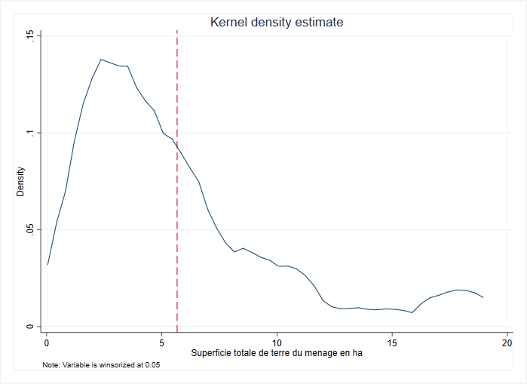

The female respondents own, on average, about 50 percent of the average size of land owned by the male respondents.

Graph. Kernel density estimate for total area of land, by gender

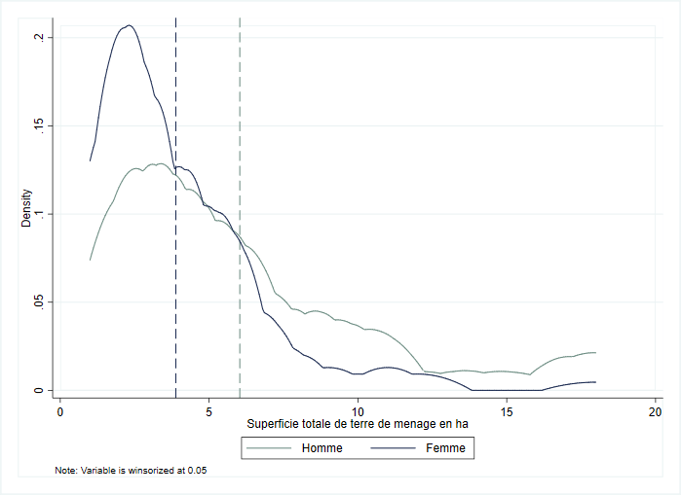

The respondents residing in Nosebou and Sorobouli account for the highest land ownership (approximately 11 hectares) while those residing in Tiogo and Bontioli own 4 and 4.6 hectares respectively.

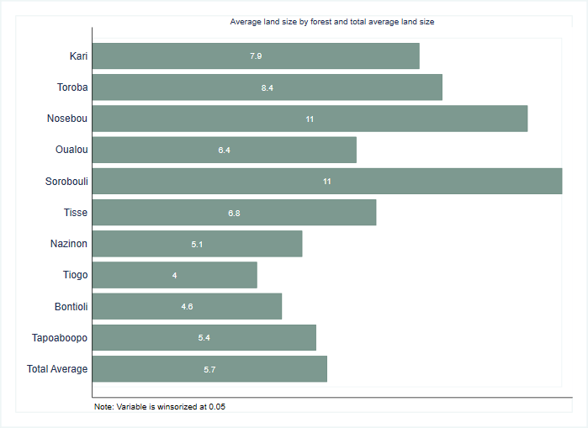

About 65 percent all of household reported cultivating all their landholdings and approximately 8 percent cultivate less than 50 percent of their available land.

Distribution of cultivated land

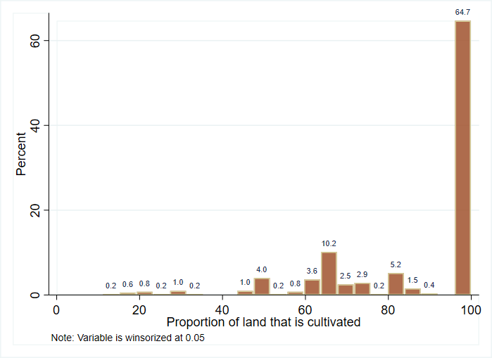

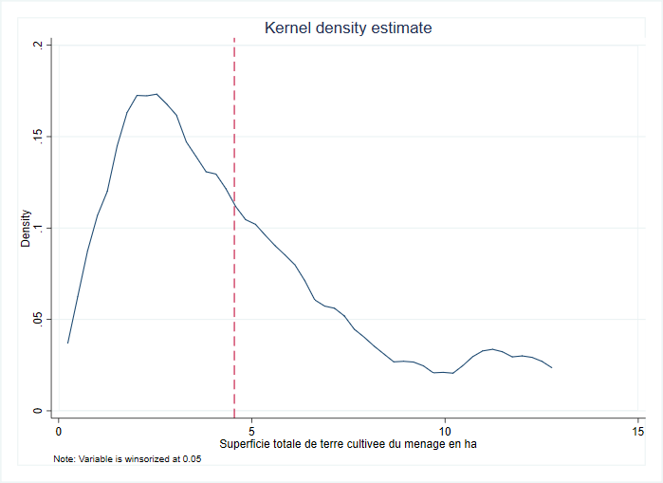

On average, the male respondents allocate about 5 hectares to farming while the corresponding figure for female respondents is 3 hectares.

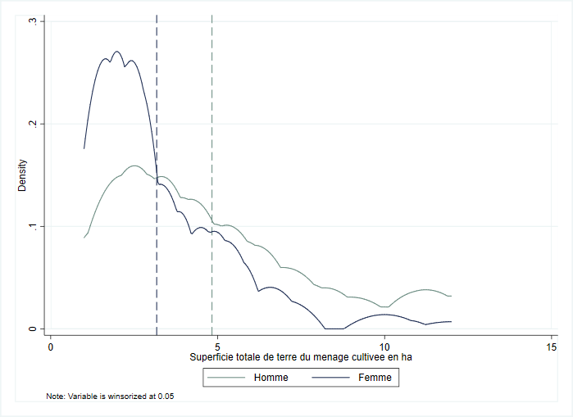

The average size of cultivated land is higher in Sorobouli (7.8 hectares), Toroba (7.7 hectares), Kari (7.1 hectares) and Nosebou (7.1 hectares). By contrast, the respondents residing in Tiogo (3.4 hectares) and Bontioli (3.6 hectares) tend to allocate less land to farming than respondents from other forests.

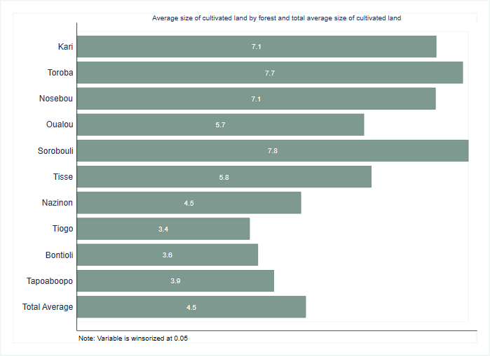

**Average expenditure on agricultural inputs by forest type**

The graph below evaluates respondents’ use of agricultural inputs. Pesticides (55 percent) followed by chemical fertilizers (52 percent) are the most popular agricultural inputs among survey respondents. Roughly 30 percent use improved seed varieties while organic fertilizers are the least popular input among survey respondents (about 15 percent).

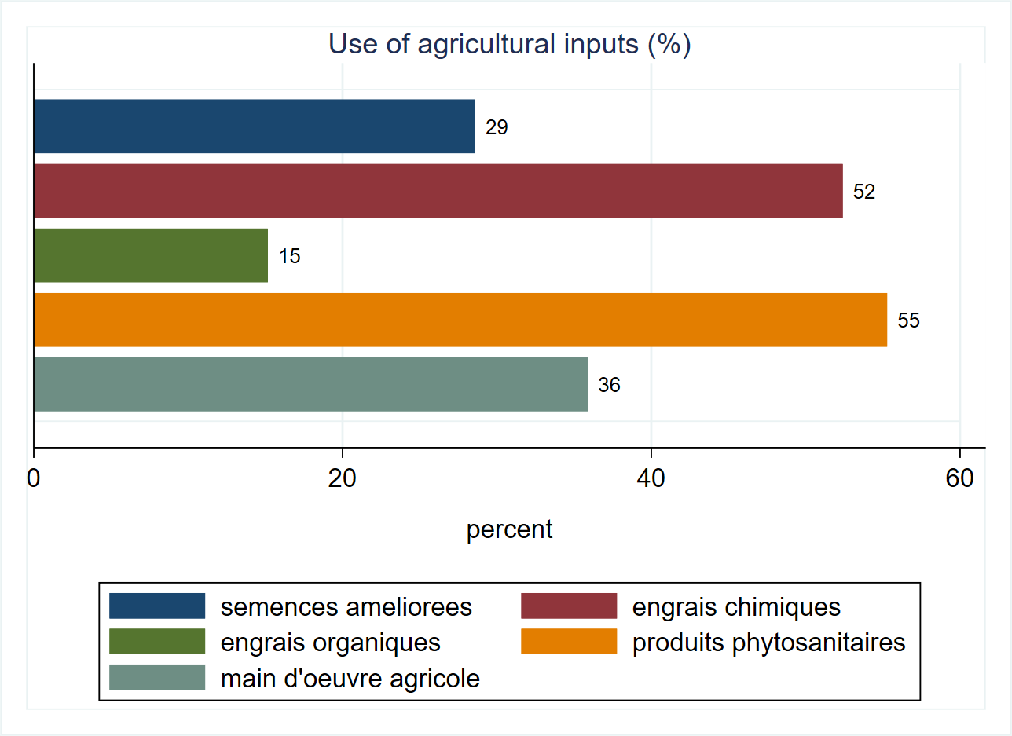

Survey respondents residing in Oualou (30,000 FCFA), Toroba (29,000 FCFA), Sorobouli (26,000 FCFA) and Kari (22,000 FCFA) tend to spend more on improved seed varieties than respondents residing elsewhere. Their average expenditures exceed the total average expenditure (14,000 FCFA) across all forests. Not a single respondent residing in the Nosebou forest area indicated spending on improved seed varieties.

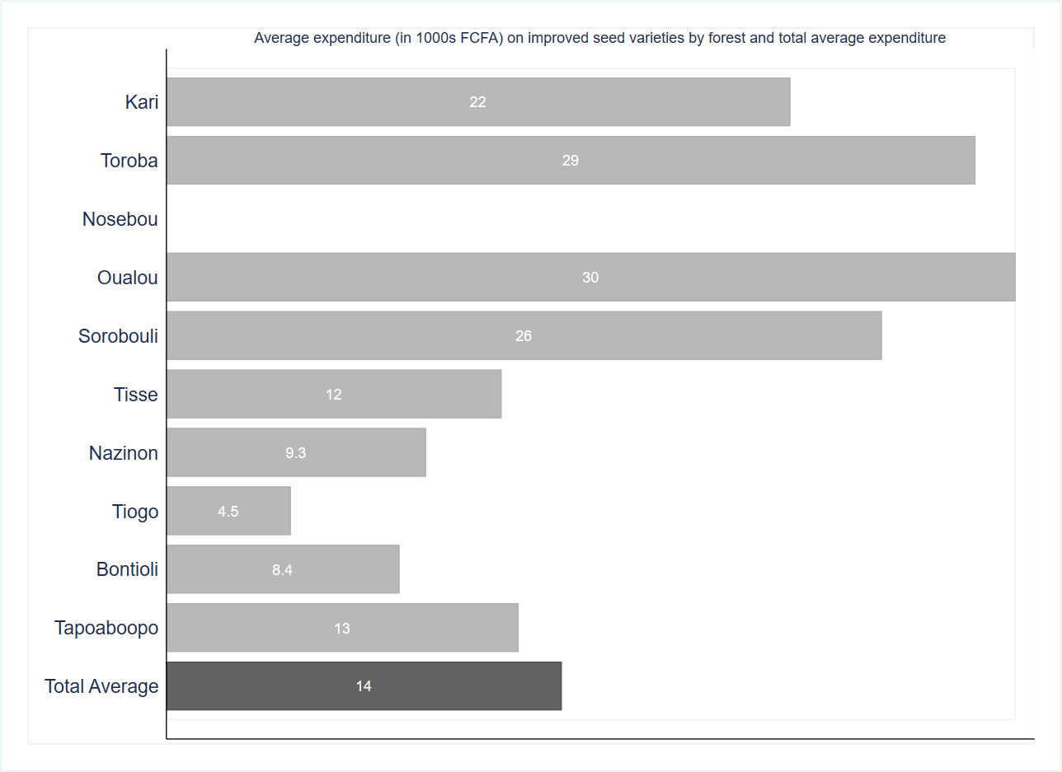

With the exception of respondents residing in Nazinon, Tiogo and Tapoaboopo, respondents in all other forests reported a relatively high average expenditure on chemical fertilizers ranging from 73,000 FCFA (Bontioli) to 223,000 FCFA (Nosebou). Particularly, the respondents living in the Nosebou area spend three times the total average on chemical fertilizers while the average expenditure of those from the Kari area exceeds twice of the total average expenditure.

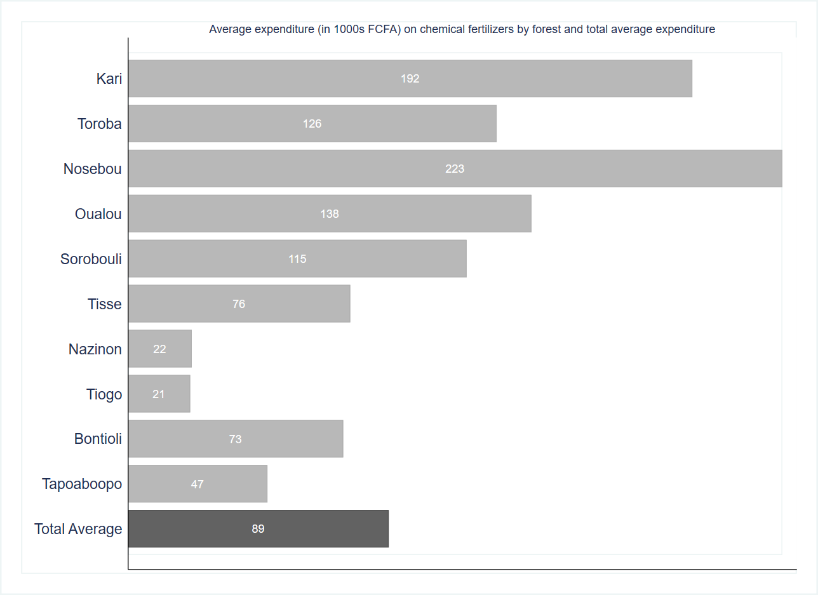

Glancing at the graph below, we observe that organic fertilizers are generally not all too popular among the survey respondents. Nosebou stands out as an exception with a substantial annual expenditure of 450,000 FCFA. Other forests with a higher than total average expenditure on organic fertilizers are Toroba (95,000 FCFA), Oualou (75,000 FCFA), Nazinon (49,000 FCFA) and Bontioli (47,000 FCFA). Not a single respondent residing in Sorobouli and Tisse indicated spending on organic fertilizers however the average expenditure on chemical fertilizers here is relatively high instead.

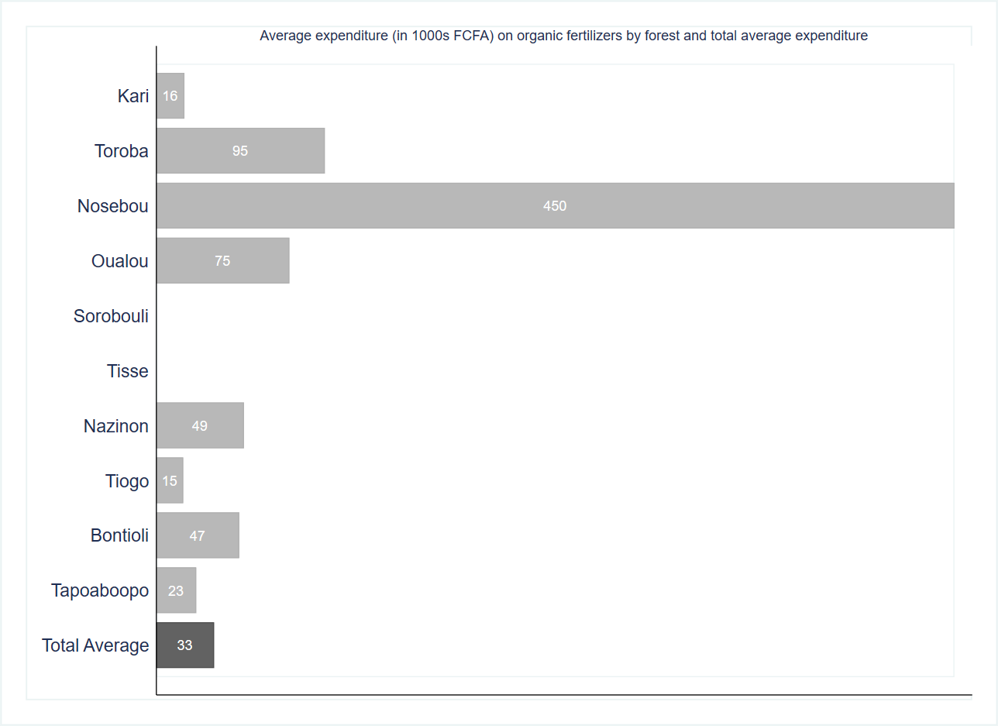

The use of pesticide products seems extremely popular in the Nosebou forest area where the average annual expenditure exceeds seven times the total average expenditure across all forests. Sorobouli comes second after Nosebou with an average expenditure of 145,000 FCFA per annum. The average expenditure on pesticides in all other forests is either at the same level as the annual total average or lower. With just 10,000 FCFA per annum respondents residing in Tiogo spend the least on pesticide products on average.

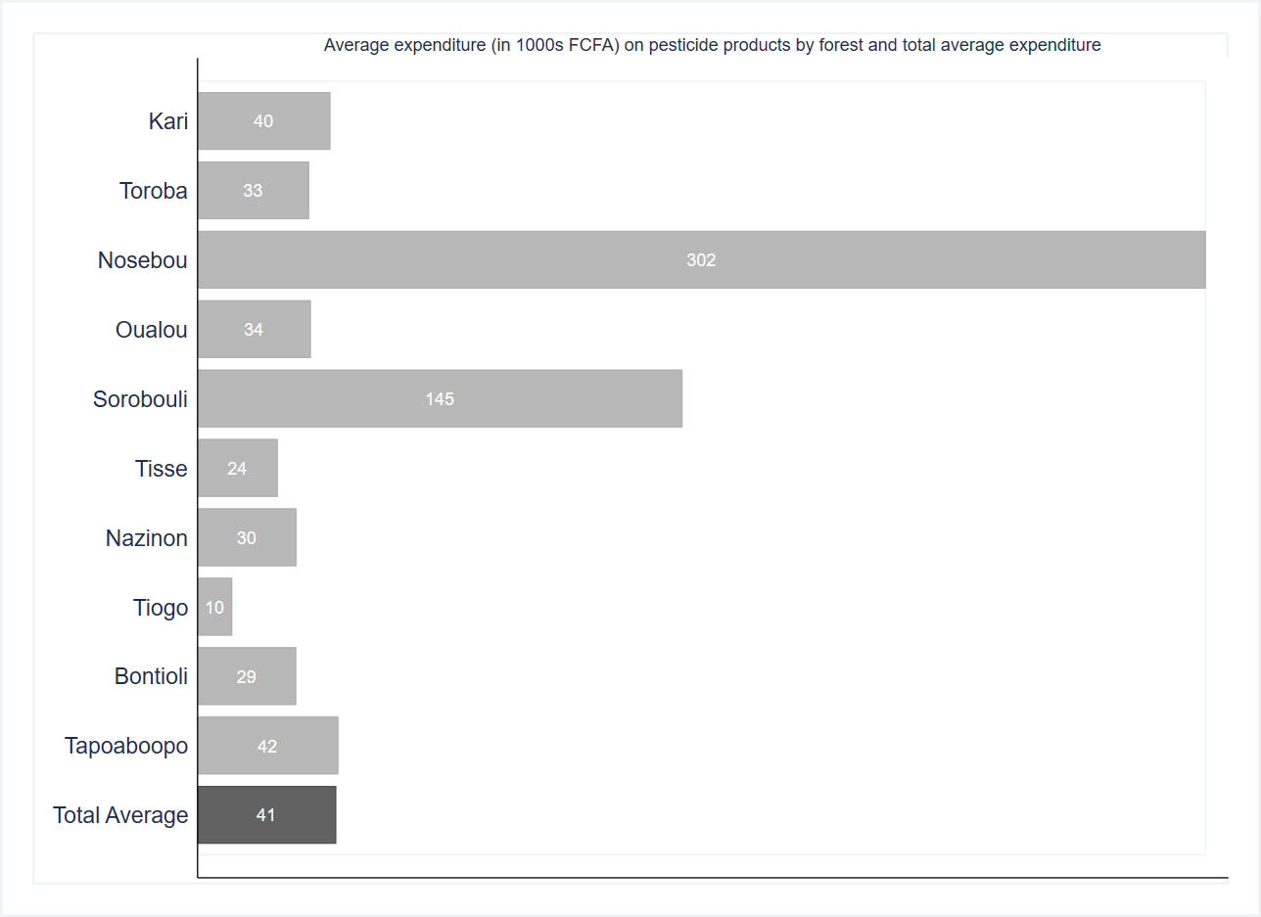

The graph below reveals huge discrepancies among the forests in the annual average expenditure on labor. Not a single respondent residing in Toroba reported spending on labor while the average expenditure on labor in Tiogo (12,000 FCFA) and Nazinon (14,000 FCFA) is far below the total average. Kari (86,000 FCFA), Sorobouli (79,000 FCFA) and Nosebou (76,000 FCFA) have a high average expenditure that exceeds twice the annual total average expenditure across all forests.

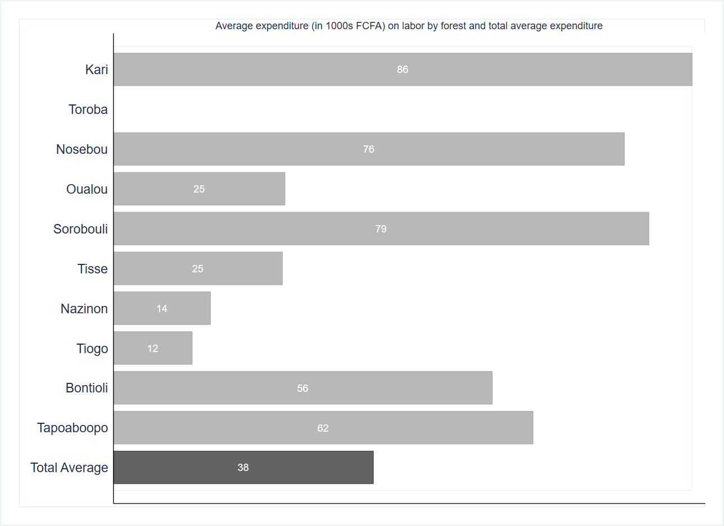

The balance table below indicates no significant differences in the level of agricultural inputs between the control and treatment groups. The two groups appear to be strongly balanced.

|  |  |  |  |  |  |
| --- | --- | --- | --- | --- | --- |
| **Table. Balance tables** |  | **(1)** |  | **(2)** | **t-test** |
| **Variable** |  | **Control** |  | **Treatment** | **Difference** |
|  | **N** | **Mean/SE** | **N** | **Mean/SE** | **(1)-(2)** |
| **Superficie de terre totale, en ha** | 259 | 5.67 | 262 | 5.66 | 0.01 |
|  |  | [0.278] |  | [0.262] |  |
| **Superficie de terre cultivee, en ha** | 259 | 4.476 | 262 | 4.616 | -0.141 |
|  |  | [0.189] |  | [0.191] |  |
| **Valeur totale des semences ameliorees achetees** | 74 | 16.384 | 75 | 11.966 | 4.419 |
|  |  | [2.537] |  | [2.204] |  |
| **Valeur totale des engrais chimiques achetes** | 134 | 82.671 | 139 | 94.789 | -12.118 |
|  |  | [8.352] |  | [12.628] |  |
| **Valeur totale des engrais organiques achetes** | 42 | 24.833 | 37 | 41.284 | -16.45 |
|  |  | [9.631] |  | [16.509] |  |
| **Valeur totale des produits phytosanitaires achetes** | 147 | 35.565 | 141 | 47.562 | -11.997 |
|  |  | [3.390] |  | [7.420] |  |
| **Valeur totale de la main d'oeuvre achetee ou louee** | 92 | 36.152 | 95 | 40.621 | -4.469 |
|  |  | [5.254] |  | [7.144] |  |
| **The value displayed for t-tests are the differences in the means across the groups.** |  |  |  |  |  |
| **\*\*\*, **, and * indicate significance at the 1, 5, and 10 percent critical level.** |  |  |  |  |  |

The average monetary value of the agricultural production is 480,000 FCFA and the level of yield, calculated in terms of FCFA per hectare of land, is on average 125,000 FCFA per hectare.

|  |  |  |  |  |  |  |
| --- | --- | --- | --- | --- | --- | --- |
| **Table. Summary statistics of agricultural production** |  |  |  |  |  |  |
| **Variable** | **N** | **Mean** | **S.D.** | **Median** | **Min** | **Max** |
| **Valeur totale de la production agricole, en 1000s FCFA** | 521 | 479.4 | 540.3 | 300.0 | 0.0 | 2000.0 |
| **Level of yield (FCFA per ha)** | 521 | 125.4 | 137.4 | 83.3 | 0.0 | 1000.0 |

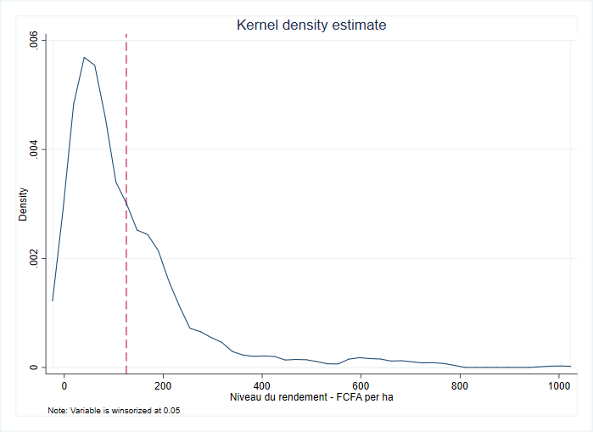

The level of yield for both women and men follows a similar distribution according to the kernel density plot below. The productivity of male respondents reveals several extreme values that push the mean value upwards. On average, the level of yield for men is approximately 127,000 FCFA per hectare and that for women is 115,000 FCFA. The women farmers in the sample are less productive than men but the productivity gap is not substantial.

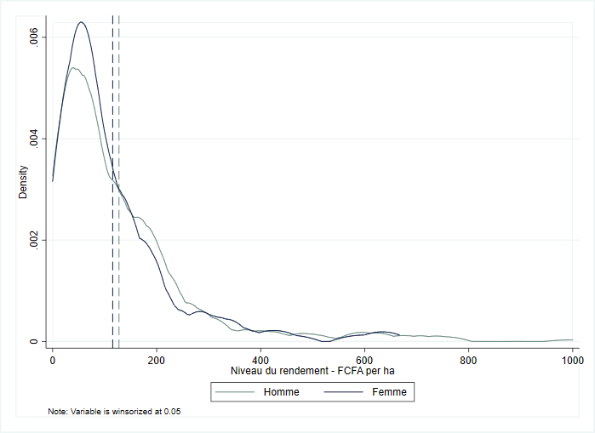

There are no massive differences in the average yield by primary occupation. With the exception of ‘other’ occupations which appear to be linked to the highest yield (174,000 FCFA per ha), livestock breeders (154,000 FCFA per ha) reported a high average yield, followed by farmers (123,000 per ha) and agro-pastoralists (120,000 FCFA per ha).

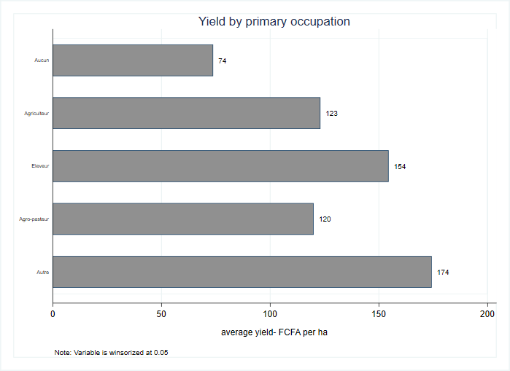

The respondents residing in the Sorobouli and Nosebou forests reported the highest yield (298,000 FCFA per ha and 260,000 FCFA per ha respectively). Previous findings pointed to a high average expenditure on labor, pesticide products and improved seed varieties in Sorobouli. Respondents in Nosebou tend to spend more on fertilizers (both chemical and organic), pesticide products and labor. Kari (63,000 FCFA) and Toroba (48,000 FCFA) reveal the lowest average yield per hectare.

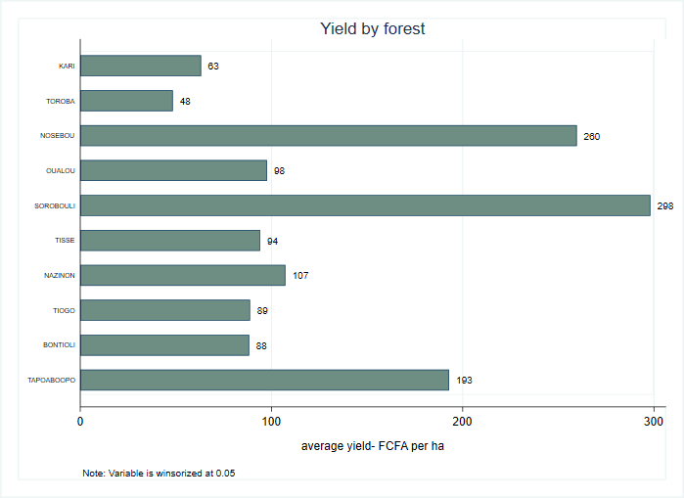

Generally, women tend to have a lower level of productivity than men across all primary occupations with the exception of ‘other occupations’. Male farmers reported an average yield of 126,000 FCFA per ha, about 16 percent higher than the corresponding yield of women farmers. The most substantial gender-based difference is in the average yield of livestock breeders. The men livestock breeders in the sample are on average four times more productive than women livestock breeders.

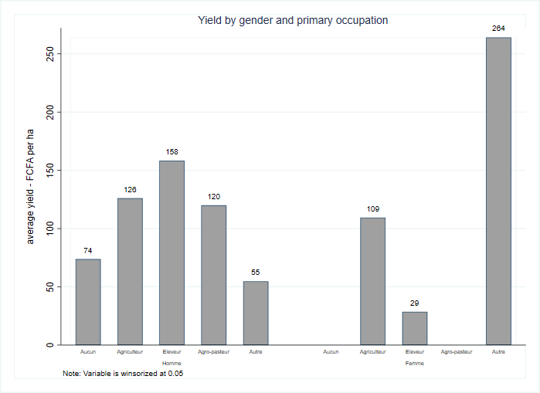

The balance table below reveals that both the control and treatment groups are strongly balanced with respect to the monetary value of agricultural production and the level of yield. There are no significant differences in either of these two variables between the groups.

|  |  |  |  |  |  |
| --- | --- | --- | --- | --- | --- |
| **Table. Balance tables** |  |  |  |  |  |
|  |  | (1) |  | (2) | t-test |
| **Variable** |  | **Control** |  | **Treatment** | **Difference** |
|  | N | Mean/SE | N | Mean/SE | (1)-(2) |
| **Valeur totale de la production agricole, en 1000s FCFA** | 259 | 457.804 | 262 | 500.688 | -42.884 |
|  |  | [33.845] |  | [33.119] |  |
| **Niveau du rendement, FCFA per ha** | 259 | 121.097 | 262 | 129.733 | -8.635 |
|  |  | [8.543] |  | [8.492] |  |
| The value displayed for t-tests are the differences in the means across the groups. |  |  |  |  |  |
| ***, **, and * indicate significance at the 1, 5, and 10 percent critical level. |  |  |  |  |  |

# Food expenditure

This section analyses the survey respondents’ patterns in food expenditure. According to the information provided below, the average monetary value of food consumed from all sources given a recall period of 7 days is approximately 22,000 FCFA.

|  |  |  |  |  |  |  |
| --- | --- | --- | --- | --- | --- | --- |
| **Monetary value of food consumed over the past 7 days** |  |  |  |  |  |  |
| **Variable** | **N** | **Mean** | **S.D.** | **Median** | **Min** | **Max** |
| **Total monetary value of food from all sources, en 1000s FCFA** | 630 | 22.4 | 32.0 | 15.4 | 0.0 | 367.6 |

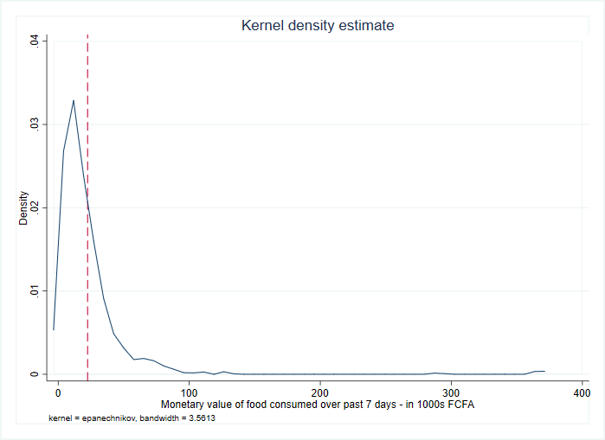

The graph below indicates no substantial gender-based differences in the average monetary value of the food consumed.

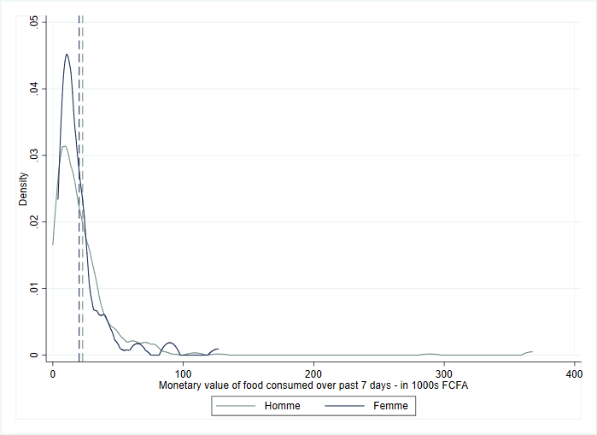

The average monetary value of food consumed is highest for livestock breeders (52,000 FCFA) and agro-pastoralists (32,000 FCFA) and lowest for those who reported not having a primary occupation (6,000 FCFA).

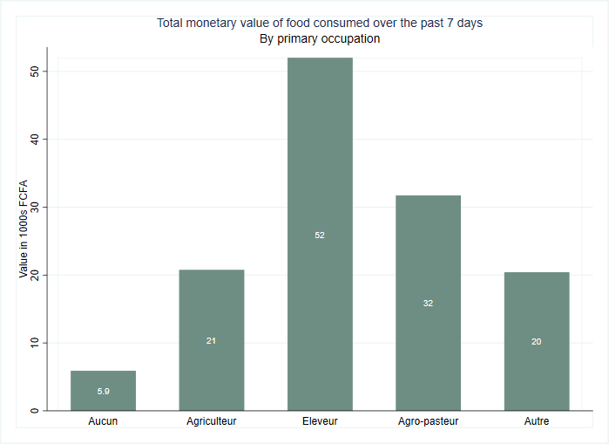

The respondents residing in Tapoaboopo (37,000 FCFA) and Oualou (32,000 FCFA) reported the highest monetary value of food consumed over the past 7 days whereas the food expenditure was lowest in Nosebou (8,000 FCFA), Sorobouli (9,000 FCFA) and Toroba (10,000 FCFA).

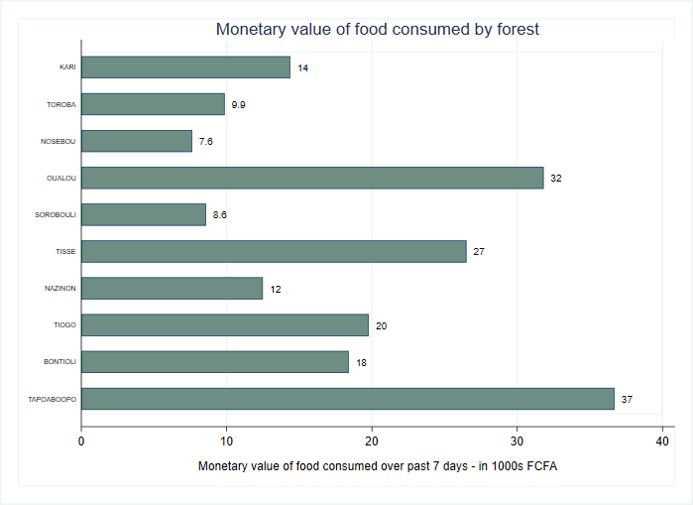

Apart from the respondents actively engaged in farming for which the average food expenditure was equal between men and women, the male respondents spent consistently more than women respondents across all primary occupations. On average, men livestock breeders spent about 53,000 FCFA on food over the past 7 days whereas the average food expenditure reported by women livestock breeders was just 7,000 FCFA during the same period.

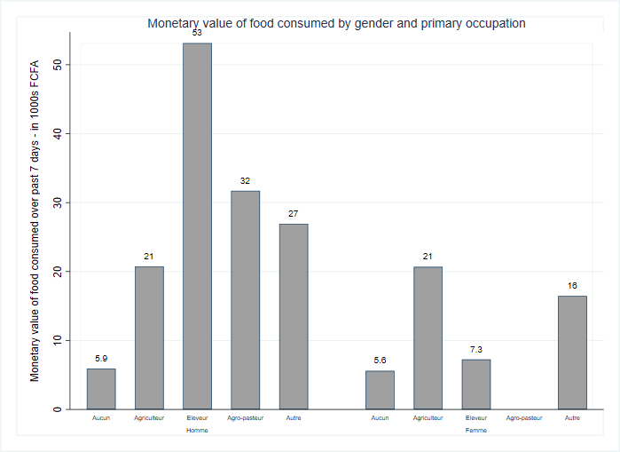

The balance table below shows a significant difference at the 10 percent level in the total monetary value of food consumed between the control and treatment groups.

|  |  |  |  |  |  |
| --- | --- | --- | --- | --- | --- |
| **Balance table: Food expenditure** |  | **(1)** |  | **(2)** | **t-test** |
| **Variable** |  | **Control** |  | **Treatment** | **Difference** |
|  | **N** | **Mean/SE** | **N** | **Mean/SE** | **(1)-(2)** |
| **Total monetary value of food consumed, en 1000s FCFA** | 307 | 24.731 | 323 | 20.27 | 4.461* |
|  |  | [2.397] |  | [0.993] |  |
| The value displayed for t-tests are the differences in the means across the groups. |  |  |  |  |  |
| ***, **, and * indicate significance at the 1, 5, and 10 percent critical level. |  |  |  |  |  |

Household dietary diversity score

The average household dietary diversity score in the sample is 5.7. The highest dietary diversity is reflected in a score of 10 and the lowest is a score of 0.

|  |  |  |  |  |  |  |
| --- | --- | --- | --- | --- | --- | --- |
| Household dietary diversity score |  |  |  |  |  |  |
| Variable | N | Mean | S.D. | Median | Min | Max |
| Household dietary diversity score | 630 | 5.7 | 2.2 | 6.0 | 0.0 | 10.0 |

The household dietary diversity scores follow the same distribution for both men and women in the sample with women enjoying higher dietary diversity on average than their male counterparts.

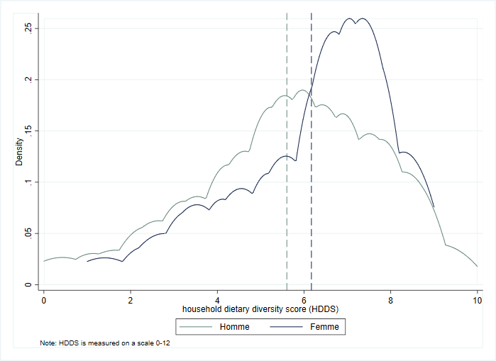

The graph below reveals relatively similar household dietary diversity scores across three primary occupations such as farming (5.7), livestock breeding (5.8) and agro-pastoralism (6). The respondents who reported having no primary occupation have the lowest household dietary diversity score of 3.5.

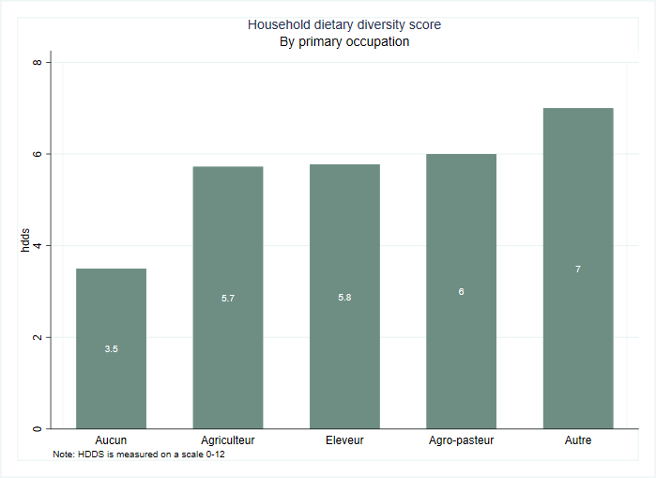

Respondents residing in Oualou (6.7), Tisse (6.6), Tapoaboopo (6.6) and Bontioli (6.2) have the highest dietary diversity in the sample whereas the average scores of respondents from Nosebou (2.8), Sorobouli (3.5) and Toroba (3.9) reflect the lowest dietary diversity.

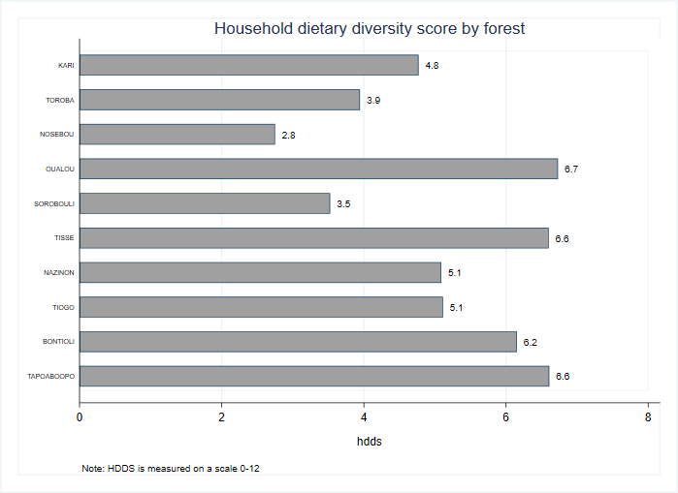

Generally, women score slightly better than men in terms of household dietary diversity although the scores are in the same range. Specifically, female livestock breeders have a household dietary diversity score of 6 while their male counterparts score 5.8. The average household dietary diversity score of women farmers is 6.2 while that of men farmers is 5.6. The female respondents that reported not having a primary occupation have a household dietary diversity of 6 as opposed to just 3.3 for their male counterparts.

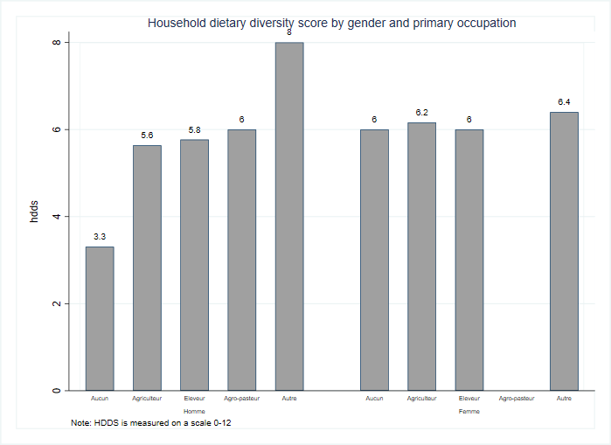

The balance table below indicates a significant difference at the 10 percent level between the control and treatment groups with respect to their household dietary diversity.

|  |  |  |  |  |  |
| --- | --- | --- | --- | --- | --- |
| **Balance table. Household Dietary Diversity Score** |  | **(1)** |  | **(2)** | **t-test** |
| **Variable** |  | **Control** |  | **Treatment** | **Difference** |
|  | **N** | **Mean/SE** | **N** | **Mean/SE** | **(1)-(2)** |
| household dietary diversity score (HDDS) | 307 | 5.84 | 323 | 5.554 | 0.286* |
|  |  | [0.119] |  | [0.125] |  |
| The value displayed for t-tests are the differences in the means across the groups. |  |  |  |  |  |
| ***, **, and * indicate significance at the 1, 5, and 10 percent critical level. |  |  |  |  |  |