今日内容，完成了剧目管理部分，解决了中文读入乱码问题，完善了剧目结构体内容

文件录入部分代码。

结构体内容完善：

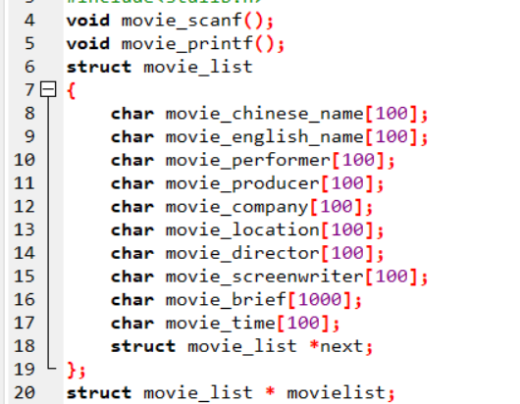

中文乱码乱码解决：

将txt文件改为ANSI存储

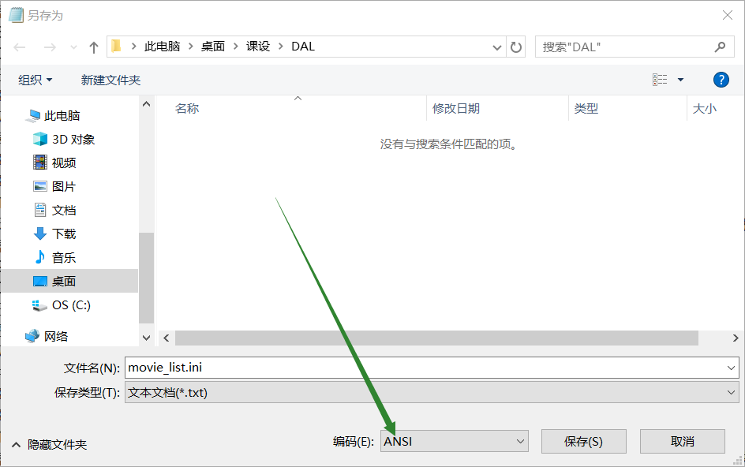

struct movie_list * movielist;

void movie_scanf()

{

FILE * fp;

fp=fopen("./DAL/movie_list.ini","rt+");

char moviechinesename[100];

char movieenglishname[100];

char movieproducer[100];

char movieperformer[100];

char moviecompany[100];

char movielocation[100];

char moviedirector[100];

char moviescreenwriter[100];

char moviebrief[1000];

char movietime[100];

struct movie_list *head,*p,*q;

head=(struct movie_list *)malloc(sizeof(struct movie_list));

head->next=NULL;

while(fgets(moviechinesename,100,fp)!=NULL)

{

fgets(movieenglishname,100,fp);

fgets(movieperformer,100,fp);

fgets(movieproducer,100,fp);

fgets(moviecompany,100,fp);

fgets(movielocation,100,fp);

fgets(moviedirector,100,fp);

fgets(moviescreenwriter,100,fp);

fgets(movietime,100,fp);

fgets(moviebrief,1000,fp);

p=(struct movie_list *)malloc(sizeof(struct movie_list));

p->next=NULL;

strcpy(p->movie_chinese_name,moviechinesename);

strcpy(p->movie_performer,movieperformer);

strcmp(p->movie_english_name,movieenglishname);

strcmp(p->movie_producer,movieproducer);

strcmp(p->movie_company,moviecompany);

strcmp(p->movie_location,movielocation);

strcmp(p->movie_director,moviedirector);

strcmp(p->movie_screenwriter,moviescreenwriter);

strcmp(p->movie_time,movietime);

strcpy(p->movie_brief,moviebrief);

if(head->next==NULL)

{

head->next=p;

q=p;

}

else

{

q->next=p;

q=p;

}

}

fclose(fp);

movielist=head;

return;

}

void movie_printf()

{

FILE *fp;

fp=fopen("./DAL/movie_list.ini","wt+");

struct movie_list * t;

t=movielist->next;

while(t!=NULL)

{

fprintf(fp,"%s\n%s\n%s\n%s\n%s\n%s\n%s\n%s\n%s\n%s\n",t->movie_chinese_name,t->movie_english_name,t->movie_performer,t->movie_producer,t->movie_company,t->movie_location,t->movie_director,t->movie_screenwriter,t->movie_time,t->movie_brief);

t=t->next;

}

fclose(fp);

return ;

}

今日份感想：

卡bug’不能方，淡定的一步一步调试。结果还是发现不了问题555

文本文档可以更改文件编码

用链表排序好像不dei行，所以改成了结构体数组，