Divvy Bike-Share Demand and Station Imbalance Analysis
DES431 Big Data Analytics - Kick-off Document, Sections 3 and 4

3 Data Description
The project uses the public trip-record archive of Divvy, the bicycle-sharing system operated in Chicago by Lyft Bikes and Scooters, LLC on behalf of the Chicago Department of Transportation. Divvy publishes one file per calendar month covering every trip taken on the system. Each record is a single completed journey, so the grain of the dataset is one row per trip, which makes it a natural fact table for analytics.
The study window for this project is the twelve months from October 2024 to September 2025 inclusive, which is the most recent complete year available at the time of writing. Taken together these twelve files hold 5,539,521 trip records across 13 columns and occupy 1,119 MB on disk as raw CSV. All twelve files share an identical header, so there is no schema drift to reconcile before the files can be treated as one table.
The data is fully structured and machine-generated: comma-delimited, double-quote qualified, UTF-8 encoded, with one header line per file. Each trip carries a unique identifier, the bike class, start and end timestamps at millisecond precision, the origin and destination docking stations where applicable, the origin and destination coordinates in WGS84 decimal degrees, and the rider's subscription type. Records are anonymised at source: there is no rider identifier, no payment information and no personally identifying information of any kind, so the dataset can be processed without privacy controls beyond the publisher's licence terms.
In terms of volume and frequency, the archive grows by one file each month. Across the study window the system recorded an average of roughly 15,200 trips per day, but that average conceals a very large seasonal swing: the quietest day in the window carried under 1,500 trips while the busiest carried more than 32,000. Monthly volume ranges from 138,689 records in January 2025 to 790,177 in August 2025, a factor of 5.7. At the current rate the archive accumulates approximately 1.1 GB of raw CSV per year, and the full historical archive published by Divvy, which reaches back to 2013, is substantially larger than the twelve-month slice used here. The combination of a multi-gigabyte, continuously growing, event-level table and analytics that must aggregate across the whole of it is what makes a distributed processing pipeline appropriate for this project rather than a single-machine workflow.

Dataset at a glance
Property | Value
Source | Divvy System Data, published by Lyft Bikes and Scooters, LLC
Source link | https://divvybikes.com/system-data
Licence | Divvy Data License Agreement (free public use, anonymised)
Data type | Structured, tabular, machine-generated event records
Format | CSV - comma-delimited, quote-qualified, UTF-8, one header row per file
Grain | One row per completed trip
Files | 12 monthly files (October 2024 - September 2025)
Records | 5,539,521
Columns | 13, identical across all 12 files (no schema drift)
Raw size | 1,119 MB CSV (approximately 1.1 GB per year)
Timestamp range | 2024-09-30 19:20:32 to 2025-09-30 23:59:57
Update frequency | One new monthly file published per month
Average daily volume | approximately 15,200 trips per day
Distinct stations | 1,920 station names, 3,435 raw station_id values

4 General Statistics of the Data
The statistics in this section were computed over the complete twelve-month dataset - all 5,539,521 records - rather than over a sample. This was possible on ordinary hardware because the profiling pass streams the data one monthly file at a time and keeps only running aggregates in memory, so peak memory stays close to the size of the largest single month (around 790,000 rows) instead of the full 5.5 million. Fixed histogram bins, running sums and running co-moments are accumulated across files and combined at the end, which gives exact answers rather than approximations from a subsample.
This is deliberately a profiling strategy, not the analytics strategy. It scales to one year on one machine, but it is sequential and it will not scale to the full multi-year archive or to the repeated, interactive aggregations the analytics stage requires. Those workloads are the reason the project moves onto a distributed pipeline, described in Section 5. Everything reported below is reproducible from the scripts in the project repository.

4.1 Number of Records
The twelve monthly files hold 5,539,521 trip records in total. Volume is strongly seasonal, which is the single most important structural property of this dataset: any model, dashboard or capacity estimate built on it has to treat seasonality as a first-order effect rather than as noise.
Records and raw file size per month
Month | Records | File size (MB) | % of total
2024-10 | 616,281 | 126.7 | 11.13%
2024-11 | 335,075 | 69.1 | 6.05%
2024-12 | 178,372 | 36.8 | 3.22%
2025-01 | 138,689 | 28.6 | 2.50%
2025-02 | 151,880 | 31.3 | 2.74%
2025-03 | 298,155 | 60.9 | 5.38%
2025-04 | 371,341 | 75.6 | 6.70%
2025-05 | 502,456 | 101.6 | 9.07%
2025-06 | 678,904 | 136.0 | 12.26%
2025-07 | 763,432 | 152.3 | 13.78%
2025-08 | 790,177 | 157.5 | 14.26%
2025-09 | 714,759 | 142.7 | 12.90%
Total | 5,539,521 | 1,119 | 100.00%

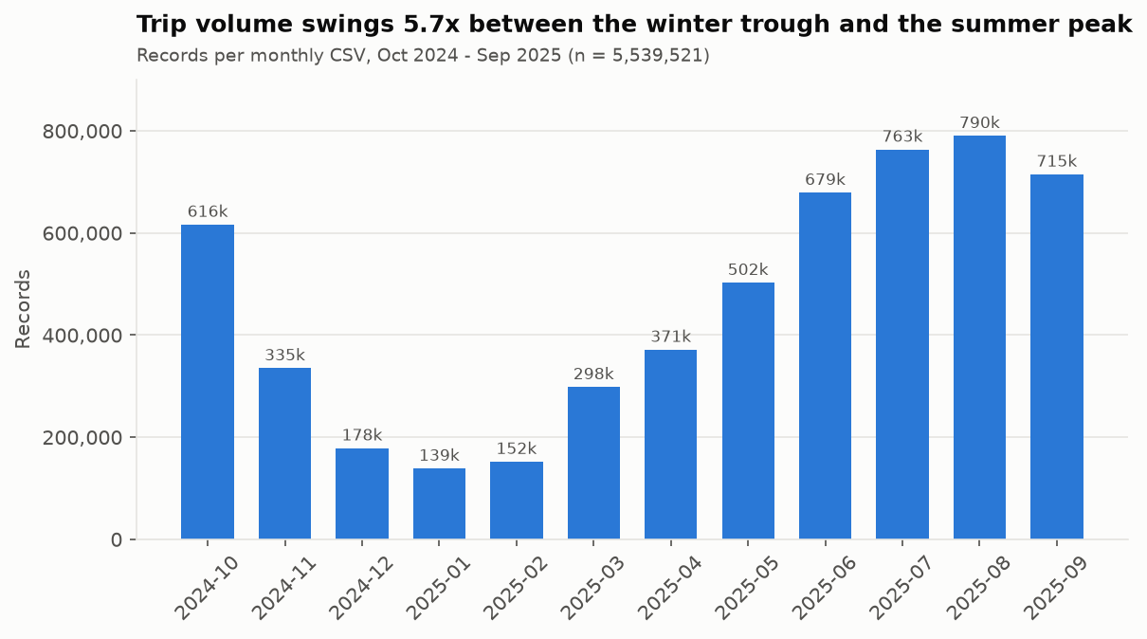
Aggregating to the calendar day shows the same seasonal cycle with a weekly rhythm superimposed on it. The sharp day-to-day spikes visible in the raw series are weather-driven: Chicago ridership responds immediately to rain and temperature, which is why the seven-day mean is a much more stable signal than any single day.
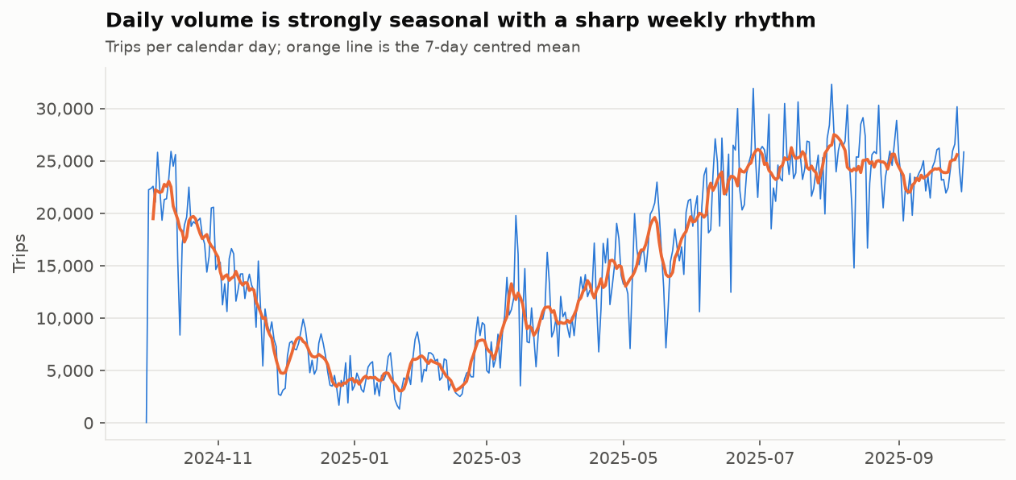

4.2 Number of Features
Every file carries the same 13 columns. The table below lists each one with its data type, the range of values observed across the whole dataset and a representative example. Two points in the table are worth flagging early because they shape the preprocessing design.
- The station columns are null on roughly one trip in five. This is not damage. It is a structural property of the system and is analysed in Section 4.3.
- The end coordinate range is impossible. end_lat spans 35.50 to 83.14 and end_lng spans -94.27 to 152.53, which would place trips in the high Arctic and the western Pacific, whereas the start coordinates stay inside a sensible Chicago bounding box. These are isolated GPS failures and there are only 24 of them in 5.5 million rows, but they have to be measured before they can be dismissed.
Raw Data Features
# | Feature | Type | Description | Range observed | Example
1 | ride_id | string | Unique trip identifier (16-character hex) | - | 4422E707103AA4FF
2 | rideable_type | string | Bike class used for the trip | classic_bike | electric_bike | electric_bike
3 | started_at | timestamp | Trip start timestamp, local Chicago time | 2024-09-30 19:20 to 2025-09-30 23:57 | 2024-10-14 03:26:04
4 | ended_at | timestamp | Trip end timestamp, local Chicago time | 2024-10-01 00:00 to 2025-09-30 23:59 | 2024-10-14 03:32:56
5 | start_station_name | string | Docking station where the trip began | 1915 distinct values | California Ave & Milwaukee Ave
6 | start_station_id | string | Divvy internal station code for the origin | 3399 distinct values | 13084
7 | end_station_name | string | Docking station where the trip ended | 1917 distinct values | California Ave & Milwaukee Ave
8 | end_station_id | string | Divvy internal station code for the destination | 3414 distinct values | 13084
9 | start_lat | double | Origin latitude, WGS84 decimal degrees | 41.6400 to 42.0700 | 41.96
10 | start_lng | double | Origin longitude, WGS84 decimal degrees | -87.8900 to -87.5200 | -87.65
11 | end_lat | double | Destination latitude, WGS84 decimal degrees | 35.5000 to 83.1400 | 41.98
12 | end_lng | double | Destination longitude, WGS84 decimal degrees | -94.2700 to 152.5300 | -87.67
13 | member_casual | string | Rider subscription type | casual | member | member

Beyond these thirteen source columns the preprocessing stage derives a further set of analytic features from them - trip duration, straight-line distance, average speed, the calendar and clock parts of the start timestamp, a geohash cell for each endpoint, and a stable station key. Those derived columns are described in the methodology rather than here, but three of them (duration, distance and speed) are used in the distributions below because they are the quantities that expose the data-quality problems most clearly.

4.3 Missing Data
Nine of the thirteen columns are complete. Missing values occur in only 6 columns, and they fall into two clearly separated groups.
Missing values per column
Feature | Missing records | % missing
ride_id | 0 | 0.00%
rideable_type | 0 | 0.00%
started_at | 0 | 0.00%
ended_at | 0 | 0.00%
start_station_name | 1,129,029 | 20.38%
start_station_id | 1,129,029 | 20.38%
end_station_name | 1,175,835 | 21.23%
end_station_id | 1,175,835 | 21.23%
start_lat | 0 | 0.00%
start_lng | 0 | 0.00%
end_lat | 5,442 | 0.10%
end_lng | 5,442 | 0.10%
member_casual | 0 | 0.00%

Breaking the same counts down by month shows that the pattern is completely stable: the missing rate moves only with seasonal volume and never jumps. Whatever causes the nulls has been operating consistently for the whole period, which already argues against treating them as a data-collection incident.
Missing values by column and by month
Month | start_​station_​name | start_​station_​id | end_​station_​name | end_​station_​id | end_​lat | end_​lng
2024-10 | 107,147 | 107,147 | 109,517 | 109,517 | 568 | 568
2024-11 | 56,203 | 56,203 | 57,644 | 57,644 | 273 | 273
2024-12 | 29,191 | 29,191 | 30,776 | 30,776 | 131 | 131
2025-01 | 22,852 | 22,852 | 24,073 | 24,073 | 61 | 61
2025-02 | 25,928 | 25,928 | 27,249 | 27,249 | 57 | 57
2025-03 | 55,337 | 55,337 | 57,984 | 57,984 | 241 | 241
2025-04 | 71,196 | 71,196 | 73,635 | 73,635 | 289 | 289
2025-05 | 103,360 | 103,360 | 107,436 | 107,436 | 551 | 551
2025-06 | 150,904 | 150,904 | 156,772 | 156,772 | 988 | 988
2025-07 | 173,529 | 173,529 | 181,506 | 181,506 | 971 | 971
2025-08 | 177,121 | 177,121 | 184,760 | 184,760 | 693 | 693
2025-09 | 156,261 | 156,261 | 164,483 | 164,483 | 619 | 619
Total | 1,129,029 | 1,129,029 | 1,175,835 | 1,175,835 | 5,442 | 5,442

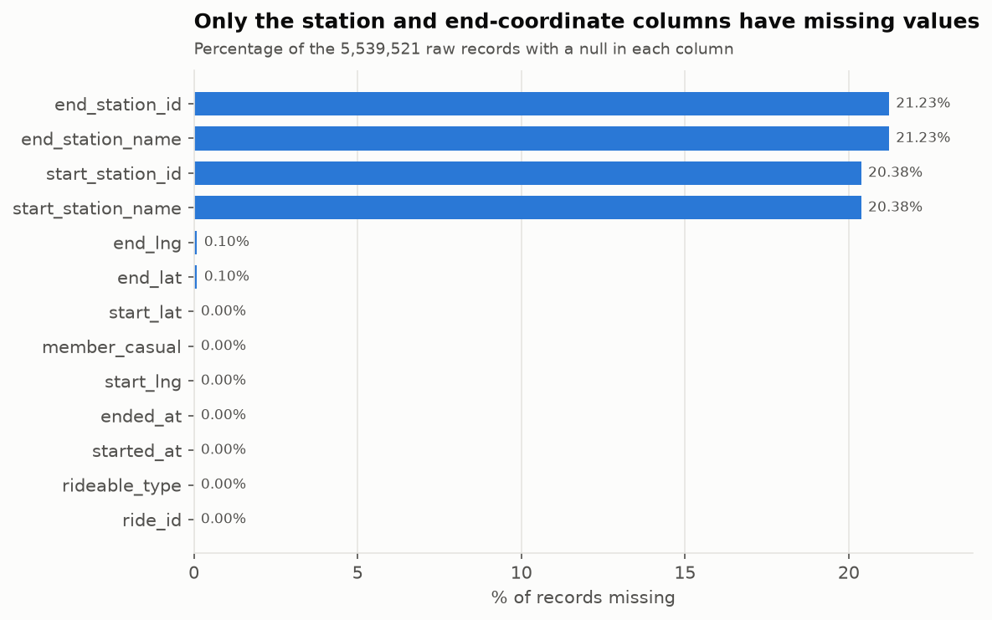
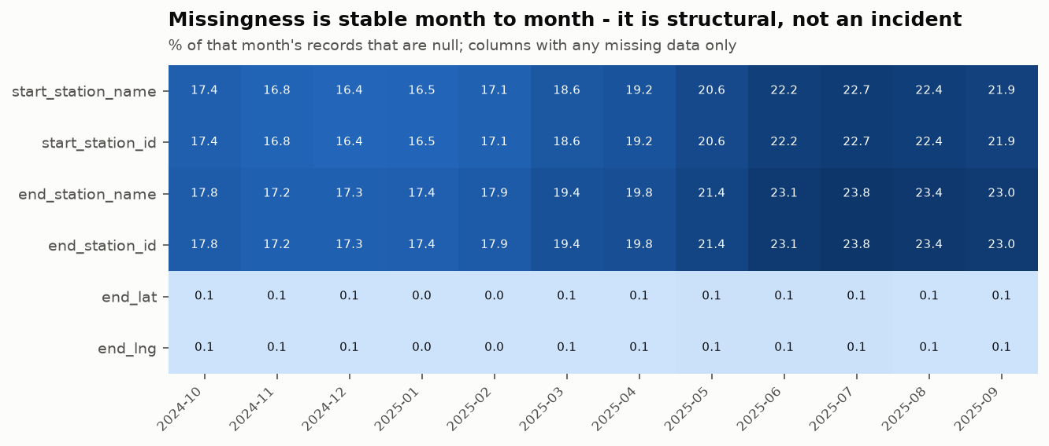

The station nulls are structural, not random
The 1,129,029 missing start-station names are the most consequential feature of this dataset, and the obvious responses - drop the rows, or impute a station - are both wrong. Splitting the missingness by bike type explains 100% of it.
Missing start-station names by bike type
Bike type | Trips | Missing start station | Rate
classic_bike | 2,077,053 | 0 | 0.00%
electric_bike | 3,462,468 | 1,129,029 | 32.61%

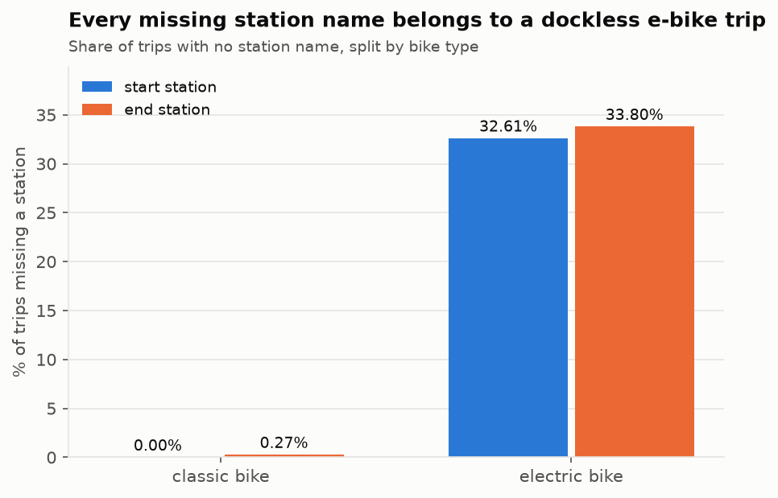
Divvy electric bikes are dockless: a rider may end a trip by locking the bike to any public rack, in which case no station is recorded. Classic bikes must be returned to a dock, so a classic-bike trip never has a missing station - the observed rate is exactly 0.00%. The nulls therefore encode a real operational mode of the system. In missing-data terms this is MNAR (Missing Not At Random), because the probability that a value is absent depends on an observable property of the record itself.
- Dropping these rows would discard 32.6% of all electric-bike trips and bias every downstream demand estimate towards the docked, classic-bike population.
- Imputing a station name would fabricate dock activity that never happened, which would corrupt precisely the station-imbalance analysis the project intends to run.
- Keeping and flagging them is the correct treatment. The coordinates are always present on these rows, so a geohash cell gives every dockless trip a usable spatial identity where a station name does not exist.
The practical difference is large. Calling dropna() across all columns would retain 3,770,024 of 5,539,521 rows, a loss of 31.9%, and would silently change the population under study from the whole system to its docked subset. The rule-based cleaning actually applied removes 142,350 rows, a loss of 2.57%, and every removed row is attributable to a named quality rule.
The second group of nulls is unrelated and far smaller: 5,442 records, 0.10% of the dataset, have no end coordinate. These are trips where the bike was never properly returned, so no closing GPS fix was written. Trip distance and speed cannot be computed for them, and they are removed during cleaning.

4.4 Sample Distributions
The distributions below are computed over the full dataset. Categorical columns are shown as shares, numeric columns as histograms with fixed bins accumulated across all twelve files, and the two high-cardinality columns - the station names - are summarised by their top 30 values and by the shape of their long tail.

Distribution of each feature
The two categorical columns split the dataset into its primary analytic segments. Electric bikes carry the majority of trips, which is what makes the dockless-station issue in Section 4.3 so significant, and members account for roughly two thirds of all journeys.
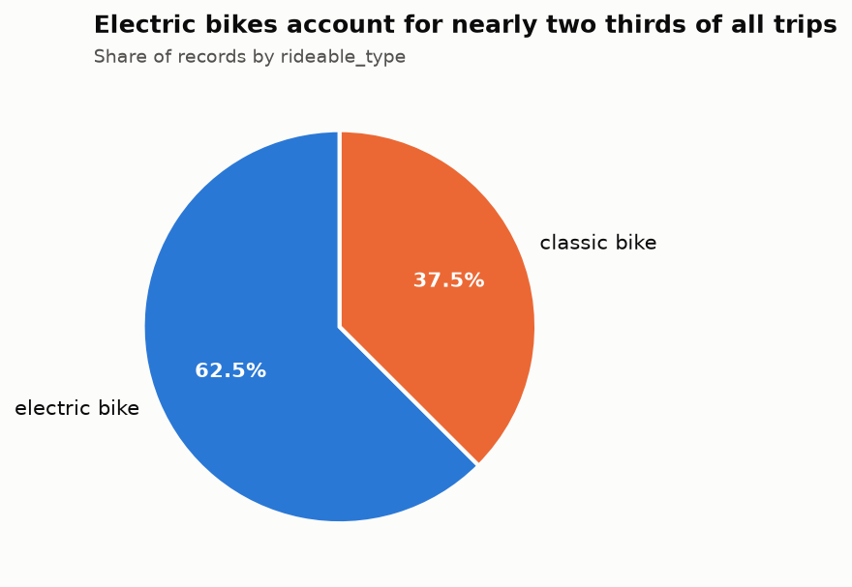
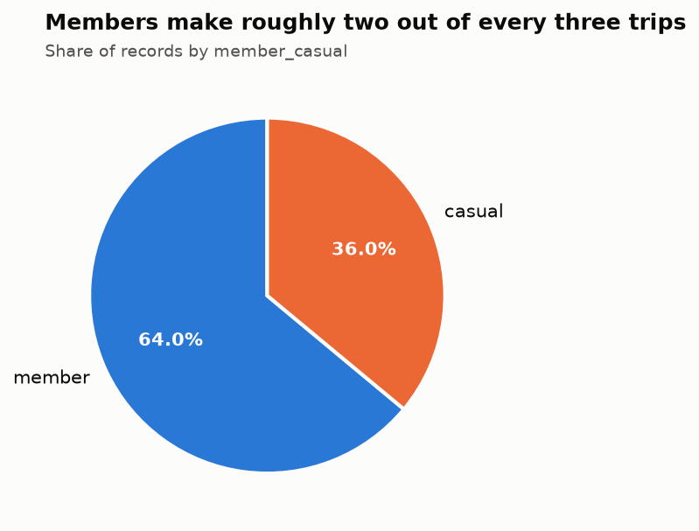
The start timestamp is the most informative column in the dataset. Broken down by hour it is clearly bimodal, with a morning commuting peak around 08:00 and a larger, broader afternoon peak around 17:00 - the signature of a system used heavily for commuting. The day-of-week view shows why the two rider segments cannot be pooled: the weekday peaks are driven by members, while casual riders shift the weekend distribution towards the middle of the day.
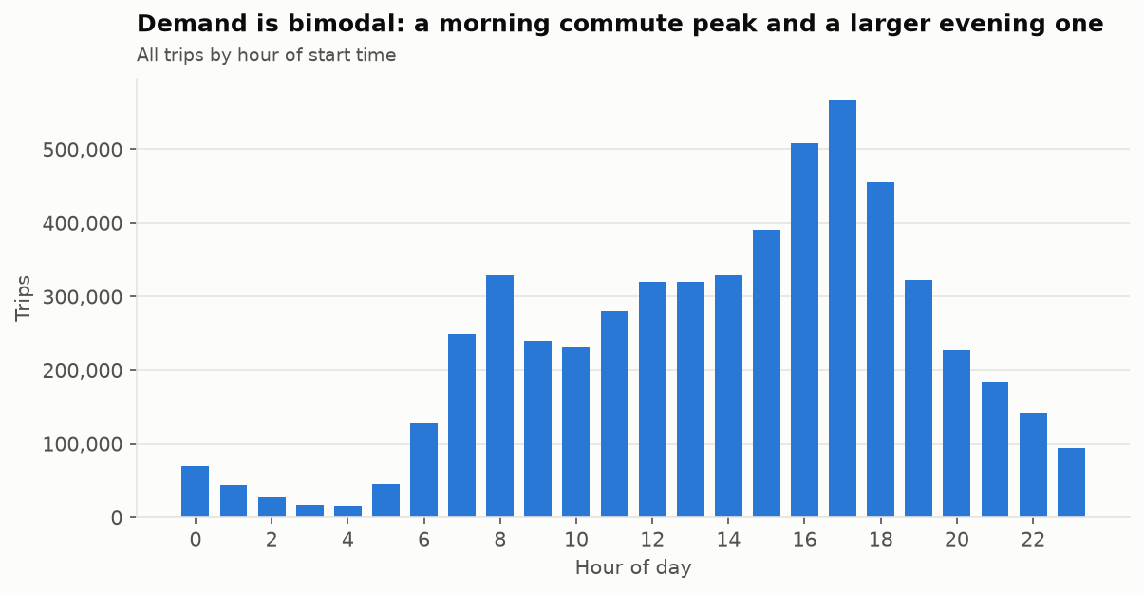
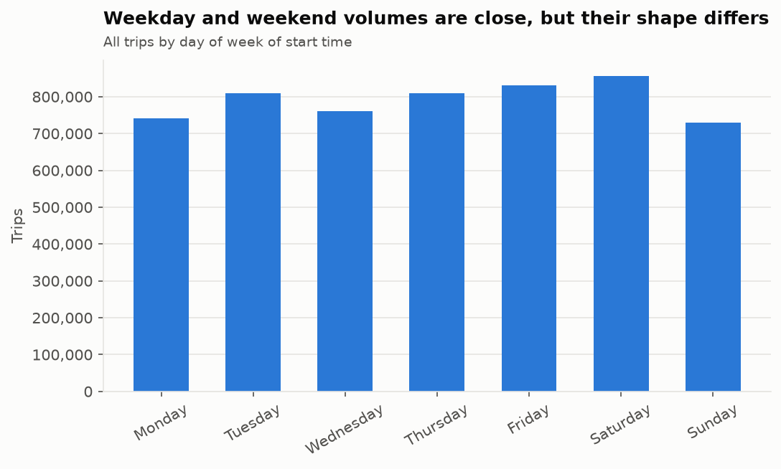
Trip duration, plotted on a logarithmic axis, reveals two populations rather than one. The main mode sits near the median of 9.45 minutes, but there is a clearly separated secondary mode in the region of 10 to 30 seconds. That second mode is the classic failed-checkout signature: a rider undocks a bike, finds a fault and immediately re-docks it. There is also a spike at exactly 24 hours - the 99.9th percentile lands at 1439.84 minutes, fractionally under the 1,440-minute mark - which is a system auto-close on bikes that were never returned, not a day-long ride. A further 43 records end before they start, with a minimum duration of -56.02 minutes, most likely clock-synchronisation or daylight-saving artefacts.
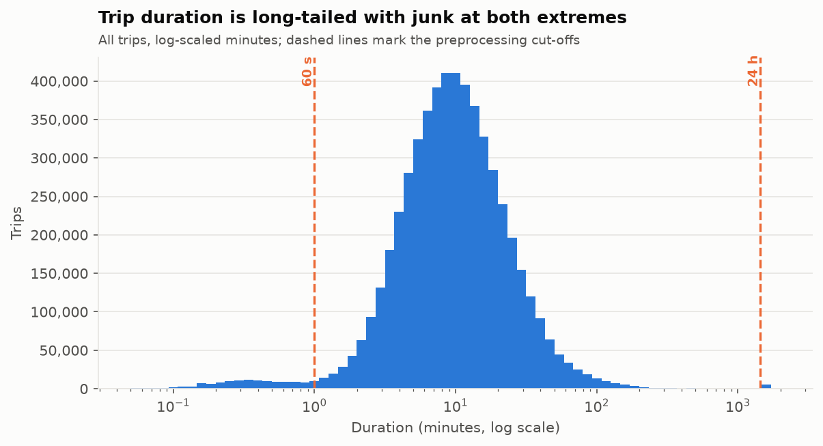
Trip duration statistics
Statistic | Minutes | Percentile | Minutes
mean | 16.06 | p1 | 0.27
std | 54.62 | p25 | 5.41
min | -56.02 | p50 | 9.45
max | 1574.90 | p75 | 16.61
count | 5,539,521 | p95 | 40.02
 |  | p99 | 89.86
 |  | p99.9 | 1439.84

Straight-line distance and average speed are derived from the coordinates and the timestamps. Both behave as expected for an urban bike-share system: most journeys are short, and average speed clusters tightly around 11 to 12 km/h. Because the distance is measured as the crow flies rather than along the route actually cycled, the derived speed is a conservative lower bound, which is exactly the property wanted when speed is used to detect impossible trips.
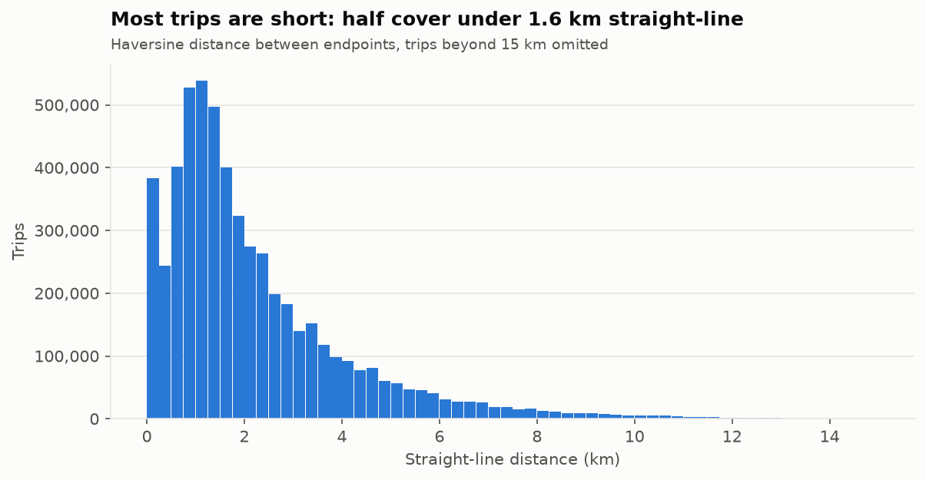
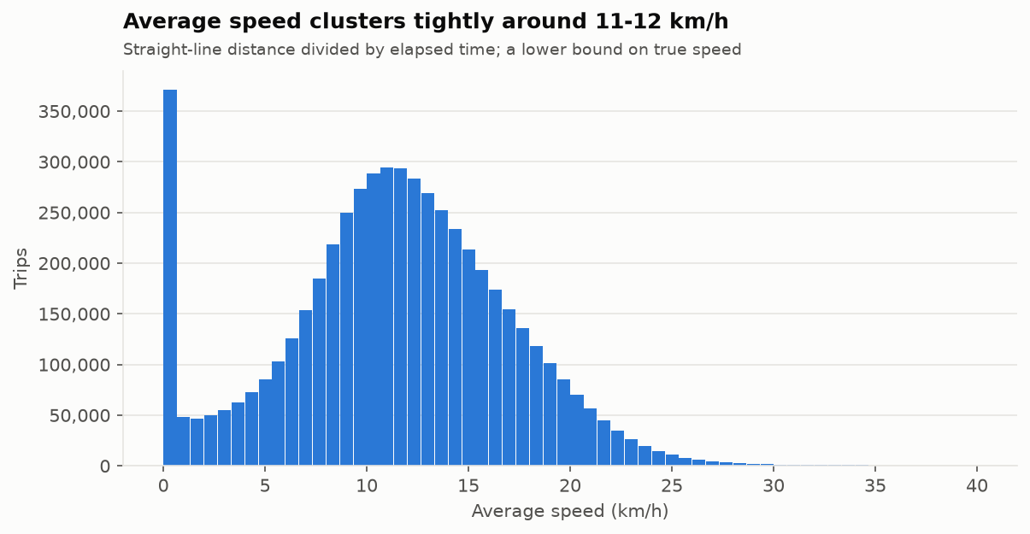
The four coordinate columns are unimodal and tightly concentrated, reflecting the geography of the service area: a dense core along the lakefront and the near North Side, thinning out towards the city boundary. Plotted on the same axes the start and end distributions are almost indistinguishable, which is expected in a system where most trips both begin and end inside the same dense core.
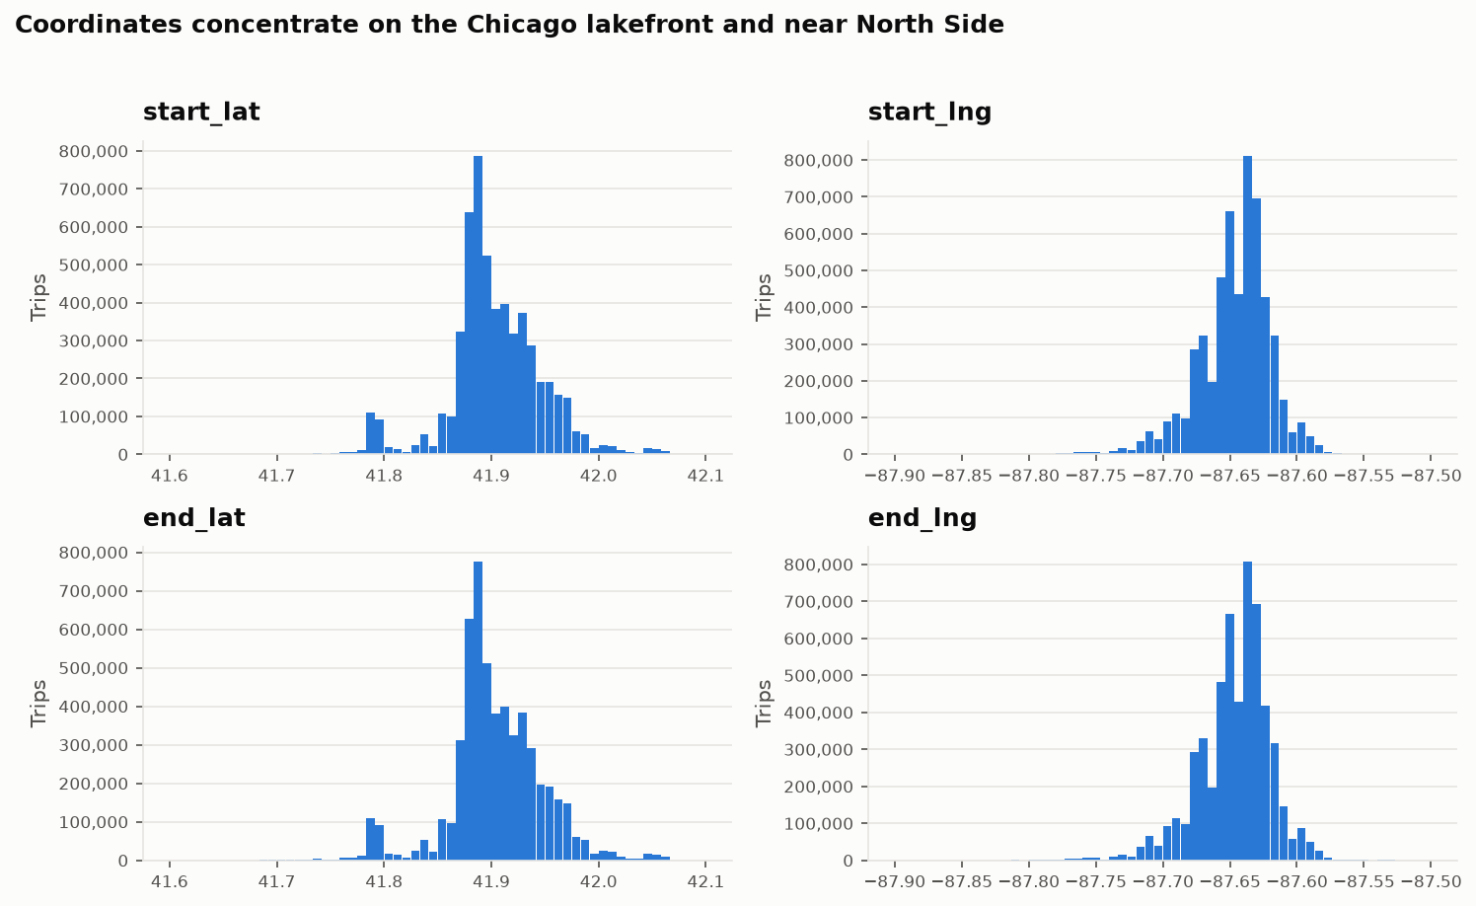

Spatial distribution of demand
Mapping the stations by the number of trip endpoints they serve makes the concentration explicit. Demand is heavily weighted towards the central business district and the lakefront parks, with a secondary cluster around the university campus on the South Side.
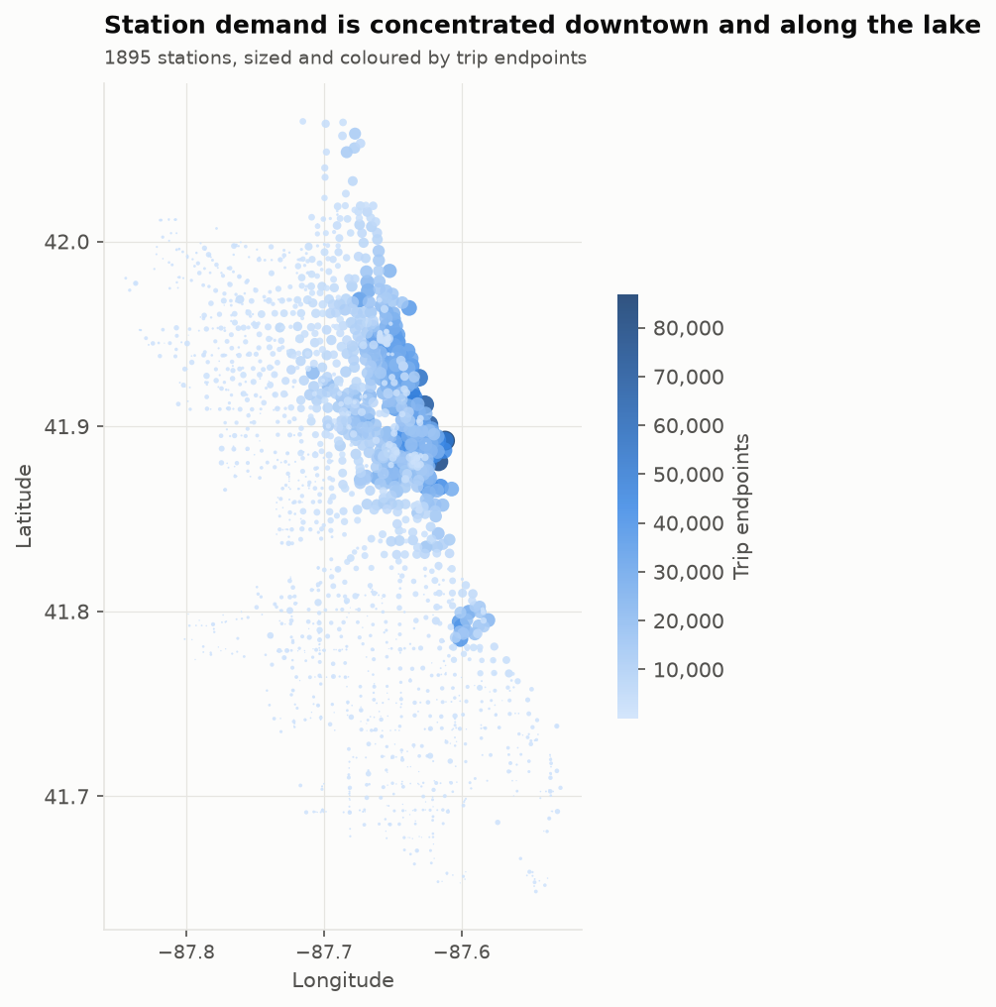

Top 30 start stations and top 30 end stations
The station-name columns have too many distinct values to plot directly - 1,920 distinct names appear across the study window - so their distribution is represented by the 30 most frequent values, in the same way the distribution of a high-cardinality text column would be. The ranking is dominated by the lakefront parks, the Navy Pier and Millennium Park tourist corridor, and the commuter approaches to the Loop.
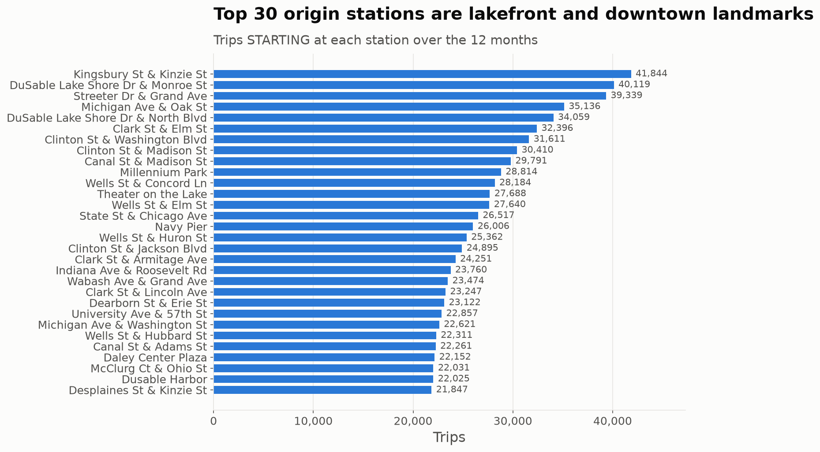
The destination ranking is near-identical to the origin ranking: the same stations appear, in almost the same order, with comparable totals. Over a full year, therefore, traffic between the busiest stations is broadly balanced. That is a statement about annual totals only, and it is worth stating explicitly because it is easy to misread as evidence that there is no imbalance problem to solve. The imbalance this project sets out to study is not visible at this resolution: it appears hour by hour, as these same stations empty during the morning commute and refill in the evening. Detecting it requires the hourly station-level aggregation prepared in the preprocessing stage, not a yearly ranking.
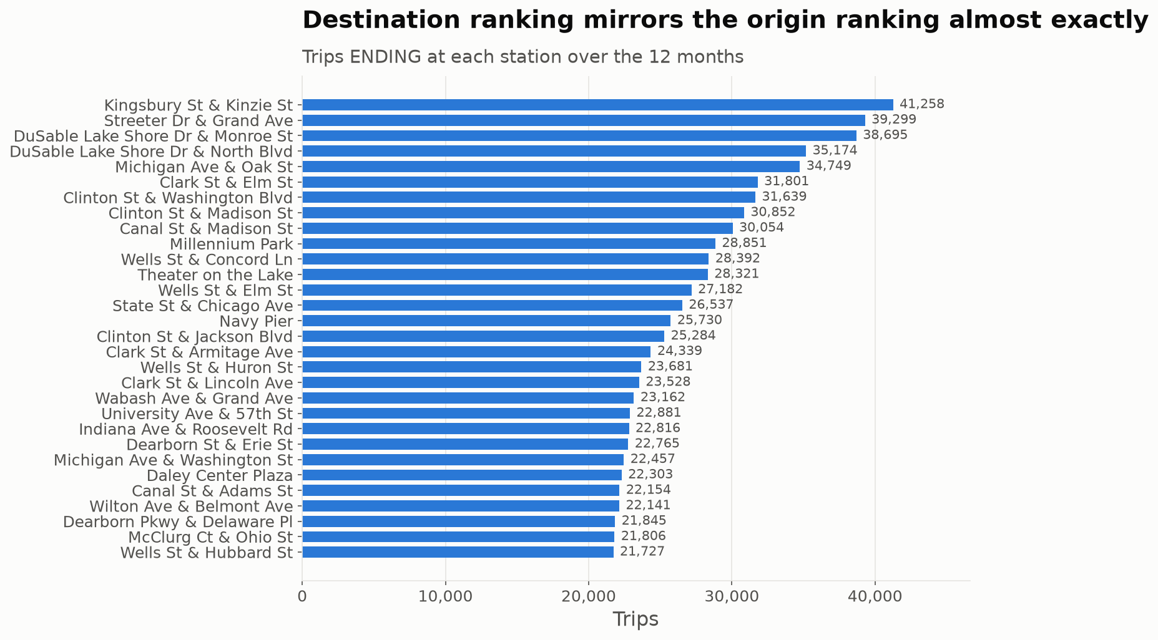

Station activity distribution
Ranking all stations by departures shows a pronounced long tail. A small minority of stations carries most of the traffic, while several hundred stations see only a trickle. Aggregating instead to the station-day level confirms this from a different angle: the median station-day carries only a handful of departures. Any rebalancing analysis therefore has to be weighted by station, because an unweighted average across stations would be dominated by hundreds of near-idle locations.
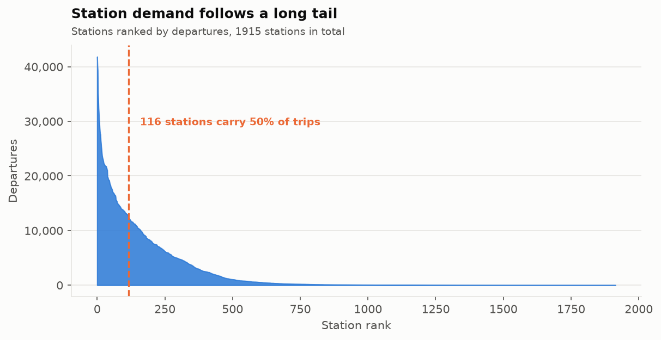
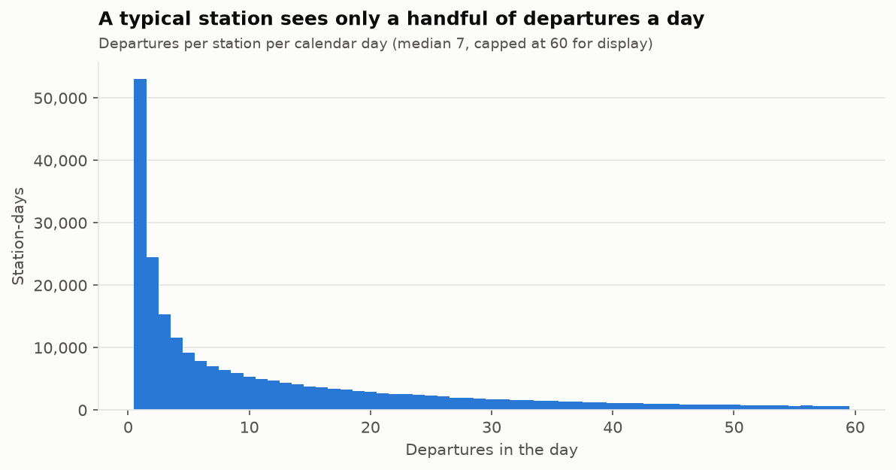

Number of active stations per month
Counting the distinct station names that appear as a trip endpoint in each month gives an apparent seasonal cycle in the size of the network. The network itself does not shrink in winter; rather, a station only appears in the data if at least one trip used it, so quiet outlying stations drop out of the count during the cold months and return in spring. This is a useful reminder that an apparently structural metric can be an artefact of how the data is recorded.
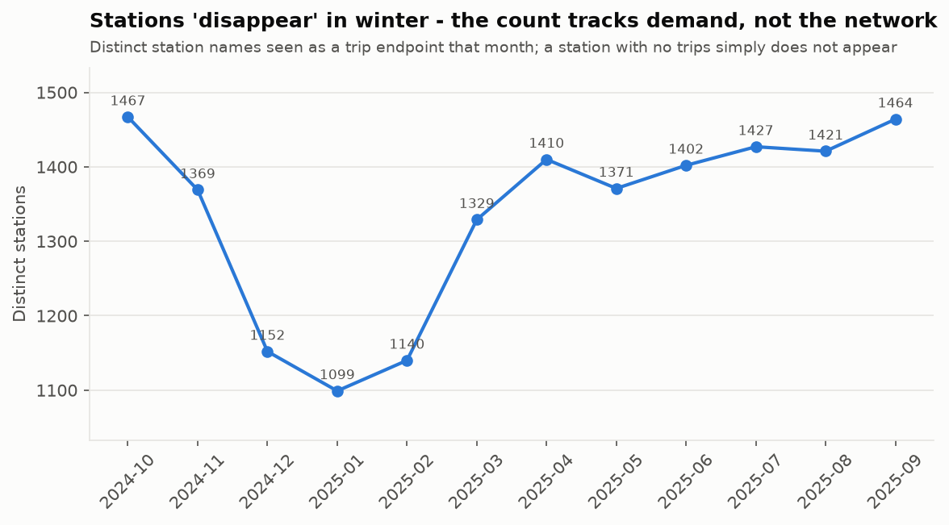

Station identifier integrity
Profiling the two identifier columns uncovered a defect that would be easy to miss and expensive to discover late. The dataset contains 1,920 distinct station names but 3,435 distinct station_id values, and 1,589 of those names - 82.8% of them - are associated with more than one identifier.
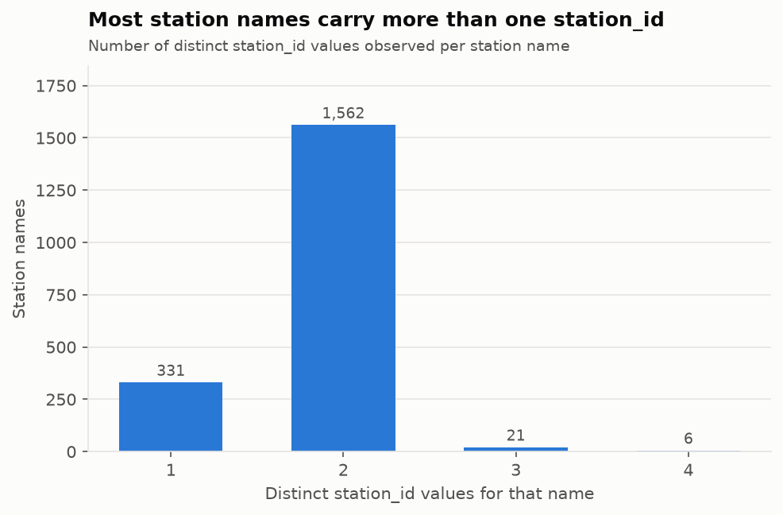
Two independent problems are at work. Divvy migrated from numeric identifiers to a CHIxxxxx scheme partway through the study window, so a single station appears under both schemes; and retired identifiers were then reassigned to unrelated stations, so 105 identifiers map to more than one name. A GROUP BY on station_id would therefore fragment most stations into two or more rows and silently merge 105 pairs of unrelated ones, with no error to warn anyone. The preprocessing stage resolves this by deriving a stable surrogate key from the normalised station name and demoting station_id to a traceability-only column.

Correlation between numeric features
The correlation matrix covers the three derived measures and the numeric source columns, computed over the 5,534,036 records that are complete in all twelve variables. The strong entries are all mechanical rather than informative: start and end latitude correlate at 0.81 because trips are short and stay within the same city, and distance correlates with end longitude for the same geographic reason. Everything else is weak.
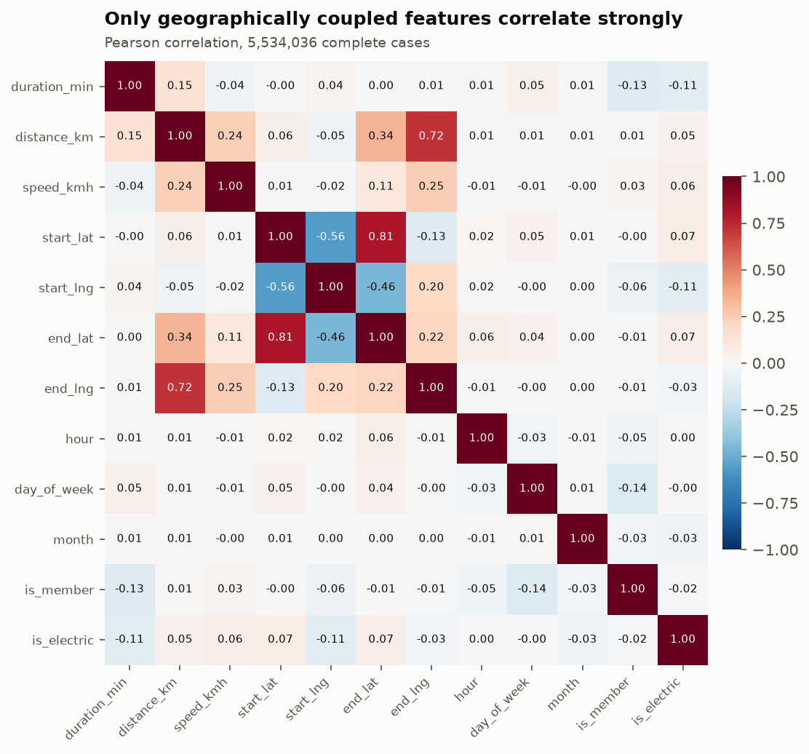
The absence of strong correlation among the behavioural variables is a useful negative result at this stage. It means there is no redundant column that can simply be dropped, and it means that the structure this project is looking for - which stations run dry, when, and which rider segment drives it - is not going to be visible in pairwise linear correlation on raw columns. It lives in the interaction between time, location and rider type, which is what the analytics stage described in Section 5 is designed to expose.

