NAME – AMAN SHARMA
REGISTER NO – 21BCE5769

REMAINDER 0

1. CODE:
USING ONLY LEX:
%{
#include <stdio.h>
#include <string.h>
int count = 0;
%}
%%
[a-zA-Z][a-zA-Z0-9]* {
int n = strlen(yytext);
for(int i = 0; i<n; i++){
if(yytext[i] >= '0' && yytext[i] <= '9')
count++;
}
if(count >=1 && count <= 3)
printf("Valid String\n");
else
printf("Invalid String\n");
}
[0-9][a-zA-Z0-9]* {printf("Invalid String\n");}
\t {return 0;}
\n {return 0;}
. {return 0;}
%%

int main(){
yylex();

return 0;
}
int yywrap(){}

OUTPUT:
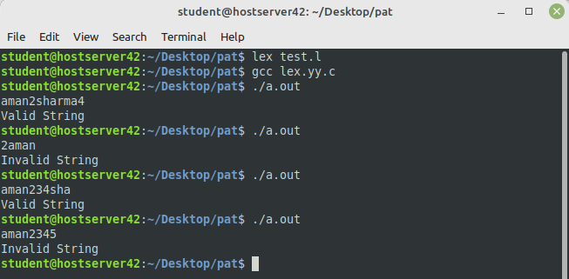

LEX:

%{
#include "y.tab.h"
%}
%%
[a-zA-Z] {return char;}
[0-9] {return num;}
\n {return NL;}
%%
int yywrap(){}

YACC:

%{
#include <stdio.h>
#include <stdlib.h>
int yylex();
void yyerror(const char* msg);
int count = 0;
%}
%token char num NL
%%
S: E NL
E : E T
E: char
;
T: num {count++;}
;
%%
int main(){
printf("Enter the string\n");
yyparse();
if (count <= 3){
printf("Valid");
}
return 0;
}
int yyerror(char *msg){
printf("Error: %s\n", msg);
exit(0);
}

OUTPUT:
SHIFT/REDUCE ERROR

2.CODE:
LEX:

%{
#include "y.tab.h"
%}
%%
[0] {return ZERO;}
[1] {return ONE;}
[2] {return TWO;}
[3] {return THREE;}
[4] {return FOUR;}
[5] {return FIVE;}
[6] {return SIX;}
[7] {return SEVEN;}

"\n" {return NL; }
. {return yytext[0]; }
%%
int yywrap(){}

YACC:

%{
#include <stdio.h>
#include <stdlib.h>
#include <math.h>
int yylex(void);
int yyerror(char *s);
int count = 0;
%}
%union{
float f;
}
%token <f>ZERO <f>ONE <f>TWO <f>THREE <f>FOUR <f>FIVE <f>SIX <f>SEVEN NL
%type <f>N <f>L <f>R <f>B
%%
E: N NL {printf("Result = %f\n", $1); return 0;}
N: L '.'R
L: L B {$$ = $1*8 + $2;}
| B {$$ = $1;}
R: R B {$$ = ($1*8 + $2)/pow(8,count);}
| B {$$ = $1; count++;}
B: ZERO {$$ = 0; count = 1;}
| ONE {$$ = 1; count = 1;}
| TWO {$$ = 2; count = 1;}
| THREE {$$ = 3; count = 1;}
| FOUR {$$ = 4; count = 1;}
| FIVE {$$ = 5; count = 1;}
| SIX {$$ = 6; count = 1;}
| SEVEN {$$ = 7; count = 1;}
;
%%
int main() {
printf("Enter the Octal Number\n");
yyparse();
}
int yyerror(char* s) {
printf("Expression is invalid\n");
}

OUTPUT:
